

Master of Business Administration Programme
LCMB7035 - Dissertation

Reputation Recovery: Managing Consumer Trust After Quality Failures in the International Clothing Industry

Student Name:Nusrat Jahan Onameka
ID:2422956

Word Count: 2700
Date of Submission: 12/11/2025
Table of Contents
1. Introduction 4
1.1 Background and Rationale 4
1.2 Research Aim 4
1.3 Research Objectives 5
1.4 Research Questions 5
2. Literature Review 5
2.1 Key Themes and Theories 5
2.2 Key Studies and Debates 7
2.3 Research Gap 8
2.4 Conceptual Framework 9
3. Methodology 9
3.1 Research Philosophy 10
3.2 Research Approach 11
3.3 Research Strategy 11
3.4 Gantt Chart 11
3.5 Data Collection Methods 12
3.6 Sampling and Case Selection 12
3.7 Data Analysis 12
3.8 Ethical Considerations 13
3.9 Feasibility 13
4. Expected Findings 13
5. Limitations 14
6. Timeframe 14
7. Conclusion 16
Reference 17

1. Introduction

1.1 Background and Rationale
Corporate reputation is one of the most valuable intangible assets a firm has, especially in the extremely dynamic international apparel industry. The reputation of a brand has such a strong impact on consumer trust, intention and long-term loyalty. However, in recent years, fashion companies have been faced with growing criticism on issues of product-quality breakdowns, unethical labour use, and lack of environmental responsibility (Kim, Giroux and Lee, 2021). The example of the Boohoo scandal of 2020, when the company was accused of labour exploitation, the accusations of greenwashing in H&M and the controversies of the supply chain in Primark demonstrate how quickly the public trust begins to depreciate in the age of digital transparency (Chandrruangphen, Assarut and Sinthupinyo, 2022). The increased visibility worldwide, social media activism, and consumer awareness have intensified the harm arising due to such a crisis, making reputation management more complex and time-sensitive. Although many studies determine what is behind the loss of brand reputation, very little has been done on the mechanisms involved in restoring trust after the crisis. It is vital to know how brands restore credibility rather than just how they lose credibility to be competitive in a socially aware market (Chandrruangphen, Assarut and Sinthupinyo, 2022). The current study, therefore, tries to fill this gap by investigating reputation-recovery practices and trust-repair strategies that are used by the global fashion brands and seeks to bring meaningful information as to how corrective measures, communication strategies and stakeholder relationships can be used to restore consumer trust and integrity of the corporate reputation.

1.2 Research Aim
To investigate how international clothing brands manage reputation recovery and rebuild consumer trust after quality or ethical failures, using a comparative case study of selected fashion brands such as Boohoo, Primark, and H&M, which have experienced significant public trust crises.

1.3 Research Objectives
- To examine the key causes and consequences of quality failures in global clothing brands.
- To analyse the strategies used by brands to restore trust after crises.
- To assess the effectiveness of corporate communication and corrective actions in reputation recovery.
- To identify consumer perceptions influencing post-crisis brand credibility.
- To recommend best practices for sustainable reputation management in the fashion sector.

1.4 Research Questions
- What factors contribute to reputation loss in the international clothing industry?
- How do brands design and implement recovery strategies after quality or ethical failures?
- Which trust-building mechanisms most effectively influence post-crisis consumer perceptions?
- How do case studies like Boohoo, Primark, and H&M illustrate similarities or differences in recovery approaches?

2. Literature Review

2.1 Key Themes and Theories
The corporate reputation concept entails the sum of perception of the past activities and future opportunities of an organisation by its stakeholders (Gorton et al., 2021). It has been built on continuity, integrity, and genuine branding. Representation has an impact on customer confidence in the international apparel industry, as well as social legitimacy in a market that is now more focused on transparency and responsibility. The reputation is a difficult strategic and psychological task to rebuild once it is damaged by a product failure or ethical scandals.
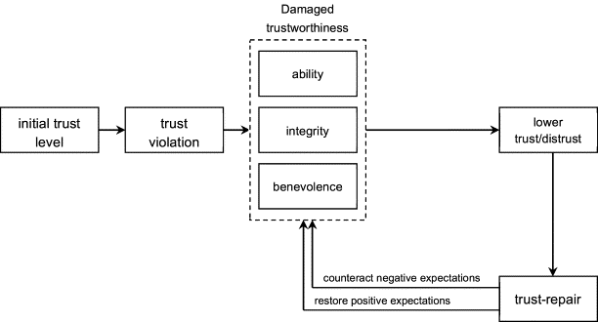
Figure 1: The Trust Repair Theory
Source: (Akoglu and Özbek, 2022)
The Trust Repair Theory is a theory that explains how consumer confidence can be regained after a breach. It recognises three main processes that include recognition of wrong, taking corrective measures and showing long-term ethical behaviour (Akoglu and Özbek, 2022). This model is highly coincidental with how fashion companies have been handling the reconstruction of consumer confidence with apologies to the public, increased labour standards or sustainability policies (Akoglu and Özbek, 2022).
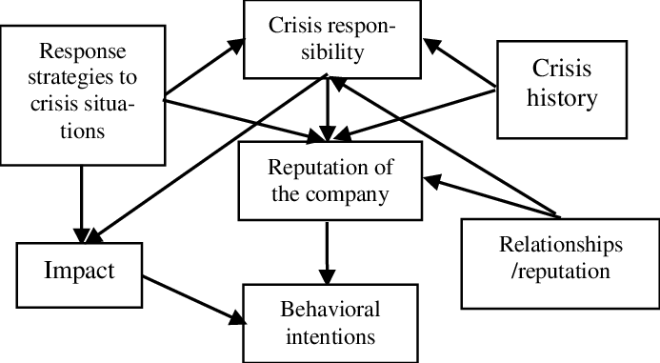
Figure 2: Situational Crisis Communication Theory
Source: (Isabel, Bergey and Smith, 2024)
Another lens that is invaluable is the Situational Crisis Communication Theory (SCCT) by Coombs. It classifies crisis response strategies, which include denial, diminishing, rebuilding and bolstering strategies, based on the level of responsibility attributed to the firm (Isabel, Bergey and Smith, 2024). To illustrate, the first refusal to acknowledge labour problems by Boohoos is in contrast with the active sustainability marketing of H&M, which is the model of reconstruction.
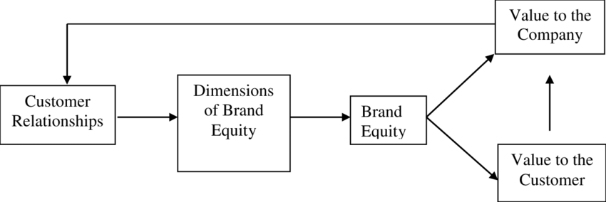
Figure 3: Brand Equity and Relationship Marketing Theory
Source: (Pyle, Smith and Chevtchouk, 2021)
The Brand Equity and Relationship Marketing Theory focus on the importance of emotional involvement and openness as the key elements of recapturing long-term consumer loyalty (Pyle, Smith and Chevtchouk, 2021). Consumers often reevaluate their perception when they see brands display honesty, shared values, and conspicuous reform, and this leads to incremental reputation recovery.

2.2 Key Studies and Debates
It is proven that the reputation crises in the fashion industry are systematic cases of consumer confidence erosion due to ethical violations as well as supply-chain dilemmas. Jones et al (2018) have performed a strict study of brand reputation restoration after corporate scandals and have established that open communication and a real corrective action are the key factor that initiates stakeholder forgiveness. Similarly, Quintus et al. (2024) investigated the way people react towards apologetic messages of companies in the apparel industry and discovered that the perceived credibility of the message has a strong effect on the rebuilding of trust.
Murphy et al. (2022) made a significant contribution to the crisis management theory in this field because they were able to empirically test the Situational Crisis Communication Theory (SCCT) during fashion-related crises. Their results show that denial or justification (reactive strategies) tends to augment negative perceptions, and acceptance and restitution (proactive strategies) are effective in lessening reputational damage. Conversely, Su et al. (2022) claimed that, especially in the digital realm, the pace and permanence of communication have an even stronger impact on the outcome of recovery than does the strategic decision.
Recent scholarship also questions the dichotomous position of social media as a channel of amplification of risks and recovery. Wang et al. (2021) proved that social media networks simplify the spread of brand crises quickly and create a space to discuss the issue openly and present corrections to the narrative. Within the context of fast fashion in particular, such duality requires a form of brand reaction not only fast but also emotionally moving and clearly explained (Pyle, Smith and Chevtchouk, 2021). Despite these changes, the available literature has largely been focused on examining individual brands, thus creating a significant knowledge gap on comparative understanding of various apparel brands in the world that face similar typologies of crises.

2.3 Research Gap
The existing literature is mostly concerned with the factors that contribute to the reduction of reputation and the concept of corporate social responsibility practices in general; nevertheless, the research on trust-recovery mechanisms in the fast-fashion sector is insignificant. Numerous studies focus on one crisis or a single segment of the market, thus failing to carry out comparative studies and cross-brand interactions (Pyle, Smith and Chevtchouk, 2021). In addition, case-studies based on secondary data that incorporate media reporting, corporate literature and consumer reactions have been under minimal academic criticism. This study fills the given gap by using a multi-case comparative study on Boohoo, Primark, and H&M, focusing on how post-crisis recovery strategies, i.e. transparency, ethical repositioning, and communication, impact consumer trust and brand reputation permanence (Roh et al., 2024). The derived empirical findings are expected to apply existing crisis management and trust-repair theoretical models to the fast-fashion setting.

2.4 Conceptual Framework
The conceptual model guiding this study proposes a sequential relationship:
Crisis Response Strategy → Consumer Trust Recovery → Reputation Restoration → Long-term Brand Loyalty.
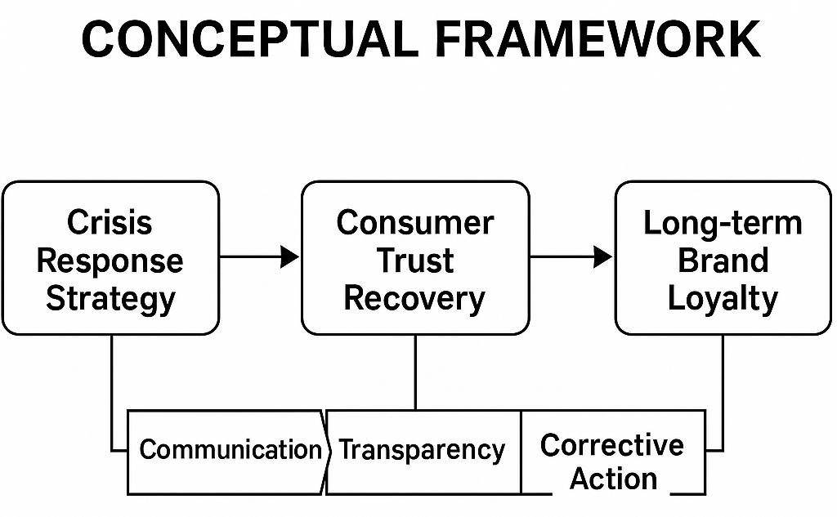
Figure 4: Conceptual Framework
Source: Self-Made
Communication, transparency, and corrective action constructs can be used as mediating variables that mediate between crisis management efforts and the consumer perception outcomes. The proposed framework, synthesising tenets based on the literature of the Situational Crisis Communication Theory, Trust Repair Theory, and Brand Equity, provides a comprehensive insight into the role of strategic responses in the process of putting back in place the image of the global apparel industry (Roh et al., 2024). This model, therefore, shall be a structural framework of the subsequent case study analysis.

3. Methodology
The methodology chapter specifies the research design using Saunders' Research Onion, which provides a systematic framework in which to clarify the philosophical orientation, methodological approach, strategic plan, data collection methods and analysis (Tseng et al., 2022). Each new layer of the onion provides the basis for and rationale for the research on reputation restoration and consumer trust.
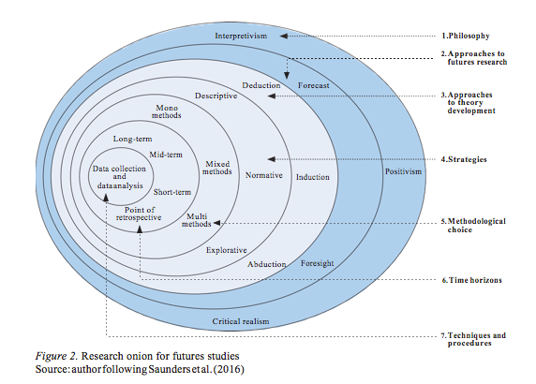
Figure 5: Research Onion
Source: (Tseng et al., 2022)

3.1 Research Philosophy
This research takes an interpretivist approach, focusing on the understanding of subjective meanings and socially constructed realities that are created by individuals and organisations. In the context of the reputation recovery process, consumer trust and brand reputation are inherently perceptual and context-dependent constructs (Tseng et al., 2022). Interpretivism allows the researcher to analyse the meaning of crisis in fashion brands and the modus for transferring trust-restoring actions, while analysing the reactions of stakeholders. The worldview enables qualitative reasoning, which emphasises rich and nuanced interpretation instead of numerical generalisation and accommodates the exploratory and comparative nature of the study.

3.2 Research Approach
Inductive research is used, and theory is extracted from the patterns which emerge from the case studies. This approach endorses the development of a conceptual framework based on empirical evidence of how brand recovery is achieved in real-world crises, rather than the testing of pre-determined hypotheses, as is the case in other methodologies (Hidayat et al., 2021). Induction is especially suitable for researching new and changing problems like the reputation repair of ethically questionable companies, where theory has to keep pace with the changing consumer behaviour. The experience from the recoveries of Boohoo, H&M and Primark will be used to shape an environment-specific model of trust recovery and reputation management.

3.3 Research Strategy
The given investigation utilises a multiple-case study approach, as it compares three major clothing brands, Boohoo, H&M, and Primark, which have faced a crisis of their reputation in the public in 2019-2024. The design will answer both how and why questions related to the reconstruction of the post-crisis trust. Based on the secondary sources, such as sustainability reports, corporate communications, media coverage, and NGO publications, the analysis focuses on differences in communicative approaches and remedial measures (Jaspers and Pearson, 2022). The case study methodology provides a detailed understanding of each brand and a general cross-case analysis in the context of the apparel industry in the world.

3.4 Gantt Chart
Milestones | W1 | W2 | W3 | W4 | W5 | W6 | W7 | W8 | W9 | W10 | W11 | W13
Introduction
Literature Review
Methodology
Data collection
Data analysis
Report writing
Completion

3.5 Data Collection Methods
Data collection is exclusively secondary with adequate coverage, reliability and feasibility. Sources include company annual and sustainability reports, press releases, independent audit documents, social media statements and investigative media articles. Evidence from NGO reports, academic journals and government publications will be used to triangulate these findings with additional information from various stakeholders and to gain further insight into their views and perspectives (Wang et al., 2023). Publishing openly accessible documents helps to increase transparency and objectivity. Secondary data techniques lend themselves well to the interpretivist and inductive approach of this study by allowing thematic examination of actual events with no interference through fieldwork. Although several data sources are used, primary interviews are not used due to access and ethical reasons, which ensures the depth and credibility of the analysis.

3.6 Sampling and Case Selection
Purposive sampling: Cases that have met certain inclusion criteria, namely: (1) global footprint of the case, (2) documented quality or ethical controversies, and (3) availability of credible secondary data. Boohoo, H&M and Primark were selected because each organisation suffered high-profile scandals, but each had to follow different routes to recovery. Boohoo highlighted transparency with independent audits, H&M increased sustainability marketing, whereas Primark built on supply chain ethics. The comparative analysis of these cases allows for the examination of alternative models of recovery and the drawing of conclusions for the restoration of trust in international apparel markets.

3.7 Data Analysis
Thematic analysis will be used to identify and interpret patterns of crisis response, trust recovery and reputation rebuilding. Themes will be formed using deductive coding based on SCCT and Trust Repair Theory and inductive coding based on evidence found in cases (Singh and Sharma, 2023). The brands are examined in terms of transparency, responsibility and customer engagement. The synthesis, data coding, and categorisation explain the differences and similarities in strategies (Wu et al., 2021). This two-pronged approach, based on reliability and theoretical flexibility, can provide some fine-tuning on brand behaviour in the unique cultural and business dimensions.

3.8 Ethical Considerations
The research is ethically sound because only known secondary data, which is published and made available to the public, has been used. All sources will be referenced according to the Harvard referencing method (Wu and Huang, 2023). No private or confidential information will be perused. Due to the sensitivity of the brand, we will maintain a neutral and evidence-based approach throughout the analysis.

3.9 Feasibility
This research work is very feasible because it is based on available, credible secondary data and requires fewer resources. It doesn't require direct organisational access, allowing completion within the 12-16 week MBA dissertation time-constrained period. The systematic approach ensures that data collection, analysis, and reporting are done efficiently while maintaining academic rigour (Wu and Huang, 2023).

4. Expected Findings
The research is likely to yield three common themes, which are critical to successful reputation rehabilitation. Transparency and accountability, consistent messaging, and genuine corrective action. It is also likely that companies taking responsibility and honestly reporting accurate information about their failures will regain consumer trust more quickly than those that use denial or image repair tactics only (Wu and Huang, 2023). Straightforward, consistent and compassionate communication is predicted to reduce uncertainty, whereas action - supply chain reforms, ethical repositioning - is likely to facilitate a sustainable reputation rebuild. It might also be shown that symbolic gestures or apologies are insufficient without accompanying structural and operational changes. Successful and sustained recovery of trust is expected to be driven largely by continued engagement, accountability and demonstrating reform rather than one-off marketing initiatives (Bandara, Fernando and Akter, 2021). Theoretically, this research is an extension of Trust Repair Theory and the Situational Crisis Communication Theory (SCCT) to explain the role of transparency and hybrid response strategies in post-crisis trust reconstruction in order to provide practical guidance for the managers of global fashion companies.

5. Limitations
Because it is based on secondary data, the study could be limited in access to in-depth information about the corporate decision-making and managerial attitudes. Furthermore, brand responses may be influenced by media bias, which can affect the interpretive objectivity. However, the analysis sample is restricted to only three cases, which may restrict general statistical generalisation across the industry (Bandara, Fernando and Akter, 2021). Third, time constraints render it impossible to track reputation dynamics over a long period of time. To counteract these limitations, the research will utilise data triangulation between several different and credible sources and build upon a well-developed theory to ensure analytical depth, reliability, and validity when primary data is not available.

6. Timeframe
Phase / Task | Duration (Weeks) | Notes
Topic selection & background reading | 1–2 | Identify key crises & case brands
Literature review | 3–6 | Thematic synthesis & gap identification
Methodology design (Research Onion) | 7–8 | Align approach & framework
Data collection & coding | 9–10 | Gather secondary data
Thematic analysis & interpretation | 11–12 | Compare cases
Drafting proposal & editing | 13–15 | Structure & refine
Final review & submission | 16 | Proofread & submit

7. Conclusion
This dissertation proposal examines how global apparel conglomerates rebuild consumer confidence after quality or ethical crises. By bringing together interlinking crisis response, restitution of trust and reputational rehabilitation, it brings together the two theoretical frameworks and practical exigencies of the field of crisis management (Chen, Hyun and Lee, 2022). A comparative case study of Boohoo, H&M and Primark is designed to discover which strategic measures engender authentic, long-term reputation repair. The methodological framework (Saunders Research Onion) ensures a philosophically coherent and analytical approach (Chen, Hyun and Lee, 2022). The projected empirical contributions will expand the knowledge of corporate resilience in fast fashion situations and provide actionable information for managerial practice. Ultimately, this research aims to contribute to the scholarly discussion on trust repair and crisis communication and, therefore, the immediate imperative of restoring global brand credibility.

Reference
Akoglu, H.E. and Özbek, O. (2022) ‘The Effect of Brand Experiences on Brand Loyalty through Perceived Quality and Brand trust: a Study on Sports Consumers’, Asia Pacific Journal of Marketing and Logistics, 34(10), pp. 2130–2148.
Bandara, R., Fernando, M. and Akter, S. (2021) ‘Managing consumer privacy concerns and defensive behaviours in the digital marketplace’, European Journal of Marketing, 55(1). Available at: https://doi.org/10.1108/ejm-06-2019-0515.
Chandrruangphen, E., Assarut, N. and Sinthupinyo, S. (2022) ‘The effects of live streaming attributes on consumer trust and shopping intentions for fashion clothing’, Cogent Business & Management. Edited by P. Foroudi, 9(1). Available at: https://www.tandfonline.com/doi/full/10.1080/23311975.2022.2034238.
Chen, X., Hyun, S.S. and Lee, T.J. (2022) ‘The effects of parasocial interaction, authenticity, and self‐congruity on the formation of consumer trust in online travel agencies’, International Journal of Tourism Research, 24(4). Available at: https://doi.org/10.1002/jtr.2522.
Gorton, M. et al. (2021) ‘What Determines consumers’ Use of eco-labels? Taking a Close Look at Label Trust’, Ecological Economics, 189(1), pp. 107–173. Available at: https://doi.org/10.1016/j.ecolecon.2021.107173.
Hidayat, A. et al. (2021) ‘Consumer Trust as the Antecedent of Online Consumer Purchase Decision’, Information, 12(4), p. 145.
Isabel, E., Bergey, P. and Smith, B. (2024) ‘Blockchain technology for supply chain provenance: increasing supply chain efficiency and consumer trust’, Supply Chain Management, 29(4). Available at: https://doi.org/10.1108/scm-08-2023-0383.
Jaspers, E.D.T. and Pearson, E. (2022) ‘Consumers’ acceptance of domestic Internet-of-Things: The role of trust and privacy concerns’, Journal of Business Research, 142, pp. 255–265. Available at: https://doi.org/10.1016/j.jbusres.2021.12.043.
Kim, J., Giroux, M. and Lee, J.C. (2021) ‘When Do You Trust AI? the Effect of Number Presentation Detail on Consumer Trust and Acceptance of AI Recommendations’, Psychology & Marketing, 38(7). Available at: https://doi.org/10.1002/mar.21498.
Murphy, B. et al. (2022) ‘Consumer trust in organic food and organic certifications in four European countries’, Food Control, 133(133), p. 108484. Available at: https://doi.org/10.1016/j.foodcont.2021.108484.
Pyle, M.A., Smith, A.N. and Chevtchouk, Y. (2021) ‘In eWOM we trust: Using naïve theories to understand consumer trust in a complex eWOM marketspace’, Journal of Business Research, 122, pp. 145–158. Available at: https://doi.org/10.1016/j.jbusres.2020.08.063.
Quintus, M. et al. (2024) ‘Managing consumer trust in e-commerce: evidence from advanced versus emerging markets’, International Journal of Retail & Distribution Management, 52(10/11). Available at: https://doi.org/10.1108/ijrdm-10-2023-0609.
Roh, T. et al. (2024) ‘What makes consumers trust and adopt fintech? An empirical investigation in China’, Electronic Commerce Research, 24. Available at: https://doi.org/10.1007/s10660-021-09527-3.
Singh, V. and Sharma, S.K. (2023) ‘Application of blockchain technology in shaping the future of food industry based on transparency and consumer trust’, Journal of Food Science and Technology, 60. Available at: https://doi.org/10.1007/s13197-022-05360-0.
Su, D.N. et al. (2022) ‘Modeling consumers’ trust in mobile food delivery apps: perspectives of technology acceptance model, mobile service quality and personalization-privacy theory’, Journal of Hospitality Marketing & Management, 31(5), pp. 1–35.
Tseng, H.-T. et al. (2022) ‘Managing enterprise social media to develop consumer trust’, British Food Journal, 124(12). Available at: https://doi.org/10.1108/bfj-11-2020-0995.
Wang, C. et al. (2023) ‘The Influence of Consumer Perception on Purchase intention: Evidence from cross-border E-commerce Platforms’, Heliyon, 9(11), p. e21617. Available at: https://doi.org/10.1016/j.heliyon.2023.e21617.
Wang, H. et al. (2021) ‘The impact of blockchain technology on consumer behavior: a multimethod study’, Journal of Management Analytics, 8(3), pp. 371–390. Available at: https://doi.org/10.1080/23270012.2021.1958264.
Wu, W. et al. (2021) ‘Consumer Trust in Food and the Food System: A Critical Review’, Foods, 10(10), p. 2490. Available at: https://doi.org/10.3390/foods10102490.
Wu, Y. and Huang, H. (2023) ‘Influence of Perceived Value on Consumers’ Continuous Purchase Intention in Live-Streaming E-Commerce—Mediated by Consumer Trust’, Sustainability, 15(5), p. 4432. Available at: https://doi.org/10.3390/su15054432.

