
LEVEL 4 ASSESSMENT SPECIFICATION

Programme: | BA (Hons) Business Management
Module: | Stakeholder Engagement
Module code: | LCBB4013 | Contribution to Overall Module Assessment (%): | 100%
Lecturer: | Nishi Ramsurrun | Internal Verifier: | Dr Anupam Mazumdar
Assignment Title: | Component 1:  Coursework-Portfolio (4 elements) | Word count (or equivalent): | 3000 words (+/- 10%)
Submission deadline: | Weekday: N/A  Weekend: 22/12/25 @ 2pm | Return date of provisional marks & written feedback: | Weekday: N/A Weekend: 30/01/26
Student ID |  | Name
Name: Cotet Claudiu Octavian
Id:2430985
Table of Contents
Element 1: Introduction 3
Description of the Project 3
Relevance of the Project 3
Identification of Key Stakeholders 3
Element 2: Application to include Stakeholder Engagement Strategies 5
Power Influence Interest Table 5
Stakeholder Map 7
Communication Plan 8
Consultation Strategy 8
Element 3: Ethical Consideration in Stakeholders Consultation, Participation, and Feedback 10
Methods of Consultation 10
Ethical Considerations When Collecting Data 10
Stakeholder Feedback Collection & Review 11
Element 4: Conclusion and Reflection 13
References 16

Element 1: Introduction

Description of the Project
The expansion program suggested by Ryanair at London Stansted Airport is focused on the expansion of its routes, higher frequency of flights, and expansion of personnel capacity to accommodate increasing passenger traffic. Since Stansted was the biggest base that Ryanair has been operating in the UK, the airline seeks to consolidate its network in Europe by introducing new routes and booking more flights per day (Graham, 2023). As a Junior Stakeholder Manager in the project of large-scale infrastructure-related enhancement in addition to expansion of routes, including but not limited to improve ground-handling, better boarding, baggage systems, and more effective passenger processing facilities. These operational enhancements are to assist Ryanair in its fast turnaround mode, which is paramount in sustaining the low-cost strategy of operation. Strengthening of infrastructure at airports also means that Stansted is able to manage moving airplanes to a greater extent safely and efficiently.

Relevance of the Project
Ryanair's expansion is quite relevant, especially as the UK aviation industry is still recovering from the effects of the COVID-19 pandemic. The flight activities in such a big hub as Stansted contribute to the expansion of the level of national connectivity, to the rise of the industry in the competition, and to the development of aviation in the long run. The local employment is also boosted by the fact that the project generates new positions in the field of customer service, operations, retail in the airport, security, and maintenance. The expansion by boosting the frequency of flights and the destinations available in the market supports tourism, improves international movement, and provides the traveller with more affordable air transportation. The positive effects have a direct impact on broader economic development in London (Dube et al., 2021).

Identification of Key Stakeholders
Numerous stakeholders are the beneficiaries of this growth. The Ryanair management has more revenue and an expansion of the market. London Stansted Airport (MAG) has increased the throughput of passengers and improved its commercial prospects. CAA gets better control of safety and regulatory performance. The positive outcome of local residents in Essex is that new working areas are created, though the people can also raise the issue of noise and the environment. The passengers and tourists have access to cheaper and more frequent modes of travel. The environmental groups are given a chance to contribute to sustainability and carbon-cutting measures. Lastly, Essex County Council progresses as a result of better investment and economy in the region (Hiney, 2024).

(Source: Corporate Ryanair, 2025)

Element 2: Application to include Stakeholder Engagement Strategies

Power Influence Interest Table
Power-influence-interest analysis assists in identifying how each stakeholder ought to be handled during the expansion project of Ryanair at London Stansted Airport. The top management at Ryanair has high power, high influence, and high stakes as they make strategic decisions concerning route expansion, investment in operations, and staffing. Stansted Airport Executive Team (MAG) is also a body that is powerful and highly influential because it regulates the infrastructure of the airports, their terminals, and ground-handling activities, which are critical in supporting more flights.

High Power - Low Interest
High Power - High Interest
- Stakeholders: Ryanair Management, Stansted Airport (MAG), Civil Aviation Authority
- Support: Positive (all want successful expansion)
- Roles/Responsibilities: Approve expansion plans, operational upgrades, safety compliance, revenue management.

- Stakeholders: Essex County Council
- Support: Neutral to Positive (focused on economic benefits)
- Roles/Responsibilities: Approve planning/licensing, support infrastructure, monitor community impacts.




- Stakeholders: Environmental Groups (if limited local influence), Retail Shops, General Media
- Support: Mixed/Neutral
- Roles/Responsibilities: Monitor project impacts, occasionally raise sustainability or operational concerns.
- Stakeholders: Local Residents, Passengers, Airport Staff & Unions
- Support: Mixed (residents may raise concerns; passengers/staff positive)
- Roles/Responsibilities: Provide feedback on noise, service quality, staffing; influence public opinion.

Low Power - High Interest
Low Power - Low Interest
INTEREST
INFLUENCE
OF
STAKEHOLDER
OF
STAKEHOLDER

The power and influence of the Civil Aviation Authority (CAA) is also high as it controls the airspace management and compliance, as well as flight safety. It is also of great interest since more flights need additional supervision and compliance. However, the power of local residents is low but of high interest since they directly experience noise, traffic, and environmental changes, yet they do not have significant formal influence on aviation decisions. Their power is medium since airport policies can be influenced by group complaints or even through the pressure of the community. The medium power, high interest, and medium influence are held by passengers since they use Ryanair to travel at a low cost, and their demand influences the business. Environmental groups are medium-powed, medium-influenced, and medium-interested because they add their input to the environmental evaluation, campaigns, and societal pressure on the sustainable aviation operations. The unions and the airport staff have a medium interest with medium influence and low to medium power since their operations and livelihoods are involved, but they are not the ones to make strategic aviation policy. The Essex County Council is less interested in the project since it is aimed at economic development, though among numerous regional projects (Nagy, 2023).

Stakeholder Map
Quadrant | Category | Stakeholders | Justification
Quadrant 1 | Manage Closely (High Power - High Interest) | • Ryanair Senior Management • Stansted Airport Executive Team (MAG) • Civil Aviation Authority (CAA) | These stakeholders have direct strategic or regulatory control over the expansion. Their decisions impact compliance, operational feasibility, and timeline. Continuous engagement is essential through meetings, operational briefings, and regulatory consultations.
Quadrant 2 | Keep Satisfied (High Power - Low Interest) | • Essex County Council • Department for Transport (DfT) | These groups have significant authority in planning, development policy, and regional transport governance but are less concerned with daily operational details. They require periodic updates to maintain regulatory alignment and political support without excessive communication.
Quadrant 3 | Keep Informed (Low Power - High Interest) | • Local Residents (Essex communities) • Passengers • Airport Employees | These stakeholders are heavily affected by the expansion experiencing changes in noise levels, travel availability and job conditions but hold limited decision-making power. They require regular updates and accessible communication to maintain trust and reduce uncertainty.
Quadrant 4 | Monitor (Low Power - Low Interest) | • Airport Retail Shops • General Media | These stakeholders are indirectly affected and have minimal influence over the project. They require only basic monitoring to stay aware of potential concerns or narratives but do not need continuous engagement.

Communication Plan
A strategised communication plan will prevent all the stakeholders of the project from getting the right information at the right time and in the right channels. In the case of Ryanair Senior Management, the communication concerns report on operations, performance of routes, employee changes, and financial influence through weekly meetings and internal reports. This makes sure that there is compliance between strategic goals and the on-ground project activities. The Stansted Airport Executive Team needs to be coordinated extensively on the working schedules of aircraft, aircraft parking locations, as well as terminals and passenger movement through daily operations meetings, emails, and digital dashboards (Florido-Benítez, 2025).
The residents of the area need to access transparent data about the noise levels, environmental analysis, and mitigation strategies. It is through monthly newsletters, public notices, and community meetings that residents can be informed and able to put forth concerns. To the passengers, communication is dedicated to the schedule change, addition of routes, and improvements in services. The fast and easy nature of social media, updates of the website, and announcements at the airport is appropriate. The CAA places an obligation of formal documentation of compliance with safety, flight approvals, and environmental impact assessment, to be made available in quarterly formal reports and regulatory meetings. There are environmental groups that are valued through open sustainability reports, noise and carbon reduction initiatives that are shared via online publications and stakeholder briefings (Pretto, 2021).
These modes of communication ensure that all the stakeholders get the relevant, timely, and accurate information. The application of multiple communication channels, e.g., emails, electronic platforms, open meetings, in-house briefings, and official reports, can be used to keep up with all groups of people and the needs and duties they have, making both transparency and trust effective during the process of expansion.

Consultation Strategy
The consultative strategy in detail guarantees the active involvement of the stakeholders in the process of expansion and a chance to make a contribution to the decision-making process. Engaging local residents and community groups will require consulting them publicly. Town meetings, community halls, and forums in the airports do allow us to address the issue of noise, the environment, and the benefits of traveling in the communities. Such consultations enhance the relations with the communities and show that Ryanair and Stansted are devoted to responsible development. The local council consultation offers a platform upon which the planning approvals, economic benefits, and alignment of infrastructure with the objectives of regional development can be discussed (JOHN, 2022).
Even digital consultation increases accessibility and facilitates the participation of travellers, staff, and residents who do not participate in real-life events. Online surveys will enable the passengers to express their preferences and opinions regarding the routes, service quality, and travelling patterns. The milestones of the project are communicated quickly through social media updates as opposed to the airport webpage, which gives an informative detail on the environmental report, frequently asked questions, and changes in the construction work or operation (dos Santos, 2023).
It should also be formally and legally consulted to satisfy the aviation standards. Safety compliance, airspace coordination, and environmental responsibility are guaranteed by reporting to the CAA. The provision of elaborate environmental issues to environmental agencies and environmental non-governmental organisations is a sign of compliance with sustainability and governance imperatives. Internal consultation aims at engaging workers and unions in the operation planning. Workforce readiness is facilitated by staff briefings and training, whereas transparency related to the change of jobs, safety procedures and working conditions is ensured through union consultations.

Element 3: Ethical Consideration in Stakeholders Consultation, Participation, and Feedback

Methods of Consultation
Consultation is a key to ensuring that the stakeholders who will be impacted by the expansion of Ryanair into London Stansted Airport can voice their opinion and make a considerable contribution to the planning of the project. The mixture of both offline and online templates will help in coming up with an inclusive approach that will reflect the requirements of different groups. Surveys are one of the most relevant means of getting feedback that can be provided by a large number of people, and this is prominent in the case of an international airport setting (Auvinen and Malinen 2022).
The advantage of the utilisation of prompt events is also relevant to the residents who may be significantly impacted by noise, traffic, or environmental alteration. During such meetings, the project representatives can explain the proposals and provide the members of the community with an opportunity to express their issues, ask questions, and engage in a free discussion. The forums within a community offer a better structured system of communicating with the residents, councils, and the airport officials on the issue in a setting where collaboration patterns can take place. Use of forums leads to the development of long-term relations, and its application is mostly effective in situations where there is no end to the issues, such as environmental protection and local quality of life (Bayır, 2024).
Digital methods, such as airport websites, mobile applications, and social media, reach more people with consultation efforts. These communication mediums facilitate constant interaction through real-time updates, project milestones, and the provision of feedback by the users in real-time. Digital communication keeps the stakeholders informed and involved in the aviation industry, where changes in operations happen within a short time period.

Ethical Considerations When Collecting Data
Ethical issues should be considered in all procedures of consultation. The processing of data protection and compliance with the GDPR are also necessary because in aviation, the work with stakeholders is commonly associated with processing personal data, with the potential of its confidentiality. All the information collected during surveys, meetings, or digital submissions has to be stored in a safe place and utilised only as a point of consultation. Anonymity of persons helps safeguard the identity of those persons who are willing to raise the issues, especially of the residents; this would foster sincere communication without exposing them to potential discrimination or hostility. Another important ethical requirement is avoiding difficulties based on bias. Consultations should be a harmony of diversity in opinions, both in favor and against, as well as the indifferent ones. The equal opportunity to participate by all groups ensures that the commercial interests of Ryanair do not prevail (Kyrylenko et al., 2023).
Another key factor is Diversity, Equity, and Inclusion (DEI). Airports work with multicultural groups, and the consultation process should capture the diversity. The availability of multilingual material will make international passengers know about the project and participate in it. By holding events in centrally located areas, providing disability assistance, and offering digital options, participation by people with mobility or communication requirements will be inclusive. To establish trust, transparency and honesty are crucial in building and sustaining trust. The dissemination of correct information concerning noise effects, aviation emissions, and flight path and reductions dispel any misinformation and will make communities understand that their interests are prioritised (Marete Ph et al., 2024).

Stakeholder Feedback Collection & Review
The method of collecting feedback will be based on various platforms, which include the online forms, airport helpdesks, meeting notes of the people, and community comment boxes. These possibilities take into account both digital-competent members and individuals who not only want or need to communicate face-to-face. After the collection phase, thematic analysis will be employed in the review of the feedback to be able to determine the problematic areas that are common. The classification of responses into themes allows the project team to focus more on the most important issues and discuss them in order of importance (Chebichii, 2021).
Project decisions will be affected by feedback directly. Some of the possible modifications involve scheduling flights to minimise noise production at night, the incorporation of other noise minimisation measures, increased communication with residents, and introducing sustainable practices like fuel-efficient planes. Showing how feedback contributes towards decisions made, proves trust, transparency, and the long-term viability of expansion by Ryanair at Stansted Airport (Kivits and Sawang 2021).

Element 4: Conclusion and Reflection
Conclusion
Structured participation, communication, and consultation, and ethical participation had been noted as particularly valuable in the stakeholder engagement process of Ryanair with regard to its growth at the London Stansted Airport. By mapping and analysing the stakeholders, the process had revealed that the various groups possessed varying degrees of power, influence, and interest, and thus, had to be approached using different levels of engagement approaches. The close management of high-power stakeholders, including Ryanair senior management, the Stansted Airport Executive Team, and the Civil Aviation Authority, had ensured that the project was not lagging behind regulatory expectations and operational requirements. Meanwhile, maintaining local residents, passengers, and staff members as informed individuals, personnel had helped to instill transparency, reduce uncertainty, and build trust.
The useful interaction had also helped in mitigating the risks of projects. Early resolution of issues- especially those related to noise, the environment, and disruption in the community has helped the team to avert most possible conflicting issues as they could increase. The transparent consultation policies had also ensured that channels of communication remained open and there was little likelihood of political stalling, opposition by the community, or regulatory hurdles.
Ryanair, Stansted Airport, and the community at large had benefited in the long run through this involvement. Ryanair also obtained a better planning background and positive PR, and the airport had an increased capacity and operational efficiency. All in all, it has demonstrated that effective stakeholder engagement led to increased sustainability of the project, improved the level of community acceptance, and contributed to a greater balance between economic development and environmental and social responsibility.
Reflection (Gibbs reflective cycle)
Description
When building the stakeholder management plan, I surveyed all the stakeholder groups in the expansion of Ryanair at London Stansted Airport. I also assessed their power, interest, and influence, developed engagement strategies, charted communication plans, and reviewed ethical considerations. It entailed the implementation of theoretical models on a real-life aviation situation.
Feelings
I was a little disoriented at the onset due to the fact that aviation projects are associated with complex regulatory bodies, environmental effects, and community issues. Nevertheless, as I made some progress, I got more assured and inspired. I loved the experience of learning the influence of various stakeholders on large-scale projects, and I understood the value of proper communication in avoiding a conflict situation.
Evaluation
The stakeholder mapping was one of the aspects that was effective. The stakeholder categorisation into quadrants allowed me to realise why various groups require various forms of interaction. The study on ethical considerations also enhanced my knowledge of responsible consultation. One of them was how to strike a balance between the conflicting interests of the stakeholders, particularly between the commercial interests of Ryanair and the environmental apprehensions of the residents.
Analysis
I have learned a lot about the power dynamics to be followed through this work and how much regulatory bodies and the senior management may influence a whole project. I also learned that consultation does not simply imply the exchange of information but the establishment of communication and trust. I achieved a better understanding of ethics, such as GDPR, reduction of bias, and inclusion. Last but not least, I realised the essence of communication planning, whereby adopting an appropriate communication strategy for each group of stakeholders can spell the difference between a project securing approval or facing rejection.
Conclusion
This experience helped me learn that responsible project management is impossible without the engagement of stakeholders. I became more skillful in analysis, a strategy of communication, moral thinking, and critical thinking. It also made me realise the sophistication of any aviation project involving a large number of people and having numerous interests to consider.
Action Plan
My future learning will be geared towards ensuring that my stakeholder research is further deepened, particularly in the areas of community concerns as well as regulatory expectations. Another activity I intend to do is to improve my capacity in developing inclusive and accessible consultation approaches. In order to enhance my stakeholder management skills to a further extent, I will train to operate more sophisticated engagement tools, research case studies, and gain experience in the actual consultation environment.
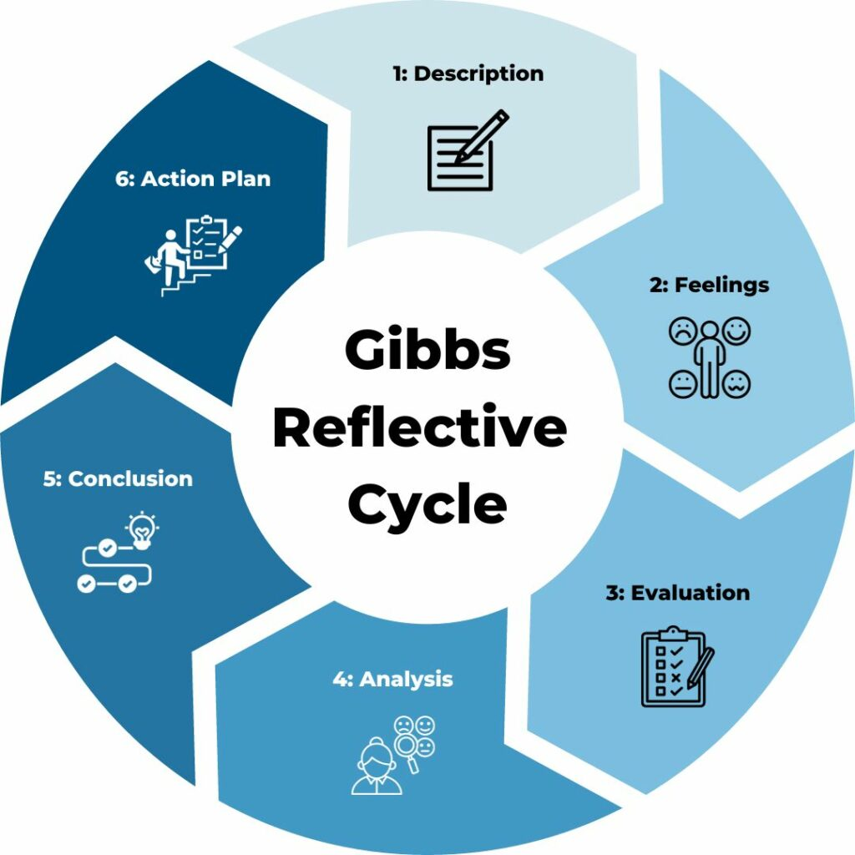
(Source: TSW Training, 2025)

References
Auvinen, T. and Malinen, M (2022) ‘Passenger satisfaction studies in global aviation context: trends and best practices’. Online available at: https://www.theseus.fi/bitstream/handle/10024/755908/Teemu_Auvinen_Miku_Malinen.pdf?sequence=2 Last accessed on: 11th Dec 25
Bayır, K (2024) ‘Efficient Coordination of Telecommunications Rooms Through Pre-Defined Ontologies in BIM-Based Airport Projects (Master's thesis, Middle East Technical University (Turkey))’. Online available at: https://open.metu.edu.tr/bitstream/handle/11511/109550/20240518_KB_Msc_Thesis.pdf Last accessed on: 11th Dec 25
Chebichii, M (2021) ‘Stakeholder Engagement and Performance of Aerospace Safety Automation Projects: a Case of Kenya Civil Aviation Authority (Doctoral dissertation, University of Nairobi)’. Online available at: https://erepository.uonbi.ac.ke/bitstream/handle/11295/160484/Mercy%20Chebichii%20-project.pdf?sequence=1 Last accessed on: 11th Dec 25
Corporate Ryanair (2025) ‘Ryanair Airline’. Online available at: https://corporate.ryanair.com/news/ryanair-appoints-handler-at-london-stansted-airport/ Last accessed on: 10th Dec 25
dos Santos, B.M.N.C (2023) ‘Local Airports as Global Intercultural Interfaces: The Paradigmatic Case of Porto Airport (OPO) (Master's thesis, Instituto Politecnico do Porto (Portugal))’. Online available at: https://recipp.ipp.pt/bitstreams/5e8e0cc0-2273-4854-a433-8d3191b0a7c9/download Last accessed on: 11th Dec 25
Dube, K., Nhamo, G. and Chikodzi, D (2021) ‘COVID-19 pandemic and prospects for recovery of the global aviation industry’. Journal of air transport management, 92, p.102022. Online available at: https://pmc.ncbi.nlm.nih.gov/articles/PMC9759696/pdf/main.pdf Last accessed on: 11th Dec 25
Florido-Benítez, L (2025) ‘Airports are the backbone of the UK tourism sector and AI will be a key component of marketing initiatives’. European Journal of Management Studies, 30(2), pp.139-163. Online available at: https://www.emerald.com/ejms/article-pdf/30/2/139/10079909/ejms-03-2025-0033en.pdf Last accessed on: 11th Dec 25

Graham, A (2023) ‘Economic Regulation of Airports in the United Kingdom. In Economic Regulation of Urban and Regional Airports: Incentives, Efficiency and Benchmarking (pp. 329-342). Cham: Springer International Publishing’. Online available at: https://westminsterresearch.westminster.ac.uk/download/9bc5bbc7d7c12fdb646dca88d3a35aead981a929df09f66861d0989d607f2142/88543/UKregulation%20paper%20revised.pdf Last accessed on: 11th Dec 25
Hiney, N (2024) ‘Regional Airports at the Crossroads (Again) Stakeholder Relationships, Business Challenges and Future Uncertainties (Doctoral dissertation, Dublin City University)’. Online available at: https://doras.dcu.ie/30222/1/NH%20Thesis-Final%20Version-21082024.pdf Last accessed on: 11th Dec 25
JOHN, C (2022) ‘OPERATOR’. Online available at: https://airportsuk.org/wp-content/uploads/2022/04/AOA-Airport-Operator-Magazine-Spring-2022_25Apr2022.pdf Last accessed on: 11th Dec 25
Kivits, R. and Sawang, S (2021) ‘The dynamism of stakeholder engagement: A case study of the aviation industry’. Springer Nature. Online available at: https://books.google.co.in/books?hl=en&lr=&id=ROEmEAAAQBAJ&oi=fnd&pg=PR5&dq=Stakeholder+Feedback+Collection+and+Review+in+business+aviation&ots=FYgUV1I4fE&sig=rxNrmBzLGrr9vq3qaZFOp_dnCi4&redir_esc=y#v=onepage&q&f=false Last accessed on: 11th Dec 25
Kyrylenko, O.M., Novak, V.O. and Podrіeza, M.S (2023) ‘Key aspects of corporate responsibility of aviation enterprises. Electronic scientific and practical publication in economic sciences’. Online available at: https://www.researchgate.net/profile/Oleg-Garmash/publication/377659292_Intellectualization_of_logistics_and_Supply_Chain_Management_20_-_2023/links/65b16c896c7ad06ab427967c/Intellectualization-of-logistics-and-Supply-Chain-Management-20-2023.pdf#page=38 Last accessed on: 11th Dec 25
Marete Ph D, C.K. and Wang Ph D, C (2024) ‘Diversity, Equity, and Inclusion: Trends in Representation of Women Professionals in the Aviation Industry’. Journal of Aviation/Aerospace Education & Research, 33(3), p.4. Online available at: https://commons.erau.edu/cgi/viewcontent.cgi?article=2069&context=jaaer Last accessed on: 11th Dec 25
Nagy, Z.J (2023) ‘Maintenance check flight accidents (a new approach to air safety investigations) (Doctoral dissertation, University of Southern Queensland)’. Online available at: https://research.usq.edu.au/download/a734d9de7596bf08a560afac97a0bc2709ed338b5285ba3567baedefb8bf1586/7713596/Jay%20Nagy%20-%20THESIS.pdf Last accessed on: 11th Dec 25
Pretto, M (2021) ‘Big data enabling quieter and cleaner air transport’. Online available at: https://air.uniud.it/bitstream/11390/1206784/2/Tesi_dottorato_definitiva_pdfA.pdf Last accessed on: 11th Dec 25
TSW Training (2025) ‘Gibbs reflective cycle’. Online available at: https://www.tsw.co.uk/blog/leadership-and-management/gibbs-reflective-cycle/ Last accessed on: 10th Dec 25

