THE WAY WE LIVE NOW Evaluation Form

Name: Abby Poulson

Please evaluate your work in relation to the two criteria below.

FINAL WORK:
From the final edit of 6-10 images, select & insert what you consider to be the 3 images that most successfully demonstrate your response to the project title. Please evaluate how resolved the final work seems and explain the conceptual relationship between the work and the original title. (100-150 words)

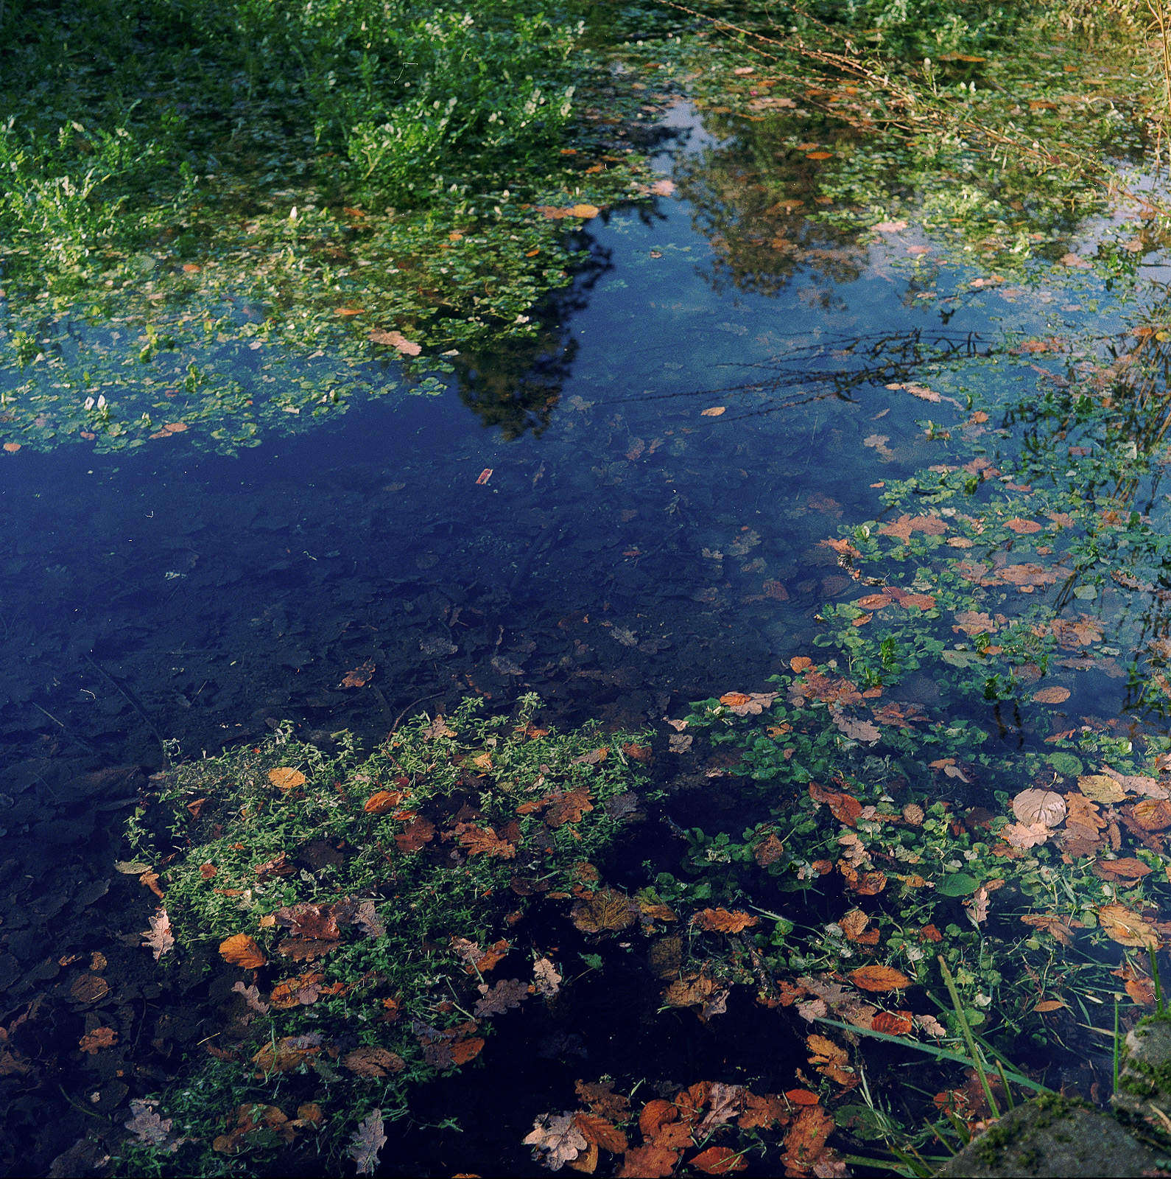
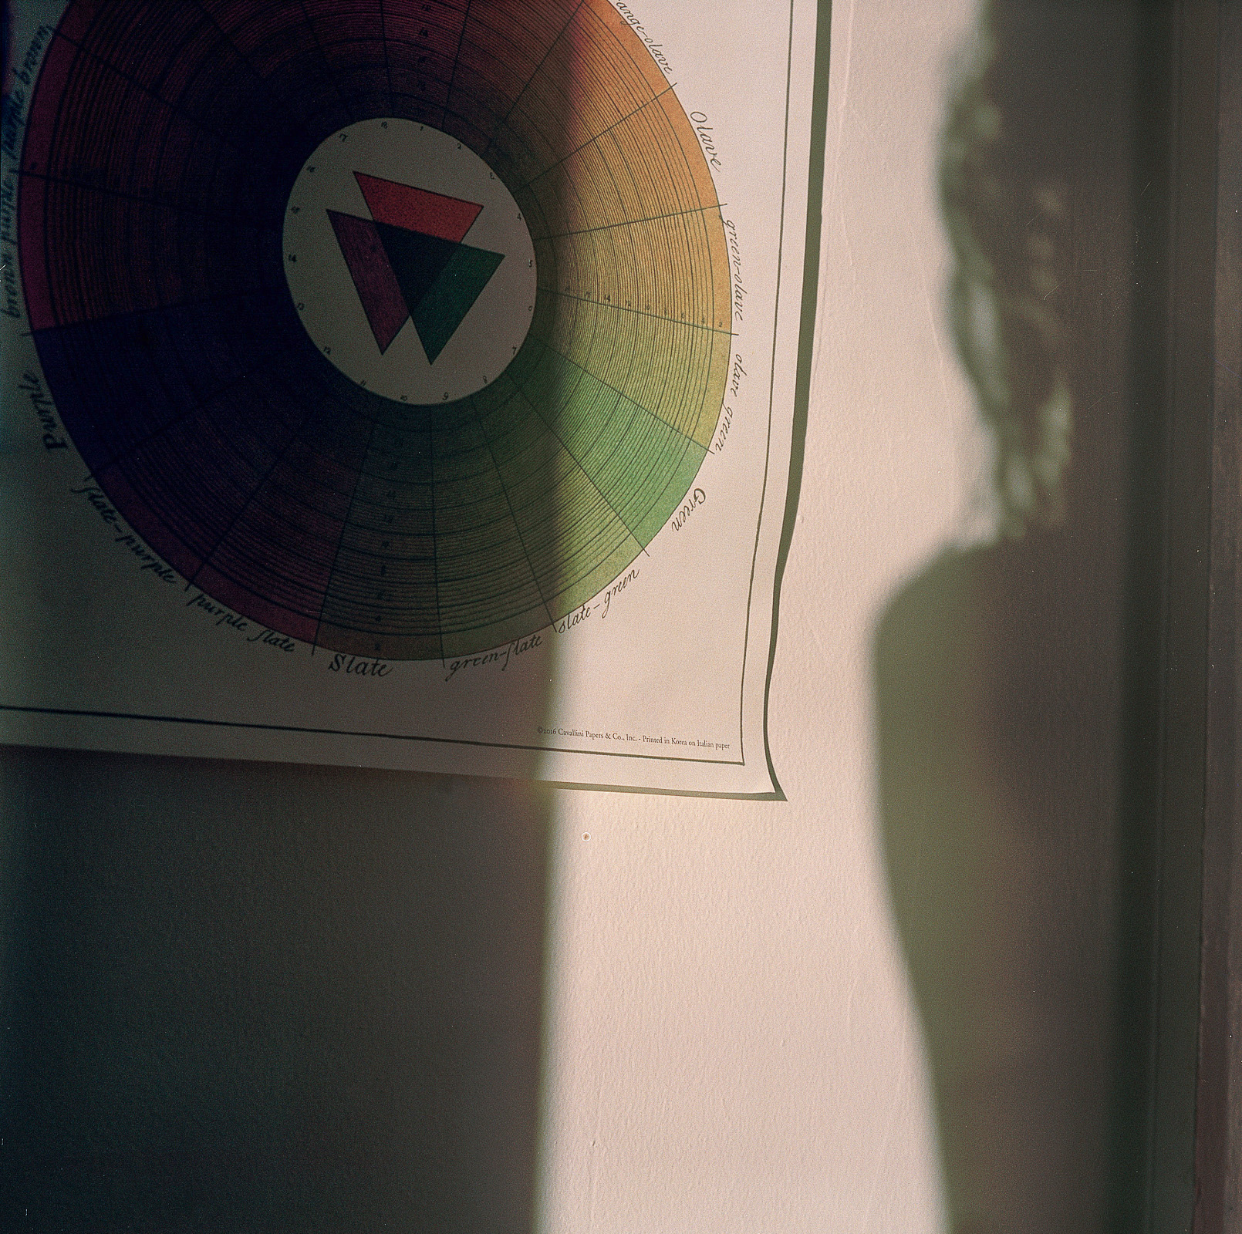
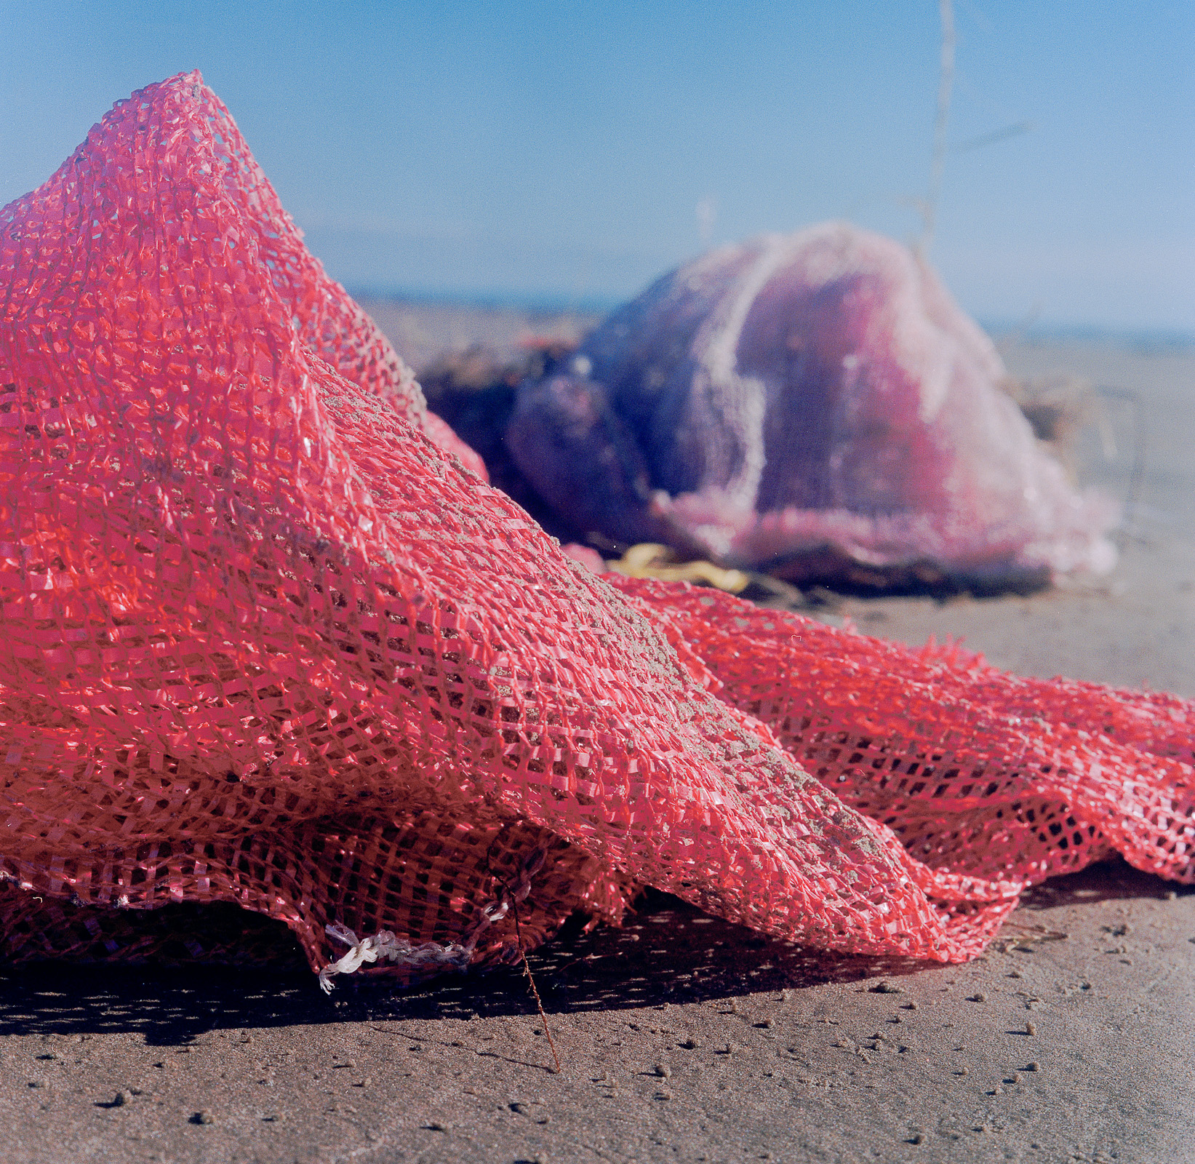

I am pleased with the final edit of my project. For the title, I wanted to concentrate on focusing on the present as I feel we and I personally spend too much time focusing in technology and worrying about the past and future. Medium format was an interesting medium to use for this concept, because instead of staring down at my phone, I could stare down into a camera instead. These images replace what I wouldn’t have seen if I’d been looking at a screen. Each image focuses on something that interested me or felt drawn to, whether that’d be shadow and light, or details that I’d noticed. I feel the six images I’ve selected work together as a collective most successfully, and together they emphasise my concept.

RESEARCH:
Please identify the 3 pieces of research that have most influenced your project and discuss how they affected the development of your work. (100-150 words)

RINKO KAWAUCHI

Rinko Kawauchi affected my development the most through the way she explores the ‘extraordinary in the mundane’. I could tell that each of her images are carefully considered, and found myself finding a lot of meaning in her photos. I felt very inspired by the way she worked and wanted to mirror this. Rinko’s images are also inspired by a Japanese view called Wabi Sabi, which takes appreciation in the imperfections. This also influenced my project.

VIVIAN MAIER

Vivian Maier inspired me to take courage in photographing the world around me. Her images were found at an auction sale, and through her photographs of ‘the self’ people could discover who she was as a person. I found this interesting, and her work has made me consider what my photographs could say about me and my character and the way I live. Even though I felt like I didn’t have enough time to develop this into a lot of my images I tried to include this idea in my final edit.

NATIONAL DAY OF UNPLUGGING

Whilst researching about the effect technology has on our daily lives I found an article about a woman who puts away all her technology for one day a week. She then went on to create an ‘international day of unplugging’ and is popular among Jewish families who treat it as a modern-day Shabbat. This gives people one day a week to unwind, unplug, relax, reflect, get outdoors and connect with loved ones. This inspired me to start taking time away from technology, but instead of taking a full day out I’ve been using parts of my day to unplug as I feel this is more doable to do as a student. This really helped me concentrate on my concept and what I wanted to portray in my photos.

PLEASE SUBMIT TO MOODLE BY 12 NOON ON MONDAY 20th NOVEMBER

