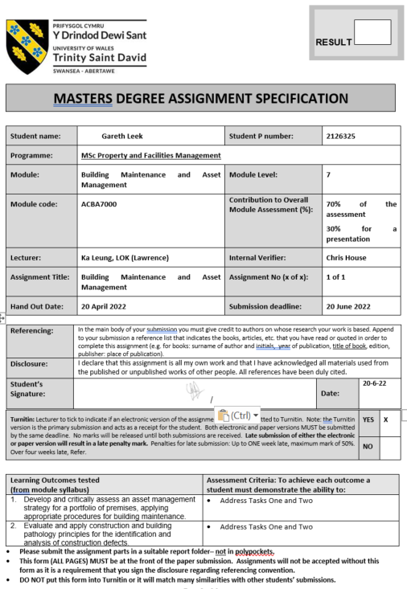

TASK DESCRIPTION

(Lecturer – please insert task(s) / questions / what the student must do, here)
Assessment for this module is a conference presentation followed by a report on the same case study. A case study will be selected via the tutor within 2 weeks of the task description being allocated but the literature search can be started immediately.

- Conference presentation using PowerPoint. 10 min plus question and answering presentation (30% of module mark)
  - Describe and analyse how an asset management strategy is delivered within a case study building (Case study building to be confirmed by the tutor). Use diagrams to facilitate your answer e.g. flow charts, photographs and a schedule of procedures for building maintenance

Date: Wednesday 8th June 2022.
- Report
Using the same case study presented in the conference write a report addressing the following. Your response should use the case study to verify your reasonings. (70% module mark)
a) Detail how you would apply construction and building pathology principles to the case study.
b) Consider an analysis and diagnosis of the construction defects in the case study.
c) Complete an in-depth maintenance and facilities audit of the case building. Give consideration to how the building currently is maintained and suggest future strategies.

Report format based on Journal of Facilities Management The indicative word count is approximately 4000 (+/- 500 words excluding appendices. 70% of module mark.
Date: Monday 20th June 2022.

Table of Contents
1.0. Question Two (a) 5
1.1. Building pathology principles overview 5
1.2. Maintenance concepts to address building pathology 6
1.2.1. Corrective maintenance 7
1.2.2. Condition monitoring 7
1.2.3. Preventive maintenance 7
1.2.4. Opportunistic maintenance 8
1.3. Step One: Desktop survey 8
1.4. Step Two: Identification 9
1.4.1 Introduction to the case study 10
1.5. Step 3: Recommendations/course of action 11
2.0. Question Two (b) 11
2.1. Scope 11
2.2 Report 12
3.0. Question Two (c) 15
3.1. Facilities Management Audit 15
3.2. Objective of the audit 15
3.3. Customer Satisfaction 15
3.4. Space Utilisation 18
3.5. Health and Safety 19
3.6. Finance 19
3.6.1. Revenue Expenditure 19
3.6.2. Capital Expenditure 19
3.7. Total Facilities Management (TFM) 20
3.7.1. Maintenance strategy 21
3.8. Resources 21
3.9. Property Strategy 22
3.10. Current operating model 22
3.10.1 Future operating model options 23
3.10.2 Considerations 23
3.11. Key facilities audit findings 23
3.12. Conclusion 24
4.0. References 26
5.0. Bibliography 27
6.0. Appendix 1 28
6.1. Appendix 2 29
6.2. Appendix 3 30
6.3. Appendix 4 31
6.4. Appendix 5 32
6.5. Appendix 6 33

1.0. Question Two (a)

1.1. Building pathology principles overview
The term pathology is a medical reference used to describe how illness may progress, within human health. People are impacted by illness or injury, and buildings have patent or latent defects. Both potentially present a myriad of symptoms.
From a building perspective, the approach requires a detailed knowledge of how buildings are designed, constructed, used and changed, and the various mechanisms by which their material and environmental conditions can be affected Watt (2007). In essence, building pathology is the approach used to understand buildings, its defects and how they can subsequently be repaired and maintained.
The British Standards Institute describes the benefits of managed risk: reducing financial losses, improving health and safety, good will and reputation, minimizing environmental and social impact, can result in reduced liabilities such as insurance premiums, fines and penalties. BSI (2014)
Our understanding of buildings is based largely on expectation (Watt 2007). As humans we anticipate what functions buildings perform, especially if their intended use differs from its original use.
To preserve safe, comfortable environments for people to live, visit and occupy, it is essential that buildings are effectively maintained. Failure to do so, can result in accidents, detrimental health effects, loss of profitability and diminishing value of an asset.
Requirements of buildings
Figure 1: Requirements of buildings
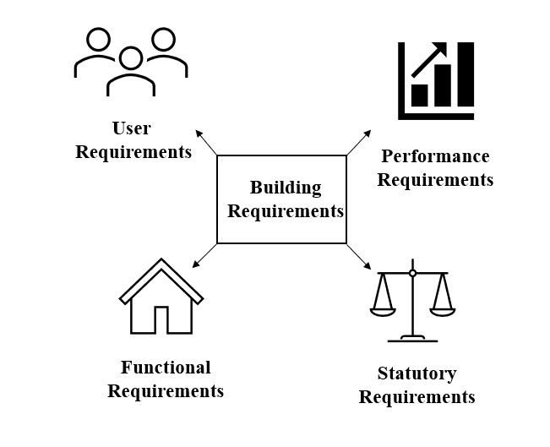
Source: Leek (2022)
Building requirements that need to be considered to help inform and guide defect diagnosis, causation, and future action.
- User’s requirements – Satisfaction of human needs and how activities are performed.
- Performance requirements- Sound insulation, strength, protection, thermal comfort etc
- Statutory requirements- Legislation associated with the provision of property i.e. Health and Safety at Work Act 1974.
- Functional Requirements-Protection from environment, human comfort, and operational requirements.
To assess the condition of any building, data gathering is an essential requirement to form a holistic opinion. The figure below, buildings in context highlights the interfaces a building may have with its key dependencies.
Figure 2: Buildings in context.
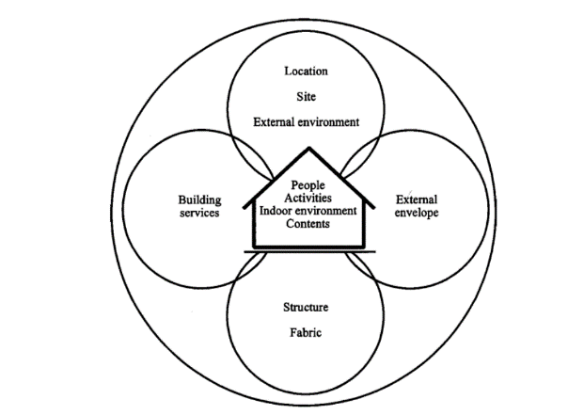

Source: Watt (2007)
Therefore prior to physical inspection of the case study, necessary due diligence needs to be undertaken.

1.2. Maintenance concepts to address building pathology
To apply the principles of building pathology to a case study, the application of maintenance is a critical part, maintenance could be viewed as the `diagnosis and medicine` for a building. There are numerous forms of which maintenance, can be prescribed, depending on the condition.
Allen writes maintenance management is a practical technique that is fragmentary and uncoordinated, reflecting the range and diversity of organizations which are involved in maintenance works. The quality and efficiency of a building maintenance management operation depends on how information on the condition of the building, the needs of the users, and the works carried out is collected and used. Allen (1993)
There are nuances in how maintenance is applied across the word. In Sweden for example AFF04 is used. The European Union apply EN 13306 maintenance strategies. You will note from the figure below that the Swedish AFF04 strategy references, returning an asset back to its previous function, which is a term that can be interpretated in a number of ways.

Figure 3: Maintenance AFF 04
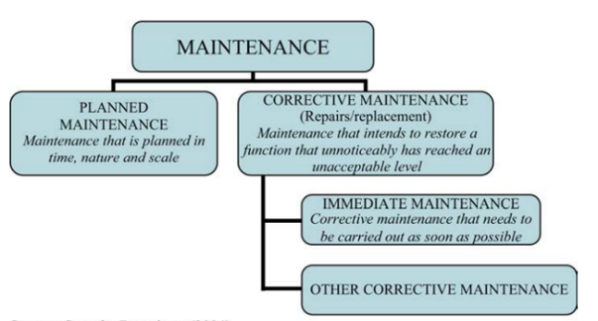

Source: Svenska Byggtjanst

Figure 4: Maintenance EN 13306

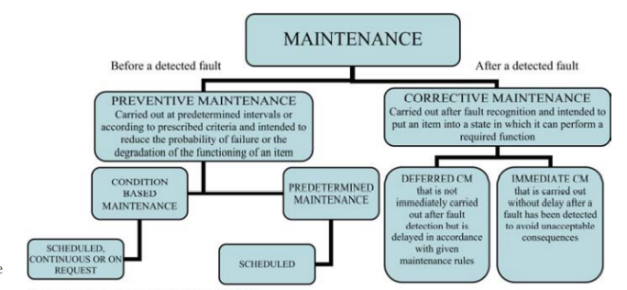
Source: European Standards (2009)
The European Standards EN 13306 is the closest model aligned to the operations undertaken within the case study. Preventative, corrective and condition maintenance are part of the existing strategy, as described in more detail below.

1.2.1. Corrective maintenance
also known as breakdown, failure based, run to failure or unplanned maintenance is the simplest type

1.2.2. Condition monitoring
maintenance, which is preventive maintenance where the object is inspected on a regular basis and the object serviced or replaced when a certain condition is observed

1.2.3. Preventive maintenance
refers to cases where repairs and/or replacement take place without the occurrence of any specific fault. As the name indicates, the plan is to prevent failures.
Lind et al (2011)

1.2.4. Opportunistic maintenance
A less familiar term, which is referenced in numerous reading material. This has been described as things are done because there arises an "opportunity" to carry out a certain activity in a cost-effective way. Typically, during the performance of a scheduled or unscheduled maintenance action LIND, H et al (2012)

1.3. Step One: Desktop survey

Figure 5: Property survey process
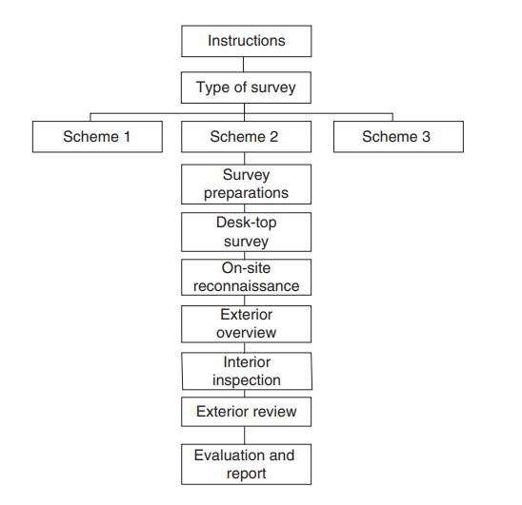
Source: Douglas et al (2011)
Following confirmation of the client brief, most surveys require preparation via a desk top survey, on site reconnaissance, site overview (interior and exterior) and the completion of a report.
Site-specific information detailed should be considered to provide a holistic view on the overall assessment. The relevance of the information needed is dependent on the survey type required.
The Institute of structural engineers also documents how building defects are aligned to their own specific construction. Buildings and structures constructed for a particular purpose or predominantly from one specific structural material often have defects peculiar to that material, age of building and type of construction. IstructE (2008)
The outcome of this analysis means that a specific targeted, information driven approach is required for each building. Glover writes most surveys require preparation via a desk top survey, on site reconnaissance, site overview (interior and exterior) and the completion of a report. (GLOVER 2013)

Table: Desktop survey reference documentation
Pre-survey information checklist | Available to case study | Appendix Reference
As built drawings | Partial | 1
Asset register |  | -
Operational and maintenance manuals |  | 1
Lease/license for alteration |  | -
Lease agreements |  | -
Schedule of dilapidations |  | -
Street view map |  | 2
Previous condition surveys |  | -
Technical due diligence reports |  | -
Planning permission/building consents |  | -
AutoCAD plans |  | 3
Title deeds |  | 4

1.4. Step Two: Identification
Determining the defects and their causation, often a physical survey on site is required as Glover explains “The purpose of a building survey is to give an independent professional opinion on the condition of a property” Glover (2013)
Defects can be either patent or latent.
Patent defects can be discovered by ‘reasonable’ inspection.
Latent defects may not immediately be apparent and will not be found with ‘reasonable’ inspection CIOB (2019)
Some of the most common defect causes can be grouped into the following categories:
- Poor workmanship, such as incompetent, poor attitude labour force or specification
- Inadequate materials, not suitable and sufficient for the task in hand.
- Defective material/performance, failure in manufacture process, damaged.
- Inadequate climate protection (weather) frost, UV light, rain etc
- Subsidence. Soil movement
Identification of the cause of the fault can often be difficult, due to the several contributing factors. The CIBSE fault finding organogram, simplifies this thought:

Figure 6: Fault finding
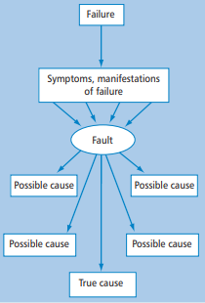
Source: CIBSE (2005)
There are similarities to the approach of building pathology and in particular surveying methodology. Synergies can be found through the guidance published by the:
- Royal Institute of Chartered Surveyors – Building Survey, Practice Note 2012
- The Institute of Structural Engineers - Surveys and inspections of buildings and associated structures 2008
- Chartered Institute of Building Surveyors - Making Buildings Work 2005

Due to the wide range of influencing factors, specific to each building. A one size fits all approach cannot be undertaken to identify defects, their causation, and remedial works, in every scenario.
The Hong Kong institute of surveyors practice guidelines 2007, specifically details the need to cover the extent of which inspections or tests will be undertaken and upon reflection this is an essential criterion, this is a legacy issue in the UK, particularly around the practice of surveying asbestos.

1.4.1 Introduction to the case study
Companies House (CH) is an Executive Agency and requires an estate for its workforce to carry out office-based working.
Location: Cardiff, Wales
Size: 18,500² (office space)
Tenure: Freehold
Building occupation: Circa 1,700
Year of construction: 1976
Land area: 4 Hectares
Construction: A reinforced concrete frame building with reinforced concrete columns at approximately 3m centers and a flat reinforced concrete slab spanning between the columns. There are 300mm long reinforced concrete drop heads either side of the top of the external columns.
The walls are of cavity masonry construction with glazing along all elevations.
Main office size: The building is approximately 120metres long by 50 metres wide.
Lifts: 7 x Passenger, 1 x goods, 4 x dumb waiters
The accommodation comprises a five storied main building with a two-storey adjoining repository.
There is a multi-storey car park, with parking on the site for over 900 cars
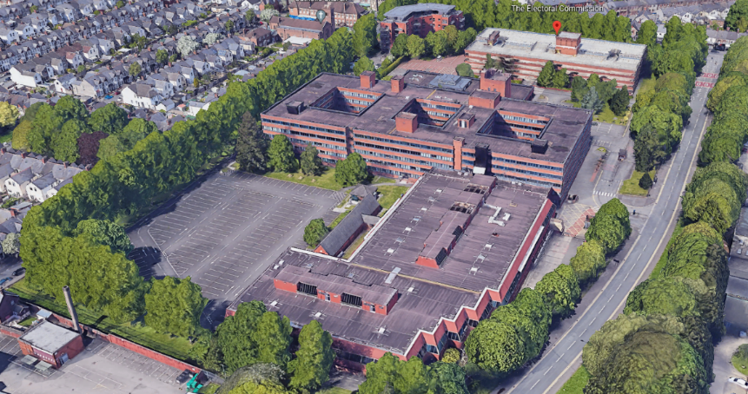
Google earth (2021)

1.5. Step 3: Recommendations/course of action
Following investigation, a proportionate course of action should be identified, to return the defect to the correct standard. Great care is required in suggesting remedial measures. It is best, if possible, to ensure that the same methods and materials are recommended as were used in the original construction. The introduction of new ‘foreign’ materials can sometimes have a serious and even catastrophic effect
Glover (2013)

2.0. Question Two (b)

2.1. Scope
It is a fundamental part of this initial process to establish the client’s requirements and, where necessary, interrogate the existing brief to obtain a full and complete understanding of the client’s expectations. RICS (2017)
Observations have been limited to the building structure and fabric, which can easily be identified without posing any risk to the author. Therefore, the locations in scope will not be in areas that pose the following risks:
- Working at height.
- poor lighting.
- asbestos containing materials.
A sample visual inspection will be undertaken in all other areas.
A visual internal and external inspection was undertaken in the main office block.

2.2 Report
Observations-schedule of defects and repair works
From the sample inspection undertaken the building is in good condition with only minor defects.
Repair timescales based on traffic light system as follows:
0-3 months Red, 3-12 months Amber, 12+ months Green
Ref | Photograph | Description | Causation diagnosis theory | Action
GL1 | 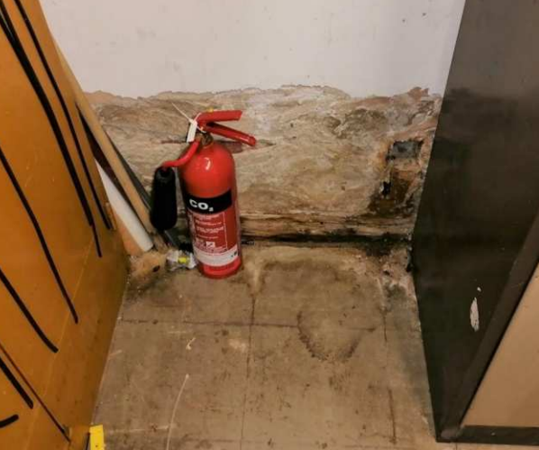 | Location: Basement  Damage to the bottom of the plastered wall. Timber skirting boards are damp and rotten | Damp penetration  (Inadequate protection)  Rooms which are partially or fully below ground level can be affected by penetrating damp, where there is a high-water table. As the depth increases so does the water pressure in ground with a high-water table, and so the outside faces of basement walls may remain permanently damp.  A common defect is the jointing of the damp-proof membrane at the internal angle of wall and floor  Douglas et al, (2011) | Remove timber skirtings to basement walls and damaged plaster. Investigate cause of water ingress.  Risk – Amber  Current status – awaiting repair
GL2 | 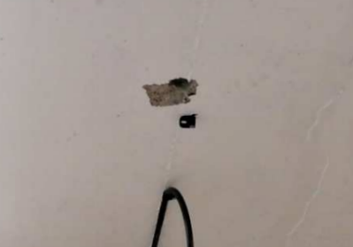 | Location: Basement  Spalling of concrete to soffit around drill hole | Poor workmanship  Lack of proper engagement of dowels in the holes or slots meant to receive them; holes not properly formed makes fixing difficult to achieve.  Noy et al (2005) | Repair with recommended product that will not cause further damage.  Risk – Green  Current status – awaiting repair
GL3 | 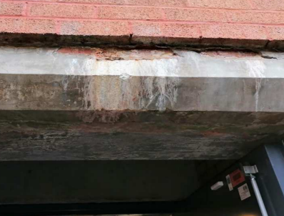 | Location: Basement  Cracking and spalling of concrete face to external stairs. See photograph location | Weather damage or possible chemical deterioration  Reinforced concrete is the most used building material worldwide, being used in several structural elements, such as columns, beams, slabs, footings, walls, etc. The solutions and results may vary depending on the type of materials used, their strength, location and environmental conditions.  Manuel J. Carretero-Ayuso et al (2021)  Post-war office blocks and other structures constructed in reinforced concrete present a particular problem and considerable care needs to be exercised if the structure has to be disturbed. Reinforced columns and beams cannot be opened up easily or exposed to see how reinforcement is arranged and such reinforcement is essential to the strength of the structure  Glover (2013) | Repair with recommended product that will not cause further damage.  Risk – Green  Current status – awaiting repair
GL4 | 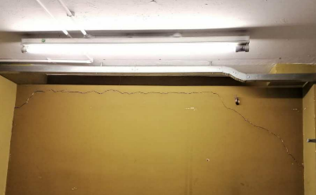 | Location:  Ground floor  Cracking to masonry breeze block wall. Externally the elevation has a glazed obscured window. Non- load bearing. | Poor workmanship  Incorrect concrete mortar  Walls built using hard cement mortars are very unforgiving of any movement and will fracture with the cracks often passing through the bricks, rather than the mortar  Glover (2013) | Take down and re-build.  Risk – Amber  Current status – awaiting repair
GL5 | 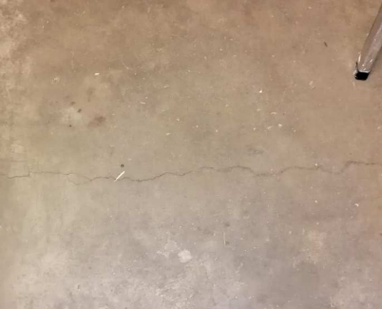 | Location:  Ground floor  Crack to concrete screed | Screed shrinkage  As the screeds dry out, they tend to shrink and if not restrained by a good key to the concrete base they will crack. Cracking is the most common fault experienced with all screeds  Noy et al (2005) | Repair crack by specialist.  Risk – Green  Current status – awaiting repair
GL6 | 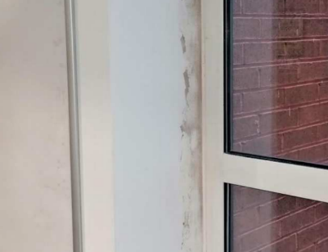 | Location:  First floor  Damage to plaster and paintwork | Damp penetration  (Inadequate protection)  Semi-circular damp patches at the junction of the window frame and plaster indicate a defective or missing vertical DPC which can also cause wet rot in the frame.  Douglas et al (2011) | Remove damaged plaster and provide waterproof cover strip  Risk – Green  Current status – awaiting repair
GL7 | 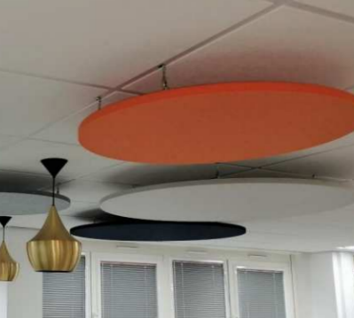 | Location:  Second floor  The decorative feature discs location is fixed directly to the ceiling grid. They do not appear to be significantly heavy; they could be affected by wind from an open window. | Poor workmanship  Patent defect | Provide additional fixing ceiling grid to concrete soffit  Risk – Amber  Current status – complete
GL8 | 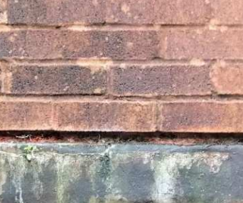 | Location:  External elevations  General – Damaged mortar joints, in numerous locations | Damp penetration  (Inadequate protection)  It can damage brickwork by saturating it; cause decay and breaking up of mortar joints  Douglas et al (2011) | Rake out and repoint  Risk – Green  Current status – awaiting repair
GL9 | 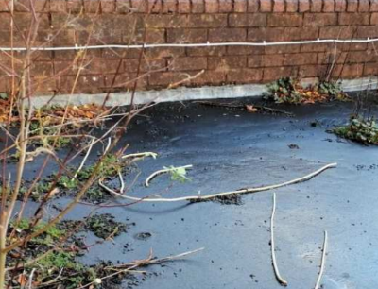 | Location:  External elevations  Debris and vegetation | Damp penetration  (Inadequate protection)  Various forms of vegetation can cause decay in masonry. Plant life growing in or on stonework or brickwork will tend to keep it permanently damp and therefore contribute to its decay  Douglas et al (2011) | Remove all debris and vegetation.  Risk – Red  Current status – complete
GL10 | 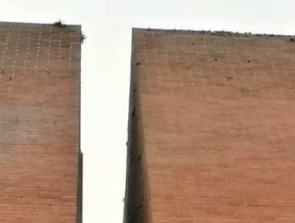 | Location:  External elevations  Debris and vegetation | Damp penetration  (Inadequate protection)  Various forms of vegetation can cause decay in masonry. Plant life growing in or on stonework or brickwork will tend to keep it permanently damp and therefore contribute to its decay  Douglas et al (2011) | Remove all vegetation.  Risk – Red  Current status – complete
GL11 | 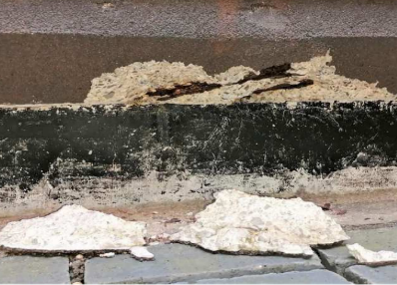 | Location:  External elevations  Corroded reinforcing bar and spalled concrete to the ground level beam to the east elevation | Weather damage or possible chemical deterioration  Reinforced concrete is the most used building material worldwide, being used in several structural elements, such as columns, beams, slabs, footings, walls, etc. The solutions and results may vary depending on the type of materials used, their strength, location and environmental conditions.  Manuel J. Carretero-Ayuso et al (2021)  Post-war office blocks and other structures constructed in reinforced concrete present a particular problem and considerable care needs to be exercised if the structure has to be disturbed. Reinforced columns and beams cannot be opened up easily or exposed to see how reinforcement is arranged and such reinforcement is essential to the strength of the structure  Glover (2013) | Refer to specialist then repair  Risk – Amber  Current status – awaiting repair
GL12 | 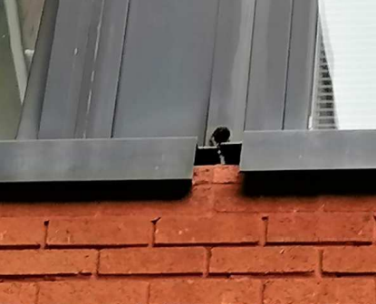 | Location: External elevations  Missing windowsill | Poor workmanship or accidental damage | Replace  Risk – Green  Current status – awaiting repair

3.0. Question Two (c)

3.1. Facilities Management Audit
Nevermore has a facilities management (FM) review offered more value. The trends in energy, materials and labour price increases provides an enhanced opportunity to review the performance of an organisation’s function, to ensure value for money.
Facility management integrates multiple disciplines in order to have an influence on the efficiency and productivity of economies of societies, communities and organizations, as well as the manner in which individuals interact with the built environment BSI (2018)
A facilities and maintenance audit of the case study was undertaken, facilities management audit is an orderly, objective process to compare an organization's FM resources Whitaker (1995)
Companies House is critical to the economy, its core functions underpin entrepreneurship and business growth in the UK and our reliable registers underpin confidence in business. Companies House (2022)
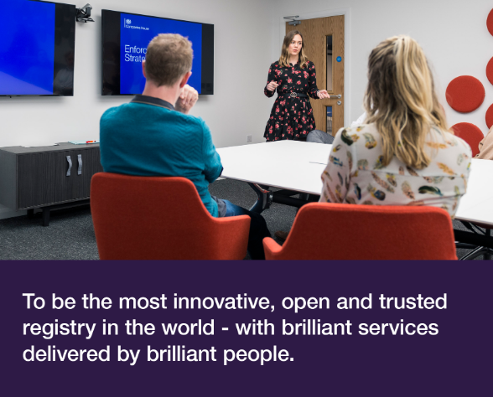
In order to support the organisation`s vision brilliant people, brilliant services. Brilliant facilities are required to support this vision.

3.2. Objective of the audit
- To provide a holistic view of current FM and maintenance performance.
- Provide options for consideration of the FM operating model

3.3. Customer Satisfaction
In January 2022, Government was mandated to participate in an industry recognised workplace survey. Leesman measure and analyse employee workplace experience for individual organisations, giving them the data and insights necessary to create outstanding work environments. Leesman (2022)
The full report can be found in Appendix 6, some of the key performance indicators related to FM, included as follows.
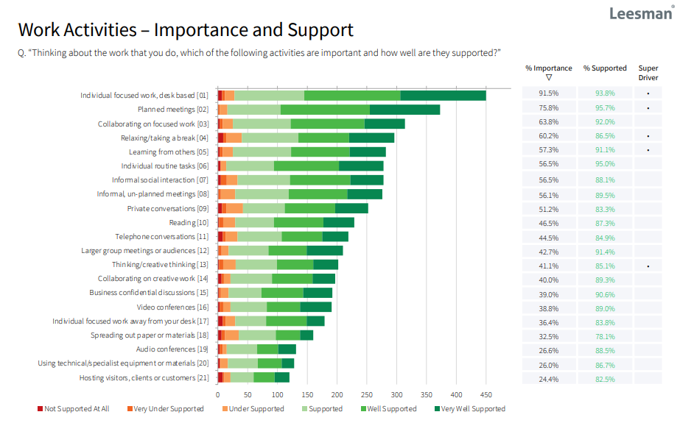

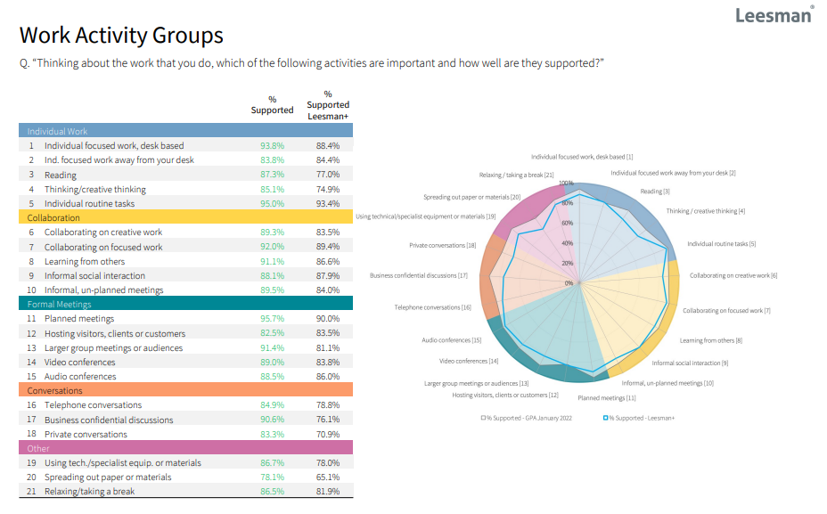
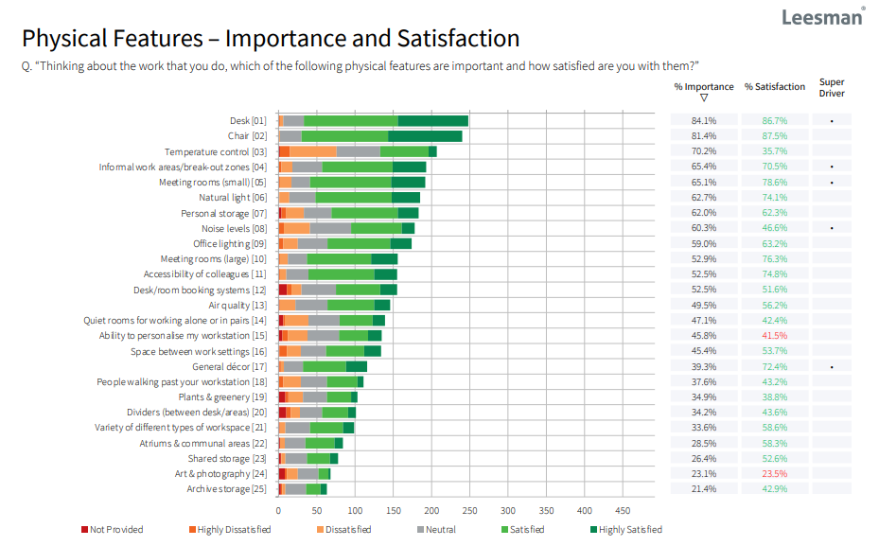

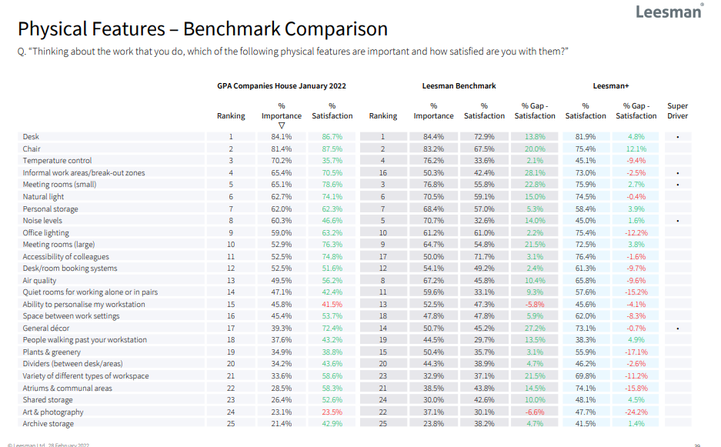

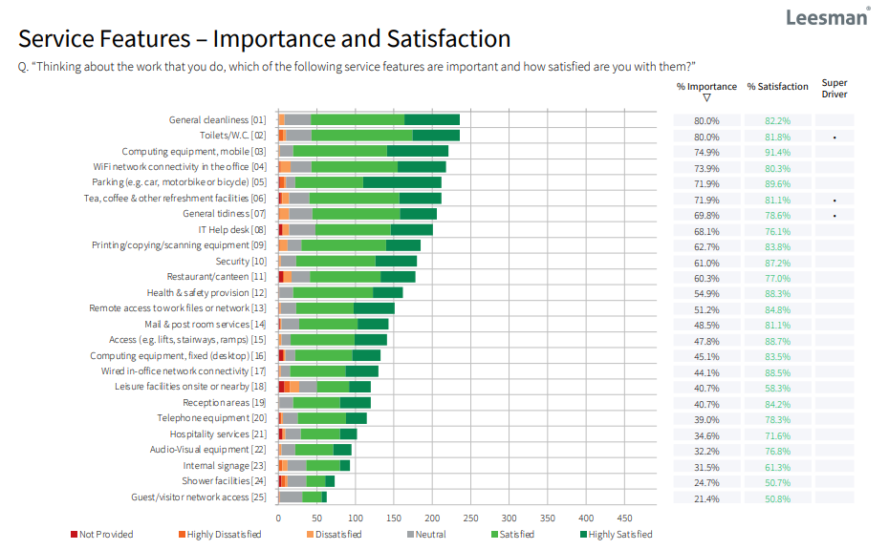
Source: Leesman (2022)

3.4. Space Utilisation
The desks in use, are predominately 1400mm in width, see appendix 3 for current desking arrangements.
This equates to circa 350 desks located on each floor.
There is circa 18,500m² space restricted to the office block in scope.
Space utilised equates to 10.88m² per person.
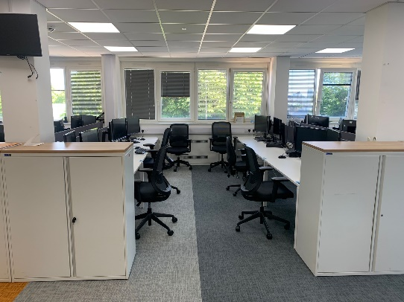
Source: Leek (2022)

3.5. Health and Safety
Overall responsibility for health and safety in CH lies with the Chief Executive.
- The organisation has a certified ISO:45001 Health and Safety Management System, that covers all operations.
- There have been four accidents reported in the last year. None of which have resulted in the Reporting of Injuries, Diseases and Dangerous Occurrences Regulations, to the Health and Safety Executive.

3.6. Finance
Included within this section is a breakdown of annual costs associated to the property provision.

3.6.1. Revenue Expenditure
Expenditure | £ (000)
Salaries | 670
Rent | 2,273
Training | 5
Restaurant | 180
Health and safety | 15
Total facilities management | 1,700
Minor works inc lifecycle replacement | 620
Rates | 876
Electricity | 855
Gas | 30
Wood pellets | 40
Water | 25
Environmental | 90
Office remodelling project spend | 280
Total | £7,659,000

3.6.2. Capital Expenditure
Expenditure | £ (000)
Office remodelling project spend | 420
Total | £420,000

Figure 7: Annual Property Spend

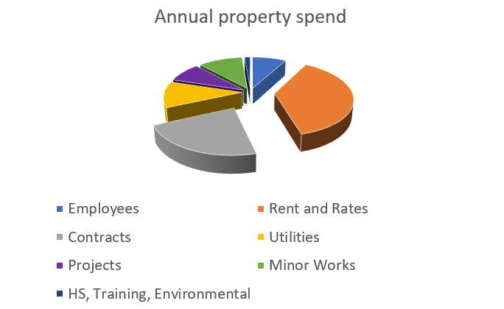

Source: Leek (2022)
Total business as usual property spends (excluding CapEx) £7,695,000
Cost per person £4,526
Cost per m² £416

3.7. Total Facilities Management (TFM)
Maintenance is outsourced to a TFM Supplier according to Katchamart (2013) when organizations employ a total facilities management that enables the cost advantage from economies of scale and scope.
The contract is pan government owned by the Government Property Agency.
The figure below identifies the measures of process effectiveness for asset maintenance works.
Figure 8: Measuring Performance

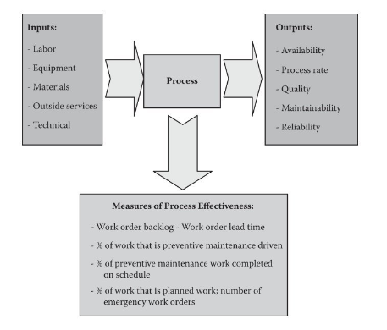
Source: Campbell et all (2011)

Figure 9: TFM supplier planned maintenance performance
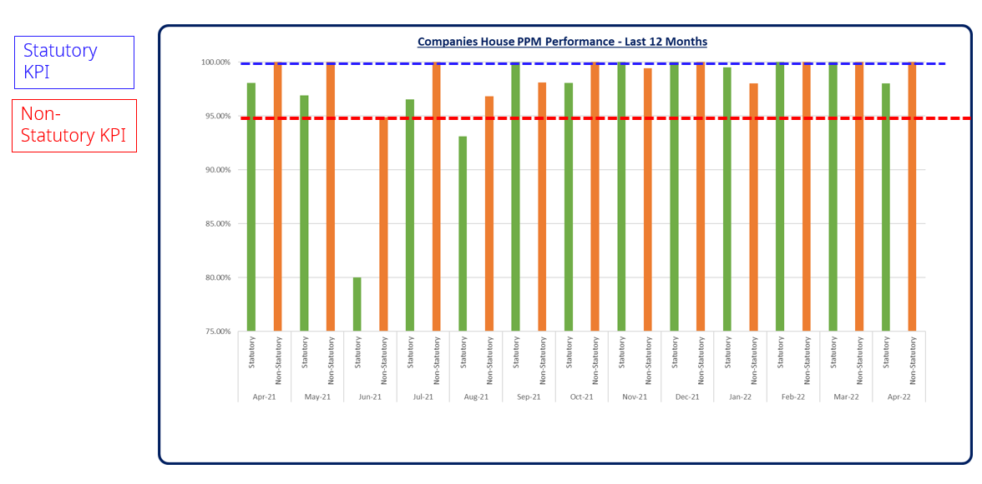 Source: ISS (2022)
The current contract expires October 2023.

3.7.1. Maintenance strategy
The current strategy is a mixture of maintenance types. Planned maintenance is aligned to the SFG20 standard. SFG20 is recognised as the industry standard for building maintenance specifications SFG20 (2022) Corrective maintenance which is logged by building users via the TFM suppliers helpdesk. There are other periodic condition/inspection surveys undertaken in line with statutory legislation, such as asbestos inspection surveys.

The TFM provider has reduced backlog maintenance from £730,000 to £400,000 in the last 12 months, with plans to reduce further within the forthcoming 12 months. Some works have been delayed due the impact of COVID:2019.

3.8. Resources
There is an Estates team of 12 people who have responsibility for managing the estate. There is a need for the development of specialisms in some areas to raise competence levels. There is a development plan in place.

Figure 10: CH estates employee organogram

Source: Leek (2022)

3.9. Property Strategy
CH property strategy described in Appendix 5, is aligned to its Corporate Strategy. The key strategic goals, are:
- Estate rationalisation
- Transition of the estate management function/change in estates operating model
- How and where we work, the environment and hybrid working.
- Enhanced skills and professions, capability
- Net zero contributions.

The organisation has a strategic asset management plan, which defines how it manages its assets, the plan is in its infancy. Opportunities for improvement have been identified in the allocation and recording of assets.

3.10. Current operating model
The estate team manage the estate and is aligning its function against the mandated Government Property Standard 004. This functional standard is part of a suite of management standards that promotes consistent and coherent ways of working across government, and provides a stable basis for assurance, risk management and capability improvement HM Government (2021)
The current operating model is a hybrid between a self-delivery estates function and TFM supplier delivering other core activities. Minor and major works and lead occupier responsibilities for running and maintaining the building currently remain with CH, such as asbestos and fire management etc.

3.10.1 Future operating model options
The following FM operating models have been described by the Institute of Workplace Facilities Management (IWFM) as options for FM delivery:

Model | Description
In house FM | Facilities delivered by bespoke FM team
Single services | Number of single service suppliers that deliver the core FM activities.
Bundled services | One supplier will manage two or more services
TFM | Entire matrix of service delivery is outsourced.
Managing agent | Consultant is appointed to manage the provision
Integrator | Mature version of the managing agent. Strategic approach
IWFM (2018)

3.10.2 Considerations
- The CH property strategy has outlined the vision for rationalisation of its footprint; therefore, some options have been excluded, ie the rationale for a in house FM team serving a drastically reduced estate cannot be justified going forward.
- Future management of the estate and associated liability will transfer to others in 2024, the residual CH estate compliance responsibilities are likely to be limited.
- The mandated Government Function Property Standard GovS 004: Property outlines the requirement for an intelligent client within smaller estate. It describes it as; the intelligent client role is accountable to the accounting officer for representing the organisation’s interests in relation to property management. HM Government (2021)
- The management of property and the associated legal responsibilities are moving further away from the business`s core function. Therefore, the future delivery model must be proportionate and considerate of wider business direction.

3.11. Key findings
- CH had an overall workplace experience survey result Leesman Index (Lmi) of 76.5. Scores over Lmi 70 are deemed as `elite high performance`. Application of surveys are supported by Folz, Opinion surveys are an accurate, affordable way to determine what large group think. Folz, D. H. (1996)
Scores in core FM provision areas, such as cleaning, toilets, health and safety were all above benchmark.
- Employee’s ability to personalise their workplace was below the Lmi benchmark, along with building signage, shower facilities, art and photography and visitor experience
- Further opportunities to improve, in terms workplace interacting with people’s health.
- There are omissions in best practice management information data available for performance measurement from the TFM supplier.
- Management of health and safety is audited and certified by an accredited body, which is best practice indicated by the British Standard Institute, the adoption of an OH&S management system is intended to enable an organization to provide safe and healthy workplaces, prevent work-related injury and ill health, and continually improve its OH&S performance. BSI (2018)
- Space utilised equates to 10.88m² per person and offers opportunity for improvement, furthermore where organizations establish that the space is underutilized, they should set targets for the reduction of space to achieve financial savings and to reduce the environmental and financial footprint of work BSI (2015)
- The implementation of the CH property strategy provides a natural stage, for operating model changes. Caution should be considered not to nullify current customer FM perception.

3.12. Conclusion
Objective 1 FM performance
The FM performance of the organisation is sufficient, and this is supported by the results of the recent Leesman survey. There are gaps in the measurement of maintenance data which needs to be reviewed.
An understanding of where improvements can be made against the survey, where the scores were lowest should be undertaken, along with maintaining performance in other areas.
Health and Safety - No compliance issues identified via independent auditing.
There is significant opportunity to rationalise the estate. A 20% reduction in space could equate to a cost saving or circa £1.5million. This could be achieved via the transition to hybrid working, which would release vacant space in the office, this could be taken up by other interested bodies.
A future maintenance/asset management strategy would need to be mixture of all maintenance types, to varying degrees. There is not a maintenance term which can meet the whole requirements of the case study on its own, agility is vital.
All maintenance approaches have advantages and disadvantages, with cost commonly being a persuading factor, this coupled with the variable building pathology factors and in the absence of a driving force to lead decision making. It would be advantageous for the case study to:
Allow the strategy to be agile, to ensure that it is continually recognising the `optimum` maintenance strategy, specific to its needs.
This approach will become increasingly more crucial, if the current economic and environmental climate gains further traction with business decision making, as Lind suggests unique and complex objects with a strong interaction with the environment makes it almost impossible to predict the degradation process and the lift-time of different components. Economic changes also affect what is rational to do with a specific building. Lind et al (2011)
Finally consider the specification if the new TFM contract, scheduled to transition in October 2023. Opportunities to include requirements that the supplier maintains and manages the client’s assets under the umbrella of a certified management system, such as ISO 55000:2014, should be considered.
This would provide an additional layer of governance.
Objective 2 - Adoption of Managing Agent Operating Model
The governments ambition for smaller departments to adopt an intelligent client role, coupled with the support of a TFM delivery partner. Caution should be applied to this model, as the balance of property knowledge will swing in favour of the supplier. This increases the potential opportunity for exploitation of commercial arrangements and exposure to failure.
The IWFM writes that a TFM model can leave the organisation dangerously lacking in the intelligent client function. IWFM (2018)
Therefore, it would be beneficial to strengthen the planned future operating model, with a hybrid approach, whilst ensuring that government is still realising some financial outcomes, that a reduced function may deliver.
The appointment of a managing agent, to oversee the TFM suppliers’ performance and wider CH estate’s needs, would ensure that the business would not have a knowledge gap. The managing agent role adds a layer of costs, however that would be partially offset, by the reduction of the residual intelligent client function.
Concerns around the impartiality and integrity of a managing agent could be addressed if the role was delivered by the likes of the Government Property Agency, who are a public body and have responsibility for the public purse.

4.0. References
BSI 2018, ISO 41001:2018 Facility management. Management systems. Requirements with guidance for use Available at: https://shop.bsigroup.com/products/facility-management-management-systems-requirements-with-guidance-for-use/standard
Accessed on 14 June 2022
BSI 2018, BS ISO 45001:2018 Occupational health and safety management systems. Requirements with guidance for use. Available at: https://shop.bsigroup.com/products/occupational-health-and-safety-management-systems-requirements-with-guidance-for-use/standard
Accessed on 14 June 2022
BSI 2014, ISO 55000:2014 Asset management Overview, principles and terminology Available at: https://shop.bsigroup.com/products/asset-management-overview-principles-and-terminology/standard
Accessed on 14 June 2022
BSI 2015, PAS 3000:2015 Smart Working – Code of Practice. Available at: https://shop.bsigroup.com/products/smart-working-code-of-practice/standard
Accessed on 14 June 2022
CIOB 2019, Code of Quality Management. Available at: https://www.ciob.org/
Accessed: 13 June 2022
IstructE 2008, Guide to Surveys and inspections of buildings and associated structures. Available at: https://www.istructe.org/resources/guidance/surveys-inspections-structures/
Accessed on: 14 June 2022
IWFM 2018, Choosing an FM operating model. Available at: https://www.iwfm.org.uk/resource/choosing-an-fm-operating-model.html
Accessed on 14 June 2022
KATCHAMART, A., 2013. Mapping value added positions in facilities management by using a product-process matrix. Available at: https://www.emerald.com/insight/content/doi/10.1108/JFM-10-2012-0045/full/html
Accessed: on 12 June 2022
Leesman 2022, Available at: https://www.leesmanindex.com/how-we-help/
Accessed on: 11 June 2022
LIND, H. et al 2012. Building maintenance strategies: planning under uncertainty Available at: https://www.emerald.com/insight/content/doi/10.1108/02637471211198152/full/html
Accessed on 15 June 2022
Manuel J. Carretero-Ayuso, Mª Teresa Pinheiro-Alves, 2021 Classification of the most common pathology processes in foundation slabs: Learning from failures.
Available at: https://www.sciencedirect.com/science/article/pii/S1350630721003976
Accessed on: 12 June 2022

5.0. Bibliography
Allen, David . Facilities ; Bradford Vol. 11, Iss. 3, (Mar 1993): 7.
Booty. (2009). Facilities Management Handbook. (4th ed.). Routledge.
Campbell, Jardine, A. K. S., McGlynn, J., & Jardine, A. K. S. Andrew K. S. (2010). Asset management excellence : optimizing equipment life-cycle decisions (2nd ed
Carnero, & Gonzalez-Prida, V. (2017). Optimum decision making in asset management (Carnero & V. Gonzalez-Prida, Eds.). IGI Global.
Chanter, B., Swallow, P. (2017) Building Maintenance Management 2nd Ed. Wiley-Blackwell
Douglas et al. 2011, Building Surveys and Reports 4th Edition
Folz, D. H. 1996, Survey research for public administration
Glover J 2013, Building Surveys 4th Edition
Noy et al. 2005 Building Surveys and Reports 3rd Edition
Sprang, & Drion, B. 2020. Introduction to facility management. Noordhoff.
Watt, D 2007, Building Pathology Principles and Practices 2nd Edition
Wood, B.J.B. (2009) Building Maintenance. Wiley-Blackwell.

6.0. Appendix 1

6.1. Appendix 2

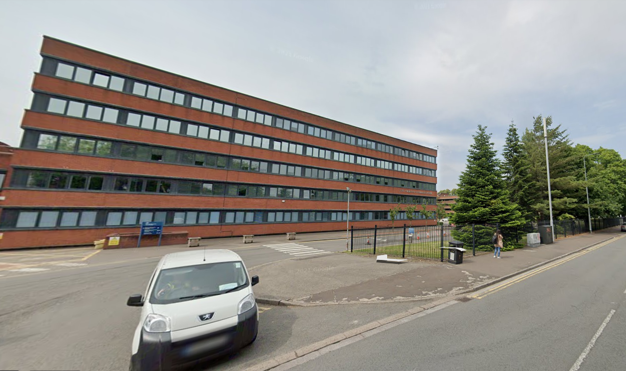

6.2. Appendix 3
AutoCad site drawing
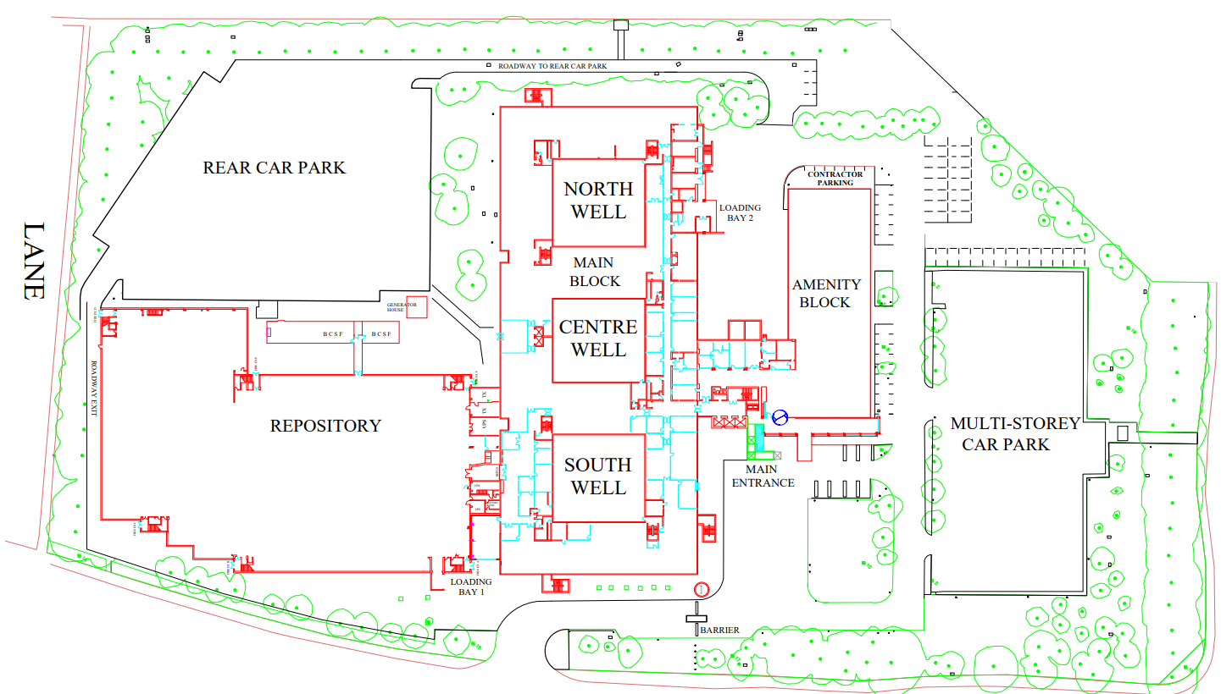

AutoCad floor general arrangment
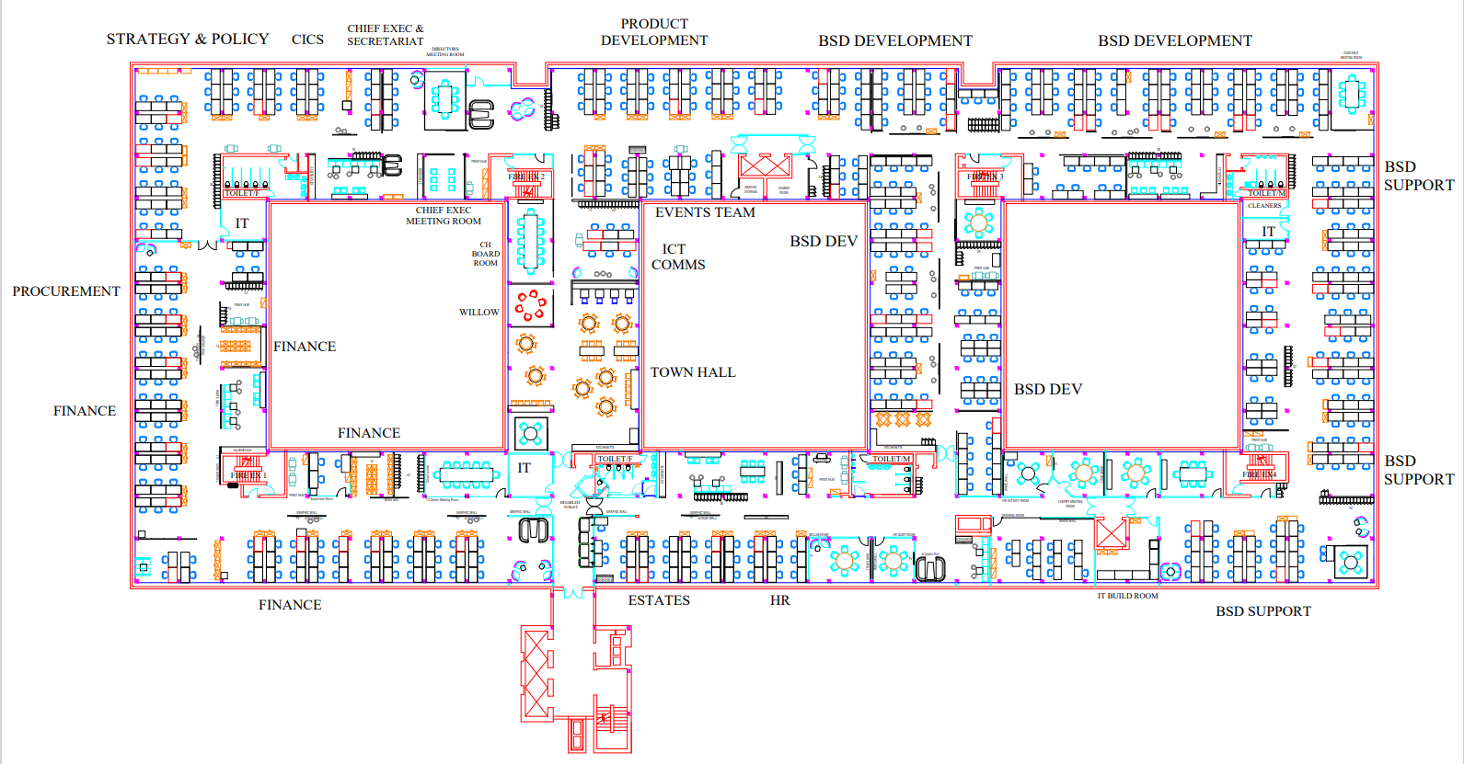

6.3. Appendix 4

CH Land registry

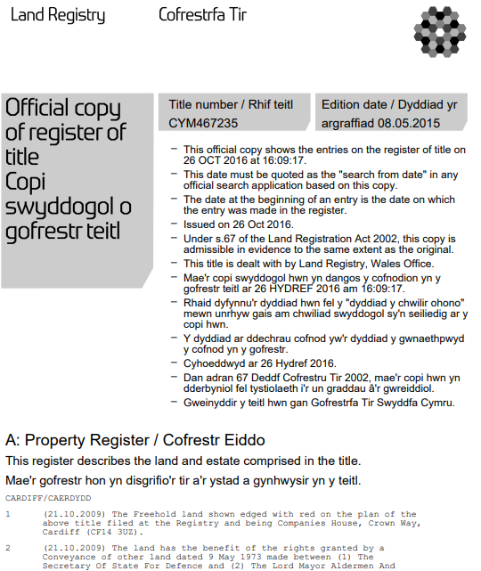

6.4. Appendix 5

CH property strategy

6.5. Appendix 6

Leesman workplace survey

