MANAGING PEOPLE

ANCA VASILE
ID UWTSD-2018716

Table of Contents
Introduction 2
Case overview 2
Employee engagement and workplace productivity 2
Diagnostic tools: measuring employees’ engagement 4
Employee value proposition 5
Strategies used to increase employee engagement 7
Conclusion 7
References 9

Introduction
The engagement of employees is the direct outcome of an organization’s strong culture that enhances business operation and workers’ well-being. Employees' engagement in an organization is referred to as connecting well to the organization’s mission, getting motivated by the management to exceed collective goals, creatively solving critical problems, and remaining committed to their respective jobs. Increased employee engagement serves to be beneficial in facilitating organizational progression while fulfilling the needs of the employees. In the pre-Covid days Greggs has seen quite some success being a popular bakery chain in Britain. However during the pandemic the bakery has seen a staggering decline in the business performance and relative employee engagement, an issue which was not addressed previously. Over time, Measures are being taken to address the prevalent concern of employee engagement in the workplace. The current case highlights how employees’ engagement can be increased during the Covid pandemic to improve workplace culture and productivity. Various diagnostic tools have been used by the organization to measure the rates of workers’ engagement.

Case overview
The current case reviews depict that employee engagement is necessary for improving the workplace culture, business profitability, and workers’ emotional and physical well-being, especially in the current covid pandemic (Locke et al. 2019). The main agenda of employee engagement can enhance business propel growth as it implements positivity in workers’ “approach to work”. Gregg’s is a well known brand all across Britain and the company used to have stable business until 2020. In the pre-Covid days the Gregg’s company used to run a successful business overall, witnessing a growth of 13.5% in sales in 2019. At the onset of Covid-19 in 2020, The Company all over witnessed a steady decline in the business sales. Gregg’s experienced a 30.5% decline in sales during the 2020 fiscal year (statista, 2022). It raised an alarming issue concerning the employee engagement with the organizational goal. The strategies that the organization has adopted during the covid pandemic to keep their employees engaged in their respective jobs are work-from-home facilities, flexible work hours, and a hygienic working environment.

Employee engagement and workplace productivity
Every organization needs to remain attentive to the well-being of their employees so that they can be kept motivated, engaged, committed, and loyal to their jobs. Organizations that have stronger workplace culture, which is free of discrimination, or unavoidable issues of inequality, can achieve long-term goals. In context, the Goal-setting theory emphasizes that in order to enhance the engagement and performance of any individual the organization must set a goal for their employees. As opined by Jeong et al. (2021), if the workers keep following the goals they can able to modify them which will also enhance their performance and workplace productivity.
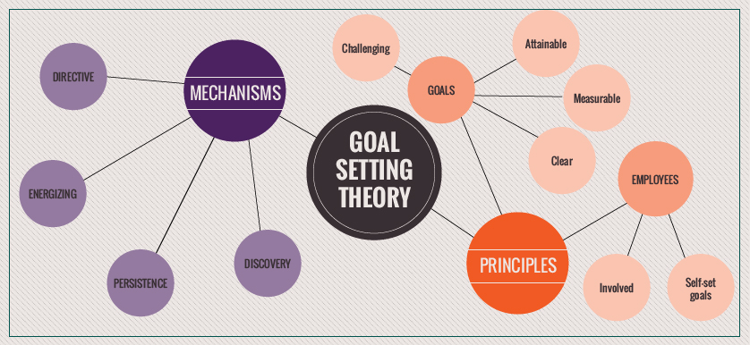
Figure 1: Goal-setting theory
(Source: Shoaib et al. 2017)
The companies must have a better understanding of their workers, talents, personality traits, and professional skills, to allocate their preferred projects. Even in times of pandemic the management of the Gregg’s bakery chain ensured that the organisation implements an effective business chain that adheres by fair norms. Even during the onset of the pandemic and the lockdown that ensured all over Britian. The company topped the furlough pay by 80% to 100% (employeebenefits, 2022). This method was practiced to ensure a provision of fair work force engagement to the employees. In 2020, Gregg’s placed around 6000 employees on furlough to ensure that the working staffs is provided with a steady remuneration even in the days of pandemic when they were bound by the obligation towards the government regulations and their personal health. Engaged employees are much more efficient and positive in their job approaches, and if the organization motivates them, they can achieve higher goals (Shoaib et al. 2017). Employee engagement allows the workers to remain committed and connect well with the mission of the organization.
Workers become more active in acquiring new business and project management skills that enhance the business operation of the organization across both national and international levels. They also gain the ability to solve critical problems or handle challenging situations creatively, valuing the organizational rules and frameworks. As opined by Osborne et al. (2017), the employees who remain highly engaged in their jobs are nearly 21% more fruitful when compared to employees having less engagement in jobs. According to the report, there are around 73% of “disengaged employees” have higher rates of turnover and search for jobs actively mainly during the covid pandemic. The records of business management across the UK have also hinted that during the crisis of the covid-19 pandemic the percentage of engaged employees is nearly about 37%, which contributed highly to the economy (Moletsane et al. 2019). If the organization can enhance their investments by 10 % for employee’s engagements then it can increase its business profit rates by nearly “$2,400” per worker every year. High employee engagement can provide the organization with the benefits of high productivity, lower rates of turnover, a strong customer base, and good customer relations.

Employee engagement and the workplace culture in the organization are the most driving problems across the globe. Employees engagements can raise the organizational culture by incorporating values, behaviours, official rituals, and equality among the workers. There are various major drivers the organization can follow to keep their employees engaged in their respective jobs (Barik et al. 2017). The administration department of the company can allocate meaningful jobs to their employees, which will also provide them with opportunities for career growth. The allocated work must empower the workers so that they gain more self-confidence. The HRM department of the organization must recruit efficient leaders to enhance the team's effectiveness and business profitability. It is also important to fulfil work relationships to keep the employees engaged in tier respective jobs. New talents need to encourage, rewarded, and appreciated by the organization to enhance the employees’ performance.

Diagnostic tools: measuring employees’ engagement
Every organization has diverse groups and mixed work culture and employee engagement can be well-maintained if diversity is incorporated into the environment of the organization. Gregg’s has ensured that there is an ambiance of inclusivity within the workplace. The company has maintained that people from all backgrounds are welcome within the organisation irrespective of their preferences and beliefs (Greggs, 2022). This sense of workplace inclusivity within the workplace has generated an effective source of employment. Gregg’s has maintained that the organisation accepts the notion of diversity within the workplace which is critical for the sustenance of business. Workplace culture affects the worker's engagements highly as a hygienic working environment can make employees feel connected, supportive, stress-free, and emotionally strong. As opined by Nasidi et al. 2019, it is much important for the administration of the organization to create a trusting culture during the covid pandemic which can keep the employees engaged and make them feel secure with their jobs. This way the company can maintain its value and image in competitive markets across the UK as well as the world.
There are various effective diagnostic tools used for measuring the engagement of employees such as arranging employee surveys, and creating “small and focused” groups of workers. Measuring the reduction, turnovers, and rates and identifying the reason behind it. Measuring the productivity metrics of all employees is the utmost responsibility of the administration of the company to keep their employees engaged with their job responsibilities (Smith et al. 2017). By conducting frequent employee surveys the organisation can measure, the rate of employees who tend to work efficiently and stay committed to the company for a longer period of time. According to the survey record, it can be stated that the organization which has a high employee engagement makes higher profits by nearly 21% and is also more productive that is about 17%. Surveys are often determined as one of the quick and effective methods of measuring the workers’ engagements in jobs (Albrecht et al. 2018). It not only helps to measure the engagement of the employees but also helps to motivate them by appreciating and valuing their ideas and thoughts. The built-in survey is mainly used as a diagnostic tool where different small groups of workers are made and through questionnaires, the workers are asked about their professional experiences.
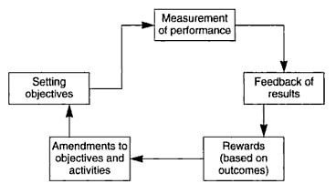
Figure 2: System of performance management
(Source: Turner, 2019)
The company needs to follow a system cycle to managements the employee's performance. The system cycle of performance management incorporated the components like setting clear objectives, measuring workers' performance and giving feedback after getting the results of performance. Other components also include a system of giving rewards based on workers' performance, and amendments to activities and objectives of the employees. The management can follow the guidelines of Campbell's Theory of Performance, to measure the performance efficiency of their employees. As opined by Al-dalahmeh et al. 2018, this theory can also help the management to determine the activeness and efficiency rates to allocate them their jobs. The organization can also arrange recognition and rewards programs for the employees who have contributed to business productivity, and helped the organization to achieve its long-term goals. It has been ensured by the organisation that the company is paid with an effective amount of salary and other additional benefits. It is ensured by the management of Gregg’s that the employees are paid efficiently higher than the National Living Wage (Greggs, 2022). Employees at Gregg’s are often paid with profit share of the organization and additional surprise rewards. This can motivate, and encourage the employees to become more efficient in their respective job roles. As per record, it has been seen that about 69% of workers can work hard and remained in an organization for a longer time when they felt that their efforts are well appreciated.

Employee value proposition
EVP or the “Employee Value Proposition” is considered to be one of the unique sets of benefits provided to the employees by the management of an organization. The organization provides their employees with benefits like high incentivizes and promotions every six months, and a good health insurance policy to make them stay longer with the company. Gregg’s has ensured that the employee is paid with effective fringe benefits that would help them to have an effective work-life balance for their propagation of business. As opined by Mone and London (2018), effective employee engagement strategies ensure healthy work place environment within the organization. Employees are provided with a maternity leave up to 12 months and for colleagues with 5 years of service with the organisation are paid up to 50% of wages during 7th to 26th week of their pregnancy. The company also provides the employees with shared parental leave and adoption leave up to 12 months (Greggs, 2022). Male employees are also provided with exclusive parental leave and paternity leave. These policies ensure that the employees engaged with Gregg’s are provided with ample facilities in return of their dedicated service to the organisation. The employees get benefits from their organization in return for their capabilities, work efficiency, experiences, and skills they give (Pawar, 2020). EVP mainly denotes the essence of the organization, its uniqueness and value in its target market segments and even in its competitive market. The most common examples of “Employee Value propositions” are true working flexibility is offered to the employees based on their location and preferred working schedule. The employees are provided with missions that go beyond their “work”. Fostering communication and collaboration bond with the employees to understand their emotional thoughts, ideas, and talents.
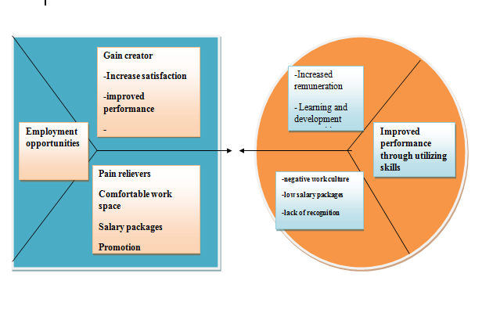
Figure 3: Employee value propositions
(Source: Turner, 2019)
Two building blocks have been incorporated into the Employee value proposition canvas, such as a Value map and an Employee profile. In the context of the Employee profile, it can be stated that “gains” provide the employees with benefits of job satisfaction, motivation, and job opportunities at international levels. “Pains” refers to the employee's negative experiences, such as risks of employment, emotional usability, and workload pressure that can de-motivate them decreasing their efficiency. As opined by Bakker et al. (2017), “Employees’ jobs”, denotes in what field they are more efficient and can be highly productive to enhance company business. In the context of the “Value map”, it can mention that “gain creators” is something that determines how the organizational services, provide the employees with value and talent appreciation. “Pains relievers” help to understand the employees’ demands and keep them engaged and committed to their jobs. The employee value proposition model actually helps the employees to get high benefits to remain engaged and committed to their respective jobs in the organization and grow with new creative talents.

Strategies used to increase employee engagement
The covid pandemic has pivoted this corporate world and a huge turnover of employees has been observed throughout the world as well as across the UK. Keeping in the mind the covid Normans and guidelines the management of the organization has thought of incorporating a new working structure and strategies that will enhance the business operation and employees’ engagements with their respective jobs. Several strategies have been undertaken by the organisation to ensure that the employees are satisfied within the workplace. In light of this belief, Greg’s ensured that the employees are paid 80 to 100% of their remuneration during the lockdown. This ensured that the employees stay engaged with the organisation and are paid effectively in return for the services. In Gregg’s the new parents are provided with support and empathy, the leave programs practised within the organisation ensures that the employees do not feel the stress of the workplace while taking care of this child.
Gregg’s also propagates and encourages values of diversity and equality within the workforce. It is ensured that people from all backgrounds are treated equally in same amount of opportunities are provided to them to have a successful career with the organisation. There are many programs that are launched that ensure employee engagement not only with the organisation but also with their relative community. Gregg’s encourages their employees to participate in ‘breakfast clubs’ for school children that helps the employees lighten the work induced stress and connect with other people. Many cities are still restricting activities that hamper the business operation of various organizations and they are settling for remote work to keep their business moving. In this unprecedented time, there are huge crises in markets and the organization is facing issues in their supply chain management and profitability and thought of keeping their employees engaged by following the working from home structure (Knight et al. 2017). The employees are allowed to work in their respective fields during flexible working hours, and if the employees are working from the office the organization must take care of their safety by following all covid norms and guidelines. The management of the company should provide their employees with job roles they are comfortable and efficient at. Other strategies that the organization can follow are creating an open collaboration and communication channel that can keep entire management and employees connected. Strong communication and bond can enhance the performance of the employees and also increase the productivity and profitability of the company’s business processes.
One of the important factors in the workplace is the communication between the emp0loyee and management. During this current pandemic situation, there is a low record of global economies, unemployment, employees’ turnovers, and job crisis. As opined by Bakker et al. (2018), most the employees became insecure with their jobs and filled with anxiety and trepidation about their future employment. The organization have incorporated a communicative channel to keep a record of the “crux of workers’ engagement” to get regulated updates regarding employees' demands, well-being, and mission. Proper knowledge about the employees also helps the management of a company to boost the commitment and confidence leeks of their employees.

Conclusion
The current study highlights the concept that employee’s engagement is essential to enhancing the performance and business productivity of the organization. It also provides the organization with an opportunity to grow at the national and international level, strengthen its customer’s base and increase its brand popularity across the world as well as in the UK. Over time, Gregg’s has practised policies that ensure effective strategies to be propagated within the organization. A healthy ambiance within the workplace ensures employee retention and effectively in their performance within the workplace. Over time, the organisation has undertaken steps to pay hefty remuneration to the organization for the employees at work during the pandemic. It has been ensured that the organisation is paid with additional benefits that ensure employee retention within the organisation. However, in light of the recent condition where the business has incurred a hefty loss, it has been necessary for the company to implement effective strategies to engage the employees at work and motivate them to drive the sales growth with digitization and other standards of work practices. To enhance the effectiveness of the employees and to keep them engaged, committed, and loyal to their respective jobs the organization must arrange frequent employees surveys and training programs. The company can also arrange rewards function for their employees who show loyalty, creativity and is fruitful in their jobs.

References
Books
Mone, E.M. and London, M., 2018. Employee engagement through effective performance management: A practical guide for managers. Routledge. New York : Routledge
Turner, P., 2019. Employee engagement in contemporary organizations: Maintaining high productivity and sustained competitiveness. U.S: Springer Nature.
Journals
Albrecht, S., Breidahl, E. and Marty, A., 2018. Organizational resources, organizational engagement climate, and employee engagement. Career Development International.
Al-dalahmeh, M., Khalaf, R. and Obeidat, B., 2018. The effect of employee engagement on organizational performance via the mediating role of job satisfaction: The case of IT employees in Jordanian banking sector. Modern Applied Science, 12(6), pp.17-43.
Bakker, A.B. and Albrecht, S., 2018. Work engagement: current trends. Career Development International.
Bakker, A.B. and Leiter, M., 2017. Strategic and proactive approaches to work engagement. Organizational Dynamics, 46(2), pp.67-75.
Barik, S. and Kochar, A., 2017. Antecedents and consequences of employee engagement: A literature review. International Journal of Latest Technology in Engineering, Management & Applied Science, 6(4), pp.33-38.
Jeong, Y.H., Healy, L.C. and McEwan, D., 2021. The application of Goal Setting Theory to goal setting interventions in sport: a systematic review. International Review of Sport and Exercise Psychology, pp.1-26.
Knight, C., Patterson, M. and Dawson, J., 2017. Building work engagement: A systematic review and meta‐analysis investigating the effectiveness of work engagement interventions. Journal of organizational behaviour, 38(6), pp.792-812.
Locke, E.A. and Latham, G.P., 2019. The development of goal-setting theory: A half-century retrospective. Motivation Science, 5(2), p.93.
Moletsane, M., Tefera, O. and Migiro, S., 2019. The Relationship between Employee Engagement and Organisational Productivity of Sugar Industry in South Africa: The Employees' Perspective. African Journal of Business & Economic Research, 14(1).
Nasidi, Y., Makera, A.U., Kamaruddeen, A.M. and Jemaku, I.M., 2019. Assessing the impact of the work environment on employee engagement among the non-academic staff of the University. SEISENSE Journal of Management, 2(1), pp.57-68.
Osborne, S. and Hammoud, M.S., 2017. Effective employee engagement in the workplace. International Journal of Applied Management and Technology, 16(1), p.4.
Pawar, A., 2020. Prognostic model for employer brand, talent attraction, and employee retention through employee value proposition. Journal of Applied Management and Investments, 9(3), pp.133-152.
Shoaib, F. and Kohli, N., 2017. Employee engagement and goal-setting theory. Indian journal of health & wellbeing, 8(8).
Smith, M. and Bititci, U.S., 2017. The interplay between performance measurement and management, employee engagement and performance. International Journal of Operations & Production Management.
Websites
Employeebenefits, 2022. About Greggs will not pay staff if they need to self-isolate after returning from holiday. Available from: https://employeebenefits.co.uk/greggs-no-pay-staff-self-isolate-holidays/ [Accessed on: April 23, 2022]
Greggs , 2022. About Family Leave FINAL 26.08.21. Available from: https://corporate.greggs.co.uk/sites/default/files/Family%20Leave%20FINAL%2026.08.21.pdf [Accessed on: April 23, 2022]
Greggs, 2022. About Greggs. Available from: https://corporate.greggs.co.uk/responsibility/people [Accessed on: April 23, 2022]
Statista, 2022. About Greggs sales growth in the United Kingdom (UK) 2006-2020. Available from: https://www.statista.com/statistics/630696/greggs-sales-growth-united-kingdom-uk/ [Accessed on : April 23, 2022]

