
Contents
A. Explanation of Code and Logic 3
A.1 Data generation (Task A) 3
A.2 Zone totals and category averages (Tasks B and C) 7
A.3 Anomaly detection (Task D) 7
A.4 Peak processing days (Task E) 8
B. Justification of Programming Choices 8-9
C. Testing and Validation 9-10
D. Efficiency and Scalability Reflection 10
E. Reflection on Learning and Use of Generative AI 10-11
References 12
Appendix A: R Console Output 13–19

List of Tables and Figures
Figures
Figure 1 Flowchart of the overall program logic 3–6

Tables
Table 1 Calculated and theoretical average processing times by category 7
Table 2 Distribution of Task D anomalies by product category 8
Table 3 Task E peak days with runner-up and zone mean 8
Table 4 Comparison of original and supplementary Task D analyses 9

Appendix outputs
A1 Task A – first ten rows of warehouse_data and its dimensions 13
A2 Task B – total units processed per zone 13
A3 Task C – average processing time per category 13
A4 Task D – all 140 daily-zone averages 14
A5 Task D – first ten anomalies 14
A6 Task D – verification checks 15
A7 Task E – most productive day for each zone 15
A8 Verification of Table 2 using loops 15
A9 Verification of Table 3 using loops 15
A10 Small test case with known outcomes 16
A11 Supplementary Task D – monthly averages and first ten comparisons 16
A12 Complete supplementary Task D daily-zone anomaly results (140 records) 17-19
A13 Supplementary Task D small test with known outcomes……………………………………………………19

A. Explanation of Code and Logic

A.1 Data generation (Task A)
Three nested for loops generate every day–zone–category combination once: 28 × 5 × 6 = 840 records (Appendix A1). For each record, RandomVariation <- sample(-12:12, 1) adds noise, and:
UnitsProcessed = BaseUnits (100) + 8 × Zone + 5 × Category + RandomVariation
ProcessingTime = UnitsProcessed × TimePerUnit (0.85)
A row_number counter writes each record to the next row of warehouse_data; set.seed(123) makes results reproducible, so a changed result during testing signals a code change rather than a new random draw.

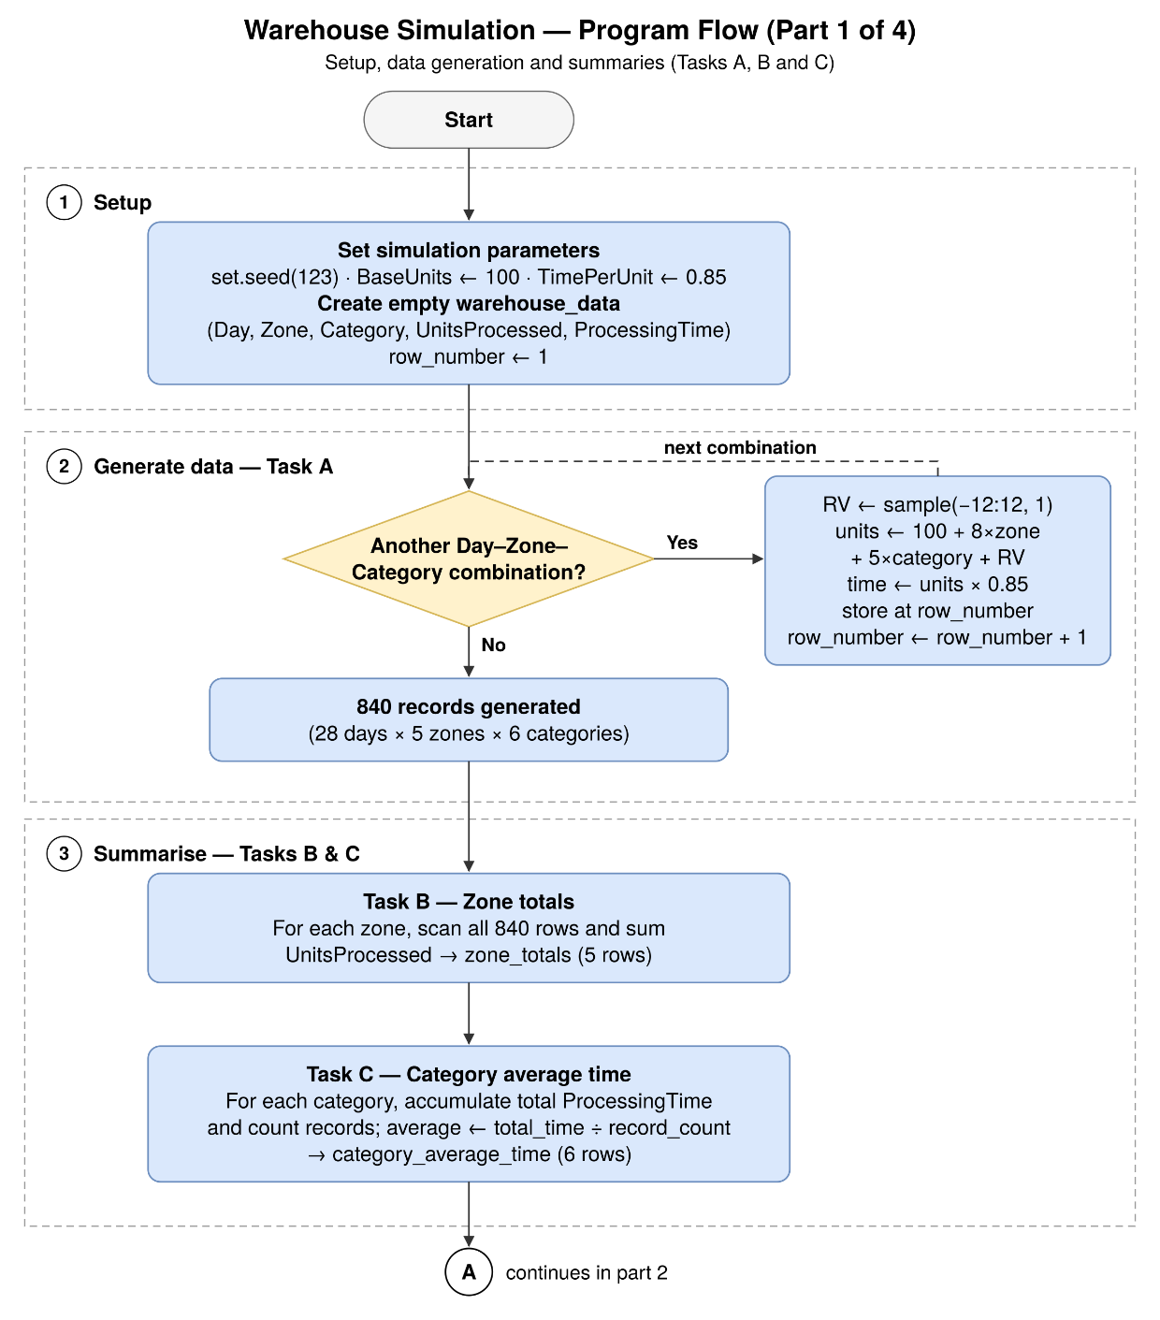

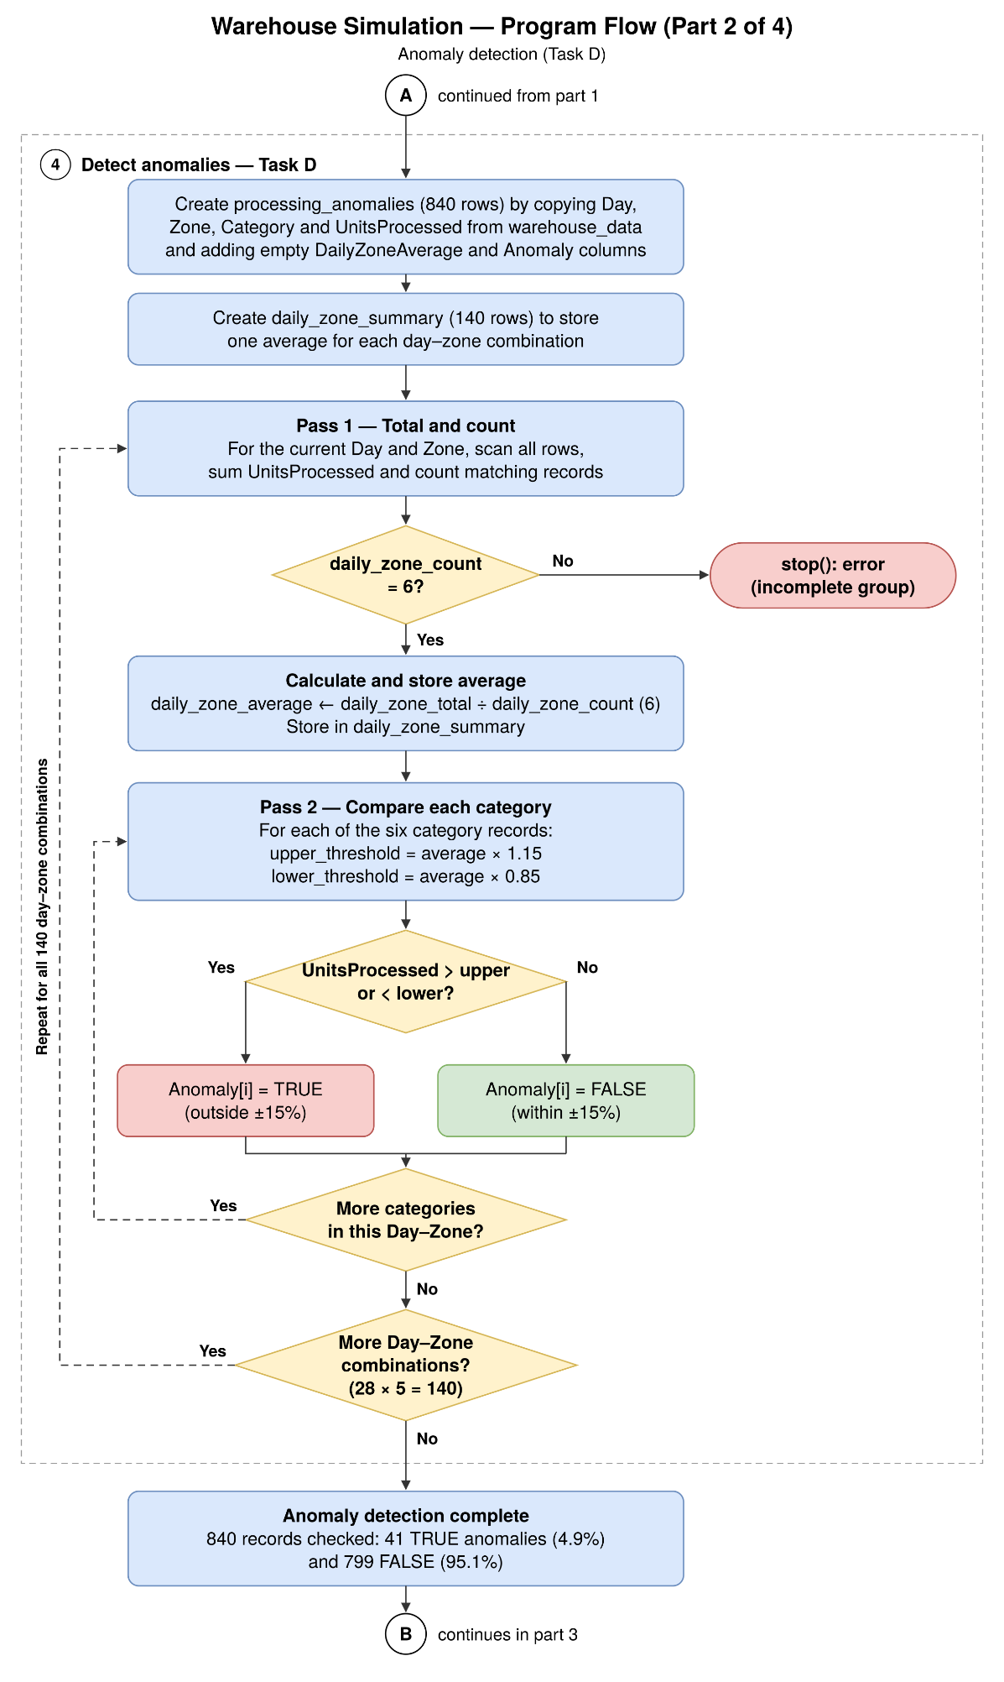

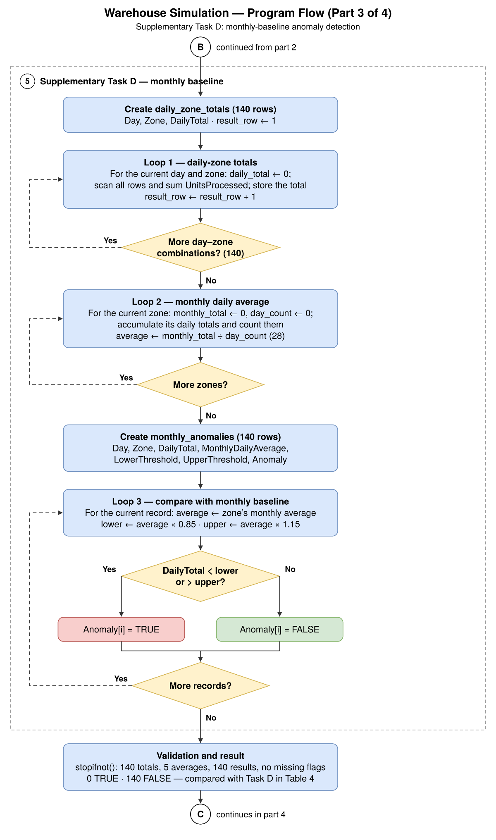
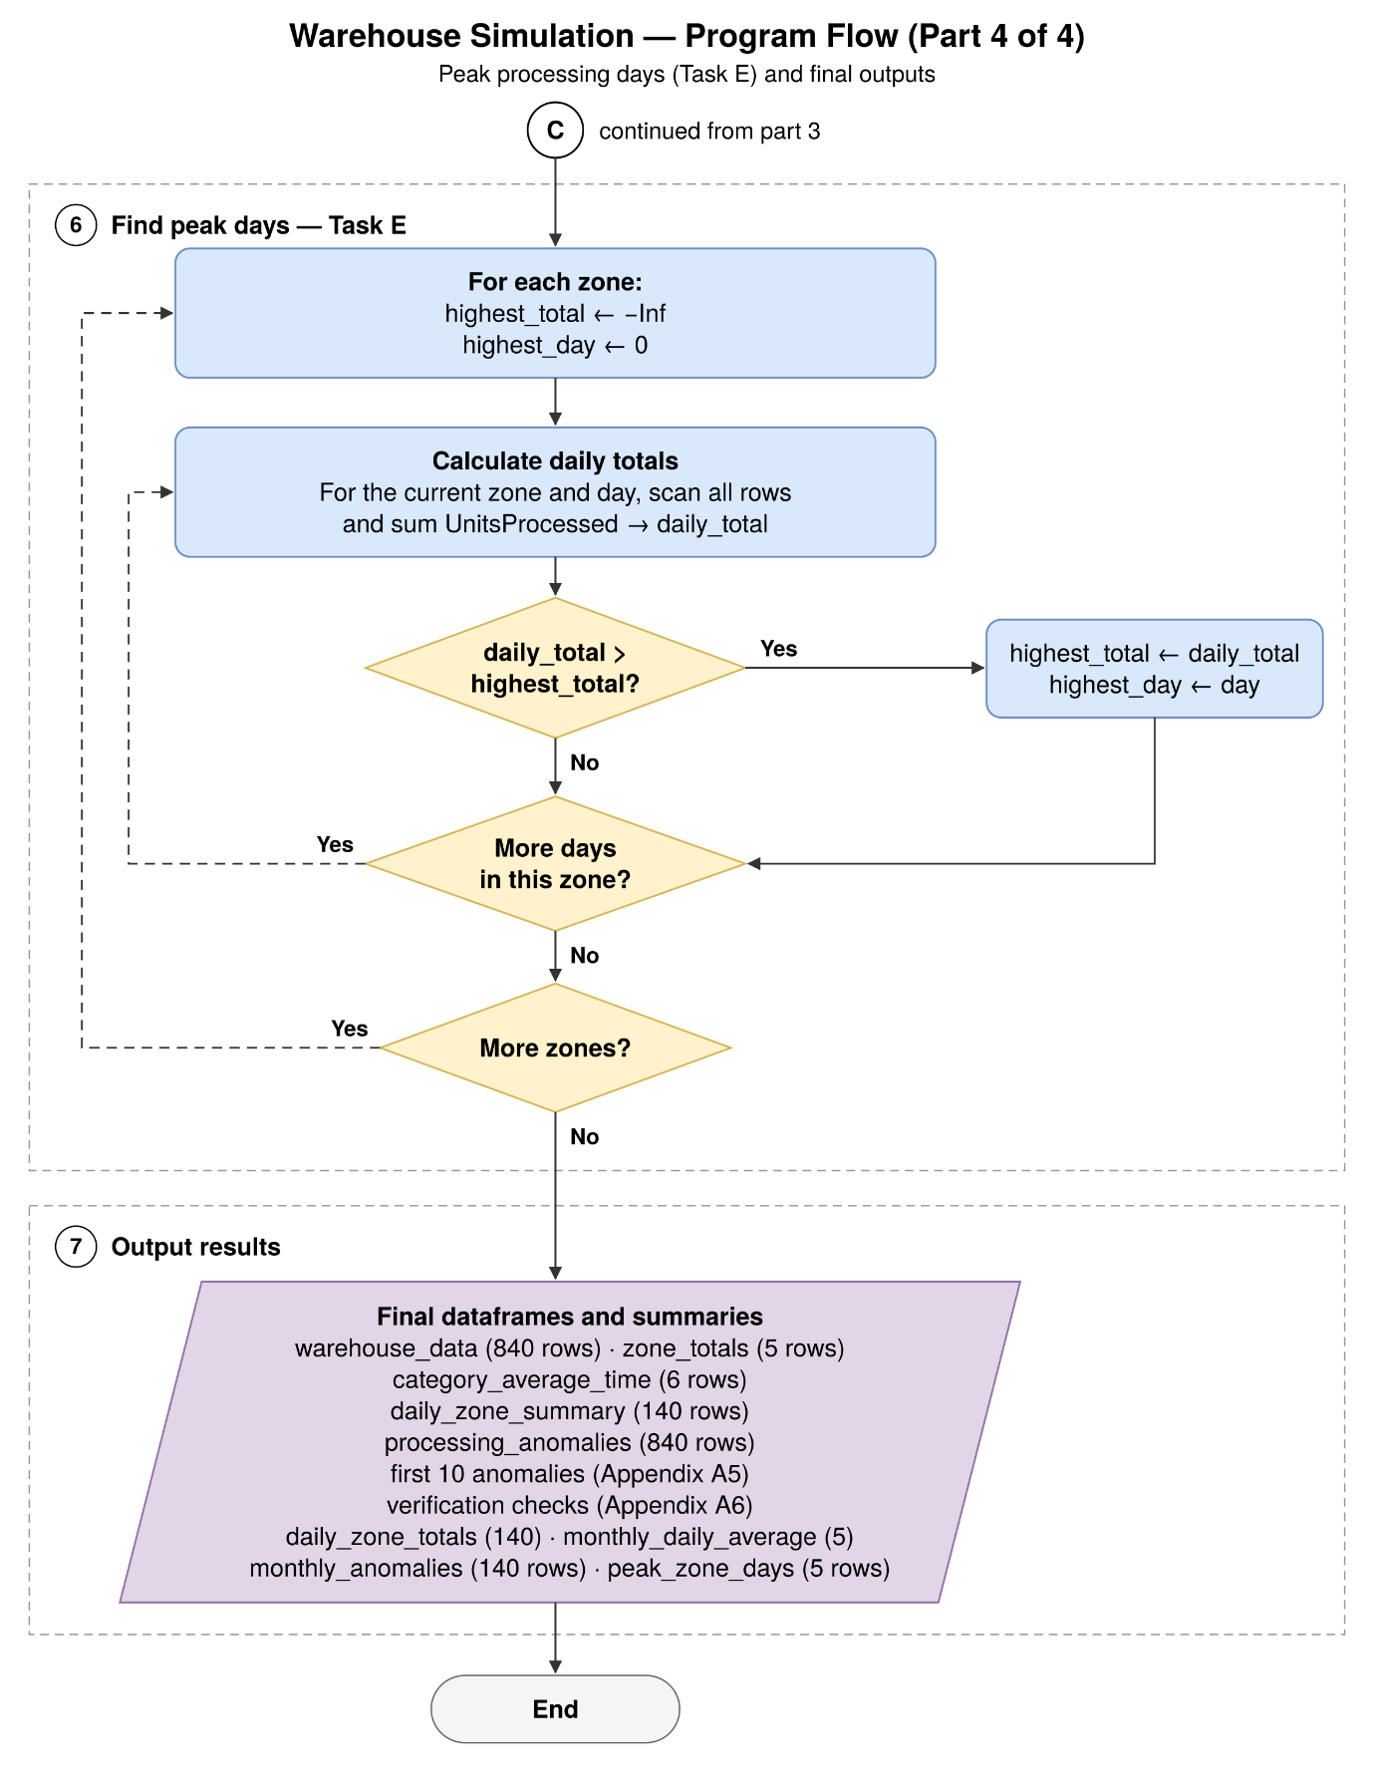
Figure 1. Flowchart of the overall program logic (parts 1–4), using standard flowchart symbols; circles A, B and C are off-page connectors, and Part 3 shows the supplementary monthly-baseline analysis.

In Figure 1, Task A builds warehouse_data, which Tasks B–E only read, storing results in zone_totals, category_average_time, processing_anomalies and peak_zone_days; Task D is the most complex, as each day–zone average must exist before any record is classified.

A.2 Zone totals and category averages (Tasks B and C)
Task B loops over zones and all 840 rows, adding UnitsProcessed to zone_total when zones match; totals rise from 21,059 (Zone 1) to 26,463 units (Zone 5), matching the eight-unit zone effect (Appendix A2). Task C divides a total_time accumulator by a record_count counter after all 140 matching records. Table 1 compares each average (Appendix A3) with theory, assuming zero mean variation and a mean zone effect of 24 (3 × 8):
Theoretical time = (100 + 24 + 5 × Category) × 0.85

Table 1. Calculated and theoretical average processing times by category
Category | Records | Total time (min) | Calculated average (min) | Theoretical average (min) | Difference (min)
1 | 140 | 15,311.05 | 109.36 | 109.65 | −0.29
2 | 140 | 15,981.70 | 114.16 | 113.90 | +0.26
3 | 140 | 16,534.20 | 118.10 | 118.15 | −0.05
4 | 140 | 17,175.95 | 122.69 | 122.40 | +0.29
5 | 140 | 17,759.90 | 126.86 | 126.65 | +0.21
6 | 140 | 18,430.55 | 131.65 | 130.90 | +0.75

Every average lies within 0.75 minutes of theory, supporting the loop logic, though the trend mainly reflects the built-in category effect.

A.3 Anomaly detection (Task D)
Task D copies four source columns from warehouse_data into processing_anomalies, adding empty DailyZoneAverage and Anomaly columns so rows stay aligned; daily_zone_summary stores all 140 day–zone averages (Appendix A4).
A first scan accumulates daily_zone_total and daily_zone_count for each day and zone; if the count is not six, stop() halts the program rather than producing a misleading average. A second scan flags each record outside upper_threshold (average × 1.15) or lower_threshold (average × 0.85), storing TRUE or FALSE at row i.
For example, Day 1, Zone 4, Category 6 (168 units) exceeds the 167.71 limit from the unrounded average of 145.8333. Overall, 41 of 840 records (4.9%) were TRUE and 799 (95.1%) FALSE; Appendix A5 lists the first ten anomalies and Appendix A6 the verification checks.
Table 2. Distribution of Task D anomalies by product category (verified in Appendix A8)
Category | Above +15% | Below −15% | Total flagged | Share of anomalies
1 | 0 | 19 | 19 | 46.3%
2 | 0 | 1 | 1 | 2.4%
3 | 0 | 0 | 0 | 0.0%
4 | 0 | 0 | 0 | 0.0%
5 | 2 | 0 | 2 | 4.9%
6 | 19 | 0 | 19 | 46.3%
All | 21 | 20 | 41 | 100.0%

Thirty-eight anomalies are in Categories 1 and 6, and flags fall from 15 (Zone 1) to 2 (Zone 5). These categories sit about 12.5 units from the day–zone mean, so the rule mainly detects the built-in category effect; a category-specific baseline would better identify unusual activity.
A supplementary monthly-baseline analysis offers a second perspective (Figure 1, Part 3): loops total each day and zone (140 totals), divide each zone’s 28-day total by 28 (baselines of 752.11, 805.25, 846.96, 902.39 and 945.11 for Zones 1–5), then compare each daily total with 85% and 115% of its baseline, testing whole-day output rather than categories. No total exceeded the limits (Appendices A11 and A12).

A.4 Peak processing days (Task E)
Task E compares each zone’s daily totals with highest_total, starting at -Inf so Day 1 sets the first benchmark; a larger value updates highest_total and highest_day (Appendix A7). Table 3 adds the runner-up day and mean daily total.
Table 3. Task E peak days with runner-up and zone mean (verified in Appendix A9)
Zone | Peak day | Peak total | Runner-up (day: total) | Margin | Mean daily total | Peak vs mean
1 | 16 | 786 | 10: 772 | 14 | 752.1 | +4.5%
2 | 6 | 838 | 26: 832 | 6 | 805.2 | +4.1%
3 | 8 | 895 | 28: 884 | 11 | 847.0 | +5.7%
4 | 3 | 948 | 9: 926 | 22 | 902.4 | +5.1%
5 | 19 | 972 | 6: 969 | 3 | 945.1 | +2.8%

Margins are small (Zone 5’s peak leads by only 3 units); with no day-level effect in the model, peaks reflect random variation and would change under another seed. The strict > keeps the earlier day in a tie (Section C).

B. Justification of Programming Choices
Data frames suit the tabular data because each column is a named vector, so variables of different types sit side by side, unlike in a three-dimensional array; numeric() vectors such as zone_flags serve as counters. Separate result data frames preserve warehouse_data, and daily_zone_summary keeps Task D averages available for verification.
Nested for loops mirror the day–zone–category structure, while accumulators and counters make every total and average explicit. Copying the source columns into processing_anomalies, rather than filling an empty data frame, removed the indexing risk found in testing (Section C).
if conditions with TRUE/FALSE flags separate values outside ±15%, using unrounded averages. Vectorised operations would be faster, but the brief requires loops, so transparency and compliance take priority; table() and sum() appear only in verification checks.
The supplementary analysis uses the same nested loops, accumulators and conditions, without prohibited aggregation or user-defined functions. The original method detects category variation within a day–zone; the supplementary one detects unusual total daily output against each zone’s monthly average (Table 4).

Table 4. Comparison of original and supplementary Task D anomaly analyses
Analysis | Comparison baseline | Records assessed | Anomalies (TRUE)
Original category-level | Daily-zone mean of six categories | 840 | 41 (4.9%)
Supplementary daily-total | Zone mean daily total across 28 days | 140 | 0 (0.0%)

The supplementary analysis flagged none of 140 daily totals, versus 41 of 840 category records: aggregation hides category variation, so the baseline and level of aggregation shape the results.
The simulation assumes 0.85 minutes per unit, additive zone and category effects, ±12 units of variation and no day-of-week effects, so it demonstrates techniques rather than predicting real performance.

C. Testing and Validation
I compared each output with a value I could predict independently: an expected size, a hand calculation, a theoretical value or a known test result.
nrow() and ncol() confirmed 840 rows (28 × 5 × 6) and five columns. Task D checks confirmed 140 day–zone averages, an 840 × 6 processing_anomalies data frame, six records per group and 41 TRUE plus 799 FALSE flags (Appendix A6); stopifnot() halts if any condition fails [1]. Hand calculations confirmed the first record (115 × 0.85 = 97.75) and the Day 1, Zone 4 anomaly.
For the supplementary analysis, stopifnot() confirmed 140 daily totals, five zone averages and 140 flags, all FALSE with none missing. By hand, Zone 1’s baseline is 21,059 ÷ 28 = 752.11, and Day 1’s 754 units lies within 639.29–864.92 (Appendix A12). A second controlled test (Appendix A13) confirmed the TRUE branch: Zone 2’s totals (247, 350) fell outside 253.725–343.275 while Zone 1’s stayed FALSE, and stopifnot() confirmed every expected value.
An early Task D counter wrote an 841st value into the 840-row data frame; indexing by source row i fixed this.
A controlled two-day, two-zone, two-category dataset without random variation, plus an injected 160-unit outlier, reproduced every hand calculation (Appendix A10): zone totals of 504 and 494, both Day 2, Zone 1 records flagged (113 < 116.03; 160 > 156.98), and Day 1 kept for Zone 2’s tied 247, mirroring testthat’s expected-versus-actual comparison [2].
Category 2’s 112.625 displays as 112.62 because round() rounds half to even, so comparisons use unrounded values. Limitations remain: one seed, untested exact ±15% boundaries, and tests that re-implement rather than rerun the Task B–E code (a shared function, if permitted, would avoid this).

D. Efficiency and Scalability Reflection
The solution suits 840 records but scales poorly. Task D scans all 840 rows twice for each of 140 day–zone pairs (235,200 row checks) and Task E 117,600; thresholds are also recalculated per record. A year with 20 zones and 50 categories (365,000 records) would need about 5.3 billion Task D checks, as cost grows with the square of dataset size. Even with loops only, accumulating totals in a 28 × 5 day-by-zone matrix in one pass and classifying in a second would need only 1,680 checks. The supplementary analysis adds 117,600 more checks; reusing Task D’s day–zone totals would avoid this. Pre-allocation and named constants would also help.

E. Reflection on Learning and Use of Generative AI
Initially, I struggled to see how nested loops, conditions, counters and accumulators interacted, so I built each task gradually, testing each section; R for Data Science [3] reinforced my understanding of iteration.
My most valuable lesson came from a Task D indexing error, which made me question my approach; examining row positions, I fixed it by indexing with the source row and copying columns, learning to find an error’s cause before changing code.
I first read the 41 anomalies as unusual activity, but 38 came from Categories 1 and 6, reflecting the formula. With no daily total outside its zone’s monthly range, the supplementary analysis showed that anomaly counts depend on the unit of analysis and baseline, so results need critical interpretation.
Generative AI supported my learning by explaining R errors, nested loops and indexing. I also used official documentation on stopifnot() [1] and testthat [2] to understand verification checks and small test cases. AI suggested a supplementary monthly comparison; I replaced its initial aggregation-based approach with explicit loops, counters and accumulators, and checked the averages, flags and validation in R. I treated AI output as guidance, testing code in R against my own calculations. In future, I would build known-outcome tests first and verify results throughout development.

References
[1] R Core Team, “Ensure the Truth of R Expressions,” R Documentation, base package. [Online]. Available: https://search.r-project.org/R/refmans/base/html/stopifnot.html

[2] H. Wickham, testthat: Unit Testing for R, R package documentation, Comprehensive R Archive Network (CRAN). [Online]. Available: https://CRAN.R-project.org/package=testthat

[3] H. Wickham and G. Grolemund, R for Data Science, 1st ed. Sebastopol, CA, USA: O'Reilly Media, 2017. [Online]. Available: https://r4ds.had.co.nz/

Appendix A: R Console Output
Output from running the submitted script in R with set.seed(123). Code lines are omitted; only the commands that print results and their output are shown.
A1. Task A – first ten rows of warehouse_data and its dimensions
First ten generated records, confirming that warehouse_data has 840 rows and five columns (Section A.1).
> head(warehouse_data, 10)
Day Zone Category UnitsProcessed ProcessingTime
1 1 1 1 115 97.75
2 1 1 2 124 105.40
3 1 1 3 124 105.40
4 1 1 4 118 100.30
5 1 1 5 130 110.50
6 1 1 6 143 121.55
7 1 2 1 130 110.50
8 1 2 2 124 105.40
9 1 2 3 123 104.55
10 1 2 4 143 121.55
> nrow(warehouse_data)
[1] 840
> ncol(warehouse_data)
[1] 5

A2. Task B – total units processed per zone
Total units processed per zone, rising from 21,059 (Zone 1) to 26,463 (Zone 5) (Section A.2).
> zone_totals
Zone TotalUnits
1 1 21059
2 2 22547
3 3 23715
4 4 25267
5 5 26463

A3. Task C – average processing time per category
Average processing time per category, from 109.36 to 131.65 minutes; compared with theory in Table 1 (Section A.2).
> category_average_time
Category AverageProcessingTime
1 1 109.36
2 2 114.16
3 3 118.10
4 4 122.69
5 5 126.86
6 6 131.65
A4. Task D – all 140 daily-zone averages
All 140 day–zone averages used as the Task D comparison baselines (Section A.3).
Day | Zone 1 | Zone 2 | Zone 3 | Zone 4 | Zone 5
1 | 125.67 | 136.17 | 146.50 | 145.83 | 156.83
2 | 123.50 | 135.67 | 138.17 | 151.17 | 160.50
3 | 125.17 | 135.83 | 143.17 | 158.00 | 157.50
4 | 124.50 | 133.50 | 140.83 | 153.00 | 158.33
5 | 128.50 | 128.50 | 145.00 | 153.00 | 155.50
6 | 124.33 | 139.67 | 138.83 | 153.33 | 161.50
7 | 122.33 | 133.17 | 141.33 | 151.67 | 160.00
8 | 127.00 | 137.50 | 149.17 | 148.83 | 156.50
9 | 126.00 | 136.33 | 133.83 | 154.33 | 157.00
10 | 128.67 | 135.67 | 138.33 | 146.00 | 156.83
11 | 120.50 | 134.17 | 134.17 | 148.83 | 152.83
12 | 128.50 | 137.50 | 139.17 | 151.67 | 155.83
13 | 127.83 | 135.17 | 137.50 | 150.83 | 159.33
14 | 125.17 | 131.83 | 142.17 | 151.50 | 155.33
15 | 125.83 | 135.83 | 139.67 | 153.33 | 157.17
16 | 131.00 | 134.83 | 141.00 | 150.17 | 158.83
17 | 125.50 | 135.67 | 142.83 | 148.50 | 153.67
18 | 128.33 | 132.33 | 144.00 | 150.33 | 161.50
19 | 120.33 | 133.50 | 144.00 | 152.33 | 162.00
20 | 121.83 | 131.67 | 139.33 | 146.00 | 157.17
21 | 119.67 | 132.67 | 139.50 | 151.33 | 159.67
22 | 124.00 | 130.83 | 141.17 | 147.17 | 153.00
23 | 123.17 | 132.17 | 145.67 | 148.33 | 159.33
24 | 128.33 | 134.00 | 139.67 | 147.83 | 157.17
25 | 127.50 | 133.17 | 138.33 | 146.33 | 155.50
26 | 123.33 | 138.67 | 141.83 | 150.33 | 158.33
27 | 127.67 | 126.67 | 140.00 | 147.33 | 158.83
28 | 125.67 | 135.17 | 147.33 | 153.83 | 154.50
Values from print(daily_zone_summary) (140 rows), arranged by day and zone for readability. Day 1, Zone 4 (145.83) is the worked example in Section A.3.

A5. Task D – first ten anomalies
The first ten of the 41 records flagged TRUE, including the Day 1, Zone 4 worked example (Section A.3).
> print(first_10_anomalies)
Day Zone Category UnitsProcessed DailyZoneAverage Anomaly
1 1 4 6 168 145.83 TRUE
2 3 1 1 106 125.17 TRUE
3 3 3 1 120 143.17 TRUE
4 3 3 6 166 143.17 TRUE
5 4 1 1 103 124.50 TRUE
6 4 1 6 147 124.50 TRUE
7 4 3 6 163 140.83 TRUE
8 5 1 6 148 128.50 TRUE
9 6 2 1 116 139.67 TRUE
10 8 1 2 106 127.00 TRUE
A6. Task D – verification checks
Task D verification: 140 averages, an 840 × 6 data frame, six records per day–zone, and 41 TRUE plus 799 FALSE flags (Section C).
> print(nrow(daily_zone_summary))
[1] 140
> print(nrow(processing_anomalies))
[1] 840
> print(nrow(true_anomalies))
[1] 41
> print(sum(!processing_anomalies$Anomaly))
[1] 799
> print(dim(processing_anomalies))
[1] 840 6
> print(names(processing_anomalies))
[1] "Day" "Zone" "Category" "UnitsProcessed"
[5] "DailyZoneAverage" "Anomaly"
> print(table(processing_anomalies$Day, processing_anomalies$Zone))

1 2 3 4 5
1 6 6 6 6 6
2 6 6 6 6 6
3 6 6 6 6 6
… … … … … …
28 6 6 6 6 6
The verification confirmed that all 140 day–zone combinations contained six product categories, accounting for the complete dataset of 840 records. The checks also confirmed 41 anomalies and 799 non-anomalies, supporting the completeness and consistency of the Task D results.

A7. Task E – most productive day for each zone
Peak processing day and total for each zone (Section A.4).
> peak_zone_days
Zone Day TotalUnits
1 1 16 786
2 2 6 838
3 3 8 895
4 4 3 948
5 5 19 972

A8. Verification of Table 2 using loops
Independent loop recount confirming the category and zone anomaly counts in Table 2 (Sections A.3 and C).
> total_anomalies
[1] 41
> category_high
[1] 0 0 0 0 2 19
> category_low
[1] 19 1 0 0 0 0
> zone_flags
[1] 15 12 9 3 2

A9. Verification of Table 3 using loops
Loop recheck confirming the Table 3 peak days, with runner-up days and mean daily totals (Sections A.4 and C).
> for (zone in 1:5) { ... } # full loop in the submitted script
Zone: 1 Peak Day: 16 Peak Total: 786 Runner-up Day: 10 Runner-up Total: 772 Mean: 752.1 Peak vs Mean: 4.5 %
Zone: 2 Peak Day: 6 Peak Total: 838 Runner-up Day: 26 Runner-up Total: 832 Mean: 805.2 Peak vs Mean: 4.1 %
Zone: 3 Peak Day: 8 Peak Total: 895 Runner-up Day: 28 Runner-up Total: 884 Mean: 847 Peak vs Mean: 5.7 %
Zone: 4 Peak Day: 3 Peak Total: 948 Runner-up Day: 9 Runner-up Total: 926 Mean: 902.4 Peak vs Mean: 5.1 %
Zone: 5 Peak Day: 19 Peak Total: 972 Runner-up Day: 6 Runner-up Total: 969 Mean: 945.1 Peak vs Mean: 2.8 %
A10. Small test case with known outcomes – 2 days × 2 zones × 2 categories, no random variation, one injected value of 160 units
Controlled 2 × 2 × 2 dataset whose outputs match the hand-calculated expected values (Section C).
> test_data
Day Zone Category UnitsProcessed ProcessingTime
1 1 1 1 113 96.05
2 1 1 2 118 100.30
3 1 2 1 121 102.85
4 1 2 2 126 107.10
5 2 1 1 113 96.05
6 2 1 2 160 136.00
7 2 2 1 121 102.85
8 2 2 2 126 107.10

Zone 1 total: 504
Zone 2 total: 494
Category 1 average time: 99.45
Category 2 average time: 112.62
Day 1 Zone 1 Cat 1 units 113 avg 115.5 anomaly: FALSE
Day 1 Zone 1 Cat 2 units 118 avg 115.5 anomaly: FALSE
Day 1 Zone 2 Cat 1 units 121 avg 123.5 anomaly: FALSE
Day 1 Zone 2 Cat 2 units 126 avg 123.5 anomaly: FALSE
Day 2 Zone 1 Cat 1 units 113 avg 136.5 anomaly: TRUE
Day 2 Zone 1 Cat 2 units 160 avg 136.5 anomaly: TRUE
Day 2 Zone 2 Cat 1 units 121 avg 123.5 anomaly: FALSE
Day 2 Zone 2 Cat 2 units 126 avg 123.5 anomaly: FALSE
Zone 1 peak day: 2 total: 273
Zone 2 peak day: 1 total: 247

A11. Supplementary Task D – monthly daily averages, first ten daily-zone comparisons and anomaly count
The five zone monthly daily averages, the first ten daily-zone comparisons and the anomaly count: 0 TRUE, 140 FALSE (Sections A.3 and C).
Console values supplied from the revised R Markdown run (set.seed(123)); values are displayed to four decimal places. These are daily TOTALS compared with each zone’s 28-day average, not category observations.

Zone | Monthly average daily total
1 | 752.1071
2 | 805.2500
3 | 846.9643
4 | 902.3929
5 | 945.1071

First ten daily-zone comparisons (all FALSE):
Day | Zone | Total | Monthly avg. | Lower | Upper | Flag
1 | 1 | 754 | 752.11 | 639.29 | 864.92 | FALSE
1 | 2 | 817 | 805.25 | 684.46 | 926.04 | FALSE
1 | 3 | 879 | 846.96 | 719.92 | 974.01 | FALSE
1 | 4 | 875 | 902.39 | 767.03 | 1037.75 | FALSE
1 | 5 | 941 | 945.11 | 803.34 | 1086.87 | FALSE
2 | 1 | 741 | 752.11 | 639.29 | 864.92 | FALSE
2 | 2 | 814 | 805.25 | 684.46 | 926.04 | FALSE
2 | 3 | 829 | 846.96 | 719.92 | 974.01 | FALSE
2 | 4 | 907 | 902.39 | 767.03 | 1037.75 | FALSE
2 | 5 | 963 | 945.11 | 803.34 | 1086.87 | FALSE

Output: print(monthly_anomalies[monthly_anomalies$Anomaly, ]) returned <0 rows>; table(monthly_anomalies$Anomaly) returned FALSE = 140. The stopifnot() checks completed without reported errors. The absence of printed output from stopifnot() is expected when its conditions are satisfied.

A12. Complete supplementary Task D daily-zone anomaly results (28 days × 5 zones)
All 140 daily-zone totals with their thresholds and flags; none falls outside ±15% (Section C).
The following table reports all 140 daily-zone totals against each zone’s monthly average daily production and its ±15% limits. Every record is classified FALSE. Values are displayed to two decimal places; the original unrounded averages were used for anomaly classification.

Day | Zone | Daily total | Monthly avg. | Lower −15% | Upper +15% | Anomaly
1 | 1 | 754 | 752.11 | 639.29 | 864.92 | FALSE
1 | 2 | 817 | 805.25 | 684.46 | 926.04 | FALSE
1 | 3 | 879 | 846.96 | 719.92 | 974.01 | FALSE
1 | 4 | 875 | 902.39 | 767.03 | 1037.75 | FALSE
1 | 5 | 941 | 945.11 | 803.34 | 1086.87 | FALSE
2 | 1 | 741 | 752.11 | 639.29 | 864.92 | FALSE
2 | 2 | 814 | 805.25 | 684.46 | 926.04 | FALSE
2 | 3 | 829 | 846.96 | 719.92 | 974.01 | FALSE
2 | 4 | 907 | 902.39 | 767.03 | 1037.75 | FALSE
2 | 5 | 963 | 945.11 | 803.34 | 1086.87 | FALSE
3 | 1 | 751 | 752.11 | 639.29 | 864.92 | FALSE
3 | 2 | 815 | 805.25 | 684.46 | 926.04 | FALSE
3 | 3 | 859 | 846.96 | 719.92 | 974.01 | FALSE
3 | 4 | 948 | 902.39 | 767.03 | 1037.75 | FALSE
3 | 5 | 945 | 945.11 | 803.34 | 1086.87 | FALSE
4 | 1 | 747 | 752.11 | 639.29 | 864.92 | FALSE
4 | 2 | 801 | 805.25 | 684.46 | 926.04 | FALSE
4 | 3 | 845 | 846.96 | 719.92 | 974.01 | FALSE
4 | 4 | 918 | 902.39 | 767.03 | 1037.75 | FALSE
4 | 5 | 950 | 945.11 | 803.34 | 1086.87 | FALSE
5 | 1 | 771 | 752.11 | 639.29 | 864.92 | FALSE
5 | 2 | 771 | 805.25 | 684.46 | 926.04 | FALSE
5 | 3 | 870 | 846.96 | 719.92 | 974.01 | FALSE
5 | 4 | 918 | 902.39 | 767.03 | 1037.75 | FALSE
5 | 5 | 933 | 945.11 | 803.34 | 1086.87 | FALSE
6 | 1 | 746 | 752.11 | 639.29 | 864.92 | FALSE
6 | 2 | 838 | 805.25 | 684.46 | 926.04 | FALSE
6 | 3 | 833 | 846.96 | 719.92 | 974.01 | FALSE
6 | 4 | 920 | 902.39 | 767.03 | 1037.75 | FALSE
6 | 5 | 969 | 945.11 | 803.34 | 1086.87 | FALSE
7 | 1 | 734 | 752.11 | 639.29 | 864.92 | FALSE
7 | 2 | 799 | 805.25 | 684.46 | 926.04 | FALSE
7 | 3 | 848 | 846.96 | 719.92 | 974.01 | FALSE
7 | 4 | 910 | 902.39 | 767.03 | 1037.75 | FALSE
7 | 5 | 960 | 945.11 | 803.34 | 1086.87 | FALSE
8 | 1 | 762 | 752.11 | 639.29 | 864.92 | FALSE
8 | 2 | 825 | 805.25 | 684.46 | 926.04 | FALSE
8 | 3 | 895 | 846.96 | 719.92 | 974.01 | FALSE
8 | 4 | 893 | 902.39 | 767.03 | 1037.75 | FALSE
8 | 5 | 939 | 945.11 | 803.34 | 1086.87 | FALSE
9 | 1 | 756 | 752.11 | 639.29 | 864.92 | FALSE
9 | 2 | 818 | 805.25 | 684.46 | 926.04 | FALSE
9 | 3 | 803 | 846.96 | 719.92 | 974.01 | FALSE
9 | 4 | 926 | 902.39 | 767.03 | 1037.75 | FALSE
9 | 5 | 942 | 945.11 | 803.34 | 1086.87 | FALSE
10 | 1 | 772 | 752.11 | 639.29 | 864.92 | FALSE
10 | 2 | 814 | 805.25 | 684.46 | 926.04 | FALSE
10 | 3 | 830 | 846.96 | 719.92 | 974.01 | FALSE
10 | 4 | 876 | 902.39 | 767.03 | 1037.75 | FALSE
10 | 5 | 941 | 945.11 | 803.34 | 1086.87 | FALSE
11 | 1 | 723 | 752.11 | 639.29 | 864.92 | FALSE
11 | 2 | 805 | 805.25 | 684.46 | 926.04 | FALSE
11 | 3 | 805 | 846.96 | 719.92 | 974.01 | FALSE
11 | 4 | 893 | 902.39 | 767.03 | 1037.75 | FALSE
11 | 5 | 917 | 945.11 | 803.34 | 1086.87 | FALSE
12 | 1 | 771 | 752.11 | 639.29 | 864.92 | FALSE
12 | 2 | 825 | 805.25 | 684.46 | 926.04 | FALSE
12 | 3 | 835 | 846.96 | 719.92 | 974.01 | FALSE
12 | 4 | 910 | 902.39 | 767.03 | 1037.75 | FALSE
12 | 5 | 935 | 945.11 | 803.34 | 1086.87 | FALSE
13 | 1 | 767 | 752.11 | 639.29 | 864.92 | FALSE
13 | 2 | 811 | 805.25 | 684.46 | 926.04 | FALSE
13 | 3 | 825 | 846.96 | 719.92 | 974.01 | FALSE
13 | 4 | 905 | 902.39 | 767.03 | 1037.75 | FALSE
13 | 5 | 956 | 945.11 | 803.34 | 1086.87 | FALSE
14 | 1 | 751 | 752.11 | 639.29 | 864.92 | FALSE
14 | 2 | 791 | 805.25 | 684.46 | 926.04 | FALSE
14 | 3 | 853 | 846.96 | 719.92 | 974.01 | FALSE
14 | 4 | 909 | 902.39 | 767.03 | 1037.75 | FALSE
14 | 5 | 932 | 945.11 | 803.34 | 1086.87 | FALSE
15 | 1 | 755 | 752.11 | 639.29 | 864.92 | FALSE
15 | 2 | 815 | 805.25 | 684.46 | 926.04 | FALSE
15 | 3 | 838 | 846.96 | 719.92 | 974.01 | FALSE
15 | 4 | 920 | 902.39 | 767.03 | 1037.75 | FALSE
15 | 5 | 943 | 945.11 | 803.34 | 1086.87 | FALSE
16 | 1 | 786 | 752.11 | 639.29 | 864.92 | FALSE
16 | 2 | 809 | 805.25 | 684.46 | 926.04 | FALSE
16 | 3 | 846 | 846.96 | 719.92 | 974.01 | FALSE
16 | 4 | 901 | 902.39 | 767.03 | 1037.75 | FALSE
16 | 5 | 953 | 945.11 | 803.34 | 1086.87 | FALSE
17 | 1 | 753 | 752.11 | 639.29 | 864.92 | FALSE
17 | 2 | 814 | 805.25 | 684.46 | 926.04 | FALSE
17 | 3 | 857 | 846.96 | 719.92 | 974.01 | FALSE
17 | 4 | 891 | 902.39 | 767.03 | 1037.75 | FALSE
17 | 5 | 922 | 945.11 | 803.34 | 1086.87 | FALSE
18 | 1 | 770 | 752.11 | 639.29 | 864.92 | FALSE
18 | 2 | 794 | 805.25 | 684.46 | 926.04 | FALSE
18 | 3 | 864 | 846.96 | 719.92 | 974.01 | FALSE
18 | 4 | 902 | 902.39 | 767.03 | 1037.75 | FALSE
18 | 5 | 969 | 945.11 | 803.34 | 1086.87 | FALSE
19 | 1 | 722 | 752.11 | 639.29 | 864.92 | FALSE
19 | 2 | 801 | 805.25 | 684.46 | 926.04 | FALSE
19 | 3 | 864 | 846.96 | 719.92 | 974.01 | FALSE
19 | 4 | 914 | 902.39 | 767.03 | 1037.75 | FALSE
19 | 5 | 972 | 945.11 | 803.34 | 1086.87 | FALSE
20 | 1 | 731 | 752.11 | 639.29 | 864.92 | FALSE
20 | 2 | 790 | 805.25 | 684.46 | 926.04 | FALSE
20 | 3 | 836 | 846.96 | 719.92 | 974.01 | FALSE
20 | 4 | 876 | 902.39 | 767.03 | 1037.75 | FALSE
20 | 5 | 943 | 945.11 | 803.34 | 1086.87 | FALSE
21 | 1 | 718 | 752.11 | 639.29 | 864.92 | FALSE
21 | 2 | 796 | 805.25 | 684.46 | 926.04 | FALSE
21 | 3 | 837 | 846.96 | 719.92 | 974.01 | FALSE
21 | 4 | 908 | 902.39 | 767.03 | 1037.75 | FALSE
21 | 5 | 958 | 945.11 | 803.34 | 1086.87 | FALSE
22 | 1 | 744 | 752.11 | 639.29 | 864.92 | FALSE
22 | 2 | 785 | 805.25 | 684.46 | 926.04 | FALSE
22 | 3 | 847 | 846.96 | 719.92 | 974.01 | FALSE
22 | 4 | 883 | 902.39 | 767.03 | 1037.75 | FALSE
22 | 5 | 918 | 945.11 | 803.34 | 1086.87 | FALSE
23 | 1 | 739 | 752.11 | 639.29 | 864.92 | FALSE
23 | 2 | 793 | 805.25 | 684.46 | 926.04 | FALSE
23 | 3 | 874 | 846.96 | 719.92 | 974.01 | FALSE
23 | 4 | 890 | 902.39 | 767.03 | 1037.75 | FALSE
23 | 5 | 956 | 945.11 | 803.34 | 1086.87 | FALSE
24 | 1 | 770 | 752.11 | 639.29 | 864.92 | FALSE
24 | 2 | 804 | 805.25 | 684.46 | 926.04 | FALSE
24 | 3 | 838 | 846.96 | 719.92 | 974.01 | FALSE
24 | 4 | 887 | 902.39 | 767.03 | 1037.75 | FALSE
24 | 5 | 943 | 945.11 | 803.34 | 1086.87 | FALSE
25 | 1 | 765 | 752.11 | 639.29 | 864.92 | FALSE
25 | 2 | 799 | 805.25 | 684.46 | 926.04 | FALSE
25 | 3 | 830 | 846.96 | 719.92 | 974.01 | FALSE
25 | 4 | 878 | 902.39 | 767.03 | 1037.75 | FALSE
25 | 5 | 933 | 945.11 | 803.34 | 1086.87 | FALSE
26 | 1 | 740 | 752.11 | 639.29 | 864.92 | FALSE
26 | 2 | 832 | 805.25 | 684.46 | 926.04 | FALSE
26 | 3 | 851 | 846.96 | 719.92 | 974.01 | FALSE
26 | 4 | 902 | 902.39 | 767.03 | 1037.75 | FALSE
26 | 5 | 950 | 945.11 | 803.34 | 1086.87 | FALSE
27 | 1 | 766 | 752.11 | 639.29 | 864.92 | FALSE
27 | 2 | 760 | 805.25 | 684.46 | 926.04 | FALSE
27 | 3 | 840 | 846.96 | 719.92 | 974.01 | FALSE
27 | 4 | 884 | 902.39 | 767.03 | 1037.75 | FALSE
27 | 5 | 953 | 945.11 | 803.34 | 1086.87 | FALSE
28 | 1 | 754 | 752.11 | 639.29 | 864.92 | FALSE
28 | 2 | 811 | 805.25 | 684.46 | 926.04 | FALSE
28 | 3 | 884 | 846.96 | 719.92 | 974.01 | FALSE
28 | 4 | 923 | 902.39 | 767.03 | 1037.75 | FALSE
28 | 5 | 927 | 945.11 | 803.34 | 1086.87 | FALSE

A13. Supplementary Task D small test with known outcomes
Controlled 2 × 2 × 2 dataset with known daily totals; Zone 2’s two days are flagged TRUE and Zone 1’s FALSE, as calculated by hand (Section C).
> # Supplementary small test (Supporting evidence section)
Day 1 Zone 1 total 231 average 252 limits 214.2 - 289.8 anomaly: FALSE
Day 1 Zone 2 total 247 average 298.5 limits 253.72 - 343.28 anomaly: TRUE
Day 2 Zone 1 total 273 average 252 limits 214.2 - 289.8 anomaly: FALSE
Day 2 Zone 2 total 350 average 298.5 limits 253.72 - 343.28 anomaly: TRUE

All supplementary Task D small tests PASSED.

