Student name: | Michael Nugent | Student ID number: | 2520530
Programme: | Construction Portfolio
Module: | Fundamentals of Construction Technology
Module code: | ACBA4022 | Contribution to Overall Module Assessment (%): | 50%
Lecturer: | Allan Nantel | Internal Verifier: | Rhodri Thomas
Assignment Title: | Site Investigation Case study | Word count (or equivalent): | 2,000 words (or equivalent)
Submission deadline: | 30th April 2026 | Return date of provisional marks & written feedback: | 28th May 2026

Preliminary Site Investigation Study Swansea Foreshore

1.Introduction:
This report presents preliminary desktop study and some recommendations for site investigation for the intended restaurant. The intended structure contains a ground floor restaurant, café, ice cream parlour and as well as a second-floor managers department and staff facilities. Theres mixed used development located on Swansea foreshores between the county hall and the Marriot hotel.
The purpose of this study is to suggest an appropriate foundation solution based off preliminary data, analyse the historical development of the site, detect any geotechnical and environmental risks and recommend any detailed investigation strategies

2.Historical background and site investigation:
Within the mid nineteenth century Swansea surfaced as a major industrial centre primary known for copper smelting adapting the nickname Copperopolis. during this time the area was engaged by the marina consisting of mainly tidal mudflats that were progressively reclaimed to support dock infrastructures, warehouses and industrial facilities. Industrial products such as Slag, ash and other waste materials were implicated in the reclamation process which incorporated the deposition of large volumes of ground. Highly variable engineering properties are caused due to deposit being heterogenous and poorly compacted. The historical development of the Swansea marina is essential when understanding present day ground conditioning.
In the early mid twentieth century post war reconstruction lacked the rigorous environmental controls expected today, escalating the likelihood of hazards existing within the made ground. Industrial activities in Swansea declined drastically, leading to the use of docklands to be diminished. The area suffered substantial damage during the Swansea blitz in 1941, widespread and destruction of buildings and infrastructures were the outcome. The subsequent clearance of bomb impaired structures led to the deposition of demolition across the site contributing to variability and potential of contamination of the ground.
The Swansea waterfront sustained significant regeneration from the 1970s onwards this Redevelopment comprised of the construction of residential, commercial and leisure facilities for instance the meridian tower. The accomplishments of these developments display the feasibility of construction in the area but also underlines the need for careful geotechnical design. Initially these projects require considerable ground improvement measures and the use of deep foundation systems on account of poor load bearing characteristics of underlying soils.
The historical evolution of the site suggests the presence of made ground contamination, and weak deposits all which must be carefully considered in the design process

3.Preliminary Ground Conditions:
The expected ground conditions at the intended development location can be assumed based on borehole data obtained from the Meridan tower site. The upper front layer is expected to consist of made ground commonly increasing to depth of approximately 2 to 3 meters while this may vary significant across the site. Highly variable density and strength characteristics are the results of the layer expecting to contain a mixture of industrial waste, demolition debris and anthropogenic materials
Soils are normally highly compressible and susceptible to consolidation under load making them unsuitable for supporting foundations without ground improvement or deep foundation systems. A layer of alluvial deposits is anticipated is anticipated compromising soft clays and sists with high moisture content and low shear strength. The presence of such deposits is consistent with the site origin as tidal mudflats
Improved load bearing capacity is provided by more competent strata being expected in the form of glacial till or dense sands and gravels at greater depths. Lastly the anticipation of bedrock, potentially consisting of mudstones or sandstones at depth and represents the most stable founding layer for structural loads. In accordance with BS 5930 this inferred state must be corroborated through site specific investigation

4. Site Investigation Recommendations:

Extensive site investigation is crucial to reduce uncertainty and inform the design process. This investigation is undertaken in accordance with BS EN 1997-1 Eurocode 7 which highlights the significance of ground characterisation in geo technical design as well as BS5930 and BS 10175.
Cable percussion drilling is suitable for the superficial deposits while rotary drilling techniques may be essential for deeper strata. The investigation includes invasive methods such as borehole drilling to essential depths ideally expanding into bedrock to confirm its level and engineering properties. Trial pits should also be excavated to investigate near surface conditions and evaluate the variability of the made ground
Standard penetration test and cone penetration tests are notably useful for assessing soil density and strength while vane shear tests may be employed in soft clays. Groundwater monitoring is vital given the sites coastal location the installation of piezometers will enable the measurement of ground water levels and the assessment of tidal influences, potentially causing implication for both construction and long-term performances. Hence in situ testing being carried out to determine the engineering properties of the soils.
A detailed contamination assessment is required considering the site industrial history. Ground water samples and soils should be analysed for heavy metals; hydrocarbons and additional contaminates frequently connected with industrial depth. Risks to construction workers and future occupants if gas monitoring isn't undertaken to detect the presence of methane or carbon dioxide. Laboratory testing, along with triaxial shear test and consolidation tests will supply further knowledge on soil behaviour underload

5.Risk Assessment:
The risk assessment is central to the proposed Swansea foreshore investigation because the site’s historical use, coastal setting and proximity to existing buildings create several interrelated hazards.
Environmental and contamination risk – High: Historic reclamation and industrial activity may have introduced ash, slag, demolition material, hydrocarbons and heavy metals into the made ground. This creates potential risks to construction workers, future occupants, groundwater and Swansea Bay. A phased contamination investigation should therefore include soil and groundwater sampling, chemical laboratory testing and ground-gas monitoring in accordance with BS 10175. Natural Resources Wales should be consulted because contamination, dewatering and surface-water discharge could affect controlled waters and the nearby coastal environment. Flooding and groundwater risk – High: The site is located directly on Swansea foreshore and may be affected by high groundwater, tidal influence, surface-water flooding and coastal flooding. Groundwater could destabilise excavations, reduce soil strength and spread contaminants. Standpipes or piezometers should be installed in selected boreholes and monitored over an appropriate period. Natural Resources Wales flood-map information and Swansea Council’s Local Flood Risk Management Strategy should also inform the investigation and finished-floor level.
Buried services risk – High: As the proposed building shares parts of the County Hall and Marriott car parks, buried electricity, gas, water, drainage and telecommunications services may cross the site. Utility records should be obtained before intrusive investigation, followed by a PAS 128 utility survey using electromagnetic location and ground-penetrating radar. Trial holes should confirm service positions before drilling.
Unexploded ordnance risk – Medium to high: Swansea experienced extensive bombing during the Second World War. The possibility of unexploded ordnance cannot therefore be dismissed, particularly where later reclamation or redevelopment may have concealed disturbed material. A specialist desk-based UXO assessment should be completed before boreholes or piles are installed. If the assessment identifies an elevated risk, a specialist UXO engineer should supervise intrusive operations. Community, noise and vibration risk – Medium: The site is close to the Marriott Hotel, County Hall, the promenade, car parks and public areas. Drilling, piling, deliveries and contaminated-soil handling could affect neighbouring users. The contractor should prepare controls covering working hours, noise, dust, vibration, vehicle movements and secure segregation of the public. This also supports the selection of CFA piles because they normally create less vibration than driven piles.
Access and logistics risk – Medium: Shared car parks, public access and the restricted waterfront position may constrain drilling rigs, material storage and emergency access. A traffic and logistics plan should establish safe rig access, delivery routes, exclusion zones and temporary car-park arrangements before investigation begins.
Archaeological risk – Medium: Historic maps indicate substantial alteration of the foreshore through reclamation and dockside development. Buried structures, quay features or deposits of archaeological interest could therefore be encountered. The Swansea Council archaeological adviser and the regional archaeological service should be consulted before extensive excavation. An archaeological watching brief may be required during trial pits or enabling works.

6.Regulatory Framework and Authorities:
Geotechnical design should follow Eurocode 7 which supply a framework for evaluating ground conditions and designing foundations in addition the suggested development must comply with the building regulations 2010 especially Part A which relates structural safety
The council is responsible for permitting planning permission, overseeing building controls, and ensuring compliances with environmental health regulations. Natural resources Wales must also be consulted particularly in relation to flood and environmental protection. The main factor in the planning and approving process lies with the local authority Swansea council.

7.Foundation recommendation:
Shallow foundations are improbable to be viable due to the presence of weak made ground and compressible alluvial soils. A deep piled foundation system is thought out the most suitable solution for recommended development based on the preliminary assessment of ground conditions. Piles can transfer structural loads to deeper more capable strata such as dense sands, gravels, or bedrock therefore deceasing the risk settlement
The use of pile caps and ground beams will circulate loads effectively and provide a balanced platform for the supporting foundation super structure. The impact on adjacent structures is minimised due the continuous flight anger piles which are exceptionally suitable for this site as they can be installed with relatively low vibrations. Instead, driven precast concrete piles could be used although these may generate higher levels of noise and vibration.
The consistency of the selection of a piled foundation despite previous development in the area including the Meridan tower, which also depends on deep foundations this precedent supports the adopted approach and illustrates its suitability for the site conditions
7.2 justification
1. weak near surface soils
Ground and alluvium unsuitable for shallow foundations
2. load requirements
- Upper floor accommodation
- Large open play foundation

Creates significant structural loads
3. Settlement Control
- Dense glacial strata
- Bedrock
This reduces differential settlement
4. Precedent Evidence
Piles systems were used supporting this approach for nearby developments for instance the Meridan tower.
7.3 Alternative Consideration
Raft foundation rejected
- Soft soils
- High settlement risk
7.4 Recommended System
- Continuous flight anger (reduced vibration near adjacent buildings)
- Reinforced concrete pile caps
- Ground beams
This solution balances:
- Structural performances
- Constructability
- Cost efficiency
7.5 foundation system Drawing/annotation
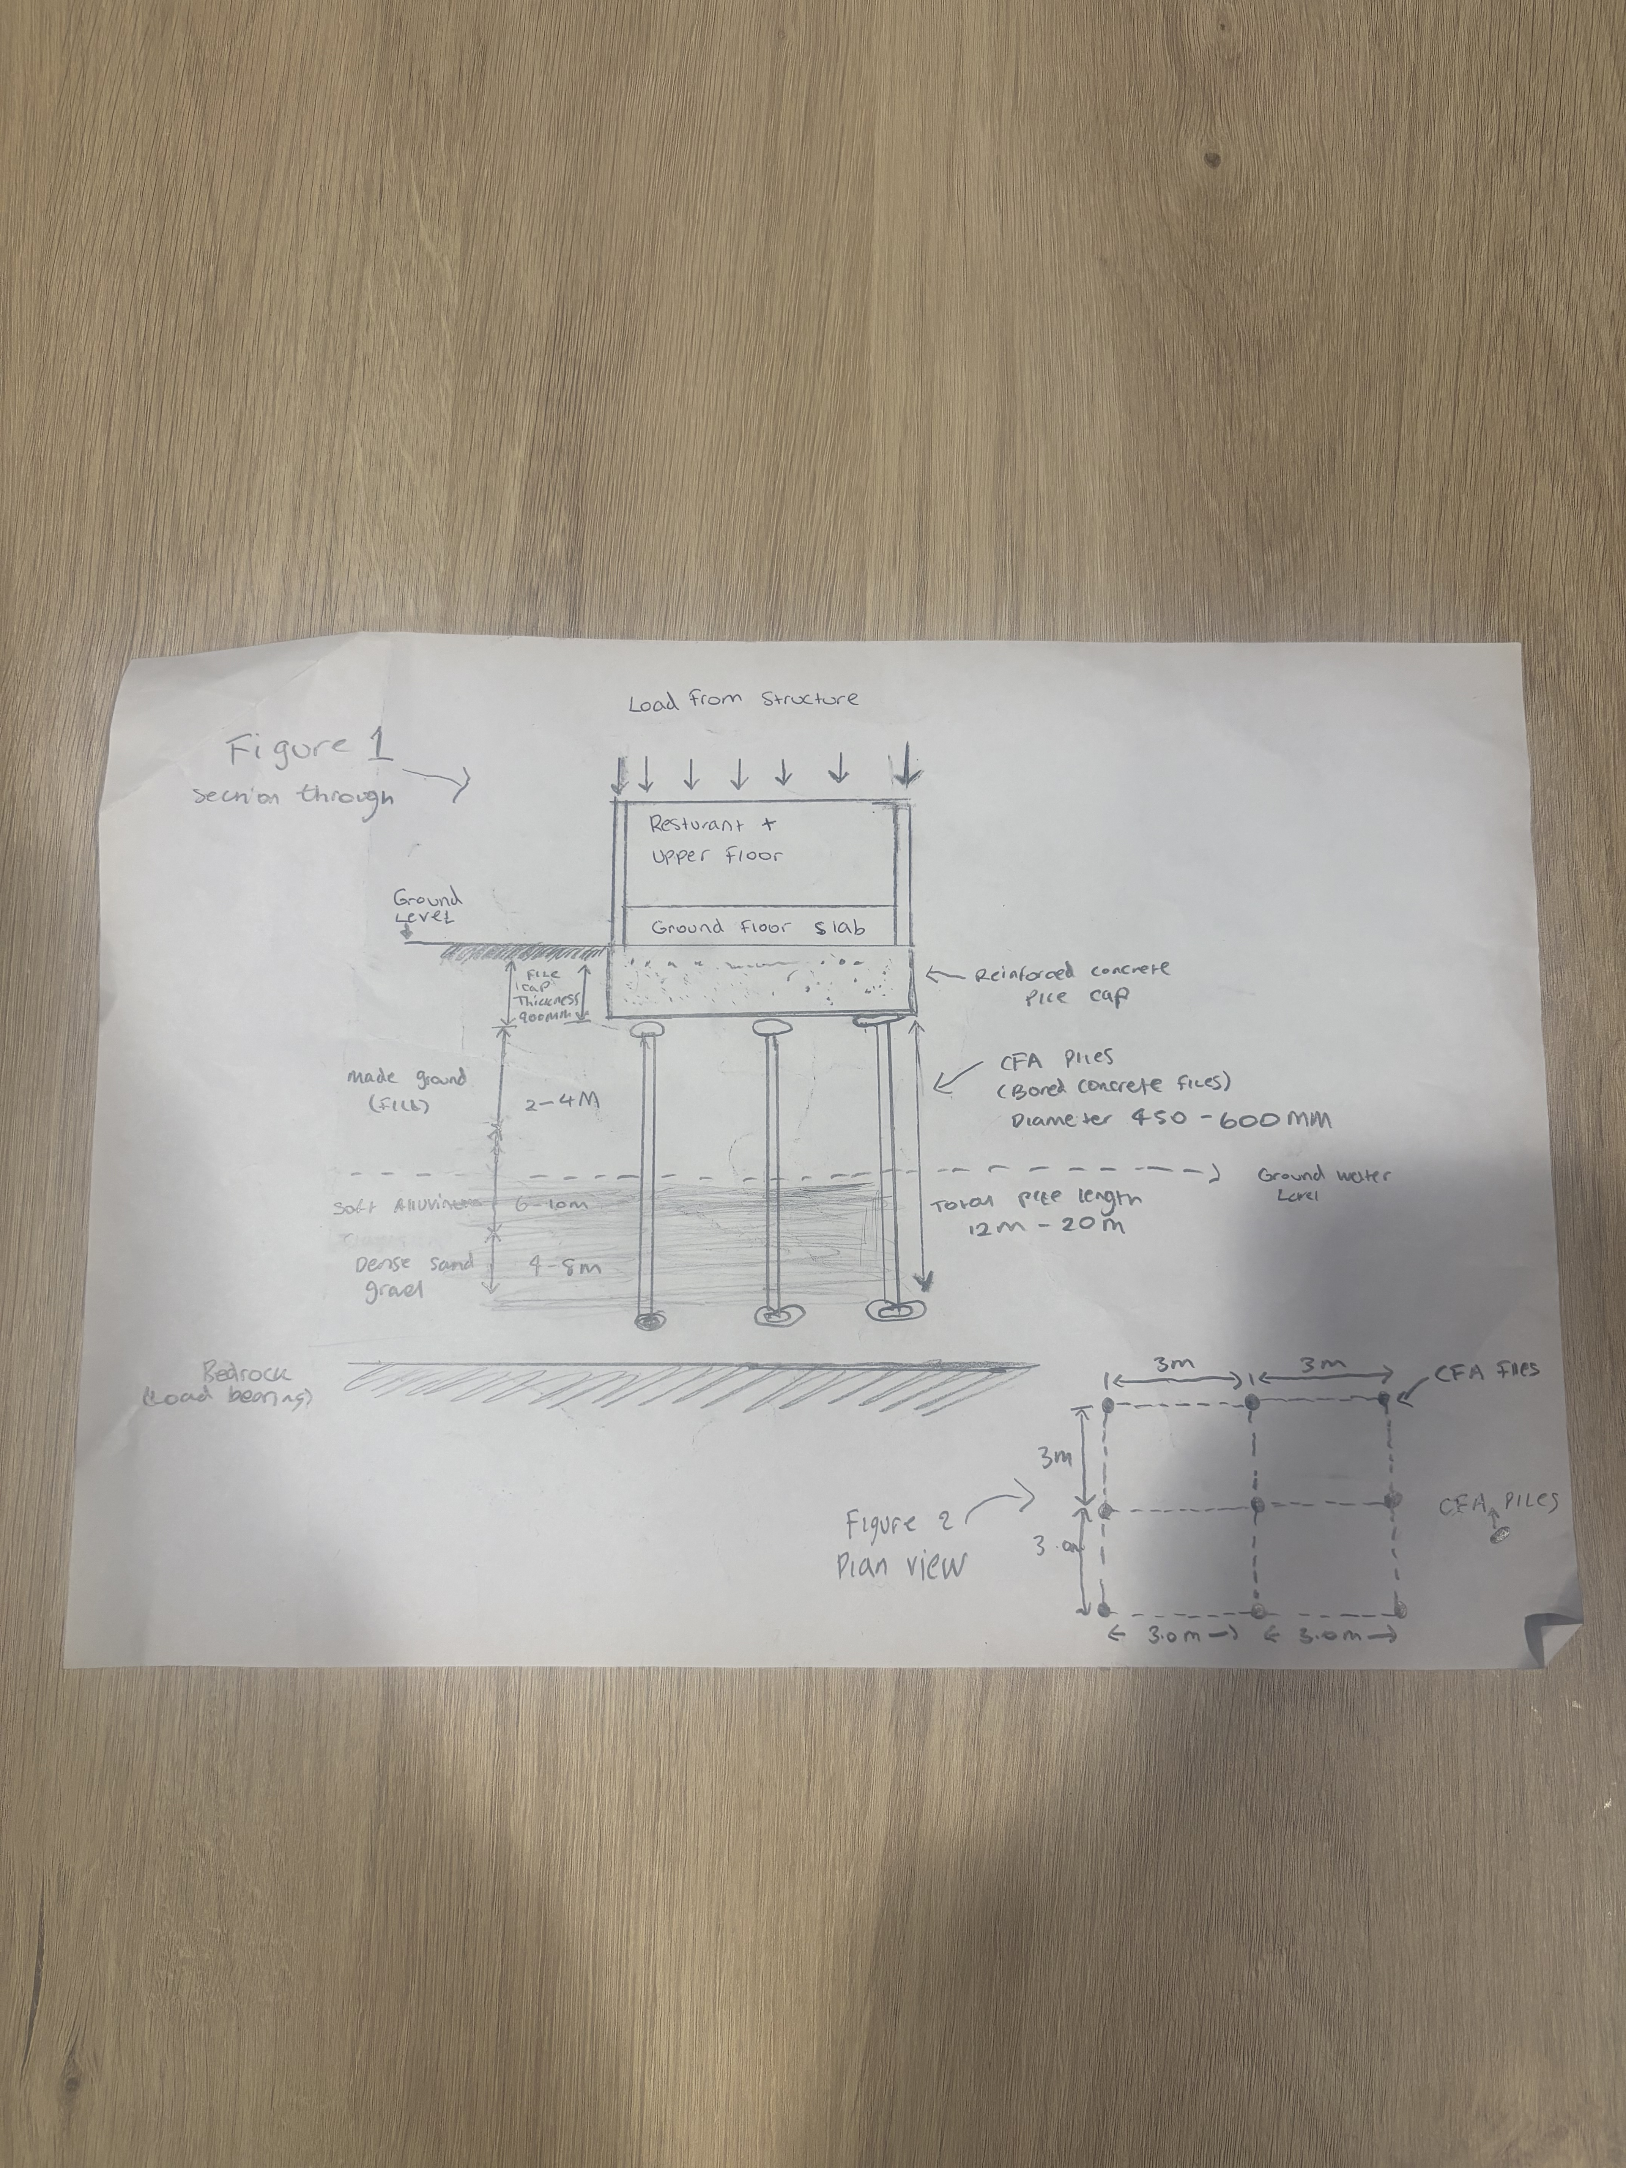
The proposed foundation solutions illustrated in figure 1 and 2 below

The Continuous Flight Auger (CFA) piled foundation system designed for the Swansea foreshore development. The section view in Figure 1 demonstrates how structural loads from the superstructure are transferred vertically through the ground floor slab into a reinforced concrete pile cap. The pile cap acts to evenly dividing loads across multiple piles, ensuring that load is not concentrated at a single point, therefore reducing the risk of differential settlement.
The CFA piles expand through the high lying made ground and soft alluvial deposits, which are identified as weak and highly compressible strata. These high layers are unsuitable for supporting weak loads directly due to their low shear strength and high settlement potential. As a result, the piles are designed to penetrate through these weak soils and transfer loads to deeper, more competent strata, such as dense sand and gravel layers or underlying bedrock.
The inclusion of the groundwater level within the drawing highlights the influence of tidal conditions associated with the site’s coastal location in Swansea. This is a critical design consideration, as elevated groundwater levels can reduce soil strength and complicate construction processes. The use of CFA piles is advantageous in this context, as they can be installed with minimal vibration and reduced groundwater disturbance compared to driven pile systems.
The plan view in Figure 2 provides an indicative layout of pile distribution beneath the structure, demonstrating how loads are spatially distributed across the foundation system. Regular spacing of piles ensures uniform load transfer and contributes to overall structural stability.

8.Conclusion:
The proposed development site on Swansea foreshore displays a range of geotechnical and environmental challenges emerging from its historical use and work natural deposits conditions. The presence of made ground underlying natural deposits contamination, soft alluvial deposits and high ground water levels necessitates an extensive site investigation in accordance with relevant British standards
Continuous flight anger piles are suggested due to their suitability for construction within sensitive urban environments. The most major risks relate to ground variability and settlement, which can be effectively mitigated via the use of deep piled investigation
A detailed investigation is crucial to confirm the preliminary findings displayed in this report and to brief the final design. With suitable planning investigation and engineering mitigation methods, the proposed development can be safely, successfully and efficiently implemented

The most substantial risk includes:
- Variable made ground
- Contaminated soils
- Compressible alluvial deposits
- High groundwater levels
Based on current evidence, a deep piled foundation system preferably continuous flight anger piles are the most appropriate solution ensuring:
- Structural stability
- Settlement control
- Comparability with surrounding infrastructure

References:

- BS EN 1997-1 Eurocode 7
British Standards Institution (2004). BS EN 1997-1: Eurocode 7 – Geotechnical design – Part 1: General rules. London: BSI.
- BS 5930
British Standards Institution (2015). BS 5930: Code of practice for ground investigations. London: BSI.
- BS 10175
British Standards Institution (2011). BS 10175: Investigation of potentially contaminated sites. London: BSI.
- Building Regulations 2010
UK Government (2010). The Building Regulations 2010. London: HMSO
BS EN 1997-2 - Eurocode 7 - Geotechnical design. Part 2: Ground properties
2179251
BS 5930 - Code of practice for ground investigations
Borehole that can be associated with Assignment.docx
CODE OF PRACTICE FOR GROUND INVESTIGATION 3.pptx

