Managing people assessment-2

Table of Contents
2
INTRODUCTION 3
TASK 3
Concept and drivers of employees engagement 3
Diagnostic tools to measure employee engagement in organisation 5
Constructs an employee value proposition including strategies to raise levels of engagement 6
CONCLUSION 9
REFERENCES 10

INTRODUCTION
Employee engagement is defined as the concept and efforts of organisation that facilitates employees to perform their defined work with efficiency and effectiveness to attain determined goals and objectives. It is essential part of human resource management process that describes the level of enthusiasm as well as dedication of organisational employees towards their defined job role. Proper and effective engagement of employees help organisation to attain the objective of growth and development and enhance employees job satisfaction and morale (Ababneh, 2020). Communication plays important role in maintaining relationship and engagement of employees towards business activities and operations and motivate them to attain higher working performance objectives in best possible manner. In this report the chosen organisation is Sainsbury which is the second largest supermarket chain of United Kingdom. The organisation is founded in 1869 by John James Sainsbury and headquarter situated in London, England, UK. Sainsbury serves its products and services in the area of United Kingdom through operating 1,428 shops. Organisation operates its operations with 111,900 employees. In this report concept and drivers of employee engagement and various tools to measure engagement of employees are discussed. Furthermore, strategies that raise the level of employee engagement are covered in this project report.

TASK

Concept and drivers of employees engagement
Employee engagement: Employee engagement is determined as the fundamental concepts as well as efforts that that facilitates organisation to understand and describe the nature of relationship between employees and organisation in both qualitative and quantitative manner. Engages employees are fully enthusiastic and have positive attitude and actions towards attaining organisational defined goals and objectives with efficiency (Amah and Sese, 2018). Sainsbury adopt the concept of employee engagement that enhance employees performance and their loyalty towards organisation. Respective organisation develop effective and positive working environment and engage employees in organisational decision making process through adopting their new, innovative and creative ideas.
If organisation engage employees in business decisions than it enhance their morale and retain them with business for longer period of time. On the other hand, if organisation do not engage employees them it impacts on their performance and longevity with organisation. As employees engagement is the emotional commitment of employees towards goals and objectives of organisation. Sainsbury implement various policies and strategies to enhance employee engagement with organisation because it provides various benefits to it (Gannon and Paraskevas, 2019). It plays important role in enhance employees productivity level, increase their satisfaction with job role and maintain higher employee retention rate with organisation that facilitates it to accomplish determined objectives with more efficiency.
According to case study, in the pandemic of Covid-19 Sainsbury organisation takes various measures that facilitates organisation to enhance the level of employee engagement such as respective organisation provide work from home to employees as well as flexible working hours. Furthermore, the organisation restructure the roles as well as follow various safety measures at workplace the improves employee engagement with operations and organisational activities. Respective organisation adopts various strategies to improve employee performance level and their well-being in organisation.
Drivers of employee engagement:
Drivers of employee engagement are defined as the items that impacts on employees engagement outcomes with organisation. Sainsbury adopts various things and maintain effective working environment that plays important role in enhancing employees participation and engagement towards organisational activities properly (Wells, 2018). Some drivers that are adopted by the respective organisation are mentioned below:
Inspiring leaders and team: Organisational team and leadership approaches plays important role in employee engagement. As respective organisation adopts democratic leadership style in organisation that engage employees in business decisions it enhance employees contribution towards attaining business goals and objectives in well-defined manner (Hamilton and Kaufman, 2019). Leaders are the individual who motivates, inspire and influence employees to perform determined activities effectively and motivate them to engage with organisation for long period of time.
Organisational working environment and culture: Effective and flexible business environment and culture is important for improving employees engagement with organisation. Sainsbury develops supportive working environment that enhance employees performance and their engagement rate through retaining them for long period of time. Leaders of Sainsbury supports employees and provide them clear direction that help to improve employee engagement rate.
learning and training opportunities: Employees retain with organisation, if there are various learning as well as development opportunities are exist that enhance employees various skills, competencies and capabilities which improve their working performance as well. Sainsbury provides work related training to employees that enhance their engagement and performance to attain determined goals with effectiveness. In the pandemic of Covid-19, respective organisation provides online training to employees that facilitates them to perform operations properly.
Rewards and recognition: If organisation provides rewards as well as recognition to employees for their excellent performance, it motivates them work with more efficiency and improve their contribution towards achieving organisational determined objectives (He, Chao and Zhu, 2019). Sainsbury allocate job role according to employees skills and capabilities that enables them to perform in best possible manner. For the efficient performance various rewards are provided to them that engage them for longer period of time with organisation.

Diagnostic tools to measure employee engagement in organisation
Diagnostic tools are defined as the technique that facilitates organisation to measure employee performance and their engagement rate in business activities and operations. There are various tools and techniques that are adopted by the Sainsbury to measure employee operations and their contributions towards organisational goals and objectives. As employees engagement is the most important aspect that facilitates organisation to attain the objective of growth and development. Respective organisation concentrates of engaging employees through implementing various strategies and planning. Some measurement tools of employee engagement are mentioned below:
Employee survey: Employee survey is the most effective tool and technique that is used by the organisation to get feedbacks of employees attitudes and feeling towards organisation. Sainsbury adopts employee survey to gain quick and effective feedbacks of employees. It facilitates organisation to measure employee engagement rate as well as motivates them to provide their ideas and concepts (Holland and Lee, 2019). There are two-way communication is adopted by the organisation to maintain engagement of workforce. Managers and HR of organisation conduct small, simple and actionable survey of employees to know about their work. Organisation develop set of questionnaire that facilitates organisation to find various employee factors such as their satisfaction level, alignment and future orientation.
Conduct exit and stay interview: As employees of organisation are leave at different point of time, so it is important for HR and manager of organisation to know actual cause of their exit. Sainsbury organisation conducts exist as well as stay interviews that enhance their understanding about which areas of organisation needs improvement to enhance employees engagement. Feedbacks of employees help organisation to improve specific areas and attract as well as retain employees. Stay interview facilitates organisation to know about their stronger areas that are the reason of engaging employees.
Evaluate employees productivity and retention rate: There are various factors such as employee productivity and retention matrix that help organisation to measure that how employees are engaged with business operations and activities. As engagement of employees directly impacts on employees retention and productivity matrix (Kaur, 2018). Sainsbury measures employees performance on regular bases and motivates them to retain with organisation. It is the effective tool that facilitates organisation to measure employees performance properly.
Conduct frequent meetings and focus on small groups: To measure employees engagement, respective organisation conducts continuous meetings in which employees directly interact with managers and allowed to share information and express their feelings freely. As Sainsbury is the multinational organisation which operates with number of employees so it formed various small groups of same department and ask them several set of questions to know their point of view and enhance their engagement with organisation.

Constructs an employee value proposition including strategies to raise levels of engagement
Employee value proposition: Employee value proposition is defined as the unique set of various benefits that are acquired by the organisational employees in return of their capabilities, skills, experience and their working performance towards organisation (Obuobisa-Darko and Domfeh, 2019). Basically, It is the promises of organisation or employer to employees in the return of their commitment. These promises included sum of various benefits as well as rewards that are received by the employees from organisation. There are various steps are followed by the organisation enhancing employee engagement with organisation. These measures are defined below:

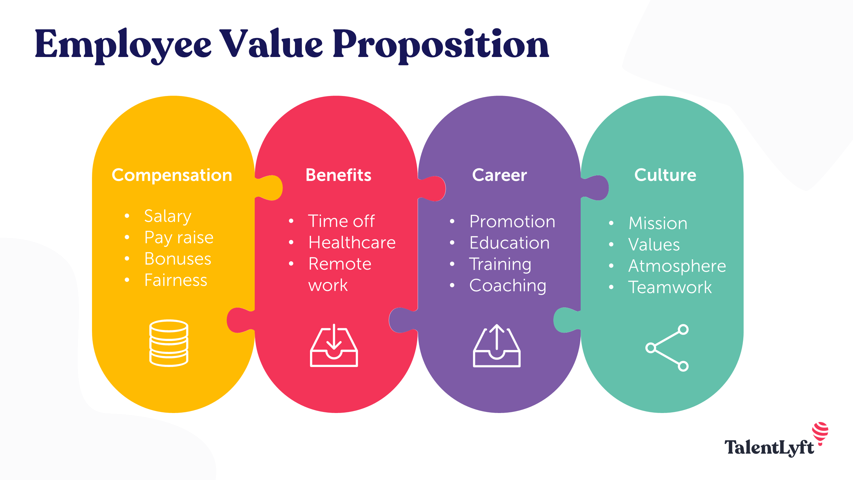Illustration 1: Employee Value Proposition (2021)
(Employee Value Proposition, 2021)

Compensation: For the purpose of constructing effective employees value proposition, organisation formulates effective compensation policies and strategies that work as the motivational factor for employees and enhance their engagement with organisation. Sainsbury maintains provides appropriate salary to employees and increment it on regular bases. For extra work organisation provides extra benefits and bonus to employees that inspire employees to perform determined operations with effectiveness.
Benefits: In the process of constructing proper employee value proposition, organisation provides various benefits to employees that work as a effective motivational factor and enhance their engagement with organisational operations (Shaik, Makhecha and Gouda, 2020). Sainsbury provides various benefits to employees other then their salary that retain them with organisation for longer period of time. If employees perform according to expectations or more then it then organisation provide extra benefits to them.
Career: It is the most important aspects for creating employees value proposition. Sainsbury provides various career development opportunities to its employees through training and coaching. Organisation promotes employees in superior department or job position that motivate them to retain with organisation and enhance their contribution as well as engagement towards attaining business goals and objectives.
Organisational culture and working environment: Organisational culture as well as working environment is the factor on that bases organisation construct its employee value proportion. Sainsbury maintain clear communication at work place and covey all mission, vision and objectives to employees. Organisation create the culture of teamwork that enhances employees engagement towards organisational operations and activities.
Strategies to raise levels of engagement:
There are various strategies that are adopted by the organisation to enhance employee engagement rate that facilitates organisation to achieve employee value proposition defined goals and objectives efficiently (Tucker, 2020). Sainsbury organisation implements various strategies as the manager of organisation employee value proposition is concerned with low level of employee engagement rate that impacts organisational viability. Some strategies that are executes by the organisation to deploy better engagement of employees with their defined work and organisation are mentioned below:
Communicate regularly with employees: For the purpose of enhancing employee engagement, organisation maintain regular communication with its employee. Sainsbury conducts regular meetings and conferences to communicate various organisational policies and strategies to employees as well as include them in organisation decision-making process that facilitates organisation to enhance their engagement level.
Invite employee fee employee value proposition and take actions: To improve employee engagement, Sainsbury adopt the strategy to get feedbacks on employees, listen them properly and take effective actions to resolve employees problems that motivates them to work in more efficient manner (Turner, 2020). Respective organisation conducts various online surveys in n the pandemic of Covid-19 to collect employees feedbacks and take immediate required actions to solve them.
Empower employees and recognise their work: Sainsbury provides conducts various training and development programme to empower employees that enhance various skills and capabilities in employees. These capabilities enable employees to perform in well defined manner and encourage them to achieve defined goals and objectives efficiently (Watson, Kuofie and Dool, 2018). Respective organisation recognised employees in meeting if they achieve expected benchmarks that enhance the level of employees engagement with organisation.

CONCLUSION
As per per above report, it can e concluded that engagement of employees plays important role in organisational growth and development. It the determined as the relationship between employee and organisation that motivates employees attain objectives of higher performance and productivity. There are factors such as organisational culture, working environment that influence employees to retain with organisation. There are various tools and techniques are adopted by the organisation like employee survey, reward, recognition, learning and development programmes that facilitates organisation to improve employees engagement rate. Furthermore Sainsbury adopts various strategies to enhance employees performance and engagement.

REFERENCES
Books and Journals
Ababneh, O.M.A., 2020. The impact of organizational culture archetypes on quality performance and total quality management: the role of employee engagement and individual values. International Journal of Quality & Reliability Management.
Amah, O. E. and Sese, E., 2018. Relational Energy & Employee Engagement: Role of Employee Voice & Organisational Support. Indian Journal of Industrial Relations. 53(3).
Gannon, J. and Paraskevas, A., 2019. In the line of fire: Managing expatriates in hostile environments. The International Journal of Human Resource Management. 30(11). pp.1737-1768.
Hamilton, I. and Kaufman, G., 2019. Approaches to managing older people using opiates and their risk of dependence. Nursing older people. 31(3).
He, H., Chao, M. M. and Zhu, W., 2019. Cause-related marketing and employee engagement: The roles of admiration, implicit morality beliefs, and moral identity. Journal of business research. 95. pp.83-92.
Holland, A. E. and Lee, A. L., 2019. Precision medicine, healthy living and the complex patient: managing the patient with multimorbidity. Progress in cardiovascular diseases. 62(1). pp.29-33.
Kaur, P., 2018. Mediator analysis of job satisfaction: relationship between servant leadership and employee engagement. Metamorphosis. 17(2). pp.76-85.
Obuobisa-Darko, T. and Domfeh, K. A., 2019. Leader behaviour to achieve employee engagement in Ghana: a qualitative study. International Journal of Public Leadership.
Shaik, F. F., Makhecha, U. P. and Gouda, S. K., 2020. Work and non-work identities in global virtual teams: Role of cultural intelligence in employee engagement. International Journal of Manpower.
Tucker, E., 2020. Driving engagement with the employee experience. Strategic HR Review
Turner, P., 2020. What Is Employee Engagement?. In Employee Engagement in Contemporary Organizations (pp. 27-56). Palgrave Macmillan, Cham.
Watson, M., Kuofie, M. and Dool, R., 2018. Relationship between Spiritually Intelligent Leadership and Employee Engagement. Journal of Marketing and Management. 9(2). pp.1-24.
Wells, K., 2018. Is Managing Getting in the Way of Leading?. Professional Safety. 63(3). pp.58-59.

Employee Value Proposition.2021 [online] available through:<https://www.talentlyft.com/en/blog/article/105/employee-value-proposition-magnet-for-attracting-candidates>

