
Postgraduate/Distance Learning
Assignment coversheet & feedback form

THIS SHEET MUST BE THE FIRST PAGE OF THE ASSIGNMENT YOU ARE SUBMITTING (DO NOT SEND AS A SEPARATE FILE)
For completion by the student:
Student Name: Deborah Harding
Student University Email: 2113339@student.uwtsd.ac.uk
Module code: HPCA7015  Module title: Foundations in Cultural Astronomy and Astrology | Student ID number:  2113339 |  |  | Educational support needs:  No
Assignment title: Essay based on a Sky Journal

Assignment due date: 2nd December 2021
This assignment is for the 1st 2nd 3rd 4th 5th 6th module of the degree
I confirm that this is my original work and that I have adhered to the University policy on plagiarism.
Signed …………Deborah Harding …………………………………………………
Email submission:if you are submitting this form via email, please tick this box □
(as a substitute for your signature) to confirm that you agree to the above declaration.
Assignment Mark
1st Marker’s Provisional mark
2nd Marker’s/Moderator’s provisional mark
External Examiner’s mark (if relevant)
Final Mark

NB. All marks are provisional until confirmed by the Final Examination Board.

For completion by Marker 1 :
Comments:

Marker’s signature: |  |  | Date:
For completion by Marker 2/Moderator:

Comments:

Marker’s Signature: |  | Date:
External Examiner’s comments (if relevant)

External Examiner’s Signature: |  | Date:

Essay based on a Sky Journal

Word count: 2094

Introduction
This essay has taken the quote, ‘To think is to walk among clouds’ and interwoven analysis of Sky Journal observations made at sunrise. I have responded to the quote on the basis of its dominant words ‘think’, ‘walk’, ‘clouds’. I made observations from 29th September to the 22nd October 2021. I am an age 60s white female. The location was the environs of a rural village in Suffolk, East coast UK. Until day 11, I watched sunrise from the edge of a ploughed field for approximately half an hour; subsequent days viewings were part of 2-mile walks. The research was documented using photography, written notes and Haiku (poetry).

Discussion
I began my observations tracking the changing position of sunrise on the horizon with photography. The following days saw this overtaken by imaginal and artistic responses. I became aware firstly of a powerful sense of ‘the archaic’; secondly of being inspired by sunrise’s illuminated cloud patterns; thirdly of a need for varying horizons, to walk and ponder; fourthly through review I began to be aware of underlying symbolism and personal meaning.

The Archaic
My initial days of sunrise found me stood quietly watching across a ploughed field as the sky grew light and the sun began to colour the clouds, finally to blaze through the distant hedge-line horizon (Figure 1). I found myself imagining how it might have been in prehistory for the local human inhabitants seeing the sunrise. Perhaps the sense of relief I too felt at the departing darkness and the return of the light and warmth? I became aware my sense of urging the sun into view on the horizon, and relief that it had done so! I wrote a haiku,
She climbs the skyscape
warmly my joyous senses
light my world within
Haiku emphasises the affinity between man and nature; its incomplete form invites a creative leap from the reader. Haiku was developed by Japan’s best known poet Matsuo Basho (1644-1694) and uses a 5-7-5 syllable pattern. I found writing haiku an immediate emotional relief, in the face of experiences sometimes difficult to comprehend.
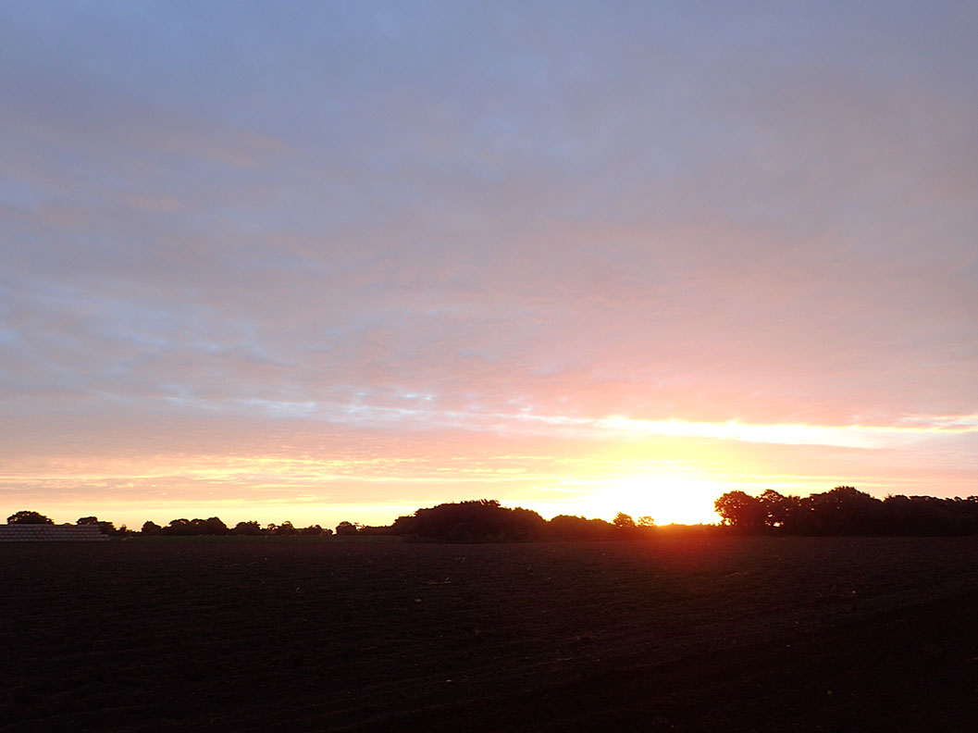
Past reading about local East Coast UK prehistory may have spurred me to imagine early humans’ experience of sunrise. A Landscape Partnership Scheme booklet looking at 2 million years on this coast tells of northern Europe’s oldest finds of tools at Pakefield, evidence of early humans. These finds are thought to be from over 680,000 years ago. This human species was likely to have been Homo heidelbergenisis, possibly the common ancestor of both modern humans and Neanderthal Man. North at Happisburgh the ‘oldest known hominin footprint surface outside Africa at between ca. 1 million and 0.78 million years ago’ was found on eroded and uncovered beach. I wondered the experience of sunrise for these early humans? Nicholas Campion, in response to the theory of biological body clocks writes,
Figure 1. Day 2, sunrise across field, 6.57am 30 September 2021. Photo: Deborah Harding.
. . . It is more likely though, that the very experience of living so close to . . . life and death, could have heightened Stone Age people’s wonder at the rising of the sun with its welcome light and warming rays’.
Was this Pakefield and Happisburgh’s early humans’ and their embryonic cultures’ responses to sunrise? I can imagine so. (I am here using the word ‘culture’ very loosely in the context of the second of Raymond Williams’ views of it, as a society’s ‘way of life’).

Illuminated Cloud Patterns
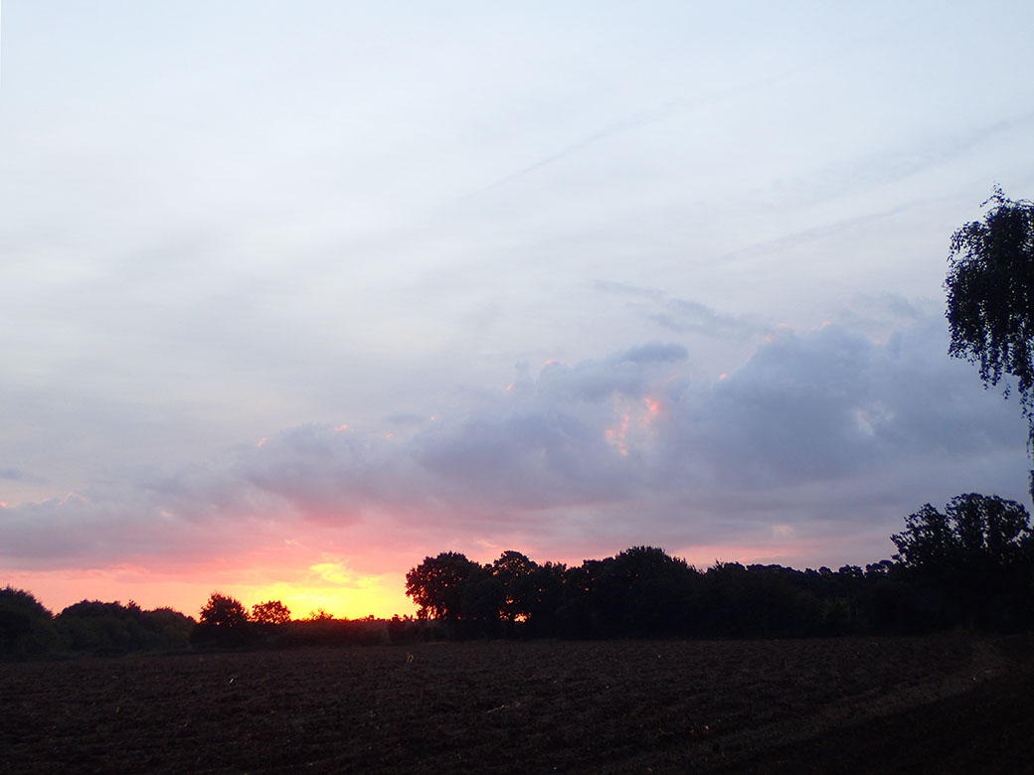
There were a number of mornings of captivating light and cloud patterns at sunrise. From my artistic perspective, clouds give intense visual interest to the sky and at sunrise catch the light’s colours in exciting ways (Figure 2, Figure 3, Figure 4, Figure 5).
Figure 2. Day 4, sunrise 7.00am 2nd October 2021. Photo: Deborah Harding.
An extreme example of cloud colourations and patterns inspiring and expressed in art was published in a paper by Svein Fikke and others, Screaming Clouds. The Norwegian authors researched the rare phenomenon of ‘mother-of-pearl’ clouds (nacreous clouds). In Norway, these have been observed and logged since 1871; they are mostly seen either just before sunrise or just after sunset, and are in the high stratosphere. In December 2014 some ‘spectacular occurrences’ over southeastern Norway led one author and photographer (Fikke) to associate what he saw with the iconic painting The Scream (1910 version) by Edvard Munch (1863-1944), which is visually illustrated in the paper. The authors describe and show photos of how the sky ‘almost ‘exploded’ into very strong and intense bands of colours, in red, yellow, blue and green . . .‘ The paper discusses their research into historic documentation of this phenomenon especially of Oslo in January 1890, Munch’s travel and known locations, his diaries and other writing by a painter colleague describing Munch’s emotions and his attempts to express and paint the sky he had witnessed and experienced. The paper gives an undated poem from Munch’s diary of 1890-92, including the lines ‘the sky suddenly became bloodish red . . . flaming clouds as blood and sword . . . I stood there shivering from dread . . . I felt this big, infinite scream through nature’. The paper explores the idea and argues convincingly that this rare cloud phenomenon led to Munch’s series of paintings associated with The Scream.
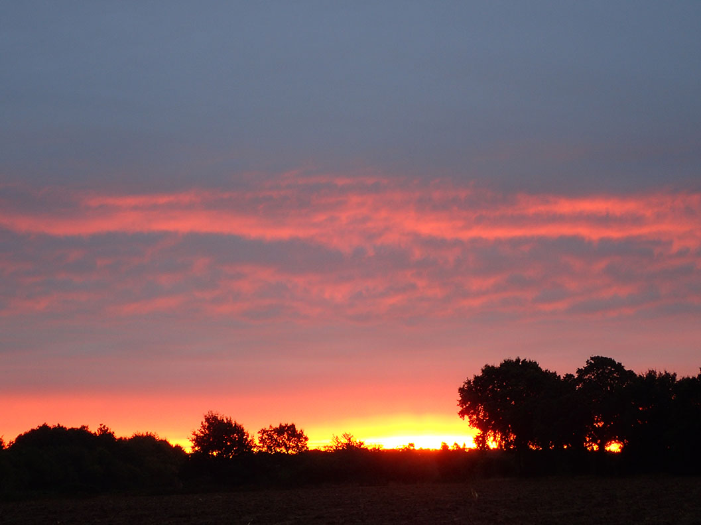
My cloud photo (Figure 3) shows sky drama to a considerably lesser extent, but none-the-less my experience felt fiery-red and a ‘worry’. Fikke and others, discuss the possible basis of Munch’s experience at some length, from what I feel is a too rational viewpoint. They begin, ‘Munch nor his friends could have had any logical reference to this dramatic phenomenon, which they had not seen before.’ Later they write, ‘. . . may appear as shocking and awe-inspiring to anyone who could not know what it was . . . I would suggest from my own lesser experience that Munch as an artist, was struggling with much deeper emotions than ‘logical’ and ‘not seen before’; that he was in touch with something of the primordial and almost inexpressible of the sky from within his own personal psychological artistic personality. His biography at the Munch Museum online says of 1889-1892, ‘He wants[ed] his art to be . . . stripped down to the existential states of the human soul’. (Museum quote no supporting citation). He did though eventually manage to make his experience visible for himself and others in his artwork.
Figure 3. Day 9, sunrise 7.02am 7th October 2021. Photo: Deborah Harding.
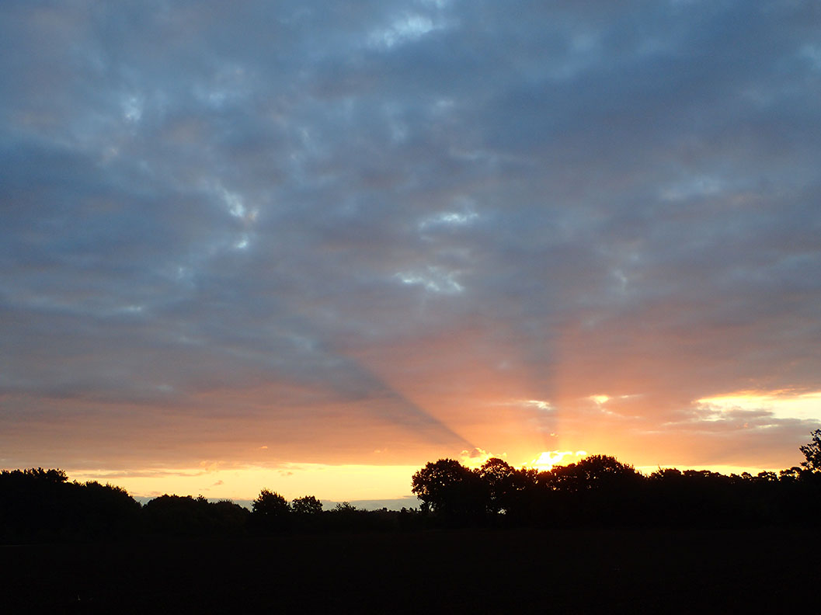
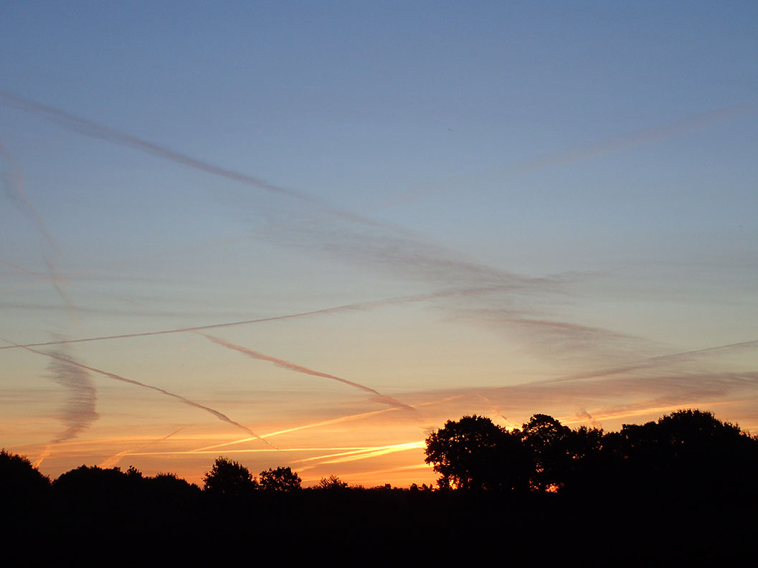
Figure 4. Day 15, sunrise 7.07am 13th October 2021. Photo: Deborah Harding.
Figure 5. Day 18, sunrise 7.29am 16th October 2021. Photo: Deborah Harding

Sky-Land Wider Horizons
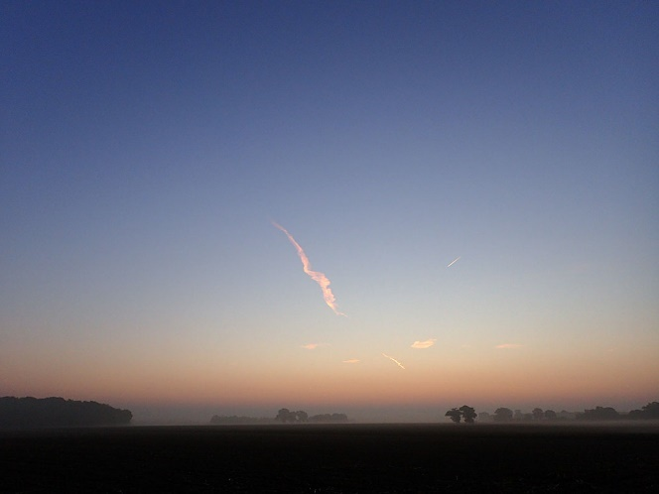
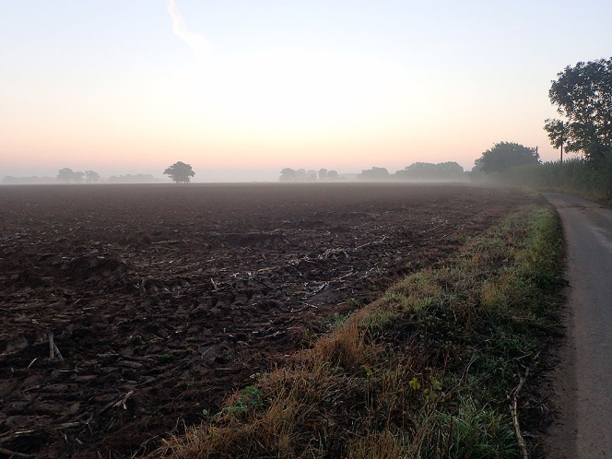
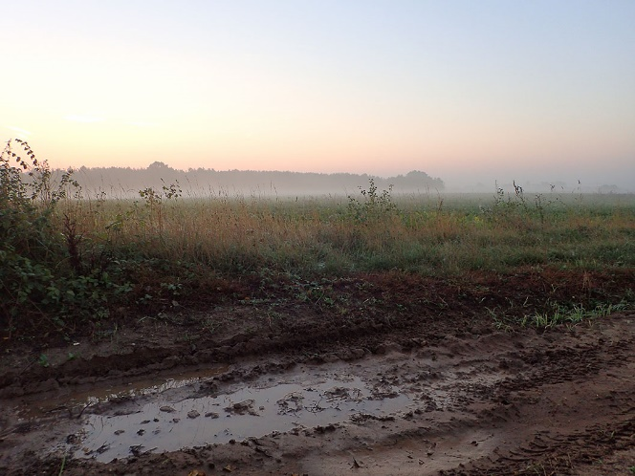
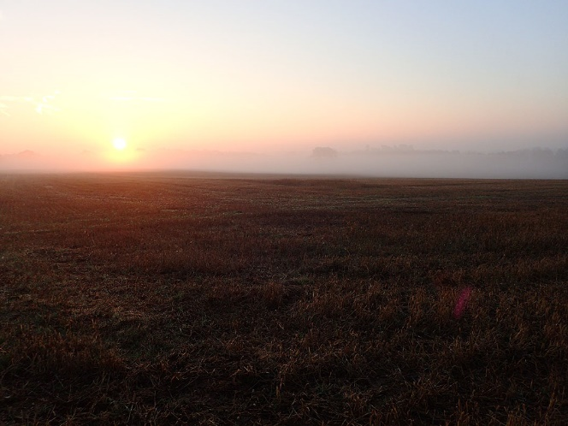
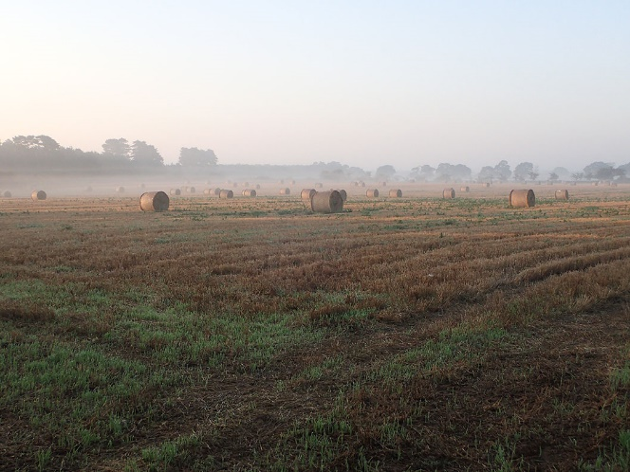
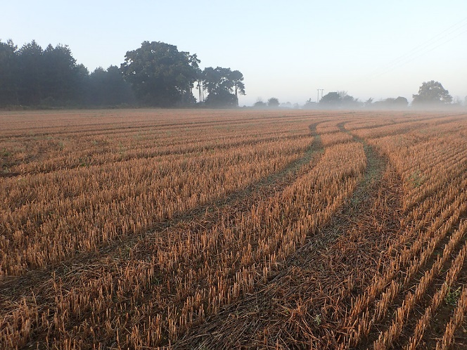
Day 11, of the Sky Journal promised to be another photogenic sunrise; instead of my usual viewing position I spontaneously walked my ‘lockdown’ route. This particular morning had its own quality. I was walking, writing words that came unbidden, photographing what I saw and felt deeply part of all about me; part of the divinity of the natural world (Figure 6). I had been rereading Adam Ford’s The Art of Mindful Walking. He says in his introduction, ‘Don’t set out to do some thoughtful walking. Just walk.’ Ford comments that thinking and walking have a long association, with written records emerging with the peripatetic philosophers of Ancient Greece. He continues, ‘there can be something spiritual about the simple physical activity of walking; it lies deep in the psyche of many religions.’ Ford explores the activity of walking as exercise of body and mind. He describes through practising mindfulness (attentiveness, alertness, awareness) ‘the feelings, thoughts, ideas and beliefs that make up the (sometimes clouded) landscape of my inner life’. He felt to be a ‘companion’ on my walks. That day’s photos expressed my need for the sky and land to be one ‘whole’.
Figure 6. Day 11, 2-mile walk sunrise 9th October 2021. Left to right and down, 6.56am, 7.03am, 7.16am, 7.27am, 7.38am, 7.53am. Photos: Deborah Harding
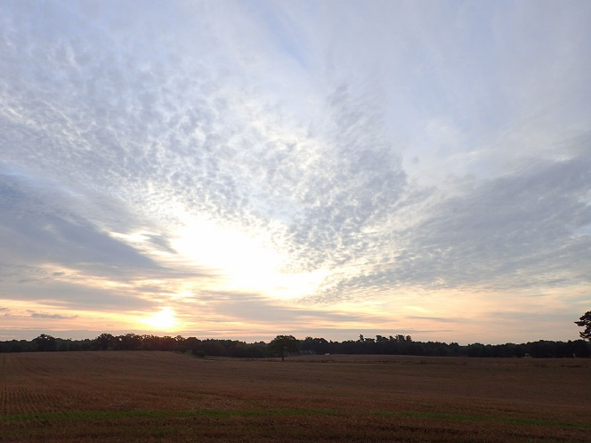
After day 11, I began to take full walks and included the big Suffolk landscapes and skies in the same photo (Figure 7).
Figure 7. Day 14. Walk, 7.47am 12th October 2021. Photo: Deborah Harding.

By day 21, I wrote:
I am finding meaning through the Sky Journal and have gradually arrived at a word I am perhaps coining? 'Wholescape'; not just sky, not just landscape but all of it, with the wide-open fields and big Suffolk skies.
The haiku that day,
Therein is meaning
I walk and meander thought
light shadow wholescape

Symbolism and ‘Becoming’
In my personal reflective writing I said,

. . . all can ‘become’, when the unconscious is allowed to work its own special magic. I ‘play’, avoid engaging the brain, and allow intuition its freedom; follow ‘my nose’. There is nothing deliberate, it is just what I do, I can’t say how. Nothing appears to be happening, until looking back I can see it has, and all the archetypes and symbolism jump up shouting, “look we’re here!” There is now a new sense of having personally shifted my ‘becoming’ to somewhere a few steps ‘on along the road’. It is quite without personal input; the ‘Gods’ have been at work!

This work has been an immersive, meaningful, solitary, creative process. I have begun to catch glimpses of the symbolic within the experience; of sunrise, ancient ancestors, light, horizon, journeying. C. G. Jung wrote in his definition of symbol that, ‘. . . it states or signifies something more and other than itself which eludes our present knowledge.’ And, a symbol,

. . . lives only when it is the best and highest possible expression of something divined but not yet known even to the observer. For under these circumstances it provokes unconscious participation. It advances life.

These ideas greatly resonate for me. I have experienced over the years this way I use art-making as perhaps within the idea of Jung's ‘transcendent function of the psyche’. He explained this concept as a reconciling of unconscious and conscious opposites through the middle ground of the symbol. ‘Function’ refers to multiple functions together; ‘transcendent’ refers not to the metaphysical but only that a transition is made.

Jung’s experience both with patients and through his own many years of creative work, led him to the idea there is a creative impulse in us all. He saw artists as the spokespeople for the unconscious of the collective, not only using art for their own ‘inner understanding’, but intuitively anticipating collective cultural changes. He wrote,

The creative process . . . consists in the unconscious activation of an archetypal image, and in elaborating and shaping this image into the finished work. By giving it shape, the artist translates it into the language of the present . . . Therein lies the social significance of art: it is constantly at work educating the spirit of the age, conjuring up the forms in which the age is most lacking.

The Sky Journal and essay has itself been imaginal art-making. I began to realise I was naturally seeking out humanity and aspects of its culture from within my Sky Journal experiences; the ‘ancestors’, Edvard Munch, and Adam Ford’s writing. Amongst all my possible underlying symbolism, for me what was surprisingly thrust into conscious illumination through opposites, is the need to live within a peopled, relational, communal, co-operative, world versus the world of divine solitude; to symbolically join sky and land, the divine and mundane, ‘heaven and earth’. Through this tension of opposites I sense future direction to find an exciting middle creative ground.

Conclusion
The Sky Journal observations in conjunction with the quote, ‘To think is to walk among clouds’, led to the imaginal and artistic themes experienced and discussed within in this essay; the archaic, illuminated clouds, and sky-land horizons. These are important themes for me, in which I ‘met’ in a manner of speaking ‘ancestors’ and imagined their lives, ‘met’ Edvard Munch and learned of his emotional life related to the dramatic skies he witnessed, and ‘met’ or was shown my need to not only have the divinity of sky nature, but for it to be joined to the divinity of land nature (Figure 6), and moreover the need to be living on the ground with people and community, in co-operative relationship. These are aspects of Man within his culture. These themes and this writing have taken me deeper to explore for the first time some of C. G. Jung’s primary source writing regarding the role of art-making and his concept of the ‘transcendent function of the psyche’ that can bring to conscious awareness through the tension of opposites and the symbolic, for both the individual and the collective. In this I sense future direction and purpose to find an exciting middle creative ground; joining my ‘heaven and earth’. This has been a meaningful piece of work involving artistic imagination initiated by the Sky, and Jungian symbolism to elucidate.

Bibliography
Ashton, Nick and others, ‘Hominin Footprints from Early Pleistocene Deposits at Happisburgh, UK’, PloS One, 9.2 (2014), e88329–e88329
Campion, Nicholas, A History Of Western Astrology Volume I (London: Continuum 2008).
Cunliffe, Barry, Wessex to AD 1000 (New York and Harlow: Addison Wesley Longman, 1993).
Fikke, Svein M, Jón Egill Kristjánsson, and Øyvind Nordli, ‘Screaming Clouds’, Weather, 72.5 (2017), 115–21.
Ford, Adam, The Art Of Mindful Walking (London: Leaping Hare Press, 2018).
Harding, Deborah, Sky Journal Digital Photographs And Notes, (personal computer file, 2021).
Harding, Deborah, Personal Reflective Writing (personal computer file, 2021).

Harris, Alexandra Weatherland: Writers & Artists Under English Skies. (London: Thames & Hudson, 2015).
Instagram, Deborah Harding (2021) <https://www.instagram.com/travellingdebb/> [accessed 8 November 2021].
Jung, C. G., H. Godwin Baynes trans., Psychological Types Or The Psychology Of Individuation (London: Kegan Paul, Trench, Trubner & Co., Ltd., 1926).
C. G. Jung, Collected Works of C.G. Jung, Volume 6: Psychological Types. Edited by Gerhard Adler and R. F. C. Hull (Princeton University Press, 1971) <http://www.jstor.org/stable/j.ctt5hhqtj> [accessed 18 November 2021].
Jung, C. G., Collected Works of C.G. Jung, Volume 15: Spirit in Man, Art And Literature. Edited by Gerhard Adler and R. F. C. Hull (Princeton: Princeton University Press, 1966) <http://www.jstor.org/stable/j.ctt5hhr2c> [accessed 18 November 2021].
Jung, C. G., Judith Harris, and Tony Woolfson, The Quotable Jung (Princeton: Princeton University Press, 2015).
Munch Museum, Edvard Munch Timeline (no date) <https://www.munchmuseet.no/en/edvard-munch/edvard-munch-timeline/> [accessed 1 December 2021].
Munch Museum, 5 Things You Should Know About The Scream (2021) <https://www.munchmuseet.no/en/the-collection/5-things-you-should-know-about-the-scream/> [accessed 1 December 2021].
Pilbeam, Mavis ed., The British Museum Haiku Animals (London: British Museum Press, 2010).
Project Gutenberg, EBook Of Poems New And Old By John Freeman (2004) <https://www.gutenberg.org/files/12026/12026-h/12026-h.htm> [accessed 12 November 2021].
Touching the Tide Our Guides, Tides Of Change: 2 Million Years On The Suffolk Coast (2021) <http://www.touchingthetide.org.uk/our-guides/> [accessed 10 November 2021].
Whittaker, John E and others, ‘The Earliest Record Of Human Activity In Northern Europe’, Nature, 438.7070 (2005), 1008–12.
Williams, Raymond, Keywords, A Vocabulary Of Culture And Society (New York: Oxford University Press, 1985).

Alexandra Harris, Weatherland: Writers & Artists Under English Skies. (London: Thames & Hudson, 2015) p245.
Instagram, Deborah Harding (2021) <https://www.instagram.com/travellingdebb/> [accessed 8 November 2021]; Deborah Harding, Sky Journal Digital Photographs And Notes, (personal computer file, 2021).
Instagram, Deborah Harding, posted 30 September 2021; Deborah Harding, Sky Journal.
Mavis Pilbeam ed., The British Museum Haiku Animals (London: British Museum Press, 2010) pp. 5-7.
Touching the Tide Our Guides, Tim Holt-Wilson Tides Of Change: 2 Million Years On The Suffolk Coast (2021) <http://www.touchingthetide.org.uk/our-guides/> [accessed 10 November 2021] pp. 6-7.
John E. Whittaker and others, ‘The Earliest Record Of Human Activity In Northern Europe’, Nature, 438.7070 (2005), 1008–12.
Nick Ashton and others, ‘Hominin Footprints from Early Pleistocene Deposits at Happisburgh, UK’, PloS One, 9.2 (2014), e88329–e88329.
Nicholas Campion, A History Of Western Astrology Volume I (London: Continuum 2008) p. 4; Barry Cunliffe, Wessex to AD 1000 (New York and Harlow: Addison Wesley Longman, 1993) pp. 69, 110.
Raymond Williams, Keywords, A Vocabulary Of Culture And Society (New York: Oxford University Press, 1985) p90.
Svein M Fikke, Jón Egill Kristjánsson, and Øyvind Nordli, ‘Screaming Clouds’, Weather, 72.5 (2017), 115–21.
Svein M Fikke, ‘Screaming Clouds’, p115.
Svein M Fikke, ‘Screaming Clouds’, p115.
Svein M Fikke, ‘Screaming Clouds’, p118.
Svein M Fikke, ‘Screaming Clouds’, p120.
Munch Museum, Edvard Munch Timeline (no date) <https://www.munchmuseet.no/en/edvard-munch/edvard-munch-timeline/> [accessed 1 December 2021].
Munch Museum, 5 Things You Should Know About The Scream (2021) <https://www.munchmuseet.no/en/the-collection/5-things-you-should-know-about-the-scream/> [accessed 1 December 2021].
Adam Ford, The Art Of Mindful Walking (London: Leaping Hare Press, 2018).
Adam Ford, The Art Of Mindful Walking (London: Leaping Hare Press, 2018) p. 7.
Adam Ford, The Art Of, p. 8.
Adam Ford, The Art Of, p. 9.
Adam Ford, The Art Of, p. 11.
Deborah Harding, Sky Journal Digital Photographs And Notes, (personal computer file, 2021).
Instagram, Deborah Harding, posted 19 October 2021; Deborah Harding, Sky Journal.
Deborah Harding, Personal Reflective Writing (personal computer file, 2021).
C. G. Jung, Collected Works of C.G. Jung, Volume 6: Psychological Types. Edited by Gerhard Adler and R. F. C. Hull (Princeton University Press, 1971) <http://www.jstor.org/stable/j.ctt5hhqtj> [accessed 18 November 2021] § 817.
C. G Jung, Judith Harris, and Tony Woolfson, The Quotable Jung (Princeton: Princeton University Press, 2015) p. 56.
C. G. Jung, H. Godwin Baynes trans., Psychological Types Or The Psychology Of Individuation (London: Kegan Paul, Trench, Trubner & Co., Ltd., 1926) p. 605.
C. G. Jung, Collected Works of C.G. Jung, Volume 6: Psychological Types. Edited by Gerhard Adler and R. F. C. Hull (Princeton University Press, 1971) <http://www.jstor.org/stable/j.ctt5hhqtj> [accessed 18 November 2021] § 819
C. G. Jung, H. Godwin Baynes trans., Psychological Types Or The Psychology Of Individuation (London: Kegan Paul, Trench, Trubner & Co., Ltd., 1926) pp. 607-610.
C. G. Jung, Collected Works of C.G. Jung, Volume 6: Psychological Types. Edited by Gerhard Adler and R. F. C. Hull (Princeton University Press, 1971) <http://www.jstor.org/stable/j.ctt5hhqtj> [accessed 18 November 2021] § 823-828.
C. G. Jung, Collected Works of C.G. Jung, Volume 15: Spirit in Man, Art And Literature. Edited by Gerhard Adler and R. F. C. Hull (Princeton: Princeton University Press, 1966) <http://www.jstor.org/stable/j.ctt5hhr2c> [accessed 18 November 2021]. § 115.
C. G. Jung, Collected Works of C.G. Jung, Volume 15: Spirit in Man, Art And Literature. Edited by Gerhard Adler and R. F. C. Hull (Princeton: Princeton University Press, 1966) <http://www.jstor.org/stable/j.ctt5hhr2c> [accessed 18 November 2021]. § 115.
Raymond Williams, Keywords, A Vocabulary Of Culture And Society (New York: Oxford University Press, 1985) p90.
Instagram, Deborah Harding (2021) <https://www.instagram.com/travellingdebb/> [accessed 8 November 2021]; Deborah Harding, Sky Journal Digital Photographs And Notes, (personal computer file, 2021).
Alexandra Harris, Weatherland: Writers & Artists Under English Skies. (London: Thames & Hudson, 2015) p245.
Raymond Williams, Keywords, A Vocabulary Of Culture And Society (New York: Oxford University Press, 1985) p90.
C. G. Jung, H. Godwin Baynes trans., Psychological Types Or The Psychology Of Individuation (London: Kegan Paul, Trench, Trubner & Co., Ltd., 1926).
C. G. Jung, Collected Works of C.G. Jung, Volume 6: Psychological Types. Edited by Gerhard Adler and R. F. C. Hull (Princeton University Press, 1971) <http://www.jstor.org/stable/j.ctt5hhqtj> [accessed 18 November 2021].
C. G. Jung, Collected Works of C.G. Jung, Volume 15: Spirit in Man, Art And Literature. Edited by Gerhard Adler and R. F. C. Hull (Princeton: Princeton University Press, 1966) <http://www.jstor.org/stable/j.ctt5hhr2c> [accessed 18 November 2021].

