Mandy Lawrence
Student number: 1811876
Module number: BMSK4005
Module Title: Professional career development

Date submitted: 30/11/2018
Time submitted:

Contents
Introduction…………………………………………………………………………………………………………………………2
  - Own learning style(s) and the learning style(s) of another member of the team…………….3
  - A simple technique for identifying own development needs and the development needs
of another member of the team………………………………………………………………………………….….3,4,5
1.3 identification of my personal barriers to learning, and how they can be overcome……. 6,7
1.4Learning/development option for myself and team member…………………………………………..7
1.5Support mechanisms for myself and team member………………………………………………………7,8
1.6 development plan to achieve a learning objective for myself and team member........…8,9
  - description of a development monitoring for myself and team member………………………..9
References……………………………………………………………………………………………………………………….9,10
2.1 appendix 1…………………………………………………………………………………………………………………………..13,14,15,16
2.2 appendix 2…………………………………………………………………………………………………………..…..17,18
2.3 personal reflection on interview process and techniques…………………………………….10,11,12

Introduction
This assignment will show you insight into how u can learn about your learning styles, how you best intake information and how you will receive it in a way where it makes sense and its understood. It will show you barriers to work/education how you can identify what potential barriers you are at risk with and how you can overcome these. It will also give you insight into how you can identify learning needs and development by using simple techniques and then being able to use these needs by searching out ways of improving these threw self help or available help threw work/teachers. It will also cover how these can been looked at and assessed threw a personal development plan (PDP) and then how your development can be monitored with regular one to one progress reports.
It also covers the recruitment process from and employee and an employer perspective, how u found it from both sides of the desk. how you would change things if you were the interviewer. It will show you a current job application form with a covering cv letter and a job focused cv
1.1 own learning style(s) and the learning style(s) of another member of the team.
Learning is important for us for growth and change, but to understand how we are best going to learn we use several different tools to understand better which style of learning is for a certain individual.
There are 3 learning style questionnaires that I completed.
When using the honey and Mumford tool on my scores it showed I was a reflector, this shows I take more in while listening and sharing, standing back and observing, thinking before I do anything.
In my second tool dantec I was able to discover from my answers that I was a type 4 learning: the dynamic learner. This shows I like to make my own discovery with trial and error, also interacting with team members and peers. And work best with more hands on work, or independent work.
In my third tool vak learning style I discovered I was a kinesthetic learner which again shows I’m better with physical experience, after spectating I’m very hands on.
In comparison to a colleague she is a theorist in honey and Mumford and vak learning style she was a visual.
On comparing the two results I would myself sit and watch and take more notice if my learning was group based and open chat while having paperwork to reflect on, where as my colleague would work better thinking things threw rather than group discussions and tends to work better on her own. My colleague would gather large amounts of research and facts and plan and organize ahead, where as I would be slow off the mark in induvial work and get easily distracted.
This is vitial to know how each person learns so that they take in what is being delivered, I myself wouldn’t leant threw book and computers alone I need interaction and demonstrations in order to receive the information better.

1.2 a simple technique for identifying own development needs and development needs of another member of my team.

To identify my own developments needs and needs of a team member I would carry out a swot analysis. This will identify what I’m good at, and maybe not so good at and what problem areas I and my team member have.
Strengths: what I’m good at, how I can contribute towards my team, and what I can do that someone else cant.
Weaknesses: what can hold me back, what needs improving.
Opportunities: chance of a better job, career progression or even self-employment.
Threats: lack of skill level, change of industry needs.
My swot analysis
Strengths  time keeping  confident  creative  adjustable | Weaknesses  IT skills  Evidence gathering  Over thinking  Essay writing  Confidence
Opportunity’s  Progression in your job  Extra training | Threats  Other work colleague with more knowledge and skills

Swot analysis for my team member
Strengths  Computer skills  Higher education  Rational | Weaknesses  Communication skills  Confidence  Time keeping
Opportunity’s  Progression within my work place and to move further up the ladder within the company | Threats  Someone who is able to work with people on a one to one basis better than myself

These internal development needs myself and my team member can work towards by turning our weaknesses into our strengths by developing them and our strengths can then become our opportunities to develop within our role or company. Our threats also become our opportunity’s.

Another system available would be The joharii window

Behavior  Personality, skills  Verbal/written communication  Appearance, looks  interests  (arena) | Bad habits  How others perceive us.  Body language  Bodily odors  (blind spot)
Confidence levels  Fetish preferences  Ambitions and dreams  Fears/true capability  addictions  (façade) | Instincts /reactions  Limits  Future, job/health  (unknown)

Known to self not know to self

Known to others

Not known to
others

This is mostly subjective, what we can tell about ourselves, for our not know to self we could ask others what they think. This is were u will better understand your self-awareness.

Also, is the go mad thinking system, it’s a framework table where u can define your goal, what u want help with and why. Then work out what your personal responsibilities would be and how u can involve others and how u can then take action and measure results, so this is a way of finding your development needs and also a table to check on for progression. This has greater efficiencies and productivity increases by up to 427% I just 100 year as quoted from the go mad thinking web page

1.3 Identification of my personal barriers to learning, and how they can be overcome.
To identify my barriers, I would need to evaluate and list my barriers in two sections.

What barriers will myself and team member personally face, travel? Childcare? Commitment? Motivation?
- External: family, no car or travel is difficult. Whether you dependent on others i.e. travel, child care, money

- Internal: skill levels, low self-esteem, level of knowledge, perceived abilities, disability, attitude, and behavioral

My personal circumstances I drive but on doing research I can get on a bus that runs every 10 minutes and takes me from my front door to my work place.
Childcare: as I have 3 dependents and a single mother this was another aspect I had to take into account, but I was able to sort this with my mother and her speaking to her employer we were able to cover the times and days needed.
Lack of computer skills: this was and still is another factor for me as my computing skills arnt upto date but on doing research I was able to enroll onto a computer course but will be start in January.
Only other barriers would my personal commitment and social life factors, but I also know why I want to do this course, I know I want to better myself and I know how long it will take, I know what I need to do it, and I also know what the end result will reward me with.

My team members barriers, she drives but also lives local so would be able to get a bus
She has children but there grown up so not dependent on her.
She works but was able to speak to employer to make sure she can leave at certain times to have full commitment.
She participates in extra curriculum activities but won’t interfere with her days or commitment.
She is very confident with computers and working well with others and is committed as she knows the benefits at the end.

1.4 learning/development option for myself and team member
When surveying mine and team members swot analysis I have taken two learning and development needs for both of us to look at.
My personal development needs would be my lack of computer skills, as most tasks are undertaken via computers i.e internet searches, essay writing, evidence gathering, general day to day work jobs. My knowledge on this subject is very slim. This can impact on me greatly in everyday tasks and my overall performance. If I was to go for promotion or progression this can hold me back greatly.
Also my lack of confidence which comes with lack of experience and knowledge, this again will impact me greatly as to be a superior I have to be confident in what I say and do, this is something that would need to be developed
learning and development needs for my team member would be lack of communication skills this would impact every day in work, being able to talk to others and being able to verbally give direct specific orders of jobs or tasks needed, this would also impact on job progression and could be an everyday problem.
The team member also has lack of confidence which will show in everyday jobs, you need to execute all jobs and direct contact confidently, also being able to speak to peers and colleges directly and confidently.

1.5 support mechanisms for myself and team member
on reflection of both mine and team members learning and development needs support available could be in two options in house support or outside.
My lack of i.t and computer skills could be helped with a placement in house with an it department or even buddying up with someone for a few hours a week for help. This could be done in a long term amd long term goal.
Could also apply for it courses out of work or threw work as extra help.
Also my lack of confidence is a personal thing so team building days which would help, my lack of confidence will also come from my lack of knowledge so improving on my development needs will confidence also
My team members lack of communication skills could be helped with team building days also and possibly, if there given maybe a job to do where they have to go around maybe once or twice a day to possibly do the sales check count to get her to interact with her colleagues more.
Team members Confidence can be helped in house with

1.6 development plan to achieve a learning objective for for myself and team member
when looking at a development plan we need to make sure that they are smart, meaning
- Specific – so the exact development need
- Measurable – how we can develop it
- Achievable – is the plans achievable
- Realistic – its able to be done
- Time based – given a time of completion.

Pdp for myself
What do I want/need to learn | What will I do to achive this | What resource4s or support will I need | What will my end goal be | How will it be reviewed
Complete a computer course to advance my development needs | Research and enroll on a course | Access to a computer and maybe shift working patterns to attend classes | To confidently be able to navigate round a computer and be able to progress in wok | Monthly reviews to check the progress and too see if any support is needed

Pdp for team member
What do I want/need to learn | What will I do to achive this | What resources or support will I need | What will my end goal be | How will it be reviewed
Complete a assertiveness course, covering confidence and communication | Research and enroll in a local class | Possible shift changes | To be able to communicate confidently with team members | Weekly reviews to see if support is needed

1.7 description of a development monitoring for myself and team member
when there is pdp in place this is then a visual aid for your development needs so an easy and affective way to monitor this ie with weekly/fortnightly/monthly reviews. Sitting down reviewing progress checking development and reviewing if there is any help that can be offered
my pdp monitoring could take place every 4 weeks as the course last 6 months and only happens 2 hours a week so weekly wouldn’t really be effective. Sit down goo over improvement and see if anything can be done in work place to help once abilities have started to change.

My team members pdp monitoring would be weekly as her course is only 6 weeks long, again monitor the progression and changes and see how she is getting on and if we can help at all.[

References

Luft,j and Ingham. (1955) the Johari window,
Honey and Mumford. (1986) the honey and Mumford learning skills
Fleming, n. (1987) vark learning styles
Diourri,m and goodchild,L and dantec,C. What is your learning style? University of Southampton.
Gilbert,A and Chackrovaity,I (2001) go mad: about coaching. bath

2.1 appendix 1
2.2 appendix 2

2.3 Reflection upon recruitment interview process and techniques.
When applying for my last job interview it was an over the phone interview then followed up with a face to face interview. I went smartly dressed, knee length skirt, white blouse. Short heel shoes and light makeup, I wanted to look current, smart, and approachable. i arrived a little early. When It was my time, I was called into an office it was a one on one interview, the interviewer was across the desk to me, the gentleman was middle aged, and I was surprised he was taking the interview, The job I was applying for was a sales customer advisor on a busy department stall selling a well-known makeup brand. I was aware of their products and prices and aware of the brand, as im a loyal and repeat customer of theirs. But I was asked to sell the gentleman a pen, he placed the pen on the Table and asked me to sell it to him. After I gave him by best sales pitch explaining why this pen was better than any other pen he had ever used, and it was cost effective as it lasted longer and was good for the environment. After this I was asked why I would be a valuable team member, I in brief gave him my knowledge on their brand and their products I explained how they worked and how I believed in what they sold. Then he asked me my facts on the business that I hadn’t really researched properly, all very accessible at a click of a button on the world web. I wasn’t that prepared as I thought. In the whole interview I wasn’t asked about my experience with customers if I could work on a one to one basis if I was good at interacting with others, I was only asked about my sales skills. I was told a week later I hadn’t received the job, I was upset but I knew when I left id let myself down by not checking on the business facts and figures. I heard back from them about 10 days later to say unfortunately at this time I was unsuccessful.
I found the whole process a bit bizarre. If this was my business and I was doing the whole recruitment process I wouldn’t ask for a job application form, I find most job applications forms are a general form and doesn’t really give u a sense of character or deeper knowledge and as this is working with the public and you have to sell the brand this wouldn’t work effectively. If you refer to appendix 1 I previously applied for a job In sales management and my covering letter and application form for the job that I was applying for it was more of a general application like a standard template. I would advertise the job post threw job centers, online and social media where more younger people would look as this, also maybe advertise on LinkedIn by having a job advert u can specifically say what your looking for, what the applicant needs, there flexibility requirements and what u can offer, pay, training, bonuses and incentives. And make the advert personal to the job role, again this well help you streamline potential and non-potential applicants. You can then ask for a full up to date cv be attached see appendix 2 this again can then show you their name you could search them up look at LinkedIn or Facebook see how their profile fits the business. There education what they achieved if it would help towards there application, if they have any further experience again that would fit in, if they could work towards progression. It will also include in the list of everyday tasks what you have done and capable of doing which will be a tick list of what an employer wants and needs showing you already capable of doing this. Also, there hobbies if they say socializing this could be someone who likes to go out a lot this could be a potential problem. See if the hobbies outside benefit work at all, ie exercise staying fit etc.. And also, reference details you can contact. A job focused cv is very important instead of a general cv as it will tell the employer that you have worked in this environment and what your already capable of which shows them, they don’t have to cover these areas as there already covered.
When it then got to my interview stages after narrowing down the applicants from the cv and job application stage I myself would do the interviews or someone who was aware of the products and could use them, someone who would go to a stand and buy it and know what its like and how it would best be sold. For myself the customer service part is just as important as the selling side, I would want some one who can interact and work well with the public, so my interview also wouldn’t be in an office. I myself would take the interviews in the work environment meeting maybe in groups or 3 or 4 giving them a product each and then asking each person to demonstrate how each product works, the benefits. And see who shines out from the small group. Who works better with outward speaking who is better at interacting and who’s confident and then you can also see who knows your products and business. I would do these small groups every hour I believe interviewing in your environment and with the products that u will be selling will show you more about the applicant as its relevant and u will see them more natural. Out of each group I would eliminate who I thought wasn’t what we wee looking for and for who got threw that process I would ask them to come back later on and have one to one sit downs to again narrow it down to my chosen few who I believe could do the job efficiently and also there personality’s would suit the job and current work force in place.

The whole advertising and job recruiting have to be fast and efficient, so by evolving with the changing times, u wouldn’t no longer advertise a job in a news paper u would advertise where it will be seen most and by the market your looking for. Nearly all job applications are done by internet searches online job applications as no one walks round giving out cvs anymore. Once u have the initial online applications and cvs and u can narrow it down by looking threw and seeing how many matches your skills needed. Once it then comes to the interview process by seeing a number of groups in small sizes again you are being effective to see who shines out in each group in the work environment and by holding one to one interview the same day once you illuminated the people not best for the job again this is cost effective. I strongly believe by holding the interviews in the work environment u can be a better judge on who would work better in the role.

Appendix 1

Hi I’m mandy. I’m applying for the job of the sales manager as I have past experience in this job, with extensive knowledge of your products and business, I’m a loyal customer and would be a valuable member of your team.

 Trade fitters' domestic windows
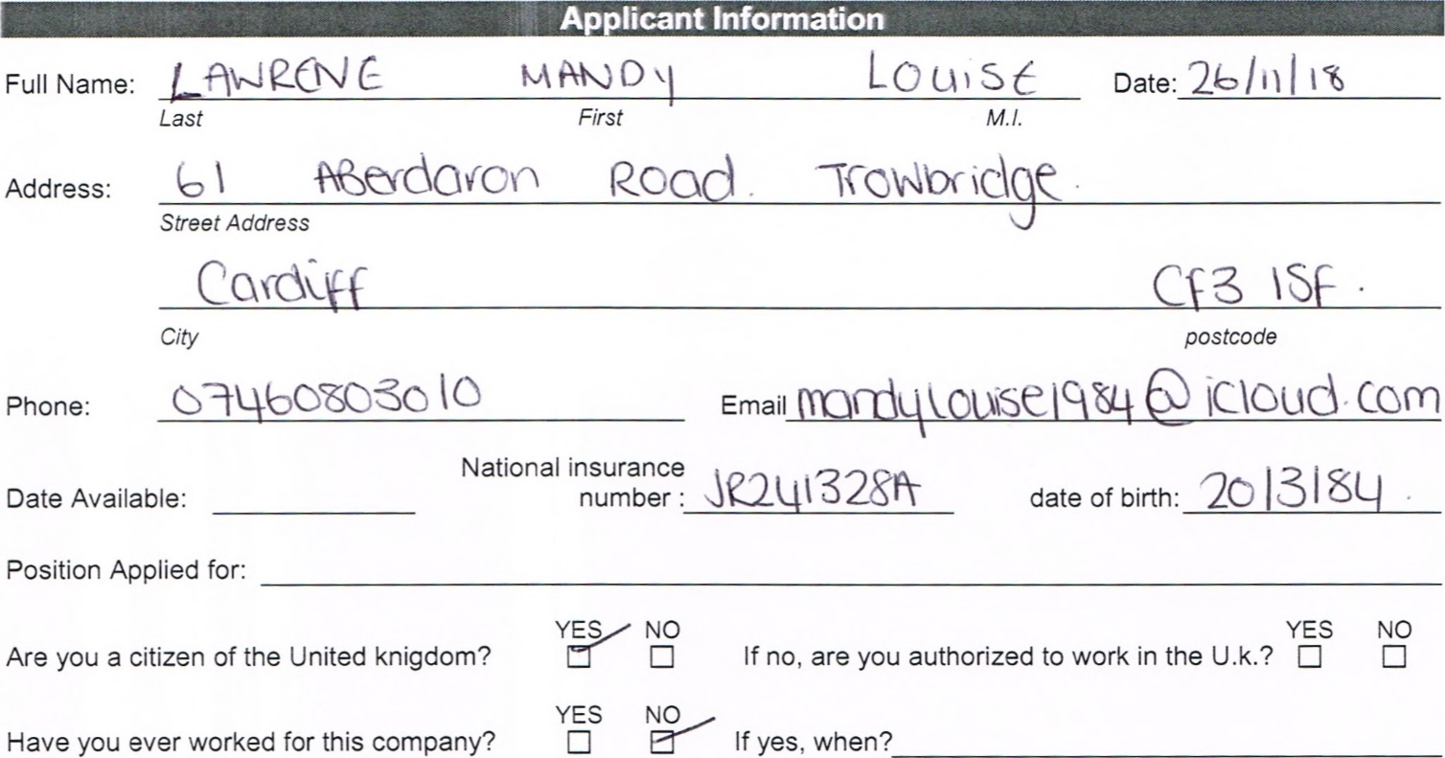
Have
yes,
Sales
manager
application
YES
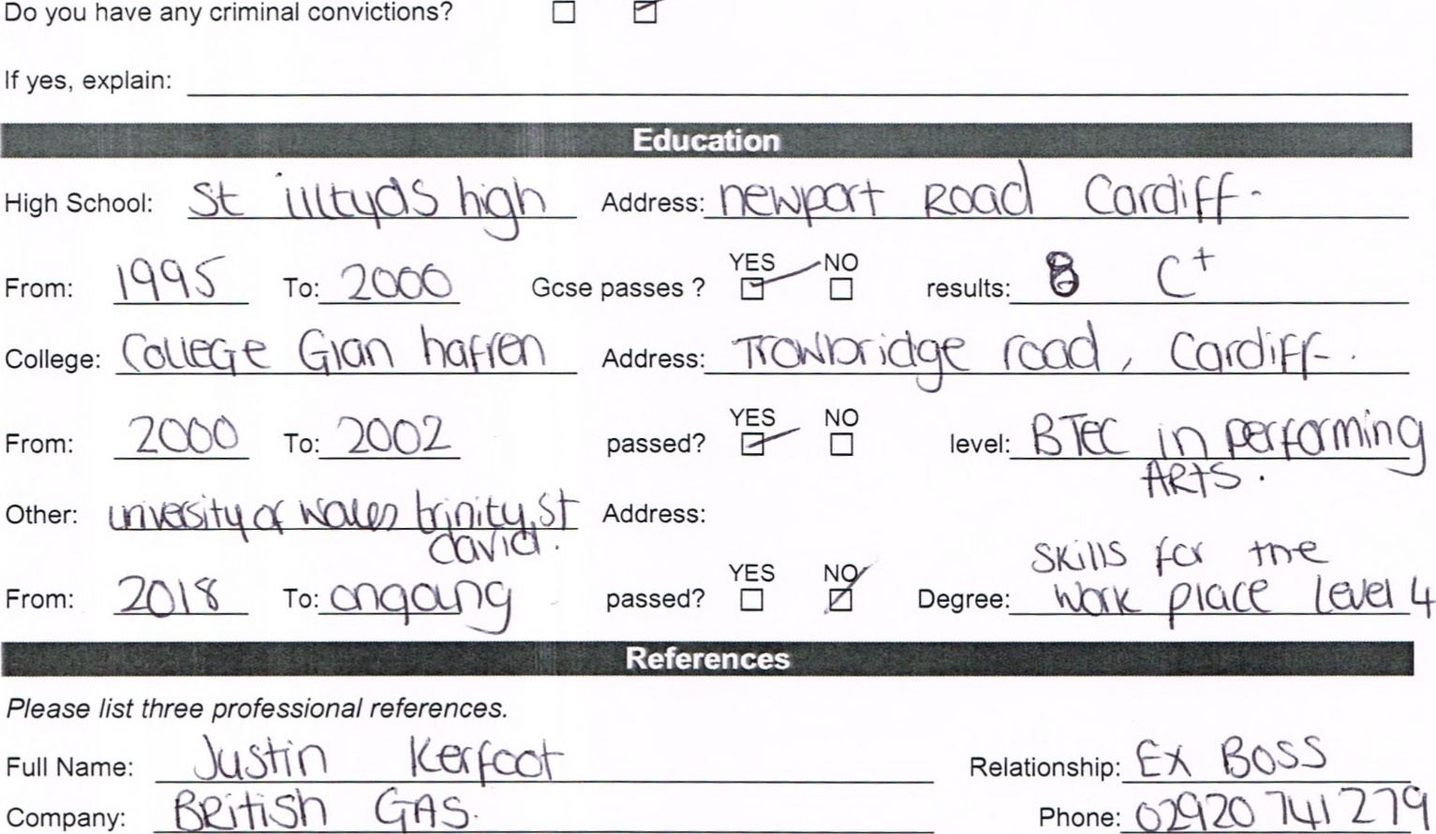
Company:
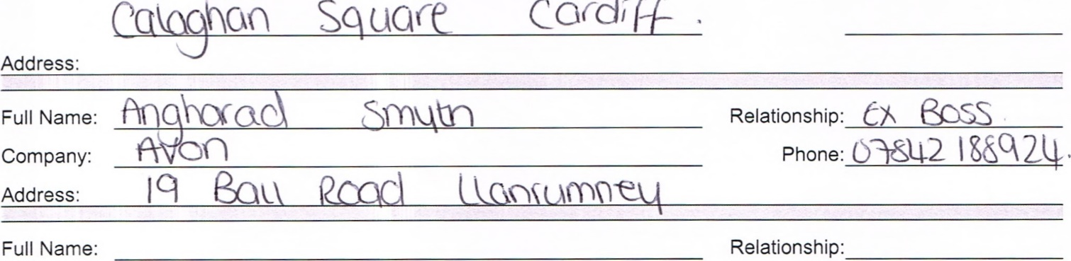
Sq
Cacdil+
Company: Phone:
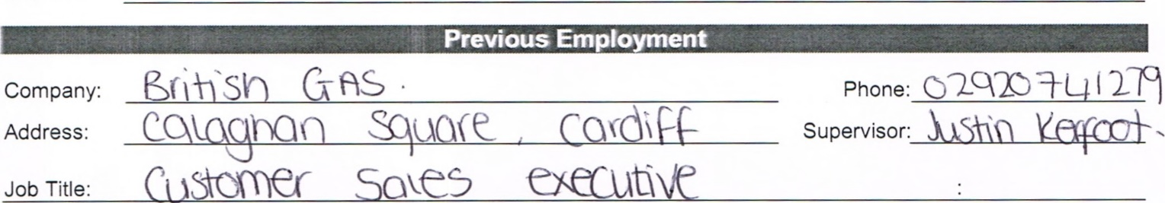
Address:
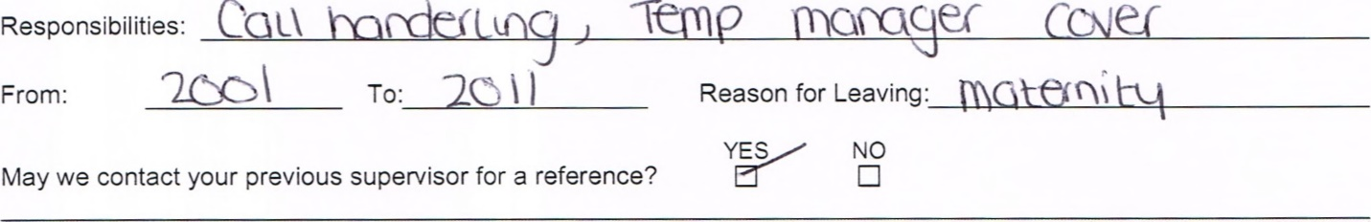Responsibilities: ea ec

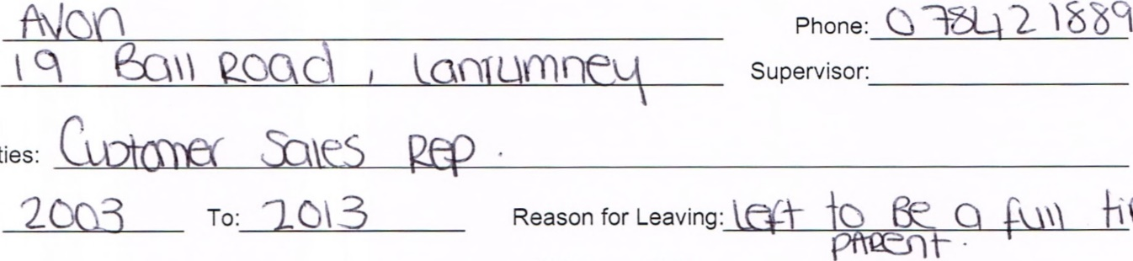
YES/
NO
May
we
contact
your
previous
supervisor
for
a
reference?
Company:
Address:
Job
title
and
Responsibilities:
From:

Company: Phone:
Address: Supervisor:
job title and responsibilities:

From: To: Reason for Leaving:
YES NO
May we contact your previous supervisor for a reference?
2
I certify that my answers are true and complete to the best of my knowledge.
If this application leads to employment, I understand that false or misleading information in my application or interview may result in my release.
Signature:

Appendix 2
mandy lawrence
Mandylouise1984@icloud.com
Very punctual and focused. Creative and ambitious. A team member and able to work on individual projects. Able to listen to instruction and execute tasks successfully

Experience

2000-2011

customer sales executive, british gas
Extensive customer care and conflict management skills
Always researching and educating myself with new procedures and products
Successful at always achieving sales targets
6 month supervisory manager increasing sales by 12% for my incentive scheme for sales target achievers

Education

st Illtyds high school, 2000
7 GCSE Passes level A-D

College glan hafren, 2002
Btec in Media, Music and Performing arts

university Of wAles Trinity saint david,
Level four skills for the workplace ACTIVE

skills
I can bring new ideas and structures to help with managing and supporting team members  Proactive and encouraging best sales targets and achievements | Good listener and accommodating  Able to adapt to new surroundings, products and procedures

ACTIVITIES

I ENJOY COOKING AND READING. IM AN ACTIVE GYM MEMBER ALSO LOVE ADVENTURES AND SIGHT SEEING.

REFRENCESS

Available on request

