

Name: Greg Thompson
Number: 1705753
University of wales Trinity Saint David
Date: 15/04/21

Course: HND / BSc (Hons) Construction Management
Module: Project Control & Contract Administration
Module Code: ACBA5006

Index

- Abstract…………………………………… Pg 3

- Introduction…………………………….. Pg 3

- Report 1 ………………………………….. Pg 6

- Report 2 ………………………………….. Pg 9

- Report 3 ………………………………….. Pg 11

- Report 4 ………………………………….. Pg 13

- Report 5 ………………………………….. Pg 15

- Appendix …………………………………. Pg 17

- References ………………………………. Pg 18

Abstract
This report identifies suitable procurement and tender strategy for upcoming projects across wales. It will recognise areas of concern surrounding the project and offer recommendations to counter the issues using the various strategies. These will all be within accordance of ISO 10845 and inline with JCT 2011 regulations. (The Joint Contractors Tribunal Limited 2011, 2011)

Introduction

Procurement

Over the last two decades the procurement of builds has seen it venture away from traditional and single tender due to more increasing pressures in modern day society, not only has Health and Safety come to the for front but so has anti-corruption and quality with the introduction of BIM into sites across the UK.

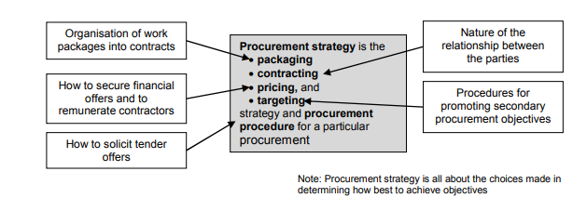
Figure 1: Components of Procurement strategy (Watermeyer, 2012)

As shown in Figure 1, there are four main considerations when choosing the correct procurement strategy, these areas will be weighed up against each other in relation to the client’s requirements and risk factors.

“Procurement is the process which creates, manages and fulfils contracts. There are three phases to the procurement process associated with the delivery and maintenance of construction works,” (ISO , 2020)

There are multiple types of procurement strategies the main ones being;

1) Traditional Procurement Characteristics
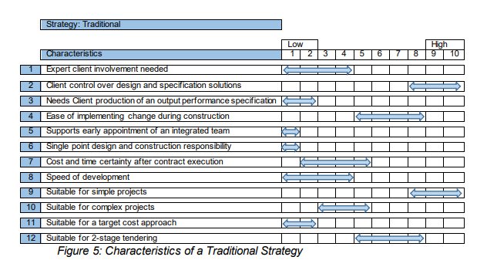

Figure 2: Traditional Procurement Characteristics (Scottish Government , 2018)

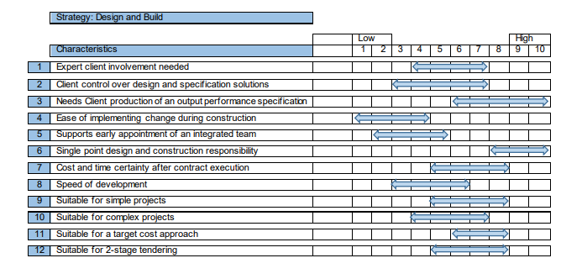
2) Design and Build (D & B) Characteristics
Figure 3: Design and Build Procurement Characteristics (Scottish Government , 2018)

3) Management – The design and risks are with the client, the contractor is responsible for the package of works and the management of the project, this route is rare in modern construction. (The Joint Contractors Tribunal Limited 2011, 2011)

Tendering

The tendering process is an integral part of the procurement process, this determines the bidding process and obtaining a price. Depending on the client this process often sees a pre-qualification questionnaire (PQQ) used, Figure 4 below shows an example of criteria required to be answered within the PQQ, this helps filter the contractors who have poor credit ratings, low quality management, poor health and safety systems and identify the contractors who are aware and up to date with current regulations etc. (The Joint Contractors Tribunal Limited 2011, 2011)

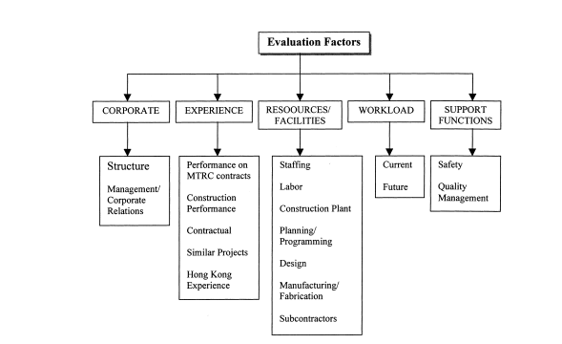

Figure 4: Prequalification criteria example (Ekambaram Palaneeswaran, 1999)

Report 1 – Private Development - Retail and office space



Location: Cardiff City Centre
Contract Value: £20 Million
Investor: Private Developer
Procurement route: Design and Build (D&B)
Tendering process: Two Stage
Use: Retail x 1 floor, office space x 9 floors
Post contract responsibility: Contractor
Considerations:
- 5 different bat species in surrounding buildings
- Restricted access due to City Centre
- Design complications due to ground floor as retail space

As a private developer is undertaking this project there could be various procurement routes taken. However, due to the requirements of wanting retail space on ground floor and office space on the remaining floors indicated that they have specific requirements for the build and therefore D & B would be best suited for this project. As shown in Figure 3, the risk element for the private investor is minimal with D & B which is ideal as they will be responsible for any losses or Variation costs.
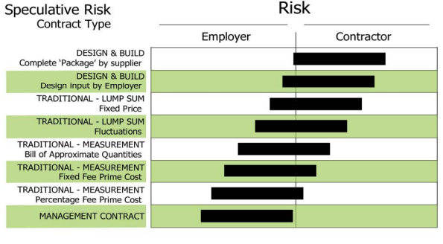

Figure 5: Employer Risk Vs Contractor Risk for specific procurement routes (Davis, 2008)

D & B procurement would be most effective route for this project as it allows the client to discuss design options with the contractor in the tender process, this is crucial when designing the layout of the floor plans to understand what is possible to construct. For example, the load bearing walls will have to be altered to allow large open areas for office space and then smaller rooms for the retail space.

Alongside D & B procurement, two stage tender process is best suited as it allows the contractor to have early Contractor involvement (ECI) with the design element of the project to ensure, there are minimal delays once the build begins. The downfall for this; is often the price cannot be negotiated with the contractor as the early involvement often rules out the change of contractor for a cheaper alternative. There can also be a risk of the contractor requesting Variations as the detail pre-construction is often weak and will need adjusting on site to suit. (The Joint Contractors Tribunal Limited 2011, 2011)

Bat species

The surrounding building have 5 variants of bat species, this would have to be considered within the pre tender package as the contractor will have to adhere to BS 42020 which is the Biodiversity in planning and development. “The successful implementation of practical conservation and enhancement measures during development” (BSi Group , 2020)
The contractor will have to consider the sub-contractor for this area of the build to ensure all regulations are followed correctly. It also specifies certain working months that they can be disturbed; this will have to be taken into consideration when in the programming stage.

Location

The location of this build is extremely challenging, the contractor will have to be experienced with undertaking projects in a city centre and knowing the issues it holds; such as, traffic plans, storage of material, working through the night for large pre-fabricated deliveries, etc. This is a large reason why the D & B would be best for this project as the client holds minimal risk when it comes to the construction and organisation of the building.

Identifying if the contractor has suitable experience and internal systems in place will be answered within the PQQ sent out prior to any design meetings. As shown in Figure 4.

The post contract process as per RIBA plan of work 2020, see appendix 1. (RIBA, 2020) There would be a hand over with the client’s team in line with Plan of Use Strategy within the RIBA plan, (RIBA, 2020) As this build will be under great scrutiny as it is located in the capitols centre, the contractor must ensure it is completed to the highest of standard with no Health and Safety issues which may affect the public. Again, with D & B all post construction queries or defects the contractor will be liable to come and correct, this reduces the post construction risk for the client.

Report 2 – Private Hospital, SA1



Location: SA1 Swansea
Contract Value: TBC
Investor: The Heath Care Management Trust (HMT)
Procurement route: Traditional
Tendering process: Single Stage
Use: Hospital
Post contract responsibility: Client
Considerations:
- Specific requirements
- Attention to detail
- Materials used due to location by the coast

As this is Trust funded project it will likely be put out to tender via an online portal allowing contractors from all over the UK bid for it. This is done using a traditional procurement route, as the Trust will have a team of Quantity Surveyor, project managers, architects, Clerk of works and other specialists involved in the pre – tender package to ensure all documents are produced to the contractor. Traditional Procurement has a greater level of detail carried out pre-tender often is at RIBA stage 4 (RIBA, 2020) (see appendix 1), compared to D & B, this can often be extremely time consuming for the client.

When contracts are sent out with PQQ’s they often hold a percentage of the award. For example, 40% PQQ answers and 60% price. This will rule out certain contractors and favour others.

As traditional procurement is best suited for this, single tender process will also be recommended. Single tender process is a lump sum quote from the contractor who will have very little involvement in the design process until on site and any queries arise.

One positive of Traditional and single tender is that client will have full control of the costings as all details and specifications would have already been submitted as a lump sum costs and there should be limited variations.

Specification

Hospitals have a large number of regulations to follow to allow them to be fully functioning under Health Building note 00-01-2. This outlines the requirements and the level of specification within and around the building. Another favourable reason for traditional procurement. (Department of Health , 2014)

Detail

The attention to detail will be part of the client’s team ensuring regular checks are made throughout the project, this is often carried out by a project manager or clerk of works. On a hospital build the level of risk is greater than a standard hospitality builds and therefore all decisions need to be made prior to construction to ensure all requirements are fulfilled.

Materials

The client’s architectural team would have specified the materials used on the project and need to consider the local environment. A problem may arise if the contractor is not used to installing a cladding system that is specific for coastal use to protect from sea salt corroding. This is where D & B is more effective than a traditional route as the contractor would be able to discuss options with the architect allowing a better understanding of the project in the pre-construction phase.

The Post contract Process for this project is vital for the efficiency of the hospital, having the management team of the hospital understanding the layout of the building, fastest routes in and out, equipment installed, etc. Due to the equipment costs within the hospital a maintenance programme is recommended to be put in place to ensure that all systems and products are achieving the warranty certificates provided. This should be part of the tender package produced by the client within the Traditional route.

Report 3 – Small World Theatre Mumbles



Location: Mumbles
Contract Value: TBC
Investor: Limited Company
Procurement route: Traditional
Tendering process: Negotiation
Use: Hospitality
Post contract responsibility: Client
Considerations:
- Client has a lack of knowledge in construction
- Liable for any loss the theatre makes so will need a quick turn around
- Specification and current Building regulations

The Volunteer group will require this work to be carried out within a tight programme as any revenue lost will be coming out of the limited company which they are liable for. Therefore, a traditional procurement route would enable them to employ a professional surveyor who will look after the full package, they will carry out an initial survey of the building, create a Bill of quantities, put together a specification in accordance to Building regulations and a programme of works. However, this Route will be more time consuming for the theatre which is not ideal, if a client was to go down the D & B route, they could be liable to the contractor ‘pulling the wool over their eyes’ and over charge the volunteers for the works.

By going down the Traditional route it will give the client piece of mind as they presumably lack construction knowledge. D & B would be an option if there was a volunteer with surveying experience who was happy to take responsibility of the project. However, that seems an unnecessary risk when the cost of the refurbishment will likely be £20k +. Another reason why the traditional route would be preferred for this project is that any variations can be monitored and are easily identified against the original schedule of works, this is crucial when the budget and programme are constricted.

The Negotiation strategy may be useful if the theatre is on a budget as they can go out to multiple contractors and find the best price. Again, similar to other contracts if the client’s surveyor puts together a basic PQQ they will be able to identify reliable contractors to carry these works out. Often these smaller projects will be done through recommended contractors so the need for a PQQ might be a waste of time for all involved.

As it is a hospitality venue there will have to be a survey carried out by Food Standards agency, (Food Standards Agency , 2018) and a building surveyor to ensure all current regulations have been adhered too. The risk of traditional procurement is that there isn’t always the same continuity between contractor and client and can lead to defects post contract. (Scottish Government , 2018)

Report 4 – Create4 Factory

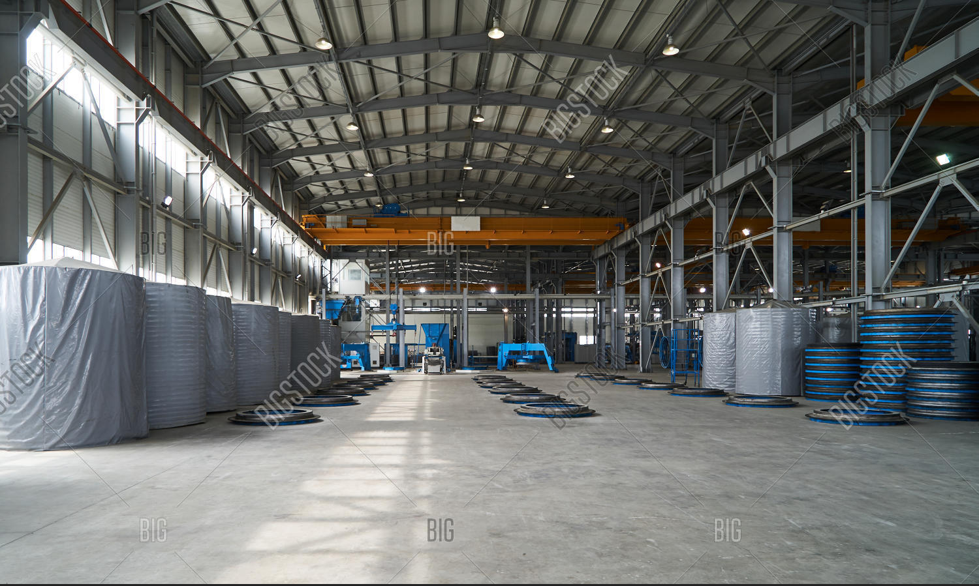

Location: Llanelli
Contract Value: TBC
Investor: Create4
Procurement route: D & B
Tendering process: Two – Stage Tendering
Use: Factory – Manufacturing
Post contract responsibility: Contractor
Considerations:
- Design of the building
- Ground conditions
- Specification

Create4 are insisting that the machinery is installed by themselves, therefore this project would be best suited to run as a Design and Build project. The reason for this is they have a clear vision of where and what machinery will be placed in the factory to ensure it runs at optimal efficiency. The contractor will have to work closely with Creat4 throughout the design stage to enable them to have the floor layout they require.

Create4’s new venture is one that they will also want to start as soon as possible, if the equipment is on lease or already bought then they will be taking a loss weekly. D & B and two stage tendering will enable the pre-construction time period to be as minimal as possible, this is also a great way to minimise costs. (Scottish Government , 2018)

It will also all for contractors to source materials early, which is a growing concern under current COVID-19 and Brexit conditions. Metal cladding sheets which this factory will be made from are currently on a 6-week lead time to any UK manufacturer.

As previously stated, the D & B will reduce the risk on the client, with the design, costs and programme. This will also be the case for the after-construction process as the contractor will be responsible for any defects post construction.

Ground condition

One consideration which may affect the procurement strategy is the ground condition and the location of the factory. This may need to be carefully planned out and may require a lengthy survey to ensure all drainage and ground stability is sufficient to withhold the weight of the machinery and plant. Traditional procurement would allow this kind of detail to be produced pre-tender, so all contractors are aware of the conditions.

Specification

Create4 often try and cut corners creating cost savings. However, with metal cladding it is important they get an expert opinion on the best product. For example, the Prisma coated cladding sheet has a fire rating of A+ and is non-corrosive whereas, the HPS2000 does not have as good of a fire rating. (Tata Steel , 2020) This could affect the company’s insurances due to the hot machinery that will be in use within the building. Again, this favours traditional procurement so the client can ensure that the correct specification and detail for the building is correct. (Scottish Government , 2018)

Report 5 – UWTSD Holiday Park



Location: Swansea
Contract Value: TBC
Investor: UWTSD
Procurement route: D & B
Tendering process: Two – Stage
Use: Hospitality
Post contract responsibility: Contractor
Considerations:
- Time scale
- Quality
- Aftercare
The main contributing factor to this project is the restricted time scale that the client has set the contractor. For that reason, Design and Build procurement along with two - stage tendering is the best route for this project. It will allow early involvement by the contractor which has been researched that 93% of clients and contractors feel that it improves overall quality of the work; as per Robert Eadie’s report. (Eadie, 2014)

D & B is extremely important for both time scale and quality of work as it allows the contractor to design the building based upon their experience and technical knowledge within their team. Again, it often limits the client to peruse other contractor options as they feel tied in with the one that has been involved from the start. However, on the contrary the client can often build a good relationship with the contractor allowing them to be transparent with costs, programme of works, quality and any non-conformities that occur on site. This grows the trust between both parties creating the overall risk of the build significantly less.

As there are multiple locations being looked at within the holiday park, the contractor would presumably have multiple sub-contractors; this can become problematic when it comes to variations. As D & B is not as detailed as the traditional route it often leaves the door open for contractor to ‘bump’ variations onto the contract. D & B is not always the best procurement method to use when the contract is complex with lots of different areas being works on. It is easy for the client to lose control of the project. (Scottish Government , 2018)

With D & B the aftercare will be with the contractor and usually will attend site to correct any defects made within the 12-month time period. With Hospitality it is crucial that the client adheres to any Guarantees that were produced during the project, a maintenance package is always advised and can be added to the contractor’s overall contract.

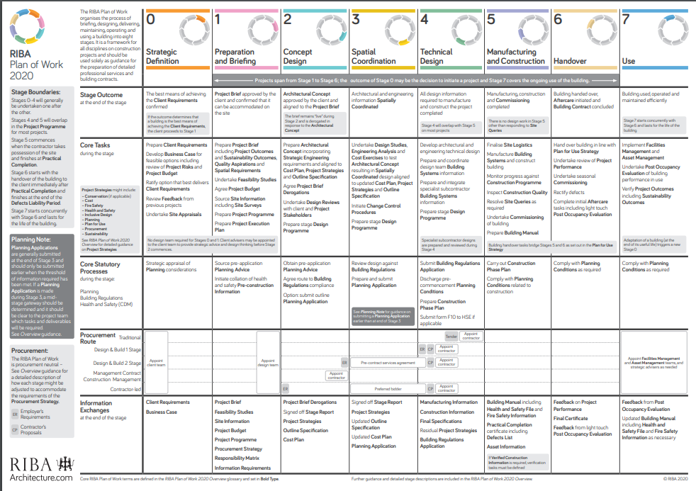
Appendix 1

(RIBA, 2020)

References
BSi Group , 2020. Smart guide to biodiversity in planning and development, London: BSI Group .

Department of Health , 2014. Health Building Note 00-01, London: UK Government .

Eadie, R., 2014. Analysing the advantages of early contractor involvement , Ulster: s.n.

Ekambaram Palaneeswaran, M. K., 1999. Recent advances and proposed improvements in contractor prequalification methodologies, Hong Kong: Department of Civil Engineering, The University of Hong Kong, Pokfulam Road, Hong Kong.

Food Standards Agency , 2018. Food safety inspections and enforcement , s.l.: Food Standards Agency .

ISO , 2020. ISO 10845-1:2020(en) Construction Procurement. [Online]
Available at: https://www.iso.org/obp/ui/#iso:std:iso:10845:-1:ed-2:v1:en
[Accessed 13 Arpil 2021].

RIBA, 2020. RIBA Plan of Work 2020 Overview, London: RIBA.

Scottish Government , 2018. Construction Procurement Handbook, s.l.: Scottish Government.

Tata Steel , 2020. Tata Steel HPS200 Ultra. [Online]
Available at: https://www.tatasteeleurope.com/ts/sites/default/files/Colorcoat%20HPS200%20Ultra%20technical%20manual.pdf
[Accessed 12 April 2021].

The Joint Contractors Tribunal Limited 2011, 2011. Deciding on the appropriate JCT contract 2011. London: Sweet & Maxwell.

Watermeyer, R. B., 2012. A framework for developing construction procurement strategy , Johannesburg: s.n.

