Student No: 2300809 PGCE Primary

 | Targed/target | What I have done in this assignment...
Targed/Target 1 | Access student services for support to structure work and use literature purposefully. Access extra support to connect reading to practical aspect of course. | I have had further sessions with student services and I have had another NQT teacher read through my work.
Targed/Target 2 | Access The University of Manchester phrasebook | I have tried to implement sentence starters from this phrasebook
Targed/Target 3 | Consult with Harvard Referencing Guide at UWTSD | I have referred to Harvard referencing guide throughout.  I have used the ‘cite me right’ referencing tool and checked against Harvard referencing.

ECAD7003 Learners, School and Communities: Where am I teaching?
March 2024 Assignment
Introduction
This assignment focuses on raising standards in reading in my placement school setting. A priority, for them, as set out in the School Improvement Plan attached at Appendix 1. The Institute of Welsh Affairs reports that “reading is at the foundation of everything in education, and our approach to it is in urgent need of change” (Wilson p1, 2023). Reading development has been a key area for enhancement at the school and in education, for some time. Progress has been made in pupils’ reading skills as evidenced in the ActiveLearn (Pearson, 2024) reading programme data (see Appendix 2). The school continues to concentrate efforts into extending this growth further. The Curriculum for Wales (CfW) and the Welsh Government (2022) states that effective language skills help learners to make sense of concepts across the curriculum. The school continue to utilise interventions that have shown good outcomes and began others, already having a positive impact.
This placement school setting is in a built-up area on the outskirts of a busy town. They have almost 400 pupils on roll and have 34.1% eligibility for free school meals (eFSM), which is above the national percentage of 18%. Their plan for developing standards and overall children’s prospects, health and wellbeing, is based on four main targets. To raise standards in Languages, Literacy and Communication, to raise standards in Welsh speaking. To develop teaching and learning through the continued implementation of the CfW with a key focus on Expressive Art. To improve monitoring and evaluation processes. The theme running through all these targets is the reduction of the impact of poverty on educational attainment (Primary School, 2023). However, as this assignment will focus on reading attainment the school intend to use many different resources available to address pupil reading achievement. Although raising standards in Languages, Literacy and Communication should be improved by raising reading standards. Notwithstanding the target of improving children’s overall prospects which should also be improved through advancement in reading. This will have a profound impact on learners’ outcomes and on future prospects in long term education, success in life, work and the wider community, as stated by Mulcahy et al. (2020).

Literature Review
The Statements of What Matters avows “clear and effective communication through language is an important life skill” Welsh Government (2022). Society requires adaptable learners who use languages in various roles, effectively interacting, exploring ideas and expressing themselves with the ability to build relationships. According to Mulcahy et al. (2020) learners’ reading ability is predictive of educational attainment across subjects, and of wider life outcomes, perhaps via the effect of reading on educational success. Learners with poor reading skills are less likely to achieve, academically and underachievement will only get worse as pupils move through the school system. When learners are expected to learn more independently the older, they get, poor reading skills will continue to let them down.
Readers retrieve prior knowledge and build comprehension from familiar texts. John Dewey (1859 – 1952) theorised that learning came from experiencing authentic contexts and dilemmas. Based on this premise, that pupils learn better in context, Herrington et al. (2014) indicate that authentic learning tasks provide opportunities for learning by allowing learners to experience the same real-world problem-solving challenges, in the curriculum, as they do in daily life. Many of the books the children read include authentic contexts. Dewey thought that understanding came from making meaningful connections between real life contexts, prior knowledge, new knowledge and the processes involved in learning McLeod, (2023). McLeod also states that by passively perceiving a problem and not experiencing consequences in a meaningful, emotional and reflective way, learners are unlikely to adapt, revise and construct new habits. When a learner learns through experience he or she can identify with concepts they are in contact with. For example, a literacy activity required learners to read part of a text with a partner and discuss what they had read. They talked and questioned one another then created a chart or character web, specific to their section of text. The charts and webs were shared with the rest of the class and all learners’ understanding of the text was enhanced.

L.S. Vygotsky (1978) agreed with Dewey to some extent. Where Dewey (1938) believed children learned best in a social situation saying that learning is a social activity, something we do together, interacting, rather than an abstract concept. Vygotsky thought that community was at the heart of the learning process. Vygotsky said that the “environment in which children grow will influence how and what they think about” (Toyokawa et.al p.495-522, 2023). Similarly, the CfW (2023) is now arranged for learners to play collaboratively and share their learning experiences, when negotiating the challenges that support the focus tasks in their daily education. This setting supports and encourages learners to work collaboratively as in Guided Group Reading (GGR) facilitated by a member of staff, whilst the reading group negotiate the different activities, text and instructions throughout the book. One child will make a prediction about what might happen in the story, from the front page and the title of the text. Another child will ask the first child a question about their prediction, and others contribute with inference, reasoning or summary. Willingham (2017) states that reading depends on memory, powers of inference and problem solving. In truth all these skills consolidated, work to provide comprehension of the whole text. He continues to explain how reading depends on many mental processes, too numerous to provide a cognitive explanation of the process. TTS (2024) produce GGR books and tell us that oracy is one of the most used and important skills to improve outcomes across the curriculum. It is at the heart of practice, as learners talk and communicate, in paired and grouped discussions. Teachers use oracy, communication and instruction to explain tasks and activities whilst planning, preparing and resourcing meaningful, purposeful endeavours for children to navigate.
Vygotsky (1978) explained how “teaching and learning is a matter of sharing and negotiating socially constituted knowledge” (The Editors of Encyclopaedia Britannica 2020). Vygotsky also understood how cognitive development stemmed from social interactions from guided learning, as in GGR, within the zone of proximal development. The zone of proximal development is how pupils learn collaboratively as they co-construct knowledge together. Vygotsky thought each learner had something to bring to the collaboration of learning and their ideas and knowledge were based on a foundation of understanding. Everyone having their own point of view, founded on their own principles and previous learning, possibly contradicting the social learning theory. However, all learners have different historical foundations of understanding so bring their own constructs and knowledge to share with peers. The Welsh Government (2021) introduced a toolkit that recognised the complexity of raising standards in reading skills. The toolkit supports the importance of whole school community, working together in a coordinated, consistent and sustained way where speaking, listening and reading are part of every aspect of school and life. My placement school strives to provide a whole school approach to develop and embed reading. Besides reading and interventions, they embed skills through Read Write Inc. (RWI) communication and oracy as pupils learn in differentiated groups in English literacy lessons and throughout topic lessons – science and humanities.
The Welsh Government Literacy and Numeracy Framework (LNF) (2024), established in 2009 is fundamental in the teaching of literacy, the implementation of reading interventions and support that my placement school’s reading attainment plans rest on. They rely and focus on the LNF (2024) which discusses how it will be the responsibility of all practitioners, across all curriculum areas, to develop and ensure progression in literacy and numeracy skills. It also states how the aim of the framework is to support schools and practitioners in providing opportunities to develop, extend and apply skills. The Welsh Government (2023) have also reported on personalised assessments, first introduced in 2018/19, taken between 2018/19 and 2022/23. Results from personalised assessments, in my setting, are used alongside other assessments, in Lexia (2024) and The Pearson Reading Programme, by the school in accordance with the CfW framework, to help support and develop reading skills.
Fox et.al (2021) explains that education is a social process powerfully influenced by cultural factors. In this setting (GGR) is a fantastic concept for social learning to take place. Readers read the same text, interpreting it in different ways which contributes a variety of explanations to group discussions.
The school use ActiveLearn (Pearson, 2024) and hwbcymru.net (2024) personalised assessment and National Reading Test (Welsh.gov, 2024) data to determine reading ages and book levels. The Welsh Government (2024) reading assessments are supported by the LNF and the Cross-curricular skills framework, (2022) explain how this regularly updated framework will develop, extend and apply skills. It continues to be available as non-statutory supporting guidance. Reading attainment is every child’s right and in article 24 The International Rights of the Child Convention (2022) affirms that learners should be able to access information that applies to them. In order to be able to do this they should be able to read. In this placement learners are encouraged towards reading improvement and their rights are displayed on the classroom wall in a child friendly manner. Pictures help non-readers to understand the rights. Learners were involved in the creation of this wall display. They were read the simplified International Rights of the Child Convention (2022) and placed into mixed ability groups. They each chose a specific right and were encouraged to discuss and consider how that right applied to them. The groups were facilitated by a member staff or an able pupil who collected ideas in posters. Learners then presented their posters to the rest of their peers and a whole class discussion, supported by the teacher, ensued. All children were given an opportunity to express their opinion and how their work would be included in the Rights wall display. So, children are aware of how their rights affect them and others. They also understand that an education is part of their rights, of which reading attainment and improvement is part. The Convention also upholds how students have the right to get information from books and other sources. It goes on to establish how adults will guide and ensure content is safe and suitable. Furthermore, the convention states that every child has the right to an education. These rights have been founded in legislation since the formation of the Children’s Act (1974). The Children’s Act has since been rewritten several times in 1989, 2004 and is now upheld by the CfW, not only academically but holistically, as there is such essential focus on the whole child and learners’ health, mental health and wellbeing.
The national personalised assessments available to schools for testing learners’ reading standards gives a guide to where reading attainment is and schools can keep a check on this twice a year. In Figure 1 below we can see results for 2021/22 data sets for The English Reading personalised assessment. This shows whether readers have understood and can make judgements on texts. It is taken annually in English medium Welsh schools by pupils aged 5 to 15.

Figure 1: English Reading: difference in attainment in 2021/22 and 2022/23 relative to 2020/21 in months
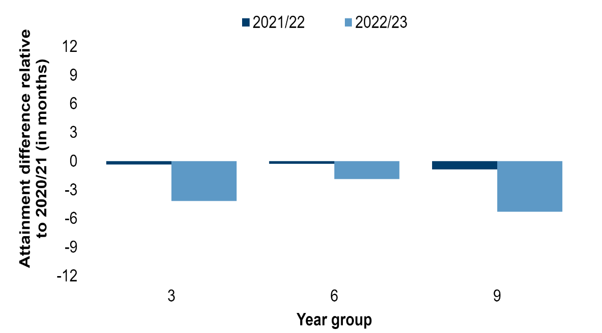 (www.gov.wales, 2023).

To sum up, in 2022/23 average attainment for pupils in English Reading was lower than it was in 2020/21, equivalent to 4 months’ lower attainment.
However, last year, readers in my placement school setting made significant progress please see Appendix 2. “When we teach students to read with precision, rigour and insight, we are truly handing over the key to the kingdom” (Driggs and Woolaway p89, 2016). Appendix 2 shows my placement’s recent quantitative data. Close to half the class have a reading age (RA) at or above their chronological age (CA). However, 11 pupils out of 20, so more than half the class have reading ages of less than their CA. Although 5 pupils are reading significantly above their CA with one pupil reading 2 years 3 months above their CA, 2 pupils are reading significantly below their CA.
However, RWI, reading interventions together with taught focused literacy tasks, in my placement school, all combine to address this imbalance. The school staff have established routines to strengthen and enhance reading, literacy and interventions. There is an inclusivity ethos at this school as all learners have equal access to high quality education as included in the EIF – Equity, diversity and inclusion statement, (2019). Online reading resources allow equity in accessing the levelled books. All staff strive for inclusion through the reading and literacy interventions, as well as differentiated lessons. With differentiation in place all pupils have the same opportunities/equity for success. The rate at which they progress is monitored and although certain pupils need more frequent practice than others, fair management of how often they read is exercised. The School’s Improvement Plan attached at Appendix 1, page 3, recommends how monitoring, evaluation and improvement strategies should focus on improving provision and pupils’ learning standards. Webster (2022) suggests that learners with difficulties may be withdrawn sometimes to work with support staff. However, in Appendix 2 it should be noted that some of the lowest and highest scores are from readers with addition learning needs (ALN). Gravestock et.al, (2017) reasons that it is important to plan and deliver teaching, learning and assessments with methods that allow all learners to engage and achieve their full potential.
Note must be made of The National Literacy Trust (2023) who conducted surveys with young people aged 5 to 18 on attitudes to and enjoyment of reading. The research was collected from across the United Kingdom and included an equal cross section of children from the age range, gender, socio-economic background and geographical region (2023). They found that young people’s reading environments are linked with their reading enjoyment and reading frequency (2023). The report also discusses how fewer learners eligible for free school meals (eFSM) enjoy reading than those not eFSM. My school placement has been forthright in including learners from all socio-economic backgrounds but has specifically targeted those from the poorer areas and particularly those eFSM. There is also a book club running during a lunch time, once per week and the school has recently run an afterschool bedtime stories club. Most learners in the local area and the categories mentioned above attend these interventions. The Welsh PISA statistics displayed, in figure 2 show the steady fluctuation of Welsh progression in reading attainment. In 2018, Wales with a score of 483, ranked just behind Austria and Switzerland but ahead of Latvia, Italy, Croatia and Lithuania. This is the highest average score since 2006, when Wales started participating in these tests although Wales is still behind the other UK nations.
Figure 2: The Welsh PISA information
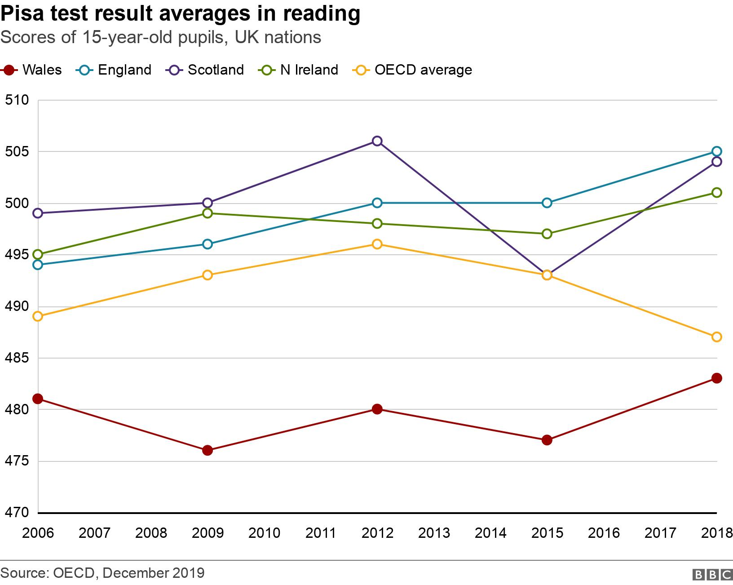
Lewis (2019)
Altogether, 3,165 pupils from 107 schools across Wales took the tests, which are set every three years. Lewis (2019) reported that 44% of pupils in Wales rarely or never read books compared with an average 35% calculated for the Organisation for Economic Cooperation and Development (OECD) and a pupil survey found attitudes towards reading were more negative than the rest of the UK. However, head teachers in Wales reported shortages of equipment and books compared to the other nations. The head of education and skills at the OECD, Andreas Schleicher (2019), said past Welsh results reflected a system where too many people were leaving education without basic skills and PISA results are a wake-up call leading to reforms. He agreed that CfW had inspiring ideas, but implementation would be key. Teaching has been identified as an area for improvement and Kirsty Williams, Educations Minister at the time, told the reporter that Wales that Wales has caught up and are continuing to improve. Latest reading test results showed increases in scores of higher achieving pupils in Wales, but lower achievers’ scores have not changed significantly. She also agreed that teaching needs to improve and there has been changes to teacher training.
Pupils in my placement school take reading books home each Friday they are checked weekly for guardian comment. There is little evidence that children read at home with parents. Starke (2020) claims that reading for pleasure is an identifiable area to develop . Reading at home with parents, grandparents or older siblings is effective in promoting a love of literature according to Starke (2020). She goes on to explain it is motivational for children to engage in reading with their families and beneficial to see their families represented in the literature that they read. Giving children as much choice of genre and book/text type as possible is the best hook for learners to become interested, successful, independent readers.
Figure 3 below, shows the performance gaps between Wales and the other three nations of the UK. Cshazn and Rees (2018) tell us the Wales mean results have a reading score of 478 with a performance gap of 219 between Wales and the closest UK nation.
Figure 3: Performance Gap in Reading achievement between Wales and the other UK Nations
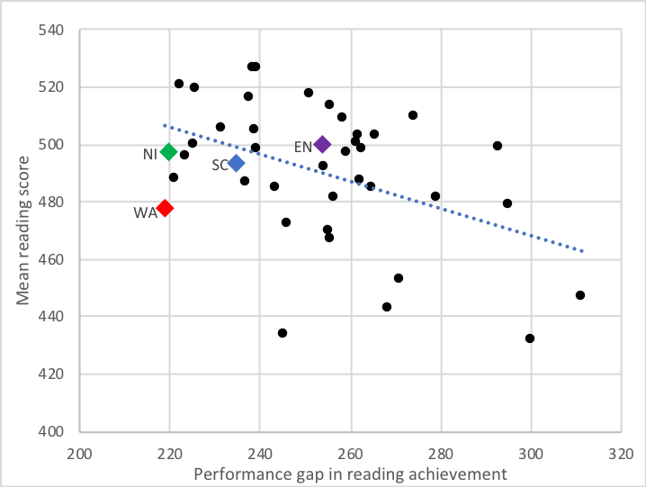
Cshazn and Rees (2018)
Several interventions have been explored to motivate learners to read in this setting. The National Literacy Trust (2023) has found through its annual survey that children’s home environment, sociodemographic background and access to books has changed reading habits. Their findings suggest that only 2 in 5 children aged 8 to 18 said they enjoyed reading in 2023. This survey goes on to explain how fewer than 3 in 10 (28%) of children and young people aged between 8 and 18 read daily and half (52.9%) of 8 to 18 year olds were encouraged to read by their parents/carers.
Figure 4: Progress in International Reading Literacy Study (PIRLS) at Age 10
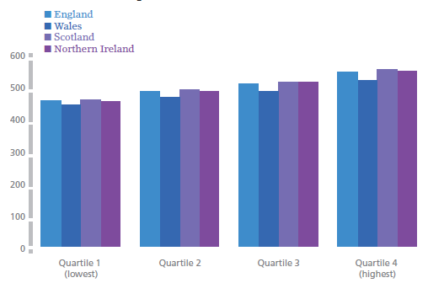
Chsazn and Rees, (2018)
Figure 4 above assesses reading comprehension at age 10. As in figures 1, 2 and 3, we can see that progress across all four UK nations is consistent. Again, Wales scores less than other UK countries but have consistently improved. The UK all score similarly compared to the rest of the world. The measures applied in countries outside the UK are less important here as educational outcome is our emphasis.
ActiveLearn (Pearson, 2024), reading intervention provides children aged 3 to 11 with reading resources in a single accessible online learning hub. Children enjoy reading ebooks on the laptop and, by using the “bug club” activities (Pearson, 2024). The children’s reading progress and comprehension of the stories and books they read is monitored and consolidated. The Literacy and Numeracy Framework (LNF), Welsh Government (2022), supports schools to develop pupils’ skills in literacy and numeracy as well as digital competency. Welsh Government (2024) tell us how the LNF works with Local Education Authorities (LEAs) to develop an approach that best suites individual schools.
Robinson et.al. (1946) explain how reading intervention builds confidence and raises standards using the theory of constructivism as it practices the skill of making meaning through deep engagement with a text. ActiveLearn (Pearson, 2024) reading intervention supports readers in consolidating the texts they read with bugclub resources and electronic games. This intervention is grounded in constructivism. Piaget, (1968) and Vygotsky (1978) theories of constructivism state that learning is built on a foundation of prior learning. According to (Phillips et.al, 1995) this prior knowledge influences what new or modified knowledge an individual will construct from new learning experiences. McLeod (2023) agrees by stating that learners reflect on their experiences, create mental representations and incorporate new knowledge, promoting deeper learning. In this way Phillips et al, (1995) confirms that pupils are constructing their own learning and comprehension through prior knowledge, influencing new or modified knowledge, constructed from new learning experiences. In my placement learners continually build their reading skills when new texts, not only contain additional key words and vocabulary but incorporate prior learning with words previously encountered in earlier texts. The words and sentences read will be in a new and different semblance and composition for each new story or book, consolidating learning. Reassessing pupils regularly confirms progression and Hwbcymru (2024) state assessment confirms text levels and authenticates the level of reading skill determined by the personalised government reading assessments.
Higher-Level Teaching Assistants (HLTAs) at the school, use the ActiveLearn (Pearson, 2024) reading programme with electronic assessments and books, to assess children’s reading skills, at least termly. HLTAs use professional judgement to recognise when children need to take a more formal assessment and level up. Two new starters to the school were assessed on the day they started in the class. Books are set through assessment, listed within the programme and children read regularly, at least twice per week, with the HLTA, the teacher and myself. Some read, practice phonics, handwriting and speech and language with a special needs support assistant (SNSA).
The school ran a bedtime story after school club across all progression steps. Learners returned home to get changed into pyjamas. The classrooms were prepared with soft lighting and bean bags. Refreshments were provided for parents and children. Learners chose the books to listen to and moved in rotation for each book. Turnout was good in progression steps 1 and 2 and although turnout was less in progression step 3, pupils heard all the stories.
Recommendations
Further opportunities to attend reading clubs should guarantee improved engagement in reading in my placement setting. Learners at key stage 1 attended Bedtime Story Club in greater numbers and engaged better than those in key stage 2. So, teachers may want to interview learners or run a survey, at the start of the year, as they get to know them. Staff could learn more about learners’ strengths, and preferences and allow learners to select their own books for the bedtime story intervention. This idea may engage learners’ interest. Provision of activities using ipads and ebook might be more akin to older learners and might improve attendance at key stage 2. Key stage 2 learners might like to present their choices to their peers using the interactive whiteboards. As Starke (2020) explained, shelves filled with age-appropriate books matching interest and reading levels is a fantastic resource. Student comprehension can be increased through characters who resemble themselves and their families. Provision of different genres to give a wide choice and give pupils ownership of their reading. Encouragement, at key stage 2, of learners to support their peers by recommending a good book they have read is also recommended. A book recommendation list could be posted on the wall in the library and learners could choose books that fit the genres and requirements of peers.
The bedtime story club is a trial that needs to continue to run at the school. I believe this would continue to find improved turn out of learners, particularly in the winter months.
Perhaps access to the online reading intervention could be made available to parents. If parents had an account, children could read ebooks and may engage better reading at home.
Conclusion
PISA results have an impact on how the CfW is implemented in Welsh schools. Welsh Government has studied models from across the world in its implementation of the CfW. The reading clubs, interventions and literacy delivered throughout children’s learning journey through the school is all implemented at the school to benefit and support learners’ literacy skills. The way forward for this placement school setting is to continue to deliver RWI and literacy throughout the curriculum as they are doing. Intervention is also another strength that supports pupils literacy and reading skills in small groups and one to one. This strategy is extremely advantageous to learners as they have much more attention from the reading teacher than in a whole class situation. The school must continue to strive for improved attendance at the reading clubs through the above recommendations.

Appendix 1
Primary School

County Borough Council

School Improvement Plan

(Incorporating Grants Spending Plan)

September 2023 – August 2024

No. on Roll: 398
No. of Classes: 16
School’s Costed Annual Plan
2023-2024
Education Improvement Grant (EIG) | Total = £134,260  including  Foundation Phase
Pupil Deprivation Grant (PDG) | £120,750
Early Years Pupil Deprivation Grant (EYPDG) | £29,900
Professional Learning Grant (PLG) | £7,253
Collaboration (COL) | £7,461
RRRs | £25,915
Additional Learning Needs grant (ALN) | £18,938

Name of School | Primary School
Headteacher

Signed: (Headteacher) Date: September 2023
Signed: (Chair of Governors) Date: October 2023

School Spending Plan 23/24
EIG  23/24 |  | PDG  23/24 |  | EYPDG  23/24 |  |  | Prof Learning Grant  & Collaboration 23/24 |  |  |  | RRRs  23/24
Activities:  Employment of Foundation Phase support staff to support the learning of ALL pupils in accordance with guidance on pupil/adult ratio, new resources and professional development/supply costs. |  | Activities:  Employment of support staff to support the learning of vulnerable pupils (including pupils eligible for free school meals eFSM) in literacy, numeracy and wellbeing, new resources and professional development/supply costs including training and pupil progress review supply cover. |  | Activities:  Employment of staff to teach and support the learning of pupils, mainly those in “Rising 3” in accordance with guidance on pupil/adult ratio, new resources and professional development/supply costs |  |  | Activities:  To purchase training opportunities as well as cover any supply costs incurred. |  |  | Activities:  Employment of support staff to support the learning of vulnerable pupils (including pupils eligible for free school meals eFSM) in literacy, numeracy and wellbeing, new resources and professional development/supply costs including training and pupil progress review supply cover.
£134,260 |  | £120,750 |  | £29,900 |  |  | £14,714 |  |  | £25,915
Role/Resources | Cost | Role/Resources | Cost |  | Role/Resources | Cost |  | Training | Cost |  |  | Training | Cost
LSO Employee EIG 1 (30 h) | 20990 | LSO Employee PDG 1 (30 h) | 21487 |  | LSO EY Employee 1 (30 h) | 21487 |  | Talk for Writing | 5000 |  |  | LSO EY Employee 1 (30 h) | 21487
LSO Employee EIG 2 (30 h) | 20990 | LSO Employee PDG 2 (30 h) | 20990 |  | LSO EY Employee 2 (12 h) | 8413 |  | Curriculum Development | 8000 |  |  | LSO EY Employee 2 (6h) | 4428
LSO Employee EIG 3 (30 h) | 20990 | LSO Employee PDG 3 (24 h) | 16940 |  |  |  |  | Staff release time | 2714
LSO Employee EIG 4 (24 h) | 16940 | LSO Employee PDG 4 (30 h) | 20589
LSO Employee EIG 5 (30 h) | 20990 | LSO Employee PDG 5 (29.6 h) | 17917
LSO Employee EIG 6 (30 h) | 20589 | LSO Employee PDG 6 (26 h) | 21483
LSO Employee EIG 7 (18 h approx) | 12,771
Equipment/resources |  | Equipment/resources | 1344 |  | Equipment/resources |  |  | Equipment/resources |  |  |  | Equipment /resources
Professional Development |  | Professional Development |  |  | Professional Development |  |  | Professional Development | 14714 |  |  | Professional Development
TOTAL | 134260 | TOTAL | 120750 |  | TOTAL | 29900 |  | TOTAL | 14714 |  |  |  | 25915
PROFESSIONAL DEVELOPMENT (inc. SUPPLY) = £14,714 |  |  |  | EQUIPMENT AND RESOURCES = SCHOOL CAPITATION
GRANTS TOTAL | EIG+ PDG + EYPDG + Professional Learning Grant + Collaboration Grant + RRRs = £324,639

Primary School – Priorities 2023-24
Target 1 | To raise standards in Languages, Literacy & Communication, reducing the impact of poverty on educational attainment.
Target 2 | To raise standards in Welsh with a focus on speaking skills, reducing the impact of poverty on educational attainment.
Target 3 | To continue to develop teaching and learning and reducing the impact of poverty on educational attainment through the continued implementation of the Curriculum for Wales with a key focus on Expressive Arts, Relationships and Sexuality Education and Outdoor Learning.
Target 4 | To improve monitoring and evaluation processes, impacting on the development of leadership at all levels.

ESTYN Recommendations – October 2022
Recommendation 1 | Focus monitoring, evaluation and improvement strategies more sharply on improving provision and the standards of pupils’ learning.
Recommendation 2 | Provide opportunities for pupils to take responsibility for their own learning and become independent learners.

Target 1 – To raise standards in Languages, Literacy & Communication, reducing the impact of poverty on educational attainment.
1a) To raise standards in phonic awareness and spelling in all progression steps.
1b) To raise standards in reading.
Key Actions | Responsibility | Timescale | Resources & Costs | Success Criteria/Outcomes | Evidence
1a) To raise standards in phonic awareness and spelling in progress steps.  1 – To review spelling and phonics data.  2 – To review phonics provision across all progression steps.  3 – To review spelling provision across all progression steps.  4 – To review programme of phonics/spelling expectations for each year group/progression step.  5 – Create Phonics and Spelling Programme of Progression.  6 – Produce an overview of expectations for phonics at each year group.  7 – Produce an overview of high frequency words to be taught at each year group.  8 – Re-introduce the Grammar Glossary and develop grammar expectations in line with year groups.  9 – Monitor and review spelling, phonics and grammar provision across the school through MER processes. | GR/GB  GR/SP | Oct 2023  Oct 2023 – May 2024  Nov 2023  Nov 2023 |  | Analysis of current performance.  Monitoring plan developed.  Clear understanding and evaluation of current provision across all progression steps.  Clear expectations of agreed word lists/phonemes.  All classes delivering good quality phonics and spelling sessions.  Nearly all pupils make at least expected progress (of 9 months) in spelling age, with a specific focus on eFSM pupils. | Learning Walks  Analysis of SWST data  Book scrutiny  Listening to Learners  Classroom displays
1b) To raise standards in reading.  1 – To audit individual reading provision across the school.  2 – To agree expectations of individual pupil reading provision.  3 – To review records of individual reading.  4 – To develop reading scheme book provision including use of Bug Club online.  5 – To observe and audit shared and guided reading provision across the school.  6 – Create progression map of high frequency words for each year group. | HT/DHT  All staff | Oct 23  Nov 23  Nov 23  Nov 23 | Paper based scheme, online Subscription, and training  £4000 PDG  £3700 - Reading  Supply cover - £900 PDG | Most pupils and nearly all eFSM pupils, to have made at least expected (9 months) progress in individual reading ages across the year (Years 2-6).  Improved national reading test data, with at least 80% of pupils achieving within the average band.  All staff are consistent in approaches to shared and guided reading, which are embedded across all classes. | MER  Expectations agreed for provision  Reading records  Bug Club data  New books enhancing library  Data – Reading ages and national test results  Class working walls/displays

Target 2 - To raise standards in Welsh with a focus on speaking skills, reducing the impact of poverty on educational attainment.
Key Actions | Responsibility | Timescales | Resources & Costs | Success Criteria / Outcomes | Evidence
1. AoLE (Areas of Learning Experience) Lead to attend welsh language progression training with CSC.  2. CSC to support in training and awareness of expectation and progression with all staff in Welsh second language.  3. AoLE Lead to work with teams to disseminate and agree the way forward for each team.  4. Teachers to implement agreed actions.  5. Review provision and standards across all progression steps.  6. Staff to continue complete online training modules to improve skill levels.  7. AoLE Lead to further develop Criw Cymraeg responsibilities across the school to raise the profile of Welsh.  8. Incidental welsh to be improved by Brawddeg yr Wythnos.  9. To achieve the Bronze Award for Siarter Iaith Gymraeg, Cymraeg Campus | HG/RE  HG/RE  All teaching staff  All teachers  All teaching staff  HG/RE  Criw Cymraeg  HG/RE | Sept 23  Nov 23  Nov 23  Nov 23  Dec 23 – June 24  Oct 23 – July 24  Dec 23 | Supply cover £1500 - PLG  Resources  £500 - EIG | Improved Curriculum Lead and staff awareness and understanding of expected standards leading to improved outcomes for most pupils.  Clear actions are in place for each teaching team and are implemented effectively.  Staff training is completed to further raise skill levels.  Improved standards of oracy in Welsh with most pupils able to use Welsh phrases and ask and answer age-appropriate questions.  Criw Cymraeg lead playground games and the use of incidental Welsh across the school.  Bronze Award is achieved. | Cluster working minutes  Cluster progression maps for Welsh second language  Team meeting minutes  Staff training audit  Book scrutiny  Listening to Learners  Criw Cymraeg minutes  Signage evident around the school  Bronze Award evidence

Target 3: To continue to develop teaching and learning and reducing the impact of poverty on educational attainment through the implementation of the Curriculum for Wales with a key focus on Relationship and Sexuality Education, Expressive Arts and Outdoor Learning.

3a – To improve standards in Relationships and Sexuality Education, reducing the impact of poverty on educational attainment.
3b – To improve provision and standards in Expressive Arts (music and digital media), reducing the impact of poverty on educational attainment.
3c – To improve outdoor learning provision across the school.
Key Actions | Responsibility | Timescale | Resources & Costs | Success Criteria/Outcomes | Evidence
3a – To improve standards in Relationships and Sexuality Education, reducing the impact of poverty on educational attainment.  1 – Research and purchase RSE resources as a cluster.  2 - Cluster working to take place to discuss way forward with the use of resources to establish cohesive approach.  3 - AoLE Lead for RSE to work with CSC and cluster colleagues to further develop awareness of expectations and produce progression maps of knowledge, skills and experiences.  4 – Cluster lead to disseminate to HTs.  5 -AoLE Lead to work with teams to disseminate and agree the way forward for each team.  6 – Year group overviews to be produced for parental information and use by staff.  7 – Parent forum to be established to ask for feedback on RSE provision.  8 - Teachers to implement RSE scheme across whole school.  9 - Review provision and standards across all progression steps.  10 – School resources audit to be completed.  10 – Further staff training to be undertaken on E-Safety. E-safety to be taught explicitly at an age-appropriate level. | & Cluster  / //cluster leads  / Cluster leads  Cluster lead  /  / /  All staff  All staff  /  All staff | May 23  June 23  June 23  July 23  Sept 23  Sept 23  June 23  Sept 23  Nov 23  Nov 23  Sept 23 | Supply costs - £1000 (tbc)  Resources (tbc following audit) | Cluster agreed resources to be bought and used.  Consistency of approach across the cluster for RSE teaching and expectations.  Improved Curriculum Lead and staff awareness and understanding of expected standards leading to improved outcomes for most pupils.  Improved standards of staff knowledge and understanding across RSE.  Improved understanding of parents in regard to the teaching of RSE.  Audit of resources completed and age appropriate across the school.  E-safety is taught consistently across the school. | Cluster working minutes  Cluster progression maps for RSE  Team meeting minutes  Parent forum minutes  Staff training completed  Book scrutiny  Planning scrutiny  Listening to Learners
3b – To improve provision and standards in Expressive Arts (music and digital media), reducing the impact of poverty on educational attainment.  1 - AoLE Lead for Expressive Arts to work with CSC and cluster colleagues to further develop awareness of expectations and produce progression maps of knowledge, skills and experiences.  2 – Staff to undertake initial training for the teaching of music as an introduction to gain confidence.  3 – Using cluster maps, create music posters for the language of music and digital media across the school.  4 - Staff training on the use of digital media in expressive arts.  5 - School resources audit to be completed.  6 – Review provision and standards across all progression steps using the cluster maps.  7 – AoLE Lead for Science and Technology to deliver training on Digital Competency Framework and skills progression as a link to Expressive Arts.  8 – Staff to use Digital Competency Framework to plan cross-curricular progressive skills  9 - Review provision and standards across all progression steps through MER processes. | CP & cluster leads  All staff  /  All staff  /  All staff  All staff | May 23  Sept 23  Oct 23  Jan 24  Oct 23  Nov 23  Jan 24  Sept 23  Oct 23 – June 24 | Supply costs - £1000 (tbc)  Resources (tbc following audit) | Improved Curriculum Lead and staff awareness and understanding of expected standards leading to improved outcomes for most pupils.  Improved standards of staff knowledge, skills and confidence across Expressive Arts.  Improved skills for all staff within DCF (Digital Competence Framework)  Improved standards of digital competency for most pupils and nearly all eFSM pupils.  Independent learning activities reflect appropriate digital competency skills for most learners. | Cluster working minutes  Cluster progression maps for Expressive Arts & DCF  Team meeting minutes  Staff training completed  Book scrutiny  Planning scrutiny  Listening to Learners
1 - Revisit the outdoor learning action plan and review current practice and provision. Update action plan to reflect findings.  2 – Identified staff to complete Forest Schools Training.  3 – Complete Forest Schools assignments.  4 – Complete First Aid and Food Hygiene for Forest Schools for identified staff.  4 - To identify good practice through research and training to plan for outdoor learning.  5 – Plan and implement learning activities across the curriculum including wellbeing.  6 – Review impact of outdoor learning activities on pupil engagement and wellbeing. | SLT  All staff  All staff  All staff | Oct 23  June 23  June 23 – July 24  Nov 23 – July 24  Oct 23  June 23 – July 24  June 24 | Forest Schools programme – costings to be worked out. £1128 - PLG  Resources (tbc) | Outdoor learning becomes embedded practice across the school.  Good practice is identified and shared.  Planning shows progressive skills and experiences for all pupils.  Outcomes of engagement and wellbeing improves for nearly all pupils.  Outdoor learning environment is developed for all pupils to access. | Outdoor Learning Action Plan reviewed  Professional reading articles and notes  Staff meeting minutes  Team meeting minutes  Planning scrutiny  Work scrutiny  Listening to Learners  Review of Forest Schools with external providers

Target 4: To improve monitoring and evaluation processes, impacting on the development of leadership at all levels.

4a – To further develop the role of ALNCO (Additional Learning Needs Co Ordinator) and staff expertise
within additional learning needs.
4b – To implement systematic monitoring and evaluation processes, developing all levels of leadership.
4c – To develop whole school systems and structures for assessment.
4d – To develop the role and understanding of the governing body in supporting the school and impacting on standards.

Key Actions | Responsibility | Timescale | Resources & Costs | Success Criteria | Evidence
4a – To further develop the role of ALNCO and staff expertise within additional learning needs.  1 – To continue to implement ALN (Additional Learning Needs) developments across the school to all staff.  2 – To implement monitoring registers across all areas of need.  3 - Regular ALN updates to be delivered in staff meetings to raise staff awareness of their responsibilities regarding ALN. Continue to develop staff knowledge and understanding of the ALN Code and its impact on classroom practice.  4 – Continuation of One Page Profiles and records of person centred provision in classes.  5 - Staff to undertake CSC training of ALN Code and develop an understanding of its implications on classroom practice.  6 – To undertake training from Cognition & Learning linked to precision teaching and differentiation.  7 – To embed the use of person-centred practice (PCP) across the school for vulnerable pupils and those with ESBD.  8 – To continue to develop IDPs as appropriate.  9 – To develop staff involvement in developing Individual Development Plans.  10 – To further strengthen the pupil progress review (PPR) process. | & all staff | Sept 2023 – July 2024  Sept 2023  Oct 2023 – Dec 2023  Nov 2023  Sept 2023-Dec 2023  Sept 2023 – July 2024 | Supply costs - £900 | ALNCO able to provide highest level of support for staff & pupils  All teachers have increased and up-to-date knowledge of Revised ALN Code  Accountability for all staff is clear.  Next actions for development are clear for all staff.  A clear system for monitoring and reviewing ALN need.  All staff understand their responsibilities regarding ALN.  Clear ALN processes and practices reflected in relevant policies.  Good quality teaching (previously universal provision) is developed for all staff within their classroom practice.  Additional Learning Provision is clarified and reviewed with all stakeholders when an IDP (Individual Development Plan) is put in place.  All staff have a good understanding of appropriate differentiation and can scaffold pupils’ learning effectively.  Most pupils can explain how they are learning and what support they have, to move their learning forward.  OPP (One Page Profiles) are in place for all pupils across the school.  RoCs (Records of Concern) and reviews are consistently implemented across the school.  IDP (Individual Development Plans) are in place for identified pupils.  Clear policy and practice regarding recording of support is in place.  Accountability for all staff is clear.  Increased staff confidence in the IDP (Individual Development Plans) process.  Pupil progress reviews include professional dialogue with the ALNCo (Additional Learning Needs Co Ordinator) where necessary, with a particular focus on eFSM pupils. | Staff meeting minutes – ALN agenda each meeting.  ALNCO meeting minutes  Completed registers of need  Records of Concern (RoC)  One Page Profiles (OPPs)  Person Centred Provision (PCP)  Individual Development Plans (IDPs)  Pupil progress review notes
4b – To implement systematic monitoring and evaluation (MER) processes, developing all levels of leadership.  1 – To review the monitoring and evaluation cycle, to focus processes and priorities.  2 – To implement the reviewed monitoring and evaluation cycle.  3 - To gather evidence against SIP priorities.  4 – To model monitoring processes for AoLE leaders, to establish a consistent approach.  5 – To involve the Junior Leadership Team in self-evaluation processes. | /  All staff | Sept 2023  Sept 2023 – July 2024  Nov 2023  Oct 2023 | Supply cover £1000 | Updated monitoring and evaluation cycle.  Staff have clear understanding of MER process.  All staff are consistent in their approach to monitoring and evaluation.  Standards of monitoring are good or better.  AoLE leads feel supported and become more confident in their approach to monitoring and evaluation.  MER processes are embedded for the purpose of improving standards of teaching and learning, with specific actions identified for improvement. | Reviewed MER cycle  Range of evidence from a variety of sources.  Learning walk evidence – Junior Leadership Team
4c – To develop whole school systems and structures for assessment.  1 – Re-visit use of Taith 360.  2 – To establish a vision for the implementation of Taith 360.  3 – Maintain AfL processes in all classes.  4 – Establish clear expectations across the curriculum for each year group – learner profiles.  5 – Complete summative assessments throughout the year at identified points.  6 – Analysis of data regularly through PPR process. | All staff  All staff  SLT/All staff  All staff  / / | Sept 2023  Oct 2023  Sept 2023 – July 24  Oct 2023  Sept 23 – July 24  Nov 23 – June 24 | Supply cover £1000 | All teachers trained in the use of Taith 360.  All staff aware of the vision for the implementation of Taith 360.  Continued development of AfL practices across the school.  A clear plan for assessment opportunities across the year are actioned and reviewed.  All staff are aware of their role within assessment and the impact that AfL strategies have on pupil outcomes.  Learner profiles established for expectations at each year group. | Taith 360  Book scrutiny  Listening to Learners  Planning  Assessment overview  Staff meeting minutes  MER cycle
4d – To develop the role and understanding of the governing body in supporting the school and impacting on standards.  1 – To set full GB meetings and Committee meetings for the academic year in first meeting of the year.  2 – To fill all GB positions.  3 – To introduce the self-evaluation toolkit from LA (Local Authority) and explain its’ purpose.  4 - To review completion of self-evaluation with GB and plan in opportunities for sections to be completed.  5 – To evaluate findings and identify targets for action.  6 - Review actions at each full GB meeting.  7 – Link governors re-established, following appointments for vacant positions. | / Chair of | Oct 2023  Nov 2023  Oct 2023  Oct 2023 – April 2024  April 2024  June 2024  Nov 2023 |  | Plan for the year’s meeting shared with all governors.  All GB positions filled.  Full self-evaluation is completed on role of governing body.  All governors know areas for improvement and take responsibility for these.  Governors improve in their knowledge and understanding of their role. | Self-Evaluation  GB minutes

Three Year Plan
Action 2022 - 2023 | Action 2023 - 2024 | Action 2024 - 2025
- To raise standards in writing across all progression steps through Talk for Writing strategies.  - To raise standards in phonic awareness in progress step1 & 2, and spelling in progress step 3.  - To raise standards in reading.  - To ensure targeted Maths interventions achieve the maximum impact on standards.  - To improve the teaching and learning of reasoning and problem solving across the school.  - To develop Curriculum for Wales in identified areas of Welsh, Science and Technology and Outdoor Learning.  - Continue to develop partnership learning with cluster and CSC.  - To improve monitoring and evaluation processes, impacting on the development of leadership at all levels to include:  - ALN  - AoLE leadership  - Assessment and Progression Steps | - Continue to raise standards of writing through second phase of Talk for Writing strategies.  - Continue to raise standards of phonics and spelling.  - Continue to raise standards in reading.  - Continue to develop mathematical skills of five proficiencies.  - Continued development of Curriculum for Wales with a focus on Expressive Arts particularly music and art.  - Further development of Relationships and Sexuality Education.  - Continued development of monitoring and evaluation processes.  - Attendance | - Continue to raise standards of writing through embedding Talk for Writing strategies.  - Continue to raise standards of phonics and spelling.  - Continue to raise standards in reading.  - Continue to develop mathematical skills of five proficiencies.  - Continued development of Curriculum for Wales with a focus on Humanities and Expressive Arts, particularly drama and digital media.  - Further development of Religion, Values and Ethics.  - Modern Foreign Languages including British Sign Language.  - Continued development of monitoring and evaluation processes.  - Attendance

Appendix 2
Primary School Reading Data for Academic Year 2022 23
Pupil Name | Reading Age Y-M | Chronological Age Y-M | Score
Pupil 1 | 8 years 1 months | 9 years | 64
Pupil 2 | 7 years 11 months | 8 years 1 months | 45
Pupil 3 | 8 years | 8 years 2 months | 52
Pupil 4 | 8 years 8 months | 9 years | 196
Pupil 5 | 8 years 3 months | 8 years 6 months | 127
Pupil 6 | 8 years 9 months | 9 years 2 months | 199
Pupil 7 | 10 years 11 months | 10 years 2 months | 289
Pupil 8 | 9 years 11 months | 10 years 1 month | 260
Pupil 9 | 9 years 10 months | 10 years | 258
Pupil 10 | 11 years 2 months | 10 years 11 months | 302
Pupil 11 | 8 years 7 months | 10 years | 158
Pupil 12 | 10 years 9 months | 9 years 11 months | 283
Pupil 13 | 13 years | 10 years 9 months | 1076
Pupil 14 | 8 years 10 months | 9 years 4 months | 219
Pupil 15 | 11 years 5 months | 10 years 11 months | 377
Pupil 16 | 10 years 4 months | 10 years 9 months | 270
Pupil 17 | 12 years 11 months | 10 years 11 months | 979
Pupil 18 | 11 years | 10 years 1 month | 291
Pupil 19 | 8 years 2 month | 9 years 1 month | 116
Pupil 20 | 8 years 5 months | 9 years | 149

References - Part B Assignment Essay:
BBC.Co.UK (2020) ‘Estyn: Education performance gap “not narrowing” – BBC Wales Live Wales LiveLive’, BBC Wales Live.
Chzhen, Y. and Rees, G. (2018) ‘Why international comparisons of education should focus on both averages and equality’, The London School of Economics and Political Science, 31 October. Available at: https://blogs.lse.ac.uk/politicsandpolicy/better-but-less-equal/ (Accessed: 18 February 2024). Views of authors are not the position of LSE British Politics and Policy, nor of the London School of Economics and Political Science.
Cross-curricular skills frameworks (no date) Hwb. Available at: https://hwb.gov.wales/curriculum-for-wales/cross-curricular-skills-frameworks/#literacy-and-numeracy-framework (Accessed: 24 January 2024).
Developing a vision for curriculum design (no date) Hwb. Available at: https://hwb.gov.wales/curriculum-for-wales/designing-your-curriculum/developing-a-vision-for-curriculum-design/#developing-a-vision (Accessed: 25 January 2024).
Gillies, R.M. (2014) ‘Cooperative learning: Developments in research’, International Journal of Educational Psychology, 3(2), pp. 125–140. doi:10.4471/ijep.2014.08.
Herrington, J., Reeves, T.C. and Oliver, R. (2014) ‘Authentic learning environments’, Handbook of Research on Educational Communications and Technology, pp. 401–412. doi:10.1007/978-1-4614-3185-5_32.
Hughes, S. (no date) Patterns in reading and numeracy attainment: From 2018/19 to 2022/23, GOV.WALES. Available at: https://www.gov.wales/patterns-reading-and-numeracy-attainment-2018-19-2022-23-html (Accessed: 09 June 2024).
Jones, C.H. (2018) Lack of diversity in welsh curriculum sparks role model concern, BBC News. Available at: https://www.bbc.co.uk/news/uk-wales-politics-44953312 (Accessed: 17 February 2024).
Lewis, B. (2019) Pisa education tests: Wales improves performance, BBC News. Available at: https://www.bbc.co.uk/news/uk-wales-50629432 (Accessed: 09 June 2024).
Mcleod, S. (2023) Constructivism as a Theory for Teaching and Learning, Simply Psychology. Available at: https://www.simplypsychology.org/constructivism.html.
Mulcahy, E., Bernardes, E. and Baars, S. (2020) The Relationship Between Reading Age Education and Life Outcomes. rep., pp. 1–14.
National Literacy Trust (ed.) (2023) Children and Young People’s Reading Research Report 2023: National Literacy Trust. Available at: https://literacytrust.org.uk/research-services/research-reports/children-and-young-peoples-reading-in-2023/ (Accessed: 22 February 2024).
National Literacy Trust (2023). Children and Young people’s Reading in 2023. [online] National Literacy Trust. Available at: https://literacytrust.org.uk/research-services/research-reports/children-and-young-peoples-reading-in-2023/.

Pearson (2024) ActiveLearn primary, Digital Phonics Teaching Program, DigitalPhonics Teaching Program | Pearson Schools. Available at: https://www.pearson.com/en-au/schools/primary/literacy/activelearn-primary/ (Accessed: 08 February 2024).
Science and Technology: Introduction (no date) Hwb. Available at: https://hwb.gov.wales/curriculum-for-wales/science-and-technology/ (Accessed: 25 January 2024).

set.et-foundation.co.uk. (2018). Raising awareness of SEND to promote inclusion in the classroom and beyond. [online] Available at: https://set.et-foundation.co.uk/resources/raising-awareness-of-send-to-promote-inclusion-in-the-classroom-and-beyond [Accessed 2 Mar. 2024].

Toyokawa, Y. et al. (2023) ‘Active reading dashboard in a learning analytics enhanced language-learning environment: effects on learning behavior and performance’, Journal of Computers in Education [Preprint]. Available at: https://doi.org/10.1007/s40692-023-00267-x

TTS-group.co.uk (2024) ‘Developing Language and Reading’, School Resources for Primary, Secondary and Early Years [Preprint]. RM Education Resources Ltd. Available at: https://www.tts-group.co.uk/blog/2023/11/07/developing-language-and-reading.html (Accessed: 04 June 2024).
Unicef (ed.) (2022) Unicef strategic plan 2022–2025, The Convention on the Rights of the Child: The children’s version. Available at: https://www.unicef.org/sites/default/files/2022-02/UNICEF-strategic-plan-2022-2025-publication-EN.pdf (Accessed: 21 February 2024).
Wales.gov Languages, literacy and communication: Introduction (no date) Hwb. Available at: https://hwb.gov.wales/curriculum-for-wales/languages-literacy-and-communication (Accessed: 21 February 2024).
Welsh.gov (222) Languages, literacy and communication: Statements of what matters, Hwb. Available at: https://hwb.gov.wales/curriculum-for-wales/languages-literacy-and-communication/statements-of-what-matters/ (Accessed: 21 February 2024).
Webster, R. (2022). Inclusion illusion : how children with special educational needs experience mainstream schools. [online] London: UCL Press. Available at: https://discovery.ucl.ac.uk/id/eprint/10149823/1/The-Inclusion-Illusion.pdf.

Wilson, F. p1 (2023). What Lessons Will The Welsh Government Learn From The PISA results? [online] The Welsh Agenda. Cardiff: The Institute of Welsh Affairs. Available at: https://www.iwa.wales/agenda/2023/12/reading-curriculum-wales-education/ [Accessed 26 Feb. 2024].
www.gov.wales. (2023). Patterns in reading and numeracy attainment: from 2018/19 to 2022/23 | GOV.WALES. [online] Available at: https://www.gov.wales/patterns-reading-and-numeracy-attainment-2018-19-2022-23-html#134590 [Accessed 27 Feb. 2024].
‌

References - Part A Presentation‌
Bridgend County Borough Council (2022), Schools and education, Bridgend CBC. Available at: https://www.bridgend.gov.uk/residents/schools-and-education/ (Accessed: 04 June 2024).
Dunbar, H. (2024) Estyn Inspection Framework, assessment360.org. Available at: https://assessment360.org/2024/04/04/new-estyn-inspection-framework/ (Accessed: 04 June 2024).
KENNEDY, D.K. (2018) ‘The New School’, Journal of Philosophy of Education, 52(1), pp. 105–125. doi:10.1111/1467-9752.12277.
mylocalschool.gov.wales. (n.d.). [online] Available at: https://mylocalschool.gov.wales/School/6722086?lang=en [Accessed 4 Mar. 2024].
Ofsted (2024) Religious Education/Deep and Meaningful the Religious Education Subject Report. rep. Cardiff: Welsh Government, pp. 1–1. Available at: https://www.gov.uk/government/publications/subject-report-series-religious-education/deep-and-meaningful-the-religious-education-subject-report (Accessed: 04 June 2024).
Shylov, M.M. (2019). Community Action Projects.
Steiner, R. (2018). Methodological Advice for Teachers.
‌Standing Advisory Council for Religion, Values and Ethics. (2021). [online] Wales: Welsh Government, p.7. Available at: https://www.bridgend.gov.uk/media/j44dhsdg/en-bridgend-sacre-sac-annual-report-2022-2023-v10.docx [Accessed 4 Mar. 2024].
Mylocalschool.gov.wales (2021) [online] Available at: https://mylocalschool.go.wales/School6722086?lang=en [Accessed 4 March 2024].
‌Welsh Government (2023) Written statement: Whole school approach to oracy and reading, Welsh Government. Available at: https://www.gov.wales/written-statement-whole-school-approach-oracy-and-reading (Accessed: 04 June 2024).
Welsh Government (2022). Curriculum for Wales - Hwb. [online] hwb.gov.wales. Available at: https://hwb.gov.wales/curriculum-for-wales.
Willingham, D.T. (2017) ‘Let’s Do It Anyway’, in The Reading Mind: A Cognitive Approach to Understanding How the Mind Reads. San Francisco, California: Jossey-Bass, pp. 56–80.

