

Leading and Implementing Change (LIC)
LCLM6003
A Strategic Change Plan

Student ID: (2310477)
Student Name: MADALINA ALIU
Lecturer name: STEPHEN MALONE
L
Table of Contents
1. Introduction to the Organisation 4
1.1 Organisational Overview 4
1.2 Industry Context 4
1.3 Purpose and Scope of the Report 5
2. Analysis of Lear Corporation Redditch’s Business Environment and Change Triggers 5
2.1 Recent Organisational Context and Performance 5
2.2 External Triggers For Change 6
2.3 Internal Change Drivers Operating inefficiencies and Skills Gaps 7
2.4 Organisation Change Adoption and Response 8
3. Evaluation of Change Management Models and Their Strategic Application 8
3.1 Lewin’s Three-Step Model 8
3.2 Kotter’s 8-Step Change Model 9
3.3 ADKAR Model 11
3.4 Critical Evaluation and Model Integration 11
4. Leadership Role and Organisational Culture in Managing Change 12
4.1 Leadership Style Analysis 12
4.2 Role of Leadership During Strategic Change 14
4.3 Organisational Culture Analysis (Schein’s Model) 14
4.3 Culture Change Strategy 16
5. Proposed Strategic Change Management Plan 16
5.1 Objectives of the Change Programme 16
5.2 Proposed Strategic Change Initiatives 16
5.3 Financial Plan 17
5.4 Communication Plan 17
5.5 Risk Management and Resistance Mitigation 17
5.6 Monitoring and Evaluation Plan 18
References 20

1. Introduction to the Organisation

1.1 Organisational Overview
Lear Corporation is an automotive technology company headquartered in the UK that specialises in designing and manufacturing EDS and automotive seating systems. This multi-national organisation operates in more than 35 countries and supplies to many of the world’s largest OEMs, including BMW, Ford, Jaguar Land Rover, Mercedes-Benz and Volkswagen (Lear, 2026). With its large manufacturing capacity around the world, solid engineering capabilities, and extensive global presence, Lear is a key strategic partner throughout the automotive supply chain.
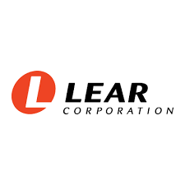
As part of its global operations, Lear’s Redditch facility is an important UK-based manufacturing and engineering site that produces automotive components that are integrated into overall European automotive production systems (Lear, 2026). Operations at the Redditch facility include advanced manufacturing processes, quality assurance, design and engineering development, logistics and supply chain management. The facility also ensures the delivery of high-quality automotive products on time and at the lowest possible cost.

1.2 Industry Context
The automotive manufacturing industry is undergoing rapid change due primarily to intense competition among players in the industry, continual innovation driven by new technology, transition to EVs, digitalisation, automation, and AI-related new ways to manufacture products at a much greater rate of speed, low cost, and environmentally sustainable than ever before (Papulová, Gažová and Šufliarský, 2022). Additionally, external factors such as the challenges presented by Brexit with respect to the complexities of international trade, inflation, and rising energy prices have resulted in a significant increase in the uncertainty of conducting business and the level of operational risk associated with those businesses.

1.3 Purpose and Scope of the Report
The purpose of this report is to provide a strategic planning framework for implementing organisational change at Lear Corporation Redditch. This will be done through an analysis of major drivers for change (internal and external), the disruption caused by an increasing reliance on technology, the inefficiencies that arise as a result of not adapting to these changes, and how these changes have impacted the workforce. The report also reviews various change management models, leadership styles/approaches/characteristics, organisational culture, and strategic planning processes, in order to provide a structured road map toward sustainable transformation of Lear Corporation.

2. Analysis of Lear Corporation Redditch’s Business Environment and Change Triggers

2.1 Recent Organisational Context and Performance
In the last ten years, Lear Corporation has had to adapt to the fast-changing automotive manufacturing environment. This is due to increasing levels of technological change, greater customer demands, and more stringent regulations (Jung et al., 2023). The traditional approach for Lear Corporation was to produce large volumes at low cost and used conventional manufacturing methods with an established supply chain. More recently, due to the changing marketplace, especially after 2018, the limitations of this way of working were apparent and required significant strategic reform.
The COVID-19 pandemic exacerbated the existing issues as a result of interruptions in supply chains, shortages of labour, fluctuations in demand, and financial difficulties. These issues forced Lear to implement more flexible and resilient operational structures such as diversifying supply sources, increasing collaboration with suppliers, and restructuring the workforce (Boonlua et al., 2023). These pressures also drove the business to explore more extensive digital and organisational transformation initiatives to enhance agility, productivity, and cost efficiencies.

2.2 External Triggers For Change
Digital Disruption and Industry 4.0
As stated above, the advent of the digital manufacturing technology revolutionised the current manufacturers’ processes and how these manufacturers approach sourcing, production, and logistics, thereby posing significant external triggers for change as a result of Industry 4.0’s increasing reliance on automation, robotics automation, and sophisticated (e.g. data analytics or statistical analysis) and AI-enabled support systems (Osakuade and Moore, 2023).
Automakers (OEM) have very precise requirements regarding how their supply chains should be configured and operated electronically connected into the real-time supply and logistics ecosystem (Mollah, 2022). As a result, Lear has come under tremendous pressure to upgrade its manufacturing processes through the use of smart manufacturing platforms, predictive maintenance, and quality control processes that utilise AI.
As with any type of technology, the adoption of these technologies is more of a strategic necessity than an optional spend consideration; failure to implement significant digital transformation within the industry, and therefore by Lear, will jeopardise Lear’s existing relationships with its OEM customers while jeopardising Lear’s suppliers (Bhargava et al., 2022). While Lear has worked to progressively integrate AI- based monitoring and automated tools into its processes, it has experienced numerous continuing issues related to availability of qualified individuals, skilled technicians, and significant capital required to support such improvements in learning.
Ecommerce, Online Retail & Changeability of the Market
Although Lear does not directly operate in the realm of online retail, the increasing prevalence of e-commerce & digital commerce ecosystems is changing and evolving how consumers purchase products, including automotive products. Customers are demanding more customisable features, faster delivery times & digitally enhanced features for the vehicles they purchase (Zhang et al., 2019). This has resulted in all of these attributes cascading throughout the automotive supply chain so that component manufacturers are experiencing greater operational burdens.
As original equipment manufacturers (OEMs) are more frequently adopting build-to-order or flexible production methods, Lear Redditch has been required to substantially improve the responsiveness of their supply chain, enhance inventory management systems and improve manufacturing flexibility (Oggero, 2024).
The e-commerce evolution has caused the organisation to invest heavily in digital supply chain platforms, real-time demand forecasting and improved coordination of logistics, thereby providing improved alignment with OEM production schedules and market volatility (Omprakash, 2024).
Sustainability & Regulatory Exigencies
Another major external catalyst for the rapid evolution of the organisation has been the emergence of environmental sustainability (Ebrahimi and Koh, 2021). Government policies encouraging carbon neutrality, increased energy efficiency and ensuring ethical sourcing have forced organisations, including Lear Redditch, to restructure their operations fundamentally to accommodate these pressures. In response to these exigencies, the organisation has begun instituting energy efficiency initiatives, waste-to-value programmes and eco-design principles, thus aligning its corporate objectives with the broader Environmental, Social, and Governance (ESG) objectives.

2.3 Internal Change Drivers Operating inefficiencies and Skills Gaps
The organisation was presented with a number of problems leading up to the transformation; process inefficiencies were leading to increased operational expenses, while also creating limitations associated with legacy IT systems that constricted both productivity and innovation (Biesinger, Kraß and Weyrich, 2019). The organisation’s workforce has also been identified as having large digital skills gaps in areas such as data analytics, digital manufacturing, and automation management. This has limited the organisation's ability to take complete advantage of investments made towards technology (Poorani and Krishnan, 2021). To address these issues, Lear has implemented a number of workforce transformation initiatives, with a focus on digital upskilling, leadership development, and cross-functional collaboration, that have supported existing organisational restructuring efforts aimed to create an agile and innovative organisation focused on continuous improvement.

2.4 Organisation Change Adoption and Response
Lear Corporation Redditch has implemented a phased and strategic approach to the implementation of organisational change, combining both incremental digital upgrades, as well as cultural and leadership transformation initiatives. Primary response strategies have included the integration of automation technologies into production processes, establishment of AI-based quality systems, implementation of increased efficiency through lean manufacturing practices, and enhanced supplier collaboration platforms (Abdul-Nasiru, 2024). Each of these response initiatives has been moderated by resistance to change, shortage of digital skills, and financial constraints resulting in a slow pace of transformation; thereby demonstrating the inherent complexity of managing large scale organisational change in a high-pressure industrial environment.

3. Evaluation of Change Management Models and Their Strategic Application
The strategic transformation of Lear Corporation Redditch initiated a structured, multi-layered change management plan that had to account for digital disruption, operational inefficiencies, workforce competency gaps, and sustainability pressures. Due to the magnitude and complexity of the changes, classical and contemporary change management models will be useful theoretical frameworks from which to assess whether the change was effectively implemented and appropriately managed.

3.1 Lewin’s Three-Step Model
Lewin’s three-stage model of change provides a robust framework for understanding the transition process of Lear Redditch. The unfreezing stage started with the buildup of external pressure in the form of technological disruption, the operational shock of COVID-19, and the changing needs of customers. These forces disrupted the existing operating equilibrium of the organisation, revealing inefficiencies in legacy systems and a traditional manufacturing model (Burnes, 2020). Through the use of performance data, identification of operational bottlenecks, and comparison with industry-best practices, the organisation’s executive leadership team created a sense of urgency to implement radical organisational change.
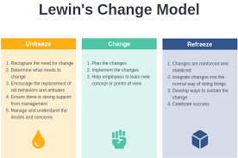
(Source: Burnes, 2020)
During the Change phase, Lear introduced numerous digital manufacturing technologies; AI-driven quality systems; and Lean Production techniques; in addition to implementing various workforce retraining initiatives. Implementing these changes required significant reorganisation of processes and behaviours, supported by considerable investments in automation and digital infrastructure (Memon, Shah and Khoso, 2021). However, implementation of these changes was uneven due to resistance to change; lack of adequate digital skills; and organisational capacity issues (financial resources); thus, highlighting a major limitation of Lewin's model — the assumption that a transition will occur in a relatively stable environment where there is little or no uncertainty — when in fact, Lear operated (and continues to operate) in a much more dynamic and uncertain industrial environment.
The Refreezing Phase of change is still occurring today because Lear continues to establish new operational routines, digital capabilities and cultural norms in the organisation (Memon, Shah and Khoso, 2021). While some progress has been made through training programs and new performance management systems; the sustainability of the change impacts continues to depend on both continued reinforcement of the change by the leadership team and continued alignment with the culture of the organisation. Both of these issues point out the limits of Lewin’s model when relying on this model to sustain change in today’s globally evolving technological environment.

3.2 Kotter’s 8-Step Change Model
Kotter's eight-step process of change offers a narrowed perspective on different methods for identifying Lear Redditch's organisational strategic change journey based on urgency created by: digital disruption; competitive threats; supply chain vulnerability (Laig and Abocejo, 2021). The creation of urgency allowed for the creation of a guiding coalition (consisting of senior leaders, operational managers, and technical specialists) to lead/drive these efforts and initiatives toward transformation.
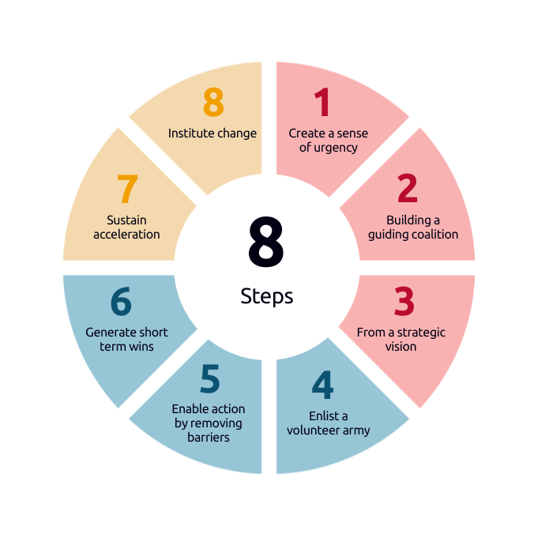
(Source: Laig and Abocejo, 2021)
Having articulated a clear strategic digital vision allowed Lear to begin to align its operational goals and objectives with its technology investment priorities; this was further reinforced through communication strategies to increase workforce engagement and acceptance of such efforts (Majka, 2024). However, communicating effectively throughout all levels of the organisation has not been consistent contributing to employee uncertainty and some reluctance; providing evidence of the challenge of securing organisation-wide buy-in, especially in a traditional manufacturing environment.
The successful placement of short-term wins such as productivity improvements due to automation, and quality improvements from use of AI based inspection systems, enhanced the commitment from management as well as provided tangible justification for continued investment in furthering the on-going commitment to change (Gborogbosi and Amah, 2025). Unfortunately, sustaining this momentum through skill shortages and limiting costs has demonstrated the complexity of embedding long-term cultural and behavioural change. In general, Kotter's change model is largely aligned to Lear's transformation strategy; however, the sequential nature of Kotter's change model does not support any of the simultaneous multi-dimensional change processes involved with the transformation strategy of Lear.

3.3 ADKAR Model
The ADKAR model has provided many insights about the people aspect of Lear’s transformation, specifically in terms of workforce capability development. Internal communications, as well as performance reviews, allowed Lear to identify its need for digital transformation; therefore, Lear implemented training programs to develop employees’ knowledge and skills in automation and data analytics (Dergletckaia, 2023). Even though Lear has implemented a significant number of training programs, persistent skill gaps and resistance demonstrate that Lear faces challenges in developing desire and reinforcement and that significant psychological and cultural barriers still exist.
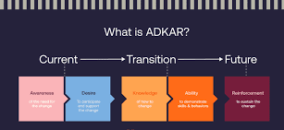
(Source: Dergletckaia, 2023)

3.4 Critical Evaluation and Model Integration
No single model can explain all of the complexities associated with Lear Corporation Redditch’s transformation. Lewin has provided structural clarity, Kotter has provided strategic depth, and ADKAR has addressed behavioural dynamics; therefore, it is necessary to utilise an integrated hybrid model of Kotter’s strategic framework and ADKAR’s people-oriented mechanisms (Sivadasan, 2025). The integration of the two types of models will allow Lear to align its strategic vision, operational execution, and employee engagement, thus increasing the likelihood of sustainable organisational change.

4. Leadership Role and Organisational Culture in Managing Change

4.1 Leadership Style Analysis
Strong Leadership is an Important Element in Supporting Corporate Wide Technology and Cultural Transformation at Lear Corporation Redditch. Historically, the company has Displayed a Predominantly Transactional Type of Leadership Similar to Other Large Manufacturing Companies Which Emphasis on Efficiency, Compliance and Performance Monitoring. As Technology Continues to Evolve with Digital Transformation Increasingly More Complexity is Required for Effective Leaders to Manage Digital Transformations (Hampton Global Business Review, 2025).
The Current Style of Leadership Associated with Today’s Workplace is Called Transformational Leadership. It was Introduced by Bernard Bass & Bruce Avolio and Provides an Appropriate Model to Manage Organisational Change Today. Transformational Leadership Theory Consists of Four Primary Elements (Bass, 2015).
Creating a Vision for the Future: Transformational leaders develop a clear and compelling vision that looks toward the future. In the context of digital transformation, it is critical for leaders to create a clear and consistent message on the importance of automation, AI integration, and redesigning processes as ways to enhance long-term competitiveness rather than just ways to reduce costs in the short term (Munir, Emeanulu and Adeyemi, 2025).
Inspiring Employees to Change: Transformational leaders motivate their employees to change for the long term, beyond their contractual commitment to do so. In an industrial workplace that is dealing with many of the anxieties of being replaced by automation, inspiring motivation gives new meaning to transformation by making it an opportunity to grow and improve one's skills rather than a threat (Pratiwi, Purwanto and Irfan, 2025).
Encouraging Intellectual Exploration: Transformational leaders create an environment that encourages innovation, questioning of established practices, and creative problem-solving. At Lear Redditch specifically, where legacy systems and rigid processes may inhibit employees from experimenting within the organisation (FRC (Financial Reporting Council). 2026; Pratiwi, Purwanto and Irfan, 2025)).
Providing Individualised Support: Individualised support, coaching, and development create trust and reduce resistance by creating engagement through individualised opportunities to develop new skills that correlate to the individual's career development plans.
Lear Redditch's transactional management style is based on a transactional leadership philosophy. The company's management systems are based on setting performance targets, supervising employees to achieve those targets, and using rewards and punishments as the primary mechanisms for maintaining operational efficiency and quality standards (Cherry, 2025; Munir, Emeanulu and Adeyemi, 2025).
Although implementing a transactional management style is beneficial for controlling performance in the short term and ensuring compliance with established processes, the use of a transactional approach will not drive cultural change within the organisation. In addition, a transactional leadership style is heavily focused on end results rather than developing the capacity to innovate and sustain for years to come. In contrast, transformational leadership is more successful at facilitating behaviour changes, shifting employee mindsets and motivating employees to adopt innovative solutions. Implementing digital transformation also requires cultural alignment in addition to making a technical adjustment, so it is necessary for Lear Redditch to move toward a more transformational approach to leadership management (Awotunde and Aregbeshola, 2025).
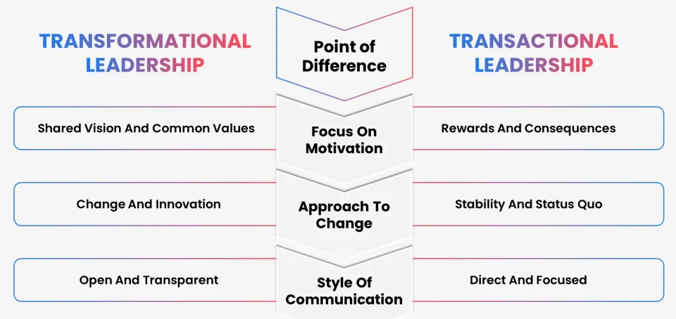
(Source: Munir, Emeanulu and Adeyemi, 2025)

4.2 Role of Leadership During Strategic Change
Articulate a Vision: Clearly articulate and communicate the organisation's vision for the digital future so that digital transformation goals align with (1) the overall organisation's strategy; (2) employee purpose; and (3) reduce uncertainty and thus resistance to digital transformation (Khalilov, Aliyev and Zeynalov, 2025).
Role Model Digital Behaviours: By adopting a personal commitment to adopting tools, making data-driven decisions and leveraging collaborative technology, an organisation will model behaviours that set expectations for employee behaviour.
Support for Innovation: By encouraging experimentation, creativity and risk-taking, a culture of innovation can be created to integrate innovation into everyday operations. Innovation should not be confined to distinct projects, but rather integrated into overall operations (Malik et al., 2025).
Manage Resistance to Change: Provide employees with a transparent and honest way to discuss change, so that their concerns are heard, to have employees participate in the change discussion, and to provide employees with an opportunity for retraining, thus easing anxieties associated with the transition.
Create Psychological Safety: Create a safe place for employees to share their ideas, to express their concerns, to learn from their failures and to not be penalised for expressing themselves (Konečná, Lisá and Čiriková, 2026).

4.3 Organisational Culture Analysis (Schein’s Model)
When using Edgar Schein's three-level model of organisational culture to analyse cultural dynamics at Lear Redditch where it can see how the organisation's cultural foundations, structures, and values affect its operations (Eskandari et al., 2025).
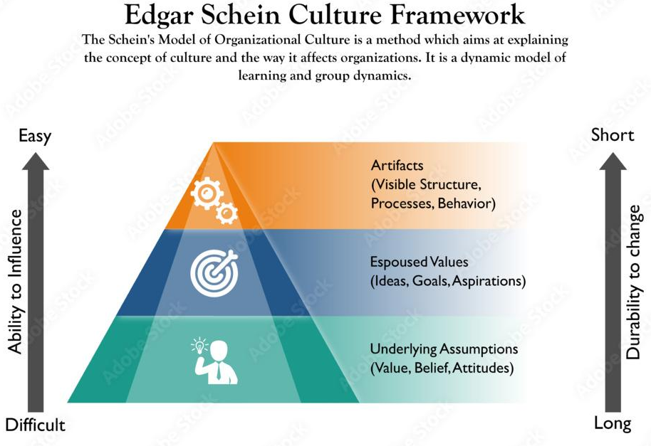
(Source: Eskandari et al., 2025)
Artifacts: The visible elements of Lear Redditch's culture are traditional manufacturing layouts, hierarchical reporting relationships, and rigid SOPs, all of which reflect a highly structured, control-oriented culture.
Espoused Value System: Quality, efficiency, safety and reliability are the values identified by Lear Redditch, which support manufacturing excellence but do not directly promote or foster innovation (Ndubuisi and FNisafetyE, 2025).
Underlying Assumptions: The organisation's deeply embedded belief systems of stability, predictability, and risk aversion conflict with digital transformation because they do not encourage experimentation or adaptability (McCall, 2025).
Cultural Barriers to Change: Cultural barriers to change at Lear Redditch include fear of job loss due to automation and resistance to adopting automation because of uncertainty regarding the new technologies involved, and perceived lack of skills to use those new technologies (McCall, 2025). Comfort with existing systems fosters stability, making employees hesitant to replace procedures with new digital procedures and new innovative methods of working.

4.3 Culture Change Strategy
- Promoting a learning environment through ongoing training and upskilling in digital areas creates a sense of control, as well as developing skill levels (Rebecca2025).
- Secondly, by promoting new ideas through the acceptance of testing of new ideas and working across functions, can help to increase levels of agility.
- Thirdly, implementing a reward system that supports the use of Digital and Improvement methods can reinforce the desired behaviour (Mueller‐Saegebrecht and Walter, 2025).

5. Proposed Strategic Change Management Plan

5.1 Objectives of the Change Programme
Lear Corporation’s strategic change programme intends to enhance sustainable competitiveness and the durability of its operations over the long haul. The primary goals include implementing AI-enabled manufacturing systems, increasing operational efficiency by 25-30% through data-driven quality control, and reducing defect rates by 40% (Lear Corporation, n.d). The second major goal is to achieve carbon-neutral manufacturing status by 2035 in support of the company's Environmental, Social, and Governance (ESG) commitments. Thirdly, an essential goal of the programme is the establishment of a digitally skilled workforce to operate and manage advanced automation technologies and to maintain continuous innovation (Yang, X., Liu, Y., Ji, J., Liu, K. and Li, W., 2025).

5.2 Proposed Strategic Change Initiatives
Digital Transformation: The organisation is going to implement smart factory technologies via an application of IOT sensors that include real-time data collection, analytics and inter-connected production systems. With the help of artificial intelligence predictive maintenance solutions will reduce downtime and improve reliability of the equipment (Kadam, Peddinti and Gupta, 2025).
Workforce Development: This strategy involves creating a comprehensive training program to supply current employees with skills associated with artificial intelligence and digital skill development. Additionally, within Workforce Development a program to acquire new digital technology skills will also be created to assist current workers redevelop or re-design their job as a result of using new automated technologies. Investment made into technologies must be matched with a corresponding investment into developing human capital (D'Costa, 2025).
Process Optimisation: Utilisation of Lean Six Sigma principles will be utilised to eliminate waste, increase process stability and maximise efficiency; while Agile Manufacturing will provide flexibility when responding to changes in Original Equipment Manufacturers (OEM’s) requirements (Kadam, Peddinti and Gupta, 2025).

5.3 Financial Plan
Significant capital resources will be dedicated to investing in automation technology, AI applications, and digital integration platforms within the automation framework. An annual training budget will also support workforce training initiatives (Ajuwon et al., 2025). The projected return on investment will be measured through projected productivity gains, cost reductions resulting from fewer defects and reduced maintenance costs. The evaluation of capital expenditures against anticipated enhancements to efficiency, savings in carbon emissions, and increased customer retention will be conducted as part of a structured cost-benefit analysis to ensure long-term financial viability (Andaru, 2025).

5.4 Communication Plan
Successful change implementation depends greatly on effective communication. A stakeholder mapping exercise will help to identify both internal and external stakeholders. The use of multiple channels for communication should create greater transparency. Engagement strategies should promote dialogue and provide opportunities for feedback. A network of trained change champions will assist with peer influencing throughout the organisation and strengthen commitment to the transformation objectives (Jwa, 2025).

5.5 Risk Management and Resistance Mitigation
To achieve the transformation objectives for Lear Corporation Redditch, effective management of risks around the transformation initiative is critical. One of the primary risks is anxiety related to workforce automation and AI adoption, in particular fears of job displacement or diminished job relevance. A risk mitigation plan includes three key elements: open and clear communication, early participation in discussions about changes, and establishing structured reskilling programs that allow for career advancement on a long-term basis (Putri and Werdini, 2025). Barrier technologies to adoption create operational risk. Implementation of the pilot phase, phased implementation to model out potential disruption, and the implementation of technical support structures will mitigate disruption (Hounnou and Ouedraogo, 2025).
Financially, the project will have significant initial investment; therefore, the use of stage financing, tracking ROI and cost-benefit analysis will be used to manage any financial risks that arise. Operational disruptions during implementation could cause significant disruptions to productivity, therefore the use of contingencies and testing of parallel systems as part of the contingency plan will ensure operational continuity. Furthermore, proactive engagement through the use of leaders visible through the organisation and change champion networks will further reduce resistance to implementing change and build organisational commitment to the new way of working (Wijaya, Madiawati and Pradana, 2025).

5.6 Monitoring and Evaluation Plan
To ensure the achievement of measurable and sustainable outcomes through the strategic transformation of Lear Corporation Redditch, the Monitoring and Evaluation (M&E) framework is being developed. To assist with measuring these outcomes, Key Performance Indicators (KPIs) will be developed for each of the following dimensions: Operational, Financial, Learning, and Sustainability (Tenas Bosch, 2025).
Operational KPIs will measure: the defect rate; improvements in production efficiency by 25% to 30% equipment downtime; and on-time delivery performance. Sustainability indicators will track energy consumption on improvements in waste reduction; and progress towards achieving carbon neutral manufacturing by 2035. Workforce metrics will measure: the number of employees who have been trained digitally, the number of skills acquired and the employee engagement score (Bai et al., 2025).
A Balanced Scorecard approach will be utilised to integrate performance measures including: financial performance and internal process improvements; customer satisfaction; and learning and growth to ensure strategic alignment within the organisation. In addition, quarterly performance reviews will be completed to determine if the organisation is on track to achieve its KPIs and to identify any variances from the KPIs measured (Manjur, 2025). Employee surveys, performance dashboards, and cross-functional review meetings will provide employees with structured feedback loops. Lean Six Sigma methods will enable organisations to implement ongoing cycles of improvement and to identify ways to make corrective and incremental improvements. This structured evaluation process helps establish the accountability and responsiveness necessary to achieve long-term transformation sustainability (Bai et al., 2025).
6. Conclusion
Lear Corporation Redditch is dealing with serious environmental obstacles including; digital disruption, supply chain volatility, regulatory sustainability and OEM evolution and expectations that have exposed the limits of current manufacturing methods and driven urgent need for strategic transformation. Introducing structured digital change is vital for improving efficiency and quality as well as providing long term competitiveness. However, the scope of any sustainable transformation will depend on; the ability of leaders to provide appropriate leadership, the evolution of culture, and fostering an environment conducive to transformational leadership and learning-based culture. Building and enhancing both digital readiness and sustainability commitments ensures that the entire organisation will be able to adapt to the rapidly changing automotive market with success now and into the future.

References
Abdul-Nasiru, I., 2024. The role of change readiness in the relationship between learning organisation and successful change implementation. Journal of Organizational Change Management, 37(5), pp.849-865.
Ajuwon, A., Oladuji, T.J., Akintobi, A.O. and Onifade, O., 2025. AI-Powered Transformations in Financial Services: Automation and Innovation in Investment and Risk Models. Engineering and Technology Journal, 10(6), pp.5397-5415.
Andaru, F.M., 2025, January. Cost-benefit analysis of corporate investments in tropical forest restoration. In IOP Conference Series: Earth and Environmental Science (Vol. 1447, No. 1, p. 012029). IOP Publishing.
Awotunde, M.O. and Aregbeshola, R.A., 2025. Effect of leadership styles on entrepreneurship success: a comparative analysis. Cogent Business & Management, 12(1), p.2516176.
Bai, H., Chen, Y., Bai, H., Liu, M. and Fan, Y., 2025. Energy optimization and efficiency improvement model for enterprise production process based on deep learning under the background of carbon peak and carbon neutrality. International Journal of Computational Intelligence Systems, 18(1), p.169.
Bass, B., 2015. Transformational leadership theory. In Organizational Behavior 1 (pp. 361-385). Routledge.
Bhargava, A., Bhargava, D., Kumar, P.N., Sajja, G.S. and Ray, S., 2022. Industrial IoT and AI implementation in vehicular logistics and supply chain management for vehicle mediated transportation systems. International Journal of System Assurance Engineering and Management, 13(Suppl 1), pp.673-680.
Biesinger, F., Kraß, B. and Weyrich, M., 2019, October. A survey on the necessity for a digital twin of production in the automotive industry. In 2019 23rd international conference on mechatronics technology (ICMT) (pp. 1-8). IEEE.
Boonlua, S., Supachaiwat, J., Thongchua, K. and Mohamad, B., 2023. Linking supply chain resilience strategies for surviving major disruptions. International Journal of Construction Supply Chain Management, 13(1), pp.154-172.
Burnes, B., 2020. The origins of Lewin’s three-step model of change. The Journal of Applied Behavioral Science, 56(1), pp.32-59.
Cherry, K. 2025. How a transactional leadership style works. [online] Verywell Mind. Available at: https://www.verywellmind.com/what-is-transactional-leadership-2795317. [Accessed 24 Feb. 2026].
Dergletckaia, V., 2023. Change Management in a Context of Digital Transformation.
Ebrahimi, S.M. and Koh, L., 2021. Manufacturing sustainability: Institutional theory and life cycle thinking. Journal of Cleaner Production, 298, p.126787.
Eskandari, D., Haghparast Ghomesheh, A., Jabbari, M., Gholami, A. and Ahmadi, O., 2025. Development of a New Index to Assessing the Safety Culture Based on the Edgar Schein Model (Audit Approach). The Scientific World Journal, 2025(1), p.3166187.
FRC (Financial Reporting Council). 2026. Lear Corporation. [online] Available at: https://www.frc.org.uk/library/standards-codes-policy/corporate-governance/corporate-culture/lear-corporation/ [Accessed 24 Feb. 2026].
Gborogbosi, L.G. and Amah, E., 2025. The effectiveness of change management models in different industries. South Asian Research Journal of Business and Management, 7(03), pp.333-343.
Hampton Global Business Review. 2025. The Evolving Role of Leadership in Tech-Driven Organizations - Hampton Global Business Review. [online] Available at: https://hgbr.org/research_articles/the-evolving-role-of-leadership-in-tech-driven-organizations/. [Accessed Date: 24th Feb, 2026]
Hounnou, E.F. and Ouedraogo, M., 2025. Methodology for calculating the Return of investment (ROI), the Benefit-Cost Ratio (BCR), and Cost Effectiveness Ratio (CER) of the integrated resilience programmes in the Sahel.
Jung, S., Kara, L.B., Nie, Z., Simpson, T.W. and Whitefoot, K.S., 2023. Is additive manufacturing an environmentally and economically preferred alternative for mass production?. Environmental science & technology, 57(16), pp.6373-6386.
Jwa, S., 2025. Written feedback dialogue: A cyclical model for student engagement with feedback. TESOL Quarterly, 59(2), pp.1024-1035.
Kadam, A., Peddinti, D.R. and Gupta, A., 2025. The Evolution of Smart Factories: Integrating IOT and Machine Learning in Supply Chain and Manufacturing. Journal of Computer Science and Technology D'Costa, C.S., 2025Studies, 7(5), pp.251-261.
Khalilov, T., Aliyev, V. and Zeynalov, I., 2025. The role of leadership and managerial skills in strategic planning. Journal of Information Systems Engineering and Management, 10(20s), pp.98-104.
Konečná, L., Lisá, E. and Čiriková, V., 2026. The role of leadership in shaping psychological safety: a qualitative study from Slovakia. Scientific Reports.
Laig, R.B.D. and Abocejo, F.T., 2021. Change management process in a mining company: Kotter’s 8-step change model. Journal of Management, Economics, and Industrial Organization, 5(3), pp.31-50.
Lear Corporation, n.d. Sustainability | Lear Corporation. [online] www.lear.com. Available at: https://www.lear.com/sustainability. [Accessed Date: 24th Feb, 2026]
Lear, 2026. Our Company. [Online]. Available at: https://www.lear.com/ [Accessed on 23rd February 2026].
Majka, M., 2024. Leading change successfully: A guide to Kotter’s 8-step process.
Malik, M., Raziq, M.M., Sarwar, N. and Tariq, A., 2025. Digital leadership, business model innovation and organizational change: role of leader in steering digital transformation. Benchmarking: An International Journal, 32(5), pp.1632-1662.
Manjur, S.A., 2025. Development of Time Management and Leadership KPIs for Managers: A Literature Review-Based Approach.
McCall, A., 2025. Technology acceptance and resistance: understanding employee adaptation to digital tools.
Memon, F.A., Shah, S. and Khoso, I.U., 2021. Improving Employee's Engagement in Change: Reassessing Kurt Lewin's Model. City University Research Journal (CURJ), 11(1).
Mollah, S., 2022. Study and definition of a digital supply chain in automotive industry (Doctoral dissertation, Politecnico di Torino).
Mueller‐Saegebrecht, S. and Walter, A.T., 2025. Strategic agility—an urgent capability for successful business model innovation? A conceptual process model and theoretical framework. Strategic Change, 34(3), pp.407-428.
Munir, R., Emeanulu, L.U. and Adeyemi, A., 2025. Examining the role of transformational leadership in shaping employee behaviour: an empirical analysis of Pakistani SMEs. Open Access Library Journal, 12(04), pp.1-23.
Ndubuisi, O.G. and FNisafetyE, F.I.S.P.O.N., 2025. Effective Quality Control Management: Enhancing Customers Satisfaction and Strengthening Organization’s Competitive Edge.
Oggero, A., 2024. The Impact of Supplier Lead Time on the Automotive Supply Chain (Doctoral dissertation, Politecnico di Torino).
Omprakash, M.K., 2024. Optimizing demand forecasting and inventory management with AI in automotive industry.
Osakuade, P. and Moore, O.M., 2023. Review of Disruptive Technology in Automotive Manufactruring. Technol Invest, 14(3), pp.137-152.
Papulová, Z., Gažová, A. and Šufliarský, Ľ., 2022. Implementation of automation technologies of industry 4.0 in automotive manufacturing companies. Procedia Computer Science, 200, pp.1488-1497.
Poorani, S. and Krishnan, L.R.K., 2021. Manufacturing technology trends in auto sector guiding skill enhancement and employee retention. Indian Journal of Training and Development, 51.
Pratiwi, E.C., Purwanto, F. and Irfan, M., 2025. Leadership 4.0: How Transformational Leadership Shapes Employee Engagement in the Era of Industry 5.0. Jurnal Informatika Ekonomi Bisnis, pp.277-281.
Putri, K.M.H. and Werdini, Y.E., 2025. Artificial intelligence adoption, job insecurity, and psychological resilience: Challenges for employee adaptation in future work environments. International Journal of Issue Science, 1(5).
Rebecca, F.L., Ritz, E., Rietsche, R., Beitinger, G. and Leimeister, J.M., 2025. How Siemens Empowered Workforce Re-and Upskilling Through Digital Learning. MIS Quarterly Executive, 24(3).
Sivadasan, J., 2025. The effects of Change Management Approaches on Employment Productivity (Doctoral dissertation, Dublin, National College of Ireland).
Tenas Bosch, J., 2025. Optimizing key performance indicator development: a data-driven framework for nonprofit organizations.
Wijaya, B.S.G., Madiawati, P.N. and Pradana, M., 2025. Strategy to Improve Service Continuity Performance Through Organizational Resilience and Business Continuity Management. Enrichment: Journal of Multidisciplinary Research and Development, 3(7), pp.3262-3278.
Yang, X., Liu, Y., Ji, J., Liu, K. and Li, W., 2025. Digital transformation and the fluid workforce: skill development and capacity building for railway workers. Journal of Asian Architecture and Building Engineering, pp.1-16.
Zhang, X., Ming, X., Liu, Z., Zheng, M. and Qu, Y., 2019. A new customization model for enterprises based on improved framework of customer to business: A case study in automobile industry. Advances in Mechanical Engineering, 11(3), p.1687814019833882.

