I confirm that I have not used any AI tools in the research and creation of this assignment. I confirm that I have not presented any AI generated materials as my own work. I confirm I have copies of my drafts, notes, and other resources I used, which I may be asked to provide in evidence.

What Can My Fear of Vulnerability Teach Me About Myself and My Therapeutic Practice?

Introduction

Attempting to explore and better understand the different facets of oneself is a crucial part of training for therapists in order to optimise their psychotherapeutic practice, facilitate meaningful connection and therapeutic change (Pereira et al., 2024). For this purpose, the current research utilises the qualitative research method of heuristic inquiry, formally conceptualised by Moustakas (1990), grounded within the philosophies of authors like Buber (1970), Rogers (1985), Gendlin (1962; 2003) and Polanyi (1964). This is an explorative, autobiographical process in which the researcher aims to uncover deeper meaning or answers to the nature of a particular personal challenge, phenomena or experience in order to better understand themself, the world and their experience (Moustakas, 1990, p. 15). This is done through internal pathways of self using the processes of self-reflection, exploration, and elucidation (Douglass & Moustakas, 1985). The current work will focus on my fear of vulnerability; how it impacts me and my therapeutic practice.

Vulnerability can be defined as ‘the quality or state of being exposed to the possibility of being attacked or harmed, either physically or emotionally’ (Oxford Languages, 2025). Considering my internal frame of reference (Moustakas, 1990), the phenomena of focus lies within the risk of psychological and emotional harm; the fear that sharing parts of my experience and self, particularly those of an emotional nature, will result in this kind of harm. This fear moved further into my awareness once starting the current Masters programme in Psychotherapeutic Practice. Around the same time, I began to attend personal therapy as part of the requirement for this course. The combination of these environments consolidated what I had sensed within myself for a long time; that this fear was deeply rooted within my early family relationships and was impacting almost all aspects of my life. Being raised by a narcissistic and emotionally immature father, along with an emotionally detached mother struggling with substance misuse meant both my caregivers were preoccupied, disconnected from themselves and their emotions, thus not able to provide appropriate emotional or psychological care for myself or my sister, in line with definitions of emotional neglect (Bowlby, 1969; Kumari, 2020). From this, I learnt it was unsafe to authentically express myself and the entirety of my experience, particularly regarding certain emotions. I learnt to hide these parts of myself, altering my expression in order to achieve psychological safety and to have my needs met by my caregivers. This pattern ultimately disconnected me from my emotional experiences, authentic self and my own humanity.
Previous academic experiences contributed to this disconnection and fear. Up until this point, I held a cold, detached dichotomy between myself and my academic work, resulting from a toxic academic culture in which personal value and humanity was judged based on achievement. I learnt it was not safe or ‘appropriate’ to bring myself and my emotional experiences into these kinds of spaces. Entering into the current academic course in which I am expected or ‘invited’ to bring my ‘whole self in’ has been an entirely novel and deeply dysregulating experience that I am continuously attempting to navigate and which this work attempts to address.

Some argue that therapeutic outcomes are not significantly predicted by therapist’s modality, training, or amount of experience, but from their ability to appropriately address difficulties that arise during clinical practice (Pereira et al., 2024; Nissen-Lie et al., 2015). My fear of vulnerability is a difficulty which acts as a barrier to my ability to truly, authentically express myself and be present with others across contexts, undoubtedly impacting my therapeutic practice. For example, supervisee self-closure is a necessary component to successful supervision, which is an essential factor in developing therapist’s competence and efficacy (Borders, 2017; Keum & Wang, 2021).

In terms of client work, Biltzer (2023, p. 82) expresses that “when we model our humanness and vulnerability, it provides our patients with a pathway to greater authenticity and interpersonal freedom”. Authenticity, defined as “one’s ability to fully represent themselves, consistent with their internal values and external responses” (Sherwood, 2021, p. 1). Thus requires self-reflection, open communication and a willingness to be deeply seen by others (Lietaer, 2001; Yang et al., 2022; Sherwood, 2021; Bachand, 2023). Our most authentic sense of self is continuously shaped through our connections with others and our willingness to be “touched, changed, and possibly wounded in unexpected ways” by others (Slavin, 1998, p. 237), making authenticity inherently relational and dependent on vulnerability (LeRoux et al., 2007; Powers, 2017).
This closely aligns with Roger’s (1961) concept of congruence; when a therapist “is genuine and without ‘front’ or façade, openly being the feelings and attitudes which at that moment are flowing in them” (p. 61). This is a dual-faceted, transient state in which the therapist is aware of their true internal experience and is willing and able to communicate this to the other (Lietaer, 1993). Thus occurring intrapersonally, within the therapist, but also interpersonally as an experiential quality of the therapeutic relationship (Kolden, 2011). Congruence is embodied by the therapist and modeled to the client through conscious, appropriate self-disclosure and communication of any relevant thoughts, feelings and observations about how they are experiencing them (Kolden et al., 2018). The therapist’s capacity and ability to be authentically present in this way has been associated with strong therapeutic alliances, relational depth and significant therapeutic change (Kim et al., 2020; Kolden et al., 2019). Importantly, clients are active agents within the relationship who impact the therapist's ability to experience and communicate congruence (McLeod, 2002; Burks & Robbins, 2012). It is through mutual vulnerability within this space that can cultivate and co-create a sense of safety and acceptance, allowing the client to be fully seen by their therapist through authentic exploration (Slavin, 1998; Burks & Robbins, 2012; Kolden et al., 2018).
Conversely, therapist’s incongruence and unwillingness to be vulnerable can be felt or sensed by clients which can impede the creation of a psychologically safe environment with the possibility of negatively impacting the development of the therapeutic alliance, limiting client change and effective therapy (Podolan & Gelo, 2023; 2024; Burks & Robbins, 2012). This kind of therapist inauthenticity can also manifest as burnout or ethical violations, ultimately negatively impacting their wellbeing and ability to practice safely and effectively (Burks & Robbins, 2012).

In order to serve as an authentic and congruent model for my clients and enhance my efficacy as a therapist, understanding and reflecting on significant barriers to this, like my fear of vulnerability, appears crucial. Kaimaxi & Lakioti (2021) express that the development of congruence is a life long, ongoing process, evolving into a way of being which requires active, constant care and nurturing. In this sense, the current research evidences my first dedicated attempt at thoroughly exploring and nurturing this part of myself, for the sake of myself and my practice.

Methodology

The current investigation utilised Moustakas’s (1990) six phases of heuristic inquiry; initial engagement, immersion, incubation, illumination, explication and creative synthesis.
Data was collected across the span of six weeks, utilising the core processes of heuristic inquiry; self dialogue, indwelling, focusing (Gendlin, 1962), considering the tacit knowledge (Polanyi, 1964), intuition and my internal frame of reference regarding the phenomena of interest (Moustakas, 1990). These processes were reflected and presented in the form of journal entries, images, songs and personal reflections surrounding my experiences within university, supervision, personal therapy, my personal relationships and therapeutic practice. No particular schedule or strategy for this data collection was set, it was purely intuitive and opportunistic in nature.

Findings

As soon as I began this process; at the stage of initial engagement, the looming, lingering phenomena of my fear of vulnerability came to the forefront of my mind. For a long time, I had possessed a deeply felt sense or tacit knowledge that this was impacting me; my relationships with others, how I navigated the world and crucially my therapeutic practice. The question remaining: ‘how and to what extent does this impact me?’. I was instinctively waiting for the opportunity to confront and meaningfully explore it. I knew this phenomenon deserved disciplined commitment and that I could no longer avoid it, similar to how Sultan (2018) and Moustakas (1990) described. I felt so strongly that for the sake of myself and practice I had to choose to engage with this.

The first piece of data comes in the form of the song ‘Curious/Furious’ by Willow Smith (2022). This embodied the curiosity and fascination I felt towards the phenomena; the feeling of being on the edge of discovering something profound, of starting a significant undertaking, an adventure. This also reflects some of the fear, anger, frustration and isolation I had been holding about this part of myself. In particular the lyrics: “And I'm takin' this adventure on my own; Walkin' through a darkened forest, goin' home; Curious, furious, I feel alone, oh, ooh;...because life doesn't choose; Either side, win or lose, right or wrong, it's a battle; That's all in your mind, you better open wide”. I’d repeatedly listen to this song, feeling energised and empowered, ready to alchemise these feelings into meaningful change.

Next, came the task of actually naming my phenomena. Translating this powerful sense into a few words proved challenging and I spent a lot of time oscillating between initial engagement and immersion in an attempt to clarify my subject and suitably define it. I was self-searching, “drawing from the mystery and sources of energy and knowledge within the tacit dimension” (Moustakas, 1990, p. 28). Most data at this stage came in the form of self-dialogue. I contemplated deeply; “Is it a fear of vulnerability? A fear of emotional expression? But I know it extends deeper than that, so is it a fear of being fully seen? Of allowing all parts of me to be seen? Of allowing my true authentic self to be seen? A motivation to hide parts of myself? Aren’t these all different words for the same phenomena? Which should I use?”

At the same time, a part of me felt light, hopeful. I was ready to trust myself, own my process and to completely surrender to it, as Sela-Smith (2002) describes. I knew that if I simply allowed myself to be with this phenomena I would find further meaning and understanding from within and outside of myself. This was reflected in a Haiku I wrote as an exercise at university (appendix 1). Constantly, I was searching for meaning from any experience or information I engaged with; through books, social media and discussions with others to try and concisely articulate this phenomena “Everything feels related, I’m really struggling to put into words this phenomena and separate it; it runs so deep and permeates so much of my experience, where do I draw the line?”. This experience of realising the interconnectivity and attempting to isolate the phenomena was further encapsulated in the image presented in appendix 2. I was holding and moving between both parts of myself; the confusion and fear of ‘doing it wrong’ along with the hope, curiosity and possibility of freedom.

After two weeks of this kind of oscillation, my phenomena was clarified, my life continued “to become crystallised around it” (Moustakas, 1990, p. 28) and I was clearly within the stage of immersion. When a relevant thought or feeling would arise, I would take note of it. When engaging with others, I would attempt to observe, holding my research topic in mind. How am I engaging with this person? What am I sharing? What am I not sharing? Do I feel motivated to share or hide? Why is this? What am I feeling within my body when I engage in this way? What is happening for me in this moment?

With time, I became gradually more deeply immersed within the topic, consistently operating within periods of hyperfixation and taking small or ‘micro periods’ of incubation between attending supervision, placement and university. The phenomena was constantly simmering under the surface of every experience and thought I had, like an app running in the background of a phone collecting information. Here, data was collected through journal entries (appendix 3). Within this, there was frustration, helplessness, defensiveness, criticism, along with a core feeling: ‘I’m tired of having to fight to make space for myself in a way that doesn’t feel like me’, ‘I’m tired of fighting to be seen and trying to push through the discomfort’. I felt defeated and exhausted from the dysregulation that came from developing greater awareness of my experience and trying to shift long ingrained behavioural patterns. The lack of control and despair I felt about this was encapsulated within two songs. Firstly, ‘Sticky’ by FKA Twigs (2025), in particular the lyrics: ‘You’re right, I hold it in my body; little snakes inside a bottle; writhing in my frustrations; but it hurts so bad; to shed my skin with you watching; you know, you know, you know, it makes me shy; count one, two, three; and show my vulnerability; come on, come on, come on; say something nice; to me’. Secondly, ‘911’ by Lady Gaga (2020): ‘Turning up emotional faders; Keep repeating self-hating phrases; I have heard enough of these voices; Almost like I have no choice’... ‘Holding on so tight to this status; It's not real but I'll try to grab it; Keep myself in beautiful places; Paradise is in my hands’... ‘My biggest enemy is me’.

These last two phrases along with two meaningful conversations with my therapist and supervisor quickly moved me into the illumination phase, in which I was ‘awakened to a new dimension of awareness and understanding’ about my experience (Moustakas, 1990, p. 29-30). After explaining my experiences in university to my therapist, they made the observation of the internal conflict that was happening within me; the battle I had described; between wanting to be seen and heard and my fear of being vulnerable. This took me back to the first assignment of the academic year; a presentation on attachment (Payne, 2024). Here I spoke about this conflict that individuals with a disorganised attachment style may feel (Bowlby, 1969) and created my own diagram (appendix 4). At the time, despite having all the information, I did not see myself in this description, but the feeling of the internal conflict, the chaos, resonated deeply within me. Here I felt compelled to depict this, as seen in appendix 5. My fear of vulnerability was a darker, shadow part of me that was driving this conflict. I further explored this, deeply relating to Crittenden’s (2006) A4 category of responding within their Dynamic Maturational Model of Attachment. These ‘compulsively compliant individuals’ attempt to prevent danger or ensure safety by inhibiting negative affect and complying to the demands of attachment figures, most often evidence when caregivers are viewed as angry or threatening (Crittenden & DiLalla, 1988). This helped shift the way in which I viewed this part of myself that I had exiled; this fear was part of an adaptive, protective response strategy to ensure my survival as a child.
Further data was collected within supervision in the form of a conversation about how we both experience each other. This led to my supervisor sharing that they could sense my withholding and that this impacted how they engaged with me. They felt compelled to share more of their experience because I was not sharing a lot about myself. Evidently, the way I was engaging, from this fear of vulnerability and lack of sharing, was creating an unequal dynamic in which others felt they needed to compensate. The conclusion from this discussion was the need for greater assertion and agency. I needed to accept the role I was playing in my own suffering and take action to share more of myself (appendix 6). Until this point, I felt passive, victimised and at the control of my hypersensitive nervous system. I noticed I was incredibly resistant and hypercritical of others within interactions involving the possibility of vulnerability and sharing. I would pick apart the environment, trying to blame anything but myself; the lighting, the number of people, the uncomfortable chairs, the colours on the walls. ‘I shouldn’t have to share if I don’t want to’, ‘I just don’t like them’; ‘they just don't understand’. I felt the irony and hypocrisy within this. ‘How can they understand if I don’t tell them?’. These were ultimately projections, reflecting a deeper unsafety within myself.

This prolonged phase of illumination closely followed and somewhat overlapped with the explication phase. I felt the whole picture of my experience forming, quickly becoming aware of the underlying themes surrounding my phenomena and underpinning all of my experiences and data collected (Moustakas, 1990). I was naturally doing my own internal thematic analysis, formally presented in appendix 7.
From here, I began to ask myself: ‘What can I do, what strategies can I put in place, to encourage myself to confront this fear and make it easier for me to share with others?’. Here, data was collected in the form of affirmations and attempts to connect with my inner child. I asked, what do I need to hear before, during and after challenging situations in which I need to share? (appendix 8). Now, my sense of agency was strengthened, and I was reminded of the quote: “Between the stimulus and response, there is a space. And in that space lies our freedom and power to choose our responses. In our response lies our growth and our freedom” (Frankl, 1946). I felt confident that I had found a way to break this relational cycle I was in and was beginning to accept my reality; just because I am aware of my patterns doesn’t mean they will just disappear, that trying to change them will be uncomfortable and that this is life long work that I am committed to. Within this, there was hope. The phrase ‘I know love exists because I am full of it’ came to me, particularly when reflecting on my relationship with my partner; how safe and capable I felt of sharing my authentic self with him and how I hope that I can utilise and translate this feeling into my therapeutic practice. Further reflection led me to discover I had already depicted this feeling in a painting I created five years ago whilst undergoing an intense period of self-reflection, change and reconnection with myself (appendix 9). This work signifies freedom, opportunity, hope, light, liberation and expansion; the love, capacity and possibility I hold within me; how expansive this is. From this, I was certain that through this process I was slowly coming back home to myself.

Creative Synthesis

The final integration or creative synthesis of data, qualities and themes discovered in the explication phase (Moustakas, 1990) is presented firstly in Diagram I. This encapsulates the overall cycle of responding that I had observed myself engaging in throughout the process, along with the strategies implemented to attempt to shift or break this cycle. Secondly, the entirety of my emotional experience was further synthesised in the form of a poem as shown below.

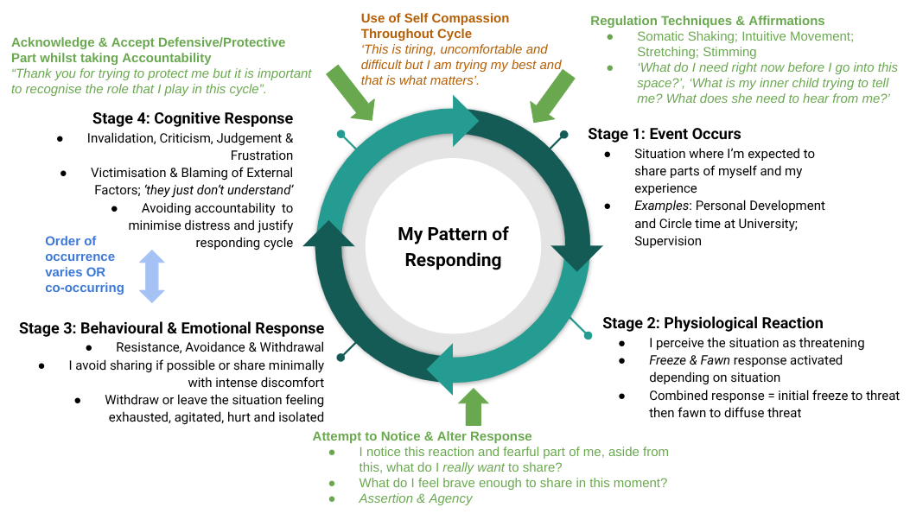
Diagram 1. A Diagram Depicting my Cycle of Responding
A Poem to Myself

It’s okay my love, it’s okay,
You tried to show up for yourself today,
You tried, you’re trying,
So hard, it hurts,
You’re trying, that’s what matters,
You are (doing) enough

That conflict, that chaos,
That void you’ve been carrying,
That anger you’ve known as long as yourself,
I know it all bubbles up as tears,
But please let it,
Let it out,
However it comes,
Let go,
You deserve it

Please my love,
Rome wasn’t built in a day,
These patterns, this way of being,
We created to protect you,
Sometimes they still serve you,
But mostly they hurt you,
You are stronger, you’re aware,
Now is the time to try something new

You’re aware, and poof!
Wait, it hasn't just gone away?
How inconvenient, how disappointing,
That this healing business takes work,
Lifelong work,
But that’s okay,
I know you’re committed,
I know you’ll find a way

I see your impatience my love,
But please remember,
You’re human, not a robot,
And how wonderful that is!
To feel all these things so deeply,
To have such richness in your life,
When apathy is the easier option,
How brilliant, how courageous you are

Please my love,
Try to live in the moment,
Give value to the process,
In the space between you and another,
Try not to wish yourself away,
Waiting for the end,
Allow yourself to be changed,
Sit in it,
Embrace it,
For this is where life happens

Discussion

This heuristic process, although attempts to provide structure within the distinct phases described, for me, was entirely non-linear. Like the ‘rhythmic dance’ as described by Sultan (2018, p.12). I continuously oscillated between and existed within multiple phases at once. Likewise, attempting to encapsulate the entirety of my experience whilst trying to dissect and separate it out into distinct categories proved challenging.

Nevertheless, this work has significantly shifted the way I view myself, others and what happens in the space between us. Noticing what happens here, owning my reactions and role in this and attempting to share with others has been deeply liberating. I now have a greater sense of direction and understanding of how I can free myself from this relational cage I have kept myself in for so long and how I may help others do the same. This process and sharing within safe spaces like with my partner and therapist has highlighted my need for deeper connection with my authentic self and with others and emphasised that this healing cannot be done in isolation. It is through these relationships that I am gradually coming home to myself and I feel strongly that I am capable of facilitating this kind of change and homecoming for my clients also.

The greater awareness I have gained surrounding my fear of vulnerability; how this is related to my own attachment and how it can show up in relational dynamics, has significantly impacted my client work, particularly regarding transference and countertransference. For example, during initial sessions, I feel it is important to emphasise the client’s agency and choice. Whilst this remains important for working in a trauma informed way, I now realise may also involve my own projections and fears about working with emotions (McCartan, 2020; Herman, 1992). I noticed myself using phrases like “There is no pressure to talk about anything specific” or “there is no rush”. I believe on some level these are attempts to reassure myself and to protect my nervous system but may be inadvertently communicating to my clients that I am not comfortable or ready to handle their emotions during the first session, potentially setting a tone for subsequent sessions. I am now more conscious and intentional about the way in which I contract with my clients and when talking about agency, choice and psychological safety.

Similarly, I noticed clients who resemble my own family members in some way result in me being less congruent and connected to myself in sessions, more cautious of self-disclosure and less motivated to focus on the client's emotional experiences, allowing us to stay in a more cognitive space. The opposite has occurred with clients who remind me of myself. Here, I have felt the least fearful, most congruent, grounded, willing to self-disclose and able to work in a more embodied way.
With these clients I have witnessed the most therapeutic change, supporting previous work emphasising the importance of congruence and co-regulation in the therapeutic relationship (Kolden et al., 2019; Kim et al., 2020; Hilpert et al., 2020). This dichotomy in my way of working reflected the inner conflict I had discovered and further highlighted the importance of finding new ways to regulate myself and start my sessions with clients from a more embodied place rather than from a place of fear and apprehension. I was introduced to the technique of heart-focused breathing in which you visualise and intentionally focus your attention on your heart whilst breathing deeply. I now practice this, along with using affirmations and somatic exercises when I feel I need them prior to sessions with clients.

This process has also encouraged me to disclose more during supervision surrounding the emotional impact of my therapeutic practice. For instance, experiences with certain clients, moments where I felt I did not practice as well as I would have liked or I feel I’ve made a mistake. Ultimately, these experiences are opportunities for personal and professional growth; being more open to sharing these experiences is likely to enhance the quality of supervision I participate in and my efficacy as a practitioner (Rønnestad et al., 2024).

The new found compassion I have found for myself during this inquiry and greater acknowledgement of my own emotional experiences has helped clarify and inform my own way of working and helped to shape my identity as a therapist. More specifically, I am intentionally utilising a more compassion-focused approach (Gilbert, 2009) with my clients. Likewise, working in an attachment-informed and emotion-focused way feels necessary and authentic to me (Greenberg, 2004; Berry & Danquah, 2016). The importance of mindfulness practices, reconnecting with the body and encouraging emotional and somatic experiencing appears particularly important (Levine, 1997; Kuhfuß, et al., 2021). Uncovering the identity of my fear of vulnerability as a ‘protective part’ along with the deeper connection with and exploration of my inner child and past versions of myself has guided me towards developing my understanding of Internal Family Systems (Schwartz & Sweezy, 2019) and how this could be helpful for myself and my clients. Ultimately, this process has enhanced my ability to work in a more humanistic and pluralistic way (McLeod, 2017).

Conclusion

This heuristic inquiry has helped me to meaningfully confront my fear of vulnerability; a core wound acting as a barrier to connection with myself, others and the development of my professional practice. This work signifies the start of my lifelong process of attempting to tend to this wound; to reconnect with my own humanity, encourage greater self-disclosure, congruence and authenticity within myself and others. Having the opportunity within this piece of work to authentically express this part of my experience has inadvertently helped to heal it, for which I am endlessly grateful.

References
Bachand, K.L., 2023. Becoming congruent: Experiences of counsellors in the development of their authentic selves (Doctoral dissertation, University of Northern British Columbia).
Berry, K. and Danquah, A., 2016. Attachment‐informed therapy for adults: Towards a unifying perspective on practice. Psychology and Psychotherapy: Theory, Research and Practice, 89(1), pp.15-32.
Borders, D., 2017. The importance of clinical supervision to effective practice. In Clinical mental health counseling: Elements of effective practice (pp. 287-312). SAGE Publications, Inc..
Bowlby, J., 1969. Attachment and loss (No. 79). Random House.
Burks, D.J. and Robbins, R., 2012. Psychologists’ authenticity: Implications for work in professional and therapeutic settings. Journal of Humanistic Psychology, 52(1), pp.75-104.
Crittenden, P.M. and DiLalla, D.L., 1988. Compulsive compliance: The development of an inhibitory coping strategy in infancy. Journal of abnormal child psychology, 16, pp.585-599.
Crittenden, P.M., 2006. A dynamic‐maturational model of attachment. Australian and New Zealand Journal of Family Therapy, 27(2), pp.105-115.
Douglass, B.G. and Moustakas, C., 1985. Heuristic inquiry: The internal search to know. Journal of humanistic Psychology, 25(3), pp.39-55.
FKA Twigs., 2025. ‘Sticky’. Eusexua. Available at: Spotify (Accessed: 5 February 2025)
Gendlin, E.T., 2003. Focusing: Revised and updated.
Gendlin (1962) Experiencing and the Creation of Meaning. Chicago: Free Press
Gilbert, P., 2009. Introducing compassion-focused therapy. Advances in psychiatric treatment, 15(3), pp.199-208.
Greenberg, L.S., 2004. Emotion–focused therapy. Clinical Psychology & Psychotherapy: An International Journal of Theory & Practice, 11(1), pp.3-16.
Herman, J.L., 1992. Trauma and Recovery Judith Lewis Herman, MD.
Hilpert, P., Brick, T.R., Flückiger, C., Vowels, M.J., Ceulemans, E., Kuppens, P. and Sels, L., 2020. What can be learned from couple research: Examining emotional co-regulation processes in face-to-face interactions. Journal of Counseling Psychology, 67(4), p.475.
Kaimaxi, D. and Lakioti, A., 2021. The development of congruence: A thematic analysis of person-centered counselors’ perspectives. Person-Centered & Experiential Psychotherapies, 20(3), pp.232-249.
Keum, B.T. and Wang, L., 2021. Supervision and psychotherapy process and outcome: A meta-analytic review. Translational Issues in Psychological Science, 7(1), p.89.
Kim, J., Joseph, S. and Price, S., 2020. The positive psychology of relational depth and its association with unconditional positive self-regard and authenticity. Person-Centered & Experiential Psychotherapies, 19(1), pp.12-21.
Kolden, G.G., Klein, M.H., Wang, C.C. and Austin, S.B., 2011. Congruence/genuineness. Psychotherapy, 48(1), p.65.
Kolden, G.G., Wang, C.C., Austin, S.B., Chang, Y. and Klein, M.H., 2018. Congruence/genuineness: A meta-analysis. Psychotherapy, 55(4), p.424.
Kolden, G.G., Wang, C.C., Austin, S.B., Chang, Y. and Klein, M.H., 2019. Congruence/Genuineness. Psychotherapy Relationships that work, 1, pp.323-350.
Kuhfuß, M., Maldei, T., Hetmanek, A. and Baumann, N., 2021. Somatic experiencing–effectiveness and key factors of a body-oriented trauma therapy: a scoping literature review. European journal of psychotraumatology, 12(1), p.1929023.
Kumari, V., 2020. Emotional abuse and neglect: time to focus on prevention and mental health consequences. The British Journal of Psychiatry, 217(5), pp.597-599.
Lady Gaga., 2020. ‘911’. Chromatica. Available at: Spotify (Accessed 5 February 2025)
Leroux, P., Sperlinger, D. and Worrell, M., 2007. Experiencing Vulnerability in Psychotherapy. Existential Analysis: Journal of the Society for Existential Analysis, 18(2).
Levine, P.A., 1997. Waking the tiger: Healing trauma: The innate capacity to transform overwhelming experiences. North Atlantic Books.
Lietaer, G., 1993. Authenticity, congruence and transparency. Beyond Carl Rogers, pp.17-46.
Lietaer, G., 2001. Being genuine as a therapist: congruence and transparency.
McCartan, K.F., 2020. Trauma-informed practice. HM Inspectorate of Probation Academic Insights: London, UK.
McLeod, J., 2017. Pluralistic therapy: Distinctive features. Routledge.
Moustakas, C., 1990. Heuristic research: Design, methodology, and applications. Sage Publications.
Nissen‐Lie, H.A., Rønnestad, M.H., Høglend, P.A., Havik, O.E., Solbakken, O.A., Stiles, T.C. and Monsen, J.T., 2017. Love yourself as a person, doubt yourself as a therapist?. Clinical psychology & psychotherapy, 24(1), pp.48-60.
Oxford Languages (2025) Vulnerability (definition). Available at https://en.oxforddictionaries.com/definition/vulnerability (Accessed 18 February 2025).
Payne, C.L., 2024. Attachment in the Therapy Room: A Humanistic Exploration of Insecure-Attachment and The Process of Facilitating Therapeutic Change. [Unpublished Assignment]
Pereira, R., Pires, A.P. and Neto, D.D., 2024. Therapist self-awareness and perception of actual performance: the effects of listening to one recorded session. Research in Psychotherapy: Psychopathology, Process, and Outcome, 27(1), p.722.
Podolan, M. and Gelo, O.C., 2023. The functions of safety in psychotherapy: An integrative theoretical perspective across therapeutic schools. Clinical Neuropsychiatry, 20(3), p.193.
Podolan, M. and Gelo, O.C., 2024. The role of safety in change-promoting therapeutic relationships: an integrative relational approach. Clinical Neuropsychiatry, 21(5), p.403.
Polanyi, M. (1964) Science, Faith, and Society. Chicago: University of Chicago.
Powers, C., 2017. Clinician vulnerability: openness to influence in relational therapy. Publications, Inc.
Rogers, C.R., 1961. The process equation of psychotherapy. American journal of psychotherapy, 15(1), pp.27-45.
Rogers, C.R., 1985. Toward a more human science of the person. Journal of humanistic psychology, 25(4), pp.7-24.
Rønnestad, M.H., Orlinsky, D.E. and Willutzki, U., 2024. Exploring influences of supervision on psychotherapists’ professional development: correlates across career-level cohorts. Counselling Psychology Quarterly, pp.1-23.
Schwartz, R.C. and Sweezy, M., 2019. Internal family systems therapy. Guilford Publications.
Sela-Smith, S., 2002. Heuristic research: A review and critique of Moustakas’s method. Journal of humanistic psychology, 42(3), pp.53-88.
Sherwood, J.R., 2024. The Developing Self: Voices of Authenticity in Beginning Therapists (Doctoral dissertation, Trinity Western University).
Slavin, J.H., 1998. Influence and vulnerability in psychoanalytic supervision and treatment. Psychoanalytic Psychology, 15(2), p.230.
Sultan, N. (2019). Heuristic Inquiry: Researching Human Experience Holistically. SAGE
Frankl, V. E. (1946). Man's Search for Meaning.
Willow Smith., 2022. ‘Curious/Furious’. Available at: Spotify (Accessed: 5 February 2025)
Yang, N., Jankauskaite, G., Gerstenblith, J.A., Hillman, J.W., Wang, R.J., Le, T.P. and Hill, C.E., 2023. Counseling psychology doctoral students’ experiences of authenticity: A collaborative autoethnography. Counselling Psychology Quarterly, 36(1), pp.89-111.

Appendices
Appendix 1: Haiku Written at University (Payne, 2025)

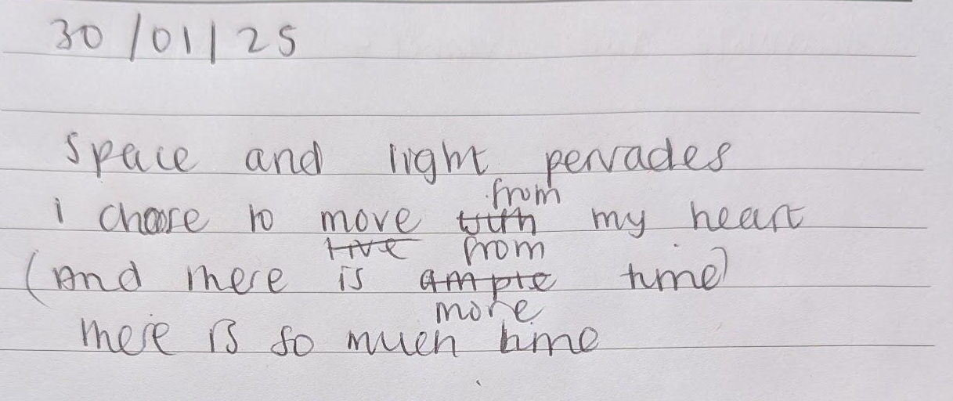
Appendix 2: Image taken from ‘Sweet Dee Has a Heart Attack’ (2008) It’s Always Sunny in Philadelphia, Season 4, Episode 10. https://knowyourmeme.com/photos/page/3?gallery_cache_key=3020425. (Accessed: 30 January 2025).



Appendix 3: Journal Entries Taken from Personal Journal (Payne, 2025)
01/02/25
In uni today I felt compelled to try to share. In the personal development group, our task was to discuss the contract and how we would all like to engage in the process. I expressed that waiting for everyone to have their 5 minutes makes me anticipate my own turn and I fixate on what I want to share, anticipating my turn for sharing, and then I struggle to be fully present to what everyone else is saying, so for me I’d prefer if we just engage in a more intuitive and natural way. But this then turned into people talking over each other and very little room for me to authentically bring in myself and help facilitate the process in the way I wanted to/that comes naturally to me.

Within groups, it's very easy for me to slip under the radar, because I feel a lot of people are determined to bring themselves in and they are simply more determined than I am. The fear holds me back and if I can avoid it I will.

I feel the group dynamic at the moment is unequal and not everyone is being respectful; people getting up and leaving when people are trying to process their experience, going on their phones and not being present, it is discouraging me from sharing even more I think. I just don’t feel brave enough to say anything right now, but it is impacting me and my learning.

Before this, I made other attempts during breaks to try and bring myself in, attempting to add to the conversation. I started the sentence multiple times; and no one noticed, I felt like no one cared; I feel so rejected and discouraged they don’t even care.

The phase ‘I guess I’ll just shut the fuck up then’ keeps coming up whenever this happens. I get so defensive, it feels so aggressive and reactive, because I’m hurt about it. I thought these people were my friends, I’m really questioning this now.

I left uni feeling exhausted, unseen, hurt and isolated. I don’t like feeling like I have to fight to be heard or that when I do share it is not wanted or appreciated. I really feel I need to take this to therapy.

07/02/25
I honestly don't know where to begin. I’m trying to observe and become aware of my patterns in every interaction as much as I can, but it is taking a lot out of me. I feel exhausted and frustrated. I can see myself doing it, withholding, the fear taking over, but I don’t feel strong enough to stop it. I don’t feel in control of it.

I tried my best to share in uni this week but it just feels like such a battle. I got so overwhelmed and dysregulated so easily I had to stop and ask for someone else to speak because being witnessed by multiple people just felt too intense. I’m glad I felt safe enough to ask for that but still. I feel like I’m getting paranoid, like everyone knows I’m not sharing everything and that pressure of feeling like I need to share and it needs to be everything keeps building. I can feel myself putting so much pressure on myself and I think I need to slow down.
Appendix 4: Powerpoint Presentation Slide taken from Previous Assignment (Payne, 2024)

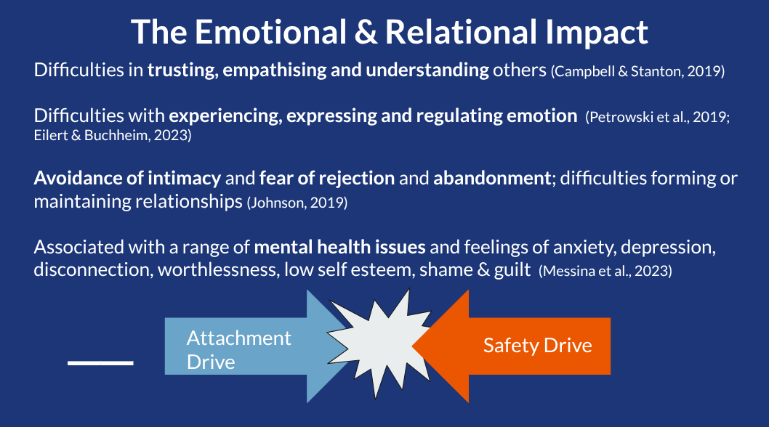

Appendix 5: ‘Depiction of My Internal Conflict’ (Payne, 2025). Original image taken from: https://www.theguardian.com/technology/2016/nov/30/evil-kermit-perfect-meme-terrible-times. (Accessed: 10 February 2025)

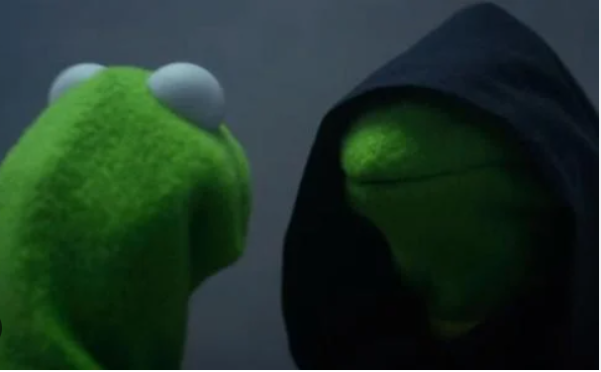
My need to be seen, heard and connect with others authentically
My fear of being vulnerable and fully seen by others

Appendix 6: Journal Entry taken from Personal Journal (Payne, 2025)
12/02/25

I feel like I’ve placed the responsibility on others to include me and make space for me to share, but I know that I am responsible for this too. As much as it feels inauthentic to me, I am going to have to demand space, whether I like it or not within this particular group.

I’ve been placing the responsibility onto others; to make the environment feel safe for me, to prompt or encourage me to bring myself in and even when that prompt was encouraged, I’d find another reason why it was not my fault. My last therapy and supervision sessions have made it so clear to me that I need to be focusing more on the role I play in all of this; that I am an equal part within any relationship and I’ve not been taking accountability in this way.

I’ve been so resistant and felt so unsafe at university and in supervision. I’ve been picking apart the parts of my environment, trying to find something outside of myself to blame; the lighting, the number of people, the uncomfortable chairs, the colours on the walls; the energy of the people, whatever, but really this is all just reflecting the unsafety and detachment I feel within myself.

Appendix 7: Table of Data Themes

Major Themes | Sub Themes | Initial Codes | Summary/Meaningful Units
‘Unsafe Spaces’ | Attachment  Authority  Academia  Supervision  ‘The Internal Conflict’ | Defence Mechanism; Fear; Threat; Dysregulation; Hiding; Protection; Avoidance; Resistance; Aggressive; Reactive; Projection; Judgement; Criticism; Cycle  Misunderstood, Hurt, Sadness, Isolation, Longing, Dread, Tired, Victim, Lack of Control, Invisible, Passive, Shame, Frustration | “There is an internal battle, a conflict between the deeply ingrained relational patterns I learnt to survive and protect myself and my need to be authentic and connect with others”.  “There patterns because no longer serve me, are causing me harm and affecting the relationships I have with others”
‘Safe Spaces’ | Personal Therapy  Partnership | Hope, Light, Liberation, Freedom, ‘I am capable’, ‘light pervades’, ‘I choose to move from my heart’; Choice; Curious  Compassion: ‘I am trying’, Inner Child, Affirmations, Love  Assertion; Agency; Authenticity; Congruence  Commitment; Consistence; Motivation | “I am capable of being vulnerable and authentic; it comes naturally in these spaces where I feel safe; where I know there is no judgement or negative consequences for expression’.  “I hope and have faith that I can translate this into my work with my clients”
‘Ambiguous Spaces’ | Therapeutic Practice | Uncertainty; Novelty; Age; Gender; Disclosure; Worry; Anxiety  Perfectionism; Pressure; ‘Good enough’; countertransference  Regulation; Similarity; co-regulation; possibility; opportunity | “There is room here for mutual safety, authenticity, vulnerability without judgement but I worry my fear of vulnerability is sensed by the client. I worry I am projecting my judgement of myself onto them, into the space and it is a barrier to their willingness to be vulnerable”.

Appendix 8: Written Affirmations (Payne, 2025)

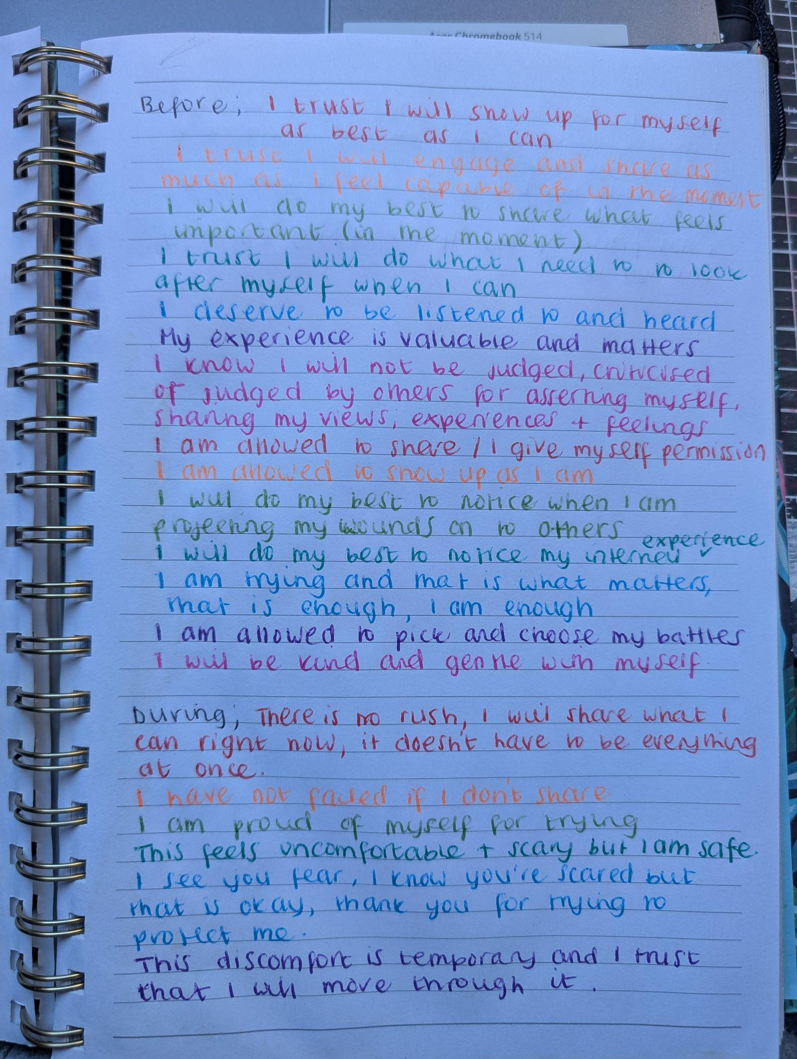
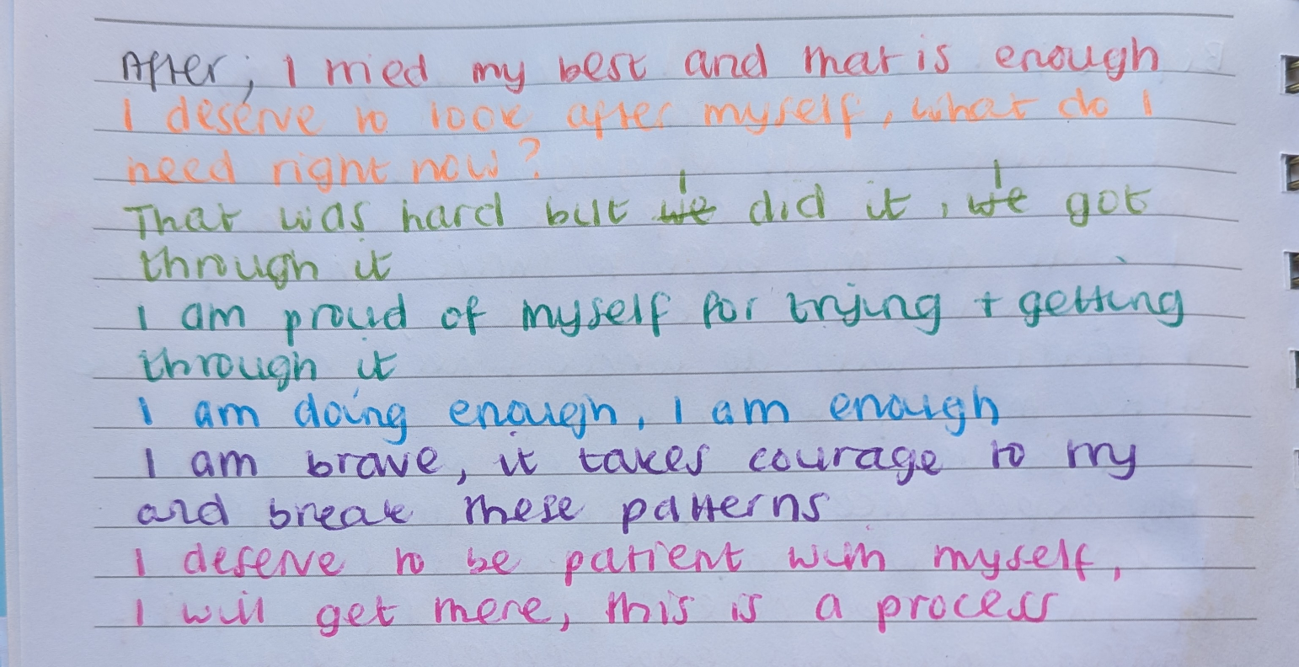

Appendix 9: Payne, C.L (2020). ‘Freedom’. Oil on canvas. Unpublished.


