- ISP
- Single home: this means there is single connection to the ISP. Since the exist just a single exit path in this type of network, this means we won’t need BGP. We might just use a static default route that points or connects to the ISP.

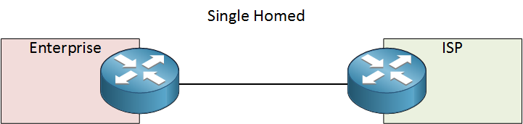

One advantage of a single home link is that it is cost effective, and the disadvantage is that there is no redundancy. The link is the only point of failure if it breaks the entire network is down.

- Dual homed: here they exist two separate links connecting to the ISP here they exist 2 different path for connection. They dual home connection includes redundancy unlike the single. But take note here you are still connection to a single ISP using two links instead of one.
This designed has different variations as shown below;

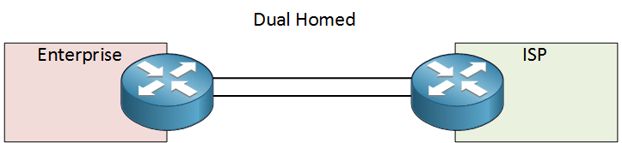
Here we use a single router on both end for redundancy.

To increase redundancy, we can add a second router:
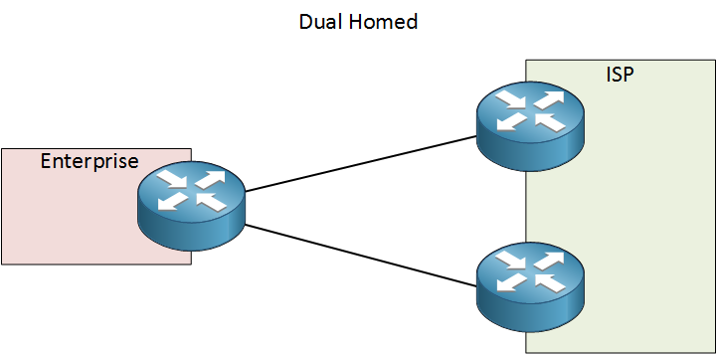
We could still use a second router at the customer side and a single router at the ISP. For even more redundancy, add a second router at both side:
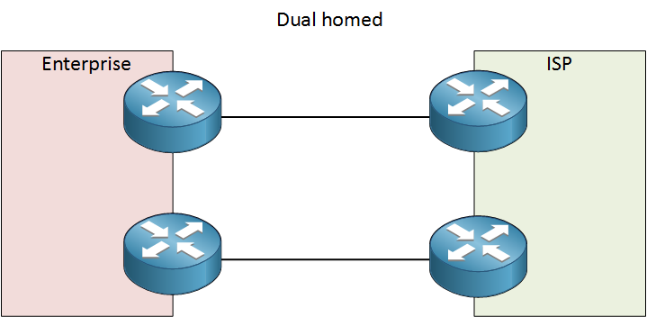this is the best which offers maximum redundancy connected to a single ISP still. It is made up of two links with two routers at each end. One disadvantage of this is we still use one ISP.

- Multi-homed: multi home means here we are connecting to at least two different ISP with more than 3 different link. the design looks as below
- 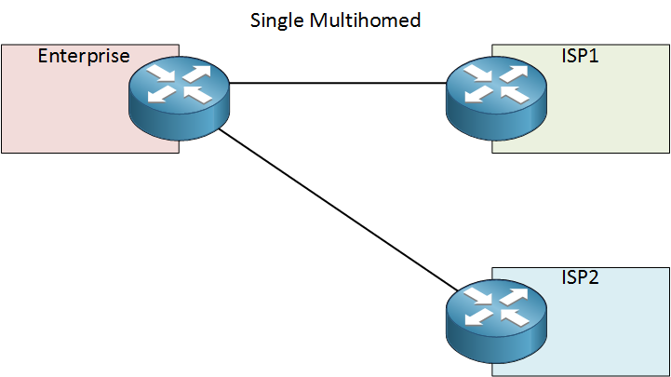
Above we have a single router at the customer side connected two two different ISP. The single point of failure here we have one router at the customer site. If it goes down the entire network goes down you won’t connect to any ISP

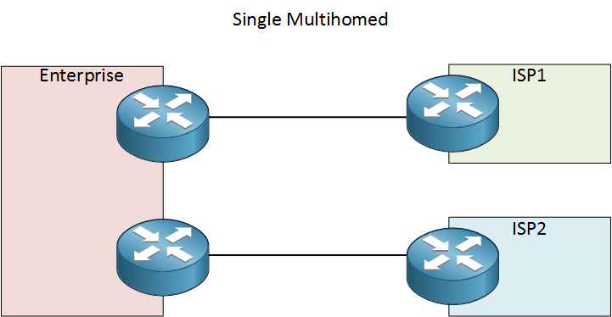

This is the improvement of the one above we add one more router to the customer site. We use a single link which connects to two different ISPs using different routers.
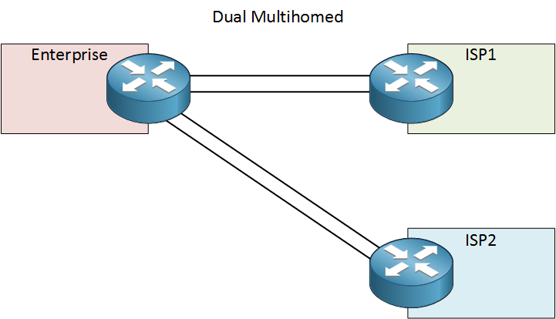
Above we are connected to two ISPs using one router and two links to each ISP. They both are very redundant but the router is still a single point of failure to improve this we add a second router.
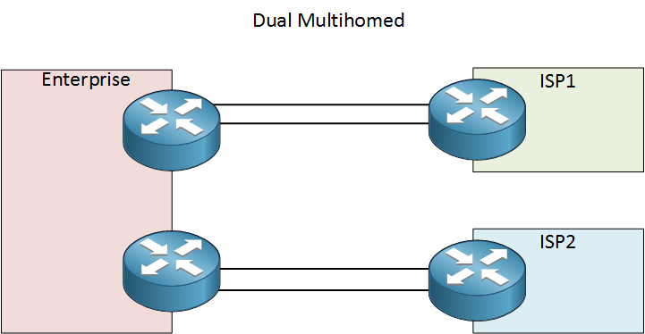
This design is better it has two customer routers and two ISP. The disadvantage here is ones one router goes down the connection between one of the ISP will be lost. We will improve this design by adding more links as shown below.
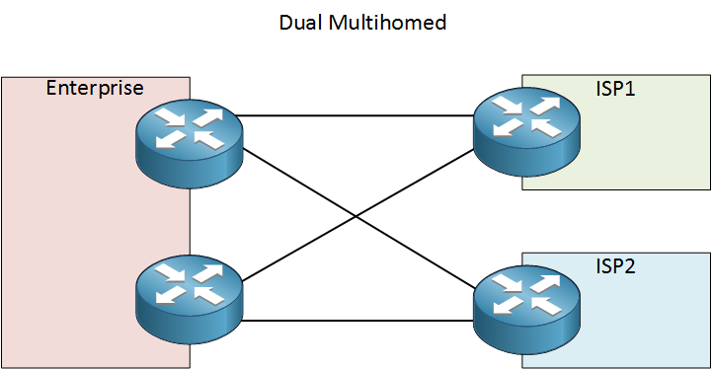
This design is made up of a very redundant ISPs, routers, and links. Both customer routers are connected to both ISPs. Though this design is the best and has the best redundancy its disadvantage is that it is very expensive.

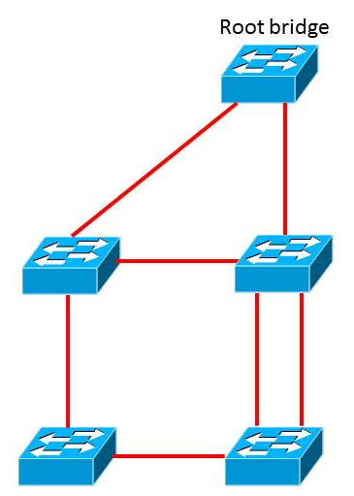

Here on the above we have a root bridge which is connected to two non-root ports. And the switch with the best bridge ID (priority and MAC address) becomes the root bridge. And being so all the other switches need to find the shortest path to the root bridge since it is like the king amongst them. They are known as the root port.

On each segment we can have only one designated port if we have above one that will lead to a loop. The port which has the capacity of sending the best BPDU ( this is how switches communicate). The root bridge will always have the best ports so all interfaces conncted to it will be designated.
The switch which receives better BPDUs ON ITS interface will will be blocked. This is the alternate port

- Routed ports are used for point-to-point links. Connecting WAN routers and security devices are example of how routed ports are used. Some switches give us a way to change the mode and operation of that switch i.e., layer 3 switches when activated the switch port becomes a routed port and acts like a router. A routed port behaves like a normal router int. since layer 3 functionality doesn’t work anymore on them, layer 2 protocols like STP wont function any more on them but some protocols like LACP and EtherChannel do function.
To configure or enable routed ports, we use the no switchport on the interface configuration mode command on the appropriate port
A routed port can enable you to reuse the same VLAN ID from another layer 3 port or layer 2 VLAN without risk of Layer 2 traffic in between. Routed port are easily managed by admins.

S1(config)#interface f0/6
S1(config-if)#no switchport
S1(config-if)#ip address 192.168.200.1 255.255.255.0
S1(config-if)#no shutdown
S1(config-if)#end
This is an example how to make a switchport into a routed port.

- Hello packet: this packet is sent by the OMPROUTED server to discover OSPF neighbours and to establish bidirectional communication
- Database description packet: as soon as the hello packets have been exchanged and the two-way communication has been established, the i5/OS and the area routers are now neighbors. Here the server knows which neighbor it can create OSPF adjacencies with.
- Link-state update packets: till the OMPROUTED databases are fully synchronized, they request and exchange more information from adjacent routers using link-state request and link-state updates packets.
- Link-state request packets: after all the descriptions have been made, the neighbors then sent out database requests for more complete information about the records that had been requested.
- Link-state acknowledgment packet: all LSA which are new must be acknowledged by the recipient to check or verify its delivery. This happens by sending a link-state acknowledgement packet containing one or more acknowledgment.

- EIGRP fast convergence: it is the presents of a feasible successor. When there is no feasible successor EIGRP uses quarries peers and has to wait for a response, and these quarries will slow down the overall convergence time. To achieve fast convergence the following needs to be done;
- Design your network properly
- Make sure you perform route summarisation to limit the scope of EIGRP queries which indirectly speeds up convergence
- Summarisation helps shrinks the number entries in the routing table to speed up CPU operation
- Having multiple paths in the routing table gives you faster convergence time bc a path already exists if one failed.
- Partial updates: EIGRP sends updates packets to propagate routing information. These update packets are sent only when required and it contains only the routing information needed and it is been sent only to routers that need it. They do not send periodical updates and route entries do not age out they send incremental updates instead when it notices the state of the destination has changed. Partial update means that the update has information about the route changes only which minimizes the bandwidth required for the update to be sent.
- Multi network layer support: eigrp supports IP, NOVELL, AppleTalk, NetWare, internetwork packet exchange (IPX) using protocol dependent modules that are responsible for protocol requirements specific to the network layer. EIGRP rapid convergence metric offer superior performance and stability when these protocols listed above are been implemented.
- Successor and feasible successor: successor is the route which has the best metric in reaching a particular network which is placed on a routing table. While feasible successor is the different route to a particular network which is used immediately if the current best route which is the successor go down or fails without a routing loop occurring. These routes are been kept in the EIGRP topology table.

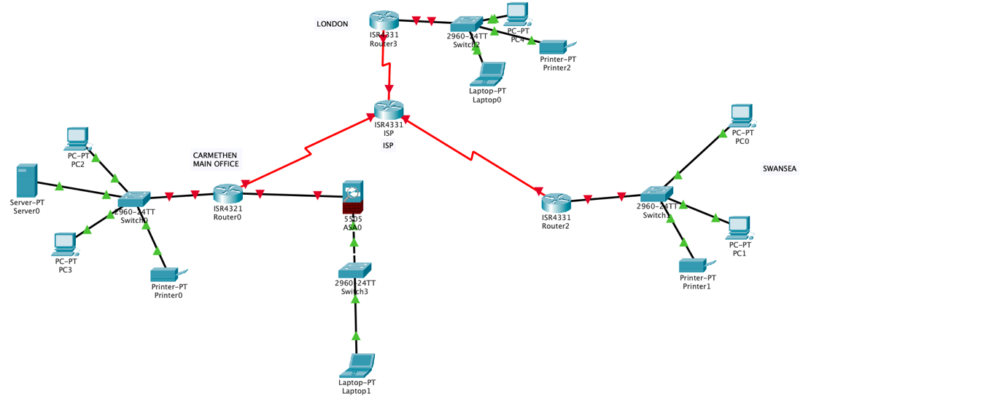

Here we have 3 campuses the main campus in Carmarthen on in London and one in Swansea we want to want all these 3 networks to communicate with each other they are all connected through a central router which acts like and Internet service provider through WAN. And all the devices are connected physically with switches in their various locations with LAN. We need to secure them all and create a communication among them. We have a server which is connected to the main campus and which can store all the information coming from the 3 locations.

since most of the command we used them multiple time I will just use this section to explain all the commands I used above.
we configure OSPF on all the routers to enable them to communicate with each other on R1 we advertise the network same as in R2 and R3.
We give IP dresses to all the devices
Next, we configure secure administrative access on all the routers switches and the ASA
We give them a security password of min-length 10. Give a warning banner which says “unauthorized access is strictly prohibited” so if an unauthorized user tries login, it that banner will pop up. We make sure to encrypt all passwords using the service-encryption cmd so no one can read the password. We configure the line console password and vty 0 4 we give them privilege level 15 the highest and exec-timeout 15 0 it logout after 15min of inactivity after password login synchronous on the vty line we give the transport input ssh to allow ssh communication instead of telnet because ssh is more secured and we can encrypt it unlike telnet which is plaintext.

Enable and Configure AAA service on the routers using the local database
Configure the routers to log login activities generate successful if the user login successfully and failure if login is unsuccessful

Configure the ssh server on R1, R2, and R3 give it an ip domain-name, crypto key rsa of 1024. We give the ssh an authentication retries of 3 time after 3 tries it shuts down the user. Secure against login attack and secure the ios and configuration file on R1 if a user experience 2 failed attempts within 30sec time span disable login for 1 min we use the cmd login block-for 60 attemps 2 within 30.

Configure a synchronised time source using NTP. We make R2(London campus) the master NTP clock source for R1 and R3 all routers and switches learn the time from R2. Its good because if there is any attack on the network you will be able to figure out the exact time the attack happened.

Configure R1(Carmarthen campus)and R3(Swansea campus) as NTP client with md5 password ntp is used to synchronise the clock time between your computer system and network. It enables the devices connected to request and receive UTC from server that in turn, receives precise time an atomic clock.

We implement monitoring features on the router by using syslog. We configure syslog on R1 and server which is the server on router 1 we set the logging host which is the ip add of the server and configure the logging severity level on R1and logging traps set to support the logging function. This trap triggers a log message we use the default log message for emergency

We use the auto secure on R3 which allows you disable common ip services that can be exploited for network attacks and can also enable ip services to aid in the defence of the network when under attack

We implement the control plane security by configuring ospf routing protocol authentication using md5 on the interfaces of R1 R2 and R3.

We implement server-based AAA authentication using TACACS and RADIUS protocol on the server and on Router1

We implement access control list ACL to filter traffic and reduce network attacks on our network on R1 we set the standard ACL to permit ip host 192.168.1.0 network to go through 172.16.3.0 network on the other side and we can deny a certain ip from going through to.

We configure the class map inside and outside on the ASA and state their policy and set a ssh configuration which permits us to ssh both inside and outside the ASA.
We configure a static NAT to the dmz server using network object. Then configure an ACL to allow access to the dmz server from the internet and apply that ACL to the ASA outside interface direction.

We implement a zone-based policy firewall on R3. We create a security zones inside and outside which allows internal host to access external resources and block external host from accessing internal resources. To do this make sure you activate your router with security package to activate it reboot the router and on R3 use the cmd license boot module c1900 technology-package securityk9 then later reload your R3

We create an inspect class-map to match the traffic to be allowed from INSIDE zone to OUTSIDE zone. Because we trust the INSIDE zone, we allow all the main protocols use the match any keyword to instruct the router that the following match protocol statement will qualify as a successful match. This result in policy being applied match for TCP, UDP, or ICMP packets.

Create a zone pair called INSIDE-TO-OUTSIDE and INSIDE-TO-INSIDE that allows traffic initiated from the internal network to the external network but does not allow traffic originating from the external network to reach the internal network.

We implement cisco IOS IPS on R3 first we create ips directory then signature storage location
Then create an IPS rule apply that rule to the interface s0/0/1with direction out to scan traffic entering the inside network

Configure IPsec VPN on R1 it secures communications at the network or packet processing layer. It helps encrypt connections between devices. It helps keep data sent over public networks secure. IPsec is often used to set up VPNs, and it works by encrypting IP packets, along with authenticating the source where the packets come from.

This protects this network from all forms of attackers like phishing, viruses etc

