Ben Long
P144121
Critical Review
Course: Creative Computer Games Design
Lecturer: Julian Hainsworth
Word Count: 2379


Declaration

This document is all the work of Ben Long and any work which is not is correctly referenced with the Harvard system.
Signed
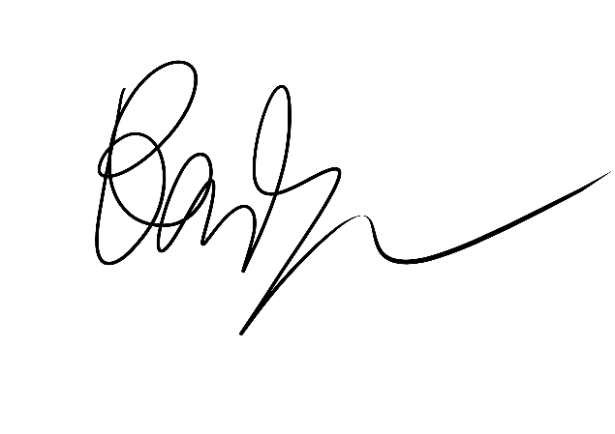
Date: 03/05/2018

Abstract
This report details the development throughout the three years of university. The work conducted over the three years has been analysed and shows what skills have developed. The showreel has been discussed and highlights what the footage was used and why. VR was a big selling point of the showreel as VR is a relatively new hardware and some companies are actively looking for experience. The report also looks at why certain projects haven’t been used in the showreel, which is mainly due to lack of experience in software or poor quality projects.
Contents
Introduction 4
Personal Development 5
First and Second Year work 5
Third year work 6
Showreel 7
Research 7
Included material 7
Excluded material 10
Conclusion 11
Future Work 11
References 12
Bibliography 13

Introduction
This report aims to show the skill development throughout the three years of university, and the showreel produced at the end of year as well as the reasoning behind the choices for the showreel. The report will review the work that was conducted from the first and second year project and then the third year project. It will compare what skills were learnt and how they have improved over the course. The development section will focus solely on the two projects conducted through university. These were the main projects throughout the course and therefore demonstrate the best work.
The showreel produced at the end of the course will be discussed to show why the footage used, has been used and why other possible footage hasn’t. It will also talk about the research that was undertaken before the showreel was created, as the research affected the final product.
A summary at the end of the report will talk about the final showreel and how it was received, with a further work section on how it would be improved in the future.

Personal Development

First and Second Year work
At the start of University it was unclear what role was going to be focused on. After learning about multiple aspect of game design, it was then decided to focus on animation and blueprint implementation, which is referred to as a technical animator. However the group had two animators so after the first year the role shifted to solely focus on blueprints. It felt that having no experience with blueprints made it very difficult to start as knowledge was lacking and blueprints are very technical. At first it also seemed that the finished project was going to be quite basic due to the lack of knowledge. This meant a lot more research through tutorials and lectures would need to be undertaken.
The game project for the first and second years was a 3D platformer called ‘Flint and the Curse of Master Beakwynn’. The mechanics for the game were relatively simple, the character would pick up items to progress to the boss fight, and would be able to fight off enemies with ranged and melee attacks. The mechanics were implemented but after reviewing them recently it is clear to see that they could be much cleaner. A lot of the blueprints seemed to be hastily put together but worked so they were left as is. This is bad practice and compared to third year work it is clear to see that this has been improved as the blueprints are commented on what they do and are ordered neatly.
However at the end of the second year the project didn’t turn out as predicted. The animations which were given quite late for the protagonist and the boss so were hastily put in, with the boss having no animations at all. Since none of the animators had learned to do animation blueprints this meant this task relied on the technical animator. This meant more work was left to the technical animator and since it was given quite late it was difficult for one member to try and get it in on time.
The team had suffered bad time management and communication throughout the project and towards the end it got worse. The animations were worked on and finished quite late which meant there was less time to try and implement them into a blueprint. This was a very important experience as it showed how easily a project can fail if unorganised planning or bad communication occurs. This was rectified in the third year with much better planning and constant communication.

Third year work
The third year project was a virtual reality shooter which was later called ‘Scrap-Town Showdown’ (See Figure .1.). Blueprint implementation for VR was a massive leap from working on a 3D platformer and in turn was very difficult. A lot more aspects were needed for VR and the lectures were a lot less tutorial based than in the previous years. This meant a lot more independent research was needed in order to achieve a realistic and satisfactory project. Using the Unreal VR Cookbook (McCaffrey, 2017) and various online tutorials the various mechanics were implemented with some extra advice from lecturers.
Early on in the projects development the game was drastically changed. The game was intended to be a standing experience in which the player stands in one spot and the enemies would pop out and shoot at them. The project then expanded so the player would traverse through a town and make their way to a final fight. This meant the game needed to include more mechanics in order for the game to work with this expansion. This also felt like the game was going to be an overall better experience as the player would be moving and the combat would be a lot more dynamic.
The end product was at a satisfactory level and was well received by peers and lecturers. However the game needed more optimization and could also would benefit from special effects which were immediately worked on after. Time management and communication was greatly improved in comparison to the previous project and a lot of the deadlines were met without fail. Working with VR provided an opportunity to test abilities and also learn new concepts in engine, such as interfaces and custom components, which in turn contributed to a better understanding of visual scripting.
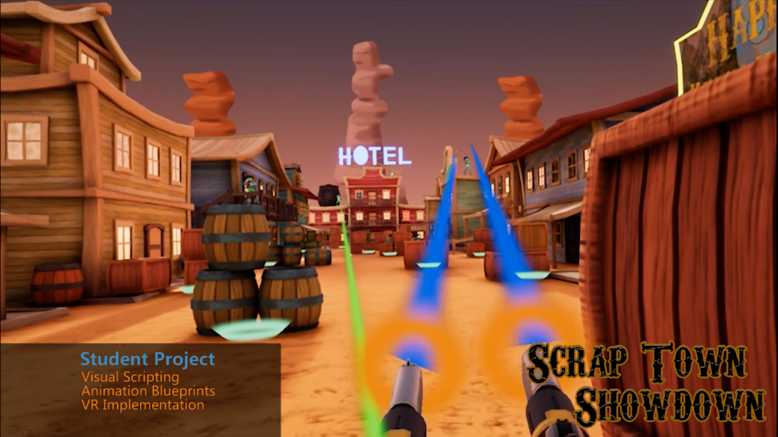
Figure .1. A screenshot of Scrap-Town Showdown in the showreel.

Showreel

Research
Before immediately starting the showreel research was conducted into current showreels and also online blogs. The Creative Bloq (2013) created a small guide on how to build a good showreel. In the article they reached out to several industry based sources on what they think would make a good showreel. Step 3 states:
‘Neil Gallagher, senior lecturer at the University of Hertfordshire, suggests opening with your best work and then, just to ensure you don’t begin with a bang and end with a whimper, close with your second-best piece.’ Creative Bloq. (2013)
This step was prominent in most of the online sources and in turn altered how the showreel was edited. Each aspect of the showreel is discussed further on and is in order of appearance in the showreel.
Also before starting the showreel it was important what role it was going to be advertising. Throughout university it seemed the obvious choice would be a technical animator, but after looking into some technical animation showreels, they seemed to show a lot of python coding in Maya. There was no experience in this aspect and the technical animators seem to focus on installable plugins alongside animation. After looking at some technical artist showreels, they seemed to show animation, shaders, particle systems, scripting and various other roles of game design. It felt best to advertise as a technical artist as the role can be focused into certain aspects, while also having a wide variety of tool sets.

Included material
Scrap-Town Showdown definitely had to be in the showreel. The VR game shows the best of the visual scripting ability, as it was the most technically advanced project within the duration of all three years. VR is also a relatively new hardware and certain companies are actively looking for VR experience in their work place, so by starting off by showing a detailed VR game is a good start to the showreel. Referring back to the Creative Bloq (2013), it says to show your best work first and this was the best piece of work that was produced throughout university.
After showing the polished VR game, it felt it was important to show more of the visual scripting. This would show a more in depth look at what exact role was done in Scrap-Town Showdown rather than showing more gameplay. To show this off, a small test scene was set up in which a player would pick items up and interact with them to show off the world interaction interface. In VR the world interaction interface was ideal for replicating blueprints that needed to follow the same functions. For example, a blueprint class would be created containing all the information an item would need to be picked up. To create another item that did the same thing, you could just create a child actor from the blueprint class and it would have all the relevant information. This method was efficient and saved time compared to making individual assets. While it is hard to visualise this in the showreel, it felt it was important to show the interactive interface at work, and by using multiple assets to be picked up it does show the interface practically (See Figure .2.).
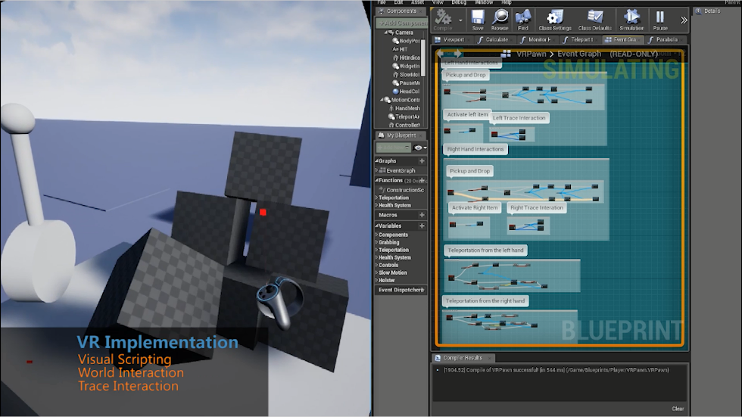
Figure .2. A screenshot of the world interaction interface in the showreel.
The small footage also showed off some trace interaction as it works with the world interaction, so having a small clip that managed to demonstrate the various aspects of VR shows more experience with the format.
When researching the role of technical artist it was clear to see that particle effects and shaders were very good selling points. These could show off very detailed, technical visual effects and they look aesthetically appealing. A small project was created which was a small gallery to show off multiple particle effects and shaders. By viewing tutorials online various particle systems and shaders were created. The tutorials helped create a better understanding of how to use the particle systems and material shaders which in turn also created a variety of effects.
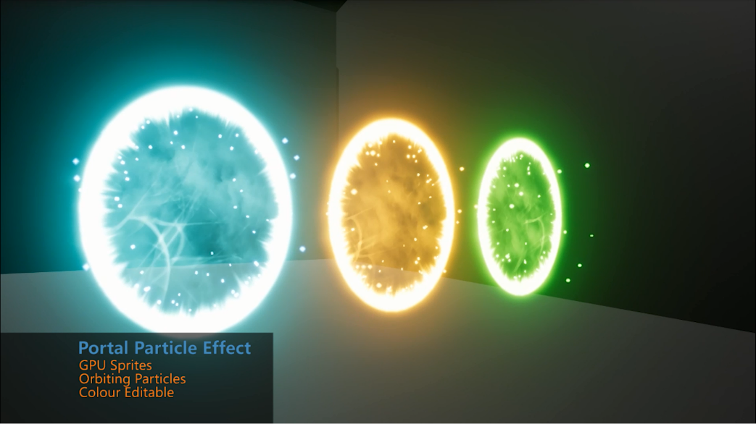
Figure .3. A screenshot of one of the particle systems in the showreel.
These tutorials were very intricate and talked about each aspect of the process. The end result meant the experience with particle systems increased and it also provided a useful footage.
As stated, shaders were also created to put in the gallery and where the particle systems show variety in complex systems, shaders had material instances which allowed for creative freedom on how an effect should look. Shaders did use a complex system but the instances is where the shaders could show how easy it was to manipulate an effect. This was the last clip in the show reel as it felt to end on a shader instance being edited looked both visually appealing and technically pleasing.
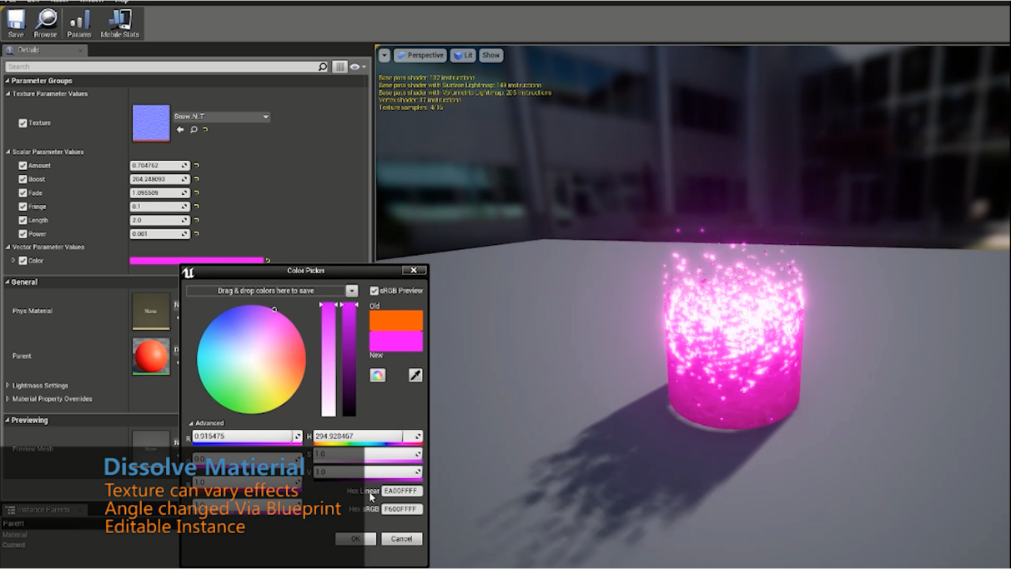
Figure .4. A screenshot of a material instance in the showreel.

Excluded material
At the start of university the original role was going to be more animation based, but due to being in groups with an adequate amount of animators the role focused more on technical art. A few side projects included some animation, including motion capture but in the end they weren’t at a satisfactory level. Where motion capture would be really good to put in the showreel, the motion capture data was very badly recorded. This was due to the inertia motion suit which doesn’t record the data as accurately as an optical motion capture system. The animations then suffered lower quality as they needed more clean up. If the data was cleaned better then it may appear in the showreel in the future but for now it remains cut out.
Flint and the Curse of Master Beakwynn wasn’t the best example of work from university. Two years were spent on making the game, from concept to competition, but the end product wasn’t good enough. There was much passion and effort into making the game work, but it wasn’t the best work and has been left out. The animations which looked rush made the gameplay mechanics look bad and it doesn’t accurately show off how the game played. Experience with visual scripting was also lacking during this time and the game could have been vastly improved. It would have been good to show more than just visual scripting for VR but at the same time, the other blueprints from previous projects would do more harm than good. They were from a time where, due to the lack of experience, they were badly put together and barely functional.

Conclusion
The final showreel turned out much better than expected. At first it felt like it was going to be hard to get one minute out of all the projects but by learning more skills the showreel had a good amount of detailed content. After receiving some feedback from peers the showreel was also edited so it would look more appealing. Receiving feedback was a really good way to see if there are any flaws and a lot of people were eager to see it. Seeing the showreel and comparing it to work done at the start of university, it is clear to see where the skills have improved and how far they’ve progressed. Using VR was also a very valuable experience that will be helpful when applying for certain roles. Where the showreel was a good way to show the skills, it is also important to network them. When creating the showreel, a website and linkedin profile were also created to work with it. These can be used with each other to promote work and also store work. This will create an online presence that can be helpful when applying for future jobs. Unfortunately an online presence isn’t enough so also more networking will need to occur. This can be as simple as going to industry events and talking with people but it is a major aspect that needs to be addressed as soon as possible.

Future Work
As more projects get undertaken it is important to keep updating the showreel as the skills improve. It would be good to show more animation in the future as that was the original role that was going to be advertised. Over time more side projects will be put in to show diversity with visual scripting, to show that VR isn’t the sole focus. Where the duration of the showreel will need to be kept short, aspects will be removed to make way for better content, and therefore the showreel will continue to show the best work.

References
Creative Bloq. (2013). Build the perfect showreel: 10 top tips. [online] Available at: https://www.creativebloq.com/audiovisual/perfect-showreel-top-tips-9134570 [Accessed 28 Mar. 2018].
McCaffrey, M. (2017). Unreal engine VR cookbook. Boston [etc.]: Addison-Wesley.

Bibliography
Cooper, J. (2013). The Game Animation Reel. [online] GAME ANIM. Available at: http://www.gameanim.com/2013/02/27/ten-steps-to-the-perfect-game-animation-demo-reel/ [Accessed 28 Mar. 2018].

