

Student name: ESTHER NANKYA
Student ID: 2336477

Module name: Changemakers: Building your Personal Brand for Sustainable Employment.
Module code: BMHP5015

Assignment Title: Component 2: Assignment (Report)

Lecturer name: Caroline Salami (module leader) G2 Christopher Mafuva

Table of Contents
1. Introduction 1
2. Job description of the selected job 1
3. Analyse the skills needed for the job and assess your skills and experience 3
Skills Required by The Job Description of Health Care Assistant 3
SWOT Analysis 4
Who can assist me in identifying my own capabilities and improving them 6
Relevant Experience and Qualifications 6
4. Development of personal skills and resources 6
Ways to Build Personal Brand 6
What Values Can Be Added 7
Resources for Skill Attainment 7
5. Action Plan and Timeline 7
6. Communication of skills to potential employers 8
7. Conclusion 9
References 11

1. Introduction
This report’s area of inclusion is identification of job description and specification for precise job role along with skill analysis considering the job. Also, includes personal skill development and resources, action plan, and communication way to target employers.

2. Job description of the selected job
My selected area of job is ‘Health Care Assistant’.
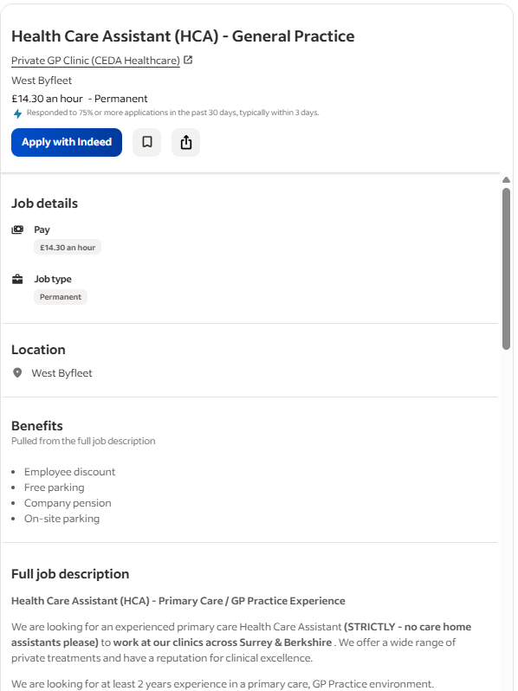
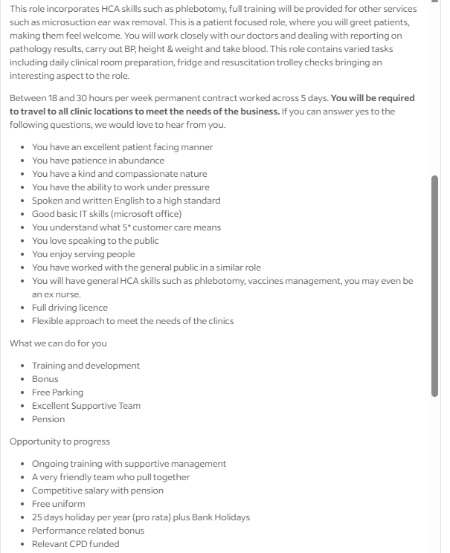
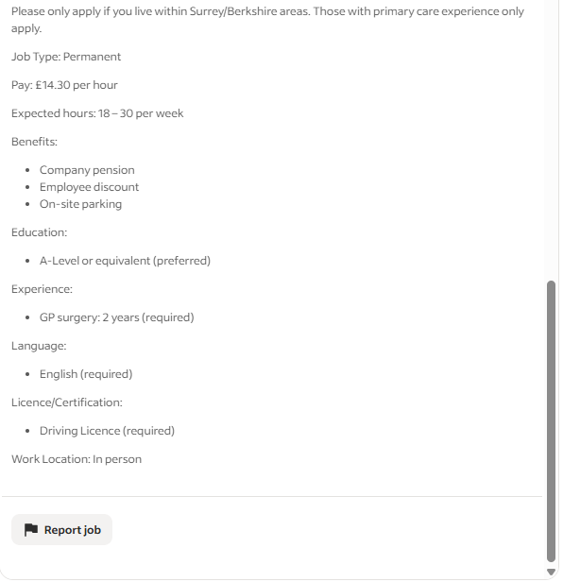
Figure 1: Job Description.
Source: (LinkedIn, 2026).
Job Description
Based on the job advertisement, the job description for ‘Health Care Assistant’ is discussed below:
Clinical Duties: ‘Health Care Assistant’ duty requires clinical performance through checking patients' blood pressure, taking blood for diagnosis, and measuring weight and height (Anderson et al., 2021).
Specialised Services: Trained ‘Health Care Assistant’ who has to manage specialised services for patients like wound care, cardiography activities, emotional comfort, and companionship (Baum et al., 2024).
Patient Care: Offering services like assisting in mobility, monitoring health signs, serving meals, ensuring patients' hygiene, and others (Bendowska and Baum, 2023).
Administrative Tasks: A ‘Health Care Assistant’ also has to greet patients and their family members, report on test results, and ensure patients' comfort.
Maintenance: A ‘Health Care Assistant’ needs to perform maintenance by checking that equipment and samples are accessible in specific places in the patients' rooms and other clinical preparations (Leong et al., 2021).
Logistic Management: A ‘Health Care Assistant’ also has to travel weekly in different clinical locations of the organisation to transport medicines, equipment, or staples (LinkedIn, 2026).
Person Specification
Clinical Skills and Expertise:
Skill in management of vaccination and phlebotomy.
Training and experience in ‘Health and Social Care’ roles (Longhini et al., 2022).
Soft Skills:
Compassionate and patient-facing skill.
Empathy and companionship skills.
Resilience to work under tough situations.
Loving and caring behaviour with patients (Nutbeam and Lloyd, 2021).
Technical Requirements:
English language proficiency.
Good ICT skills.
Driving license.
Knowledge of person-centred care (Sorensen et al., 2021).

3. Analyse the skills needed for the job and assess your skills and experience

Skills Required by The Job Description of Health Care Assistant
Clinical Skills
Phlebotomy Skill: As a ‘Health Care Assistant’ must have training and experience in Phlebotomy skills to collect patients’ blood samples by controlling infections, manual dexterity, and steady hand for comforting patients (Anderson et al., 2021).
Health Sign Monitoring: Knowledge of practice use of equipment to monitor diabetes levels, blood pressure, weight, height, and temperature, and other health signs (Baum et al., 2024).
Clinical Testing and Reporting: As a ‘Health Care Assistant’ must skilled in processing blood samples in laboratory and reporting transparently and accurately of test results to support effective interventions (Bendowska and Baum, 2023).
Operational and Safety Skills
Clinical Maintenance: As a ‘Health Care Assistant’ must skilled in handling clinical rooms, like daily arranging clinical equipment and supplies in patients' rooms, along with securing stocks of gloves and masks in the room (Leong et al., 2021).
Emergency Readiness: As a ‘Health Care Assistant’ must be present in emergency situations and handle tasks like resuscitation trolley checks, emergency equipment handling, and assisting doctors in controlling patients’ conditions (LinkedIn, 2026).
Documentation: Managing patients' files through using Microsoft Office tools, the internet, and Electronic Medical Record systems so that doctors can have access to patient-related data to prescribe or change medications (Longhini et al., 2022).
Interpersonal and Patient-Facing Skills
Empathetic: As a ‘Health Care Assistant’ must be empathetic while communicating with patients to listen to patients carefully without showing hesitations so that patients can have a feeling of companionship (Nutbeam and Lloyd, 2021).
Observation: A ‘Health Care Assistant’ must be careful in all health signs of patients through frequent observations so that can inform doctors to control patients' health signs immediately (Rawles, 2025).
Resilience and Patience: During performing role of ‘Health Care Assistant’ can face tough situations and have to work under pressure. So, at this moment, one needs to have resilience and patience to work in tough situations (White et al., 2024).
Logistic Related Skills
Mobility: As a ‘Health Care Assistant’, must have driving licence and driving skills to travel to different clinical settings to inform organisations' needs (Rawles, 2025).

SWOT Analysis
I used SWOT analysis in reflecting on my strengths, together with my improvement areas as a ‘Health Care Assistant’.
Strengths | Weaknesses
Observation: During my training in ‘Health and Social Care’ setting, I served people with autism by regularly observing changes in their health signs and reporting this to professionals (counsellors and doctors) (Sorensen et al., 2021).  Health Sign Monitoring: I used a Sphygmomanometer, Thermometer, Glucometer, and Stethoscope to monitor patients' blood pressure, temperature, blood sugar, and listen to heart & bowel sounds (Anderson et al., 2021).  Resilience and Patience: I remain positive during working in pressure and in tough situations to support others to control patient’s condition instead of being nervous.  Empathetic and Compassionate: I favourably built friendship and companionship relations with patients during my training sessions (Bendowska and Baum, 2023).  English Literacy: Since I got training under a ‘health and social care’ setting where colleagues, supervisors, and patients were from English languages, I efficiently communicated throughout the training sessions (Bucknell et al., 2022). | Phlebotomy Skill: I can not get blood samples as I did not practice it.  Clinical Testing and Reporting: I only have experience in simple handwritten report making on patients' conditions, but not experience in clinical testing and reporting through tech uses (Bucknell et al., 2022).  Clinical Maintenance: I can recognise clinical equipment, but did not handle it practically.  Emergency Readiness: In clinical settings, I did not work to support emergency situations with doctors and others.  Documentation: I can document information using Microsoft Office tools, but cannot use Electronic Medical Record systems.  Mobility: I know driving, but not prominent in it.
Opportunities | Threats
Driving Course: I can be proficient in driving and get a driving license by completing accessible driving courses (Bendowska and Baum, 2023).  Internship: I can search for internships at hospitals and engage in those programs to develop Phlebotomy skills, clinical maintenance skills, emergency readiness, and documentation (Longhini et al., 2022). | Experienced Candidates: Candidates who already experienced in clinical settings are threats; because of them I can miss job opportunities for ‘Health Care Assistant’.  AI in Hiring: In today’s world, hospitals using AI in hiring, like in screening CVs and candidate shortlisting. This can a bigger threat for me as AI can eliminate my CV from shortlisting due to experience and skill gaps (Nutbeam and Lloyd, 2021).

Who can assist me in identifying my own capabilities and improving them
My colleagues and supervisors at my training settings supported my skill identification by offering feedback on my performance to serve people with autism. They gave feedback on that I have great competency in resilience and patience while dealing with patients as well as managing emergency situations. Also, offered feedback on my observation skills in monitoring temperature, blood pressure, and other signs immediately and with careful hands (Bucknell et al., 2022). Moreover, another feedback was that I am proficient in empathy management as patients with me feel relaxed and share their health concerns without hesitation and fear.
Therefore, in future, my colleagues and supervisors at a professional setting will also offer me feedback through which I will identify my ‘health and social care’ related capabilities. Also, my supervisor as well as professionals (counsellors, doctors, and others) will propose to me job shadowing and networking scopes to continuously develop my ‘health and social care’ related competencies (Sorensen et al., 2021).

Relevant Experience and Qualifications
I have experience working as a carer during training sessions to support people with Autism through my practical resilience and patience skills developed. Also, builds my empathy and observation skills. Moreover, I am trained in serving people with autism, like managing their hygiene, assisting in mobility, checking their health signs, and other aspects (Bucknell et al., 2022).
I am qualified in ‘Health and Social Care’ area as I completed education in ‘Leadership in Health and Social Care’ and Level 4 in ‘Health and Social Care’. This illustrates my current ‘health and social care’ knowledge and competency to apply for ‘Health Care Assistant’ position.

4. Development of personal skills and resources

Ways to Build Personal Brand
Since I am ambitious in attaining my desired ‘Health Care Assistant’ role, I will work to develop my personal brand in a prominent way that can build a professional awareness about me among my target audience (employers, professionals, and hiring managers) in ‘Health and Social Care’ settings. Such as:
I will utilise available resources like Canva to design my LinkedIn profile by including images that can reflect my professionalism as well as my name and other information so that target audience can gain a brief knowledge about me instantly just by seeing my profile image (Joseph, 2024). Also, my LinkedIn profile will be personalised where I will comprise my educational background (Certificate in ‘Leadership in Health and Social Care’ and Certificate in Level 4 in ‘Health and Social Care’). Also, my interest areas in ‘Healthcare Assistant’ related jobs will reflect my interest to my target audiences (Szántó and Radácsi, 2023).
I will also create a personalised Curriculum Vitae (CV) for me to create my personal brand as CV is the personal portfolio that presents to employers and hiring managers to judge skills, expertise, and efficiencies of an individuals relevant to precise role (Joseph, 2024). Therefore, my CV will comprise my personal information, like name, email, and mobile number, along with career summary. Also, will comprise qualifications, training, experiences, skills, and personal attributes. These information’s will highly reflect my expertise as a ‘Health Care Assistant’ so that target audience can have a positive mindset about my expertise in this field instead of any confusion (Szántó and Radácsi, 2023).

What Values Can Be Added
My unique selling points are my SDGs awareness, like ‘Good Health and Wellbeing’, ‘Reduced Inequalities’, ‘Climate Action’, ‘Gender Equality’, and others (United Nations, 2025). This knowledge in today’s healthcare setting is crucial as hospitals are also aligning their endeavours with SDGs to become sustainable healthcare provider (Anderson et al., 2021). Also, I am knowledgeable of ‘Person-Centred Care’ policies, like partnership in service provision, dignity for patients, information sharing, individual care, and others. In today’s healthcare settings, this knowledge is crucial for meeting care standards (White et al., 2024). Also, I am trained in offering ‘health and social care’ supports along with a strong background with a certificate in ‘Leadership in Health and Social Care’ and Certificate in Level 4 in ‘Health and Social Care’.

Resources for Skill Attainment
Course: In-person course on driving is the crucial resource for me to build my driving proficiency and get a driving license to meet requirement of mobility as a ‘Health Care Assistant’.
Training: Training in Phlebotomy skills, clinical maintenance skills, emergency readiness, and documentation are crucial resources for my skill attainment as a ‘Health Care Assistant’ (Rawles, 2025).
Voluntary Work: Voluntary work engagement to practice skills gained through training is significant to improve my personal branding on LinkedIn and CV to become an ideal candidate for job of ‘Health Care Assistant’ (Bendowska and Baum, 2023).

5. Action Plan and Timeline
Skills Needed to Attain | Resources and Ways | Timeline
Phlebotomy Skill | Internship and voluntary programs at clinical settings (Rawles, 2025). | 1 year
Clinical Testing and Reporting | Internship and hand on training programs at clinical settings. | 1 year
Clinical Maintenance | Internships and engagement at opening job roles at hospitals (White et al., 2024). | 1 year
Emergency Readiness | Internship as a nurse and health care assistant. | 1 year
Documentation | Internship and training as health care assistant (Sorensen et al., 2021). | 1 year
Mobility | Driving Course | 3 months

6. Communication of skills to potential employers
As a candidate for ‘Health Care Assistant’, I will plan to communicate my expertise and skills to my target employers through a personalised CV and LinkedIn profile.
My LinkedIn profile will be as follows:
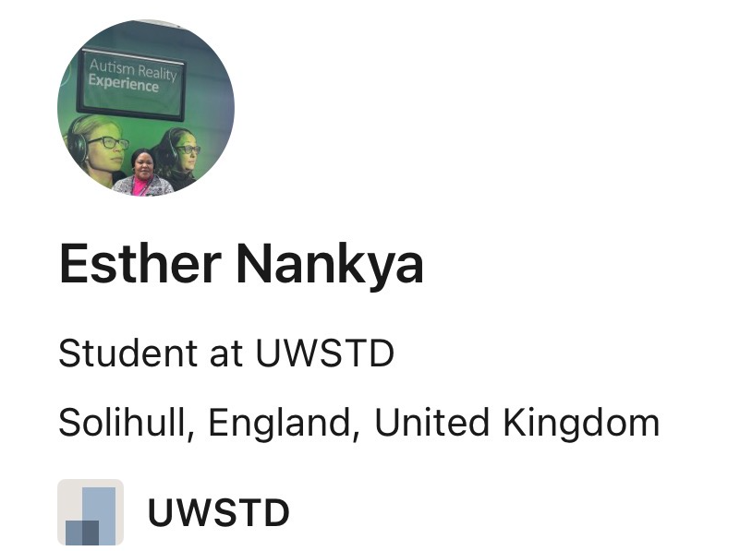
Figure 2: Own LinkedIn Profile Example.
Source: (Own).
Like in the image, I will include a background in my profile picture that can reflect my professional interest in ‘Health and Social Care’ setting. Also, my profile will reflect my education, name, personal interests, and job interest areas to target employers, professional, and hiring managers to get scopes of available jobs and hidden jobs (Joseph, 2024).
I will design a personalised CV by comprising overall personal to professional information. For instance, my CV will offer awareness of my name, contact information, email, and address, along with a career summary. Also, will reflect professional information like education, training, skills, experiences, and referrals (Szántó and Radácsi, 2023).

7. Conclusion
The findings revealed that the duties of a ‘Health Care Assistant’ require challenging skills in patient care, maintenance, administrative tasks, logistic management, and specialised services. To get job as a ‘health care assistant’, individual must be skilled in Phlebotomy, clinical maintenance, and others, but I lack these skills, but am proficient in empathetic communication, resilience & patience, health sign monitoring, and others. I can utilise Canvas to build a LinkedIn profile and can build a personalised CV for personal branding. Moreover, my SDGs and person-centred care awareness’ are my unique value propositions. Also, I can attend internships, voluntary work, training, and courses for attaining relevant skills and can communicate my skills to target employers through LinkedIn profile and CV.

References
Anderson, M., O’Neill, C., Macleod Clark, J., Street, A., Woods, M., Johnston-Webber, C., Charlesworth, A., Whyte, M., Foster, M., Majeed, A., Pitchforth, E., Mossialos, E., Asaria, M. and McGuire, A. (2021). Securing a sustainable and fit-for-purpose UK health and care workforce. The Lancet, 397(10288), pp.1992–2011. Available at:https://doi.org/10.1016/S0140-6736(21)00231-2.
Baum, C.M., Christiansen, C.H. and Bass, J.D. (2024). The Person-Environment-Occupation-Performance (PEOP) Model. Routledge eBooks, 4, pp.47–55. Available at:https://doi.org/10.4324/9781003522997-5.
Bendowska, A. and Baum, E. (2023). The Significance of Cooperation in Interdisciplinary Health Care Teams as Perceived by Polish Medical Students. International Journal of Environmental Research and Public Health, [online] 20(2), p.954. Available at:https://doi.org/10.3390/ijerph20020954.
Bucknell, K.J., Kangas, M. and Crane, M.F. (2022). Adaptive self-reflection and resilience: The moderating effects of rumination on insight as a mediator. Personality and Individual Differences, 185, p.111234. Available at:https://doi.org/10.1016/j.paid.2021.111234.
Joseph, Dr.J. (2024). Ultimate Personal Brand Checklist. Notion Press.
Leong, S.L., Teoh, S.L., Fun, W.H. and Lee, S.W.H. (2021). Task shifting in primary care to tackle healthcare worker shortages: An umbrella review. European Journal of General Practice, [online] 27(1), pp.198–210. Available at: https://pmc.ncbi.nlm.nih.gov/articles/PMC8330741/.
LinkedIn (2026). Job Description: Health Care Assistant (HCA) - General Practice. [online] LinkedIn. Available at: https://uk.indeed.com/jobs?q=Healthcare+Assistant&l=London&mna=&gclsrc=aw.ds&aceid=&gad_source=1&gad_campaignid=23317320197&gbraid=0AAAAADe30jN4wkJFYQpA_Zv0-Rm0BzQ8M&gclid=Cj0KCQjwkYLPBhC3ARIsAIyHi3QMW2i-3MF3maV5jRV2G6vHI5bLHA9XWvp6m3-sDWxABOWxYhHRXbYaAiTuEALw_wcB&from=mobRdr&utm_source=%2Fm%2F&utm_medium=redir&utm_campaign=dt&vjk=2c8974f611af706b.
Longhini, J., Rossettini, G. and Palese, A. (2022). Digital Health Competencies Among Health Care Professionals: Systematic Review. Journal of Medical Internet Research, 24(8), p.e36414. Available at:https://doi.org/10.2196/36414.
Nutbeam, D. and Lloyd, J.E. (2021). Understanding and responding to health literacy as a social determinant of health. Annual Review of Public Health, [online] 42(1), pp.159–173. Available at:https://doi.org/10.1146/annurev-publhealth-090419-102529.
Rawles, Z. (2025). Essential knowledge and skills for healthcare assistants. Taylor & Francis.
Sorensen, G., Dennerlein, J.T., Peters, S.E., Sabbath, E.L., Kelly, E.L. and Wagner, G.R. (2021). The future of research on work, safety, health and wellbeing: A guiding conceptual framework. Social Science & Medicine, [online] 269(1), pp.1–9. Available at:https://doi.org/10.1016/j.socscimed.2020.113593.
Szántó, P. and Radácsi, L. (2023). Defining personal brand, personal branding and personal brand equity. Prosperitas, 10(In press), pp.1–11. Available at:https://doi.org/10.31570/prosp_2022_0043.
United Nations (2025). Sustainable Development Goals. [online] United Nations. Available at: https://sdgs.un.org/.
White, K. M., Dudley-Brown, S. and Terhaar, M. F. (Eds.). (2024). Translation of evidence into nursing and healthcare. Springer Publishing Company.

