

Task 1 – Reading Task Template
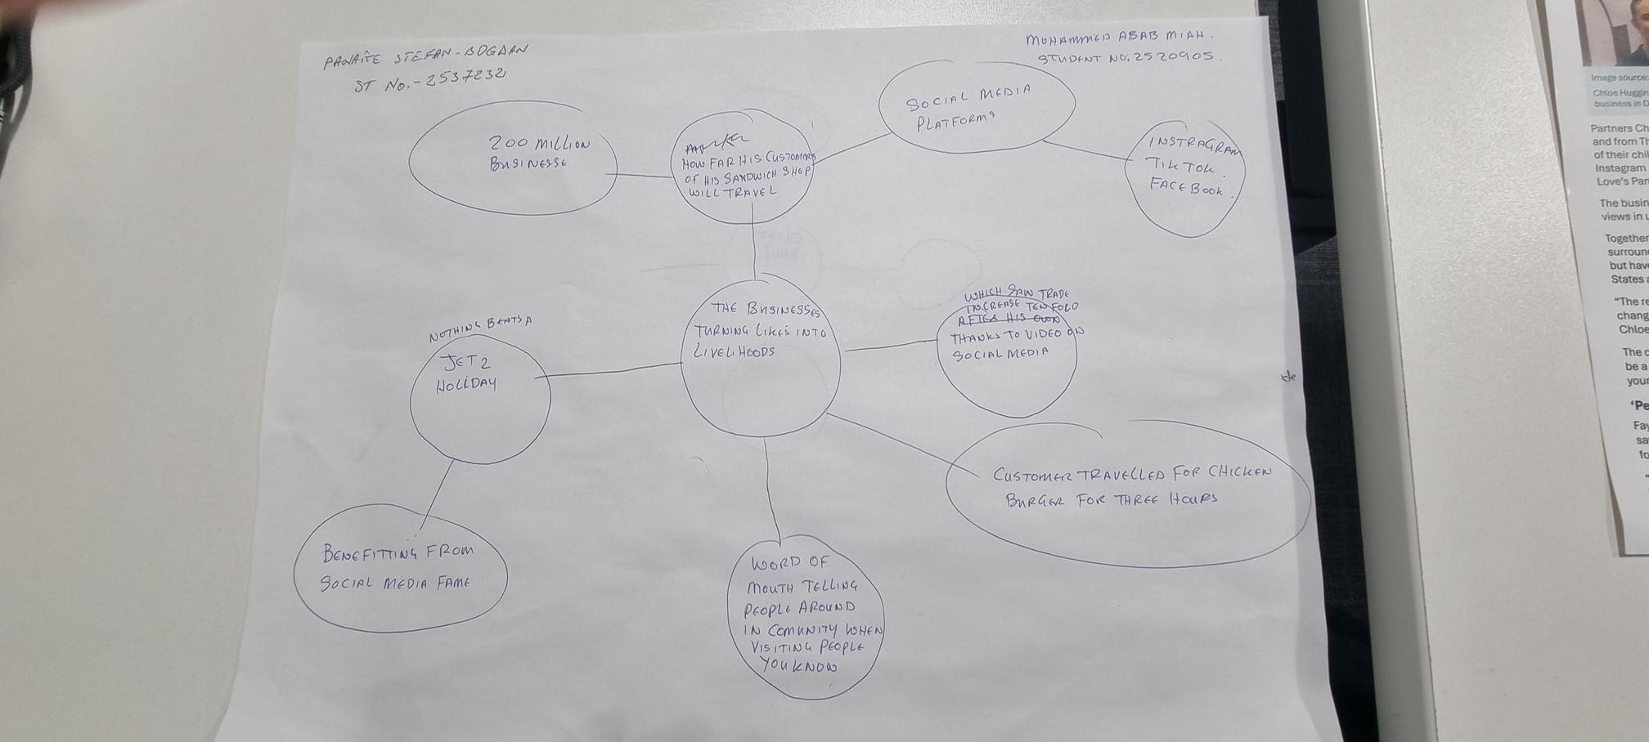

Upload your photo of your A3 in-class notes here:

1. Answer these questions using the sentence starters below
a. What is the main idea of the text?
The core concept is that small businesses can go all the way to popularising themselves and gaining numerous customers when social media posts or videos are viral.
b. What are two key points?
One key point is that businesses such as Honywood Sandwich Shop have gained many new customers because of viral social media posts.
One thing to note is that platforms such as TikTok and Instagram are becoming easier for small businesses to be seen by those who are far away.
c. What part of the text did you find most important? Why?
The most important thing is the story about Honywood Sandwich Shop because it illustrates how social media can draw in travellers who have to come from far and wide to taste the product.
d. Was anything unclear or difficult to understand?
I'm not sure about some of the brands that were mentioned in the article and how they first got viral online.
e. How did your group help you understand the text better?
My group assisted me with main ideas and clarifying portions of the article that I did not comprehend.
3. One-sentence reflection
Question: What did you find challenging about this task?
The hardest part was figuring out which information in the article was important and summarising it in my own words.

