The influence of Sustainable Relationship Marketing Policies and Practices and the Impact on Tesco Performance

Roxana Meader
2222009
28/11/2024
University of Wales Trinity Saint David
BMSW5007_SWAN
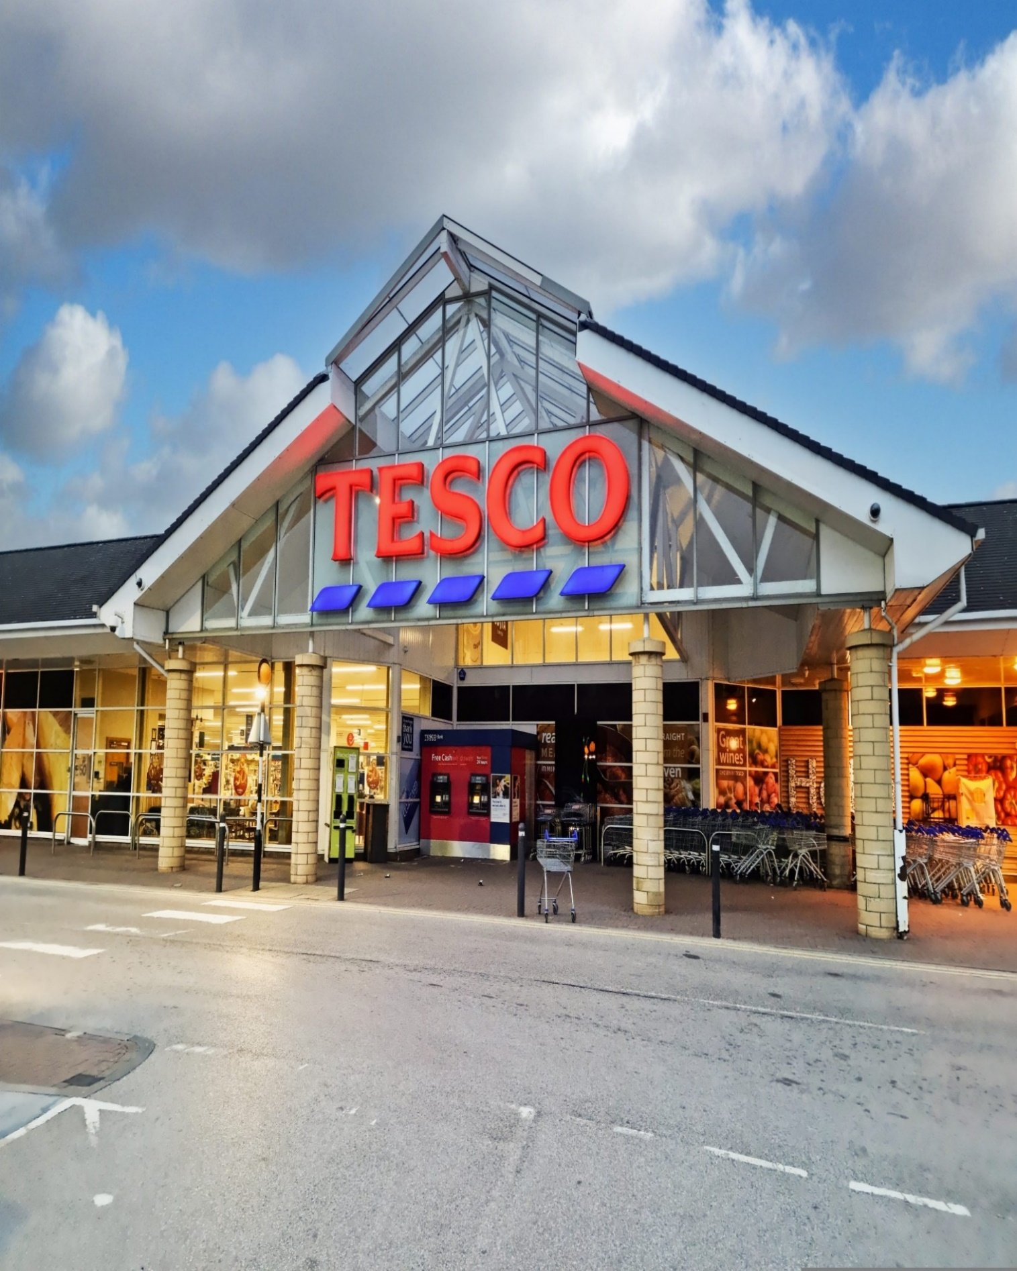

1.0. Executive Summary

This report is compiled to give an overview of Tesco PLC background and its marketing strategies, the primary areas of success of its relationship management strategy and further recommendations that may ensure its further development.

Tesco has been the leading groceries retailer in the UK for the last 10 years, and it has based its success on focusing on a customer-orientated strategy. The company successfully covers several market segments and provides products that meet their customers’ needs.
Tesco is using data collection, analysis, and evaluation strategies to gather information about its customers, their habits, choices, and needs, based on demographics, behavioral and psychographic aspects. Thus, utilizing the data provided by Club card, surveys, customer feedback and in store and online interactions, the organisation creates a database designed to facilitate the customisation of its products based on buyer’s preferences. The customer centricity strategy applies to every aspect of their business, from price, quality, customer service, planning and sustainability. The organisation is adapting its services to the customers’ demands, providing a variety of services in shops and online, such as different stores chains, from hypermarkets to convenience shops and its new website opened in 2024. The products are tailored to satisfy shoppers’ needs, from value and low budget choices to high quality and ecofriendly alternatives. This leads to customer satisfaction, an increase in loyalty and retention, and an improvement in Customer Lifetime Value (CLV).

Although the success of the company is still ongoing, there are areas of their strategy that should be reinforced and focused on. Due to the rapid technological development, especially concerning AI and online marketing, Tesco needs to concentrate and further invest in its digital presence. The organisation needs to maintain the focus on ethical and sustainable practices and follow the data control policies and procedures.

Table of Contents

1.0. Executive Summary 1
2.0. Introduction 3
3.0. Main Findings
3.1. Brief Tesco historical development and growth 4-5

3.2. The impact of data collection on Market customer 6-7
relationship

3.3. Critical discussion on Tesco market strategies and 8-11
custom centrality and differentiation.

3.4. Ethics and Sustainability 12-14

4.0. Conclusion 15
5.0. Appendix 1 16
6.0. Appendix 2 17-19
7.0. Appendix 3 20-22
8.0 Appendix 4 23-24
9.0. Reference 25-28

2.0 Introduction

This report has been requested by the Marketing Executive Officer of ‘Marketing Focus’ and is part of the assignment for BMSW5007_SWAN module conducted by the lecturer Gwyneth Jones.
The report has been compiled by Roxana Meader and it is based on research collected from secondary sources such as academic textbooks, websites, journals, and reliable online sources that were used to illustrate Tesco’s history, past and present development and the marketing strategies employed in its ascension.
The author has utilized the main research findings in a critical and analytical manner, trying to provide a clear picture of the organisation marketing approach, based on customer centrality and sustainability, its benefits and disadvantages, and potential recommendations.

3.0. Main Findings

3.1. Brief History of Tesco PLC.

The birth of Tesco retailer company originates in 1924, when Jack Cohen began selling groceries from a stall in London. He had a vision of selling affordable food for every household; The name came about after Jack Cohen bought a shipment of tea from Thomas Edward Stockwell. He made new labels using their initials and he expanded his business from the first branded Tesco tea product in 1929, to opening a chain of stores that operates on multinational levels and being the third largest retailer in the world in 1919. (Tesco PLC., 2024).

Currently the company offers a variety of products such as fresh foods, bakeries, frozen foods, drinks, baby products, household appliances, pets’ products, entertainment, clothes and shoes, electronics and electrical goods, petrol, health, and beauty products.

Tesco conducts its business to cater to customers’ needs and recently extended the shopping experience online. The considerable influence on the business market is emphasized by the banking, consultancy, telecom, and insurance services and its presence in Europe. (Global Data., 2024).

The mission statement of the organization remains the same: “serving the customers, community and planet a little better every day.” (Tesco PLC, 2024), and it is a commitment of the company to put the customers’ values and needs at the center of its activity by providing better, healthier, and more affordable choices and adhering to environmentally sustainable practices.
Although the organisation reveals a clear trajectory on the improvement in the sustainability area, the breach of protocols and legislation is still present. In 2017 Tesco has been fined £8million in health and
safety charges. (Gov.UK, 2017).

In 2024 Tesco is still the leading grocery retailer in the UK with a share of 27 percent of the market. (Bedford E., 2024)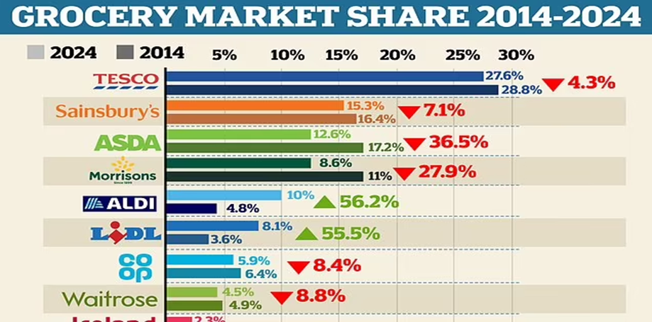 (This is money.co.uk. ,2024).
According to Marketing Week in the preliminary results for year 2024 Tesco achieved “7.2% growth year-over-year to £61.48bn.” (Niamh Carroll, 2024).
Tesco PLC Annual Report and Financial Statement 2024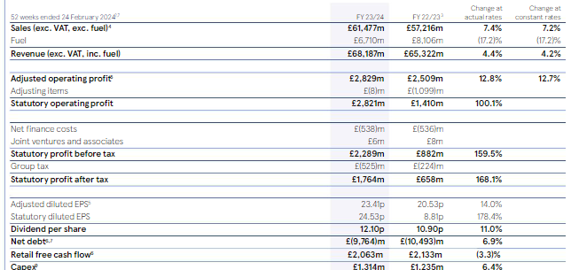
(Tesco PLC, 2024).
The pictures above illustrate the annual financial report of the company in the current year, which shows an increase in sales and revenue, comparing to previous years and Tesco leading place in market share for the past 10 years.
Both research quoted above imply the hight quality performance that Tesco has in today’s competitive market and the healthy profit margins that the organisation sustains.
In 1995 Tesco launched the membership Clubcard and According to Sky news, in 2024 Tesco attains considerable growth in customers after focusing its marketing strategy on value and price, and Tesco Clubcard covers 23 million households. (Sillars J., Sky News, 2024).

3.2. The impact of data collection on Market customer relationship

To create strong customers relations and sustainable retention, an organisation needs to gain insight into client’s needs, values, choices, habits, and backgrounds. Armstrong states that “The marketing world is filled to the brim with information from innumerable sources.” (Armstrong G., Kotler P., 2023).
According to Glazer data and information are crucial in the marketing field. (Glazer R.,1991). At Tesco data collection and analysis provides an insight in customer needs and choices and helps create customised algorithms for each shopping experience.
Tesco collects data through the usual customer touch points, such as physical store with self-checkout and POS systems, CCTV and foot traffic analyses, web, computer, smart phone, customer service, surveys and feedback, email, social media, advertising, and through club cards.
As stated by BizTech there are four important types of customer data collected, such as: Identity data, descriptive data, behavioural data, and qualitative data, and they provide information on ethnicity, age, sex but also patters, behaviours, choices, feedback, and ratings. (BizTech, 2021).
The data collected will be analysed, stored, and used by the CRM system, which is the “core business strategy that aims to create and maintain profitable relationships with customers” (Buttle F., Maklan S.,1919). Tesco is using Dunnhumby as a data Hub. (Retail Media,2023)
The CRM will enable a better understanding of customers insights, will “tailor and promote products and services to customers in the way that the customers prefer “(Fairhurst P., 2001). The data collected from Club cards and the other customer touchpoints helps the organisation understand the customer behaviours and choices and optimise its products and services according to the customers’ demands, providing a personalised shopping experience through magazines and vouchers, but also a better communication with its audience. More data collection information and the impact on marketing relationships are mentioned in Appendix 1.
According to Medium.com Tesco Clubcard led to sale increase and elevated the organisation to the rank of leading supermarket retailer in UK. The Clubcard provided information to each customer and purchase but also the insights in how expenditure and choices varied. (Chowdhury B., 2023).
Conversely, in 2023, Tesco was accused of “misleading customers with unclear Clubcard pricing”. (Lower R., 2023), the allegation can endanger the brand image and customer loyalty.
In conclusion, data collection constitutes a key factor in the customisation and enhancement of customer relationships, which consequently will produce an increase in the lifetime value of the customers and their retention trough a boost in loyalty.
According to Goodgrowth.co.uk limitations will arise due to the customers concerns on data privacy. Furthermore, the continuous increase in the volume of data can be a cause of “data blindness and the necessity for analytic tools, data quality and data privacy” should be brought forward. (Good Growth, 2024).
Although Tesco’s policy is to not share or sell personal data, privacy risks will always be present by data breach incidents. In 2014 Tesco Clubcard accounts have been hacked and password were posted online. (The Guardian. 2021).
In 2024 Tesco rises controversy again by proposing the use of AI to “nudge Customers” into buying heathy products and by doing so risking alienating loyal customers that are against that form of intrusion and potential shopping control. (The Telegraph. 2024).

3.3. Critical discussion on Tesco marketing strategies,
custom centrality and differentiation

“Customer centrality is the view that the customer's needs, wants and predispositions must be the starting point for all decision-making within the organisation.” (Blythe J., 2019).

Segmentation
In present economy is not possible for a “company to target an entire market due to time and cost limitations” (The Economic Times, 2024). Consequentially, the market divides into different segments that will aim to fulfil customers’ expectations, by providing products tailored to their own needs, behaviours, and backgrounds. Marketing segmentation is the key to successful customer relationships, as it helps understand the audience needs and provided targeted products and services.
From the beginning Tesco focus was customer orientated, and with the use of marketing segmentation strategies, the organisation is developing products designed to meet buyer’s needs. Therefore, Tesco concentrates on a differentiated market strategy, for different segments of the market and a mixture of segmented and micromarketing in small neighbourhood shops, such as Tesco Express.
From the data collection and analysis that Tesco is undertaking, the main segments of the market separate, based on the following types of marketing segmentation.

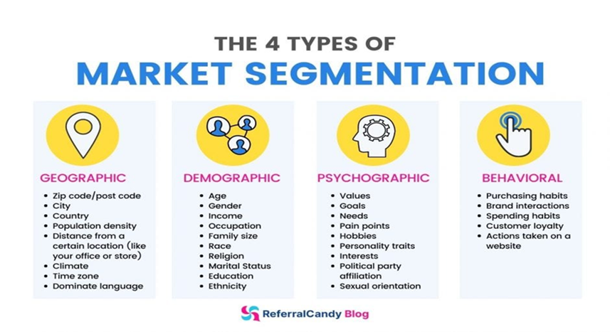
Tesco is using the segmentations strategies through loyalty cards, feedback, and targeted marketing campaigns. This way the organisation can reach a wider audience and can tailor products after customer needs. Tesco uses the geographic aspect to adapt the stores and optimise convenience, meeting the demands of different customers based on logistic and accessibility and operates a total of 2,048 small convenience stores in the UK. (Statista, 2024). In terms of accessibility Tesco also introduces the Scan as you shop technology which simplifies customer experience and saves time.
The demographic, behavioural and psychographic segmentation differentiates through the loyalty card which will provide information about age, gender, income, purchasing habits but also values, cultures, interests, and spending habits.
Differentiation
“The concept of differentiation originates at the product level” (Waldman, D. E., and Jensen, E. J. 2013).
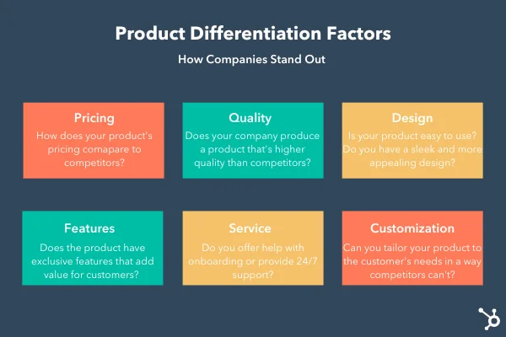
Tesco is attempting to differentiate on multiple levels, such as reward strategy with club card, product quality with unique ranges as Tesco finest, price decrease and price match with own brand products, customer convenience and accessibility by introducing Scan as you shop.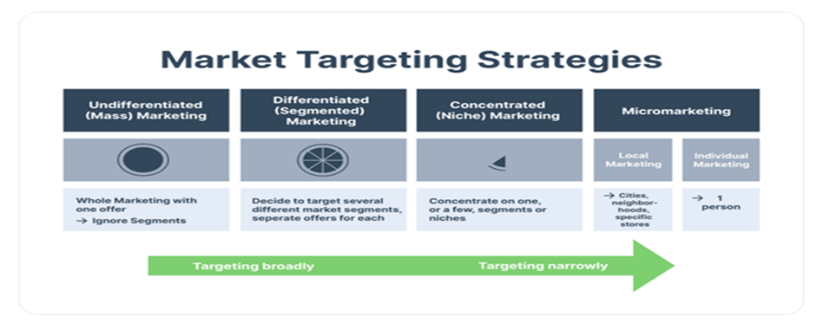
The organisation customises its products and provides a wide range of items such as health-conscious options: vegan, vegetarian, organic, gluten free or any other dietary specific products. It also provides budget orientated products with the own label brands, Tesco Value and Tesco finest, which would satisfy the quality/budget specific audience. Using Behavioural segmentation Tesco provides discounts and rewards to the customers based on shopping patterns.
David Hughes argues that Tesco has been for a long time a leader in “taking the differentiated product approach forward” and identifies six customers segments. (Hughes D, 2014)

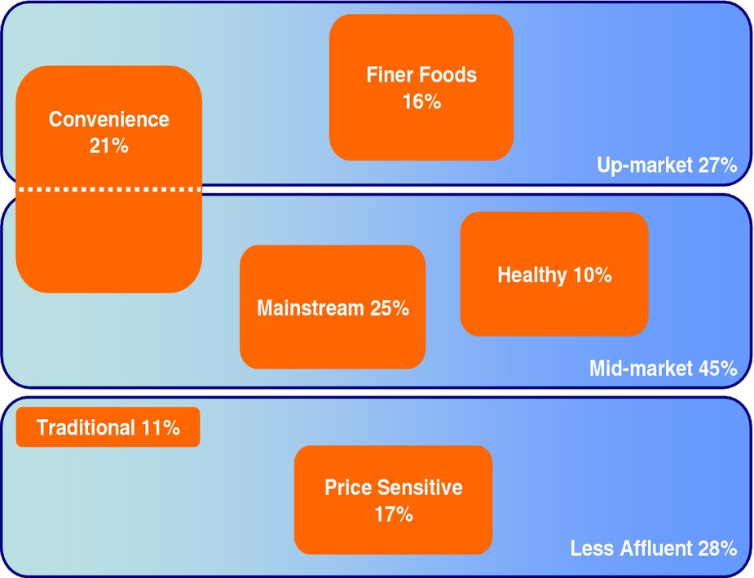

The product customisation comes with few difficult aspects in terms of data privacy and price range. Whenever Tesco is providing products to its wide audience, is focusing its segmentation strategy on the marketing mix.

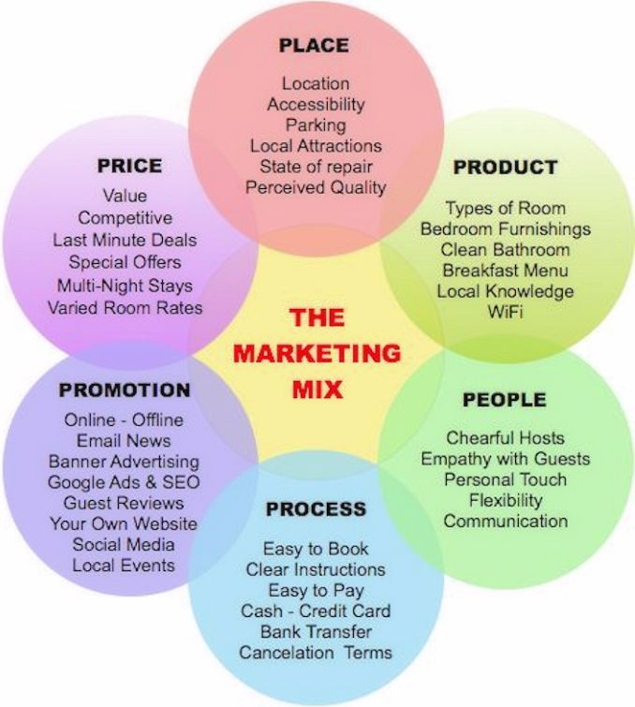
Reuters attests that Tesco’s marketing strategy is profitable, and customers are more interested in the quality of the products, Tesco finest brand is up with 15.7 %, and the strategy of matching prices of Aldi is advantageous. (Reuters, 2024).
Pricing Strategy
In terms of competitive strategy Tesco is using a mixture of cost leadership and differentiation.

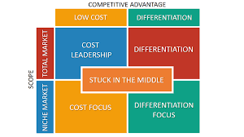
According to Porter’s theory there are two types of “competitive advantage an organisation can posses and those are low cost and differentiation” (Porter M. E., 1985).
Tesco is competing to achieve both advantages by using strategies as price reductions, with the Tesco value brand, but also by matching prices with competitors.
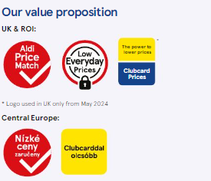

Regardless of Tesco’s steady growth and marketing strategy, controversy can still arise that may damage the organisation image or customer relations. According to BBC News, there is a discrepancy between Tesco’s price match with Aldi’s and the product quality. The article in question can affect Tesco image and customer perception. (BBC News, 2024). Additionally, the club card program will always be at risk to raise privacy and data concerns.
(More information on customer centrality is available in Appendix 2)

3.4 Ethics and sustainability

Ethics constitutes one of the main pillars of a successful business and according to Bryars and Stanbery “a company enters a social contract with the society as a whole” and must strive to achieve social benefits. (Byars, S. M., & Stanberry, K. 2018).
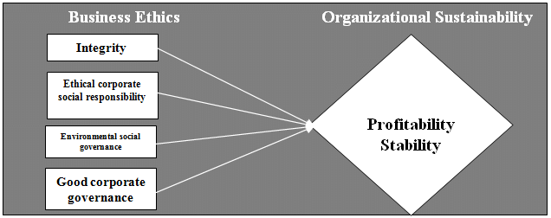
By extension Tesco PLC values are committed to its customers, community and employees and it is functioning responsibly in terms of sustainability.
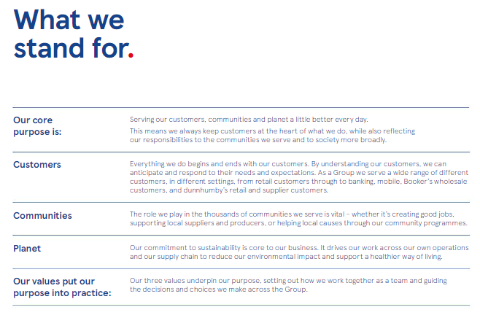
By providing customised products and services Tesco ensures its customer centrality and upholds its commitment to the buyers’ values and needs. The club card offers the insight into the current choices and needs of the audience and allows Tesco to reinforce its CSR and sustainability practice by offering products with reduced environmental impact and orientated on health and wellbeing.
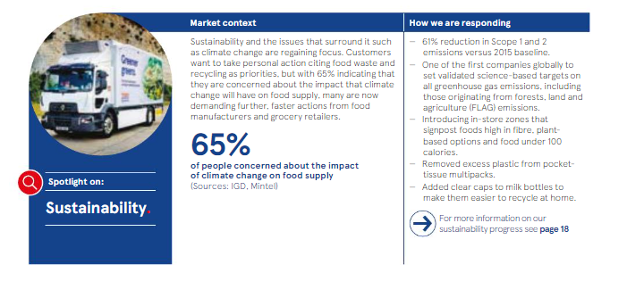

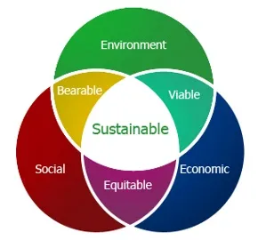

In accordance with the Triple bottom line framework, Tesco is following the Employment, Health and Safety laws, by using the moral and ethical principles of the society when dealing with stakeholders, by engaging in philanthropical activities like food donations and using environmentally friendly products.

Tesco understands that in a continuous changing world the ethical and sustainability values are the way forwards and is committed to environmental health and its legal and moral obligations towards its stakeholders. Thus, the organisation provides fair employment opportunities, commitment to community, ethical treatment to suppliers but also eco friendly product options and works on plastic and carbon print reduction. (Appendix 3).
Regardless of the ethical value the organisation is professing, Tesco has been involved in several scandals that were brought to media attention. (See Appendix 4).

4.0 Conclusion

In conclusion, the leadership place that Tesco occupies in UK market in terms of shares and international sales is a result of successful CRM strategies. The organisation is orientated on extensive customer centric strategies and loyalty programs, engaging customers online and in shops, providing personalised products and recommendation through Club Card and monthly magazine. With the involvement in community and CSR practices such as, reducing the carbon footprint, engaging in different charity works, investing in environmentally conscious products, reducing plastic usage, Tesco built a favourable image focused on customer centrality and sustainability.
Tesco should continue to consolidate its customer centric strategies but keep in mind that privacy and customers data will aways bring forward breaching risks. Tesco’s internet presence is gradually getting stronger, but there is nowhere close to some competitors such as Amazon. Therefore, close attention and investment into digital strategy, should be promoted. The investment should be extended to further involvement into community initiatives, such as supporting local businesses, maintaining eco-friendly and fair-trade approaches and reach carbon neutrality as predicted by 2035.

Appendix 1

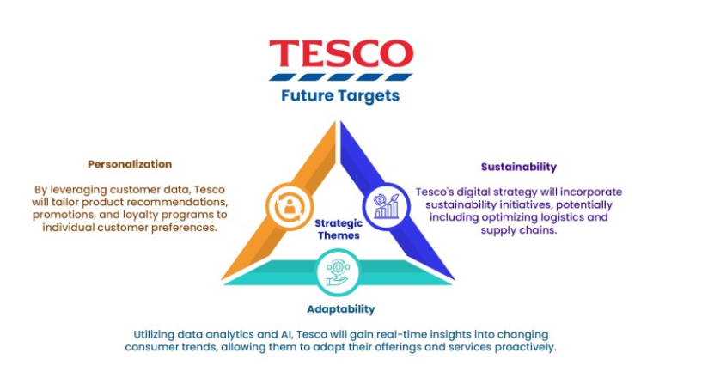

Data collection will enable Tesco to identify customers needs and enhance their experience through personalised services and products. This way the organisation can use predictive analysis to identify trends and build sustainable customer relationships. The CRM system that Tesco is utilising helps quantify the customer satisfaction and their overall experience, and with the feedback provided through reviews and customer service, it will allow the organisation to take informed decisions and make advantageous improvements. The loyalty rewards programs are personalised and can enhance and strengthen the customer’s brand experience, and in essence “marketing is also carried out by buyers” by the continuous feedback they provide back into the market. (Kotler, P., Armstrong, G., et al., 2001, p 10). Consequentially the brand image and the customer loyalty and retention will increase.
Regardless of the data collection benefits, the organisation must be aware of its risks, which are numerous and vary from data misuse to data breach and the intrusive effect that may have on customers. This may lead to reputation damage and loss of customer loyalty and retention.

Appendix 2

The focus of Tesco succes is constituted by its customers.In essence, in the competitive market that Tesco operates in, the importance of customer centricity is fundamental.
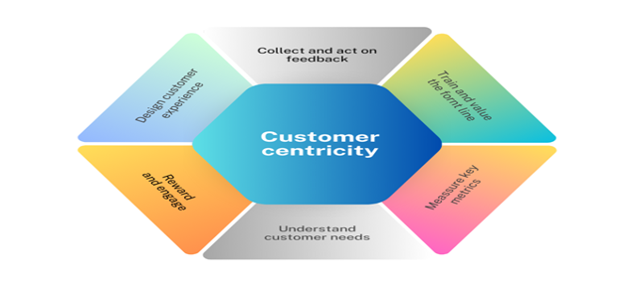

The organisation has built its whole marketing strategy and image on customer orientated practices. Tesco stores are designed for customer’s needs, with customised facilities (touch free taps, dryers, disability and changing facilities) and the customised customer shopping experience (self-serving tills, customer service, online). The organisation products and services are also designed to meet different choices. Thus, Tesco is using a marketing strategy based on segmentation, price, differentiation and ethical and sustainable policies and practices.
Segmentation.
The segmentation strategy at Tesco is vast and covers a wide range of areas. Tesco has products dedicated for general audiences but also a Free from range, designed for individuals with allergic conditions, an organic range, a vegetarian and vegan range, a selection of products based on budget but also an international selection of products for minorities or customers with an eclectic tastes. Most data collected for the segmentation strategy comes from the Clubcard, which bring forward a few drawbacks. Data collection will always be a sensitive and grey area for the customers, as it comes with privacy concerns and misuse of information. In addition, the Clubcard may provide unclear pricing and can only be purchased by over 18 individuals that are residents of UK. (Tesco PLC, 2024)

Differentiation
Tesco differentiates itself not only by its products (Tesco value range and Tesco Finest) but also by the services provided. The organisation is suppling a wide range of services that enhance the customer shopping experience, such as Scan as shop scanners, soft plastic recycling points, Clubcard offers and personalised discounts, customised facilities and family parking, and customer service.
Pricing
Tesco is known for its pricing campaigns such as Every Little helps and Aldi price match.
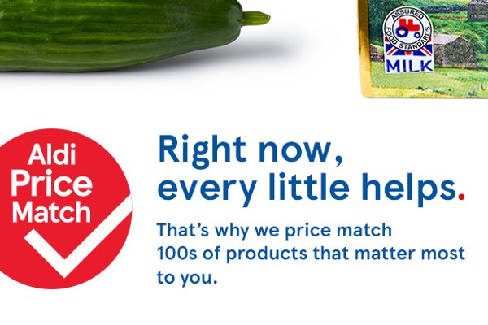
In 2023 the organisation implemented the campaign low everyday prices which brought advantages to its customers.
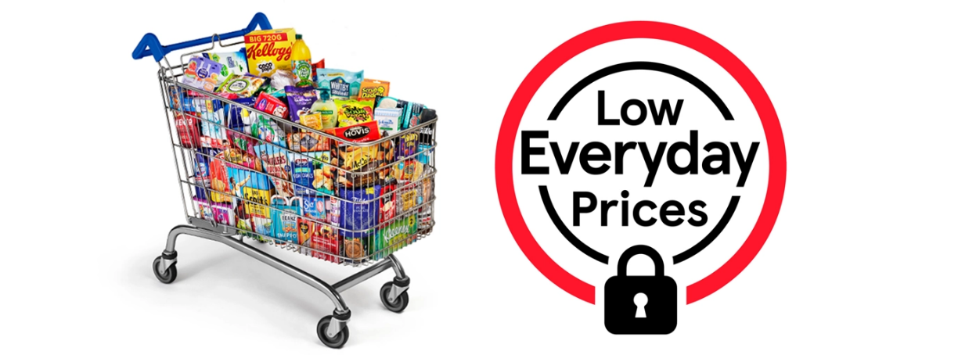
Although Tesco is continuously investing in marketing strategies, it became apparent that the pricing strategy is not as successful as competitors.
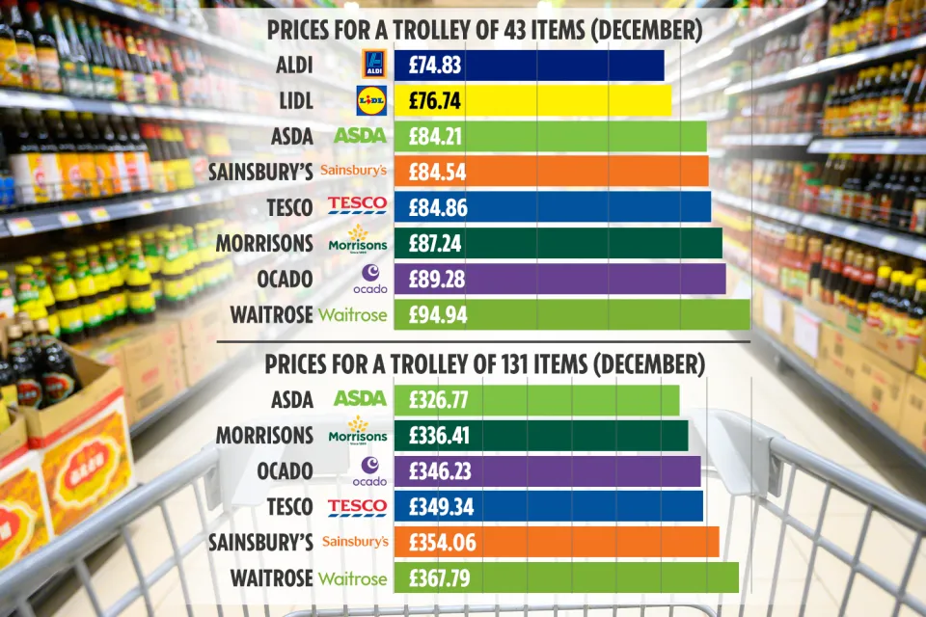
(The Sun, 2024)
The above image displays Tesco performance in terms of price and affordability. Due to the competitive market Tesco is ranking lower than Aldi and Liddle in terms of product price.

Appendix 3
In our current society the customers are more aware of the impact the economy can have on the environment, and they are prioritising their choices based on sustainability practices. According to Greenpeace 83% of Tesco customers believe that “supermarkets have the duty to act on deforestation”. (Greenpeace, 2021)
In 1987, the United Nation defined sustainability as “meeting the needs of the present without compromising the ability of future generations to meet their own needs.” (United Nations, 1987)
Tesco is operating in accord with the sustainability policies and practices required by its clients and by extension, by the society. To maintain transparency and customer centricity, the organisation is adapting its products and services to provide better eco friendly alternatives and higher ethical services for its stakeholders.

Packaging and plastic.
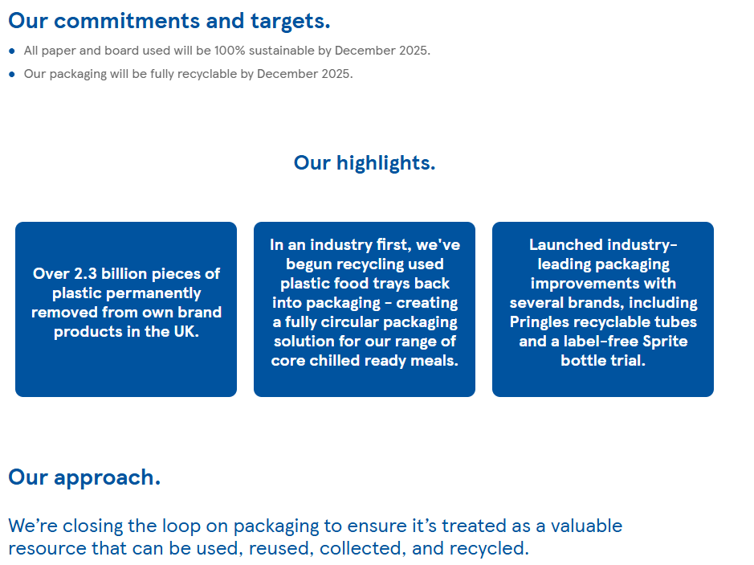
Tesco intends to remove packaging and plastic by using the 4R strategy: Remove, Reduce, Reuse, Recycle. Tesco customers are encouraged to reuse carer bags, and the plastic packages are used less frequently. In 2019 “Tesco introduces the first recycled food grade soft plastic packaging from materials returned by customers.” (Plastic Energy, 2024).

Farming and animal welfare.
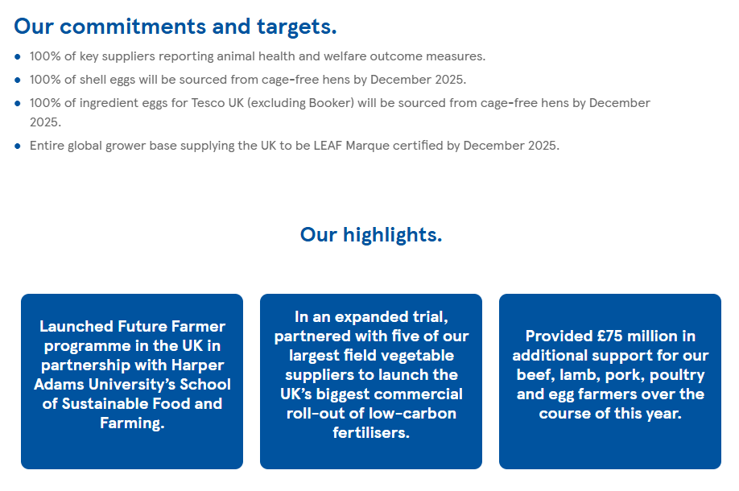
Tesco promotes food compatible to the ethical and sustainable standards. The organisation is getting involved in programmes that provide support to local farms, thus contributing to the community.

Healthier Communities
Tesco helps raise awareness to health problems, such as diabetes and provides free blood pressure checks and advice how to maintain a healthy diet. In the Tesco magazine the organisation provides healthy recipes.
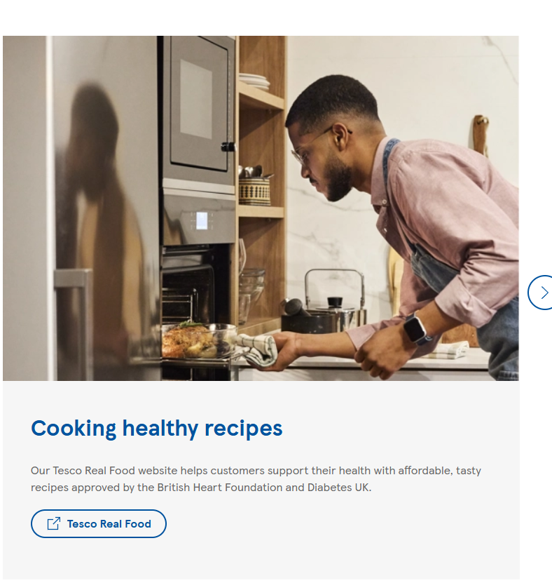

Reduction to Carbon Print
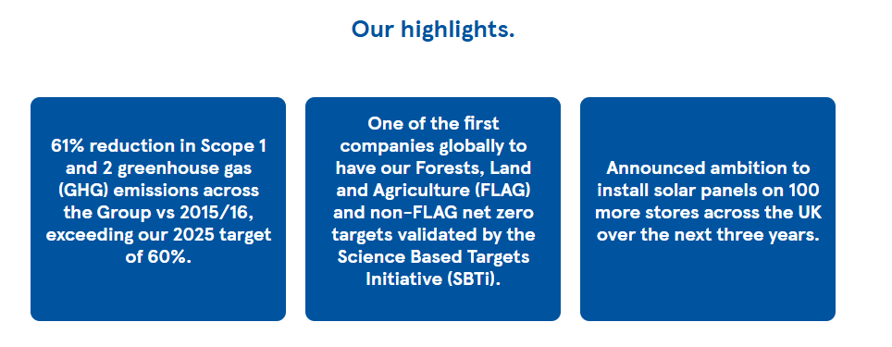
Tesco aims to gain carbon neutrality by 2035. The organisation used 100% renewable energy for its stores and works on purchasing renewable gas made from its food waste
(Tesco PLC, Sustainability report, 2024)
Those are few of the practices that Tesco is either involved in or vows to follow through. By adopting the sustainability rules and regulations, the organisation ensured the creation of its brand reputation and the success of its customer centrality strategy.
The ethical and sustainable praxis increased the shareholders loyalty and customer retention. By implementing appropriate environmental conscious norms and ethical regulations Tesco can increase its reputation and attract potential customers but also ensure the loyalty of its shareholders.

Appendix 4

In 2017 Tesco has been prosecuted and pleaded guilty for selling food past its used date.
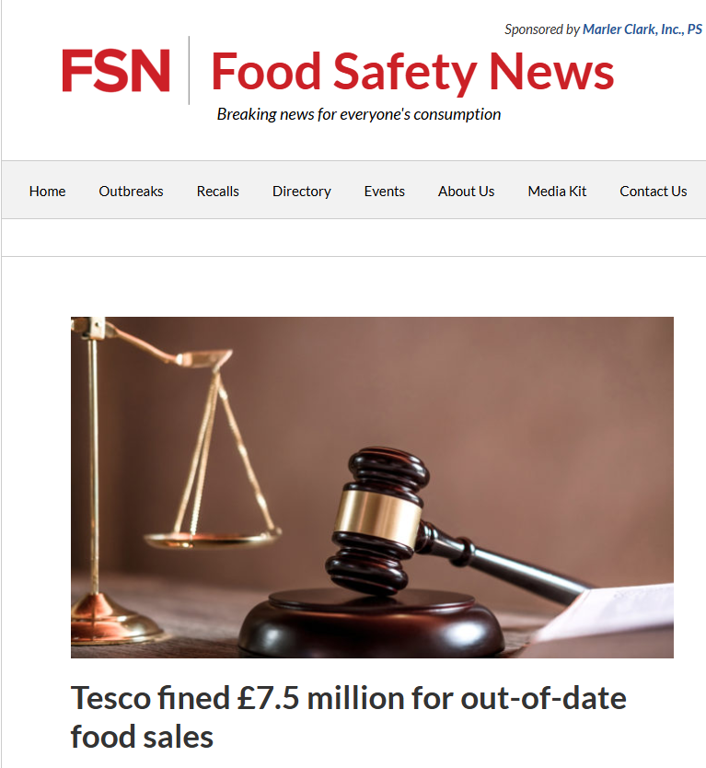

(Food Safety News, 2021)
In December 2022, Tesco faced lawsuit for forced labour, exploitation and wage theft.
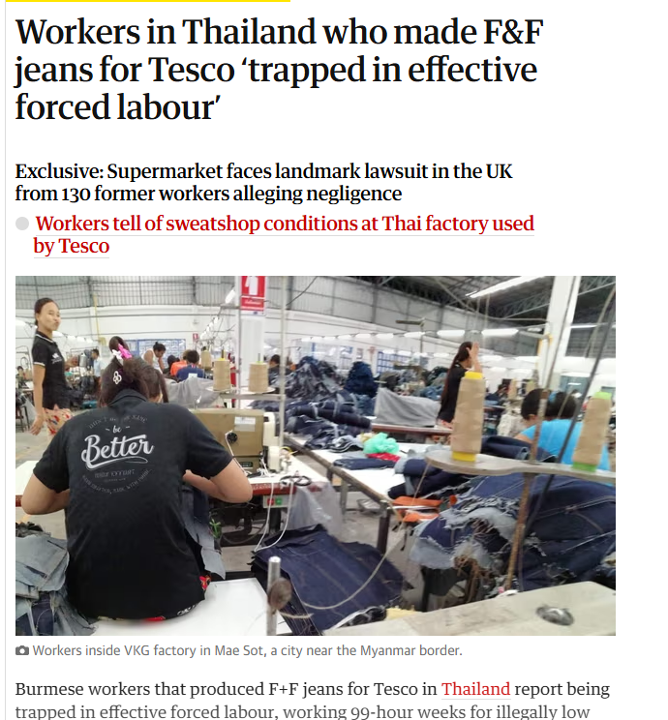(The Guardian. 2022)
In 2023 Tesco was accused of lack of transparency in its prices and of misleading the consumers with the club card offers. (Which, 2023). Both accusations constitute a breach of ethical conduct and according to the researchers, unlawful practices. 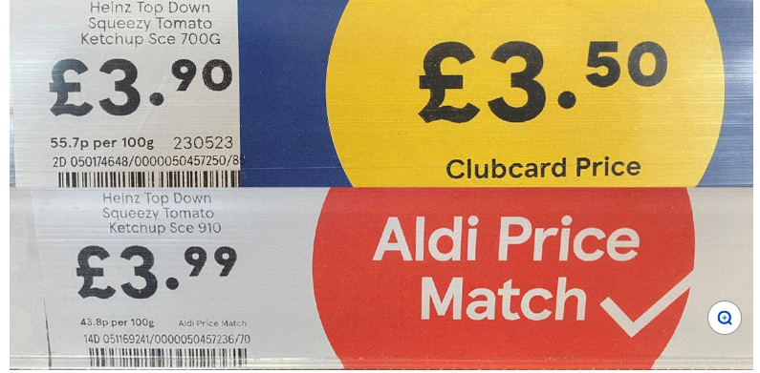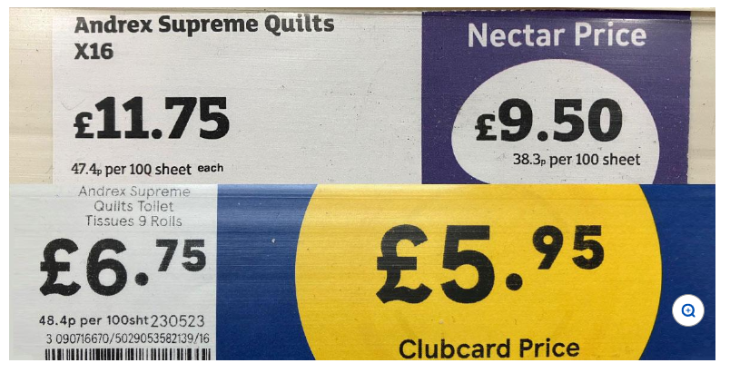

7.0 Reference

Armstrong G., Kotler P. (2023). Marketing an introduction. 15th ed. London: Pearson Education Limited. p.124.

BBC News. (2024). Aldi price match at Tesco - some goods not like-for-like. [Online]. BBC News. Last Updated: 23 September 2024. Available at: https://www.bbc.co.uk/news/articles/c0m0vrmlzgyo [Accessed 26 October 2024].

Bedford E. (2024). Tesco PLC - statistics & facts. [Online]. Statista. Last Updated: Jun 14, 2024.

Buttle F., Maklan S. (2019). Customer relationship management. 4th ed. New York: Routledge. p.17.

Niamh Carroll. (2024). Tesco CEO claims retailer ‘more competitive than ever’ on value. [Online]. MarketingWeek. Last Updated: 10 Apr 2024. Available at: https://www.marketingweek.com/tesco-ceo-more-competitive-value [Accessed 23 October 2024].
Blythe, J. (2009). Key concepts in marketing. SAGE Publications Ltd, https://doi.org/10.4135/9781446221617
Boland H. (2024). UK’s biggest supermarket could urge shoppers to replace unhealthy purchases. [Online]. The Telegraph. Last Updated: 17 September 2024. Available at: https://www.telegraph.co.uk/business/2024/09/17/tesco-clubcard-data-to-warn-shoppers-unhealthy-food- [Accessed 13 November 2024].
Byars, S. M., & Stanberry, K. (2018). Business Ethics. OpenStax College, Rice University.

Chowdhury B. (2023). The Role of Data in Tesco’s Retail Success: A Look at the Clubcard Strategy. [Online]. Medium. Last Updated: Mar 5, 2023. Available at: https://medium.com/@boktiarchowdhury/the-role-of-data-in-tescos-retail-success-a-look-at-the-clubcar [Accessed 25 October 2024].

Davie J. (2024). UK's Tesco forecasts profit rise as consumer sentiment improves. [Online]. Reuters. Last Updated: April 10, 2024. Available at: https://www.reuters.com/world/uk/britains-tesco-expects-profit-rise-202425-year-2024-04-10/ [Accessed 26 October 2024].

Environment Agency. (2017). Tesco hit with major £8million fine for pollution incident. [Online]. Gov.UK. Last Updated: 16 June 2017. Available at: https://www.gov.uk/government/news/tesco-hit-with-major-8million-fine-for-pollution-incident#:~:text [Accessed 13 November 2024].

Friedman M. (1970). A Friedman doctrine‐- The Social Responsibility of Business Is to Increase Its Profits. [Online]. The New York Times. Last Updated: Sept. 13, 1970. Available at: https://www.nytimes.com/1970/09/13/archives/a-friedman-doctrine-the-social-responsibility-of-busines [Accessed 27 October 2024].

Dugan E. (2022). Workers in Thailand who made F&F jeans for Tesco ‘trapped in effective forced labour’. [Online]. The Guardian. Last Updated: Sun 18 Dec 2022. Available at: https://www.theguardian.com/business/2022/dec/18/workers-in-thailand-who-made-ff-jeans-for-tesco-tra [Accessed 4 November 2024].

Glazer, R. (1991). Marketing in an Information-Intensive Environment: Strategic Implications of Knowledge as an Asset. Journal of Marketing, 55(4), 1-. https://doi.org/10.2307/1251953

Global Data. (2024). Tesco Plc: Overview. [Online]. Global Data. Last Updated: November 2024. Available at: https://www.globaldata.com/company-profile/tesco-plc/ [Accessed 18 October 2024].

Good Growth. (2024). The Data-Driven Rise of Supermarket Loyalty Cards and the Risk of Data Blindness. [Online]. Good Growth. Last Updated: 2024. Available at: https://goodgrowth.co.uk/articles/the-data-driven-rise-of-supermarket-loyalty-cards-and-the-risk-of- [Accessed 25 October 2024].

Fairhurst, P. (2001). e-CRM. Journal of Database Marketing & Customer Strategy Management, 8(2), 137–142. https://doi.org/10.1057/palgrave.jdm.3240028

Hughes, D. (2014). European Food Marketing: Adding Value in Mature Food Markets through Market Segmentation and Product Differentiation. EuroChoices, 13(2), 20–26. https://doi.org/10.1111/1746-692X.12058
Kirkman A. (2021). Poll: 88% of Tesco Customers Believe Supermarkets Shouldn’t Do Business with Deforesters. [Online]. Greenpeace. Last Updated: April 30, 2021. Available at: https://www.greenpeace.org.uk/news/poll-88-of-tesco-customers-believe-supermarkets-shouldnt-do-busin [Accessed 15 November 2024].
Kotler, P., Armstrong, G., Saunders, J., & Wong, V. (2001). Principles of Marketing, 2nd edition. Corporate Communications, 6(3), 164–165. https://doi.org/10.1108/ccij.2001.6.3.164.1

Lawer R. (2023). Misleading customers with ‘unclear Clubcard pricing’. [Online]. Marketing week. Last Updated: 9 Jun 2023. Available at: https://www.marketingweek.com/tesco-cma-clubcard-pricing/ [Accessed 4 November 2024].

News Desk. (2021). Tesco fined £7.5 million for out-of-date food sales. [Online]. Food Safety News. Last Updated: April 24, 2021. Available at: https://www.foodsafetynews.com/2021/04/tesco-fined-7-5-million-for-out-of-date-food-sales/ [Accessed 4 November 2024].
Plastic Energy. (2024). Tesco Introduces the First Recycled Food Grade Soft Plastic Packaging from Materials Returned by Customers. [Online]. Plastics Energy. Last Updated: 2024. Available at: https://plasticenergy.com/tesco-introduces-the-first-recycled-food-grade-soft-plastic-packaging-from [Accessed 13 November 2024].
Porter, Michael E., "Competitive Advantage". 1985, Ch. 1, pp 11-15. The Free Press. New York.
Retail Media. (2023). Tesco Media and Insight Platform, powered by dunnhumby, has unveiled a range of new onsite and in-store media channels. [Online]. Retail Technology
Innovation Hub. Last Updated: October 10, 2023. Available at: https://retailtechinnovationhub.com/home/2023/10/10/dunnhumby-powered-tesco-media-and-insight-platfo [Accessed 13 November 2024].
Sillars J. (2024). Tesco sees sales growth after focus on value and rise in premium shoppers. [Online]. Sky news. Last Updated: 3 October 2024. Available at: https://news.sky.com/story/tesco-credits-value-drive-for-hike-to-annual-profit-expectations -13226956 [Accessed 24 October 2024].

Smith E. (2021). The 4 Types of Consumer Data That Matter to Retailers. [Online]. BizTech. Last Updated: 29 September 2021. Available at: https://biztechmagazine.com/article/2021/09/4-types-consumer-data-matter-retailers-perfcon#:~:text=C [Accessed 24 October 2024].

Statista. (2024). Number of Tesco group stores in the United Kingdom (UK) as of financial year end 2023/24, by type. [Online]. Statista. Last Updated: 2024. Available at: https://www.statista.com/statistics/490955/tesco-group-stores-by-type-united-kingdom-uk/ [Accessed 26 October 2024].

Tesco. (18th October 2024). Our history. [Online]. Tesco plc.com. Last Updated: 18th October 2024. Available at: https://www.tescoplc.com/about/our-history [Accessed 18 October 2024].

Tesco PLC. (2024). Sustainability Report. [Online]. Tesco.com. Last Updated: 2024. Available at: https://www.tescoplc.com/sustainability/planet/protecting-nature/climate-change [Accessed 4 November 2024].

The Economic Times. (2024). What is 'Segmentation'. [Online]. The Economic Times. Last Updated: 26 October 2024. Available at: https://economictimes.indiatimes.com/definition/segmentation [Accessed 26 October 2024].

The Guardian. (2021). Tesco website and app back online after hack attempt. [Online]. The Guardian. Last Updated: Mon 25 Oct 2021. Available at: https://www.theguardian.com/business/2021/oct/25/tesco-website-app-back-online-hack-track-deliveries [Accessed 13 November 2024].

This is money.co.uk. (2024). Grocery market share. [Photograph]. London: This is money.co.uk.

United Nations. (1987). Sustainability. [Online]. United Nations. Last Updated: 1987. Available at: https://www.un.org/en/academic-impact/sustainability#:~:text=Sustainable%20development%20requires%20 [Accessed 27 October 2024].

Waldman, D. E., and Jensen, E. J. (2013) Industrial organization: Theory and practice. Pearson Education, 2013.

Which? (2023). Unclear Tesco pricing could be ‘unlawful’, Which? warns, as it reports the grocer to the regulator. [Online]. Which? Last Updated: 09 June 2023. Available at: https://www.which.co.uk/policy-and-insight/article/unclear-tesco-pricing-could-be-unlawful-which-war [Accessed 13 November 2024].

