Julian Hart
5499
Corporate governance in policing module BMPO7002
The Challenges of Corporate Governance in Policing
The term Governance is believed to have been first used in 14th Century France where it meant seat of government (Pierre & Peters, 2000). It has however been used since well before the 14th century and its origins can be traced back to the Latin word Gubernare, which means to steer. Ancient and prominent philosophic minds such as Socrates, Plato and Aristotle were pivotal in establishing the social constructs of what Governance is in a societal framework theory. This includes how we ought to live in society, the link between happiness, living in a just city, how society should conform the right way, including political regime, the role of family, women, and art in society etc. Whilst these are among the earliest concepts of societal formation from an idealistic perspective the notion is that these inter-dependent aspects of society cannot co-exist without leadership, therefore governance begs the question of what governance and subsequently good governance is. It is captured best perhaps by Cicero “He that governs sits quietly at the stern and scarce is seen to move” (Cadbury, 1998, pp. 1-14). This suggests that whilst largely governance goes unnoticed in calm waters, any organisational structure depends on a good governance when perhaps the ship is veering off course.
As this paper is focused on Corporate Governance in policing it will touch on organisational governance within public bodies before moving specifically into policing.
There are several definitions of what either public or good governance are, we will now go on to explore some of those definitions, and outline which are preferred for the purpose of this paper and why.
“Public governance is how an organization works with its partners, stakeholders and networks to influence the outcomes of public policies” (Governance International, 2024). This definition is very simple and on the whole covers what it should do as an aim, i.e., the interests of the service user, which is effectively better outcomes, however for policing terms the picture is much more complex than this definition affords.
We are then offered some further definitions around Good Governance.
Good governance has eight major characteristics. It is participatory, consensus oriented, accountable, transparent, responsive, effective, and efficient, equitable and inclusive and follows the rule of law. It assures that corruption is minimized, the views of minorities are considered and that the voices of the most vulnerable in society are heard in decision-making. It is also responsive to the present and future needs of society (UNESCAP, 2024). Here we start to see some of the more complex nuances introduced into governance including values or principles that are required across public bodies to govern ethically.
Corporate Governance is defined by the Chartered Governance Institute UK and Ireland as ‘the system of rules and practices and processes by which a company is directed and controlled’ (The Chartered Governance Institute UK and Ireland, 2024). Here we see the introduction of the word system, a key factor as we move forward. It goes on to suggest that it includes the way a company is governed and identifies whom holds power for decision making and to what extent. It includes a systemic set of processes and control measures to achieve its organisational objectives, satisfy the interests of stakeholders, whilst ensuring regulatory compliance and confidence in its infrastructure to make sound and ethical decisions that provide long term value and sustainability to the health of the business.
What is clear from the definitions above is depending on what type of organisation or body governance is being considered, would determine which is the most suitable. For policing at least there must be cognisance of values and principles-based governance, as opposed to being financially driven as in business. Also, that governance extends beyond government and that it is cyclical as opposed to linear and requires constant evaluation. Figure 1 illustrates a Principled based model. Partners and stakeholders must be given a voice, and a decision around weighting in stakeholders favour, or at least a consideration must be factored into the priority setting given the specific issue at hand in any given scenario as outlined by Loeffler (2016). The UNESCAP definition is therefore best suited for the purpose of a policing context and this paper, which will now move on to cover Governance in Policing.
Governance in UK Policing is complex (The Police Foundation, 2022). Owing to devolution there are forty-three territorial forces in England and Wales, a national force in Scotland and Northern Ireland, additionally there are a further four ‘special’ forces which include British Transport Police, Civil Nuclear Constabulary, Ministry of Defence Police, National Police Air Service. There is no single unified policy the UK (House of Lords Library, 2020). Focusing on England and Wales this means the Home Office is responsible for funding and policy and Police specific legislation, this includes strategic priority setting. The New mission-driven government objectives laid out by Labour (2024) may enhance clearer unified and more visionary priorities to rebuild the UK particularly as one of the five priorities is aimed at the criminal justice service, taking back our streets. The Home Secretary Yvette Cooper is also proposing new strategies for halving knife crime and violence against women and girls, an uplift in Neighbourhood Policing along with the creation of a new performance unit and additional £500m funding increase for policing (Parallel Parliament.co.uk, 2024). Both are still in their infancy in terms of implementation.
Whilst there are some other bodies that contribute to collective policy and governance such as the College of Policing (2024) a professional body which is independent of policing and seeks to improve wholesale operational police delivery via best practice and academic support. The National Police Chief’s Council (2024) which focuses on setting direction and driving progress through; co-ordination, collaboration, communication with Police leaders and largely considers itself to be a decision maker across policing on the national landscape at the highest level. His Majesty’s’ Inspectorate Constabulary Fire and Rescue Service (HMICFRS) inspect and report on efficiency and effectiveness and provide structured recommendations for improvement to the force and Home Office regarding best practice.
None therefore can hold true outright governance, more, best practice, direction and decision making about the collective operation of Policing UK.
This leaves forty-three forces with their own local governance structures, and whilst there may be some forces still collaborating on a regional perspective any governance by way of accountability will be down to each specific force to contend. This paper will touch upon accountability in more detail. The specific make up of governance within each force will no doubt vary, not all follow the same models, this can be due to size, collaboration, portfolio owners and geography which are factors for governance. When considering specific mechanisms each force will have a meeting schematic or structure that allows them to see how and where each meeting sits within the structure, in terms of to whom it reports, frequency and terms of reference. It is necessary to understand what place the meeting has in any governance structure as quoted by former Deputy Chief Constable Garry Forsyth when discussing corporate meetings “If I pull a lever over here, something should pop up over there” (Forsyth, 2016). All force structures ultimately report to a Chief Constable and then, they to a Police and Crime Commissioner, whose role is to be the voice of the people and hold the Police to account, PCCs must employ statutory officers of a Chief Executive Officer (CEO) and a Chief Finance Officer (CFO) (Association of Police and Crime Commissoners, 2024). Other than this office make-up varies in terms of resources and more notably spend with each office.
It is on this note that we now turn to one of the most polarising and significant changes to Policing Governance in the last century which is the introduction of Police and Crime Commissioners (PCCs) from the previous Police Authorities in 2012. The Police Reform and Social Responsibility Act (2011) abolished police authorities and replaced them with Police and Crime Commissioners. The 2011 Act gave PCCs responsibility for the ‘totality of policing’ within their force area, requiring them to hold the Chief Constable to account for the operational delivery of policing including in relation to the Strategic Policing Requirement published by the Home Secretary whilst both a PCC and a chief constable are individually corporation sole in terms of legal entities.
The main responsibilities of the PCC are -
- To set the strategic direction and objectives of the force by issuing a Police and Crime Plan (The highest level of governance)
- To hold the Chief Constable to account for the performance of the force.
- To set the force budget and the council tax precept.
- To appoint the Chief Constable (except in London where the appointment is made by the Queen on the recommendation of the Home Secretary).
- To remove the Chief Constable subject to a process laid out in the Act.
- To enter into collaboration agreements with other PCCs that improve the efficiency or effectiveness of policing.
- To monitor complaints made against officers and staff. (The Police Foundation, 2022).
Since the creation of the PCC role, it has widened to include ‘and crime’ this includes a wider remit and a focus on crime reduction, victim support services etc, however this paper will focus on elements within Policing Governance and accountability only. One of the reasons for the highly controversial introduction of the PCC was exactly how much governance did they have over the Chief Constables, whilst the act states, ‘totality of policing’ Chief Constables still maintain the ‘operational responsibility’ for running their own forces, but where is the relationship need in democracy for elected officials to engage in the delivery of public service. Bovaird & Loeffler (2016, p. 224) tell us, “Public administrators are the servants of politicians, who in turn are subject to intermittent but regular electoral contest through which citizens express their opinion on their promise and performance”. With this in mind we see that PCC’s, elected every four years are by virtue are an example of Governmental decentralisation or denationalisation, which has seen a surge in Western Governments in recent years to address inadequacies of localised issues being dealt with at the national level by national parties and to support more independence of democracy in communities (Hopkin, 2003). This also provides many benefits and a platform for local charismatic figures (politicians), that are influential in bringing about change. These include quicker decision turnaround times, as it removes unnecessary bureaucracy, which are made closer to the users, supports better and more local context differentiation (Bovaird & Loeffler, 2016). Another area of focus is how much public awareness about the role of PCC’s exist within communities, this is evidenced in the most recent election turnout being an average of 23.2% across 35 PCC elections in 2024 (House of commons Library, 2024). This is clearly a very low turnout and by proxy approval rating when considering say the 2024 US presidential (64%) (US News.com, 2024) or 2024 general elections (57.9%) (House of Commons Library, 2024) particularly as PCC’s can influence decision making much closer and local priorities to the user.
To put the PCC accountability mechanisms into context Figure 3 shows the governance meeting structure for Humberside Police, note that the inflows to the force are fed from the monthly accountability board meeting. This is a joint Police / Office Police Crime Commissioner (OPCC) meeting whereby the Chief Constable can present to the PCCs progress against set priorities and objectives. This allows the PCC to hold the Chiefs to account on those priorities, the meetings are also held in public for transparency to allow the public and media to submit questions to both Chief Constables and PCCs. The meeting terms of reference covers delivery and performance against Inspections, Audits and Reviews, People, Finance, Collaboration and Partnerships, Risks, Current and Significant Issues. There are also several other ways that the OPCC can hold the Police force to account, however these are largely informal, via briefings, one to ones and assurance conversations. Additionally, there are also some external measures whereby the OPCC can be both advised and scrutinised by the Joint Independent Audit Committee which provides advice on governance processes and internal and external audit. The attendees for this meeting consist of independent members as well as force and OPCC representation to assist with providing effective and efficient assurance arrangements. There are also Independent Ethics and Scrutiny Board meetings, again with membership containing independent members as well as force and OPCC members, this meeting seeks to understand at a greater depth, issues raised and fed in by other groups. The TOR for this meeting is to provide an organisational learning platform and update on any national or local policy or priority changes and challenges (Humberside Police and Crime Comissioner, 2024).
Each PCC is also subject to governance from a Police and Crime Panel (PCP), the role of PCC and their accountability will be covered in more detail further in the paper.
With a responsibility to hire and fire Chief Constables this is a powerful office for a democratically elected political figure official to hold and one which can offer a real conflict in relationships between CC’s and PCC’s, perhaps this is all but inevitable as outlined in their article on Principal-Agent theory (Davies & Johnson, 2016). This is where recommendation 4 regarding the appointing of middle agents, such as statutory CEOs or Deputy Commissioners for PCC’s and Deputy Chief Constable may assist not only on relationship clashes but also on goal divergence and information asymmetry (Waterman & Meier, 1998).
Given PCC’s controversial introduction what is their evaluation since their implementation. In his research study Derfoufi (2023) concludes that PCCs tend to achieve incremental results at best and that they are not as powerful as assumed, given the constraints of operational independence by CC’s. They can however enhance prospects of reform using ‘soft powers’ such as seeking support from PCP’s and the commission of national bodies to review areas of concern.
Conversely a letter from the Home Affairs Committee inquiry on Police and Crime Commissioners 10 years on to the Home Secretary outlined in its review that overall PCC’s were making good progress in a number of areas and that the role had developed since its creation, but there were a number of challenges (Home Office Affairs Committee, 2024). In reference to accountability this included that the PCP’s could be seen as a bit of a ‘toothless tiger’ as they were prohibited from investigating non-criminal complaints about PCCs’ and no powers to sanction them other than suspend where the PCC has been charged with an offence that carries a 2 year term of imprisonment (Home Office, 2011). Whilst the PCC can suspend or remove Chief Officers (subject to PCP consultation) they themselves cannot be removed from office except via suspension (above). The Home Secretary can issue ‘directions’ to a PCC if they are failing to discharge their functions (House of Commons Library, 2024).
On face value at least it would appear that governance & accountability in policing is comprehensive under the tripartite system (The Police Foundation, 2022), which suggests that authority within policing governance is split among the Home Office, Chief Constables and PCC’s, however there are gaps particularly where cultural leadership is concerned as the IOPC will deal with misconduct at individual officer level, the PCC will hold the CC to account, however the HMICFRS & PCPs have limited power in terms of sanction as they inspect and provide recommendations only and so collective sanction where required appears to be a lacking around leadership, intervention and learning. The Barber review (2022) sets out recommendations that a mayoral system has greater advantage to provide a wider range of services across an authority area, and that where possible and coterminous the mayor should become the PCC for the area. Mayors can also be more influential in terms of strategic partnership development.
There is a greater need to develop such partnerships in Policing with both wider public and private partners (PPPs), which also includes the 3rd sector such as voluntary and charitable services have increased in recent years. This is due to an almost necessary shift in understanding of what different organisations can bring to the table in terms of solving ‘wicked problems’ (Rittel & Webber , 1973). The notion that standalone bodies (public or private) can now solve some of society’s most complex issues is now consigned to last century thinking, thus the benefits offered by joint working can include in addition to problem solving, service provision gaps to be filled resulting in better service delivery. Public Cost saving reductions by sharing expertise and resources and avoiding duplication, joint risk taking, experimentation, cultural and experiential benefits (Bovaird & Klijn, 2016). In terms of typology whilst some of the partnerships in policing are more formalised through statutory requirements including Community Safety Partnerships (CSPs) which include Police, Fire and Rescue, Local Authorities, Health Partners and Probation service (Home Office, 2024), contractual obligations such as service provision, purchasing and strategic collaboration. Many are informal and derived from a problem-solving centred approach meaning they are more ad-hoc or informal based on a task and finish objectives. Some may be formed by the need resolve problems at the operational level and begin to use strategic planning tools such as PESTEL / SWOT (perhaps even unwittingly) to address shared issues and improve outcomes or at least these will be drivers being considered not least the political exposure.
Some PPPs are now embedded across UK towns and cities particularly with Policing as an external partner (given that there are multiple internal Police based partnerships) these include Business Improvement Districts, Night-Time Economy, Retail Crime Prevention, Rural Task Forces, Farm Watch and so on are a few that have harnessed the Police Partnership approach. There is now increasing evidence to support that whilst overcoming initial barriers which have included difficulties in sharing data, cultural and ideological clashes, levels of perceived power of agencies and a general perception of an ineffective mechanism support sustained benefits (N8 Policing Research Partnership, 2024).
Mazerolle (2014) concludes that Policing Partnerships also build momentum for longer term solutions due to activating latent mechanisms that exist beyond the initial lifespan of initial PPP intervention so support both long- and short-term gains.
Necessity has previously been a basis for PPP’s as in the case of the Lincolnshire Police – G4s alliance Strategic Partnership following austerity measures in 2010. Whilst the shift to ‘outsourcing’ of custody, contact centre and front office counters may have been a result of a market or finance based decision as driver for making savings, however as highlighted by White (2014) in his article on Public-Private partnerships highlights that whilst this was a trailblazer in terms of the first contract of its type, it has been far from plain sailing. It was shrouded in controversy and complexity and was seen as ‘semi privatisation’ of the Police Force by critics at the time for not delivering the citizen focussed approach it had intended at the outset. Whilst it is an exemplar and early adopter recent history has shown it is perhaps for the wrong reasons, but as further financial crises may loom an observant lesson to draw on is akin to the dangers of transformation thesis (White & Gill, 2013).
This paper has already highlighted what good governance is within one organisation, however the same is needed in complex partnerships too. Whilst previously the Police may have been slower to engage in partnership working, recent studies have found more consistent examples of Police engaging with partnership working certainly within an operational context in their approach to problem solving (O'Neil & McCarthy, 2014). It is at strategic or managerial level where the practices of good governance need originate from as highlighted by Kort & Klign (2011) whom suggest that jointly agreed practices and rules for decision making and good communication links support good performance and therefore governance. There is perhaps somewhat of a double jeopardy for those engaged partnership management, as they are now accountable for partnership decisions as well as answering to their own organisational line management too (Pollitt, 2016).
It is fair to say that most external partnerships that involve the Police would conform to being a Complex Adaptive System (CAS). That is to say that they are dynamic in nature and shift with priorities, goals or desired outcomes, also known as Governance Networks as defined by (Koppenjam & Koliba, 2016).These complex networks involved several actors drawn from various agencies, that together act with the intention of achieving shared objectives that cannot be realised alone, through sharing resource, policies and funding etc. There are several complexities to achieving successful Governance networks (Substantive, Strategic and Institutional) (Bovaird & Loeffler, 2016). One of the biggest benefits or drawbacks is the relationships formed by actors. This can be due to rotation of leads (particularly in Policing) whereby once a good trusting and respected relationship is formed it is back to square one when an actor leaves the network, another drawback could be wearing too many hats whereby one actor is involved in other Governance Networks or CAS and there becomes a conflict. Either way it is fair to say that a single actors influence is unlikely to be able to change the direction of the CAS as a whole however charismatic they are instead they should be skilled in art of tacit knowledge (Busch, 2008). Understanding then that there are several complex governance mechanisms within policing and wider partnerships, which are effectively there to deliver better outcomes for service users, what impact do they have on operational delivery. One area that has increased over recent years is the introduction of the performance stat system leadership strategy (Behn, 2016). It is believed to have originated in the NYPD in 1994. It has since been adopted by other Police forces, public and government departments. In most Police forces these are represented by online, binary systems which appear in the form of a league table type graphical interface, they can be manipulated into granular detail around crimes, outcomes and other searchable criteria, however they are one-dimensional and the measurement of one area such as measuring response times to incidents is purely quantitative rather than qualitative, yes it is important to arrive safely to deal within incidents in a timely manner, however if the service on arrival is sub-optimal this is as important if not more so from a victim perspective This ‘performance deficit’ cannot be measured by a bar chart or graph and so digging deeper is required. It is also true that when performance deficits are identified via this process resources can be moved around to support better delivery outcomes, however when policing in a system this is robbing Peter to pay Paul from a resource perspective. When one element of a system or process is optimised, at the cost other parts this is known as sub-optimisation Guilfoyle (2013). Another concern is that focus is solely on achieving targets via regular one to ones with managers that review past performance and want to drive marginal gains (Syed, 2016). Moving off the bottom of the league table to avoid the gaze of the management, and so bigger picture mission and objectives are diminished in addition to a real citizen focus approach. Sparrow (2015) suggests that Police executives need a broader range of indicators instead of reliance on narrow definitions of success such as crime, arrest and clearance rates and response times and this will assist with help to gauge and manage the multiple dimensions of performance. Police Planning units are key to understanding some of the broader ranges as noted by Albrecht (2024). They are pivotal in researching best practice, planning for capital, equipment, resources, and strategy as well as other areas including crime analysis, and other catch all functions to support operational effectiveness. In the UK planning units are usually only reserved for bigger events as opposed to every-day policing due to being intelligence rather than data led.
Whilst Police and Crime Plans may set out priorities and objectives over a number of projected years are they the view of what the public want or have they been devised by those in office that think they know what the public want. Citizen Engagement in modern day policing is as imperative as it has ever been, in his paper on Community Engagement in Policing (Modise, 2023, p. 3895) states law enforcement agencies should consider stronger community relations to enhance communities engagement and that neither can function effectively in isolation. Engagement can now take many forms, both in person by individuals in person or online or as groups such as Independent Advisory Groups (IAG) whose purpose is to give the community a voice in police decision making or online. The range of engagement will cover several typologies from information, consultation, participation in decision making and co-production of public services and outcomes as theorised by the ladder of engagement set out by Arnstein (1969). Whilst this is dated it is still relevant save for the increase in growing online engagement (Loeffler & Martin, 2016). The question is whom should be engaged, for example to provide better outcomes for citizens means knowing what citizens want, all too often Police leaders will determine what citizens want based on Home Office imposed targets that is, they feel achieving those targets will meet those needs but this is evidence of providing services to citizens not with them and shows a lack of understanding specific needs of a community, particularly victims of crime with vulnerabilities as there is little research in this field (Heap, 2021). Also, how can an effective outcomes be measured if there is no engagement, better empowerment and community governance can motivate a community, and improve participation capacity (Cheng & Huang, 2022). There are some drawbacks such as survey fatigue, online authenticity, low turn-out and apathy, but there are also huge benefits such as improved public perceptions of safety and actual decreases in crime and disorder and stronger communities. It can also support better understanding of communities with better responses and increased satisfaction, legitimacy trust and confidence (Myhill & Bradford, 2011).
When it comes to leading strategic change to meet future demands there is strong emphasis on Leadership as a key attribute and it is, in itself a challenge in terms of governance. This is no more important than in public governance to address inter-connected problems and heed the calls to adapt in a knowledge intensive economy (Bovaird & Loeffler, 2016).
Leadership definitions are plentiful across industries, sectors, and philosophy, but relevant to a public governance leadership context (including within a CAS), leadership is not free from the sway of political influence or power (Robbins, 1987). In her research study of core skills needed for effective operation of the public service leaders Chechel (2017) highlights three core skills required: -
Strategic thinking skills – determine ability to vision a mission and goals, conceptualize those into tangible goals. Communicative interaction skills – these are required to manage and influence relationships and have awareness of emotional intelligence, socialisation, self-awareness and regulation and motivation in a bureaucratic environment.
Technical skills – identifying through knowledge of subject or referent source to achieve the objectives and drawing on that knowledge or deficit to elicit and generate new ideas.
The are recent high-profile lessons learnt around leadership challenges whereby political influence has played its part and politics has crossed the line into operational policing, such as the effective dismissal of Dame Cressida Dick (Shaw, 2022). The Mayor of London Sadiq Khan, a member of the Labour party and without the approval of the then Conservative Government Home Secretary Priti Patel dismissed Dick, this demonstrates that whilst Leadership has so many complexities within any public body, internal and external political factors could be as impactive to those leaders given the wider wranglings at play in a complex system.
The Strategic review of Policing (2022) highlights three problematic and critical areas around Police leadership being: -
1) Promotion and selection - highlighted as part of their inspection for selection and development HMICFRS (2019 ) highlighted that there is evidence that personal relationships with candidates and chief constables can matter than their ability. It also suggested that there is a greater likelihood of success from internal candidates suggesting cronyism may exist in some forces. Whilst female officer promotions mirror the proportion of the populous this does not include Chief Officer ranks, and this is even lower for BAME officer.
2) Developing leaders – additionally there are concerns raised about the ongoing development for leaders when transitioning from frontline or functional roles to roles in middle-management and beyond in terms of formal leadership development one example highlighted by The Police Foundation (Hales, 2015) illustrates the case in point whereby a newly promoted Chief Superintendent with a responsibility for a £54m budget felt they were under qualified for this area of responsibility and whilst this is now somewhat dated the researcher would argue not much has changed in this regard with some middle managers seeking external development via academic attainment external to their forces!.
3) Wellbeing of police leaders - it is acknowledged that Police leaders face an ever-increased demand from a growing range of more complex pan-organisational wicked problems to resolve and whilst those at the top of the organisation do have some autonomy over their calendars it is those middle managers that find themselves vulnerable to being exploited. The specific rank that causes this concern is the rank of Inspector, it is not protected by The Police Regulations Act 2003 as comprehensively as Constable and Sergeants, it has no fixed shift pattern, is salaried and can be drawn upon with relative short notice for covering abstractions at a recent conference the rank has been likened to modern day slavery (Partington, 2024). It is deemed that there needs to be an intervention at this pivotal leadership role in terms of pay and conditions.
Whilst this paper accepts that there are many varied challenges around Police Governance, perhaps the biggest current challenge is the culture among the senior ranks in terms of misconduct.
This is supported by Westmarland whom comments:
One of the central issues seems to be who should decide whose morals are lacking and how to manage this when senior officers are also committing offences against the Code of Ethics. Personal morals also present a problem for governance, because it is difficult to peer inside the self of another, to view what an officer feels or believes was the motivation behind a particular action or behaviour (Westmarland, 2016, pp. 352-369).
There are currently no fewer than eight Chief / former Chief officers under investigation for alleged misconduct (Dodd, 2024). Clearly the steer for trust and legitimacy in policing must start at the top of the organisation.
This paper has set out to cover the most significant governance challenges facing policing at the highest level. What is clear is that there are clear gaps and available sanction in outright governance and a professional body within policing, particularly where cultural intervention is required in either Chief Constable or Police and Crime commissioner behaviour. To address this the researcher is in favour of the creation of a professional regulatory body which sees establishing independent boards as recommended by The Police Foundation (2024).
Focusing on PCC’s, other significant concerns include that there is no formal experience or training required to conduct or continue in the role (Jones, 2024). The power held by a non-accredited and arguably ill prepared in many cases individual to hire and fire Chief Constables does feel ill-advised, given the public focus and scrutiny that may influence relationships in favour of political sway there should be greater checks and balances and a reform of the role. The researcher favours the Barber review that a mayoral system has a greater advantage and where possible recommends Mayors should absorb the role of PCCs to both professionalise and provide greater exposure and giving greater public service provision. In the absence of this adoption there should be an urgent amendment to legislation to give powers to the Home Secretary to remove PCCs from office in wider and specific circumstances as it currently feels like the role is ‘untouchable’ from external action.
Further recommendations include external or independent promotion centres to support more impartial and objectivity for Police Leaders, this includes increasing diversity and reducing cronyism and a focus on non-functional learning such as mandated academic studies at senior ranks.
Better welfare provision for Police officers, particularly at Insp and above ranks that have little protection by way of Police Regulations and are vulnerable to authoritarian leadership, knee jerk responses this would include establishing new legislation to prevent the continued abuse of power by those in senior roles supporting better retention and less absence in the workplace.
The new mission-driven objectives have only just been launched but promise great things for the country but also policing from 2025 onwards. These appear to be innovative in design, but will they impact Policing for the better, it is yet to be seen.

Figure 1
Guiding Principles of Corporate Governance
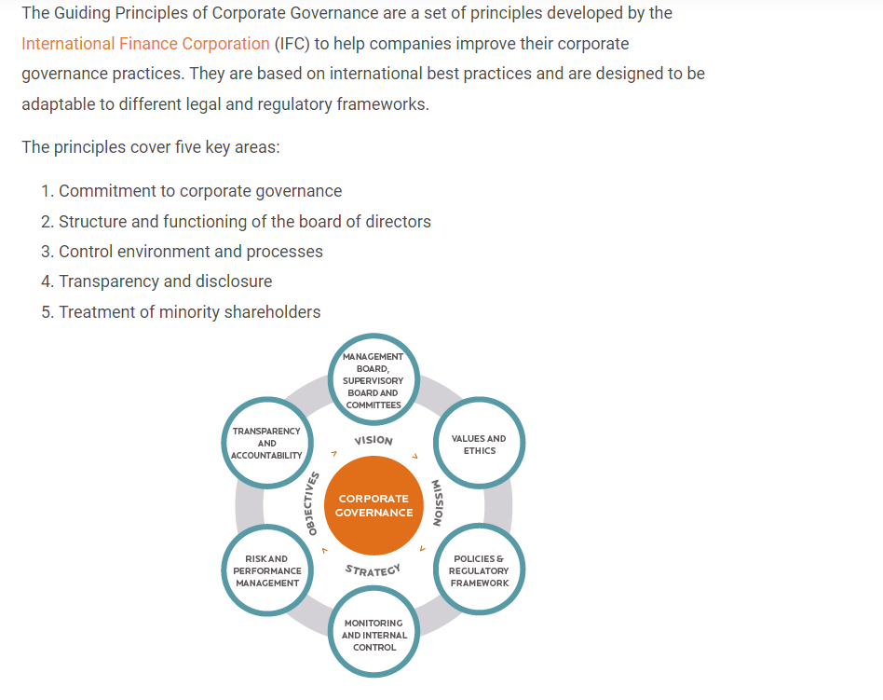 (Governance International, 2024)

Figure 2
Joint Governance Structure York & North Yorkshire OPP
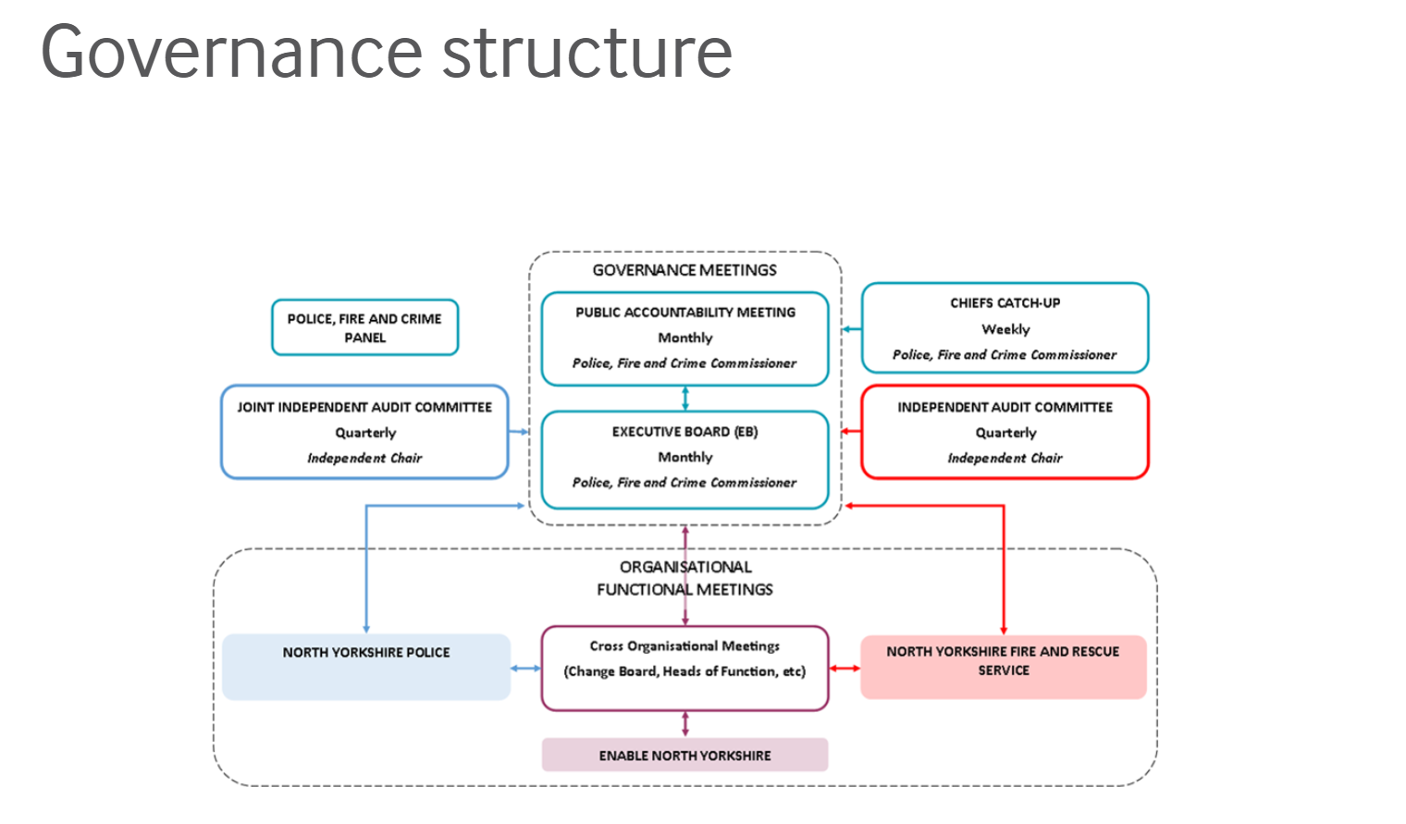
(York & North Yorkshire OPFCC, 2024)
Figure 3 - Humberside Police Governance, Scrutiny, and accountability structure

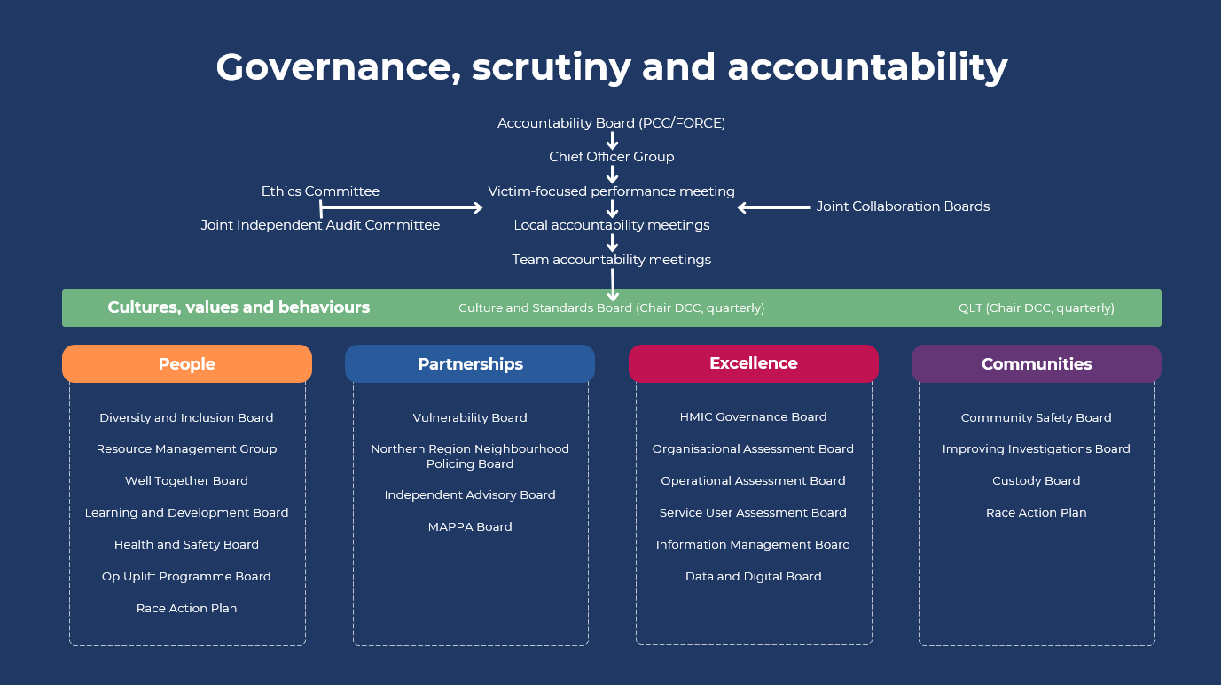
(Humberside Police, 2024)

Bibliography
Albercht, J. F., 2024. Special topics in Policing; Critial Issuesand Global Perspectives. In: Effective Strategies to enhance Police Service Delivery. Cham, Switzerland: Springer Nature , pp. 257-267.
Anon., 2024. Mission driven government. [Online]
Available at: https://labour.org.uk/change/mission-driven-government/
[Accessed 16 December 2024].
Arnstein, S., 1969. The ladder of citizen participation. Journal of the American Institute of Planners, 35(4), pp. 216-214.
Association of Police and Crime Commissoners, 2024. The role of the PCC. [Online]
Available at: https://www.apccs.police.uk/role-of-the-pcc/
[Accessed 21 October 2024].
Behn, R. D., 2016. The PerformanceStat Leadership Strategy. In: Public Management and Governance. Abingdon: Routledge.
Bovaird, T. & Klijn, E.-H., 2016. Public Management and Governance. 3rd ed. Abingdon: Routledge.
Bovaird, T. & Loeffler, E., 2016. Public Management and Governance. Abingdon: Routledge.
Bovaird, T. & Loeffler, E., 2016. Public Management and Governance. 3rd ed. Abingdon: Routledge.
Busch, P., 2008. Tacit Knowledge in organizational learning.. 1st ed. Hershey: IGI Pub.
Cadbury, A., 1998. The future for governance; the rules of the game. Journal of General Management , 24(1), pp. 1-14.
Chechel, A., 2017. Leadership skills as a criteria for assessing the professional competence of heads of departments of the public administration. International Scientific Journal of Universities and Leadership, Issue 4.
Cheng, S. & Huang, J., 2022. Full Empowerment and the participatory Governance in rural coomunities; A comparative study based on two cases. Contemporary social sciences, 7(4), pp. 83-106.
Davies, M. & Johnson, J., 2016. Navigating the One-on-One Model of model of accountability: Lessons for Police and Crime Commissioners and Chief Constables through the lens of Principal-Agent theory. Policing: A Journal of Policy and Practice , 10(3), pp. 278-287.
Derfoufi, Z., 2023. Power Struggles: Police and Crime Commissioners, Chief Constables, and the battle over operational policing.. Policing: A journal of Policy and Practice, Volume 17.
Dodd, V., 2024. The Guardian Devon and Cornwall Chief Constable suspended over work phone claims. [Online]
Available at: https://www.theguardian.com/uk-news/2024/nov/28/devon-and-cornwall-chief-constable-suspended-over-work-phone-claims
[Accessed 5 December 2024].
Forsyth, G., 2016. Corporate meetings structure [Interview] 2016.
Foundation, T. P., 2024. Fit for the future; The case for a national policing landscape, s.l.: s.n.
Governance @ work, 2024. 3 Essential Principles of Corporate Governace Explained. [Online]
Available at: https://governanceatwork.io/blog/principles-of-corporate-governance/
[Accessed 21 October 2024].
Governance International, 2024. Governance International. [Online]
Available at: https://www.govint.org/english/
[Accessed 20 October 2024].
Guilfoyle, S., 2013. Intelligent Policing. s.l.:Triarcy Press.
Hales, G., 2015. How can the Police meet leadership challenges ahead, s.l.: s.n.
Heap, V., 2021. Exploring the effects of long-term anti-social behaviour victimisation. International review of victimology, 27(2), pp. 227-242.
HMICFRS, 2019 . Leading Lights: An inspection of the police service’s arrangements for the selection and development of chief officers, s.l.: The Home Office.
Home Office Affairs Committee, 2024. Home Office Affairs Committee inqury on Police and Crime Commissioners:10 years on , s.l.: s.n.
Home Office, 2011. The Police Reform and Social Social Responsbility Act. s.l.:s.n.
Home Office, 2024. Community Safety Partnerships. [Online]
Available at: Community Safety Partnerships - GOV.UK
[Accessed 12 November 2024].
Hopkin, J., 2003. Political Decentralization, Electoral Change and Party Organizational Adaptation: A Framework for analysis.. Sage Journal .European Urban and Regional Studies, 10(3), pp. 227-237.
House of Commons Library, 2024. 2024 general election: Turnout. [Online]
Available at: https://commonslibrary.parliament.uk/general-election-2024-turnout/
[Accessed 2024 December 2024].
House of commons Library, 2024. Police and Crime Commissioner Elections 2024, s.l.: UK Parliament.
House of Commons Library, 2024. Police and Crime Commissioners, s.l.: House of Commons.
House of Lords Library, 2020. Policing in the UK; Governance , Oversight and Complaints. [Online]
Available at: https://lordslibrary.parliament.uk/research-briefings/lln-2020-0013/?__cf_chl_f_tk=xxye_5uxwB8Gh9fKlZ_M9JQ0IjhFCsnueerurym91QI-1729516768-1.0.1.1-JQPIT7Cgwb1cOEVZf5Yd2cuHjamlVmvSpWqjPDJa_TM
[Accessed 21 October 2024].
Humberside Police and Crime Comissioner, 2024. Humberside Police & Crime Comissioner Accountability Board. [Online]
Available at: https://www.humberside-pcc.gov.uk/Your-Police/Documents/Accountability-Board-Holding-to-Account.pdf
[Accessed 26 October 2024].
Humberside Police, 2024. Governance, scrutiny and accountability meeting structure. Hull: s.n.
Jones, L., 2024. CEO South Wales OPCC [Interview] (3 December 2024).
Koppenjam, J. & Koliba, C., 2016. Managing networks and complex adaptive systems. In: Public Management and Governance . Abingdon: Routledge, p. 262.
Kort, M. & Klijn, E. H., 2011. Public-private partnerships in urban regeneration projects;Organizational form or managerial capacity?. Public administration review, 71(4), pp. 618-626.
Labour.co.uk, 2024. Mission-driven government. [Online]
Available at: https://labour.org.uk/change/mission-driven-government/
[Accessed 16 December 2024].
Loeffler, E. & Martin, S., 2016. Citizen Engagement. In: Public Management and Governance. Abingdon: Routledge, p. 27.
Mazerolle, L., 2014. The Power of Policing Partnerships; sustaining the gains. Journal of Experimental Criminology, Volume 10, pp. 341-365.
Modise, D. J. M., 2023. Community Engagement in Policing: A path to more meaningful, knowledgeable, and successful public consultation. International Journal of Innovaive Science and Research Technology, 8(6), p. 3895.
Myhill, A. & Bradford, B., 2011. Can Police enhance public confidence by improving the quality of service?. Policing and Society, 22(4), pp. 397-425.
N8 Policing Research Partnership, 2024. Policing Partnerships; Evidence Review. [Online]
Available at: PolicingPartnerships_EvidenceReview.pdf
[Accessed 12 November 2024].
NPCC, 2024. About us. [Online]
Available at: https://www.npcc.police.uk/About-Us/about-us/
[Accessed 21 October 2024].
O'Neil, M. & McCarthy, D. J., 2014. (Re)negotiating police culture through partnersip working;Trust, Compromise and the 'new' pragmatism. Criminology & Criminal Justice, 14(2), pp. 143-159.
Parallel Parliament.co.uk, 2024. Police Reform Debate. [Online]
Available at: https://www.parallelparliament.co.uk/mp/yvette-cooper/debate/2024-11-19/commons/written-statements/police-reform
[Accessed 16 December 2024].
Partington, J., 2024. Police Federation National Council Conference. s.l., s.n.
Pierre, J. & Peters, G., 2000. Governance, politics and the state. New York: St.Martin's Press.
Pollitt, C., 2016. Decentralized Management. In: Public Management and Governance . Abingdon: Routledge, pp. 244-245.
Rittel, H. & Webber , M., 1973. Dilemmas in a General Theory of Planning. Policy Sciences, Volume 4, pp. 155-169.
Robbins, S., 1987. Organization Theory; concepts, controversies and applications.. Eaglewood Cliffs, New Jersey: Prentice Hall .
Shaw, D., 2022. An almost impossible job: The lessons from Dame Cressida Dick's departure. [Online]
Available at: https://policinginsight.com/topics/governance/
Sparrow, M. K., 2015. Measuring performance in a modern police organization. Psychosociologial Issues in Human Resource Management, 3(2), pp. 17-52.
Syed, M., 2016. Black Box thinking: Marginal gains and the secrets of high performance. s.l.:John Murray.
The Chartered Governance Institute UK and Ireland, 2024. What is Corporate Governance?. [Online]
Available at: https://www.cgi.org.uk/about-us/policy/what-is-corporate-governance#:~:text=Corporate%20governance%20is%20the%20system,accountability%2C%20and%20who%20makes%20decisions
[Accessed 13 October 2024].
The College of Policing , 2024. College of Policing - Police Leadersip Programme. [Online]
Available at: https://www.college.police.uk/career-learning/learning/courses/police-leadership-programme-stage-5-executive-leaders
[Accessed 24 March 2024].
The Police Foundation, 2022. A New Mode of Protection. The Strategic Review of Policing England and Wales, London: Rapspiderweb.com.
UNESCAP, 2024. United Nations Economic And Social Comission For Asia and the Pacific. [Online]
Available at: www.unescap.org/pdd/prs/ProjectActivities/Ongoing/gg/governance.asp
[Accessed 21 October 2024].
US News.com, 2024. How Many People Didn’t Vote in the 2024 Election?. [Online]
Available at: https://www.usnews.com/news/national-news/articles/2024-11-15/how-many-people-didnt-vote-in-the-2024-election
[Accessed 16 December 2024].
Waterman, R. & Meier, K., 1998. Principal-Agent Models: An Expansion. Journal of Public Administration Research and Thoery, 8(2), pp. 173-202.
Westmarland, L., 2016. Governance of policing and cultural codes: interpreting and responding to policy directives. Global Crime, 17(3-4), pp. 352-369.
White, A., 2014. Post-crisis Policing and Public-Private Partnerships ; The case of Lincolnshire Police and G4S.. The Britiish Journal of Criminology, 54(6), pp. 1002-1022.
White, A. & Gill, M., 2013. The Transformation of Policing; from ratios to rationalities. The British Journal of Criminology , January, 53(1), pp. 74-93.
York & North Yorkshire OPFCC, 2024. Joint Governance Corporate Governance Framework. [Online]
Available at: https://www.northyorkshire-pfcc.gov.uk/police-oversight/governance/governance-process/process/
[Accessed 21 October 2024].

