Charlene griffiths
student number 1904882

ecad4010
cycle 1 researching the learning: what, how and why I am teaching?

Table of Contents

ECAD4010 Cycle 1:researching the Learning: what, how and why am I teaching? 2
A critical analysis and evaluation of the observation research tool, ‘Leuven Scale’ 2

References 8
Appendices 12

Appendix 1 - Example of a foundation phase classroom 12
Appendix 2 - Yr Athrofa Research Dispositions 12
Appendix 3 - My Observation Schedule 13
Appendix 4 - The Leuven Scale for Wellbeing 14
Appendix 5 - The Leuven Scale for Involvement 14
Appendix 6 - The Observation using my Observation Schedule 15
Appendix 7 - The Research Cycle 16

Ychwanegwch eich targedau o’ch aseiniad diwethaf (Ond yn berthnasol os yr ydych wedi cwblhau aseiniad) / Please add your targets from the previous assignment (Only relevant if you have completed an assignment)
Targed/Target 1 | Be more analytical by considering the strengths as well as the limitations or challenges of theory and practice.
Targed/Target 2 | In order to further develop your academic writing style, use the first person ‘I’ for reflection but try and use the third person or impersonal form of the verb wherever else possible.
Targed/Target 3 | Make full use of all the literature available rather than over-rely on a few key texts.

ECAD4010 Cycle 1:researching the Learning: what, how and why am I teaching?

A critical analysis and evaluation of the observation research tool, ‘Leuven Scale’

Compare and contrast a range of literature (journals, blogs, government reports, websites, Estyn reports) related to observation of the learning environment within the foundation phase class. The learning environment may include indoor or outdoor spaces and resources. Observation should focus on a small group of learners, using the Leuven Scale as a tool.

You need to engage critically with the literature in making tentative conclusions about the creation of an effective learning environment. Consideration also needs to be given to the potential impact of using the Leuven Scale on your own practice as an ethical researcher and the development of learners.

During this assignment I will carry out empirical research using my own observation schedule to critically analyse and evaluate the observation research tool ‘Leuven Scale’, and how it can be used in a Foundation Phase setting, I will look at the Athrofa Research Dispositions to become a sceptical, ethical, a skilled researcher and part of an inquiry profession (Evans, 2020) as I look at theoretical literature. I have chosen video 3, and the research question- ‘To what extent does the roleplay environment provide opportunities for pupil involvement and learning?’ The activity is set in an early year setting which follows the Foundation Phase, this curriculum is for all 3-7-year olds in Wales. The Foundation Phase encourages children to be creative and imaginative, making learning more enjoyable and effective by learning through play and enjoying new experiences (welsh.gov, 2015).
Learning in the Foundation Phase can be based inside or outside, and has continuous provisions where children work independently following on from focus activities and enhanced provisions where the children build on what they have learned during a task. These are set up in different areas of the classroom to help the children build on their previous knowledge (welsh.gov 2015). This style of learning follows Vygotsky’s theory of Peer Collaboration and Bruner’s Scaffolding Theory where the children build on previous knowledge through additional activities (Gray and Macblain, 2012). From my experience of working in a nursery class, a classroom is usually set up with different areas for the children to explore and promote different experiences and skills for all children. For example, if you look at appendix 1, this is one example of a Foundation Phase classroom with different areas to help the children explore and learn new skills.
Research is a crucial part of teaching today, and as practitioners it is important that we take an active role in research throughout our careers (Donaldson, 2015) this was also discovered by Stenhouse (1975) many years ago where he developed the Teacher-as-Researcher model, and believed for education to significantly improve a research tradition was needed by teachers and learning.
The OECD (2016) found research plays an important part for schools to become learning organisations and provide new skills and understanding to all children. For PTE1 I was placed in a school that took part in this research and involved all the children to create ‘Express Events’ on topics the children wanted to research (school ‘X’, 2019). This is also quoted by BERA:
‘Teachers and Students thrive in the kind of settings that we describe as research rich, and research rich schools and colleges are those that are likely to have the greatest capacity for self- evaluation and self-improvement’ (BERA, 2014, P4)

Moore (2000) believes teachers should perceive themselves as researchers and theorists to become great practitioners.
Welsh Government (2008) believes observing children is equally informative whether the observations take place indoors and outdoors, this is agreed by Griggs (2013). MacLeod-Brundenell (2004) suggests that observation has been described as the only true test of the quality of a practitioner’s work. I have chosen to observe children indoors using the roleplay area for my research, as I enjoy observing how children imitate each other and the world around them. Walsh et al (2017) believes that teachers who provide the highest quality of teaching and learning experiences use an array of tools and pedagogical approaches such as roleplay to get the best outcomes for their learners. Ricker et al (2018) believes opportunities and limitations happen in all role-play activities. Outcomes become harder to control, but chances for engagement and surprise increase. Bassey (2010) believes roleplay is an emerging but proven pedagogical method, effective across all education. Roleplay can encourage creativity and imagination, foster social and emotional development, improves communication and language, helps develop thinking, learning and problem solving and supports physical development (conscious craft, 2018).
The Foundation Phase is seen as learning through play, however Walsh et al (2017) believes play is seen as an accessory to the learning experience, rather than how children learn best, Walsh et al (2010) also found research which states providing more play-based activities does not necessarily promote children’s cognitive processes. Bodrova (2008) believes the children’s ability to engage in high level play is less developed than it should be for their age. Also, Bodrova (2008) and Hunter and Walsh (2014) all found if practitioners did not fully understand the learning outcomes, the children’s understanding, skills and creativity would not be fully recognised and developed. However Siraj- Blatchford and Sylva’s (2004) project known as Researching Effective Pedagogy in the Early Years (REPEY) shows that teachers were not abandoning responsibilities by letting the children learn through play but the most effective practitioners showed a good understanding of the areas in the curriculum and showed a balance between child-led activities and adult-led activities, providing different levels of challenges for the child’s individual needs. This is shown in the New Curriculum where it will be more child-led and experiential to learners to explore and develop new skills and experiences (Donaldson, 2015).
Observation plays a key role in everyday practice in the Foundation Phase. The main purpose of observing children is to asses how much progress the children have made over a period, and whether children need further opportunities to grasp the learning outcome as well as identifying exceptional ability (Welsh.gov, 2017). To carry out this observation I have taken on board The Athrofa Research Dispositions (please see appendix 2) and created my own observation schedule (please see appendix 3) including the Leuven Scale to answer the research question- ‘To what extent does the roleplay environment provide opportunities for pupil involvement and learning?’
The Leuven scale for emotional well-being and involvement was created by Professor Ferre Leavers, he found that the level of involvement the child shows in their play and learning shows a key sign of the quality and effectiveness of the activity provided by a practitioner (education.gov.scot, 2018). Leavers also believed that involvement and emotional well-being are the two main indicators that should be considered when planning any educational setting (Dubiel, 2014). Fredrickson (2009) believed a happy, involved child can experience the world at its fullest, this is also seen in Maslow’s Hierarchy of Needs where children need to gain each stage to reach the top of the triangle which includes engagement and wellbeing (Gray and Macblain, 2012). Both Lewis (2019) and Dubiel (2014) explain that The Leuven scale has two different scales one for Involvement and one for Well-being. Leavers research found that high levels of well-being and involvement lead to high levels of child development and deep level learning. Both scales have levels 1 – 5 1 being extremely low and 5 being extremely high (please see appendix 4 and 5). Good observational and formative assessment practice will support children in following their own interests and what they excel at and encouraging children to develop where they show struggle or lack interest (Welsh.Gov. 2017). The Leuven scale helps us as practitioners to find out what the children enjoy, and interests are by using the scale to determine the level of each child during different activities, this is agreed by Fredrickson Research (2009).
By observing children and noting progress, involvement and enjoyment , this in future will help practitioners plan a more appropriate curriculum that supports children’s development according to individual needs (Welsh.gov, 2008). This also helps the practitioner to determine the learning styles preferred to the individual child, and to help them develop different learning styles for different areas of learning to get the best outcomes for all (Welsh.Gov, 2008). McNamara (1994) suggests that the classroom is a community and that some of the teacher’s work is devoted to sustaining physical, social and emotional order within the classroom community.
To answer the research question- ‘To what extent does the role play environment provide opportunities for pupil involvement and learning? I chose the Leuven scale for involvement for the observation as I believed that it would help collect better quantitative data for my research. Therefore, I believe I found that the Leuven scale showed that child A and child B were very involved and engaged in the activity of playing active roles in a travel agents, booking a trip to Japan, as they scored level 5 but child C was very quiet and did not engage with the other two children well as child C scored 3 (please see Appendix 3). Using the Leuven scale to observe play helps us indicate which opportunities the children take and shows that play educates emotionally, socially, cognitively and physically by the interaction of child A and child B in my observation (Walsh et al, 2017). One disadvantage is that a one-off observation is not enough as children can change over time and I do believe that my results of this observation could be biased as I do not know the children and child C might act differently with different children or in a different area, McNamara (1994) believes what works with one child does not always work with another child. As a teacher the importance of knowing your children helps observation and planning for the individual. Hattie (2012) suggests that to become a great teacher you must remember that all children are different, and will need to adapt all learning needs individually, by knowing the children, teachers will get the best outcomes for all children. However, Palaiologue (2008) suggests that to become a skilful observer you need to develop objectivity and step out of the role of being a teacher and look at the observation as an outsider.
When looking at my findings, the results show that I listened to the children, and the language they used to communicate which showed they had great understanding of what they learnt during the topic Japan, as they were able to talk about different excursions and how they would reach the destination. It is important that practitioners listen to the children as well as watch them when observing, as the learner can express their understanding through speech (welsh.gov 2008), this is also agreed by Grigg (2013) who believes observation is a process of watching the children carefully and listening to what they say.
I believe my observation schedule can serve several purposes in assessing children’s development- what they need to improve on, shedding light on the teachers practice- if anything needs to change and providing information for reporting to parents, as it includes extra comments and findings. Grigg (2013) agrees that observation can serve these purposes. My research showed that child A and child B achieved level 5 in the roleplay area, showing understanding of the theme they have been learning about and trying to get child C involved during the activity. This can be seen as an example of Vygotsky’s ZPD theory as child A and child B are acting as the knowledgeable others during the activity as they show understanding of Japan to book excursions when visiting (Pound, 2005). Vygotsky also believed when the teacher participates in a playful manner during role play and different activities, the teacher can encourage children to explore and engage with new knowledge, skills and understanding which open up genuine learning opportunities for the child (Walsh et al, 2017).
Therefore, for my conclusion I do believe that the Leuven scale showed a true value of how role play provides opportunities for children involvement. From observing as a non-participant observer, two of the children showed great involvement and understanding of learning during the role play activity. I do believe that the Leuven scale is a good observation tool to use in the foundation phase as the scale can be used in different activities throughout the different areas of learning (welsh.gov, 2015). This observation also shows the role play area is a key factor for children to interact with each other using prior knowledge and showing understanding of everyday life as suggested by Bassey (2010).
In the future I would like to undertake the following research question – How to gain children’s engagement within an introduction to tasks? I have chosen this question as during my PTE 1 this is where I struggled slightly, when introducing the activity to keep the children engaged. Before carrying out this research question I would need to follow the BERA guidelines (2018) to gain consent from parents and assent from the children. To keep my data confidential and anonymous ensuring I keep each child safe and give them the opportunity to withdraw following the UNCRC that children should make informed choices and have a say in what data should be used (Hill, 2005). Therefore, if the child wants to carryout the research or changes their minds as BERA (2018) endorses the UNCRC, the best interests of the child are the primary consideration, then that research would not be able to be used. I would then carry out observations and use the action research cycle (Kemmis and McTaggart, 1982) (please see appendix 7) to help me reflect and act on the findings I found using different observation tools such as the Leuven scale, everyday observation and individual observation together with collaboration from other teachers and guidance.

References

Bassey, M.O. (2010) ‘Educating for the real world: An illustration of John Dewey’s principles of continuity and interaction’, Educational studies, 36(1), pp.13-20.

BERA (2014) Research and the Teaching Profession. Building the capacity for a self-improving Education. Available at : https://www.thersa.org/globalassets/pdfs/bera-rsa-research-teaching-profession-full-report-for-web-2.pdf (Accessed: 28 April2020)

BERA (2018) Ethical Guidelines for Educational Research. 4th edn. London: BERA

Bodrova, E. (2008) ‘Make believe play versus academic skills: A Vygotskian approach to today’s dilemma of early childhood education’, European Early Childhood Research Journal, 16(3), pp. 357-369.

Conscious craft (2018) 5 reasons why role play is important for kids. [blog] Available at: https://consciouscraft.uk/blogs/news/5-reason-why-role-playing-is-important-for-kids# (Accessed: 4 May 2020)

Donaldson, G. (2015). Successful Futures: Independent Review of Curriculum and Assessment Arrangements in Wales. Available at: https://gov.wales/sites/default/files/publications/2018-03/successful-futures.pdf
(Accessed: 20 April 2020)

Dubiel, J (2014) Learning and Development: Assessment – Measuring up. Available at: https://www.nurseryworld.co.uk/features/article/learning-development-assessment-measuring-up (Accessed: 6 May 2020)

Education.gov.scot (2018) Involvement and wellbeing as a measure of quality learning processes and provision. [blog] Available at: https://blogs.glowscotland.org.uk/gc/public/gccleadersofearlylearning/uploads/sites/7271/2018/12/Ferre-Leavers-SICS-for-LPAS.pdf (Accessed: 6 May 2020)

Evans, A. (2020) Yr Athrofa Research Dispositions. [Moodle] Available at: https://uowtsd-my.sharepoint.com/:p:/g/personal/alison_evans2_uwtsd_ac_uk/EXcGRVDT3jVJkOGPdPrWyscB9w7axVLjYVdjpG5hbUH1kw?e=tj68W8
(Accessed: 20 April 2020)

Fredrickson, B. (2009) Positivity. New York: Crown

Gray, C. and Macblain, S (2012) Learning Theories in Childhood. SAGE publications Ltd: London

Grigg, R. (2013) Becoming an outstanding Primary School Teacher. Oxon: Routledge.

Hill, M. (2005) ‘Ethical Considerations in Researching Children’s experiences’ in Green, S. and Hogan, D (ed.) Researching children’s experiences: Approaches and Methods. London: SAGE Publication Ltd

Hunter, T. and Walsh, G. (2014) ‘From policy to practice? The reality of play in Primary school classes in Northern Ireland’, International Journal of Early Years Education, 22(1), pp. 19-36.

Kemmis, S. and McTaggart, R. (1982) The Action Research Planner. Geelong, Vict.: Deakin University Press

Lewis, K. (2019) Ferre Leavers Emotional Well-being and Involvement scale. Early Learning HQ [blog] Available at: https://www.earlylearninghq.org.uk/earlylearninghq-blog/the-leuven-well-being-and-involvement-scales/ (Accessed: 29 April 2020)

MacLeod-Brundenell, I. (2004) Advanced Early Years Care and Education. Oxford: Heinemann.

McNamara, D. (1994) Classroom Pedagogy and Primary Practice. London : Routledge

Moore, A. (2000)Teaching and Learning- Pedagogy, Curriculum and Culture. London: Routledgefalmer.

OECD (2016) What makes a school a learning organisation? Available at:
https://www.oecd.org/education/school/school-learning-organisation.pdf (Accessed: 23 April 2020)

Palaiologue, I. (2008) Childhood Observation. Exeter :Learning Matters.

Pound, L. (2005) How Children Learn. London: Step Forward Publishing Limited

Ricker , A. et al (2018) The mock conference as a teaching tool: Role‐play and “conplay” in the classroom. Available at: https://web-a-ebscohost-com.ezproxy.uwtsd.ac.uk/ehost/detail/detail?vid=0&sid=ee5e6b43-9c0e-4647-9418-fb11d30ecb83%40sdc-v-sessmgr01&bdata=JnNpdGU9ZWhvc3QtbGl2ZQ%3d%3d#anchor=bib4up&AN=127359679&db=eue (Accessed: 1 May 2020)

School X (2019) Available at: http://www.edunet.link/craigfelen/
(Accessed 7 May 2020)

Siraj-Blatchford, I. and Sylva, K (2004) ‘Researching pedagogy in English preschools’, British Educational Research Journal, 30(5), pp. 713- 731.

Stenhouse, L. (1975) An introduction to Curriculum Research and Development. London: Heinemann Education Books.

Walsh, G., McMillan, D., McGuiness, C. (2017) Playful Teaching and Learning. London: SAGE Publications Ltd

Walsh, G., McGuinness, C., Sproule, L. and Trew, K. (2010) ‘Implementing a play based and developmentally appropriate curriculum in Northern Ireland Primary Schools: what lessons have we learned?’, Early Years, 30(1), pp. 53-66

Welsh Government ( Revised 2015) The Foundation phase.
Available at: https://gov.wales/sites/default/files/publications/2018-02/foundation-phase-framework-revised-2015.pdf (Accessed: 30 April 2020)

Welsh Government (Revised 2017) Foundation Phase Profile Handbook.
Available at: https://gov.wales/sites/default/files/publications/2018-03/foundation-phase-profile-handbook-revised-september-2017.pdf (Accessed: 23 April 2020)

Appendices

Appendix 1 - Example of a foundation phase classroom

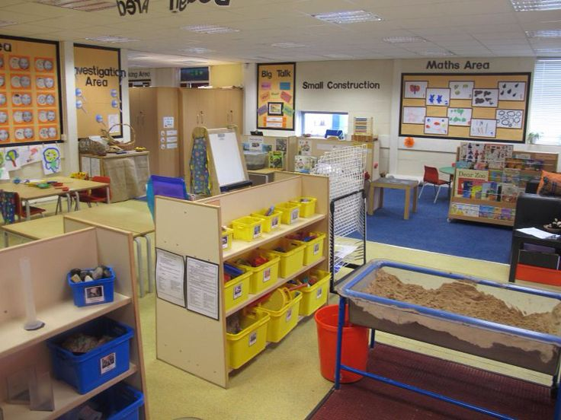
Source: Pinterest, (2020) Available at: https://www.pinterest.co.uk/pin/463448617880571386/?autologin=true&lp=true

Appendix 2 - Yr Athrofa Research Dispositions

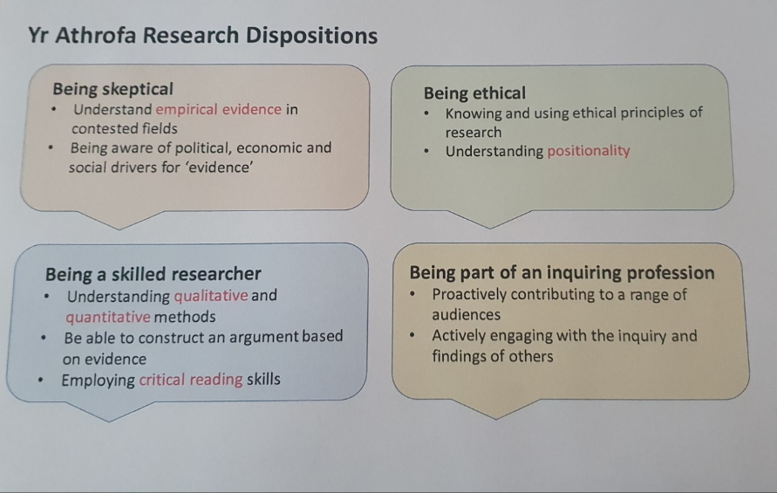
Source: Evans, A. (2020) Moodle

Appendix 3 - My Observation Schedule

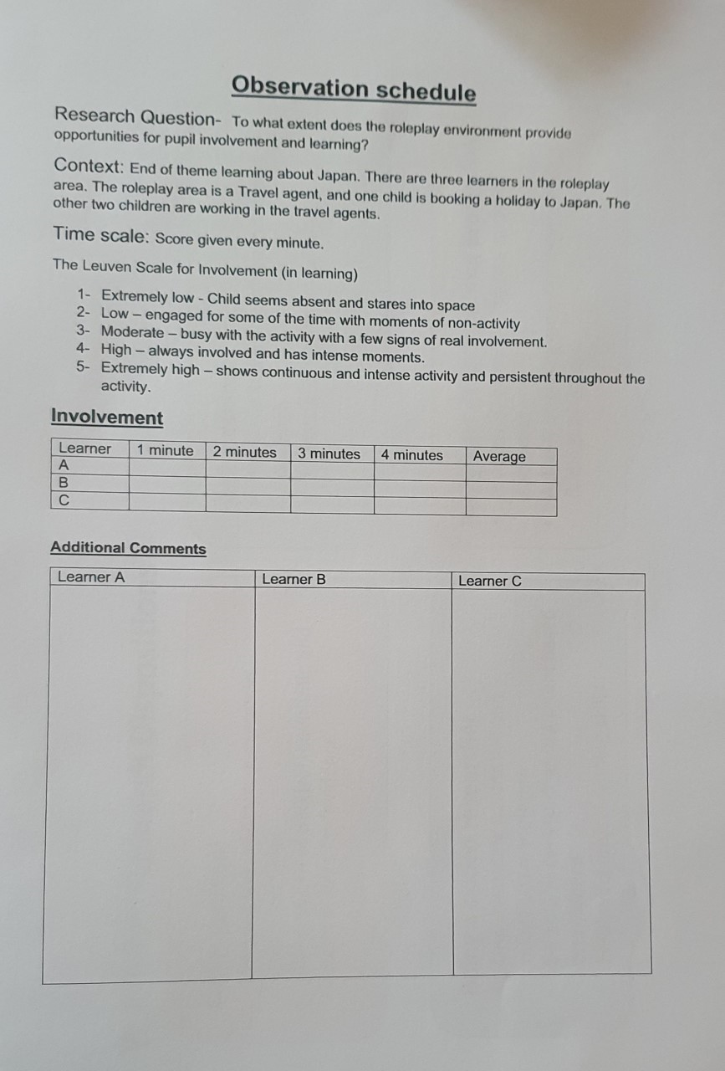
Source: My Personal Observation Schedule, (2020)

Appendix 4 - The Leuven Scale for Wellbeing

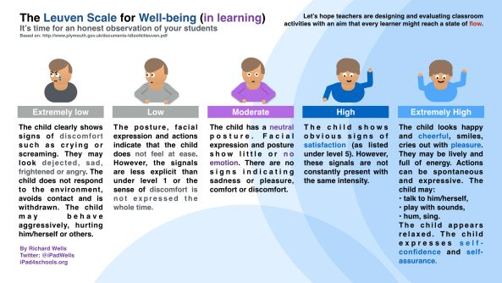
Source : EduWells.com, (2015) Available at: https://eduwells.com/2015/02/28/can-ipads-help-achieve-a-state-of-flow/

Appendix 5 - The Leuven Scale for Involvement

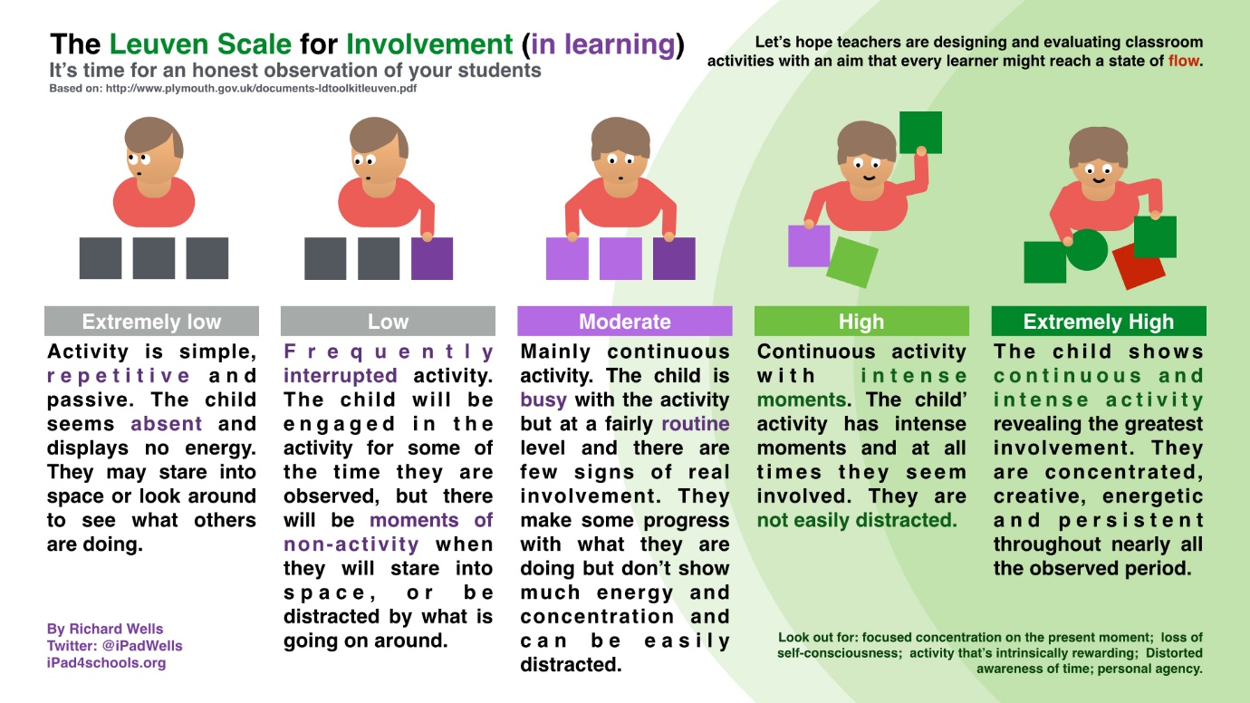
Source : EduWells.com, (2015) Available at: https://eduwells.com/2015/02/28/can-ipads-help-achieve-a-state-of-flow/

Appendix 6 - The Observation using my Observation Schedule

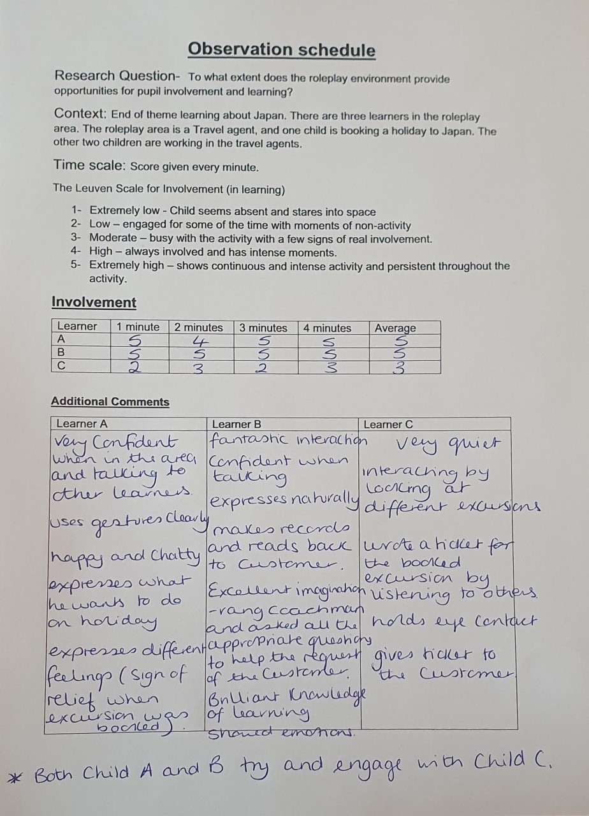
Source: My Personal Observation Schedule, (2020)

Appendix 7 - The Research Cycle

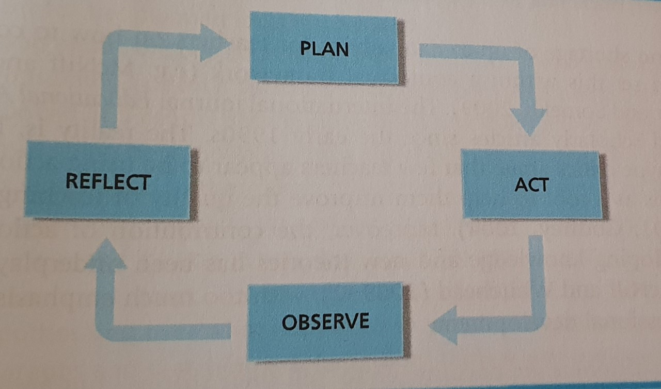
Source: Kommis and McTaggart, (1982)

