A comparison of the marketing methods of two multinational hotel brands
Name : Cristina-Maria Petrache
Student ID number : 2234360
Module title : Marketing Essentials BMIH4005
Lecturer’s name : Dale Clarke
Word Count : 1505

In today's competitive hospitality industry, hotel brands strive to differentiate themselves and attract travellers by offering unique experiences and exceptional services. This essay aims to compare and contrast two prominent hotel brands, Six Senses Hotels and Holiday Inn, shedding light by analysing these brands through frameworks like SWOT and PESTLE.
By examining the existing outcomes and evaluating the brands, we can gain insights into their competitive positions and identify potential future scenarios. Additionally, considering market trends, customer preferences, and industry advancements, they can make informed predictions and assumptions about how Six Senses Hotels and Holiday Inn might evolve and navigate the changing landscape of the hospitality industry. Through this examination, it aims to provide valuable insights into the expected outcomes, predictions, and assumptions for Six Senses Hotels and Holiday Inn.
Consequently, to effectively compare the two hotel brands, Six Senses Hotels and Holiday Inn, the main points to outline are to introduce the purpose of the comparison and highlight the significance of analysing and contrasting these two hotel brands. Moreover, identifying similarities and differences in the external factors affecting their operations
Comparing Six Senses Hotels and Holiday Inn through the SWOT and PESTLE analyses can provide a more detailed perspective on their strengths, weaknesses, and the external factors that can influence their performance. Six Senses Hotels strengths include a sustainable business model and a holistic approach to hospitality, attracting a market segment that is environmentally conscious and focused on personal well-being. Additionally, Six Senses Hotels stand out through the luxurious design of their properties and the unique experiences offered to guests. However, a weakness could be the high room rates and service prices, which limit access to a broader market segment. As for opportunities, Six Senses Hotels can take advantage of the growing interest in responsible tourism. Nevertheless, there are threats, such as increased competition in the industry and dependence on global economic stability.
Regarding Holiday Inn, through the SWOT analysis, we can identify their strengths, such as affordable prices, an extensive global presence, and strong brand recognition. However, a weakness could be the standardisation of services and experiences, which may diminish their attractiveness for certain market segments seeking personalization and authenticity. In terms of opportunities, Holiday Inn can capitalise on the rising demand for business travel and mass tourism. Nonetheless, there are threats, such as strong competition in the industry and rapid changes in customer preferences and needs.
A comparison through the PESTLE analysis involves evaluating the external factors that can influence both hotels. In terms of political factors, tourism legislation can impact both types of hotels, but their specific implications may vary depending on the countries they operate in. Economic factors, such as economic growth, can affect the affordability and demand for services provided by Six Senses Hotels and Holiday Inn. Socio-cultural factors, including changing demographics and cultural preferences, can shape the target market segments for each hotel brand. Technological factors, such as advancements in reservation systems and guest experience management, can influence the operational efficiency and competitiveness of both Six Senses Hotels and Holiday Inn. Legal factors, such as employment laws or safety regulations, are important considerations for both hotel brands. Lastly, environmental factors, including climate change, have significant implications for Six Senses Hotels, given their strong emphasis on sustainability.
In conclusion, through the SWOT and PESTLE analyses, we can gain valuable insights into the unique strengths, weaknesses, opportunities, and threats associated with Six Senses Hotels and Holiday Inn. Understanding these factors can assist in strategic decision-making and identifying areas for improvement and growth within each hotel brand.
For the purpose of this comparison based on the 7Ps of marketing, considering the brands Six Senses Hotels and Holiday Inn, the first brand portrays a luxurious and holistic image. Their products focus on providing unique and personalised experiences that promote wellness and sustainability. The hotels are known for their breath-taking locations and exclusive amenities such as spas, wellness programmes, and gourmet dining options. In terms of pricing, Six Senses Hotels are positioned as high-end luxury properties, targeting affluent travellers who seek premium experiences. The people factor is crucial, as they hire skilled and knowledgeable staff who offer personalised service and cater to guests' needs. Their processes are designed to ensure a seamless and memorable guest experience, from reservation to check-out.
On the other hand, Holiday Inn presents a more mainstream and accessible brand image. Their products are focused on providing comfortable and convenient accommodations for a wide range of travellers. Holiday Inn hotels are typically located in prime locations, including both urban and suburban areas, catering to various customer segments. Pricing is positioned in the mid-range to accommodate budget-conscious travellers without compromising on quality. The brand emphasises a warm and friendly atmosphere with attentive staff providing personalised service to guests. Holiday Inn's processes are designed to ensure efficiency and ease of use, with streamlined check-in and check-out procedures. They heavily invest in promotion, utilising various marketing channels to reach a broad audience and highlight their offerings.
In terms of similarities, both brands prioritise the people element by ensuring their staff delivers exceptional service and meets guest expectations. Six Senses Hotels focus on luxurious and sustainable designs, while Holiday Inn aims for comfortable and inviting atmospheres.
However, there are notable differences between the two brands. Six Senses Hotels position themselves as a luxury brand, offering exclusive and high-end experiences, whereas Holiday Inn targets a broader market segment with more affordable pricing and a focus on accessibility. Six Senses Hotels emphasise unique wellness experiences and sustainability, whereas Holiday Inn focuses on convenience and comfort.
In conclusion, when comparing the 7Ps of Six Senses Hotels and Holiday Inn, it becomes evident that while they share similarities in certain areas, such as the importance of people and physical evidence, their positioning, product offerings, pricing strategies, and target markets differ significantly. Understanding these differences can assist in effectively catering to different customer segments and crafting tailored marketing strategies for each brand.
In terms of using the Similar Web tool, various customer segments can be identified based on several variables. These variables include website traffic or referral sources. In the case of Six Senses hotels, the customer segment appears to be high-end luxury travellers seeking exclusive and eco-friendly experiences. Similar Web data reveals that Six Senses attracts a substantial amount of organic search traffic, indicating a strong brand presence and recognition. The referral sources indicate a significant amount of traffic from travel-related websites and luxury lifestyle publications, reinforcing the brand's association with luxury travel. On the other hand, Holiday Inn's customer segment appears to be more diverse, catering to a broader range of travellers. Similar web data shows a higher volume of overall website traffic compared to Six Senses, indicating a larger customer base. Referral sources for Holiday Inn consist of a mix of travel-related websites, review platforms, and booking portals, suggesting a balance between leisure and business travellers. In summary, while Six Senses targets high-end luxury travellers with a focus on exclusivity and sustainability, Holiday Inn caters to a more diverse customer base, appealing to a broader range of travellers with different budgets and travel purposes.
Regarding targeting strategies, Six Senses hotels employ a targeting strategy focused on high-end luxury travellers by emphasising exclusivity, sustainability, and unique experiences. They position themselves as an exclusive and environmentally conscious brand, appealing to affluent individuals with personalised services. Their marketing efforts revolve around promoting their eco-friendly practises.
In contrast, Holiday Inn adopts a broader strategy that aims to attract a diverse range of travellers. They position themselves as a reliable hotel brand, targeting both leisure and business travellers. Their marketing focuses on offering affordable and comfortable accommodations with convenient amenities and services. By targeting a wider audience, Holiday Inn aims to capture various segments of the market, including families, budget-conscious travellers, and corporate guests.
Furthermore, positioning tools can be utilised to identify the distinct positioning strategies of Six Senses and Holiday Inn in the hotel industry. Six Senses employs the positioning tools of luxury and exclusivity. The focus on eco-friendly practises and wellness offerings differentiates it from competitors, allowing the brand to offer unique and environmentally conscious experiences. In contrast, Holiday Inn uses the positioning tools of affordability and accessibility. By offering competitive pricing and reliable services, Holiday Inn targets a broader market segment. Six Senses and Holiday Inn establish their distinctive market positions, catering to different customer segments within the hotel industry.
In conclusion, the initial thesis, based on assumptions and predictions, has been confirmed through the positioning analysis of Six Senses and Holiday Inn. These two hotel brands have successfully implemented their strategic positioning, aligning with expectations for a promising future in their respective market segments. Six Senses hotels excelled in luxurious amenities and personalised service, while Holiday Inns focused on affordability and convenience. Factors such as location, customer reviews, and pricing were analysed to determine their strengths and weaknesses. The revelation was that Six Senses hotels emphasised sustainability while Holiday Inn prioritised affordability. Future studies should explore guest satisfaction and environmental impact in relation to these contrasting approaches.

David, F.R. (no date) Strategic management: Concepts and cases, Google Books. Pearson Prentice Hall. Available at:https://books.google.com/books/about/Strategic_Management.html?id=TR8SSgAACAAJ (Accessed: May 8, 2023).
Enz, C.A. (2010) Hospitality strategic management: Concepts and cases. Hoboken: Wiley.
Person, Michael, J. and Olsen, Z. (2008) Handbook of Hospitality Strategic Management: Michael Olsen, Jinlin Z, Taylor & Francis. Taylor & Francis. Available at: https://www.taylorfrancis.com/books/edit/10.4324/9780080914343/handbook-hospitality-strategic-management-michael-olsen-jinlin-zhao (Accessed: May 8, 2023).
Gregory Dess and Gerry McNamara and Alan Eisner and Seung-Hyun Lee and G.T. Lumpkin (2020) Strategic management: Creating competitive advantages, Strategic Management: Creating Competitive Advantages. Available at: https://www.mheducation.com/highered/product/strategic-management-creating-competitive-advantages-dess-mcnamara/M9781260706628.html (Accessed: May 8, 2023).
Person, Fevzi, L. and Okumus, A. (2010) Strategic management in the International Hospitality and Tourism Indu, Taylor & Francis. Taylor & Francis. Available at: https://www.taylorfrancis.com/books/mono/10.4324/9780080940465/strategic-management-international-hospitality-tourism-industry-levent-altinay-fevzi-okumus-prakash-chathoth (Accessed: May 8, 2023).
Luxury hospitality: Redefining luxury in the Hotel Industry (no date) Hospitality News & Business Insights by EHL. Available at: https://hospitalityinsights.ehl.edu/redefining-luxury-hotel-service (Accessed: 08 May 2023).
Hotel pricing in a social world | wiley online books (no date). Available at: https://onlinelibrary.wiley.com/doi/book/10.1002/9781119162285 (Accessed: May 8, 2023).
Luxury resorts, wellness spas, and Five star hotels: Six senses (no date) Luxury Resorts, Wellness Spas, and Five Star Hotels | Six Senses. Available at: https://www.sixsenses.com/en (Accessed: 08 May 2023).
Destination Deluxe (2020) Six senses is the leading sustainable luxury travel destination, Destination Deluxe. Available at: https://destinationdeluxe.com/six-senses-sustainable/ (Accessed: 08 May 2023).
Chen, J.S. (2010) Advances in hospitality and leisure. Bingley, UK: Emerald.
Atwal, G. and Bryson, D. (no date) ‘Introduction’, Luxury Brands in Emerging Markets [Preprint].
O’Fallon, M.J. (2010) Hotel Management and Operations, Google Books. Available at: https://books.google.com/books/about/Hotel_Management_and_Operations.html?id=G0AnmDecKpQC (Accessed: 08 May 2023).
The hotel: A week in the life of the plaza (no date) Goodreads. Available at: https://www.goodreads.com/en/book/show/22852140-the-hotel (Accessed: 08 May 2023).
Matassa, C. (no date) The 12 best luxury hotel chains in the world, Business Insider. Available at: https://www.businessinsider.com/best-luxury-hotel-brands-in-the-world-belmond-four-seasons (Accessed: 08 May 2023).
Team, C.R. (2020) Compare the best hotel brands, ConsumerAffairs. Available at: https://www.consumeraffairs.com/travel/hotels.html (Accessed: 08 May 2023).
Morrison, K. (2016) ‘The targeting of the Holiday Inn’, Sarajevo’s Holiday Inn on the Frontline of Politics and War, pp. 193–202.
Teare, R. (1994). Marketing in Hospitality and Tourism: A Consumer Focus. Burns & Oates.

Harris, P. (2013). Profit Planning: For hospitality and tourism (extended edition). Goodfellow Publishers Ltd.

APPENDIX
- Gleichauff, P. (2022, November 11). Bowman’s Strategy Clock - Making Sense of Eight Competitive Positions. Pinterest. 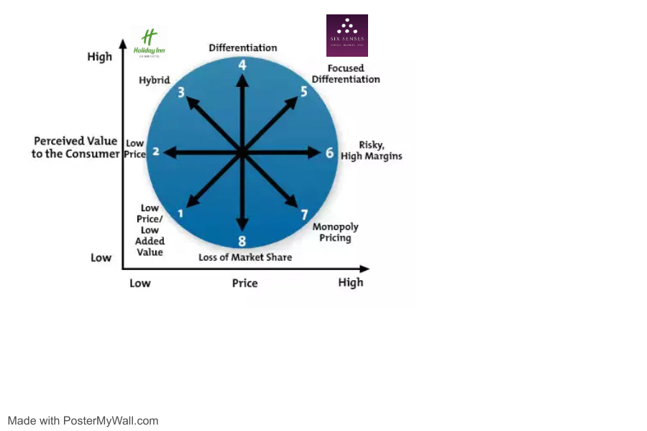
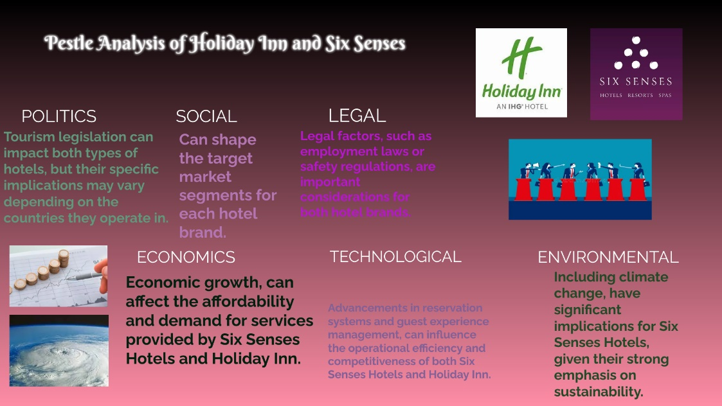
- SimilarWeb Identity. (n.d.). https://pro.similarweb.com/#/digitalsuite/home
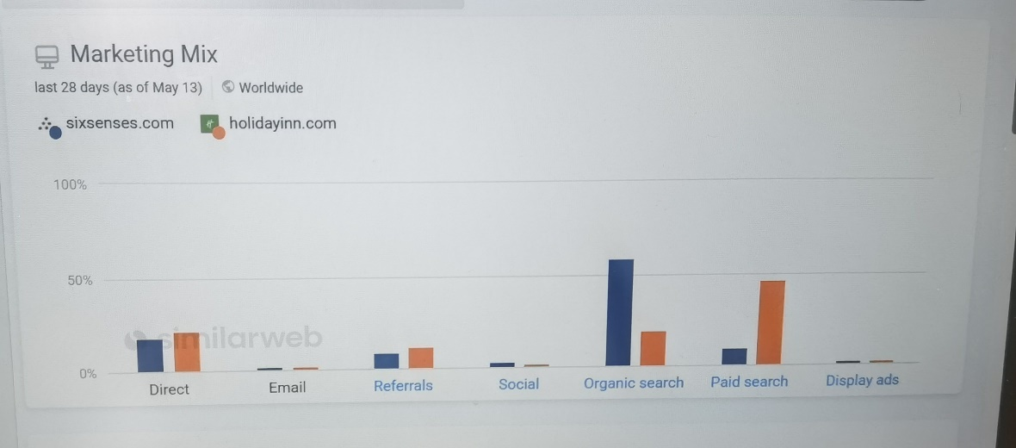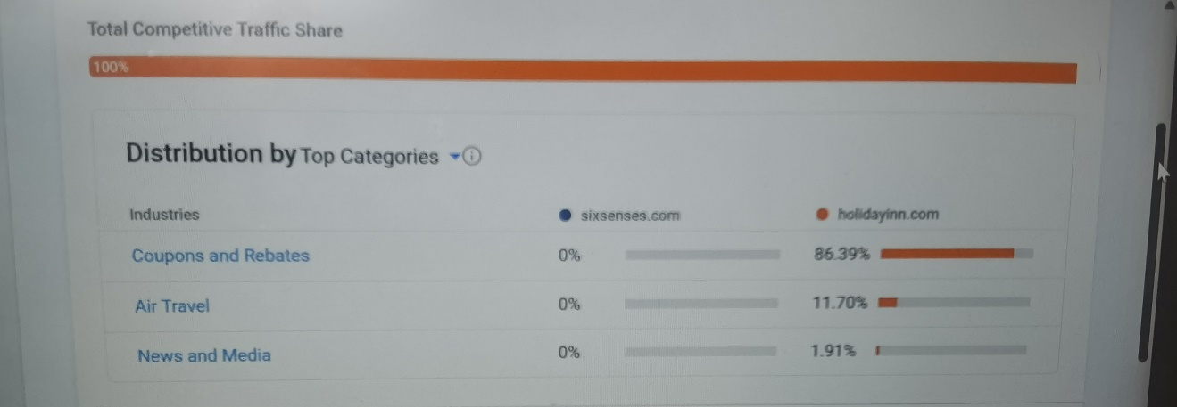
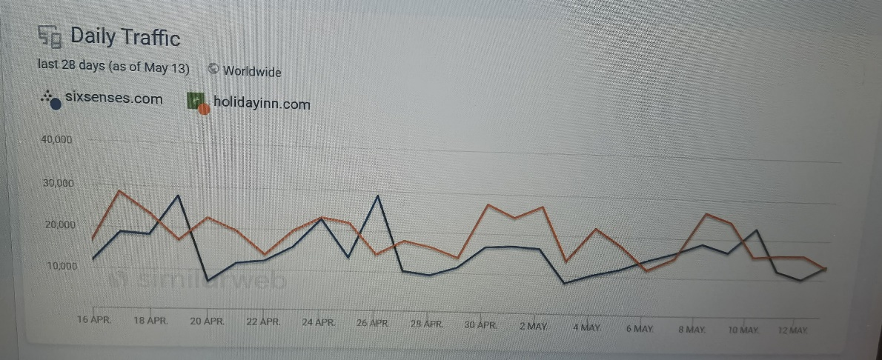
- Hospitality ON. (2023, May 5). Hospitality ON. https://hospitality-on.com/en/worldwide-hospitality-awards/holiday-inn-holiday-inn-express/holiday-inn-and-holiday-inn-express

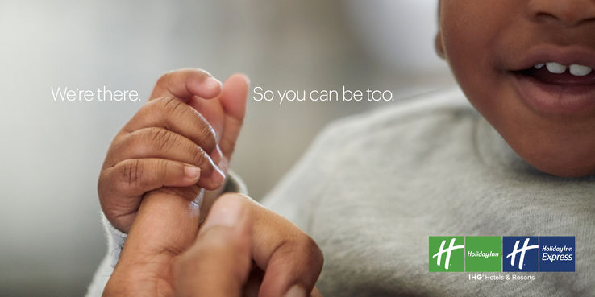

- Senses, S. (2019, August 30). Six Senses Launches a New Website. Hospitality Net. https://www.hospitalitynet.org/news/4094860.html#void



