HIGH AND LOW CUTURE ESSAY

Lee Richards’s, p149987, Illustration yr. 2
Tutors: Louise Burston, Sarah Tombs
Word count =1904

The best that has been thought and written in the world”—is in danger, or is indeed already “lost,” because of widespread popular education, popular communications systems, and what is often called “mass society.” On High and Popular Culture: Raymond Williams 1974
newrepublic.com/article/79269/high-and-popular-culture
Development of technology has spread all aspects of culture to a much wider audience. Are the terms high and low culture now redundant?

In response to the question, are the terms high and low culture now redundant? In my opinion I would agree with the statement as the development of technology has increased the global use and normalization of social media. This is being used by both the social and wealthy elite of the high culture and the normal main stream people of the low culture. Therefore both high and low culture societies are being exposed and influenced by what’s trending and popular on the internet, With both sides of high and low culture society following and setting lifestyle trends which are influencing each other.

This is therefore creating a bigger blurred line and grey space on which it is becoming more and more difficult to distinguish the differences between each culture, when compared to past centuries. This is also closing the gap between the terms which set both cultures apart. As Raymond Williams famously said, “culture is one of the two or three most complicated words in the English language” (Williams, 1976). Which perfectly links with how technology has made it more difficult to distinguish the differences of each.

In the following text I will explore the blurred line/ grey space with examples of themes which is causing the terms to become redundant. Growing fashion icons, the use of appropriation and mass production will be the chosen themes. While looking at differences in society and technology with each example.

To begin with I will look at the rise of fashion brand SUPREME, from a skating clothing brand to a billion dollar cooperation. Technology has changed the fashion agency massively in recent years and is massive in what defines different cultures, as Craik mentions:
“Fashion is everywhere. It is one of the main ways in which we present ourselves to others, signaling what we want to communicate about our sexuality, wealth, professionalism, subcultural and political allegiances, social status, even our mood. It is also a global industry with huge economic, political and cultural impact on the lives of all of us”. (Craik, 2009)

Supreme was founded in 1994 in New York City, with an original target audience of youth, skateboarding, hip hop and rock cultures which at the time were mainly associated with low culture. However as time changes so do people tastes and opinions. In the present day supreme now cater towards the high culture society with an ever increasing demand but with low quantity stock, increasing the selling cost to premium prices. The main reason for this is that they have managed to promote themselves through rise of social media because, “social media touches nearly every facet of our personal and business lives.” (Qualman, 2010, p. Xiii).
Supreme doesn’t spend any money on advertisement campaigns at all but let’s its brand speak for itself on social media, such as Instagram where they have 12.1 million followers and where each of their posts get over 100,000 likes. To do this they rely on collaborations with iconic and notably high society brands such as Lacoste, Louis Vuitton and famous people such as singers Morrissey, Sade etc. While also collaborating with more low culture trends and icons, such as Nike, Kermit the frog etc. So when supreme release a new low quantity clothing merchandise, they are instantly sold out and can be frequently be seen being worn by celebs such as Kanye west, drake, Victoria Bechkam. Now many of these celebs and collaborators are popular and dominate on social media with millions of followers which are mainly the people associated with the low society culture. Now the reason the supreme is involved in the grey space between high and low culture is because it still sticks to founding roots of skateboarding styled merchandise which was originally linked to low culture. As, “Fashions fade, style is eternal” (McCollom, Holder and Hunter, 2006).

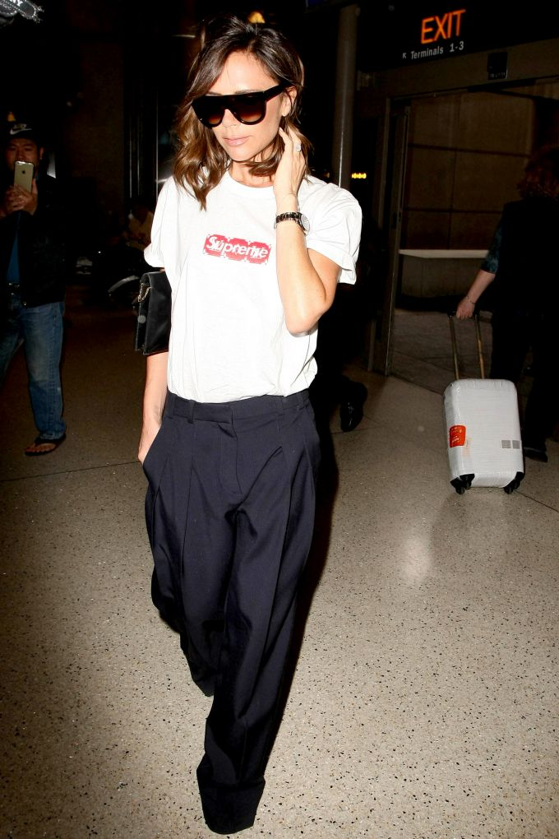
(STARZFLY/BAUER-GRIFFIN/GC IMAGES. 2017)

So therefore when the low culture society see there celebrity icons on social media promoting and wearing supreme clothing they go on and copy there fashion styles and buy supreme merchandise to in a way have a piece of/ copy high society, have a piece of rare clothing which will increase in price massively over time and also to feel a connection between them self and there icon through the high culture costing and the low culture skateboarding style, blurring on which side of the culture line it stands on.

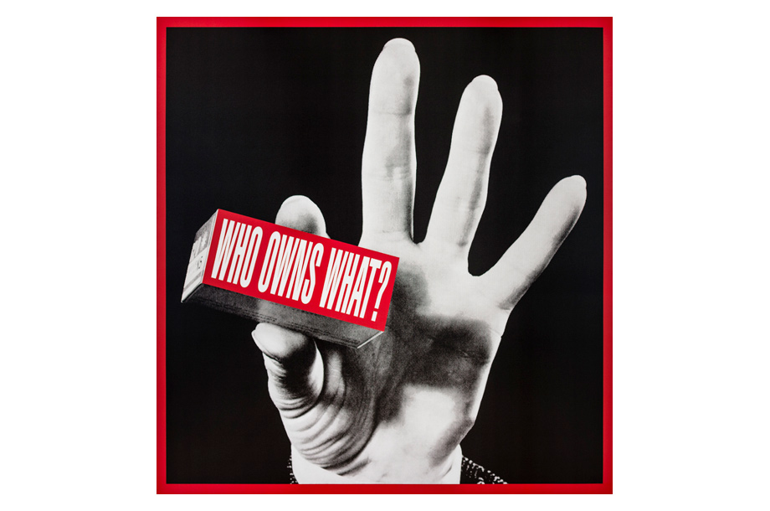
Also the brands main logo is heavily influenced by American artist Barbra Kruger who is critically acclaimed contemporary culturist artist. The logo uses the same white on red Futura Bold Oblique condensed text which is frequent in her work. So basically supreme appropriated Barbra Kruger’s bold graphical style to be the backbone of their own brand. Why I find this interesting is that for example her work, I shop therefore I am, was about challenging the society of consumer culture at the time in 1987, but now supreme uses the exact same style to promote consumer culture which emphasizes the point of the terms high and low culture becoming more redundant. This shows how the rise of social media through the rise of technology has blurred art work such as Barbara Kruger’s into the grey space and blurred line where Supremes appropriated style is now a trend, due to technology spreading to a wider audience.

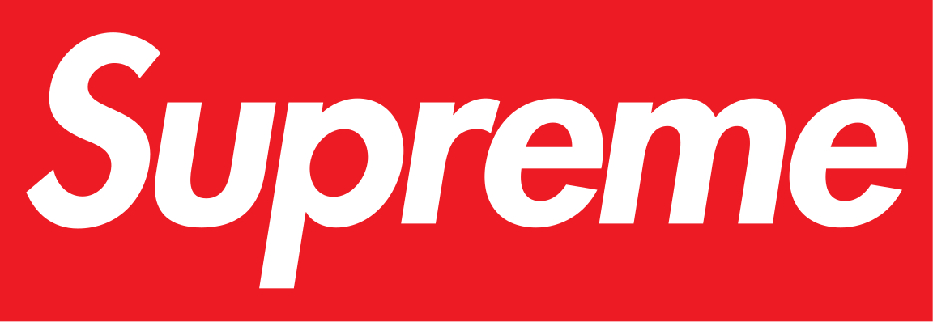

(Kruger, who owns what? 2012. Tate Modern) (Supreme, 1994)

Appropriation in art is the practice of using pre exciting images and objects in their work with hardly making any changes. The reason why I’ve also decided to include this as a part of my essay is because in recent year’s appropriation has become more mainstream and apparent in everyday life, as various things such as, music, videos, films, images, cultures and art is becoming easier to appropriate. In the sense of “every exploration is an appropriation” (Barthes, 1997) linking to how the development of technology makes this type of exploration much easier to do so. To explain why this is relevant to high and low culture becoming redundant, I will first use Andy Warhol as an example. Andy Warhol is probably the most recognizable artist associated with appropriation. He’s been noted for saying, “Art is what you can get away with” (Parsons, Maclaran and Chatzidakis, 2009), as he was famous for using photographs (many of which weren’t photographed by himself) of celebrities and everyday objects such as the Campbell soup cans in his work. Which involved converting them into multi layered colorful silk screen prints. Now this is in my opinion a good example of how he also blurred high and low culture into redundant terms. The Campbell tin soups were a popular and recognizable tin food brand associated with the average normal food shopping for people in the low culture society. While high culture society wouldn’t necessarily go out and buy such an average piece of tin food as it would be classed beneath them. Then comes Andy Warhol who appropriates the soups 32 different flavors into screen prints which then became a must have and collectible piece of art for high society. Launching his career from an illustrator to a fine artist.

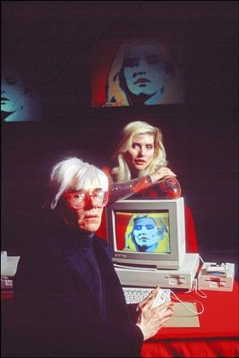
Therefore he made the Campbell soup image a low and high culture representation on how the terms can be blurred together through the use of appropriating mass culture. Then years later in 1985 Andy Warhol was chosen to show how computers could be used to create artwork by the computer company commodore. So he proceeded to create a portrait of Debbie Harry (Blondie), in the same style as his iconic screen prints. This is an early example on how appropriation could be made easier to do with technology. Which influenced him so much, that he, “went so far in embracing the machine as to wish that he would become one himself” (Lovejoy, 2004).So since then technology has advanced with computer programs such as Photoshop, and applications such as Pinterest which with a few simple clicks and can take any image and place it on a cup for merchandising, or alter an image slightly to make it more photogenic or even give a normal photo a painted look/effect. All of which can be done in very short time. Therefore any object or image related to high/low culture can be appropriated to suit any need. This also can cause it to drop or increase its cultural value.
(Computer History, 1985)

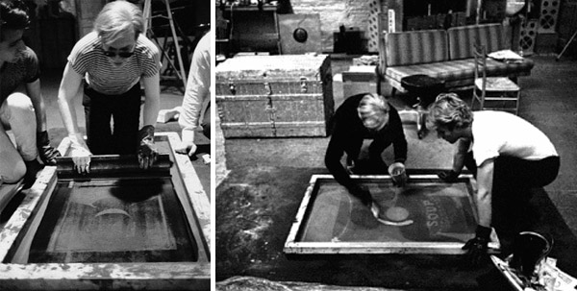
Another interesting point to make about Andy Warhol is that his work also challenged the idea of art being mass produced. Artwork throughout the centuries has been linked to hand painted/ handmade pieces of work, which sell for prices mainly affordable only for the high culture society. While low culture was mainly linked with mass produced items such as magazines, photos, newspapers that showed artwork. Andy Warhol challenged this by basically only using silkscreen printing (as he found it a faster method to make work), in his work. Eventually though in time he stopped making his own work but instead his assistances and other creatives make prints for him in his the New York studio. Which was called The Factory. Then after that it led to work most of his work being mass produced which became easier with technological advances. Which also links to his work being based off ordinary house old items which were also mass produced, such as the Campbell soup cans, linking to the reason by art is so diverse in the present day. So yet again is another example on how he challenged the rules behind low and high culture society, as his mass produced work became very collectible for high society art collectors.

(Revolverwarholgallery, 2014)

Due to the advancement of technology, mass production has become much more common, and also more common in the modern day art scene. A good example of this is Jeff Koons, who is an American artist who uses themes of lower class banal objects such as blown up balloon animals. These are made usually from stainless steel and then polished to a mirror finish surface, all of which is created in a factory like studio (similar to Andy Warhol’s) by his assistants which number between 90-120. He also known for his work to be cutting edge and uses advances in technology in his work which can make them a challenge to curate in gallery’s or museums .Such as when he collaborated with the fabrication firm Arnold to create a custom stainless steel alloy for the mirror surfaces on his balloons. As he said in an interview, “I work with technology the way I do is that I can really be assured that the vision I have from the outset is what will be at the end” (Brockes, 2015).Like Andy Warhol he converts low culture objects in to high values of art which sell for example, his balloon dog (orange) sold for $58.4million. Which just goes to show how the traditional high culture standards of handmade/ painted pieces of work, are becoming more redundant as mass production is clearly a popular, profitable and acceptable in today’s art world.
In conclusion I would say in my opinion that the terms for high and low culture started to become more redundant in the last few decades. However the technological improvements in social media has quickened this process substantially more as all aspects of different cultures can be so easily shared/ seen by millions of people instantly across the globe, with a click of a button.

(koons, Balloon Dog (Orange), 1994)

Reference list
Williams, R. (1976). Keywords. New York: Oxford University Press, p.49.

Craik, J. (2009). Fashion: The Key Concepts. 1st ed. [ebook] London: Bloomsbury Academic. Available at: https://eprints.qut.edu.au/98367/ [Accessed 8 Dec. 2018].

Qualman, E. (2010). Socialnomics: How Social Media Transforms the Way We Live and Do Business. 1st ed. Hoboken: John Wiley & Sons, p.Xiii.

McCollom, M., Holder, G. and Hunter, R. (2006). The way we wore. 1st ed. New york: Glitterati Incorporated, p.12.

STARZFLY/BAUER-GRIFFIN, (2017), VICTORIA BECKHAM SUPREME LOUIS VUITTON AIRPORT OUTFIT [ONLINE]. Available at: https://www.refinery29.com/en-gb/2017/04/150450/victoria-beckham-supreme-louis-vuitton-tshirt [Accessed 8 December 2018].

Kruger, B. (2012). Who owns what?. [Digital print on vinyl] London: Tate.

Supreme (1994). Supremes logo. [image] Available at: https://en.m.wikipedia.org/wiki/File:Supreme_Logo.svg [Accessed 8 Dec. 2018].

Barthes, R. (1997). The Eiffel Tower, and other mythologies. 1st ed. Berkeley: University of California Press, p.14.

Parsons, E., Maclaran, P. and Chatzidakis, A. (2009). Contemporary issues in marketing and consumer behaviour. New York: Routledge, p.55.

Lovejoy, M. (2004). Digital Currents. Abingdon: Routledge, p.Xiv.

Computer History (1985). Andy Warhol with Debbie Harry at the 1985 Amiga Launch at Lincoln Center. [image] Available at: http://www.computerhistory.org/atchm/warhol-the-computer/ [Accessed 9 Dec. 2018].

Revolverwarholgallery (2014). ANDY WARHOL SCREENPRINTS – THE PROCESS AND HISTORY. [image] Available at: https://revolverwarholgallery.com/andy-warhol-screenprints-process-history/ [Accessed 9 Dec. 2018].

Brockes, E. (2015). Jeff Koons: ‘People respond to banal things – they don’t accept their own history’. The guardian. [online] Available at: https://www.theguardian.com/artanddesign/2015/jul/05/jeff-koons-people-respond-to-banal-things-they-dont-accept-their-own-history [Accessed 9 Dec. 2018].
koons, j. (1994). Balloon Dog (Orange). [mirror-polished stainless steel with transparent color coating] london: Anthony d'Offay Gallery.

Bibliography
https://fizzymag.com/articles/history-of-supreme-logo
https://revolverwarholgallery.com/andy-warhol-art-appropriation/
http://www.computerhistory.org/atchm/warhol-the-computer/
https://chrisrusak.com/jeff-koons-is-not-an-artist/
https://emptyeasel.com/2007/05/22/andy-warhol-mass-produced-art-with-popular-appeal/
https://eprints.qut.edu.au/98367/
https://www.refinery29.com/en-gb/2017/04/150450/victoria-beckham-supreme-louis-vuitton-tshirt
https://revolverwarholgallery.com/andy-warhol-screenprints-process-history/
https://www.theguardian.com/artanddesign/2015/jul/05/jeff-koons-people-respond-to-banal-things-they-dont-accept-their-own-history

