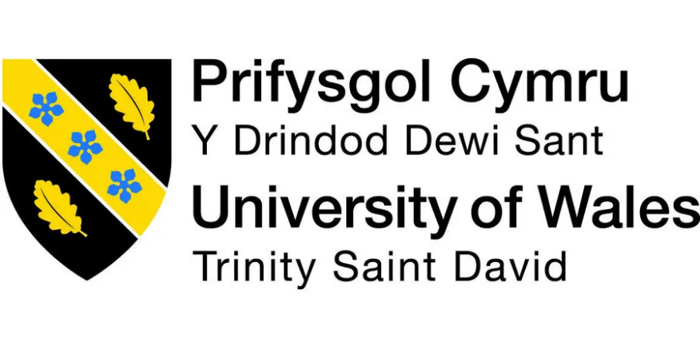
Management Accounting for Managers
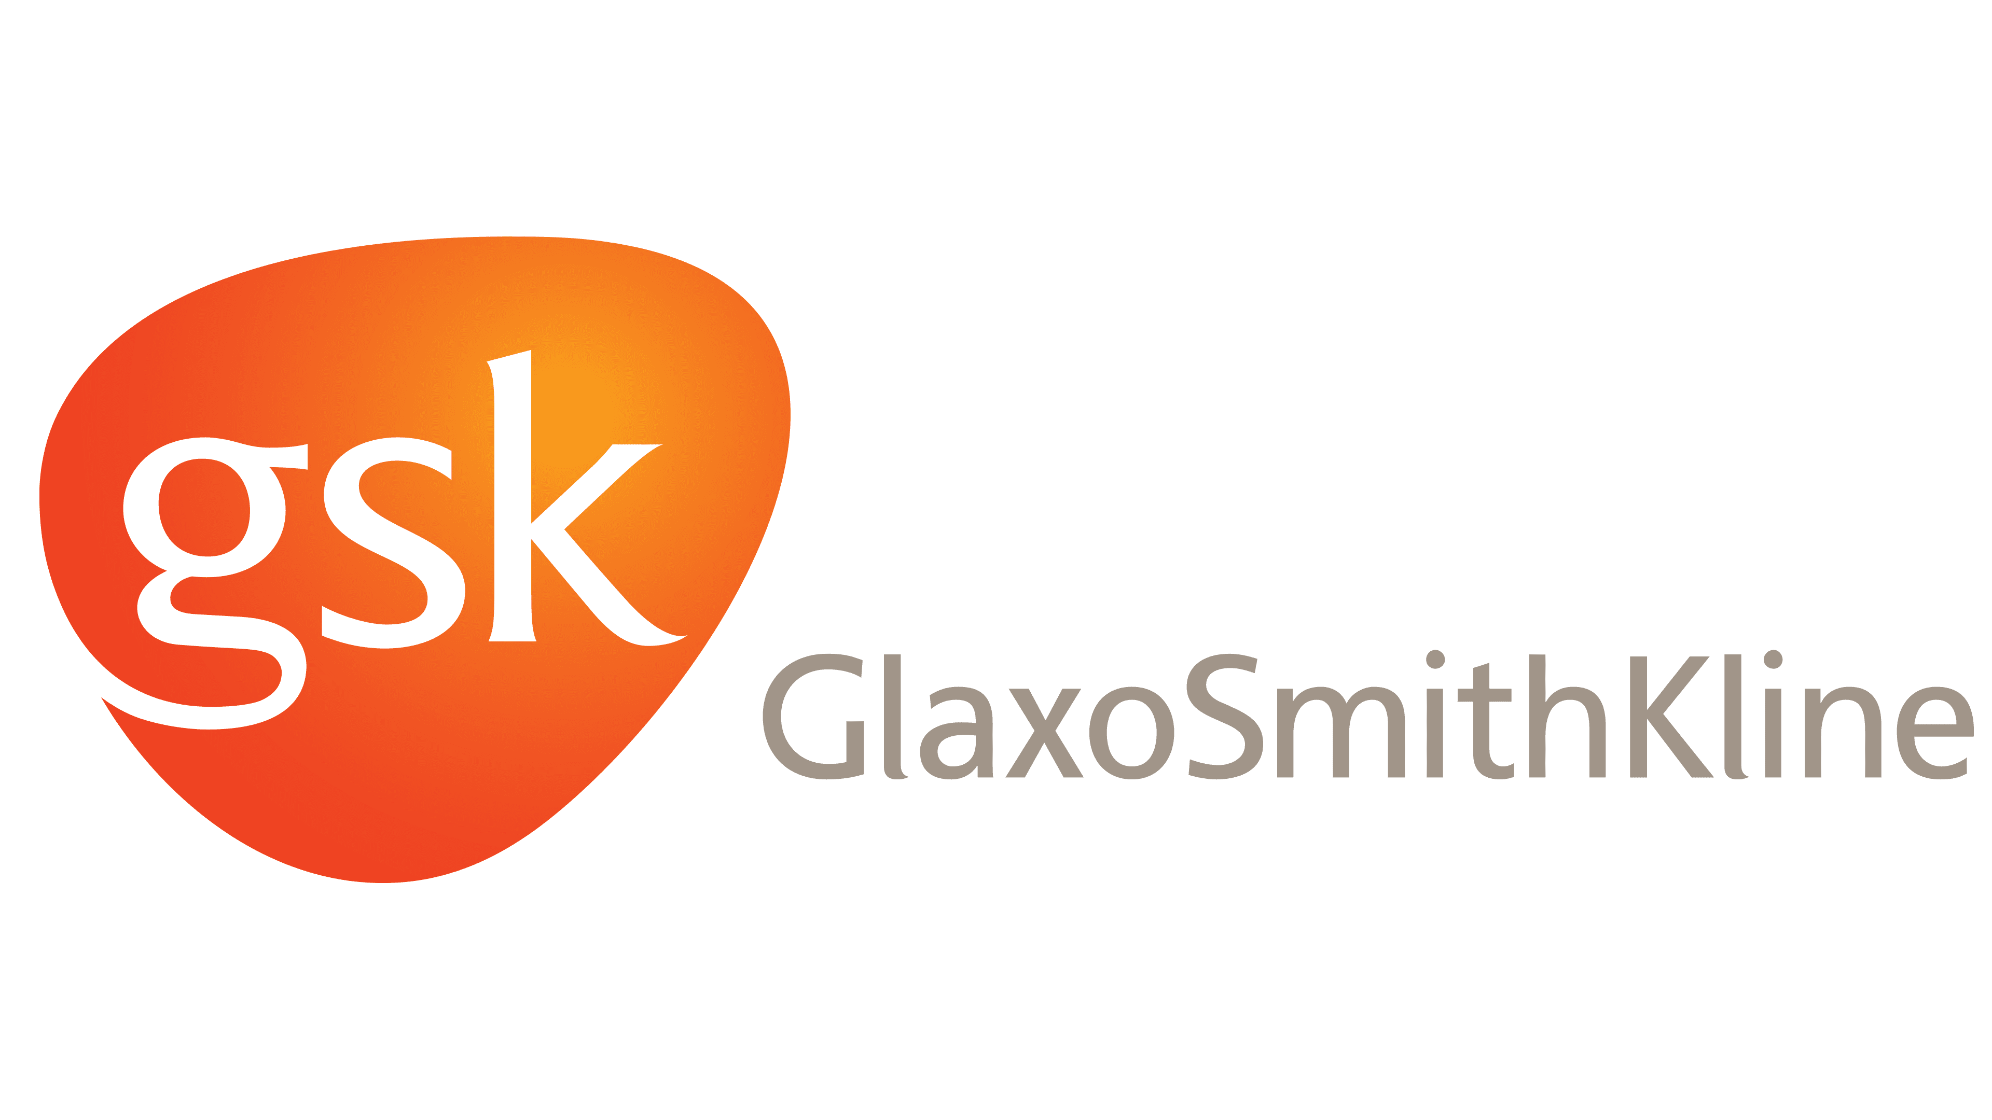

Assignment 1
Submission deadline
17/07/2026

Name: Badru Keanene
Student ID: 2416450
Module code: LCBB5010_LON
Lecturer: Zainab Atta
Table of Contents
1. Introduction 3
1.1. Importance of management accounting in decision-making 3
2. GSK’s Cost Analysis and Business Model 4
2.1. Revenue Model 5
2.2. Cost Structure 5
3. The Role of Budgeting in GSK's Operations 7
4. GSK’s Performance Measurement and Decision Making 8
5. GSK's Integration of Sustainability into Financial Decision-Making and Ethical Cost Management 10
6. Conclusion and Recommendations 11
7. References 12

1. Introduction
GlaxoSmithKline (GSK) is a British multinational pharmaceutical and biotechnology company headquartered in London, England. It was established in 2000 through the merger of Glaxo Wellcome and SmithKline Beecham. GSK focuses on specialty medicines, vaccines, and general medicines, with key therapeutic areas including HIV, respiratory, cancer, and infectious diseases. GSK is also known for its innovative products, including the first malaria vaccine and various over-the-counter medications (Gsk.com, 2025)
The list of the top 10 pharmaceutical companies by total revenue in 2024 comprised Roche, Merck & Co., Pfizer, Johnson & Johnson, AbbVie, AstraZeneca, Novartis, Sanofi, Bristol Myers Squibb, and Eli Lilly (IntuitionLabs, 2025).

GSK's share of the global pharmaceutical market is approximately £32.7 billion of industry revenue in 2025, representing about 2.4% of the global pharmaceutical market.
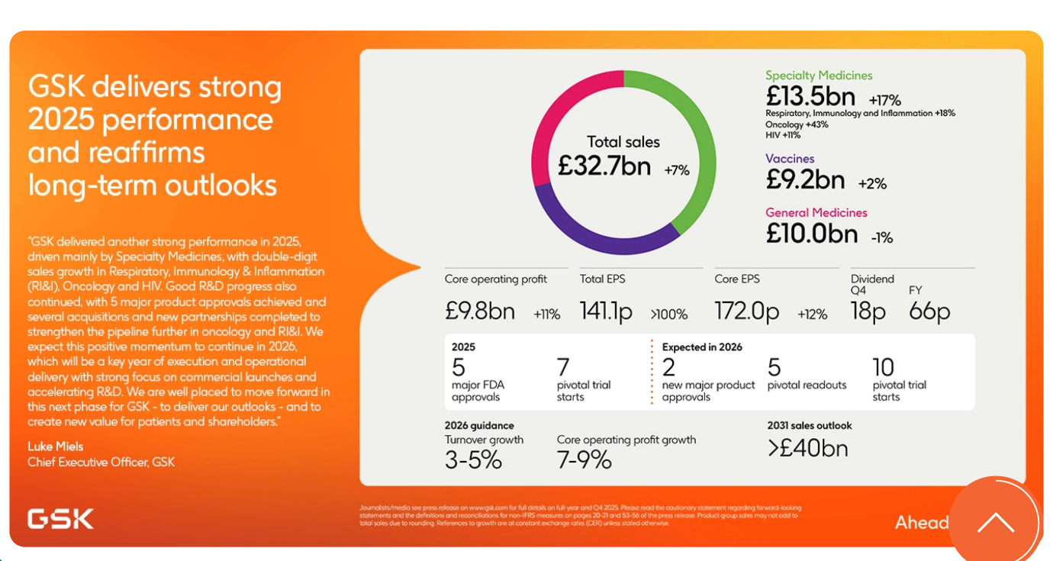
Source: (Gsk.com, 2025)

1.1. Importance of management accounting in decision-making
According to CIMA, management accounting plays a critical role in providing information that supports managerial decision-making. Specifically, cost analysis within management accounting offers essential data that underpins effective decisions by managers, as highlighted in the connection between managerial decision-making and accounting information (CIMA, 2023).
For example, GSK has recently bought Nuvalent which specialise in lung cancer treatment for £10.6bn (Gsk.com, 2026). Management accounting would have provided an analysis and indicated that the return on investment if GSK bought this firm, given the increase in cancer rates (ScienceDaily, 2026).

2. GSK’s Cost Analysis and Business Model
GSK is a research-based biopharmaceutical company that creates value through the discovery, development, manufacturing, and commercialisation of prescription medicines and vaccines. Following the demerger of its consumer healthcare business in 2022, GSK’s business model is focused on three revenue-generating segments: Specialty Medicines, Vaccines, and General Medicines. In 2025, GSK generated £32.7 billion in turnover, of which £13.5 billion (41%) came from Specialty Medicines, £9.2 billion (28%) from Vaccines, and £10.0 billion (31%) from General Medicines. Its largest therapeutic areas are HIV, oncology, respiratory disease, immunology, and infectious diseases (Gsk.com. 2025).
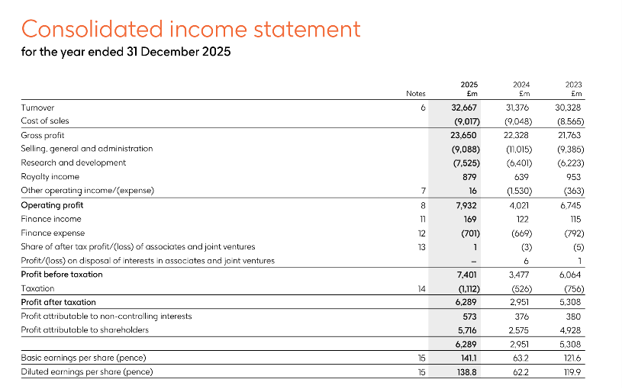
Source: (Gsk.com. 2025).

2.1. Revenue Model
GSK makes most of its money by selling products, mainly prescription drugs and vaccines that have patents. The company's business model depends a lot on intellectual property. These patents give GSK exclusive rights to sell certain products for a limited time, allowing them to charge higher prices. Popular products like their HIV treatments, Shingrix, and Trelegy bring in a lot of money. This cash is then used to fund new research and development. Besides selling products directly, GSK also gets money from licensing deals, royalties, and working with other drug companies. This approach is pretty standard in the pharmaceutical industry, where new discoveries and patent protection are crucial for making profits (Gsk.com, 2025; Umbrex, 2026).

2.2. Cost Structure
GSK (GlaxoSmithKline) does not publish a standalone "cost structure" document, but rather details its cost base in its comprehensive annual financial disclosures. The overarching operational and cost structure is detailed across multiple official reports, breaking down expenditures into Cost of Sales, SG&A (Selling, General, and Administration), R&D (Research & Development), and Restructuring.
Key Cost Structure Components
- Costs required to produce GSK's specialty medicines, vaccines, and general medicines.
- Selling, General, and Administration (SG&A): The largest overhead and commercial cost block. This includes global sales force expenses, marketing operations, legal/compliance costs, and corporate administrative functions. GSK SG&A expenses for 2025 were $11.984B, a 14.86% decline from 2024 which had expenses of $14.076B (Macrotrends, 2026a).
- Research & Development (R&D): Major investments in clinical trials, scientific platforms, and drug discovery. GSK consistently allocates a significant portion of total turnover (typically 14% plus) to its R&D pipeline. GSK allocated £6.6 billion to core R&D in 2025, representing a 9% increase in AER and 11% in CER compared with 2024. Their development pipeline now includes 58 assets, with more than half originating from business development activities (GSK, 2025).
- Restructuring Costs: Ongoing operational transformation and site optimisation expenses designed to improve long-term margins. GSK is cutting approximately 350 R&D roles across its US and UK operations as part of a broader restructuring of the division (Williams, 2026).
Variable costs go up as you make and sell more products. These costs cover things like raw materials, drug ingredients, packaging, shipping, and some marketing. Making vaccines also needs special biological materials that change based on how much you produce. But once a drug is developed and approved, making more of it doesn't cost that much compared to the initial research and development spending. Because of this, drug companies often find that producing more makes each unit cheaper (economies of scale) and they can make a good profit on successful drugs.
Overall, GSK’s business model is characterised by high fixed costs associated with innovation and comparatively lower variable production costs. Consequently, long-term success depends on maintaining a strong pipeline of patented medicines and vaccines capable of generating sufficient revenue to recover substantial R&D investments and support future growth (Gsk.com, 2025).

3. The Role of Budgeting in GSK's Operations
Budgeting is really important for how GSK runs its business and plans for the future. It helps the company put money where it's needed most, keep costs in check, fund its research, and meet its long-term money goals. GSK is a biopharmaceutical company that does a lot of research. This industry requires a lot of money, takes a long time to develop products, and has strict rules to follow. So, budgeting gives GSK a way to decide which projects are most valuable and make sure the whole company spends money wisely (GSK, 2025). A big chunk of GSK's budget goes into research and development (R&D). This is key to keeping a steady stream of new medicines and vaccines coming. By planning the budget, managers can look at where to invest, estimate how much money they'll have coming in, and decide how much to spend on things like clinical trials, making products, meeting regulations, and selling them. Budgeting also helps measure how well the company is doing. By comparing what was actually spent to what was planned, managers can see where the differences are and make changes if needed (GSK, 2025).
The year-on-year change in operating expenses reported in GSK’s 2025 Annual Financial Statement reflects a notable decline compared with 2024, signalling both internal managerial actions and external macroeconomic influences. According to Google Finance and GSK's 2025 Annual Report, GSK's operating expenses declined year-on-year. Operating expenses decreased from approximately US$34.96 billion in 2024 to US$32.62 billion in 2025, representing a reduction of around 6.7% (Macrotrends, 2026). This reduction is primarily attributed to lower significant legal charges and contingent consideration liabilities, which had materially inflated operating costs in the prior year.
GSK’s 2025 performance was shaped by stronger SG&A (selling, general, and administrative expenses) efficiency and a more disciplined allocation of R&D spending, signalling a shift toward cost effectiveness and targeted investment in late-stage assets (GSK, 2025). The company’s emphasis on high-margin Specialty Medicines particularly HIV, oncology, and respiratory treatments—enhanced operating leverage, enabling revenue growth without a proportional rise in operating costs. This mirrors a wider industry trend in which pharmaceutical firms prioritise specialised therapeutics to improve profitability (PwC, 2024).
External conditions also supported lower operating expenses. A stronger British pound reduced reported costs when converted to US dollars, highlighting the influence of currency movements on multinational companies. Additionally, declining inflation in 2025 eased pressure on input and logistics costs, while post-pandemic stabilisation in healthcare demand reduced operational strain. These factors allowed GSK to normalise spending after elevated legal and restructuring costs in 2024.
Overall, the reduction in operating costs resulted from both effective internal cost management and favourable macroeconomic conditions. Together, these improvements strengthened GSK’s operating margin and positioned the company for sustained financial performance and future growth.

4. GSK’s Performance Measurement and Decision Making
Key Performance Indicators, or KPIs, are specific, measurable targets that show if a company, department, or project is on track to meet its main goals. In managing strategy, KPIs give a solid, fact-based way to check how things are going. They help managers decide what to do and make sure daily work supports the company's long-term plans. For GSK, KPIs are crucial for tracking money matters, how well they innovate, their sustainability efforts, and how the company runs overall. This helps them move forward with their goal of being a top biopharmaceutical company (Hennigan, 2024).

GSK’s 2025 Annual Report outlines several KPIs that illustrate the company’s financial resilience, research output, sustainability progress, and organisational culture. Group Turnover rose to £32.7 billion, reflecting 4% growth at AER and 7% at CER, signalling the company’s continued ability to strengthen its market position and deliver stable revenue. Additionally, Core Operating Profit increased to £9.8 billion, an 11% rise at CER, indicating enhanced operational efficiency supported by stronger sales and focused productivity measures (GSK, 2025).
Innovation performance is measured through the R&D Pipeline, which in 2025 included 58 pipeline assets, 17 Phase III or registration programmes, five major approvals, and 14 new collaborations and acquisitions. These non-financial KPIs indicate strong future revenue potential and sustained investment in biopharmaceutical innovation (Gsk.com, 2025)

GSK’s Responsible Business Performance Rating reached 92%, covering sustainability, ethics, product governance, inclusion, and global health (Gsk.com, 2025a). The company achieved a 45% reduction in operational carbon emissions from its 2020 baseline, sourced 100% imported renewable electricity, contributed £6 million to the Global Fund through ViiV Healthcare, and supplied 560 million doses to lower-income countries advancing its goal of reaching 1.3 billion people by 2030 (Potter, 2026). Finally, Employee Engagement remained above 80% for the third consecutive year, reflecting strong organisational culture, motivation, and talent retention (Gsk.com, 2025).

GSK’s 2025 KPIs played a direct role in shaping strategic priorities for the year. Strong financial results in its Specialty Medicines portfolio particularly HIV, oncology, and respiratory treatments supported increased investment in high-growth therapeutic areas while reducing dependence on slower-growth General Medicines. The strength of the R&D pipeline, alongside new partnerships, reinforced continued acquisitions and licensing activity aimed at bolstering late-stage assets. Productivity insights guided more efficient SG&A spending, allowing GSK to raise R&D investment without broad cost-cutting. Instead, funding was deliberately redirected toward oncology, vaccines, and other innovative medicines with greater long-term value potential.
Non-financial KPIs also guided decision making. Sustainability achievements reinforced investment in environmental and global health programmes, while strong employee engagement supported leadership development and cultural initiatives. Together, these KPIs illustrate GSK’s Balanced Scorecard approach, enabling the company to balance short-term profitability with innovation, sustainability, and long-term shareholder value (Gsk.com, 2025).

5. GSK's Integration of Sustainability into Financial Decision-Making and Ethical Cost Management
GSK integrates its ESG priorities directly into corporate strategy and investment planning, rather than treating sustainability as a standalone responsibility programme. The company’s Responsible Business Performance Rating (RBPR) evaluates outcomes across six core areas: access to healthcare, global health and security, environmental impact, inclusion, ethical conduct, and product governance. In 2025, GSK achieved or surpassed 92% of these measures, demonstrating that sustainability performance is tracked and managed with the same rigour as financial results (GSK, 2025).
Furthermore, GSK reported a 14% reduction in Scope 1 and Scope 2 operational carbon emissions in 2025, reflecting continued investment in low-carbon operations and resource efficiency as part of its long-term financial strategy. Climate-related risks are also integrated into enterprise risk management and financial governance through oversight by both Sustainability and Finance committees, ensuring that environmental risks are considered in strategic investment decisions (Gsk.com. 2025).
GSK’s ethical principles shape both its cost management and pricing decisions. As a global pharmaceutical company, it aims to balance commercial performance with fair patient access and the broader benefits its medicines provide to health systems. The firm uses tiered and responsible pricing especially for vaccines and essential treatments in low- and middle-income countries and collaborates with partners such as Gavi to expand access. In 2025, GSK supplied 99 million vaccine doses through Gavi, demonstrating how pricing and distribution choices support commercial sustainability and public health goals (GSK, 2025).
Its cost strategy also reflects ethical priorities by maintaining strong investment in research and development while improving productivity rather than reducing innovation funding. This approach ensures responsible cost control without compromising product quality, patient safety, or scientific progress (GSK, 2025). Academic research shows that integrating sustainability and ethical governance into financial decisions strengthens long-term resilience and stakeholder trust (Eccles, Lee and Stroehle, 2020), positioning GSK as an example of balanced, sustainable financial management.

6. Conclusion and Recommendations
GSK’s 2025 results illustrate a robust, innovation-driven operating model supported by solid revenue expansion, disciplined financial management, and sustained investment in high-value therapeutic areas. The company’s cost profile marked by substantial fixed R&D spending and relatively low marginal manufacturing costs continues to benefit from economies of scale and deliberate resource allocation. Its use of both financial and non-financial KPIs, including meeting 92% of responsible business targets and delivering 99 million vaccine doses through Gavi, highlights GSK’s commitment to ethical governance and long-term value creation. Collectively, the evidence shows that GSK successfully integrates sustainability, financial discipline, and strategic planning to strengthen organisational resilience.
Recommendations
- Adopt ROI-driven R&D portfolio optimisation to reinforce investment choices across oncology, HIV, and vaccine development.
- Implement activity-based costing (ABC) to improve cost visibility across SG&A and manufacturing processes, supporting margin enhancement.
- Expand sustainability-linked budgeting frameworks to embed carbon-reduction targets into financial planning and reinforce progress following the 14% emissions reduction reported in 2025.

7. References
CIMA (2023). Secure the Future of Your Career in Finance | CIMA. [online] myfuture.cimaglobal.com. Available at: https://myfuture.cimaglobal.com/starting-a-career-in-management-accounting/ [Accessed 30 Jun. 2026].
Eccles, R.G., Lee, L.E. and Stroehle, J.C., 2020. The social origins of ESG: An analysis of Innovest and KLD. Organization & environment, 33(4), pp.575-596.
Gsk.com (2025a). Responsible business | GSK. [online] Gsk. Available at: https://www.gsk.com/en-gb/investors/responsible-business/#ourperformance [Accessed 13 July 2026].
Gsk.com. (2025). Annual Report 2025 | GSK. [online] Available at: https://www.gsk.com/en-gb/investors/financial-reports/annual-report-2025/?utm_source [Accessed 24 Jun. 2026].
Gsk.com. (2026). GSK enters agreement to acquire Nuvalent, Inc. | GSK. [online] Available at: https://www.gsk.com/en-gb/media/press-releases/gsk-enters-agreement-to-acquire-nuvalent-inc/ [Accessed 30 Jun. 2026].
Hennigan, L. (2024). What Is A KPI? Definition & Examples. [online] Forbes. Available at: https://www.forbes.com/advisor/business/what-is-a-kpi-definition-examples/ [Accessed 2 Jul. 2026].
IntuitionLabs (2025). Global Pharmaceutical Industry: History and Market Size. [online] IntuitionLabs. Available at: https://intuitionlabs.ai/articles/pharmaceutical-industry-history-market [Accessed 18 Jun. 2026].
Macrotrends, (2026). GSK Operating Expenses 2012-2026 | GSK. [online] Tmacrotrends. Available at: https://www.macrotrends.net/stocks/charts/gsk/gsk/operating-expenses?utm [Accessed 13 July 2026b].
Macrotrends, (2026a). GSK SG&A Expenses 2012-2026 | GSK. [online] Macrotrends.net. Available at: https://www.macrotrends.net/stocks/charts/GSK/gsk/selling-general-administrative-expenses [Accessed 12 July 2026].
Potter, L. (2026). What’s Inside GSK’s 2025 Responsible Business Report? [online] Sustainabilitymag.com. Available at: https://sustainabilitymag.com/news/whats-inside-gsks-2025-responsible-business-report [Accessed 13 July 2026].
PwC (2024) Pharma 2024: Industry Trends and Strategic Priorities. PricewaterhouseCoopers. Available at: https://www.pwc.com/gx/en/industries/healthcare.html (Accessed: 1 July 2026)
ScienceDaily. (2026). A global cancer surge is underway and the world is not ready. [online] Available at: https://www.sciencedaily.com/releases/2026/01/260106224644.htm [Accessed 30 Jun. 2026].
Umbrex (2026). GSK Strategy and Business Model. [online] Independent Management Consultants. Available at: https://umbrex.com/resources/company-profiles/glaxosmithkline/ [Accessed 25 Jun. 2026].
Williams, H. (2026). GSK cutting jobs in UK and US as part of ongoing R&D changes. [online] Yahoo Finance. Available at: https://uk.finance.yahoo.com/news/gsk-cutting-jobs-uk-us-143824067.html [Accessed 12 July 2026].

