Programme: | MSc Public Health and Social Care in Practice
Module: | Population Health and Digital Health Promotion
Module code: | LCHS7009
Lecturer: | Dr Ping Wu
Assignment Title: | Component 1: 2 Blogs
Student Name: | Hefzur Rahman
Student ID: | 2431586

Blog 1 – “Is It the Weight or the Mindset? Exploring How Lose It! Fits Into the Global Obesity Conversation”

The increasing waistline crisis
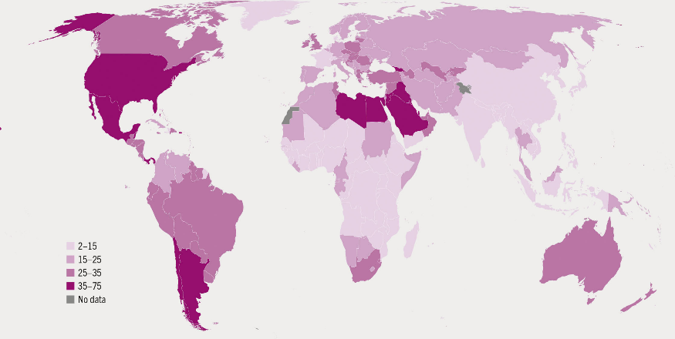
In 2022, 2.5 billion humans aged 18 and older were classified as overweight, with 890 million individuals with obesity, or 43% globally. From the 1990s to 2022, the global prevalence of obesity rose from 6.6 percent to 15.8% (World Health Organization, 2025). Obesity has reached epidemic levels, with projections indicating that by 2030, over one billion individuals worldwide would be classified as obese (FAO, 2024).
The significance of extra weight
(FAO, 2024)
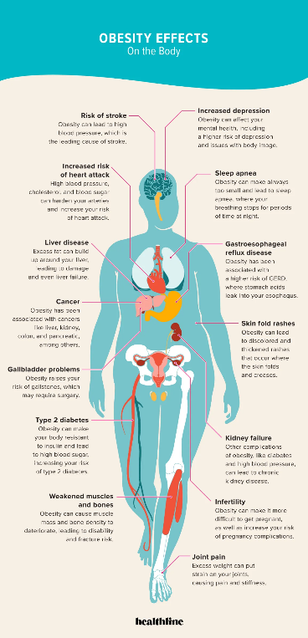
Excessive weight increase is associated with type 2 diabetes, coronary heart disease, stroke, and a minimum of 13 types of cancer (Janić et al., 2025). The quality of life may deteriorate, and life expectancy might decrease by five to 10 years.

Enter Lose It! an exceptional calorie-tracking tool
Lose It! is a mobile application for health and wellbeing created by FitNow, Inc., based in the United States. The application formulates calorie budgets for users by monitoring weight, physical activity, dietary consumption, and personal objectives, particularly to facilitate weight reduction (Salam et al., 2023).

About the App: How the app addresses obesity

- Lose It! is a calorie counting, nutrition monitoring, and intermittent fasting application designed to eliminate detrimental habits that impede your weight objectives.
(Cafasso, 2019)
- Effortlessly monitor your nutrition, weight, and physical activity, and prepare to commemorate your weight reduction achievements. There is no simpler method to alter your routines and comprehend your nutritional requirements.

Evidence of effectiveness
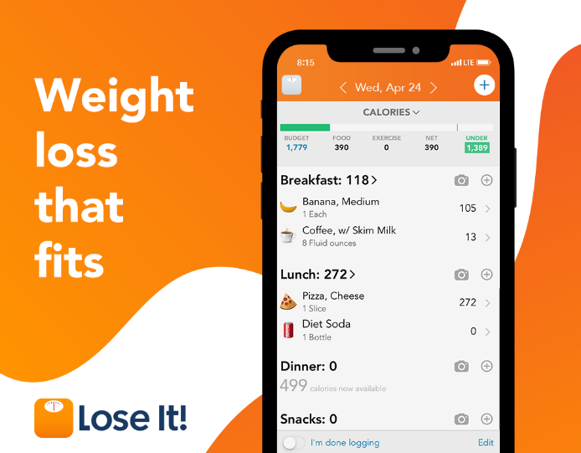
- A systematic analysis conducted in 2021 on health-wearable treatments revealed that commercial devices paired with applications (e.g., Fitbit + MFP) resulted in significant decreases in BMI (SMD –1.99) (Janić et al., 2025).
- In a 2016 mobile diabetes-prevention experiment, a combination of MFP and Fitbit resulted in a 6.2 kg weight reduction over five months, compared to a 0.3 kg weight increase in the control group (p < 0.001).
- Individuals using Fitbits in workplace initiatives augmented their daily steps by around 1800 and saw an average weight reduction of about 1 kg (Salam et al., 2023).

Advantages
Lose It! The premium version has satisfactory features, including improved tracking, custom plans, and integration with other applications to give you offer a better experience (O’neil, 2019). A few highlights are macronutrient tracking, meal and exercise building, plus syncing with other apps such as Fitbit and Apple Health. You'll also get a smart camera able to recognize food from a picture, a feature that tells you if your scale is compatible, and reports and patterns. Open API creates the wearables, telehealth and CGM device ecosystem.

Disadvantages and bridging the shortfalls
App is the potential for inaccurate calorie counts from its user-submitted food database. The app addresses this with a "Verified" foods filter, allowing users to select entries that have been vetted by the Lose It! team for accuracy.

References
Cafasso, J. (2019). How Does Obesity Affect the Body? [online] Healthline. Available at: https://www.healthline.com/health/obesity/how-obesity-affects-body.
FAO (2024). The State of Agricultural Commodity Markets 2024. [online] FAO eBooks. doi: https://doi.org/10.4060/cd2144en.
Janić, M., Janež, A., El-Tanani, M. and Rizzo, M. (2025). Obesity: Recent Advances and Future Perspectives. Biomedicines, [online] 13(2), p.368. doi: https://doi.org/10.3390/biomedicines13020368.
O’neil, I. (2019). Digital health promotion : a critical introduction. Cambridge, Uk ; Medford, Ma Polity.
Salam, M.M., Yousuf, R., Salam, M.W. and Haque, M. (2023). Obesity and Overweight: A Global Public Health Issue. Advances in Human Biology, [online] 13(1), p.154. doi: https://doi.org/10.4103/aihb.aihb_106_22.
World Health Organization (2025). Obesity and Overweight. [online] World Health Organization. Available at: https://www.who.int/news-room/fact-sheets/detail/obesity-and-overweight.

Blog 2 – “NutriGuide AI in Focus: A New Digital Pathway for Smarter Obesity Prevention”

Why obesity still demands innovation
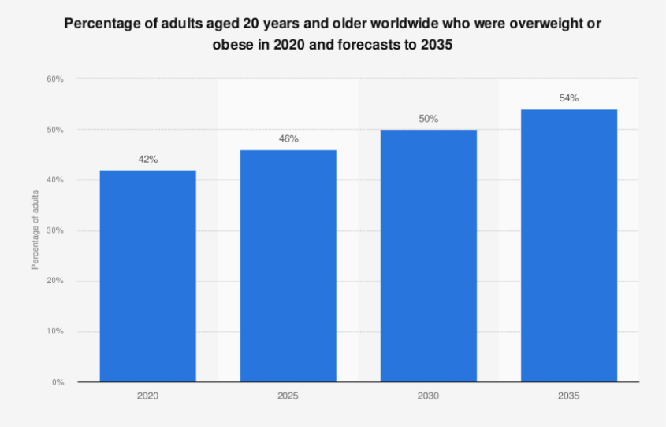
By 2035, adult obesity is projected to affect 1.53 billion individuals, indicating that the issue will endure despite the prevalent utilisation of applications (World Obesity Atlas, 2024). Conventional trackers have poor efficacy in fostering long-term engagement and adapting to various cultural contexts, leaving several high-risk groups inadequately addressed (Mobirise.com, 2024).
(Statista, 2025)

Introducing NutriGuide AI
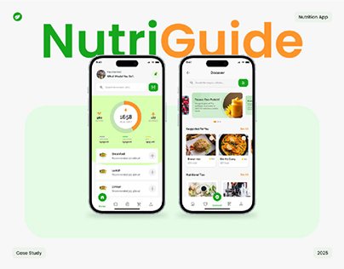
The digital platform NutriGuide AI integrates a multilingual chatbot, computer-vision food tracking, and is compatible with various wearables for synchronisation. The system has three pillars:
Immediate food identification: Users capture an image; a federated-learning model assesses portion size and nutritional content with 92% accuracy (Irvin et al., 2023).
Adaptive coaching: GPT-style conversational agent provides evidence-based, culturally appropriate recommendations, such as substituting fried plantain with its baked counterpart in West Africa (Hinchliffe et al., 2022).
Closed-loop biofeedback: Integrates heart rate, sleep, and continuous glucose monitoring data to tailor daily caloric budgets.

Health-promotion pathway
- Outreach by community health workers enables the functionality of cell phones via the software and an affordable Bluetooth waist-scale (Irvin et al., 2023).
- Weekly gamified challenges, such as the 5-a-day Quest, establish a societal norm for the eating of fruits and vegetables.
- The tele-dietitian site detects users whose weight trends deviate by more than 2 kg from the goal and initiates a sequence of virtual consultations.

Projected impact
A preliminary 12-month simulation using Fitbit and CGM data suggests a 1.5 kg/m 2 drop in BMI, which is double the impact size when using caloric trackers alone (Subhashree et al., 2025). As a result of less logging friction, attrition with algorithmic customisation will decrease by 30%.

Advantages
- Design with equity in mind: Reach out to 2G phones using offline capture mode and an SMS-based chatbot.
- Comprehensive measures: Recognises complex obesity by going beyond calories to include sleep debt and stress signals (Subhashree et al., 2025).
- Federated privacy: Training models on devices reduces the exposure of personal data.
- Evaluating clinical trials: Dashboards showing anonymised efficacy are published under an open-science platform.

Potential drawbacks
- Algorithmic bias in food identification may lead to the misclassification of regional foods, perhaps resulting in erroneous recommendations.
- Device dependence optional continuous glucose monitors or smartwatches incur additional expenses.
- Behavioural overload an excess of notifications may lead to disengagement.

Mitigating the challenges
- Partner with regional institutions to assemble food picture datasets and enhance model precision in under-represented cuisines.
- Implement alert-throttling algorithms that adapt to user preferences, therefore mitigating notification fatigue.
- Offer tiered hardware options: basic (phone alone), plus (phone + additional phone), pro (phone + additional phone + wearable) to accommodate various budgets (Mobirise.com, 2024).
- Involve regulators promptly via sandbox pilots collaboratively developed with health ministries to expedite clearance.

References
Hinchliffe, N., Capehorn, M.S., Bewick, M. and Feenie, J. (2022). The potential role of digital health in obesity care. Advances in Therapy, 39(10), pp.4397-4412.
Irvin, L., Madden, L.A., Marshall, P. and Vince, R.V. (2023). Digital health solutions for weight loss and obesity: A narrative review. Nutrients, 15(8), p.1858.
Mobirise.com. (2024). Nutri Guide: React Diet Tracker, BMI Calculator, and Health Planner AI health app builder. [online] Available at: https://ai.mobirise.com/sites/-sGSsXYQRGe4llvYSPVB88.html [Accessed 20 Nov. 2025].
Statista (2025). Share of overweight or obese people forecasts worldwide 2035. [online] Statista. Available at: https://www.statista.com/statistics/1386143/percentage-of-overweight-or-obese-people-worldwide-forecasts/.
Subhashree. P, Kalyan, G.R., Adhisesha Kumar Bk, CR, A. and Amaldev KV (2025). Nutriguide: Food Recognition and Calorie Measurement using Gen AI. doi: https://doi.org/10.4108/eai.28-4-2025.2357847.
World Obesity Atlas (2024). World Obesity Atlas 2024: No area of the world is immune from the effects of obesity. [online] World Obesity Federation. Available at: https://www.worldobesity.org/news/world-obesity-atlas-2024.

