Digital surveying

Assignment 1

Steffan Dancey

2014079

Table of Contents
Part 1: 3
Introduction 3
What is surveying? 3
Classification of surveying 3
Plane surveying 4
Geodetic Surveying 4
Based on purpose 4
Cadastral Survey 4
City Survey 4
Construction Survey 4
Forestry Survey 4
Hydrographic Survey 4
Based on method 5
Triangulation 5
Trilateration 5
Traversing 5
Brief history 5
Part 2: 7
Digital surveying of listed buildings 7
Planning 8
Fieldwork 8
Computing and mapping 8
Report 8
Tools 8
Tape measures 9
Laser measurement 9
Digital camera 10
Thermal camera 10
Moisture Meter 10
Telescopic inspection camera 11
Summary 11
References 11

Part 1:
Surveying can be classified based on different factors, outline these factors, and discuss in details different types of surveying under one of the factors.

Introduction
Part 1 of this report will outline different factors and discuss in detail, these different types of surveying of the different factors and Part 2 of this report will look to describe the application of digital surveying technologies in surveying listed buildings, providing examples of appropriate tools to be used and the information to be collected from surveys.

What is surveying?
“Surveying is the technique of determining the relative position of different features on, above or beneath the surface of the earth by means of direct or indirect measurements and finally representing them on a sheet of paper known as plan or map.”
Information from Civil Today, https://civiltoday.com/surveying/13-definition-and-importance-of-surveying, Accessed 20/12/21.

Modern day surveying applications include but are not limited to:

- Mapping earth.
- Mapping below water levels.
- Preparation of navigational maps.
- Development of databases including natural resource management.

Whilst surveying, surveyors will cover the following five main areas:

- Research & analysis.
- Field work (Data acquisition).
- Computing (Data processing).
- Mapping (Data representation).
- Stake-out.

Classification of surveying
Surveying can be classified using the two primary classifications, which are Plane Surveying and Geodetic Surveying.

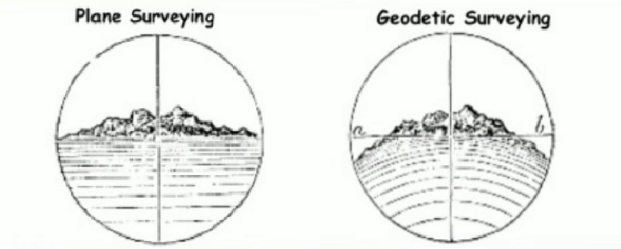
Image from Civil Crews: https://civilcrews.com/chain-surveying/, Accessed 26/12/21.

Plane surveying
This classification is suitable to carry out surveys on areas of land no more than 300 square miles, this makes it suitable for application on small/flat areas of land, as it provides relatively low levels of accuracy. Using this method, the area is considered plane surface and the curvature of earth is not taken into account. The line joining any two stations is considered a straight line, and the triangle formed by any three points is considered as a plane.

Geodetic Surveying
Geodetic surveying is carried out for large areas typically larger than 300 square milees, and does consider the curvature of the earth, therefore making it suitable for large areas of land. The line of joining two stations is considered a curved line and the triangle that is formed by any three points is considered spherical.

Based on purpose
Surveying can be classified based on purpose, there are multiple forms of surveys each providing a unique purpose and required set of tools, these include:

Cadastral Survey
Cadastral Surveying is essentially land surveying that defines and re-establishes borders of land. The information recorded from surveys is used on plans such as maps and other documents. It is vital all information is recorded accurately, as they determine things such as property boundaries, dimensions and rights associated with land.

City Survey
City surveys provide a survey typically used for large scale works including water supply, sewer systems, and development of new roads etc. City surveys allow creation of maps, establishment of benchmarks and reference points, and topographic survey of land.

Construction Survey
A construction survey establishes reference points and markers that aid the construction process. It is carried out to provide a layout for engineering and construction works. Measurements are taken for reference points that will decide the location of planned works, Horizontal & Vertical positioning and dimensions to control the elevations of new buildings.

Forestry Survey
Forestry surveys divide a forest into areas and the description of the areas. The survey will include investigating the boundaries of a forest area and the division of forestry areas into sections and survey of the compartment grid. It will also look into the formation of valuation plots in the compartment grids and compilation of a valuation description, charts and maps.

Hydrographic Survey
Solely based on characters underwater, measuring factors underwater that affect marine activities, this includes marine construction and offshore drilling. The works are primarily carried out through the use of sensors and sounding systems to collect data and produce nautical charts including depths, piers, and improved channels.

Based on method
Surveying can be classified into the categories, based on the method used. These three methods are listed below.
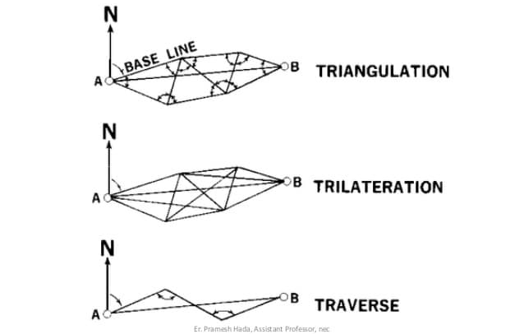
image from Slideshare https://www.slideshare.net/gokulsaud/triangulation-and-trilateration-pdf, Accessed 20/12/21.

Triangulation
Triangulation surveying is where control points are founded through series of triangles. Through taking a measure of one length of each triangle and deducing its angles and length of other two sides through observation from the baseline, the method of triangulation surveying was first presented by a Dutch man named Sneli.

Trilateration
Trilateration surveying is where Distances are measured for exercising the control meaning the angles are calculated. It is used to determine horizontal positions in addition to methods like triangulation. Trilateration uses an EDM (Electronic Distance Measuring instrument) to measure lengths of the triangle’s sides not the horizontal angles as done with triangulation.

Traversing
Traversing surveying allows the length and direction of any line to be measured with any direction measuring tool such as theodolite or compass and a measuring tape can also be used.

Brief history
Surveying has evolved massively in recent years with the introduction of modern digital technologies, however surveying dates back centuries to approximately 3000BC in Egypt where there was a recorded land register, and reinstatement of land boundaries after floods, near the time of construction of the Great Pyramid of Giza. The Egyptians used measuring ropes to scale the measurements of land and then use it to tie knots at various intervals of significance.
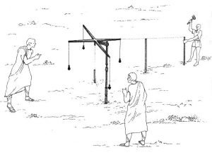
image from Moore Engineering Inc, https://www.mooreengineeringinc.com/2020/03/18/interesting-facts-history-of-surveying/, Accessed 20/12/21.

The next significant milestone of surveying was a Greek development in 120 BC of surveying equipment. The creation of the diopter was the first piece of equipment ever invented for surveying, it was a portable tool that included a wheel, screw and water level used as a method to measure terrestrial and astronomical elements. This then enabled the Greeks to develop a set of guidelines for surveying methods.

Joshua Habernel invented the next surveying tool in 1571, called the theodolite. This tool is a very accurate tool consisting of a tripod and a compass. This tool was later amended in 1725 by Jonathan Sission by adding a scope to the previous tool. These tools are still used today in modern day surveying showing how advanced and accurate the tool is.

Hi-tech and accurate measuring instruments are used in recent years for collecting data effectively, however the basic concept of land surveying has remained the same. The space probes used the same mathematical values to measure the surface of the moon as the ancient Egyptians used to measure the banks of the River Nile, only in a more modern and accurate way.

Part 2:
Briefly describe the application of digital surveying technologies in surveying listed buildings giving examples of appropriate tools to be used and the information to be collected from the survey.

Digital surveying of listed buildings
Surveying technologies have evolved enormously, first reports of surveying date back to approximately 3,000 B.C. in Ancient Egypt. This is where ancient Egyptians used the method of surveying for the taxation of land. Equipment such as measuring ropes, plumb bobs were used to measure the plots of land.

Example of listed building below:
Cardiff castle was first listed in 1952 and is currently listed at grade 1.

“Listed Grade I as an exceptional building with outstanding architectural features from many historical periods. The High Victorian interiors are of the highest architectural and historic interest, and include important original fittings and furnishings, designed and executed by leading designers and craftsmen.”
Information from British listed buildings, https://britishlistedbuildings.co.uk/300013662-cardiff-castle-castle#.Ydmfvy2cbUo, accessed 03/01/22.

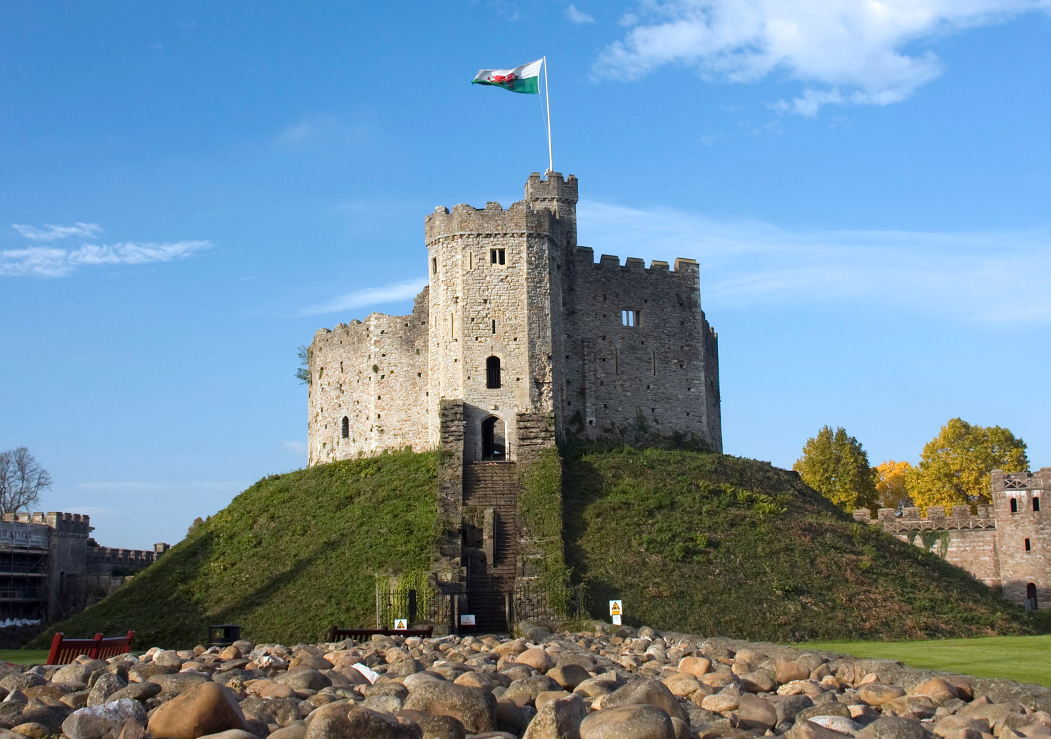
Image from Britannica, https://www.britannica.com/place/Cardiff-Castle, Accessed 03/01/22.
Historic buildings are often very important parts of heritage, to display character, and help us to understand history of significant locations. The buildings provide a connection with the skills of historical creations. Listing a building will allow recognition of the qualities of each building, to protect them for the future. Listed buildings in Wales are divided into the three different categories listed below:

- Grade one — buildings of incomparable significance, these contribute to less than 2% of the total number of listed buildings in Wales.
- Grade two — these are buildings of special interest that justify every effort being made to preserve them. These make up approximately 91 per cent of the total number of listed buildings in Wales
- Grade two star — particularly important buildings of more than special interest, these make up about seven per cent of listed buildings.

Regardless of a building’s grade, all listed buildings are treated equally in the planning system. Listing recognises that a building or structure has special architectural or historic interest.

Planning
A Survey Report may be required when looking to assess a listed buildings condition or to help obtain detailed plans of the existing structure. When conducting a survey, the surveyor must do research prior carrying out any fieldwork, this is to ensure that all equipment is identified and the surveyor is able to assess any risks beforehand, such as previous asbestos surveys etc.
As a part of research, the surveyor will look for as much existing information as possible such as as-built drawings, O&M Manuals, Fire plans and previous records on building regulation work. As Listed buildings are historic and may not hold the information listed above, information such as Historic maps and property deeds may be the only information readily available.

Fieldwork
Prior to fieldwork being carried out it is vital to gain access to information such as title, address, and client’s name. it is also important to assess the property status and the occupancy, as vacant properties may require keys to be sourced. Depending on the survey required, there may be attendance necessary from a specialist such as electrician or structural surveyor.
Whilst carrying out the fieldwork, the surveyor will examine levels of detail for the walls, roofs, floors, and drainage. They will assess any major or minor defects within the building’s components, such as any timber damage including rot and woodworm. The surveyor will also test the roof area and walls for moisture content and advise accordingly, possible recommendations for specialist inspections may be advised in some scenarios to receive specialist advice.

Computing and mapping
Once the data has been collected through conducting the fieldwork on site, it is recorded and put to one side. Once off-site, the data will be processed through noting all information including measurements taken. All pictures taken will also require uploading to a system where they can later be added to the report as required. Sketches may also be required in this process, using the measurements taken to display ideas and explain scenarios.

Report
The report is the procedure of formally presenting the data collected from the field work in a well presented, accurate, brief and clear way. The final report will provide advice on areas of the building and describe the risks of potential or hidden defects. It will also provide help a reasoned decision for purchasing or planning repairs, and where practicable, provide an estimate for repairs identified.

Tools
To ensure the survey is accurate, all tools must be used correctly in all applications, this is also to make sure:
- Equipment is suitable for intended use.
- Safety of operatives.
- information is captured accurately.
- Systematic and instrumental error is minimised.

There are many tools used to collect accurate information whilst conducting a survey, these items are listed below but are not limited to:

Tape measures
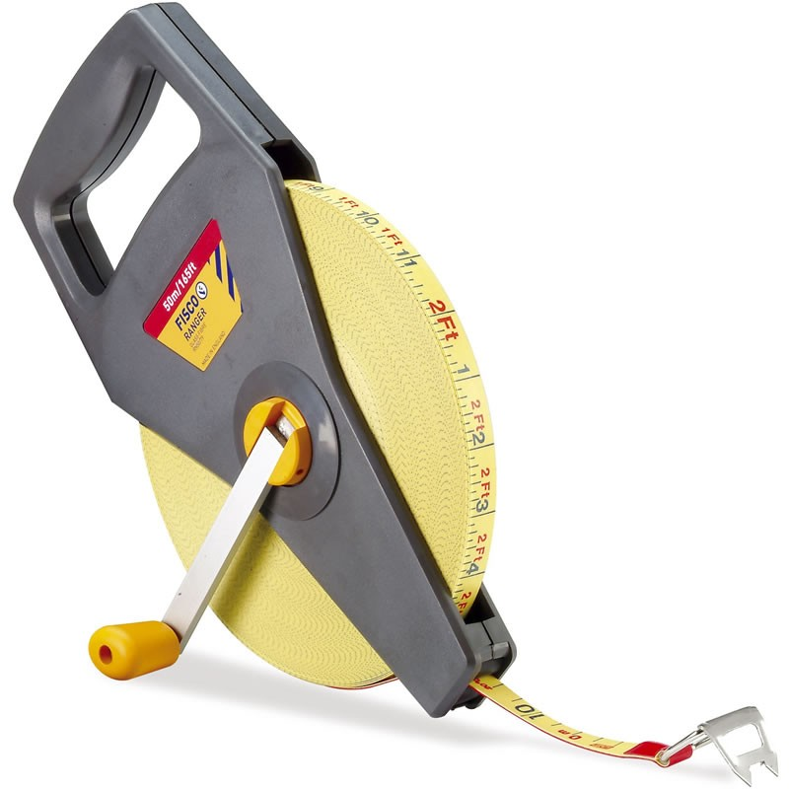
Image from Sunbelt Rentals, https://surveyequipment.com/fisco-ranger-50m-fibreglass-tape/, Accessed 22/12/21.
Tape measures specifically measure linear measurements and vary in size to be as long as 100m in length. The two most popular types of tapes are Fibreglass and Steel, each have their pros and cons. For example, Fibreglass tape measures. these tape measurers are made from fibreglass strands inserted in PVC and are much lighted compared to steel, while remaining more flexible and less likely to break. However, they stretch more whilst under tension, and are not as accurate as a steel tape.

Laser measurement
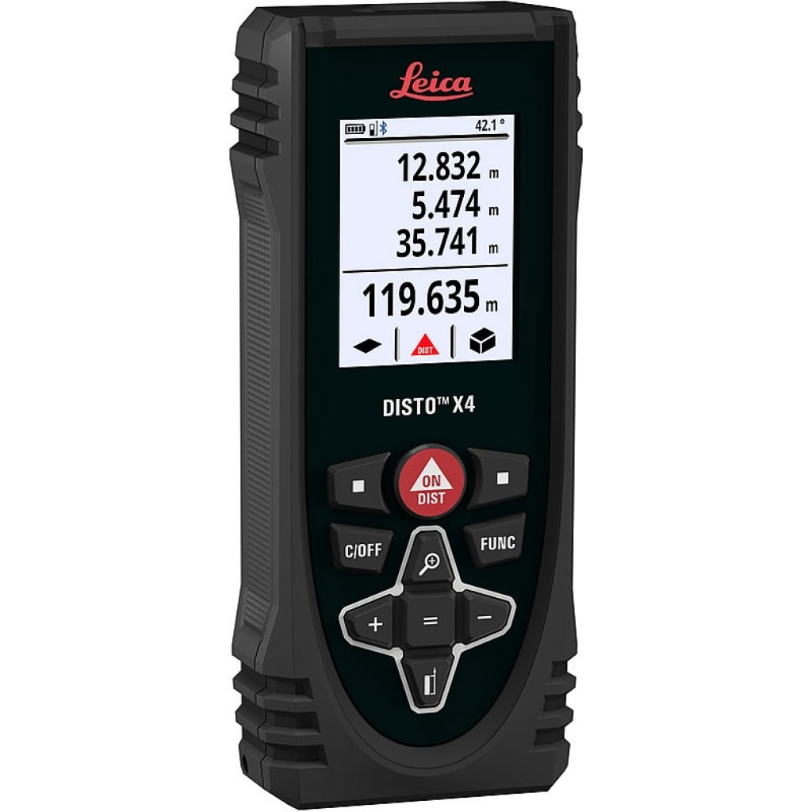
Image from Sunbelt Rentals, https://surveyequipment.com/fisco-ranger-50m-fibreglass-tape/, Accessed 28/12/21.
Laser measurers are a modern-day surveying tool typically used in building surveys to measure linear measurements, and to calculate room areas, volumes and angled slopes. As they use laser technologies, they are very accurate with a tolerance of ±3mm in 200m and allow measures of inaccessible areas to be taken. But laser measurers do require baseline calibration and are known to receive errors due to bad weather.

Digital camera
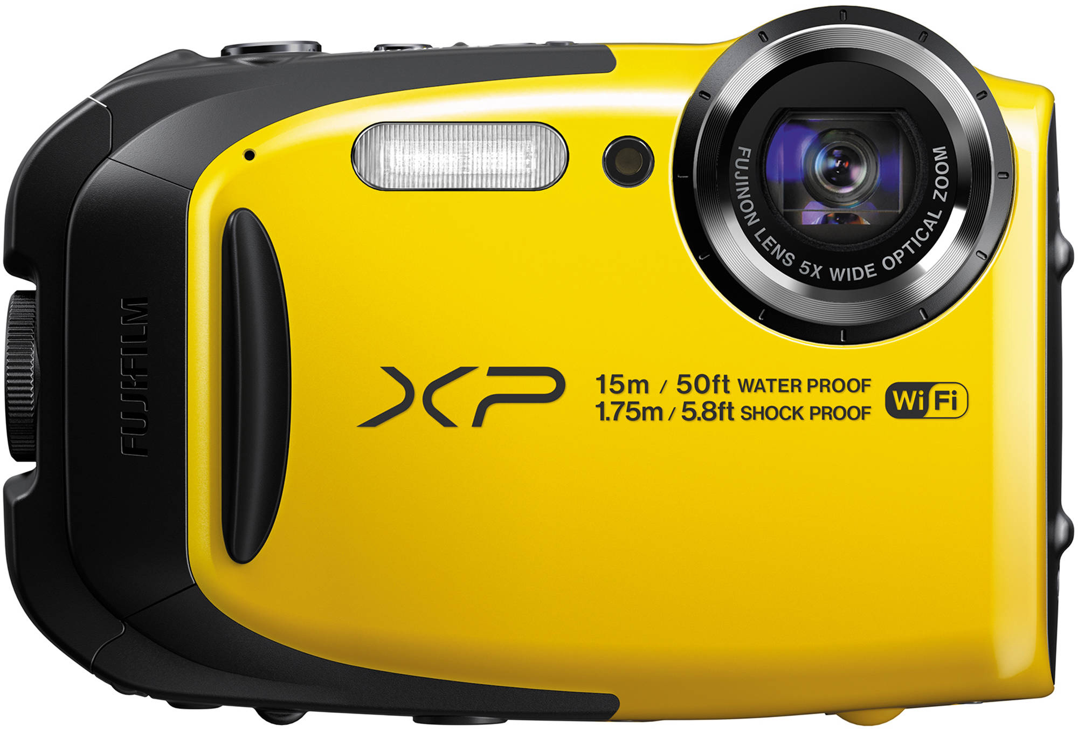
Image from B&H Photo, https://www.bhphotovideo.com/explora/photography/buying-guide/guide-rugged-and-waterproof-point-and-shoot-cameras, Accessed 28/12/21.
Digital cameras will be used to capture photos of small details with accuracy, these can then be used in the technical report, to provide evidence.

Thermal camera
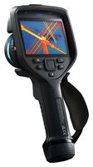
Image from Farnell, https://uk.farnell.com/flir/flir-e96-24/thermal-imager-640-x-480-30hz/dp/3584538, Accessed 30/12/21.
Thermal cameras can sense thermal bridging and/or heat loss, detecting areas of poor detailing, damage or construction defects. This can then allow the surveyor to propose advice on improving the buildings overall efficiency.

Moisture Meter
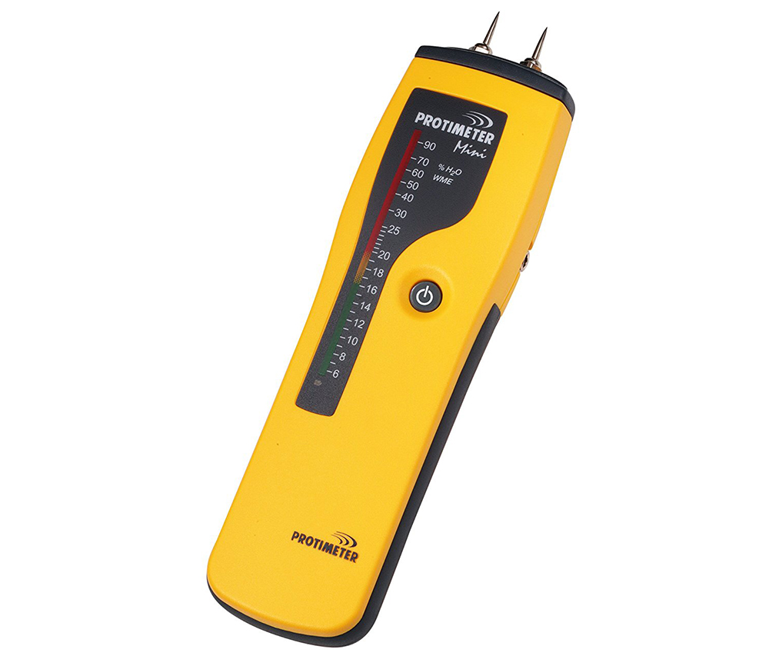
Image from Mark One Hire, https://www.mark1hire.co.uk/product/moisture-meter, Accessed 02/01/22.
Moisture meters are used to detect areas of damp and water ingress detecting both moisture (damp)and humidity levels. This tool can be used to detect moisture content in materials such as timber and insulation.

Telescopic inspection camera
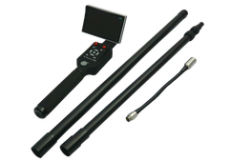
Image from Oasis scientific Inc, https://www.oasisscientific.com/telescopic-pole-inspection-camera-systems.html, Accessed 03/01/22.
Telescopic inspection cameras are made for taking photos of areas that are awkward to access, such as roofs and gutters. They are usually fitted to the top of a telescopic, self-locking pole.

Summary
In this written report the different factors of surveying have been explained whilst discussing the details of different types of surveying and their uses in different scenarios and situations. A brief history of surveying development was also included within the report, displaying key dates in chronological order. This report also provides an explanation of what listed buildings are, and the process of surveying them. The report provides examples of appropriate tools to be used and the information to be collected from the survey of a listed building.

References
Information from Civil Today, https://civiltoday.com/surveying/13-definition-and-importance-of-surveying, Accessed 20/12/21.
image from Moore Engineering Inc, https://www.mooreengineeringinc.com/2020/03/18/interesting-facts-history-of-surveying/, Accessed 20/12/21.
Image from Civil Crews: https://civilcrews.com/chain-surveying/, Accessed 26/12/21.
image from SlideShare, https://www.slideshare.net/gokulsaud/triangulation-and-trilateration-pdf, Accessed 20/12/21.
Image from Sunbelt Rentals, https://surveyequipment.com/fisco-ranger-50m-fibreglass-tape/, Accessed 22/12/21.
Image from Sunbelt Rentals, https://surveyequipment.com/fisco-ranger-50m-fibreglass-tape/, Accessed 28/12/21.
Image from B&H Photo, https://www.bhphotovideo.com/explora/photography/buying-guide/guide-rugged-and-waterproof-point-and-shoot-cameras, Accessed 28/12/21.
Image from Farnell, https://uk.farnell.com/flir/flir-e96-24/thermal-imager-640-x-480-30hz/dp/3584538, Accessed 30/12/21.
Image from Mark One Hire, https://www.mark1hire.co.uk/product/moisture-meter, Accessed 02/01/22.
Image from Oasis scientific Inc, https://www.oasisscientific.com/telescopic-pole-inspection-camera-systems.html, Accessed 03/01/22.
Information from British listed buildings, https://britishlistedbuildings.co.uk/300013662-cardiff-castle-castle#.Ydmfvy2cbUo, accessed 03/01/22.
Image from Britannica, https://www.britannica.com/place/Cardiff-Castle, Accessed 03/01/22.

