Stupnitska Mariia
Cuckoo Dene 16, W7 3DP,London
Bottega Veneta
23.11.2025

Dear Hiring Manager
I wish to apply for the role of Supervisor - Bond Street, London, currently being advertised on Indeed. Please find enclosed my CV for your consideration.
As you can see from my attached CV, I have over 1,5 years of experience in the retail industry, and I believe I am well prepared to take on supervisory role at Bottega Veneta. In my current role as a Sales Assistant, I have developed strong skills in customer service and effective communication with a diverse customer base.
In addition, I have demonstrated the ability to work under pressure, solve problems quickly, and maintain high standards of organisation. These skills align well with the role mission, which includes ensuring that company policies and procedures are always followed, supporting the Store Manager, and handling complaints professionally.
My experience working with a team has given me a strong sense of responsibility: I collaborate well, support my colleagues, and contribute positively to the store environment. I am solution-oriented, detail-focused, and reliable — exactly the type of person who can “provide constructive feedback” and “support everyone to get things done,” as required in this role.
Furthermore, my dedication, motivation, and “strong command of Microsoft Office Suite” — listed among my skills — position me well to assist with operational and administrative tasks. These competencies will help maintain efficient store operations and support continuous improvement.
I am confident that joining Bottega Veneta as a Supervisor on Bond Street would allow me to contribute meaningfully to the team. I share the brand’s passion for excellence, craftsmanship, and high standards, and I am excited about the opportunity to support your store’s success.
Thank you for considering my application. I look forward to the possibility of discussing my suitability for the role and how I can contribute to your team.

Yours sincerely,
Mariia Stupnitska

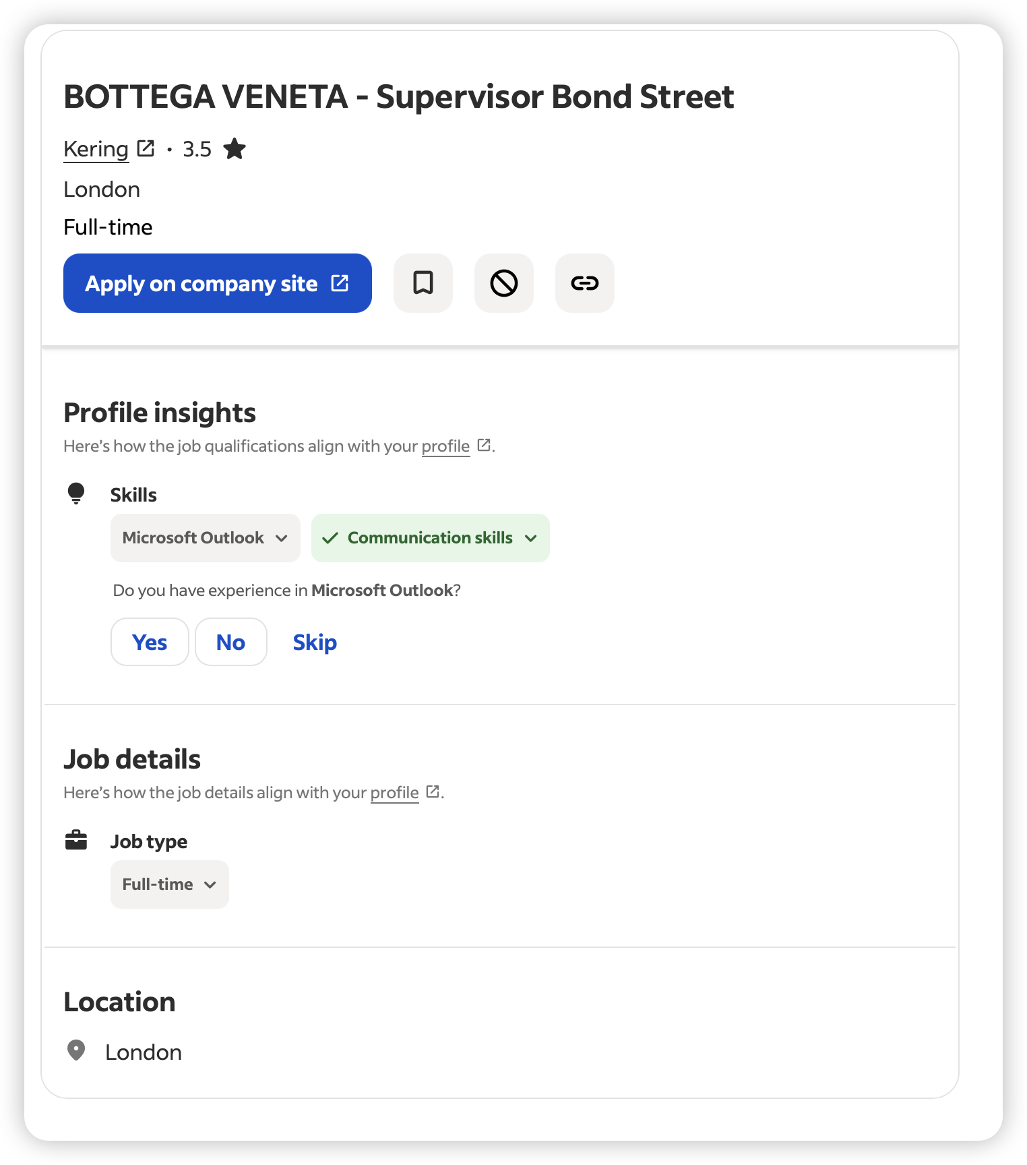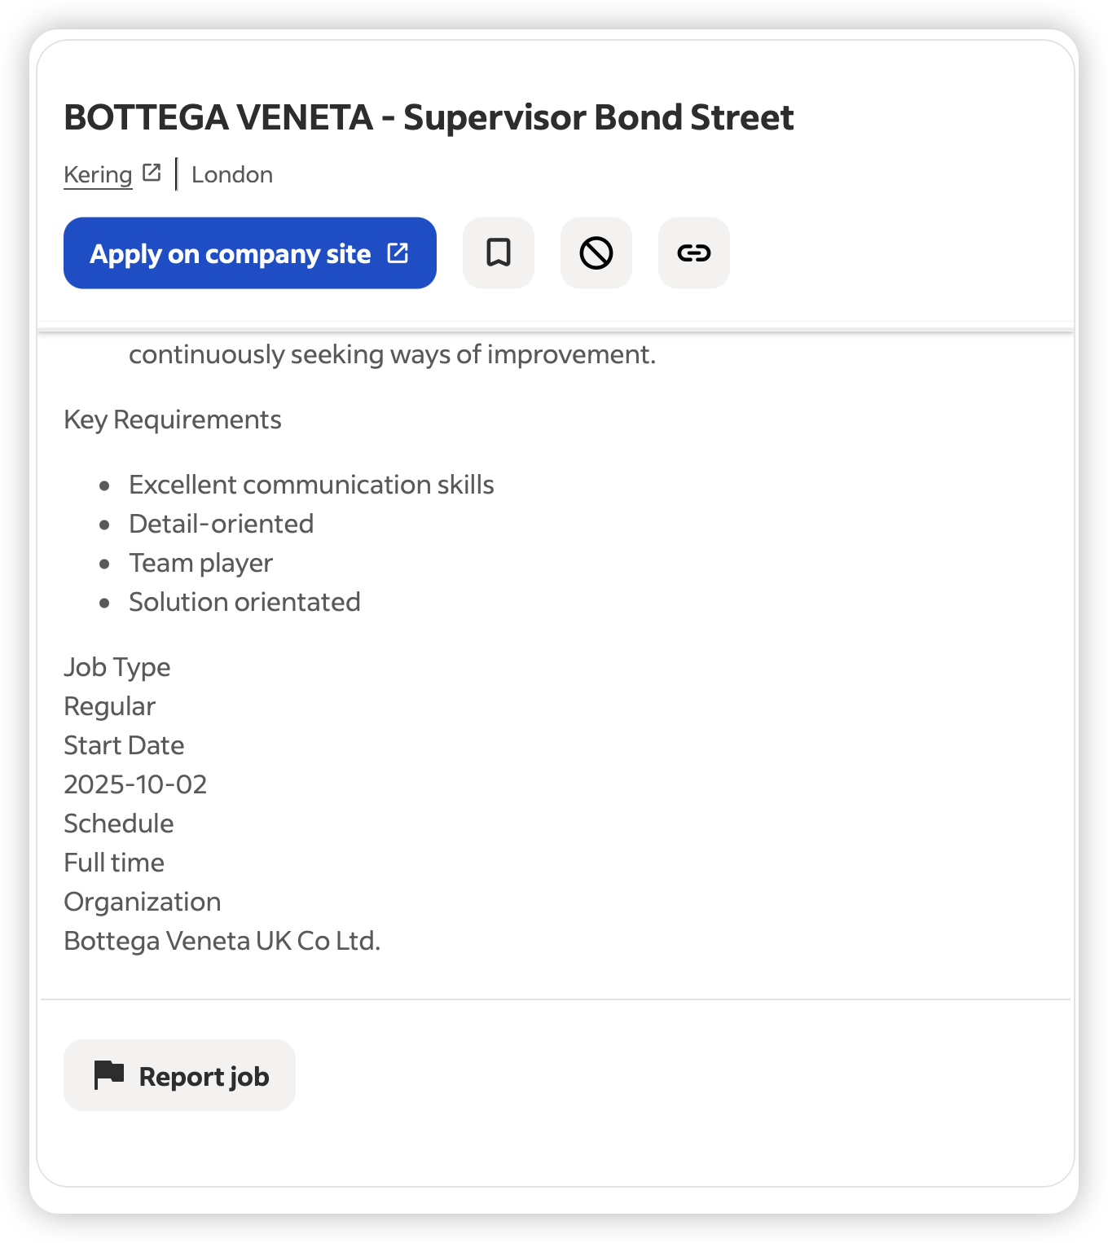

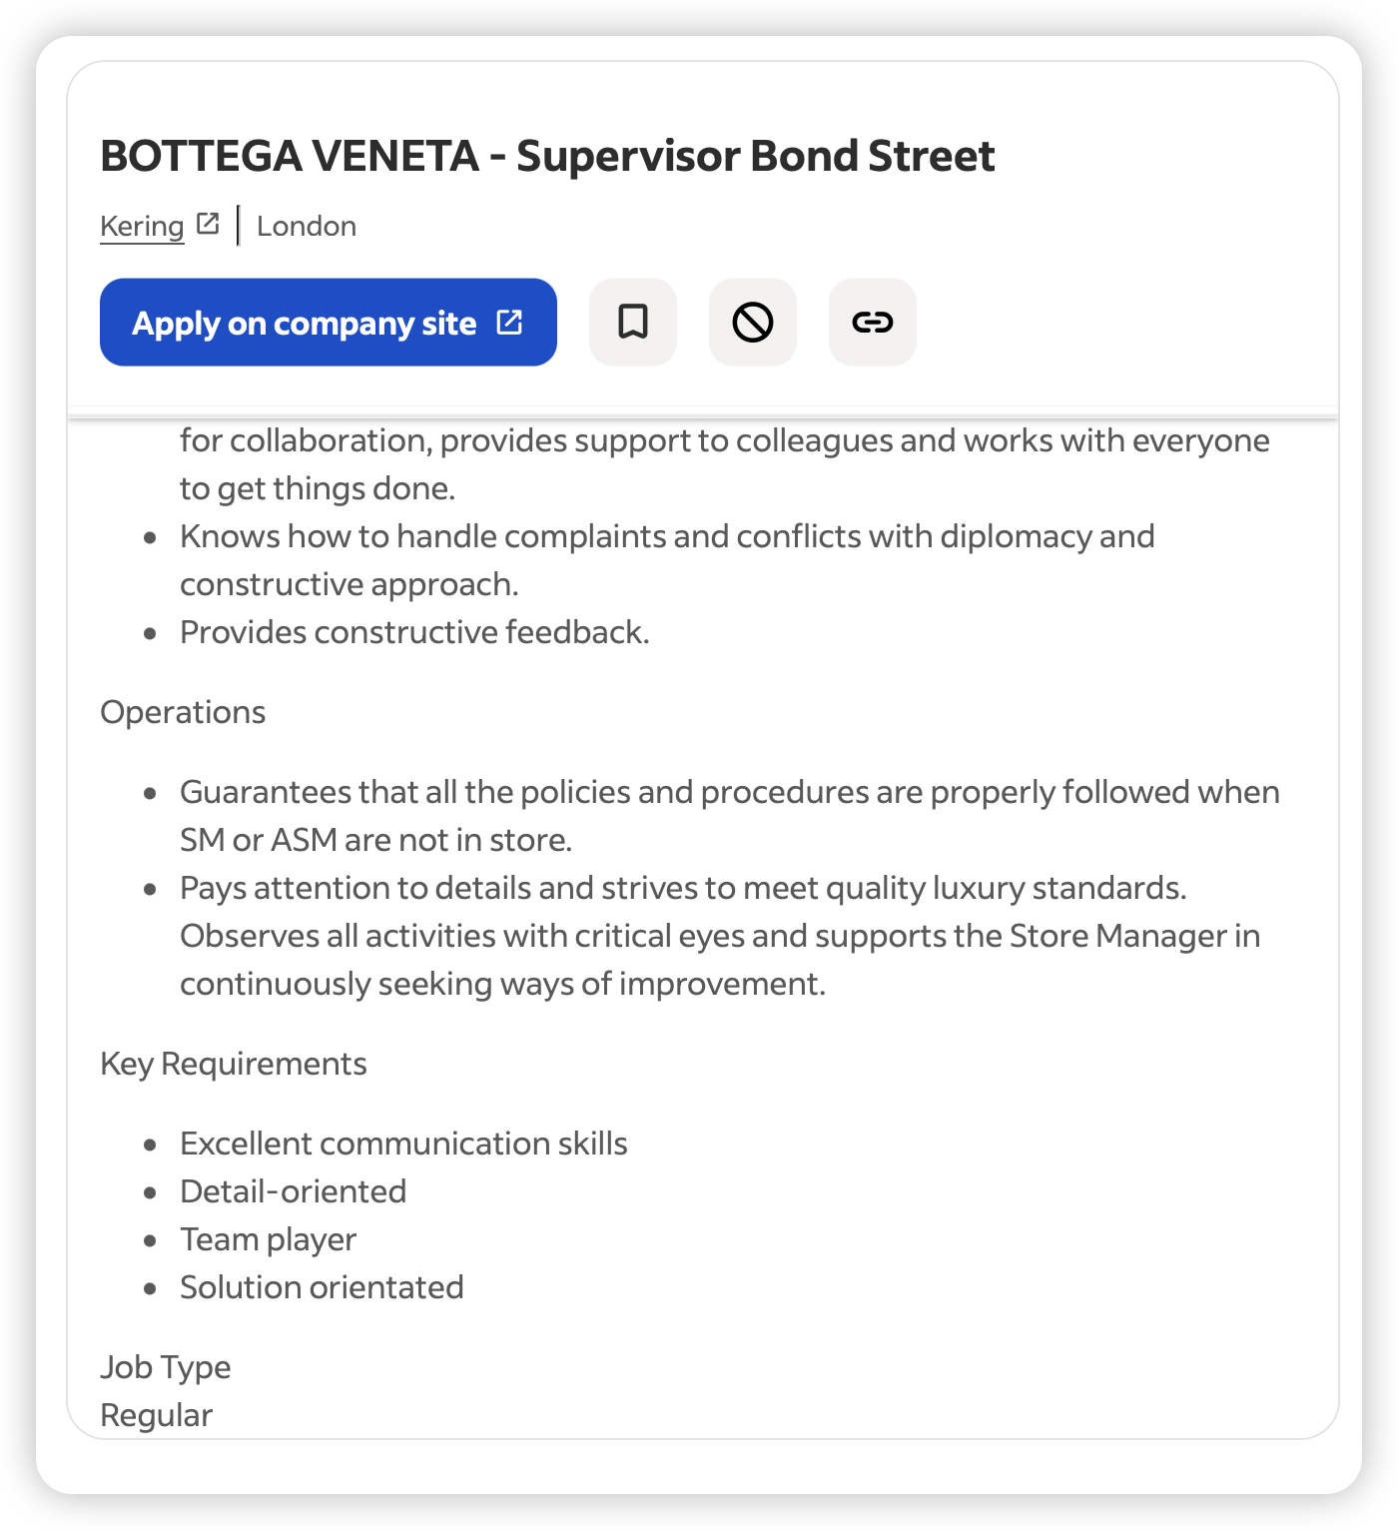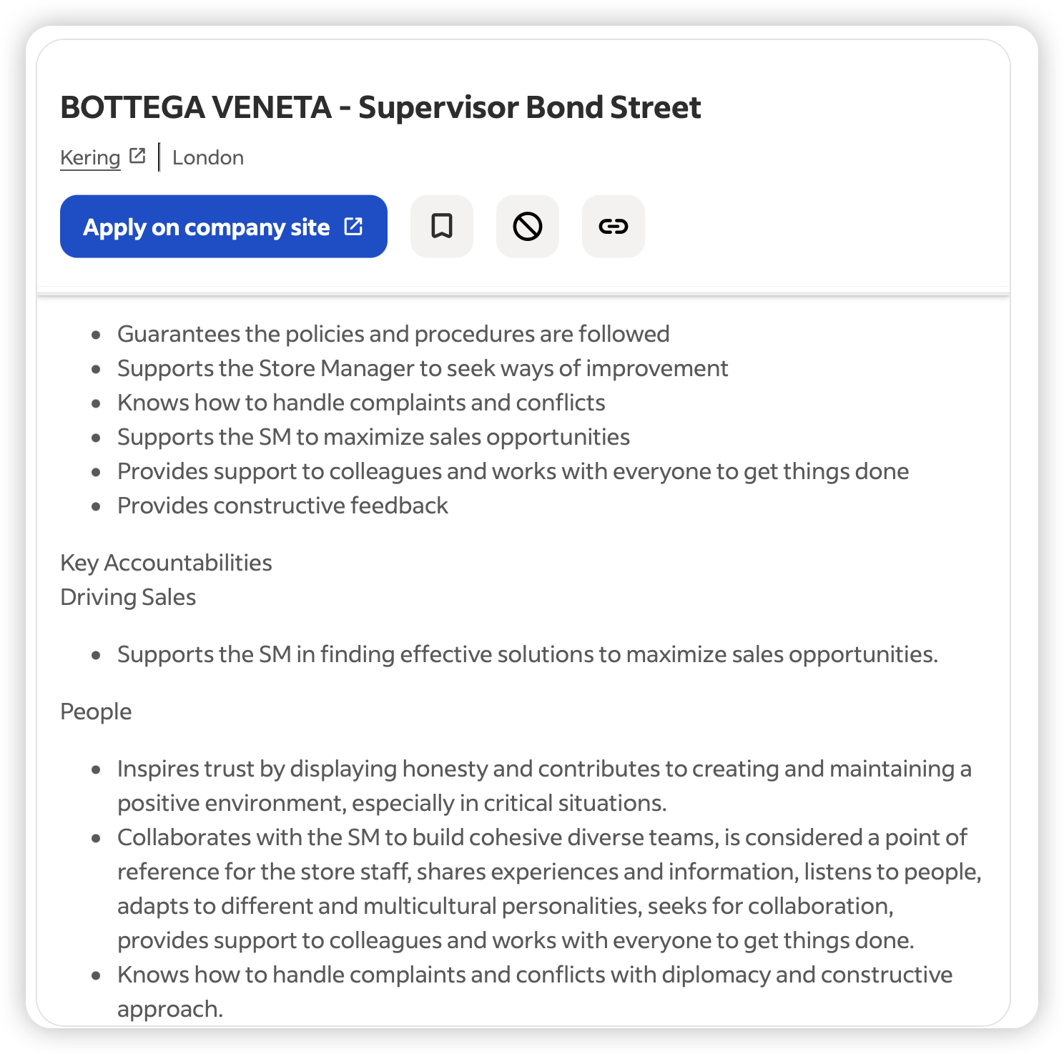
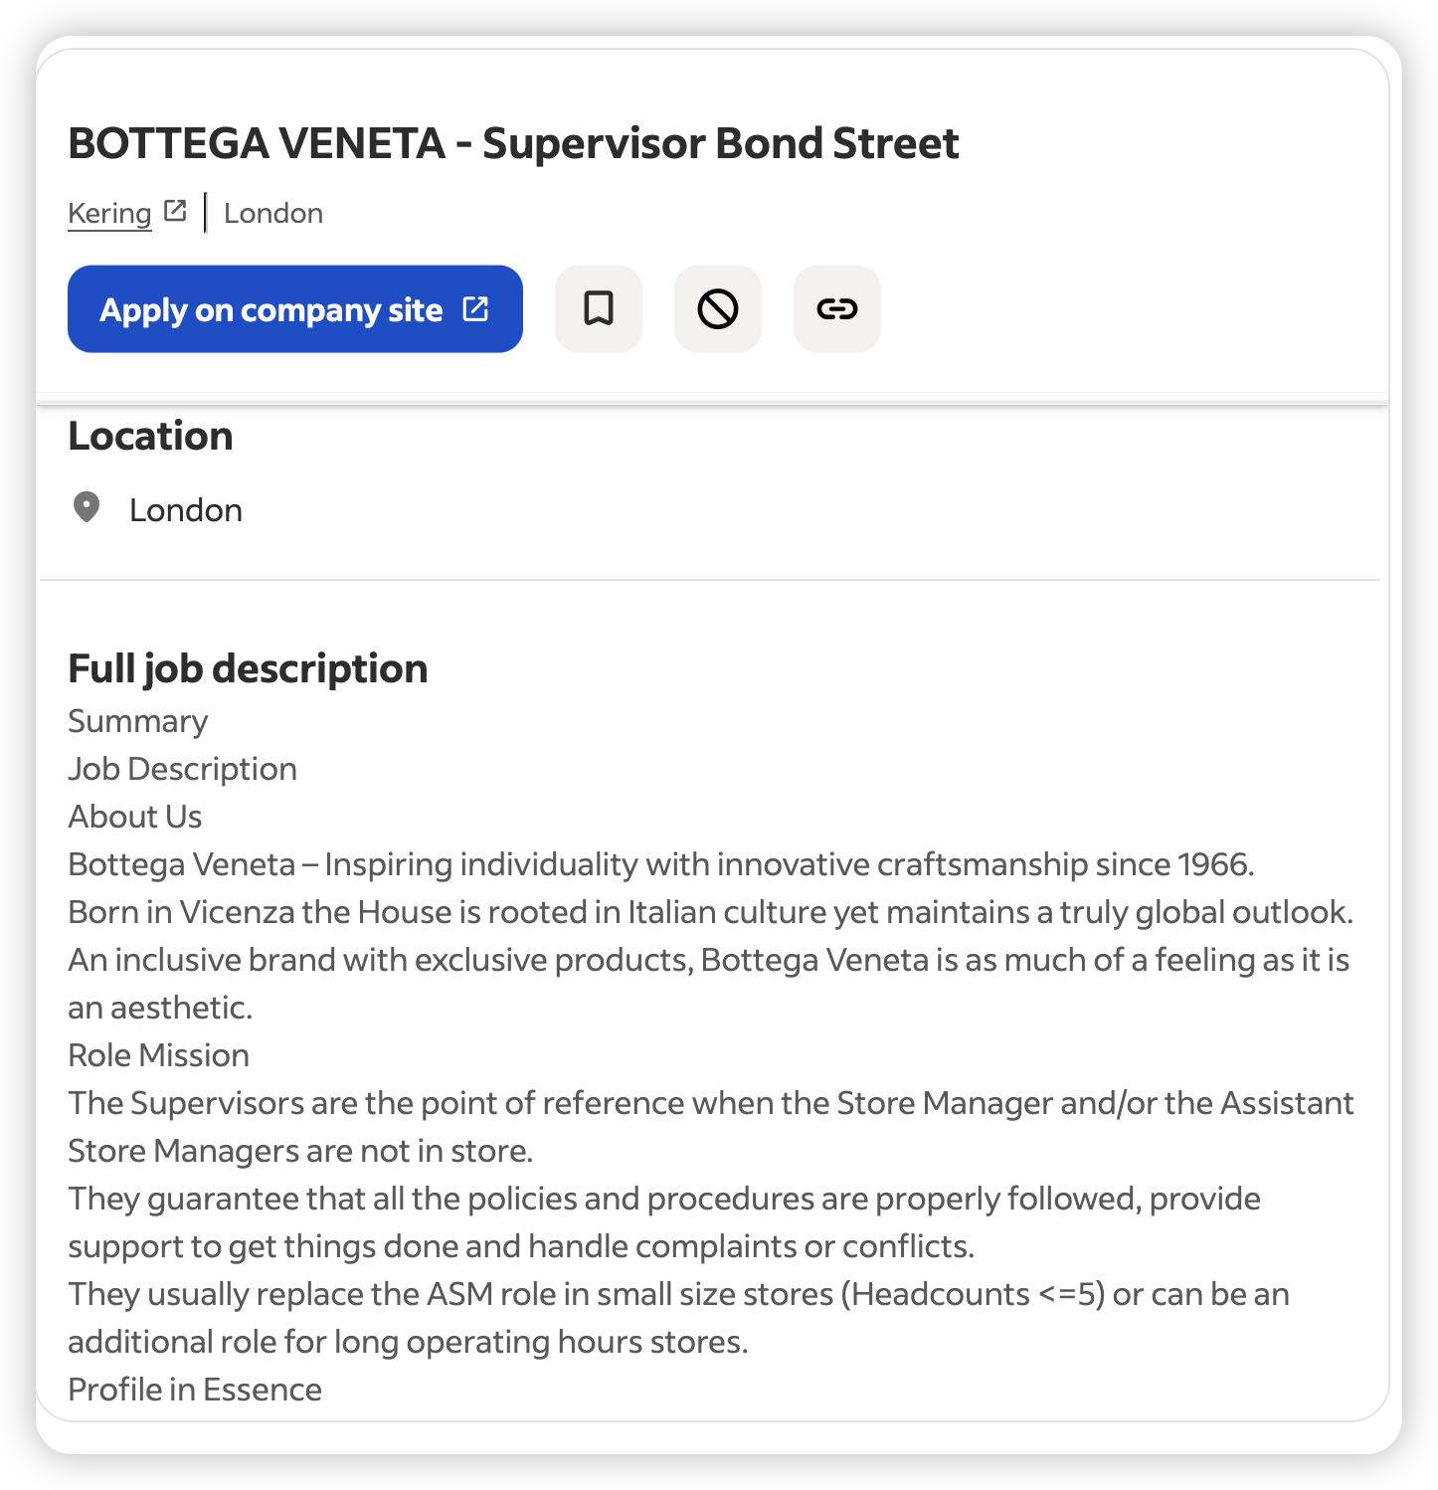
https://uk.indeed.com/viewjob?jk=7ef468d5146abdda&from=shareddesktop_copy

