

Change and stability management BMMB700

Change in TATA GROUP

Sumit Gauri- 2227583

5th May 2023

Contents
Introduction 3
Reason for change 4
Work from home 4
Key change management model 4
Kotter’s 8 step Model 4
Outlining how the models can be utilized when considering incremental (small scale) or a large scale change program 7
Kurt Lewin’s Force field analysis 7
Reasons Why 7
Powers of Restraint 7
Kurt Lewin's three-step model……………………………………………………………………………………………..8
Stakeholder analysis 9
The driver factors for change 9
The resistance factors to the change 11
Clarifying how one would know when the change program has been completed and how they might assess its effectiveness 12
Conclusion 13
Bibliography 14

Introduction
Mumbai, India is home to the TATA group, a conglomerate of businesses. Jamsetji Tata established it in 1868, and now it is one of India’s biggest and most prestigious conglomerates.
Steel, automobiles, IT, hotels, and telecoms are just few of the various sectors in which the TATA group is active. In addition to Taj Hotels, the Tata Group is also responsible for the equally recognizable Tata Steel and Tata Motors.
The organization has made a name for itself via its dedication to charitable giving and other forms of CSR. The Tata Trusts are a collection of nonprofits founded by the Tata family that provide money to causes including healthcare, education, and rural development.
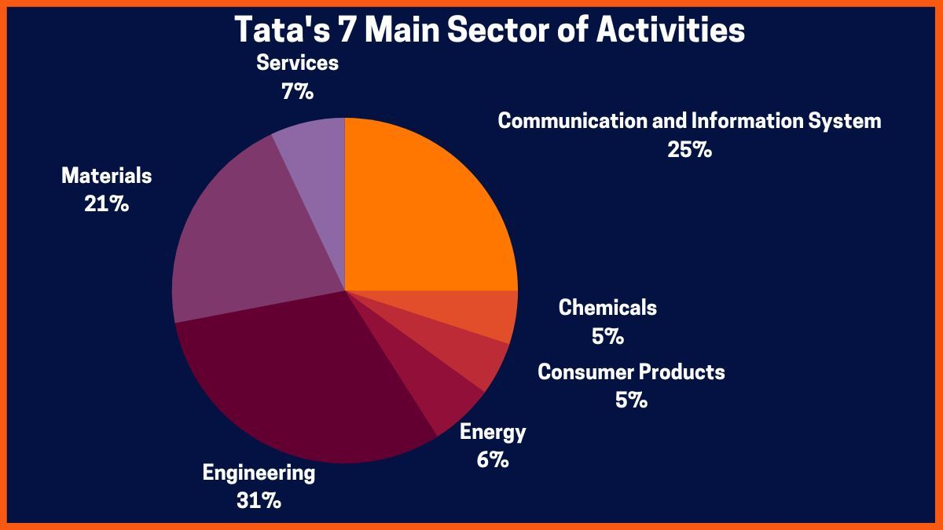
Figure 1: Tata Group: An Indian Multinational Conglomerate Company
The TATA group as a whole has earned a solid reputation for ethical business practices, technological leadership, and community service, and it remains a powerful force in India's and the world's commercial communities. The Tata Group is well-known for its dedication to CSR and its business practices that are guided by the company's core principles. Jamsetji Tata, the company's namesake and visionary creator, believed that enterprises should aid in the betterment of society. The Tata Group has remained one of India's most prestigious and prosperous corporations because to its ability to anticipate and respond to changing market circumstances ("Tata Sons confers title of Chairman Emeritus on Ratan Tata, 2012).

Reason for change
This decision was made when a substantial number of Tata consultancy service began working remotely due to the COVID-19 pandemic. The purpose of the "connected workforce" software is to track potential exposures to the coronavirus. With the help of installed cameras, a COVID risk profile assessment of employees, scientific contact tracing and face-detection, and social distancing checks via artificial intelligence, this digital technology enables a crowd sensing solution to prevent and detect violations of social distancing on shop-floors.

Work from home
Businesses have adjusted in a number of ways as a result of the rise of remote labour. For instance, businesses have had to adopt cutting-edge software and hardware to facilitate remote workers' ability to communicate and work together. Managers now have to adjust to new ways of tracking staff output and performance. Companies that allow their workers to work from home have discovered a number of advantages, including lower overhead expenses, more employee autonomy, and access to talent pools worldwide.
Companies may decide to amend their remote work practices as the situation develops and evolves, but it is crucial to realize that the effect of COVID-19 is still changing.

Key change management model
The TATA Group has relied on a number of different change management approaches throughout the years to help the company adapt to its many transformations. The TATA Group has relied heavily on the Kotter's 8-Step Change Model, which was created by the eminent change management expert John Kotter ("Ratan Tata | Jamsetji Tata: Ratan Tata pays tribute to Tata Group founder Jamsetji, 2016).

Kotter’s 8 step model
The following are the eight stages of Kotter's 8-Step Change Model, which is intended to aid organizations in successfully implementing change:
- As with any process of transformation, the first step is to instill a sense of urgency about the necessity of change. This requires explaining why change is necessary and what would happen if no action is taken.
- The most successful way to bring about change is to rally a group of people behind the cause and work together to make it a reality. Finding and involving those who will be affected by the change is a crucial step (Rautray, 2017).
- The third stage of the transformation process is to develop a compelling vision for the future of the organization. Specifically, you must specify how the company will operate once the modification has been made.
- The vision for change must be communicated to all relevant parties after it has been developed. Creating a communication strategy and informing all stakeholders of the goal and their part in attaining it are essential steps.
- In order to successfully execute change, it is necessary to provide people the authority to carry out the vision. There has to be a lack of resistance to the change, availability of resources, and acquisition of knowledge and expertise on the part of people.
- Make quick improvements one of the hardest parts of bringing about change is keeping the ball rolling. Gaining momentum and showing tangible progress towards the vision may be aided by achieving a series of smaller, more immediate goals (Timmons, 2017).
- Gains should be consolidated and the change should be thoroughly integrated in the organization once initial success has been achieved. This includes rejoicing in victories, giving thanks to those who contributed, and removing any lingering obstacles to progress.
- The last element of the change process is to firmly establish the new practises inside the organization's culture. This means incorporating the change into the organization's culture and ethos in a way that makes it permanent.
The TATA Group has successfully navigated leadership changes, business model revamps, and cultural upheavals with the help of Katter’s 8-Step Change Model. When Cyrus Mistry was abruptly replaced as chairman of Tata Sons in 2016, for instance, the TATA Group used the Katter’s 8-Step Change Model to oversee the company's transition to new leadership under Natarajan Chandrasekaran (effect", 2018).
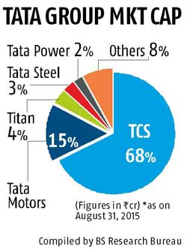

Figure 2: Tata Group Market Cap
The TATA Group used Kotter's 8-Step Change Model to instill a sense of urgency about the need for change, build a coalition of supporters, articulate a compelling vision for the future, give others the authority to make that vision a reality, achieve rapid initial success, sustain momentum, consolidate gains, and firmly establish new practices as part of the company's ethos. This proved the efficacy of the Kotter's 8-Step Change Model in handling complex organizational transitions and helped to achieve a smooth and successful transition to new leadership (Timmons, 2017).

Outlining how the models can be utilized when considering incremental (small scale) or a large scale change program
The Tata Group may use Kotter's 8-Step Change Model for both minor and major transformation initiatives. The procedures may be adjusted to meet the demands of any size program.
The procedures may be streamlined and modified to match the needs of a smaller-scale program or project. For instance, the change team may only include those who would be most directly impacted by the transition, rather than rallying support from throughout the organisation.
The stages may need to be modified and increased for more complicated program or for making significant adjustments. In this situation, the tasks may be segmented into more manageable sub-parts (effect", 2018).

Kurt lewin's Force field analysis
Kurt Lewin developed the Force Field Analysis to identify and analyze the factors that promote and inhibit change. It has a wide range of potential uses, especially in the context of organizational transformation. Here's how the instrument may be used to examine Tata Group's work-from-home initiatives:

Reasons Why
- The need of keeping workers safe during the epidemic of COVID-19
- Remote employment is made possible by technological improvements
- Employees are afforded more freedom and convenience
- Savings by having less need for costly office space

Powers of Restraint
- Lack of openness to new ideas among workers and supervisors
- Worries that output will suffer from a lack of management and teamwork
- Problems with connection and other technical aspects of working remotely
The importance of keeping morale high among distributed teams.
Tata Group may learn more about the success or failure of its work-from-home policy by doing a force field study. To guarantee a smooth transition to a remote work paradigm, this information may be used to build plans to strengthen the driving factors and alleviate the restraining forces.
For instance, Tata Group may invest in improved connection choices for its workers to help them deal with the technological difficulties of remote work. With addition, the organization might provide training and assistance to aid with the transition. Tata Group may improve its work-from-home policy for the sake of the firm and its workers by paying attention to both the motivating and constraining factors (Singh, 2019).

Kurt Lewin’s three step model

In the case of Tata Group's work-from-home policy, the release phase required identifying the need for changes due to the COVID-19 pandemic and the need to ensure business continuity. The transition phase includes implementing home office policies, providing employees with the equipment and support they need to work remotely, and communications to ensure employees communicate with each other and customers stay connected. It included establishing a channel. The refreeze phase made the work-from-home policy permanent and integrated into the company culture.
Lewin's model played a key role in Tata Group's work-from-home policy by providing a framework for managing change. This model has helped organizations identify the need for change, plan and implement change, and ensure that change is permanent. By following Lewin's model, Tata Group was able to effectively manage change, ensure business continuity and adapt to the new normal caused by the COVID-19 pandemic.

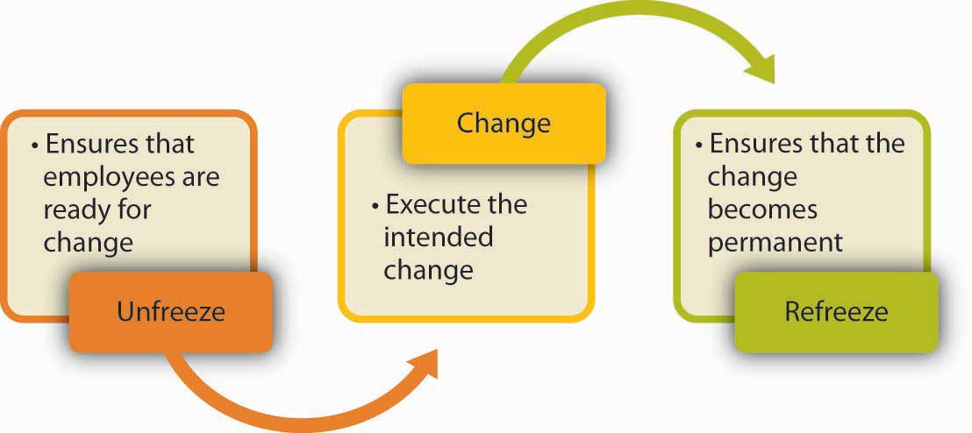

Stakeholder analysis
The Tata Group might potentially have the following stakeholders represented in a stakeholder analysis:
Employees: There are thousands of people working for the Tata Group. These workers are a key stakeholder since their livelihoods are intimately tied to the organization's actions and choices.
The Tata Group serves a diverse variety of businesses, from automobiles to hotels, thanks to its loyal customer base. Because they are the primary contributors to the company's bottom line, customers are a crucial constituency.
Since the Tata Group is a public company, its shareholders are an important constituency. The company's growth and payouts are important to its shareholders.
The Tata Group relies on a huge supplier base to support its many divisions. Since they play such a crucial role in the company's supply chain, suppliers are an essential stakeholder group.
Since the Tata Group does business in a strictly regulated sector, regulators are a key constituency. Government agencies, trade groups, and other watchdogs all have a role in policing the business (Jayaraman, 2020).

The driver factors for change
Like any other major organization, the TATA Group must adapt to the ever-changing environment. Some of the most important forces that have compelled TATA Group to adapt are as follows:
The TATA Group has a strong corporate culture that is rooted in the company's illustrious past. However, as the nature of business evolves, the team's culture has had to shift to ensure continued success. For instance, the team has been focusing on flattening established power structures in order to become more nimble and creative (loss", 2008).
Changes in the TATA Group's leadership have been an important factor in recent developments. Changes in leadership often bring about modifications to the organization's goals and overall course of action. For instance, when Cyrus Mistry was removed as chairman of Tata Sons, there was a major reorganization and shift in strategy.
Power: Power dynamics within the TATA Group may be a source of innovation. The organization is owned by a board of directors and a number of different shareholders. Shifts in the composition of power within an organization may have far-reaching effects on its ability to function effectively (Pathak, 2018).
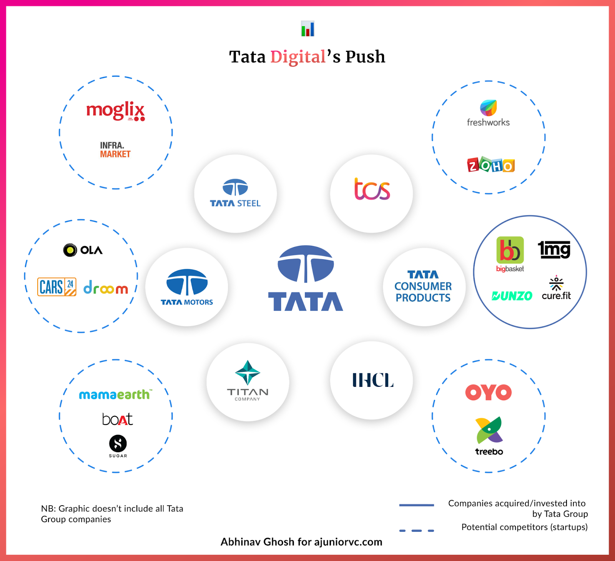
Figure 4: Tata Digital push
The proliferation of digital technology is another force pushing the TATA Group in a new direction. In order to maintain competitiveness and satisfy shifting client needs, the firm has embraced digitalization across all of its operations. For instance, Tata Motors is preparing for the future by spending heavily on electric cars and connected car technology (H.M, 2018).
The TATA Group, like any other business, is subject to the forces of competition. Several of the group's most important operations, such as Tata Steel, Tata Motors, and Tata Consultancy Services, have been met with intense rivalry. The company has been innovating and bettering its offerings in order to keep up with the market.
Culture, leadership, power dynamics, digitalization, and competitiveness are just some of the change drivers that the TATA Group must contend with. The group's long-term success and viability depend on its members' skill in navigating these forces.
Tata Group must take into account the digitization of change while launching a new initiative. The use of digital tools and technology may help a business improve its operations and procedures, which in turn can boost its productivity, efficiency, and bottom line.
Using a digital transformation plan is one method that Tata Group may adapt to the digital age. Customer experience, supply chain, and operations are just a few examples of sectors that might benefit from a strategy overhaul, and the one being developed should detail how to get there. Planned use of digital technologies like cloud computing, big data analytics, AI, and the Internet of Things (IoT) to accomplish the transformation should also be included in the strategy (D'Souza, 2018).
Tata Group is also embracing digital transformation by increasing interdepartmental communication and cooperation via the use of digital communication and collaboration technologies. Especially when members of a team are spread out across different locations, they might benefit from digital communication systems like Slack and Microsoft Teams.
Another benefit of digitization is that it may help the business gather and analyse data about its operations, customers, and rivals. Using this information, we can pinpoint problem spots, track development, and evaluate the impact of our efforts to implement change.
To boost efficiency and output, businesses may now leverage digital tools and technology to automate procedures and operations. The usage of chatbots, for instance, may automate customer support jobs and enhance the customer experience, while robotic process automation (RPA) can be used to automate repetitive processes and eliminate mistakes.

The resistance factors to the change
Understanding the causes of resistance to the transition of working from home and developing a plan to address them is essential for identifying and resolving resistance issues. Here are the measures to take:
Find out why people aren't cooperating: The first step is to learn why certain workers may be resistant to working remotely. Fear of losing control, decreased productivity, and social isolation are three major causes. Employment-life balance issues, a lack of appropriate technology or infrastructure, or special situations may also make remote employment less appealing.
Take care of the issues: The next stage, after figuring out why people aren't cooperating, is to do something about it. For instance, if workers are worried about being micromanaged, assuring them that they will retain the independence necessary to do their jobs well might help ease their minds. If workers are concerned about productivity, you may show them how other companies have effectively adopted work-from-home rules. Reluctance may be lessened if these worries are addressed.
If workers are hesitant to work remotely due to a lack of equipment or infrastructure, employers should make such resources available to them. Equipment like computers and internet access may be included. Giving workers access to these tools will improve the likelihood of a productive telecommuting arrangement.
Regular communication is essential for successful change management. Be careful to keep your staff updated on the change's progress and justification on a regular basis. Trust may be established and worker participation ensured in this way.
Give them the tools they need to succeed while working remotely, including training if necessary. Strategies for concentration, time management, and remote interaction with coworkers may be discussed. The success of workers working from home may be improved by providing them with training on how to do so.
Resolve any issues or objections that may arise from the change's potential impact on stakeholders. This may be achieved by attentive listening, addressing comments and inquiries, and addressing concerns with explanations supported by evidence. It's crucial to respond to people's worries in a timely and courteous way, and to be flexible enough to make changes to the change plan if needed (Aparna V. Singh, 2014).

Clarifying how one would know when the change program has been completed and how they might assess its effectiveness
The success of a change project can only be judged after its duration has elapsed. TATA Group may evaluate the success of the change program and decide when it is complete by using the following methods.
Outline the desired outcomes: TATA Group must first determine its desired outcomes before launching its transformation project. When these milestones are reached, the transformation process will be complete.
The success of a change program may be gauged by soliciting input from those who will be affected by it. TATA Group may gauge the effect of the change on its workforce, clientele, and vendors by means of surveys, focus groups, and individual interviews (James Crabtree, Financial Times).
Keep an eye on levels of resistance; it might affect how well your transformation plan works. TATA Group can tell whether the change plan has been effective in reducing resistance and increasing buy-in from stakeholders by keeping an eye on resistance levels.
The success of a project to affect change may be gauged in part by ensuring that it can be maintained over time. To guarantee the change program has long-lasting effects, TATA Group may evaluate how well it has permeated the organization's culture and daily operations.
We can evaluate the success of a project to influence change by taking a look at the money and manpower that went into it. The success of the project may be gauged by whether or not the desired changes were implemented without exceeding the available funds and time.
In conclusion, a change program for TATA Group may be considered successful if its aims and objectives are met, its timeframe is adhered to, its results are measured, its stakeholder input is evaluated, its resistance levels are monitored, its sustainability is checked, and its budget and resources are reviewed. TATA Group may evaluate the success of the transformation plan by looking at these indicators and making any required modifications (D'Souza, 2018).

Conclusion
At the end, it is concluded that The TATA organization has been around since the nineteenth century, and its history is long and illustrious. Jamsetji Tata, a forward-thinking businessman, and philanthropist, established it. The core concept that he instilled in the TATA group, that business can and should be used to promote social and economic development, remains unchanged. The TATA Group has diversified its holdings and broadened its commercial operations throughout the years, and has been successful due to its ability to respond to shifting consumer preferences and industry standards. The global business climate has changed significantly in recent years, and this has had a direct impact on the TATA group. The most successful way to bring about change is to rally a group of people behind the cause and work together to The transformation process involves developing a compelling vision for the future of the organization, communicating it to all relevant parties, providing people with authority to carry out the vision, making quick improvements, consolidating gains, and firmly establishing new practices inside the organization's culture. The TATA Group has successfully navigated leadership changes, business model revamps, and cultural upheavals with the help of Katter's 8-Step Change Model. The model can be utilized when considering incremental (small scale) or a large scale change program, and can be used to instill a sense of urgency about the need for change, build a coalition of supporters, articulate a compelling vision for the future, give others the authority to make that vision a reality, achieve rapid initial success, sustain momentum, consolidate gains, and firmly establish new practices. The most important details in this text are the steps that need to be taken to adjust the procedures for any size program or project. These steps include making the situation seem urgent, assembling a group of advocates, developing an inspiring future vision, sharing the vision, encouraging others to take action, and identifying and capitalizing on quick successes.

Bibliography
"Ratan Tata | Jamsetji Tata: Ratan Tata pays tribute to Tata Group founder Jamsetji, t. '. o. I. i. o. h. b. a., 2016. The Economic Times.
"Tata Sons confers title of Chairman Emeritus on Ratan Tata, C. M. t. b. C. f. D. 2., 2012. The Economic Times. .
Aparna V. Singh, I., 2014. "The Tata Group: From Torchbearers to Trailblazers". Business Journal.
D'Souza, N., 2018. Inside Tata, India's Most Admired and Secretive Conglomerate". Fortune: https://fortune.com/longform/tata-group-business-conglomerate-india/.
effect", ". r., 2018. Journal of Management.
Group", "., 2019. Titan Corporate.
H.M, M. E. P. a. C., 2018. Tata Group: India's Global Business. Harvard Business Review.
James Crabtree, Financial Times. "Tata: How India's Biggest Business Group Fought Off Globalisation". Journal of Management.
Jayaraman, N., 2020. "CorpWatch : Stolen for Steel: Tata Takes Tribal Lands in India". Corpwatch.org..
loss", "., 2008. Hinduonnet.com.
Pathak, K., 2018. "Tata Group commits ₹1,500 crore to fight Covid-19". Journal of Marketing.
Rautray, S., 2017. "Supreme Court Stays NCLAT order restoring Cyrus Mistry as Chairman". The Economic Times.
Singh, D. K., 2019. "Tata Trusts accused of favouring Harvard over 'under-privileged' Indian universities". ThePrint..
Timmons, H., 2017. "Tata Pulls Ford Units into Its Orbit". The New York Times..

