University of Wales Trinity Saint David
BA Automotive & Transport Design
Engine Performance Characteristics

Name - George Battin
Student Number – 2000553
Date- 12/8/2021
Lecturer – Abi Summer Field
Module -Vehicle Technology ACHA4004
Contents
1.0 – Introduction 1
2.0 – Experimental Procedure 1
3.0 – Results 2
4.0 – Analysis 4
4.1 – Torque against Engine Speed 4
4.2 – Corrected Power against Engine Speed 4
4.3 – Brake Mean Effective Pressure against Engine Speed 5
5.0 – Conclusion 6
5.1 – Torque Against Engine Speed 6
5.2 – Corrected Power Against Engine Speed 6
5.3 – Brake Mean Effective Pressure Against Engine Speed 7
6.0 – Evaluation 7
Bibliography 8

1.0 – Introduction

For this test an engine dynamometer test was carried out to compare the relation between Power, Torque and Brake Mean effective Pressure (BMEP) against the engine speed using raw data of load as well as speed at a throttle opening of 100%. This was compared by calculations and the results were plotted graphically to compare against other models and similar engines.

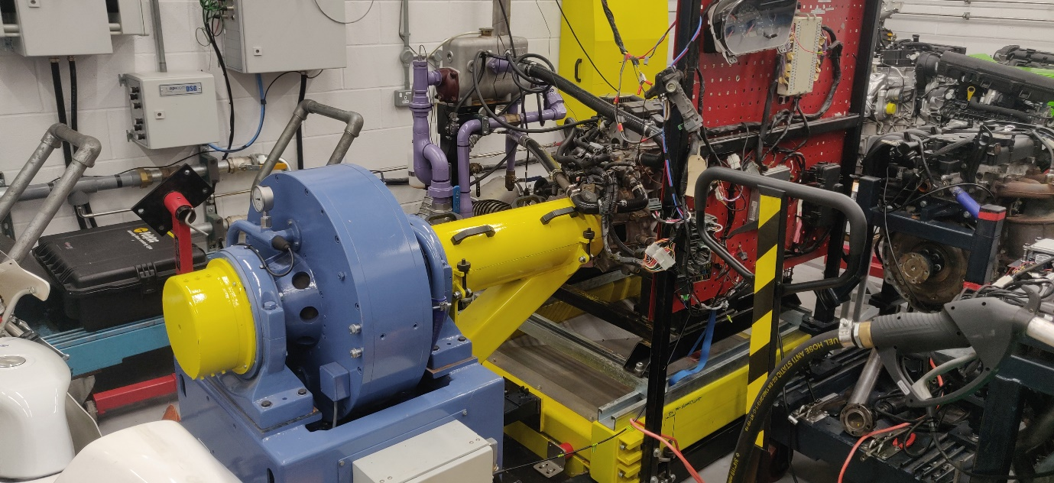
2.0 – Experimental Procedure
Figure 1 - Engine Dynamometer
The data was collected using a Honda Civic 1.6 D16 2003 engine connected to an engine dynamometer (Figure 1). An engine dynamometer works by ‘The engine driving a large generator by lacing an electrical load into the circuit’ (Stockel, et al., 2015, p. 110) . Friction is placed onto the spindle using electromagnets in the dynamometer whilst the throttle body is 100% open and from this the dynamometer takes readings for the amount of force placed around the centre of the spindle. And by increasing the amount of electricity sent to the electromagnets it alters the amount of friction which can then be used to calculate the force
Before starting any test, the dynamometer had to be calibrated. To do this install the calibration arms (Figure 2), which are an identical mass and length(815.744mm), were installed to either side of the dynamometer. Then by adding a known mass to one of the arms you can calculate the load placed on the dynamometer by using the equation:
$$Work Done=Mass X g X Distance$$
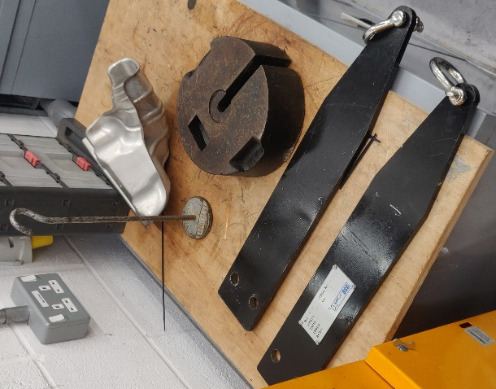
g is known as 9.8N and the use of two calibration arms removes the issue of the mass of the arms changing the load on the dynamometer as the mass of each arm in opposite direction cancels each other out. Once calculating the work in newtons this value can then be cross referenced to the data on the computer to the reading’s shown from the dynamometer before beginning any tests and can be adjusted to calibrate the dynamometer. During the experiment a sweep and step test was completed however data was only used from the sweep test. A sweep test slowly ramps rpm up to a specific rpm with the starting rpm of 1000 and the max rpm set at 5000 for this test and data was collected every 10 rpm. In comparison the step test holds the engine at a set rpm and takes data averages at the rpm over a period before rising to a different rpm and repeating. For this experiment a sweep test was preferred so then we had more data to create a graph from.
Figure 2 - Dynamometer calibration arms

3.0 – Results
Figure 3 - Sweep test results
Engine | Honda Civic 1.6 D16 2003
Temperature | 26 | °C | 299 | k | Cylinder Diamater (d) | 0.075 | m
Barometric Pressure | 1010.67 | mBar | 1.01067 | bar | Stroke(l) | 0.09 | m
Humidity | 42.8 | % |  |  | Area(A) | 0.0044179 | m^2
Torque arm | 815.744 | mm | 0.815744 | m
Figure 4 - Engine & Atmospheric Data

Force (N) | Engine Speed (RPM) | Force (N) | Engine Speed (RPM) | Force (N) | Engine Speed (RPM)
130.037 | 1000 | 160.64 | 3100 | 129.994 | 5200
130.61 | 1050 | 160.269 | 3150 | 128.245 | 5250
131.485 | 1100 | 159.847 | 3200 | 126.542 | 5300
132.641 | 1150 | 159.295 | 3250 | 125.13 | 5350
133.729 | 1200 | 158.657 | 3300 | 123.554 | 5400
135.143 | 1250 | 158.007 | 3350 | 122.083 | 5450
136.396 | 1300 | 157.267 | 3400 | 121.004 | 5500
137.723 | 1350 | 156.714 | 3450
139.186 | 1400 | 156.031 | 3500
140.496 | 1450 | 155.394 | 3550
141.522 | 1500 | 154.841 | 3600
142.271 | 1550 | 154.283 | 3650
143.07 | 1600 | 153.895 | 3700
143.631 | 1650 | 153.537 | 3750
143.895 | 1700 | 153.207 | 3800
143.984 | 1750 | 152.982 | 3850
143.769 | 1800 | 152.81 | 3900
143.411 | 1850 | 152.686 | 3950
143.045 | 1900 | 152.585 | 4000
142.816 | 1950 | 152.443 | 4050
142.873 | 2000 | 152.235 | 4100
143.19 | 2050 | 151.91 | 4150
143.772 | 2100 | 151.399 | 4200
144.551 | 2150 | 150.827 | 4250
145.344 | 2200 | 150.068 | 4300
146.106 | 2250 | 149.154 | 4350
146.954 | 2300 | 148.116 | 4400
147.835 | 2350 | 147.008 | 4450
148.72 | 2400 | 145.914 | 4500
149.675 | 2450 | 144.832 | 4550
150.825 | 2500 | 143.855 | 4600
152.138 | 2550 | 142.954 | 4650
153.556 | 2600 | 141.876 | 4700
155.005 | 2650 | 140.982 | 4750
156.482 | 2700 | 140.028 | 4800
157.786 | 2750 | 139.039 | 4850
158.838 | 2800 | 137.983 | 4900
159.646 | 2850 | 136.865 | 4950
160.156 | 2900 | 135.733 | 5000
160.53 | 2950 | 134.623 | 5050
160.755 | 3000 | 133.253 | 5100
160.772 | 3050 | 131.742 | 5150
Figure 5 - Sweep Test Results

4.0 – Analysis

4.1 – Torque against Engine Speed

Figure 6 - Graph showing torque against engine speed
Figure 6 compares the relationship between Torque in Newtons against the Engine Speed in Revolutions per Minute. Torque (T) is calculated using the known load places on the engine (W) as well as the radius at which its acts upon(R) using the equation:
$T=WR$. (Summerfield, 2021, p. 22)
4.2 – Corrected Power against Engine Speed

Figure 7 -Graph showing power against engine speed
Figure 7 compares the relationship between Corrected power in Watts against the Engine Speed in Revolutions per Minute. Corrected Power (P_{s}) is calculated to show the actual power figure as it varies under different atmospheric conditions. Measured power (P) was found in 4.and the kambient pressure (p_{a}) and ambient temperate (T_{a}), which on the day of the test was 1.01067 Bar and 299 kelvin can be substitutes in. These values compared against standard temperature of 293 kelvin and standard pressure of 1.01325 bar can be calculates to find corrected power using the equation:
$\frac{P_{s}}{P}=\frac{1.01325}{p_{a}}\sqrt{\frac{T_{a}}{293}}$$CITATION Sum21 \backslash p 27 \backslash l 1033 (Summerfield, 2021, p. 27)$

4.3 – Brake Mean Effective Pressure against Engine Speed

Figure 8 - Graph showing brake man effective power against engine speed
Figure 8 compares Brake Mean effective pressure in pascals against engine speed in revolutions per minute. BMEP is calculated by using a rearrangement of the equation:
$BP=\frac{\left(BMEP\right)l.A.N.n}{60 X 2 }$$(Summerfield, 2021, p. 23)$
So that it reads:
$$BMEP=\frac{60 X 2 X BP}{l.A.N.n}$$

As Brake Power (BP) is equal to corrected power and we can find the dimensions of the Cylinder Diameter (d) and the stroke length ($l$) which are 0.075m and 0.09m (Honda Motor Co LTD, 1987, p. 36). Using these dimensions, the piston area (A) can be found using the equation:
$$A=\frac{πd^{2}}{4}$$
These values can be substituted into the equation for BMEP along with the Engine Speed (N) and the knowledge that the engine has 4 cylinders (n) to calculate BMEP.

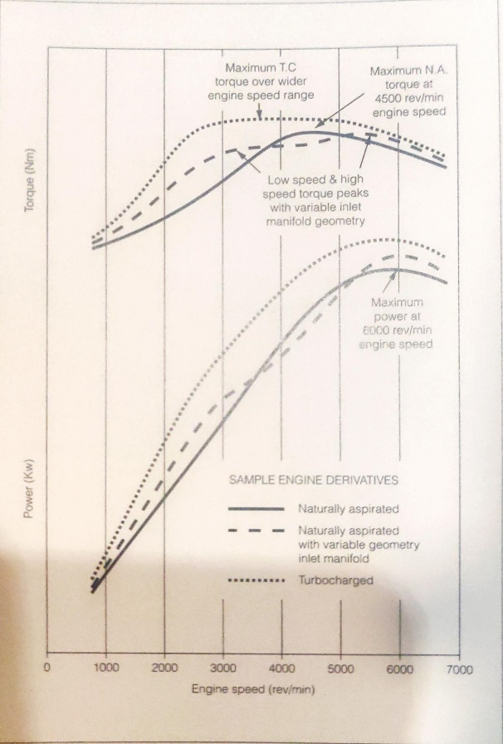
5.0 – Conclusion
Figure 9 - Sample automotive petrol engine performance curves (Manning, 2012, p. 106)

5.1 – Torque Against Engine Speed
Once the torque is plotted against the engine speed it produces a smooth curve showing a starting torque of 106nM before peaking at 131Nm before dropping down to 98nM. The only outlier is that between 1850rpm and 2050rpm the torque stays constant at around 116nNm instead of steadily increasing.
The shape of the curve in Figure 6 is like that shown in Figure 9 ignoring any outliers. The difference is that the peak in our test was at 3000 rpm instead of 4500 in Figure 7. This just shows that the Honda engine has more low-end torque compared to the generic engine as the torque peaks quicker. Showing it has more torque when acceleration. This is expected as the engine is a Honda CRX engine which is used in their sport-coupe models.

5.2 – Corrected Power Against Engine Speed
The graph shows that the Power increased proportionally to engine speed from 1000rpm to 4500 rpm before levelling off at 60000 W at 5000rpm before dropping to 57577w at 5500rpm.
When comparing to Figure 9 to Figure 7 the curves of the graphs have similar properties and shapes. However, the Honda engine peaks later at 5000rpm instead of 4000rpm. This drop in Power is at a similar time to the drop in Torque. This may be due to the tune of thew engine and the range its tuned for.

5.3 – Brake Mean Effective Pressure Against Engine Speed
Once the BMEP is plotted against the engine speed it produces a smooth curve showing a starting pressure of 838138.5 Pa before peaking at 1036237.4 Pa before dropping down to 779917.3 Pa. The only outlier is that between 1850rpm and 2050rpm the pressure stays constant at around 920000 Pa before steadily increasing to the peak.
The curve in Figure 8 for BMEP is near identical to that in Figure 6 for torque. This is because BMEP is the pressure that forces the pistons within the engine and as Torque increases so will the pressure required to move the pistons. And when the pressure reaches a climax, the engine cannot produce any more torque as there is no more extra force pushing the pistons resulting in both torque and pressure to drop back down at higher rpm range.

6.0 – Evaluation
During the experiment error was eliminated by, first, calibrating the dynamometer. As well as this the test was carried out in the same atmospheric conditions so then they were a constant throughout with a barometric pressure of 1.01067 bar at a humidity of 42.8% and temperature of 26ºC. The test was also completed several times producing repeatable results. The engine was also kept at a constant temperature and when collecting data all data was recorded or converted into base units so then it was transferable across all equations.

Bibliography
Honda Motor Co LTD, 1987. Honda Civic Coupe CRX Shop Manual. s.l.:s.n.
Manning, J., 2012. Internal Combustion engine Design.. Shoreham-by-Sea , West Sussex: Ricardo.
Stockel, M. W., Stockel, M. T. & Johanson, C., 2015. Auto Fundamentals : How and why the design , construction and operation of automobiles: applicable to all makes and models. 11th ed. Tinley Park , IL: The Goodheart-Willcox Company, Inc..
Summerfield, A., 2021. Vehicle Technology Part 1. Swansea UK: UWTSD.

