DS 1 Template

My Screenshots/Photos
- Please add 4–6 screenshots or photos of your digital life.
- You can use your phone or laptop.
- For each screenshot, write one or two sentences explaining what it shows.

Screenshot/Photo 1
Dashboard of my moodle, my current course
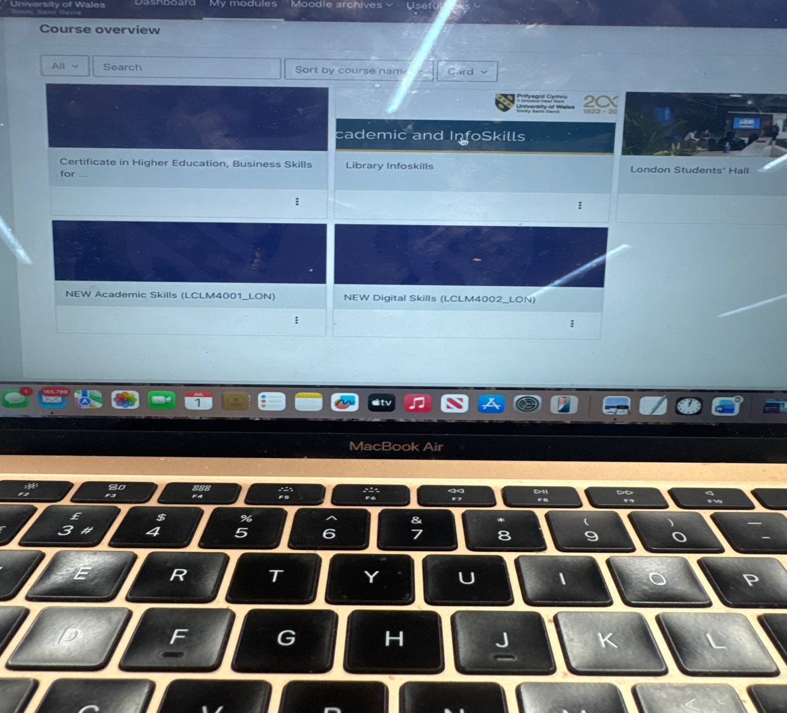photo of some of the work I do in class, how I navigate the dashboard of moodle.. I use this to complete tasks and reflect on my work in class.

Screenshot/Photo 2
Outlook Calendar
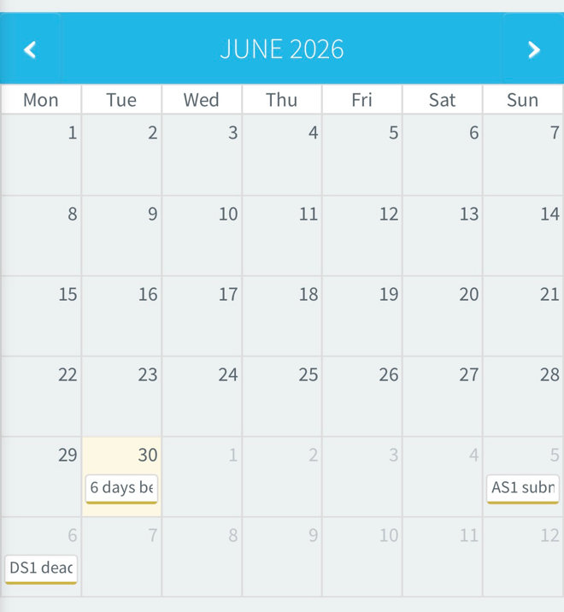
Picture of my Calendar in my app that I use to set my reminders and deadline.

kScreenshot/Photo 3
Spotify app
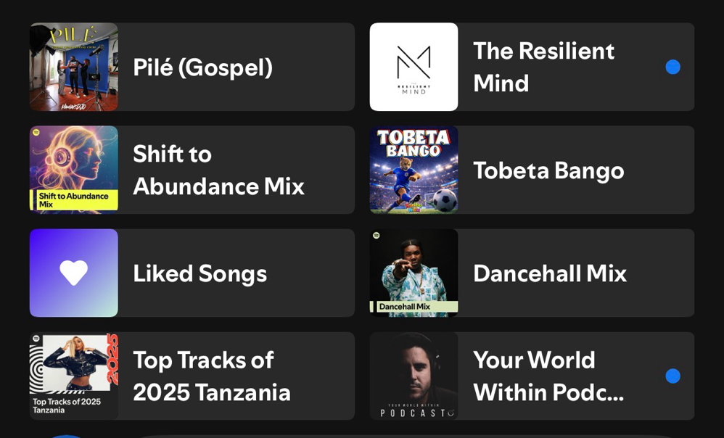
Picture of my spotify app home page, showing some of the podcasts and music I listen to.

Screenshot/Photo 4
City mapper app
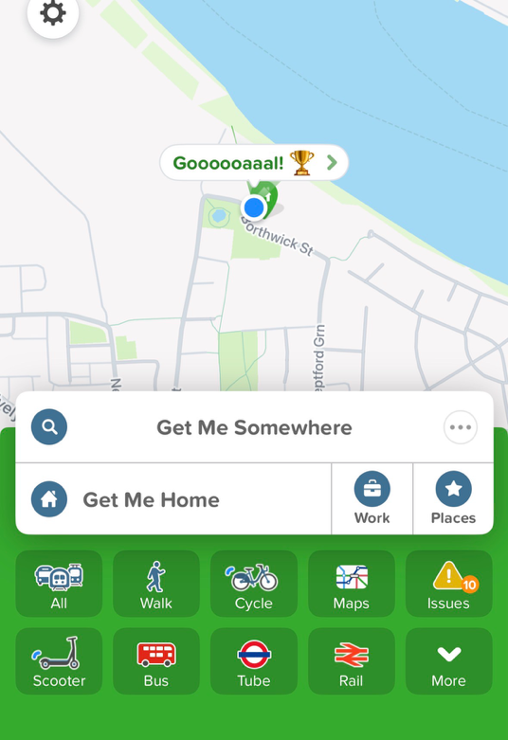
My city mapper app that helps me navigate to reach any unknown location but also provides faster routes and shortcuts.

Screenshot/Photo 5
Youtube app
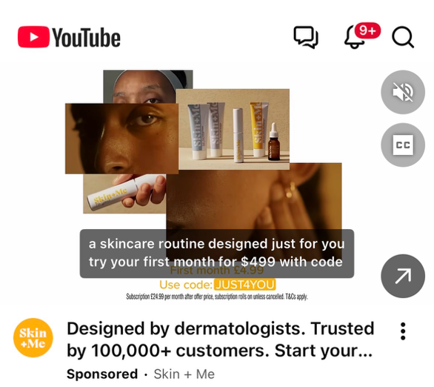
I use you tube to listen to some of my favourite youtuber pod casts. I also use it for nostalgic films and shows.

Screenshot/Photo 6
My ‘Hotels’ app
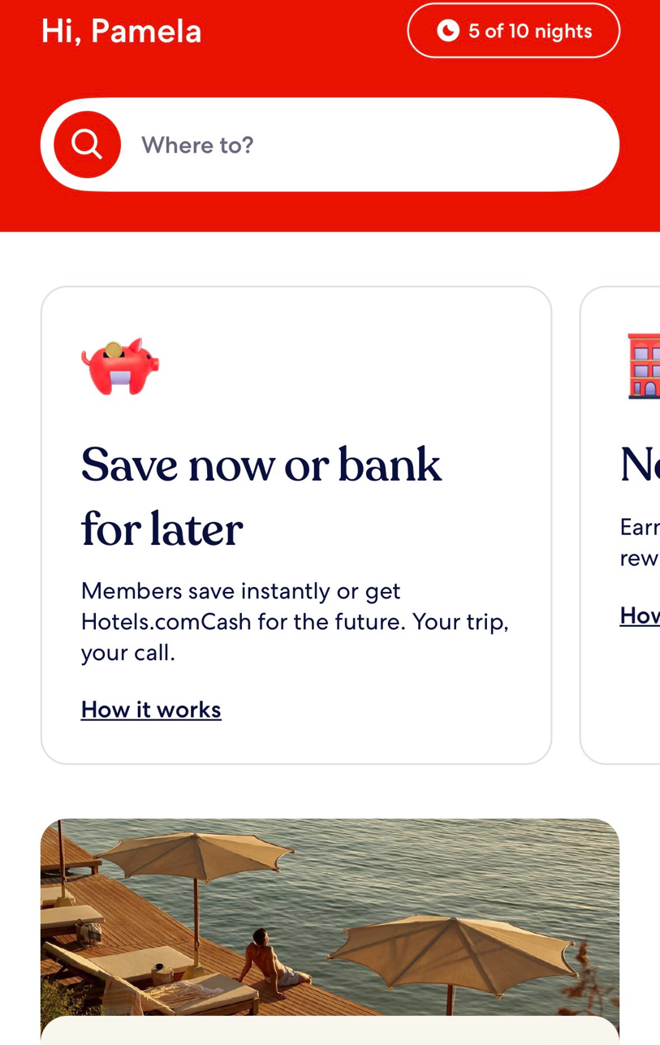
I use the app to get my self some cheap hotel reservations all around the world, it also helps with last minute accommodation search.

My Short Reflection
- Write 5–8 simple sentences about your digital life.
- You can use the sentence starters below if helpful.

Sentence starters
- I use digital tools to manage my everyday life, like online banking, city mapper, youtube, calendar to make my life a bit simpler and easier to navigate.
- I feel confident when I can get more acquainted with using these tools daily.
- I want to improve on some of my skills like excel spread sheets and using other applications like adobe and LinkedIn.
- I often use these tools sometimes to navigate my day, like the city mapper allows me to get to locations faster than I would normally.
- I sometimes feel nervous about using the wrong control and then blocking the app.
- I hope this module will help me to gain more skills digitally and be more confident to spot and use them in everyday life.
- Digital skills are important for me because when I eventually decide to work for myself, I will need them for both my personal and business ideas.
- I want to be able to confidently apply digital skills to eventually market my products online.

Submission Checklist
Before you submit, please check:
​​​ ☐ I added 4–6 screenshots
☐ I wrote short sentences for each screenshot
☐ I wrote my short reflection
☐ My work is my own
☐ My file opens correctly
​​☐ My file opens correctly

