Contemporary Challenges
Blog:
Username: kerenek
Password: tourism123

Unit 1 Visions of the future
https://kerenek.wordpress.com/2023/03/10/contemporary-challenges/
Unit 1 topic 1 'visions of the future' is about how our planet is facing significant challenges that threaten its existence the topic covers global warming. Climate change has become a global problem, and its impact can be seen across the world through extreme weather events such as hurricanes, droughts, flooding, and forest fires. The tourism industry is not exempt from these threats, as rising sea levels, more frequent natural disasters, and changing weather patterns can all have a significant impact on destinations, infrastructure, and transportation. It is crucial to tackle the issue of climate change head-on and take significant steps towards mitigating its effects to avoid its adverse consequences on tourism and society in general.
Climate change does not only directly affect the tourism industry, but also triggers numerous issues and threats that have major consequences for it. For instance, the increased frequency and intensity of extreme weather events can not only damage infrastructure and property but also impact tourism services, leading to reduced demand and loss of tourists. Moreover, environmental degradation and ecosystem destruction caused by climate change can damage some tourism assets such as wildlife, parks, and protected areas, ultimately resulting in reduced attraction and value for destinations.
According to the commonwealth Marine economies programme, 'Practical initiatives to control the risks of climate effects, protect communities, and enhance economic resilience are critical steps forward in adapting to climate change for small islands.'
Increasingly, tourists are witnessing the negative impacts of climate change first-hand during their travels, as destinations around the world are experiencing the effects of global warming. One such example is the Great Barrier Reef in Australia, which has suffered from coral bleaching due to rising water temperatures. Similarly, the city of Venice faces the threat of flooding as sea levels continue to rise. As travellers become more aware of these environmental challenges, it is important for the tourism industry to address these concerns and strive towards sustainability in order to ensure the preservation of these beloved destinations for future generations to enjoy.
Additionally, changing weather patterns and global warming can increase the spread of diseases, negatively affecting tourists' health and safety.
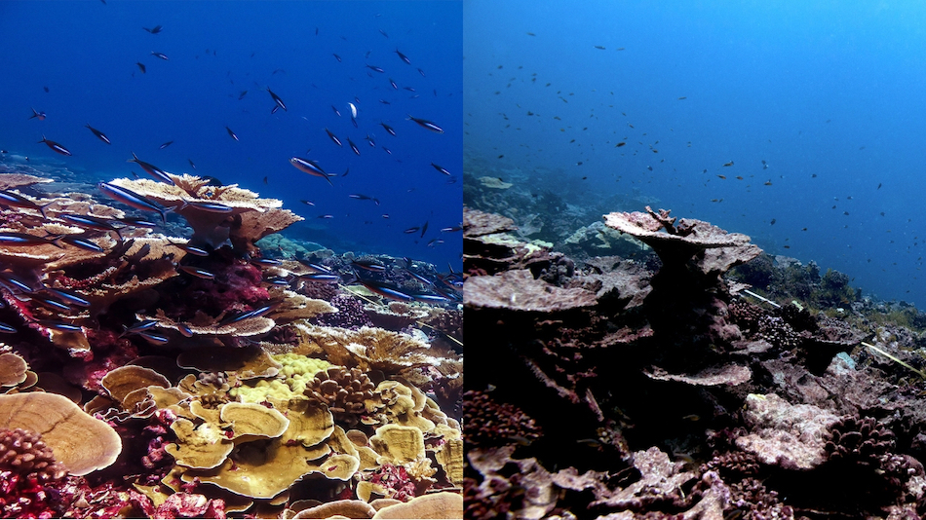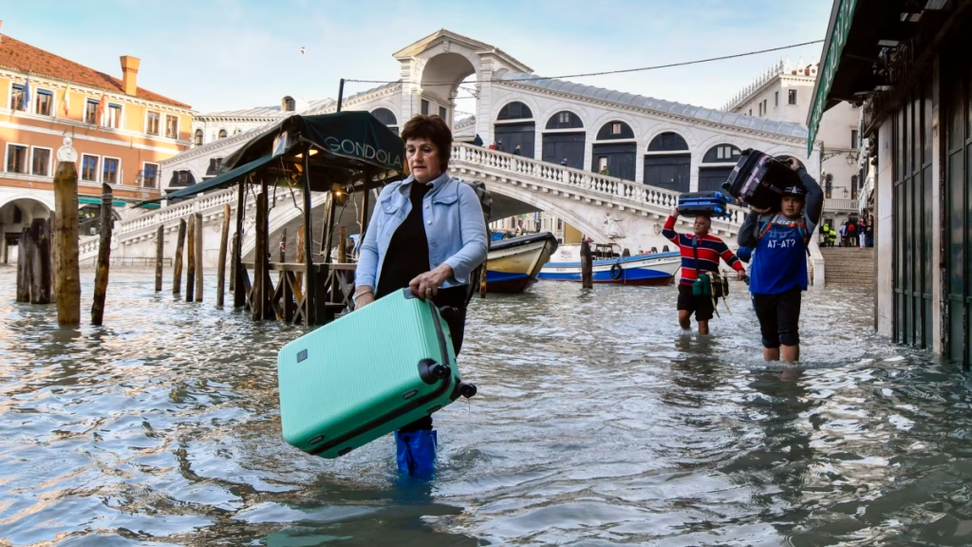

Topic 2
In today's society, one of the most significant issues that the tourism industry faces is inequality and discrimination. This problem can be judged based on various categories such as class, wealth, gender, and race. Unfortunately, this issue is still prevalent in our society, and it poses a significant threat to the tourism industry.
To tackle this issue, a movement was introduced called "Black Lives Matter." The primary intention of this movement is to address discrimination and promote equality. It is a movement that stands against racism, prejudice, and injustice towards people of colour. The movement emphasizes the importance of diversity of race, religion, age, and gender in our society.
In the tourism industry, the impacts of inequality and discrimination are widespread. People from certain social classes and races are often excluded or marginalized, which limits their opportunities to travel and experience different cultures. This exclusion can lead to a lack of understanding and empathy towards others, resulting in the perpetuation of harmful stereotypes and prejudices.
Furthermore, tourism can also contribute to the perpetuation of inequality and discrimination. Tourist destinations that are not inclusive and welcoming to all can deter potential visitors from diverse backgrounds. This can lead to a lack of economic growth and development in areas that rely on tourism as a source of income.
In conclusion, the issue of inequality and discrimination is a significant societal issue that affects the tourism industry in numerous ways. The Black Lives Matter movement is an essential step towards addressing this issue and promoting diversity and inclusion. As individuals and as an industry, we must work towards creating a more equitable and inclusive society that values and respects all individuals regardless of their background.

Topic 3
Tourism is not just about traveling, but also the impact it has on people's health, wealth, and happiness. The third topic, "health, wealth, and happiness," is particularly important due to the rising concern regarding global health issues caused by the lack of physical exercise. Physical inactivity contributes to serious health problems such as strokes, diabetes, and heart diseases. As per a 2018 report by the WHO, 1.4 billion people worldwide are not sufficiently active.
Topic 4
As machines and technology continue to advance, there is no doubt that they will have a significant impact on the tourism industry. While there are certainly benefits to be gained from increased automation and efficiency, there is also the worry that many jobs traditionally performed by humans may become outdated. For example, Waymo's driverless car technology may revolutionize travel, but could also potentially put countless drivers and other transportation industry workers out of work. As tourism professionals, it is crucial to stay informed about these developments and adapt to the changing needs and demands of the industry.


Post 2

Unit 2- The future is human.
https://kerenek.wordpress.com/2023/03/10/post-2/
Topic 1
Topic 1 is about philosophy and how in today’s world, many people are searching for a sense of purpose and direction in their lives, and the first topic of unit 2 could not be more relevant. One of the key components of this topic is the exploration of different meanings of life, which is a question that has puzzled philosophers for centuries. One of the most well-known philosophical concepts is Plato’s cave, which describes the journey from darkness to clarity or from ignorance to enlightenment. It's fascinating to explore this concept and how it relates to modern society.
Continuing with Plato's allegory, the role of media and its influence on individuals are still relevant today. Disinformation, the intentional spreading of false information, has become an even bigger concern in the age of social media where information can easily be shared and amplified. It is crucial to distinguish disinformation from misinformation, which is the unintentional spread of false information. To combat the spread of disinformation and misinformation, individuals can ask themselves six critical questions before sharing any information. With this topic, I have developed understanding skills, which I believe within the tourism industry, will be very beneficial to succeed in the role I will one day take on.
Topic 2
Topic 2 is about conflict. As conflict is a natural occurrence that arises due to different opinions and perceptions, it is highly likely to happen in the workplace, especially in roles involving management. Dealing with conflict effectively and in a calm and considerate way is crucial to maintain a positive work environment and successful outcomes. One must possess strong communication and problem-solving skills to handle any difficulties that may arise. In the tourism industry specifically in roles such as campaign managers, any type of managerial or even just as a normal working employee, conflict resolution is key to ensuring that guests are satisfied and have a pleasant experience, making it an essential skill for success in the field.

Topic 3
In the tourism industry, negotiation skills and the ability to influence others are essential for success, especially in a highly competitive and dynamic environment. Negotiation involves effectively communicating your needs and wants to others while also understanding and respecting their needs and wants. There are different tactics for negotiation, including soft and hard tactics, but ultimately, the goal is to find a mutually beneficial solution. Being able to effectively influence others requires not only strong communication skills but also emotional intelligence and the ability to build strong relationships.

Topic 4
Decisions play a crucial role in our personal and professional lives. When it comes to the tourism sector, decision-making skills are essential for success. Delayed gratification is a vital aspect of decision-making in tourism. It helps professionals to assess the opportunities and rewards that come with making specific decisions.

Unit 3-Change by design
https://kerenek.wordpress.com/2023/03/10/post-3/

Topic 1
Topic 1 is about how in today's highly competitive world, possessing the right skills is critical for success in any field, especially in the field of tourism. As employers are seeking professionals who can analyse problems and use innovative thinking to come up with creative solutions, developing critical thinking skills is essential. In addition, being imaginative and adaptive is crucial, as tourism is an ever-evolving industry that requires a forward-thinking approach to be successful. These skills play a significant role in ensuring that tourism professionals can effectively market destinations, plan events, and provide effective customer service to meet the needs of customers, regardless of their unique demands.

Topic 2
Design Thinking is a method for tackling creative problems that are used to co-create original ideas and bring them to life. It can be used to solve practically any issue. You will examine the first three steps of the process—Empathy, Define, and Ideate—in this topic.
Topic 3
Topic 3 in design thinking focuses on generating solutions to the problem that has been identified. The fourth stage of the design thinking process is prototyping, which involves creating and testing various ideas and concepts to see how they could potentially solve the issue at hand. Prototyping is a quick process that allows professionals to experiment with different approaches and refine their solutions based on feedback received during testing. Successful prototyping requires a certain mindset and skillset, including the ability to be adaptable, think creatively, and take a user-centric approach.

Topic 4
As one begins to explore the skills necessary for success in the field of tourism, it is important to consider the various methodologies that may enhance one’s performance. The concept of design thinking has gained significant attention in recent years for its potential to promote innovative problem-solving and creativity. Many experts argue that it is not limited to designers or entrepreneurs but is a versatile tool applicable across industries. Proponents of design thinking also suggest that it can help individuals limit their biases and approach challenges in a more holistic and empathetic way, which can be especially beneficial in the field of tourism where understanding and catering to diverse needs is necessary.

references
Impacts of Climate Change on Tourism in the Coastal and Marine Environments of Caribbean Small Island Developing States (SIDS) (2017). Available at: https://assets.publishing.service.gov.uk/government/uploads/system/uploads/attachment_data/file/605067/12._Tourism.pdf (Accessed: March 9, 2023).
Our Work In Wildlife And Environmental Conservation - WWF - Australia (no date). Available at: https://www.wwf.org.au/what-we-do (Accessed: March 9, 2023).
Window to Save World’s Coral Reefs Closing Rapidly (2018) National Geographic. Available at: https://www.nationalgeographic.com/science/article/coral-bleaching-reefs-climate-change-el-nino-environment.
WHO., 2020., WHO guidelines on physical activity and sedentary behaviour., https://www.who.int/publications/i/item/9789240015128 (Accessed 17th August 2022).

