Laweza Ali
Research Methods
M5X02111
P150429



Contents page:

1: Introduction
1A: Research question
1B: Aim/objectives of research
1C: Background

2: Research rationale

3: Literature review

4: Proposed research methodology
4A: Sampling
4B: Data Analysis

5: Research ethics and risks -
5A: Recourse planning

6: Appendix

7: Bibliography

1: Introduction:
Within this report I will include a literature review of the research question along with a Proposed research methodology, Data analysis tools and Research ethics and risks.

1A: Research question:
The question being used for research is how the popularity of clubbing holiday destination in Greece changed to family holidays and how they effected the destination in both a positive and negative way, and why there is a decline in clubbing holidays.

1B: Aims and objectives:
1: How the demand of Greece changed overtime from a party destination to a family destination?
2: Why there is decline in party holidays?
3: Positive and negative effects

2: Research Rationale:

The investigator is trying to achieve a look into the world of Greece’s clubbing holiday turnaround, and what the effects of clubbing holidays is both in a negative and positive way, by researching and getting answers from those who have experienced the effects first hand.

Drinking alcohol is such a big part of the British culture, where not drinking is a sign of weakness. “Before, this area would be filled with young English people. They were good customers. For 15 years we had them on pub crawls on 18-to-30 holidays, but then there was trouble because the hotels that catered for families couldn’t deal with them. They just wanted older people and families. They cracked down on young people and they left, with nothing to replace them.” (Gkouma, 2013)
Greece initially started off as a party destination, but soon realised that the trouble that came with it, was not worth it. So slowly have shifted their tourism target audience to family holidays which has then further caused a decline within clubbing holidays. (relate to appendix 1.A)

Even the people of Kavos are taking action “Change is coming to Kavos. Local people — led by an organisation called the Kavos Cultural Association — are leading a backlash against the drunken British youth who now dominate life in the resort.” (Tweedie, 2017)

3: Literature review:

Butlers theory:
According to Butlers destination life cycle theory there are 6 stages (appendix 1B)
with two options that are attached to stage 6, decline or rejuvenation. Every tourist destination will go through, either one of them. In the case of Greece making a successful turnover from the clubbing holiday reputation to the family resort holiday at stage 5 of Butlers Theory comes Stagnation, this is when the facilities for the tourists may face a decline as they become old and run down, the numbers of tourists may decline too. However, Greece went into rejuvenation where the government invested and modernisation started to occur which leads to improvements and visitor numbers started to increase again, but this time as a family holiday. This is then further tourism motivation into the country and a way of creating an exciting new reputation.

Maslow hierarchy of needs theory:

The decline in clubbing holidays is currently on the rise with many people’s desires changing and the target audience growing in maturity. Maslow’s theory (Appendix 1C) comes into work when stage 3 of Love and belongingness needs, comes into the research the need for friendship, intimacy, trust, acceptance and being part of a group, is human nature. Therefore, going on clubbing holidays fulfills that need. However, when stage 6 the self-actualisation needs, realising personal potential, self-fulfillment and seeking personal growth comes into research, the tourists visiting the locations realise they have had enough and change the style of holiday they go on. This is down the the personal growth of people and the change in style that they want.

“This five-stage model can be divided into deficiency needs and growth needs. The first four levels are often referred to as deficiency needs (D-needs), and the top level is known as growth or being needs (B-needs). Deficiency needs arise due to deprivation and are said to motivate people when they are unmet. Also, the motivation to fulfill such needs will become stronger the longer the duration they are denied.” (Maslow, 1943)

Positive & Negative:
There is a lot of secondary research which is bias and draws many people towards the negative side of clubbing holidays, in places like Zante and Kavos having with more negative than positive reports, people will be led to believe that the destination in question is not a great place to go. Putting people in positions where they choose new destinations.

“Last month, nine British women faced charges of prostitution, having taken part in an "oral sex competition" at Laganas beach. And this was not an isolated incident. While British tourism is a major boost to the local economy, the reputation of certain resorts impacts significantly on all of Zakynthos”

“Clubbing took off in the Nineties and has dominated the resort ever since.
The loud-mouthed youngsters who sully the resort, semi-naked on drink and drugs, are not in the slightest bit ashamed. They even contribute photographs of their antics to a Facebook page celebrating Kavos’s ugly image — called ‘Turns out Kavos was ready for you’.

The pictures posted feature a collection of unconscious bodies — one strewn across a pile of refuse sacks, another cradling a washing-up bowl in preparation for the inevitable reckoning, and yet another in a death-like pose on the beach. In the comments below each photo, young tourists heading to Kavos warn each other: ‘That will be you.’

Sobriety is not an option in Kavos. Drinks menus promise almost instant annihilation for the unwary. There is the Black Death, a cocktail boasting 250ml of pure alcohol, and the charmingly-named Head slammer, a pint of spirits including the potent ingredient absinthe. The legal drinking age here is 17.” (Neil, 2017)

Although there are negatives, being a clubbing holiday destination will bring you tourists weather it is used as a pedestal onto the tourism ladder or a permanent choice. The brits brought in income for the locals and jobs “But others blame the lack of business – that has seen some lose as much as 90% of their earnings – solely on the crackdown that began 10 years ago.” (Thompson, 2013) Since there was not much on the secondary data for positive effects the researcher investigated by taking interviews and questionnaire’s.

4: Proposed research methodology

Figure 1. Onion Research (200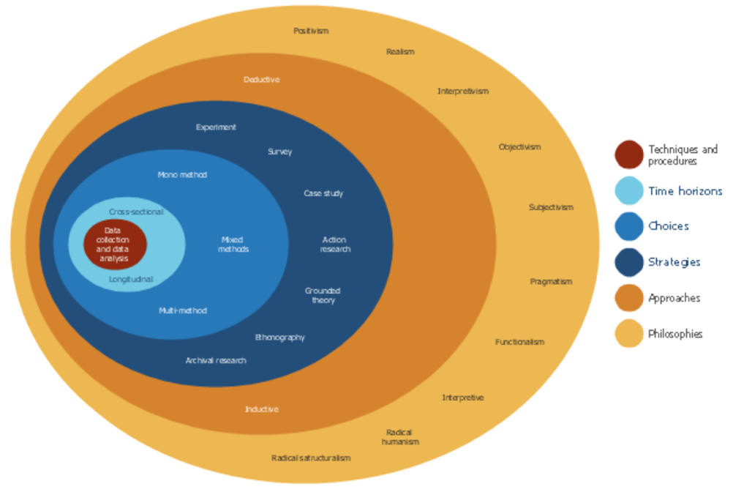8)

The researcher will use both a balance of both primary and secondary research through out the research process. Primary data is the data that has been collected from the investigator themselves for a specific research topic, and the secondary data is already out there as for this research topic there are many journal reports that will be used throughout.

However, using qualitative data there will be primary research done thoroughly to make sure all areas are covered, since majority of secondary research is bias and takes a slight negative approach towards the whole idea of clubbing holidays. Qualitative data research helps you explore further into your topic of research since you would be communicating with respondents and will understand and hear different experience people have had.

Qualitative research further gives you the ability to build relationships with the respondents and doing so is important, this will help the investigator get a more in depth, detailed and honest research completed. Qualitative research can get collected and tallied into many different types of numerical charts, manual tallies, spreadsheet analysis and SPSS. Typed up transcripts of interview responses is another way and Data matrix show the results equally, making this research reliable.

However, qualitative data research can be time consuming since the researcher would have to print off questionnaires, create and then find respondents to take part in the research. Qualitative research can at times be unreliable since the questions asked could be answered incorrectly.

The methodology used will be a series of interviews and questionnaires from people varying at the ages of 18-30

4A. Sampling:
The researcher will use 10 people who will have a questionnaires read out to them and will then reply according to their personal experience, within the sampling the investigator will also have interviews with 10 people bringing both results together to get a reliable and fair result. This sampling will be cross sectional research, since the time taken up by questionnaire’s is far greater than interviews.

4B. Data Analysis tools:
The investigator will be using SPSS and spreadsheet analysis to gather information. When doing interviews there will be transcripts typed up and video recording to relate back to what all 10 interviews had to say fairly. The researcher will then use Microsoft in order to put the result in one place via excel or bar charts.

5: Research ethics
Asking for consent from the respondents taking part in the samplingis important and they will be made aware of the reasoning behind the research and what the topic of research is. The researcher will make the participants aware if they prefer to be anonymous that is an option or if they don’t mind being known throughout the research then they would have to say so. There will be set confidentiality promises to protect the participants Mason (2016) “gaining informed consent is quite a complex and difficult business.”

According to Banister et al (1994) “ethical concerns must be part of the fundamental design of any research project, and ideally any proposed research” so therefore when the video is rolling the participants will then be asked for consent again on camera. Since there are no children involved a DBS will not be neccsary and neither will there be any risk or embarrassment to the researcher or participants.

6A: Resource planning
Ensuring that the researcher completes this research and it is credible at the end of the research, there will be a lot of resources that will be needed. These resources will come from online reports, journals, books and online libraries. Making sure that the investigator has the correct equipment to work from home is vital, as the researcher will require access to a laptop/PC, printing facilities, social media and access to Survey Monkey to complete tasks. There will be a time limit placed on how long the researcher will have in order to successfully complete the research. The investigator will use a Gantt chart (Appendix 1D) to keep track of what needs to be done by the end of the month and stay focused on the tasks given. The time given is from July to January.

7: Appendicies:

1A:
(Tweedier, 2017)
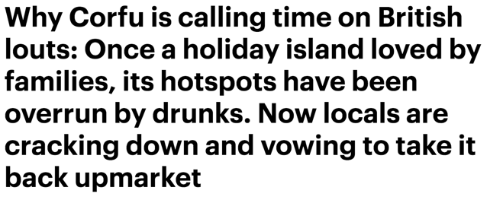

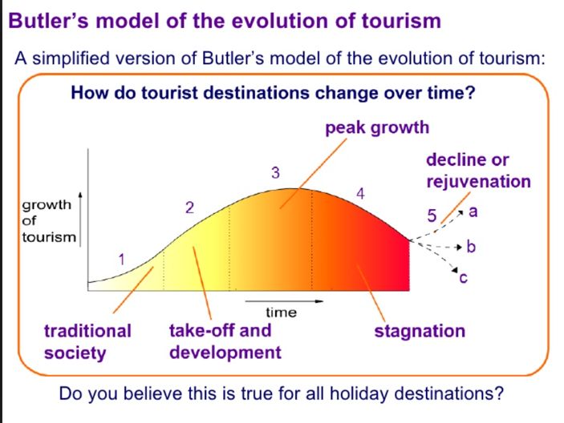
1B: Butlers Theory

1C: Maslow Hierarchy:

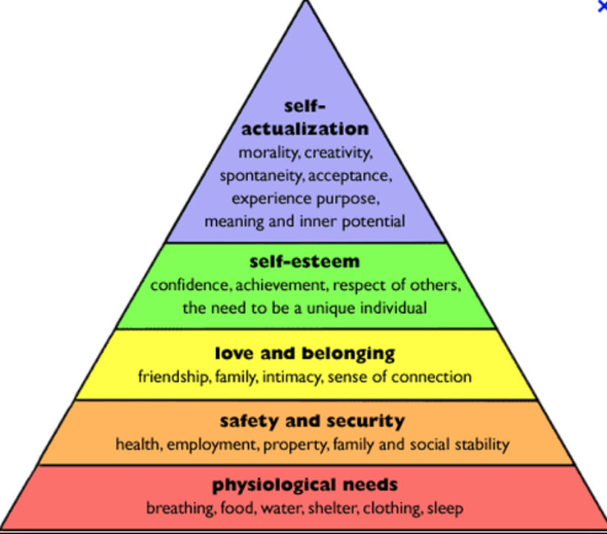

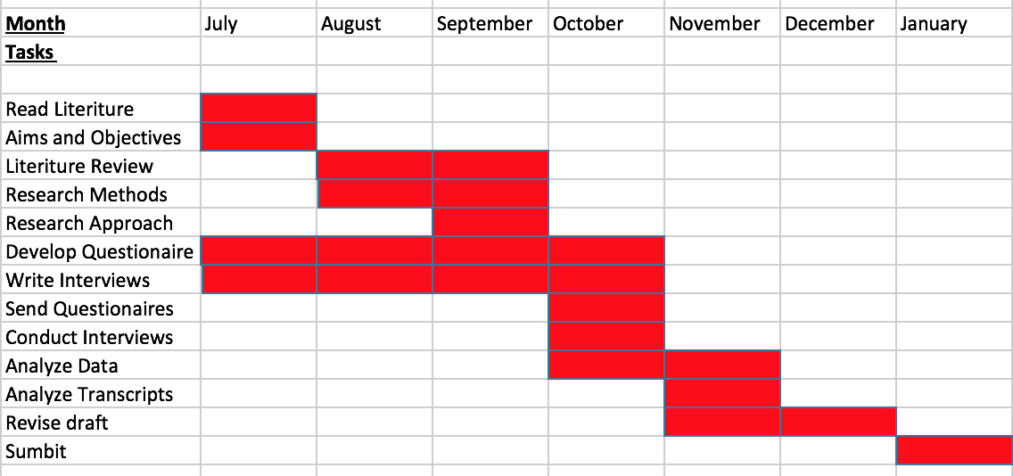
1D: Gnat Chart

8: Bibliography:
https://www.thesun.co.uk/travel/5452493/drunk-british-tourists-partying-hard-in-european-party-hot-spots-prove-exactly-why-locals-are-fed-up/

https://www.vice.com/en_uk/article/3kk4bv/how-party-tourists-are-destroying-europes-towns-and-cities

https://inews.co.uk/opinion/greece-needs-lighten-brits-abroad-great-fun/

http://www.dailymail.co.uk/news/article-4779942/Why-Kavos-calling-time-British-louts.html

https://www.telegraph.co.uk/travel/news/the-end-of-the-lads-holiday/

https://abta.com

http://www.bbc.co.uk/schools/gcsebitesize/geography/tourism/tourism_uk_rev1.shtml

https://www.theguardian.com/theobserver/2016/aug/14/young-people-night-time-social-activities-museums-running-tim-lewis

http://www.bbc.co.uk/schools/gcsebitesize/geography/tourism/tourism_uk_rev1.shtml

https://www.slideshare.net/egan2/butler-model-9565119

https://www.mirror.co.uk/news/world-news/decline-faliraki-after-10-year-clean-up-2103167

https://www.mfa.gr/usa/en/about-greece/tourism/for-sustainable-tourism-industry.html

https://www.simplypsychology.org/maslow.html

https://www.slideshare.net/egan2/butler-model-9565119

Maslow, A. H. (1943). A Theory of Human Motivation. Psychological Review, 50(4), 370-96.

Banister, P, Burnman, E, Parker. L, Taylor, M and Tindball, C (1994) Qualitative Methods in psychology: A research guide, Open university Press: Buckingham

Mason, J. (2018) Qualitative Researching, Third edition, Sage publications, London

http://www.dailymail.co.uk/news/article-4779942/Why-Kavos-calling-time-British-louts.html

