

Applied Computing
Wales Institute of Science and Art (WISA)

Network Operating Systems and Services (NOSS)
(ACCA5023)

Component 2

Managing and maintaining network resources and services by applying suitable policies and drafting security and redundancy practices.

By:

Ethan Matthews -2117013

Team Name: GECA
Team Members:

Student Name | Student ID
Ethan Matthews | 2117013
Geminiano Aguilar | 2001127
Cameron Brown | 2004688
Jack ‘Ava’ Kennedy | 2003924

Team Evaluation

 | Ethan | Geminiano | Cameron | Jack
Ethan | 5
Geminiano | 5
Cameron | 5
Jack | 3.5

Student 1 - Myself:

Overall I gave myself a 5 rating as i feel like i contributed well towards the team and the overall would that was created and helping out the others where i could.
Student 2 - Geminiano ‘Gio’ Aguilar:
Overall I have also given Gio a 5 as he also contributed well to the team and helped us where necessary and also provided us with some of the photos used and communicated with us very well.

Student 3 - Cameron Brown:

I have also given Cameron a 5 as he also contributed well with the team and provided us with photos and annotations to the photos in both of the tasks and communicated well and helped when necessary.

Student 4 - Jack ‘Ava’ Kennedy:

Aside from receiving the lowest rating due to Jack barely being here during the lessons when the rest of us were in, over the last few weeks that he has been in he contributed very well and even helped us all out when we needed it.

Page of Contents

Contents | Page Number
Student Evaluation | Pages 2 - 3
Introduction | Page 4
Task 1 | Pages 5 - 18
Task 2 | Pages 19 - 39
Task 3 | Pages 40 - 43
Appendix | Page 43

Introduction

This assignment was yet again a group based assignment where we were partnered with the same group we were with from assignment 1. In this assignment we had to maintain and manage a variety of different network resources and the services that it provided whilst also maintaining an understanding of the different OS environments that were provided to us. There were also two tasks provided the first split in two but was a practical team working task and the second being an individual observational task.

Task 1: MANAGING AND MAINTAINING NETWORK RESOURCES USING NETWORK POLICY AND SECURITY PRACTICES
1.1 - Understanding NTFS and Share Permissions
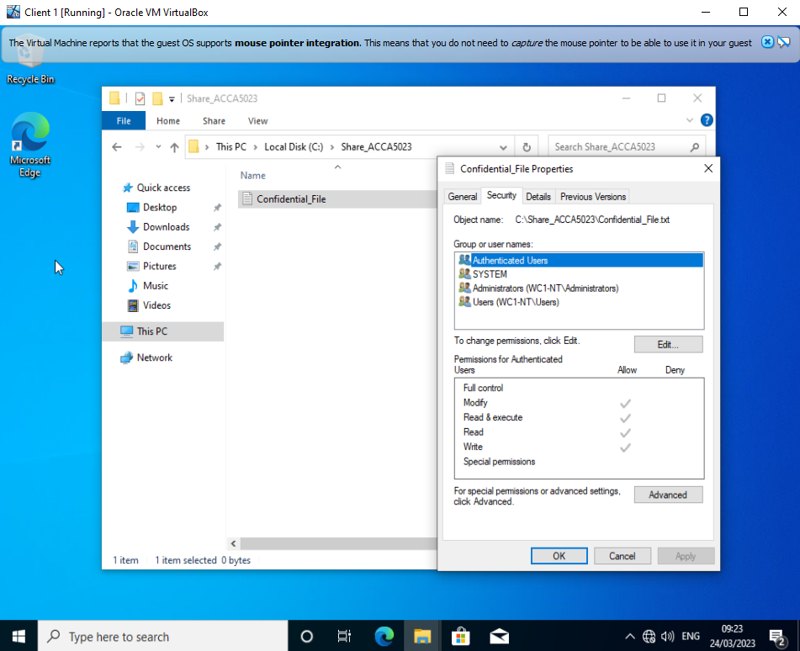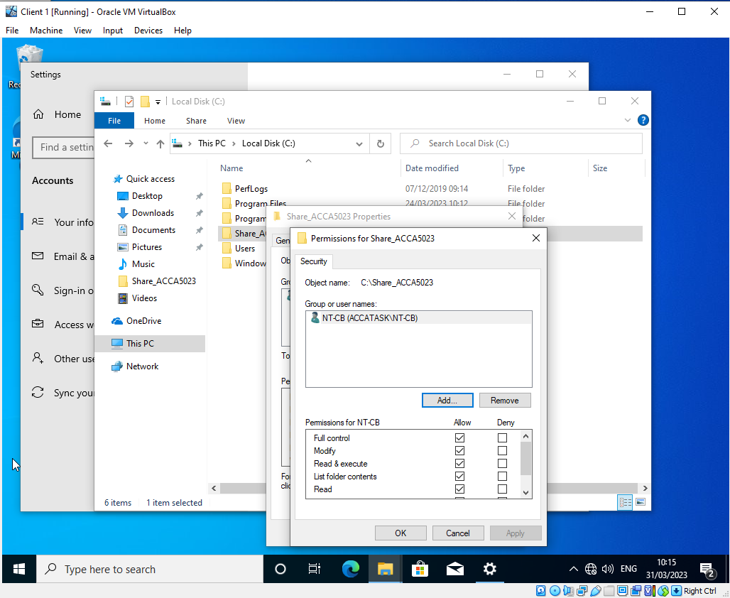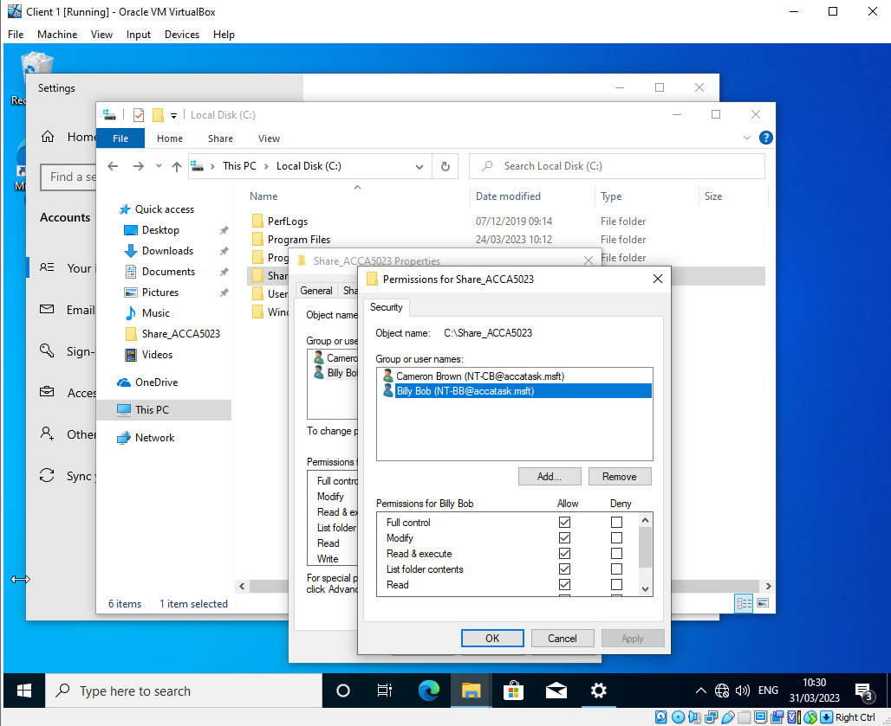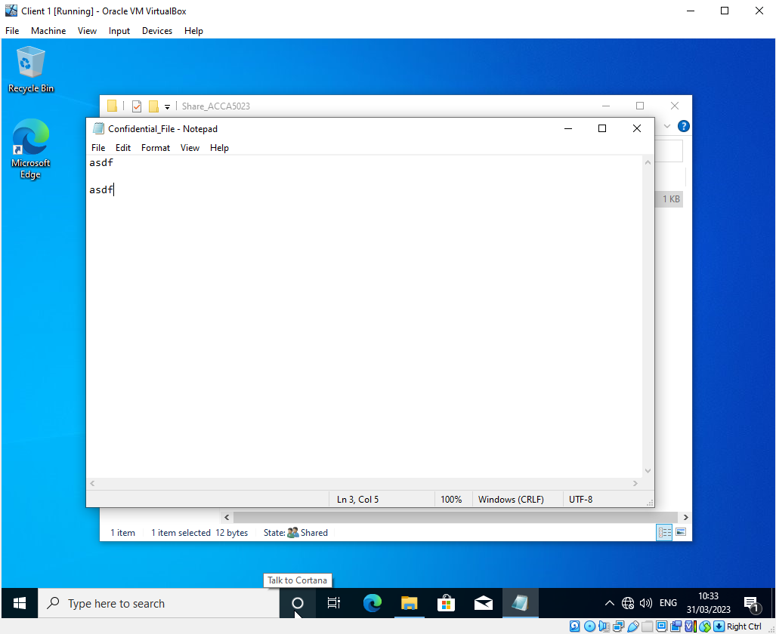
In the above screenshots, a folder was made and a file was created within it. Then permissions were changed to only allow access to these through one user. This will deny access to anyone else accessing it besides the user with full control. After that, another user was added but only given read and execute permissions, meaning that they cannot modify the contents at all.

1.2 Share Permissions

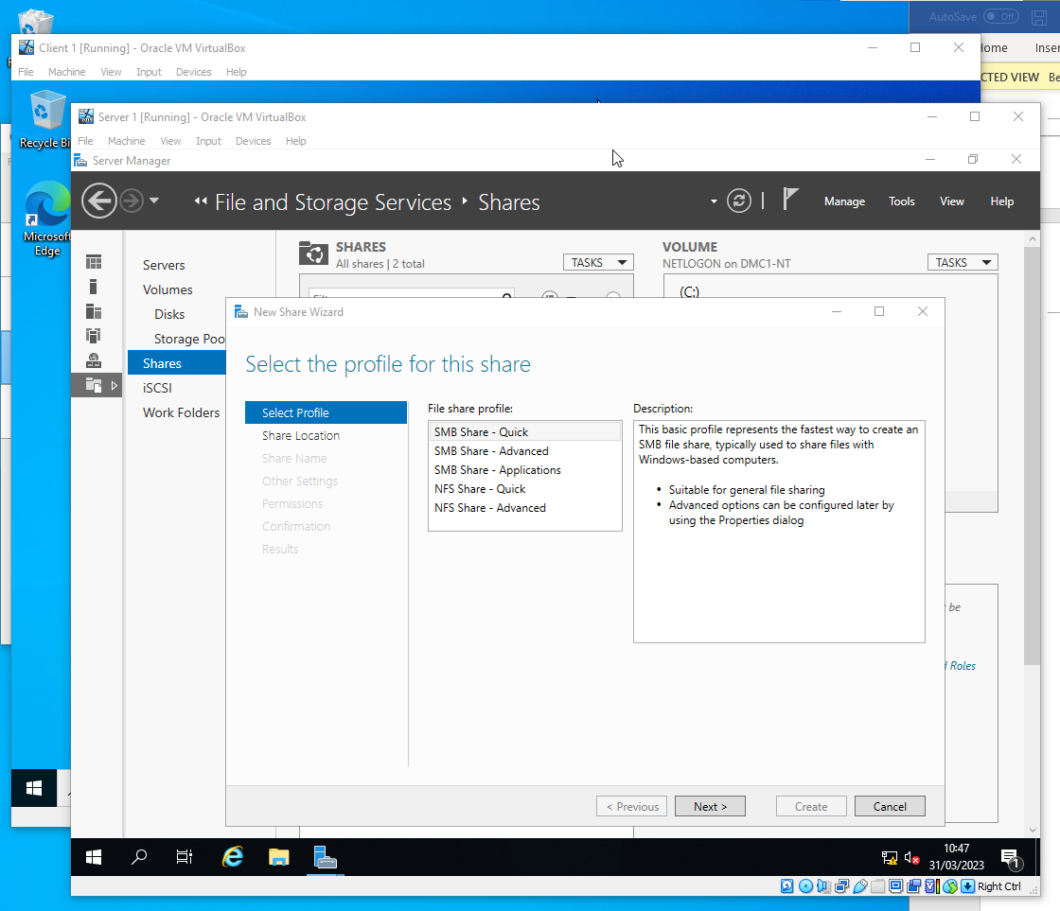
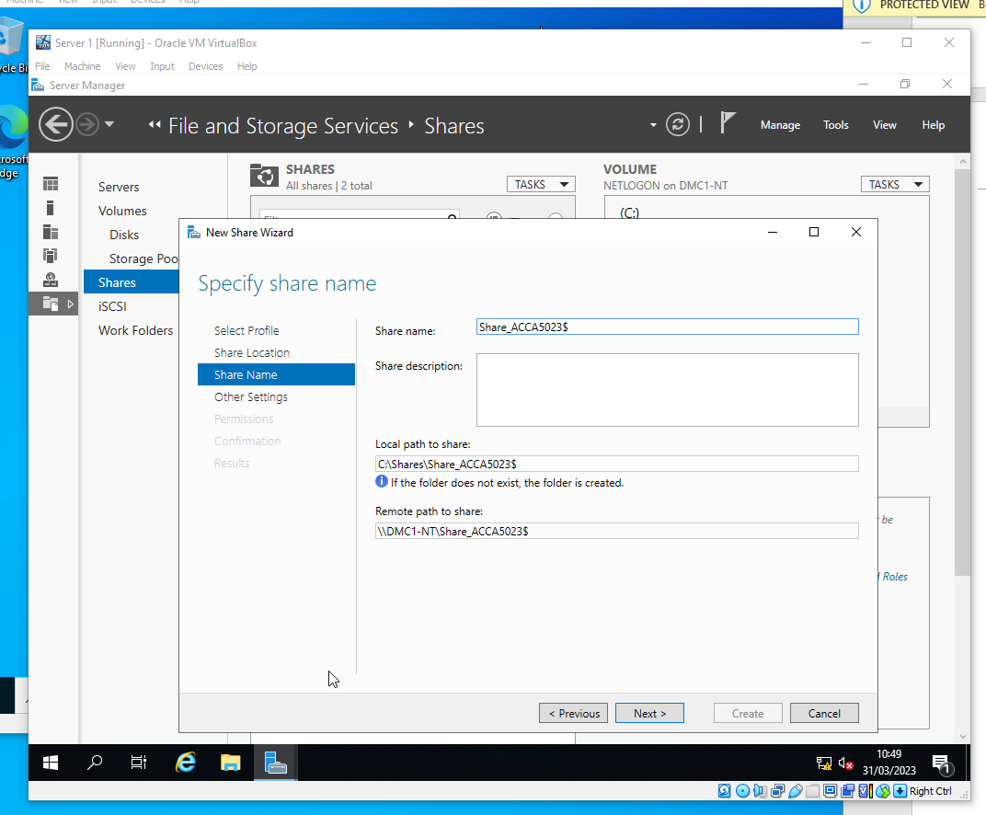
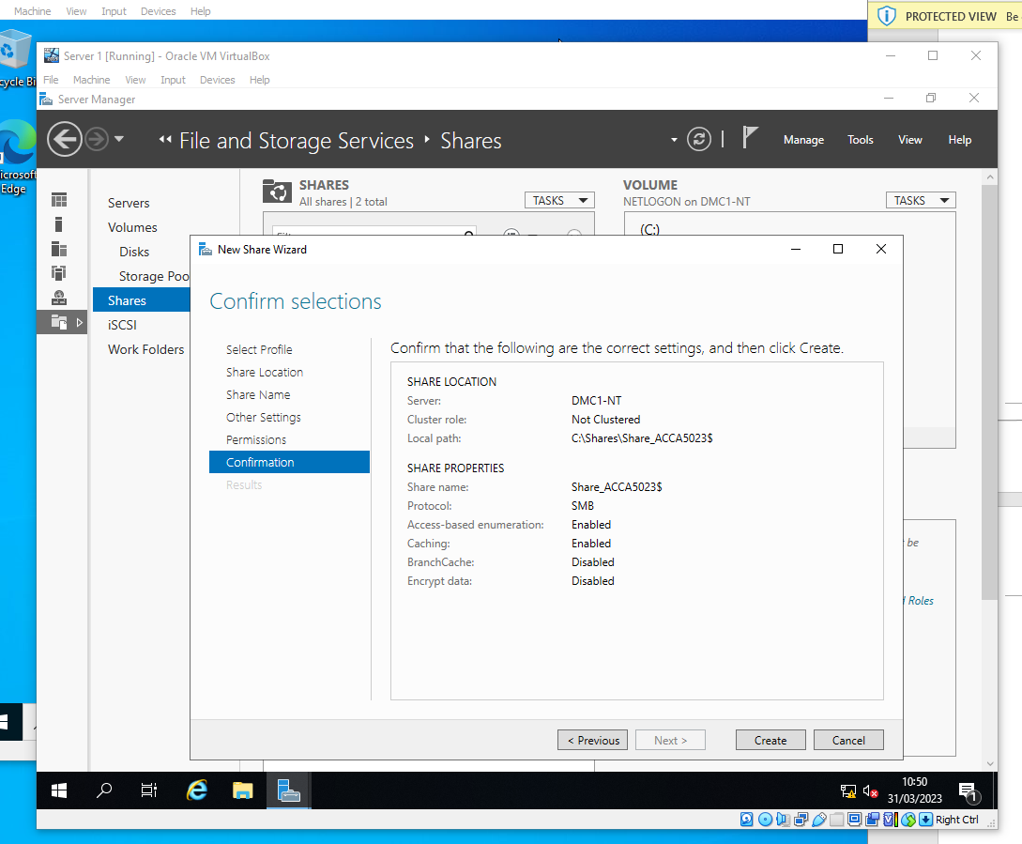
In this section, a shared storage service was created. This was done by loading into the server manager on the Server 1 VM and going through the process of setting up the shared storage, which includes entering the name and location of the shared storage and specifying permissions. As mentioned in the worksheet, administrators were given full control while 2 more users were added with only read and execute permissions.

1.3 Accessing the file share/server over a network
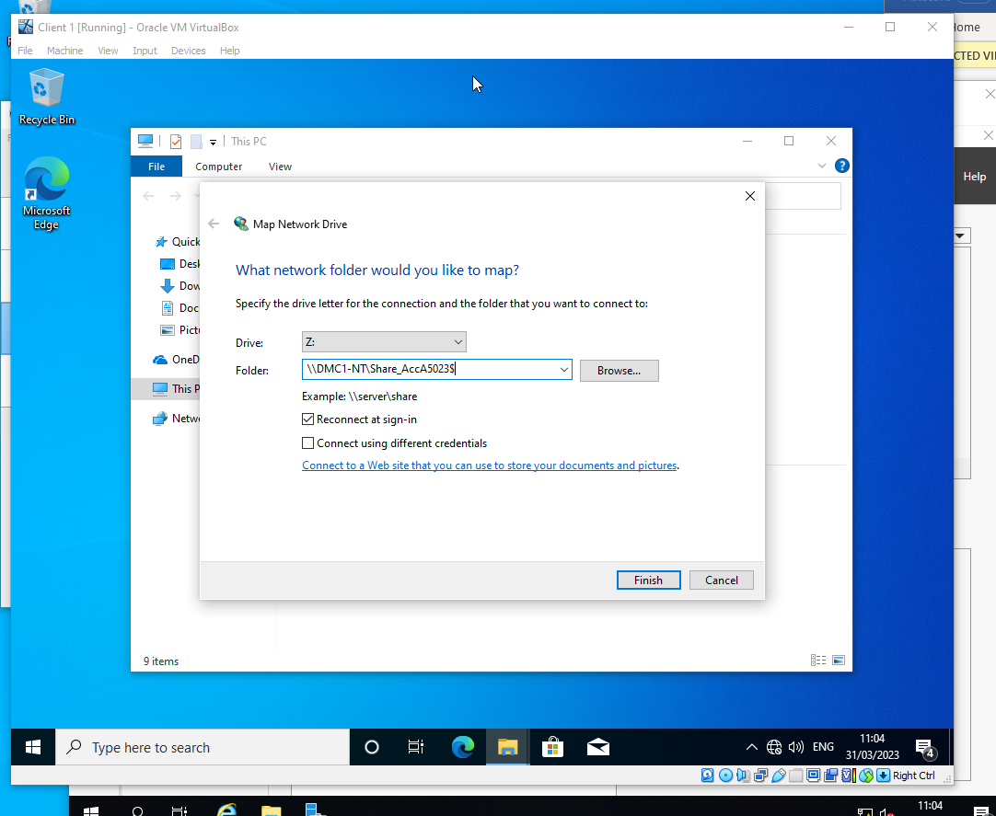
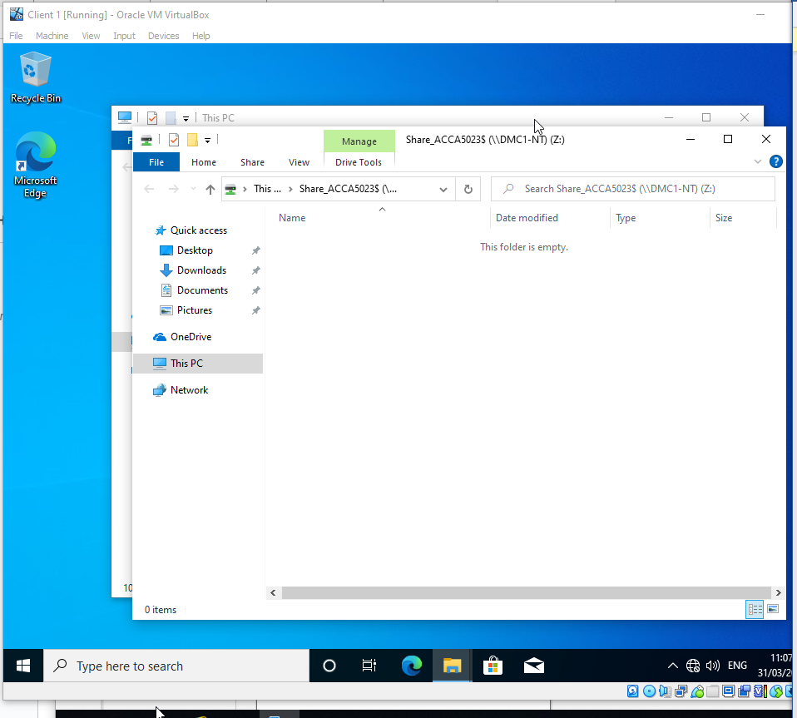
This shows that a network mapped drive was created in order to make sure that potential snoopers won’t be able to find/access the shared drive.

2.1 Configuring User Environment and Computer Environment, ‘Network Group Policy Objects’

GPO 1 - Moderating Access to Control Panel
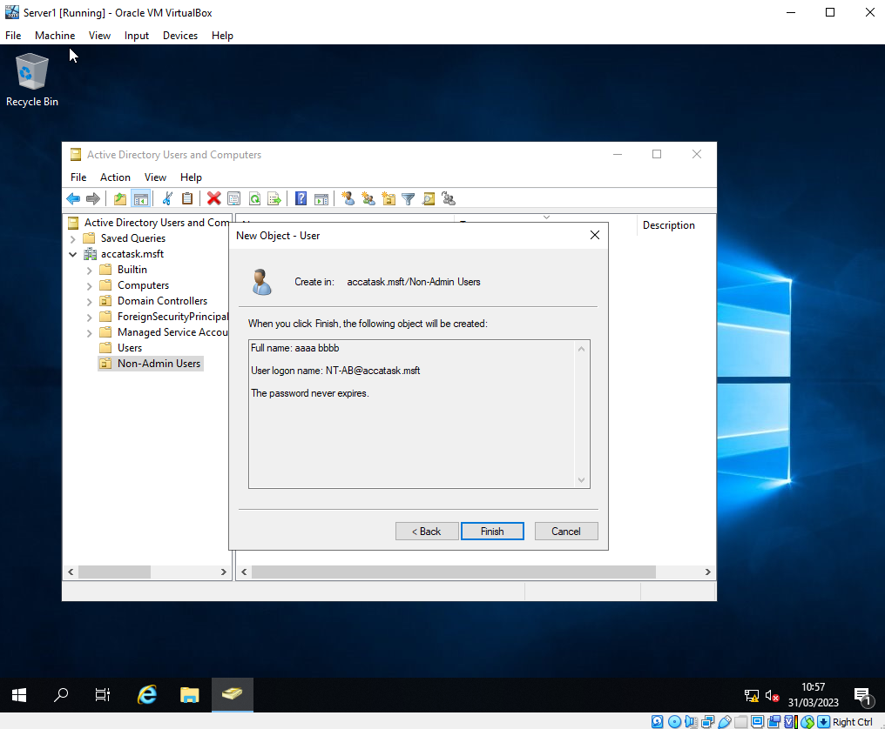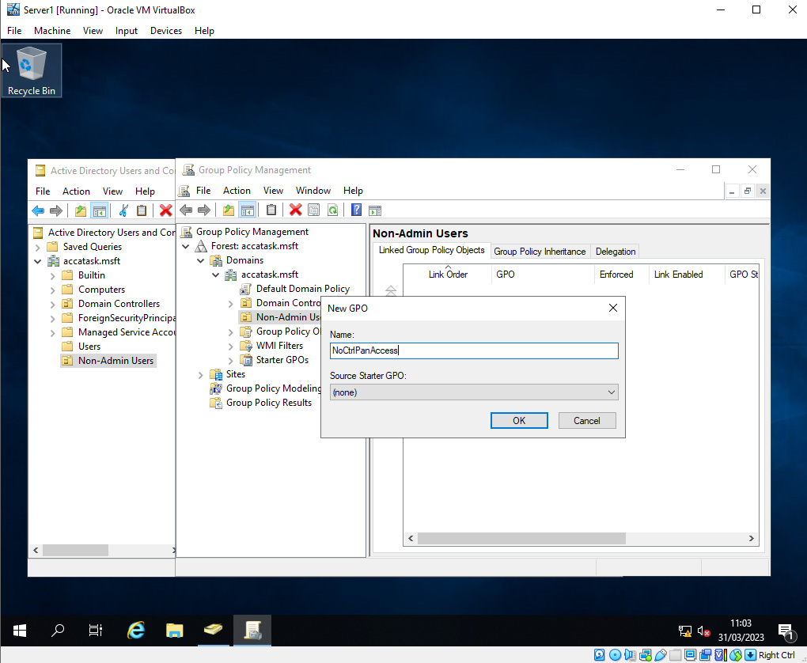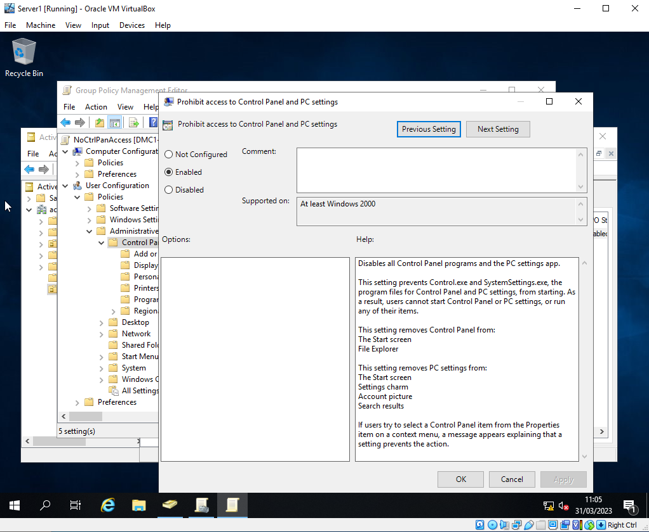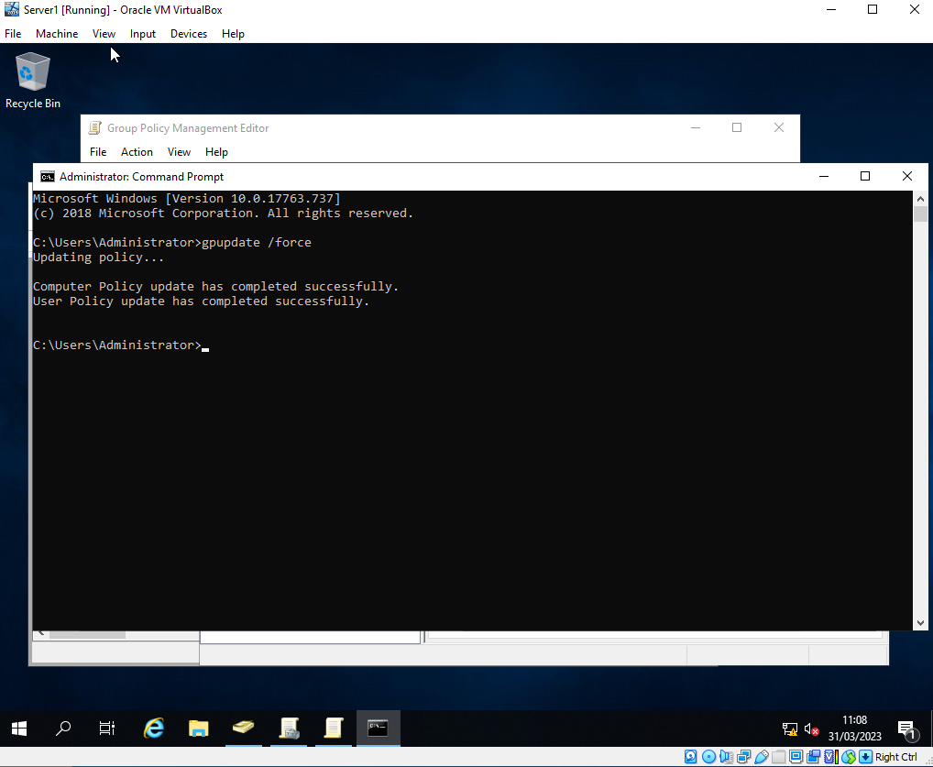
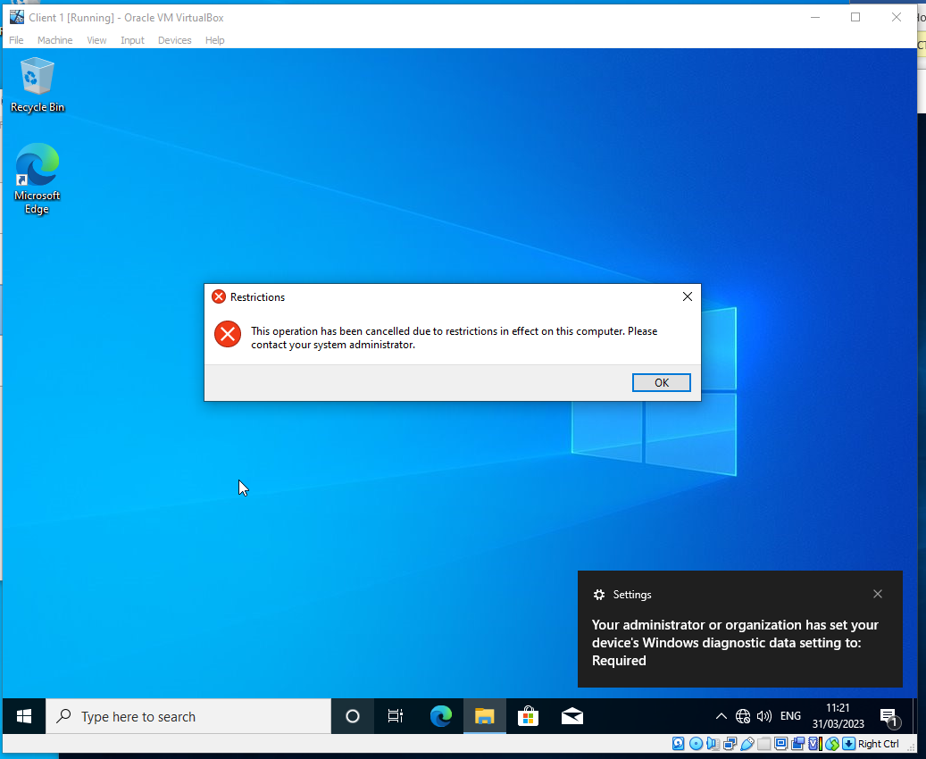
Group policy management was used to restrict access to the control panel. Since it wouldn’t be ideal to restrict all users' access, user groups had to be created using GPO so that the restriction only affected certain users, this was done via use of the Organisational Units. This is because some users need access to the control panel while some other users do not benefit from it at all, so it has been restricted for the ones that don’t require access for security purposes. The final 2 screenshots above show that the restriction had worked.

GPO 2 - Removing Access to Command Prompt
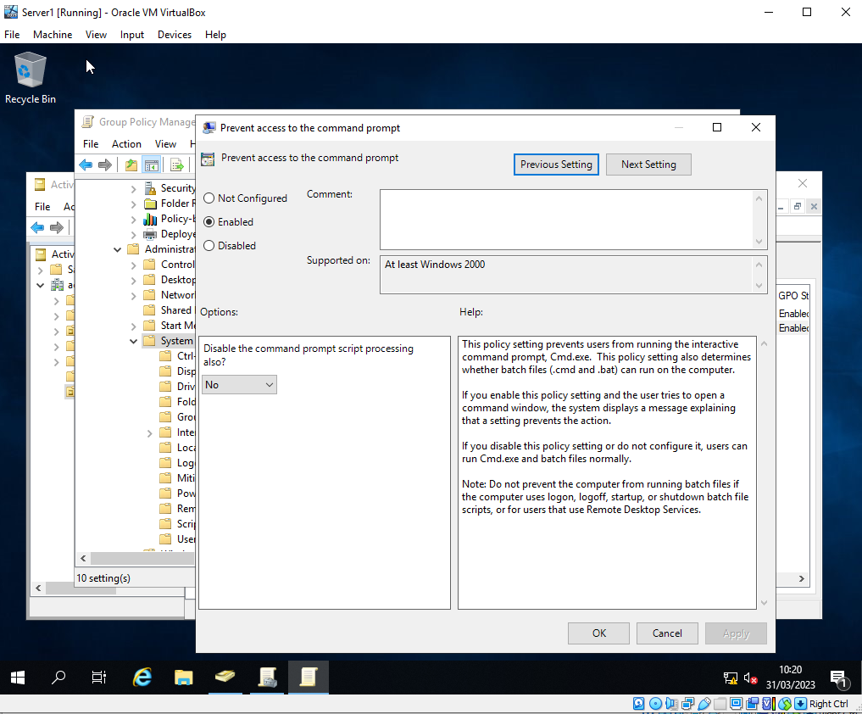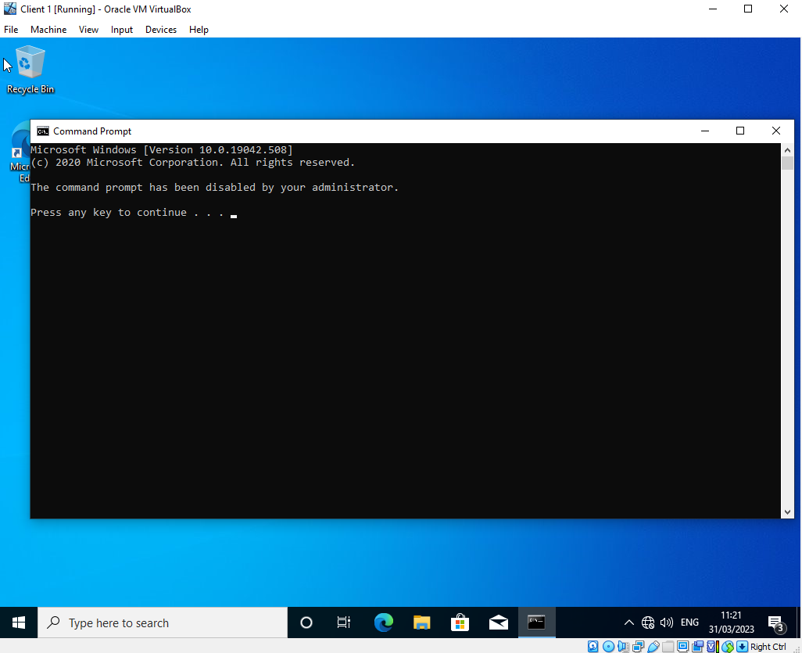
Due to the same reasoning as the control panel restrictions, the command prompt was also restricted to the same group of users by using the same method. The above screenshot shows that the restriction had succeeded.

GPO 3 - Restricting Access to Removable Media Devices

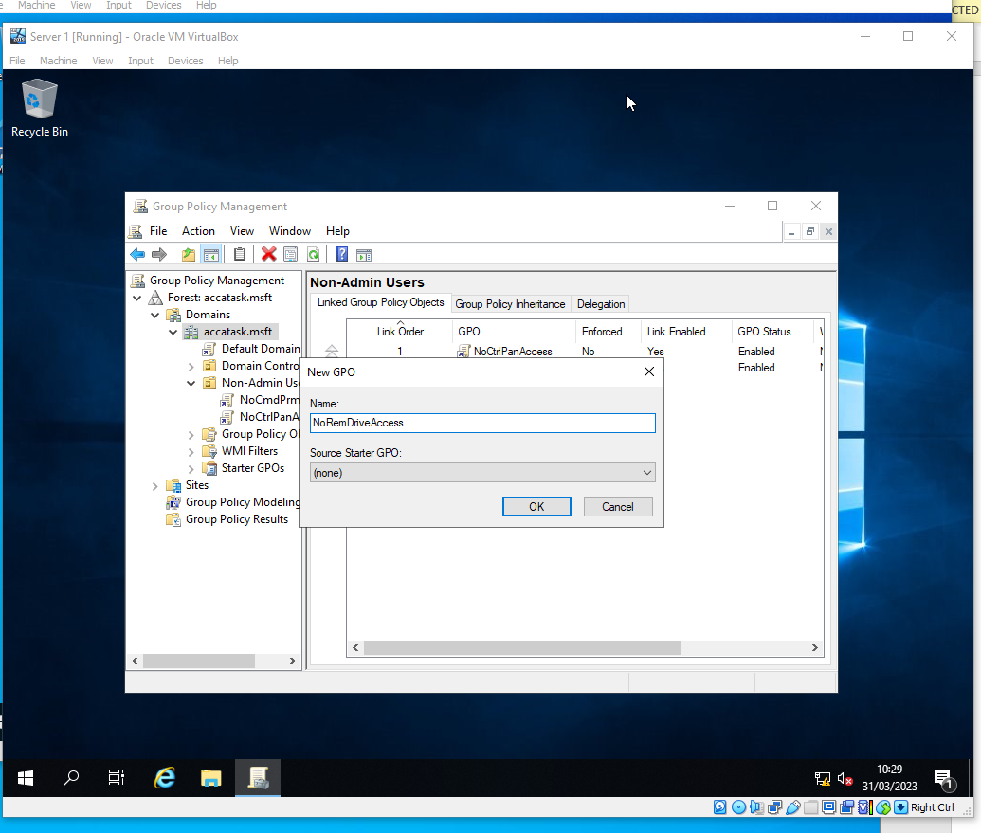
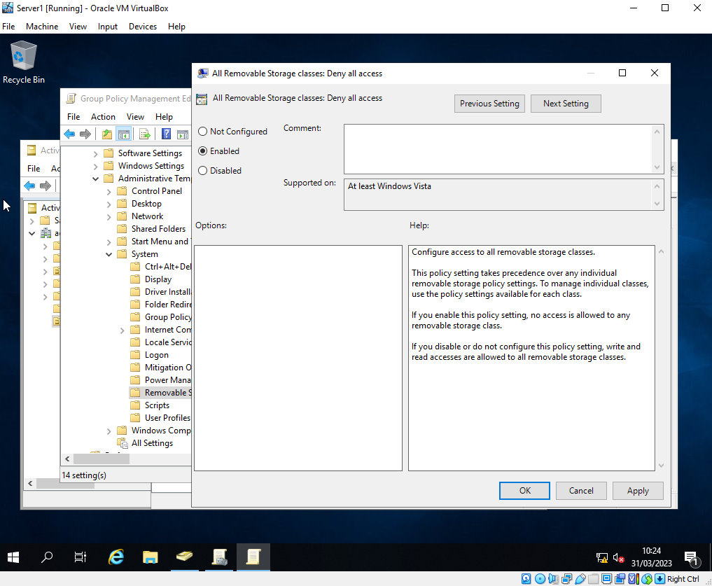
In order to keep the networks secure, a restriction on access to removable media devices was also made. This is due to them being an easy way to carry viruses and malware. The same restriction as the previous 2 tasks was applied here.

GPO 4 - Restricting Software Instals
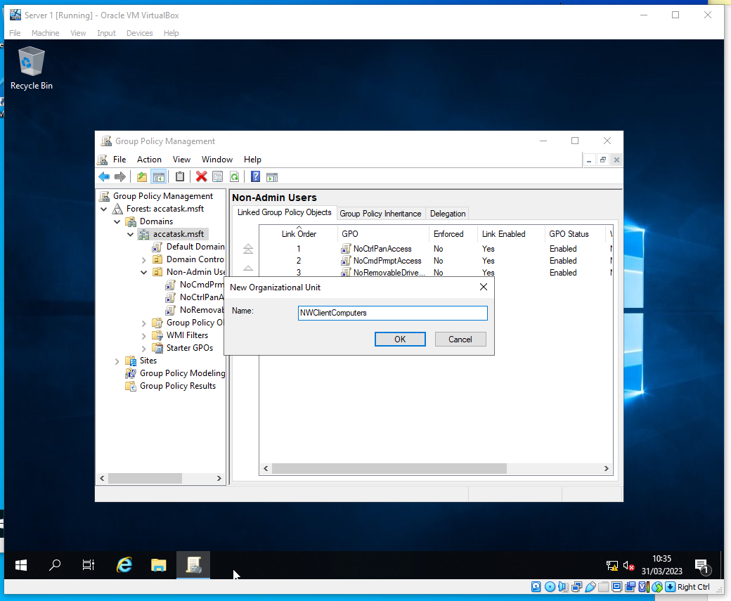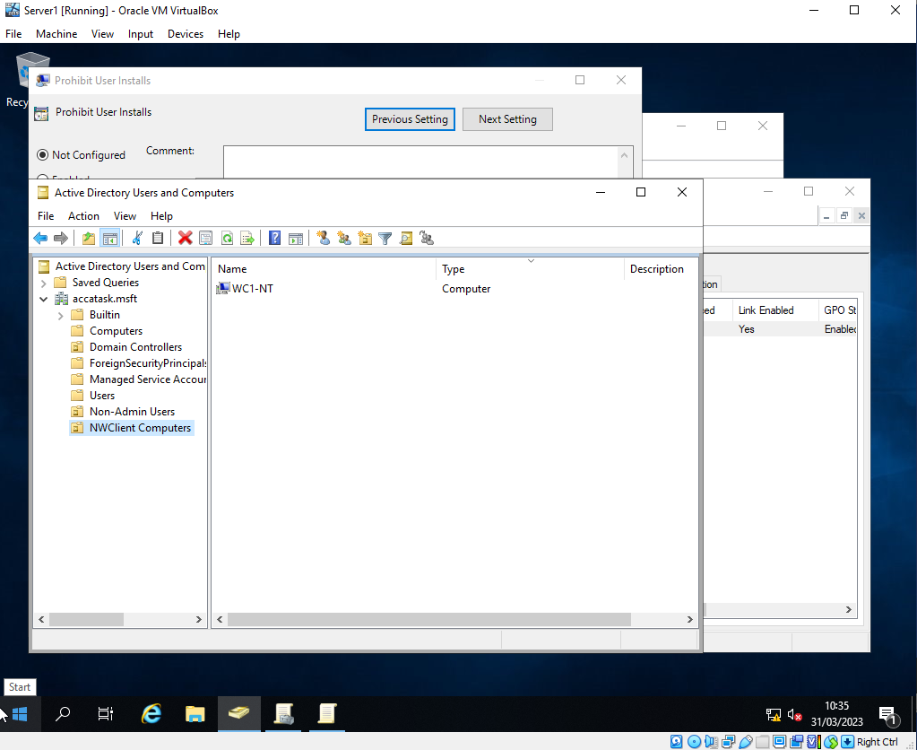
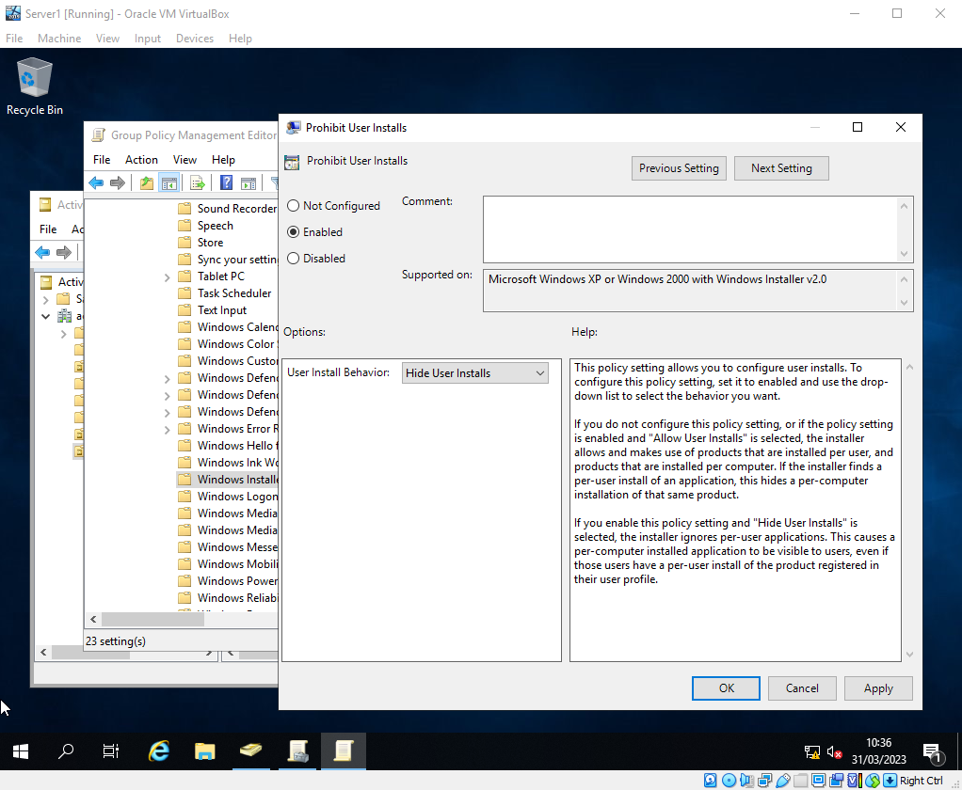
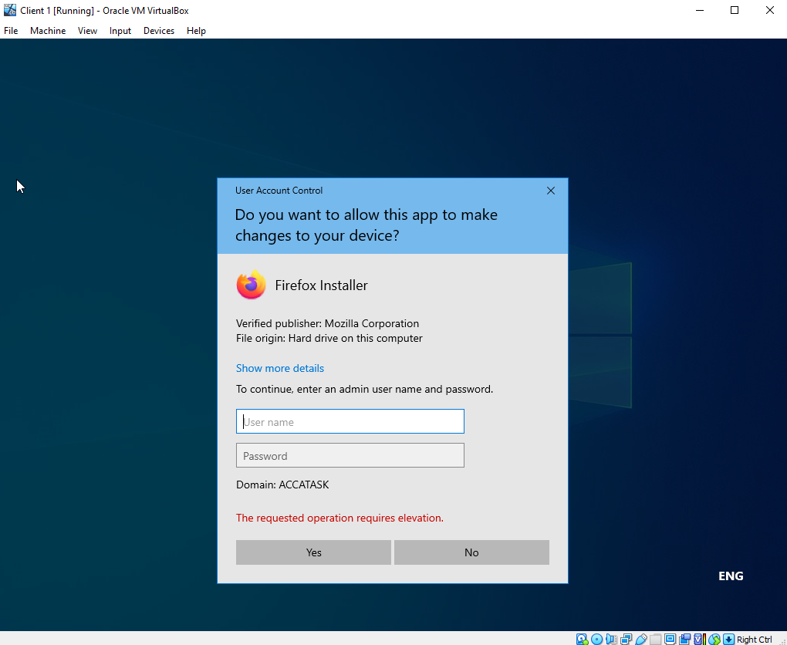
Unauthorised software installations can be dangerous for a network. This is because the software can be used to exploit vulnerabilities in the network. Due to this, a restriction was set on users in which only authorised administrators could install software to these machines. The final screenshot above shows this in effect.

GPO 5 - Enforcing Password Policy in the ‘accatask.msft’ Domain

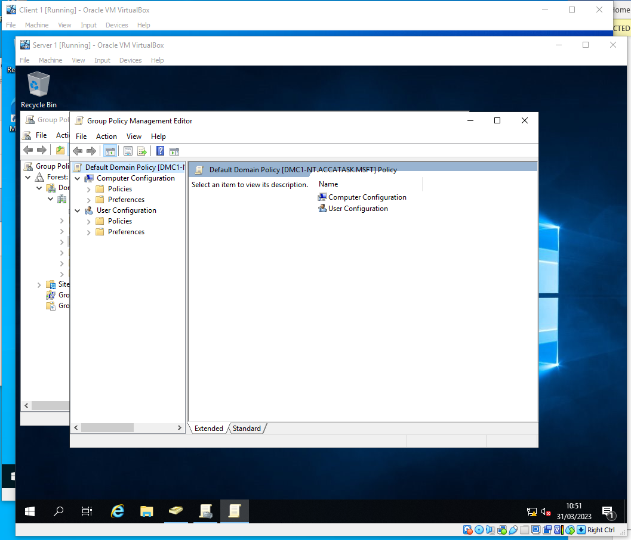
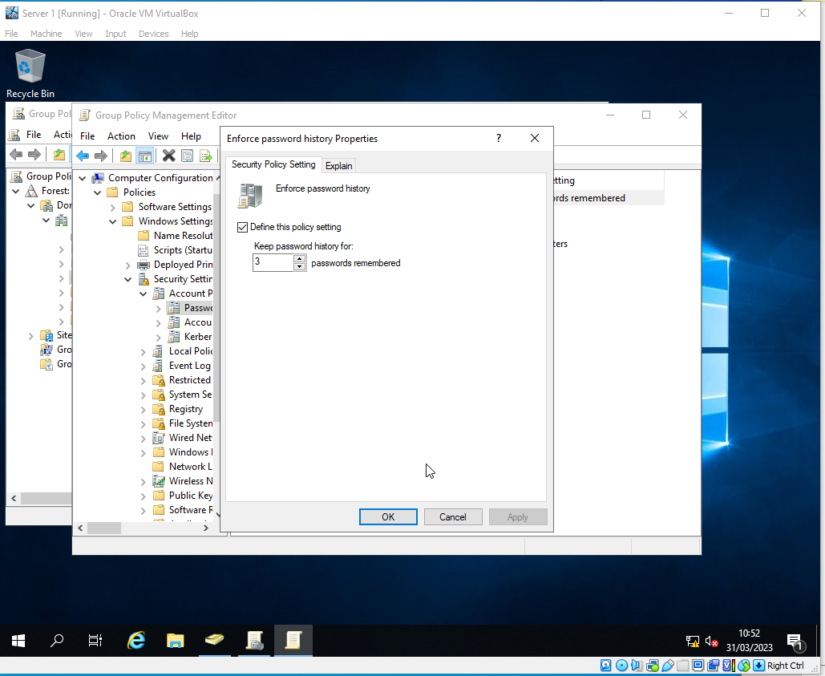
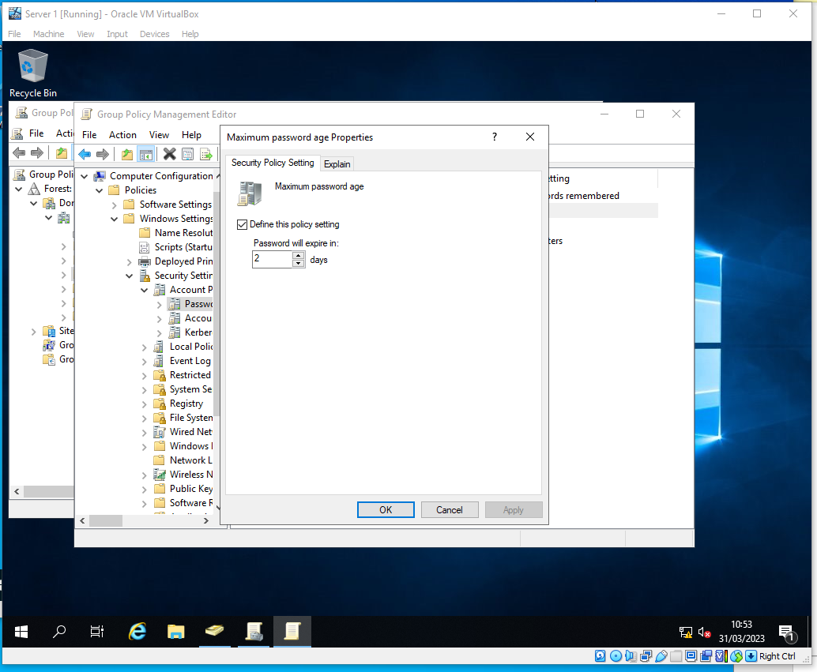
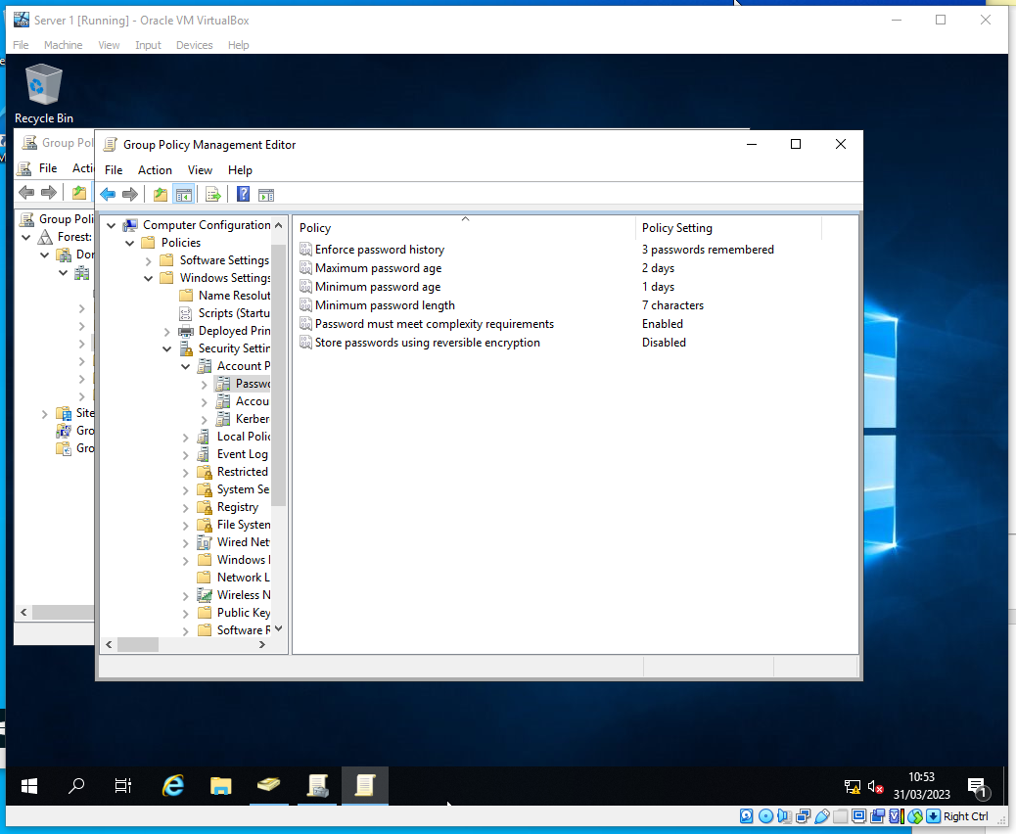
To further increase security, a password policy was added across the entire network. This policy ensured that passwords had to be at least 7 characters in length, and that the policy remembers the previous 3 passwords so that a user couldn’t keep reusing the same 2 passwords over and over. A complexity requirement was also added to make sure that the passwords were as secure as possible.

Task 2: ROUTING AND PACKET FILTERING WITHIN CORE TCP/IP SERVICES AND CRITICAL FAILOVER/REDUNDANCY PRACTICES

1 - Utilising ARP and Routing Tables

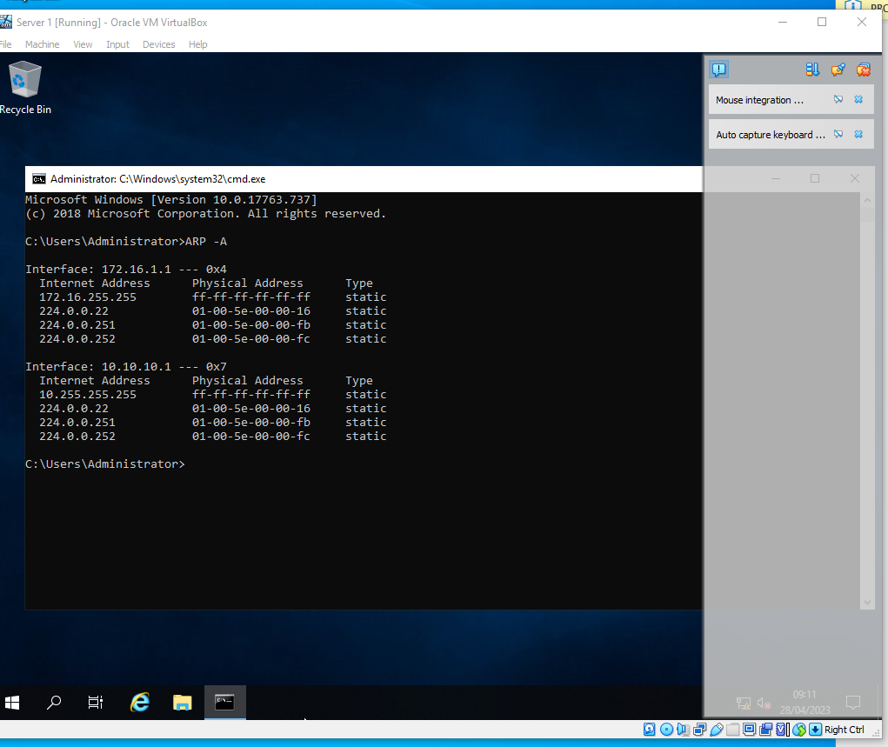
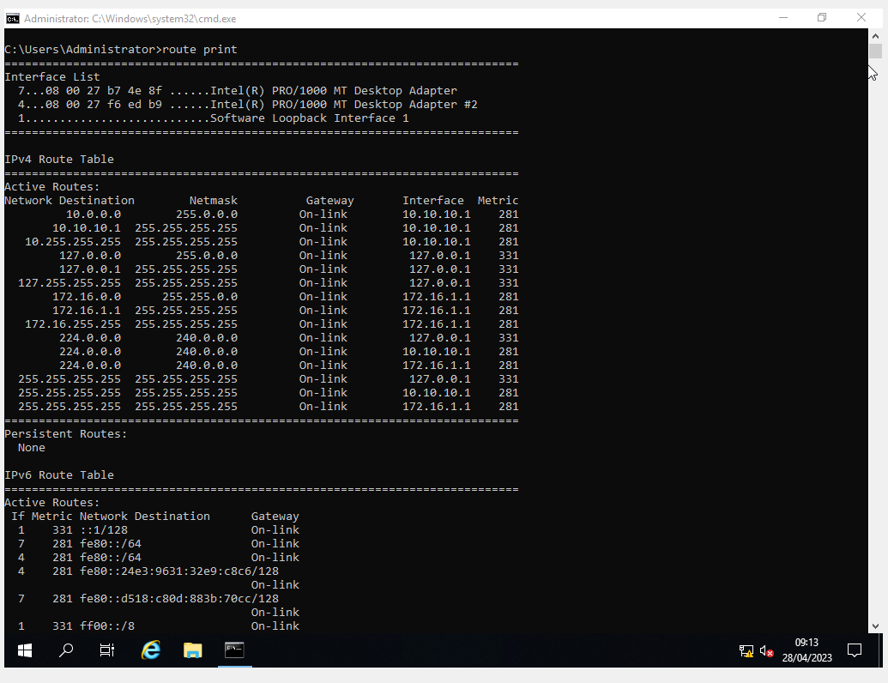
The “arp -A” and the “route print” command were used to display the MAC table, which includes the NIC, the MAC and the IPs of the NICs.

2 - Deploy Core Services

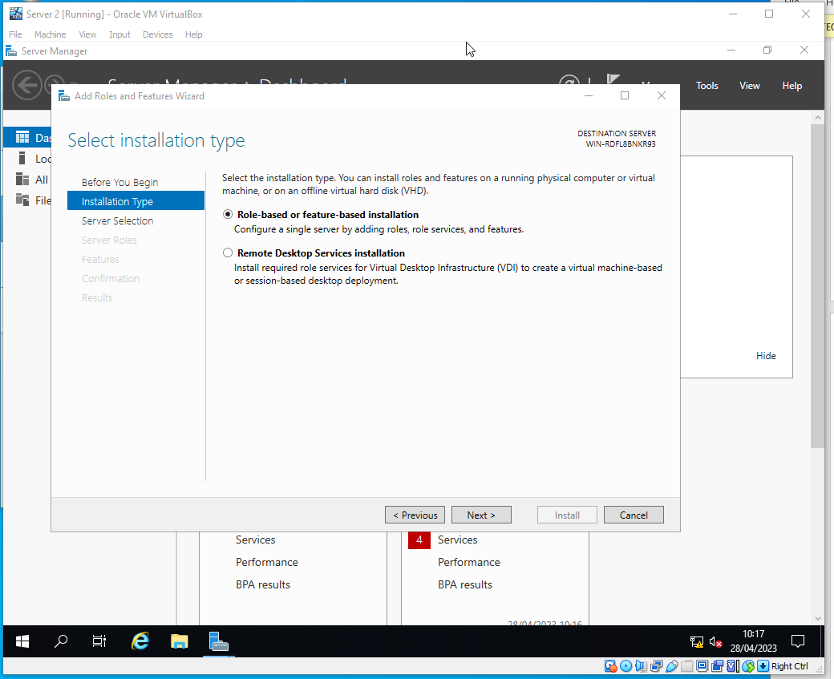

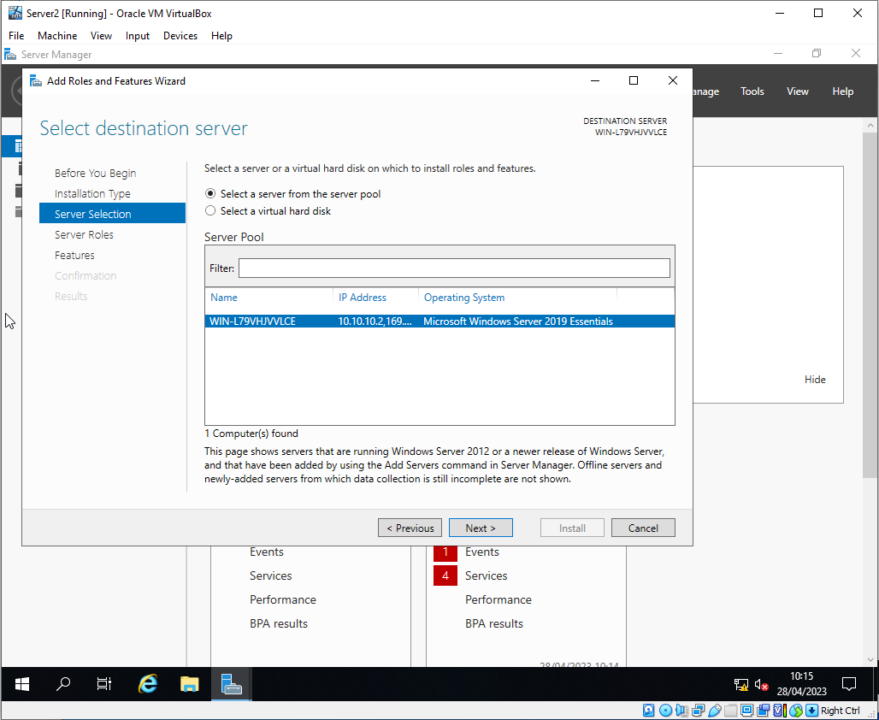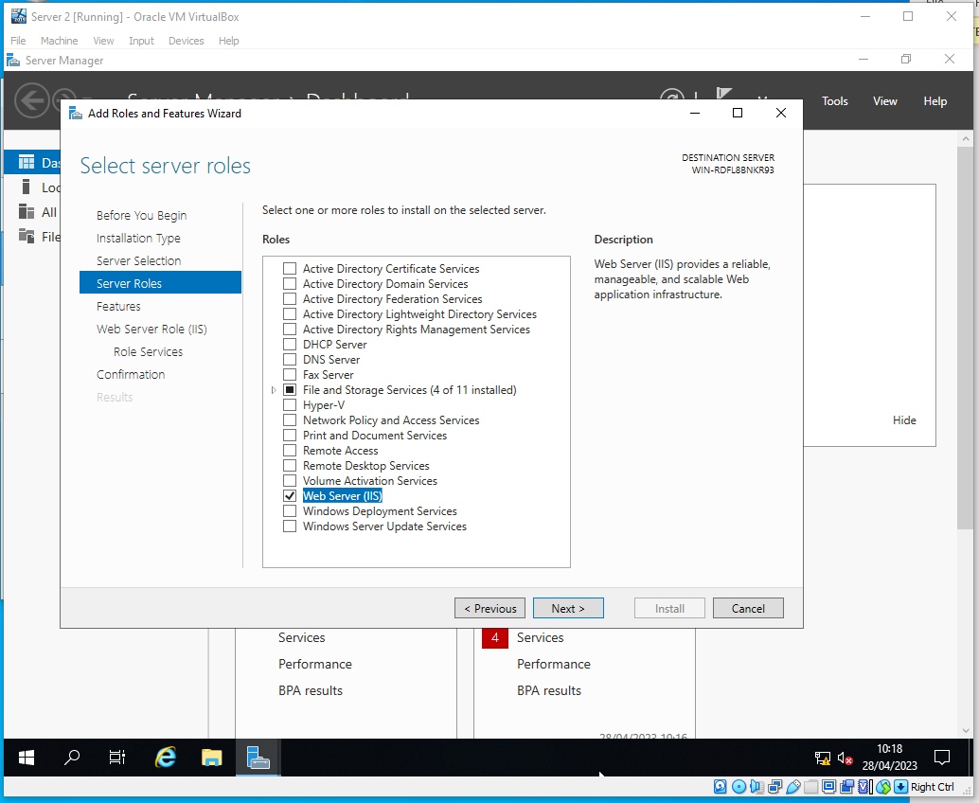

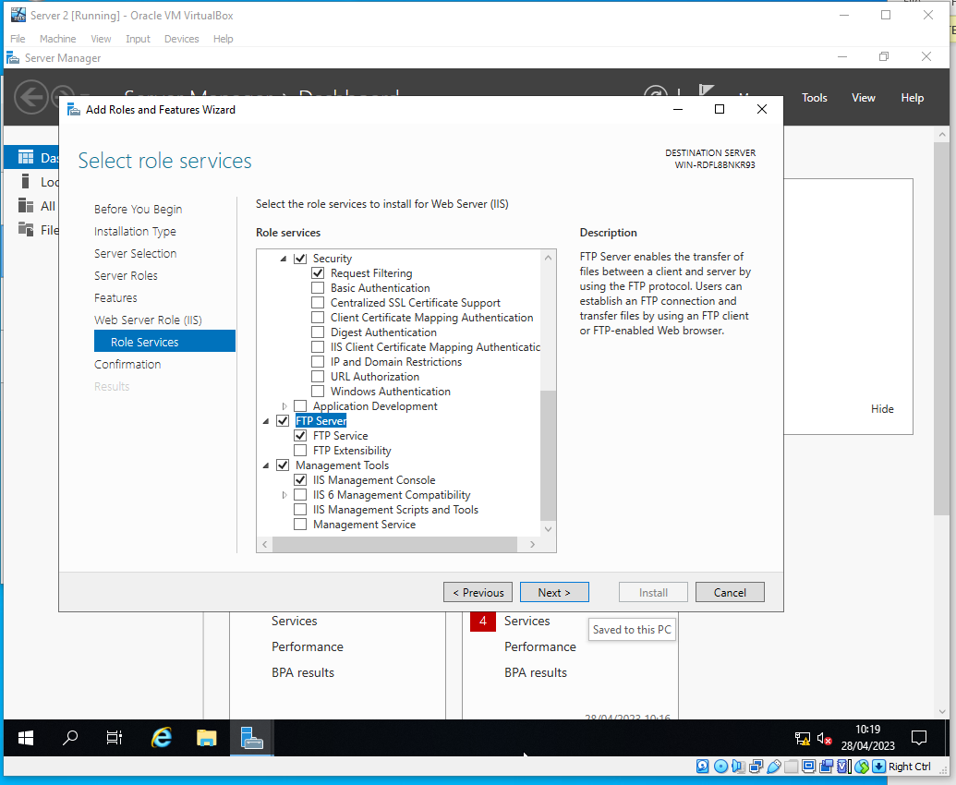
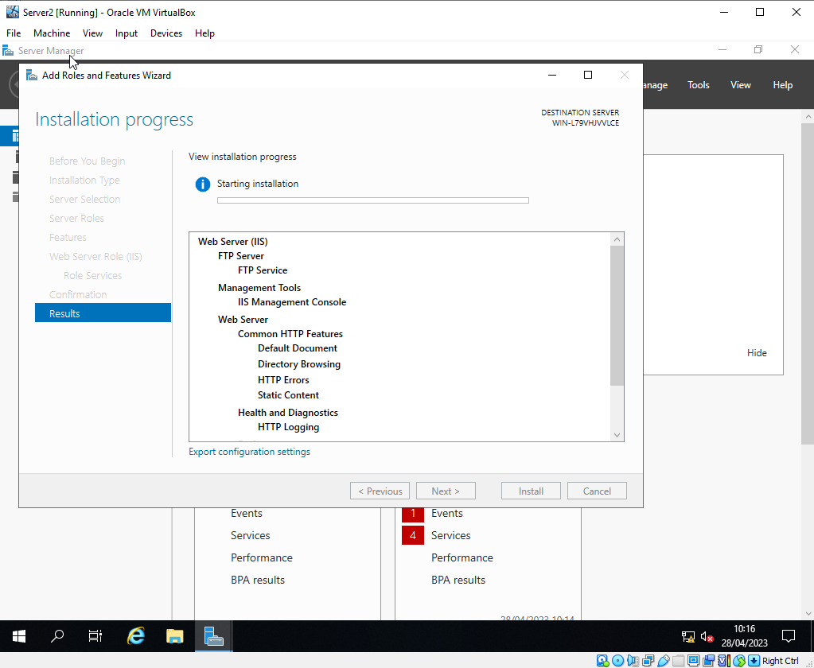
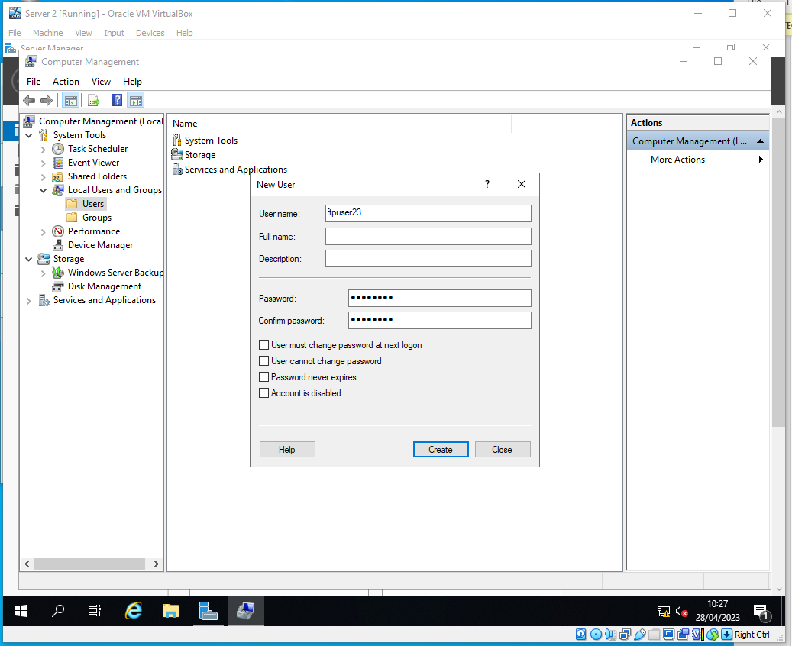

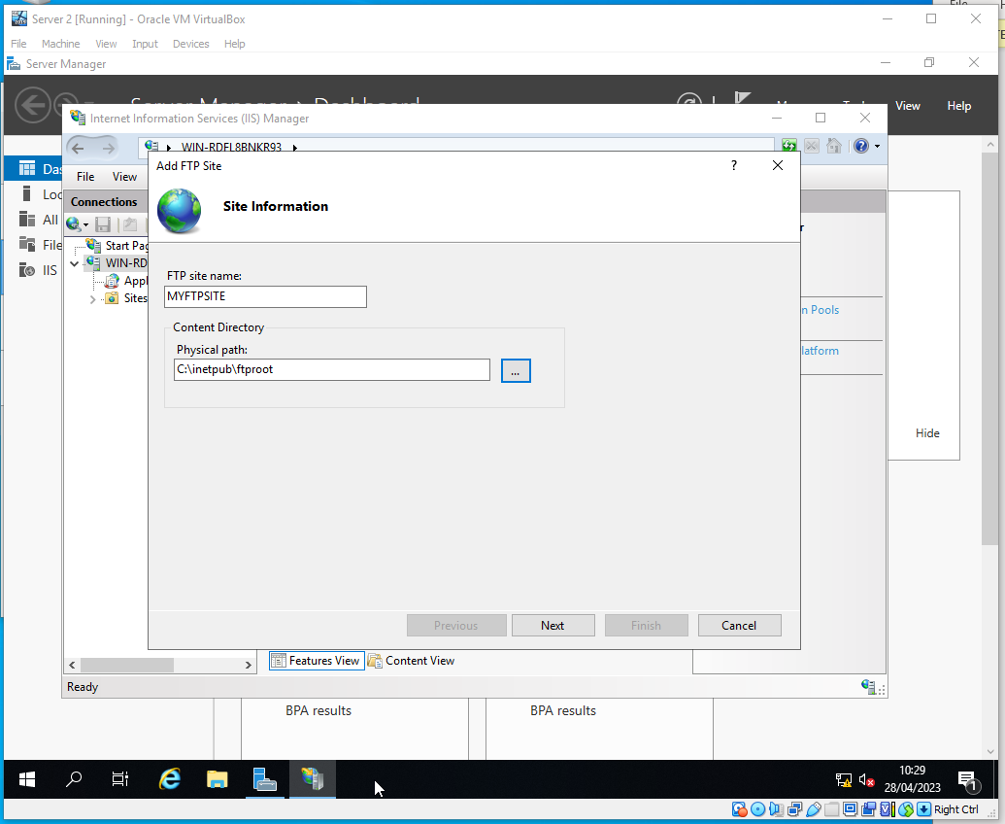
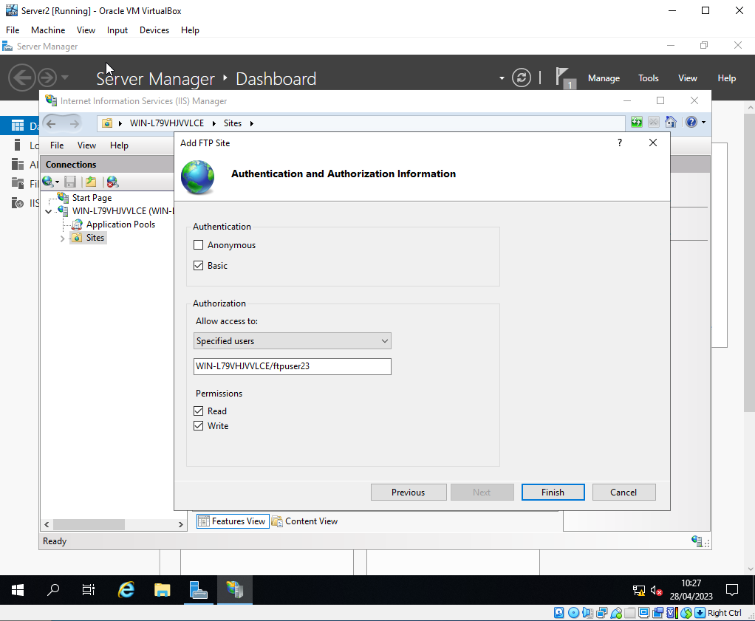
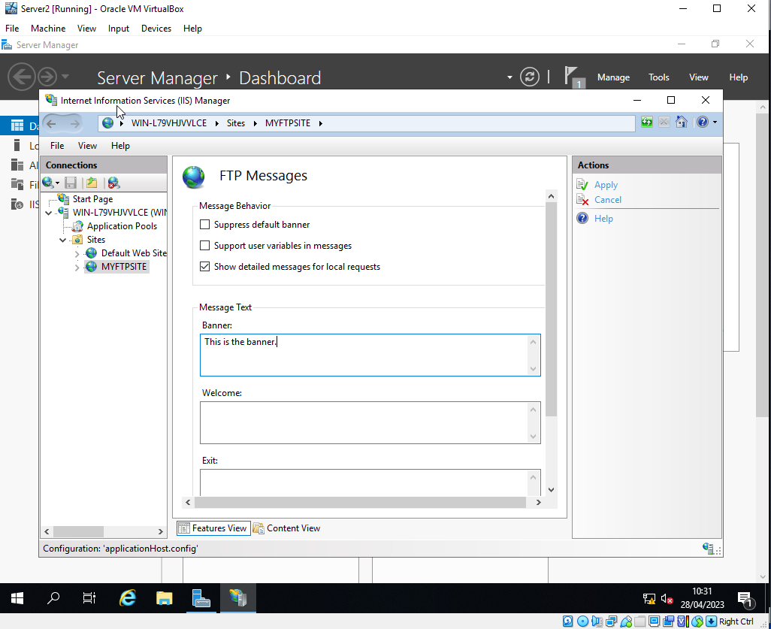
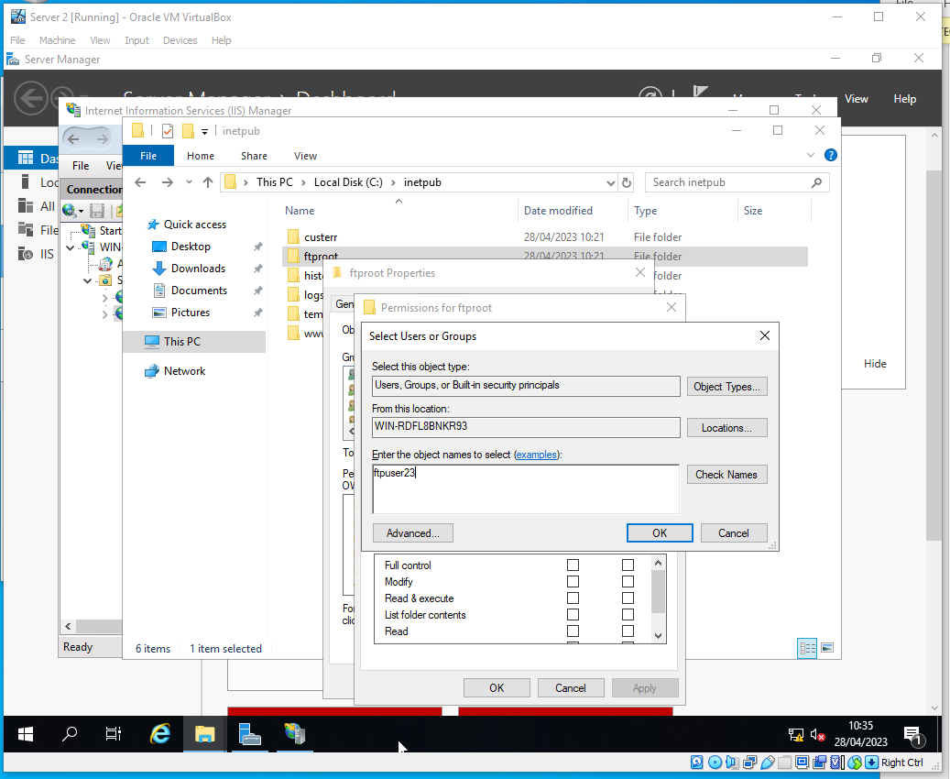
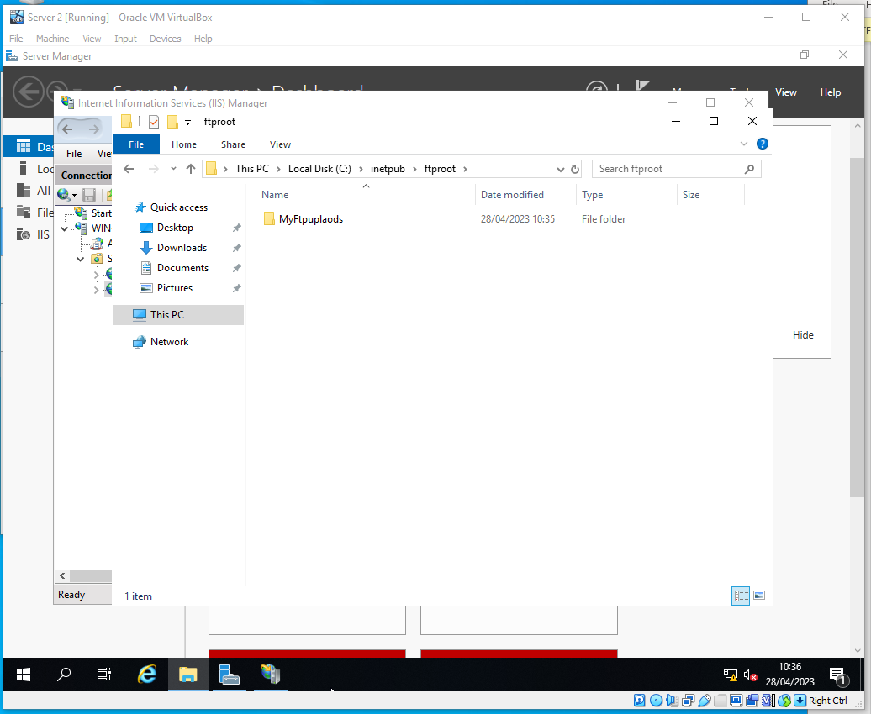
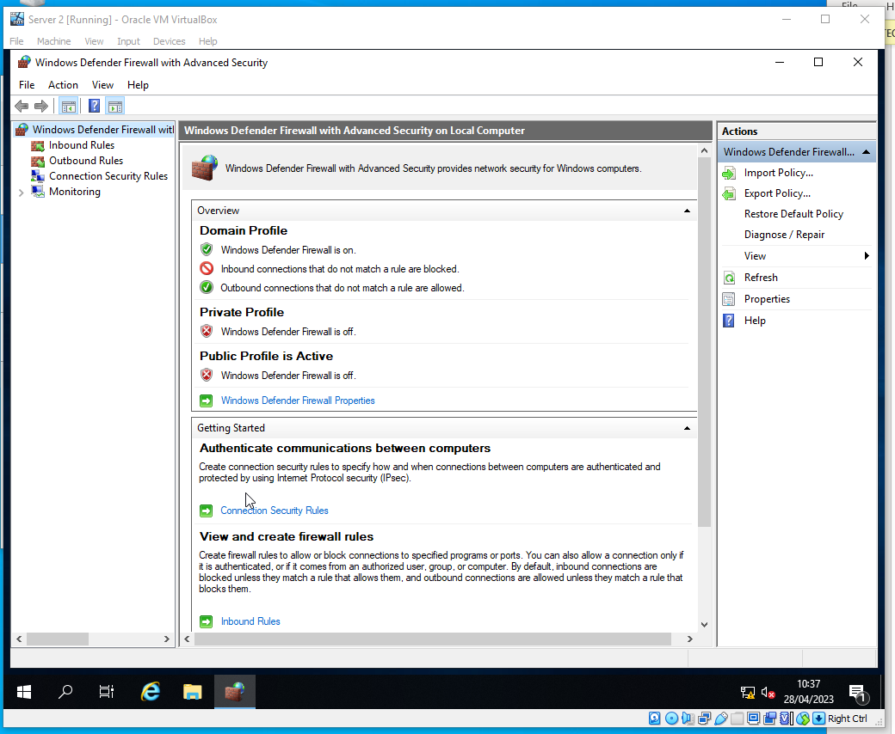

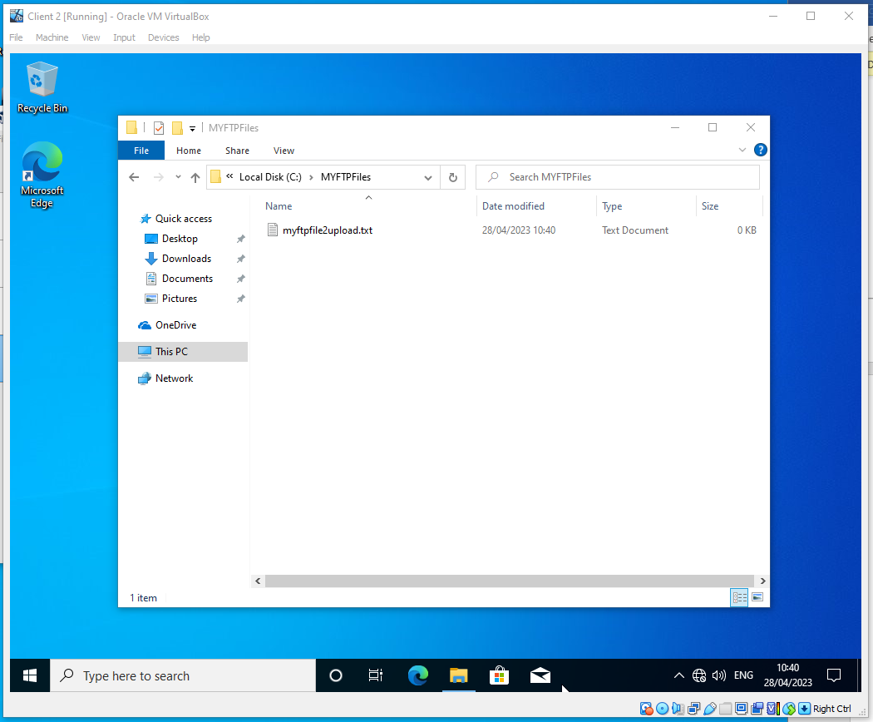
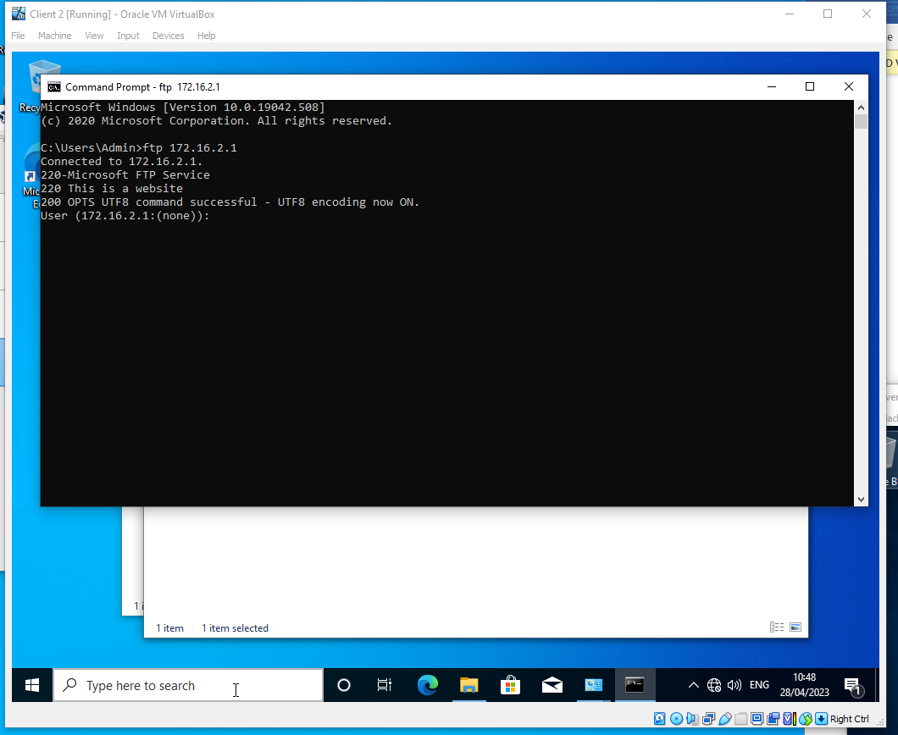

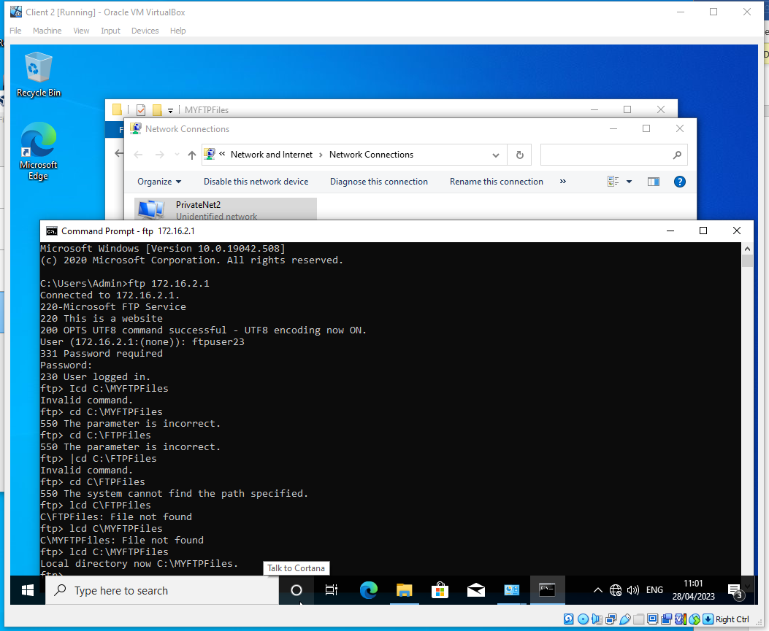

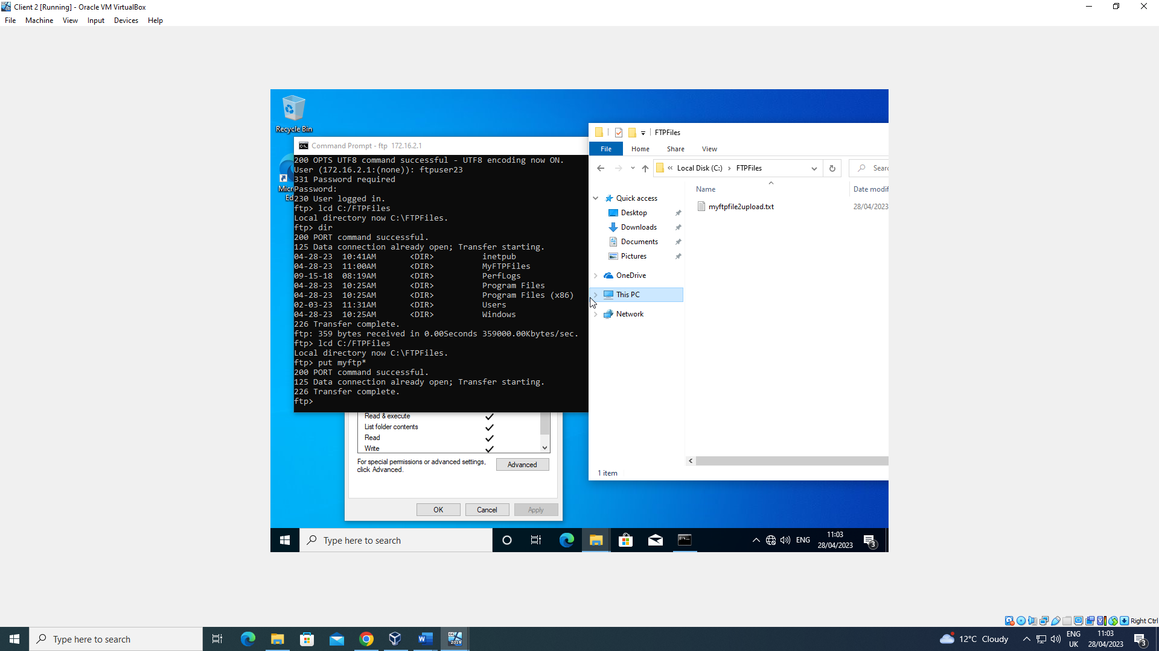

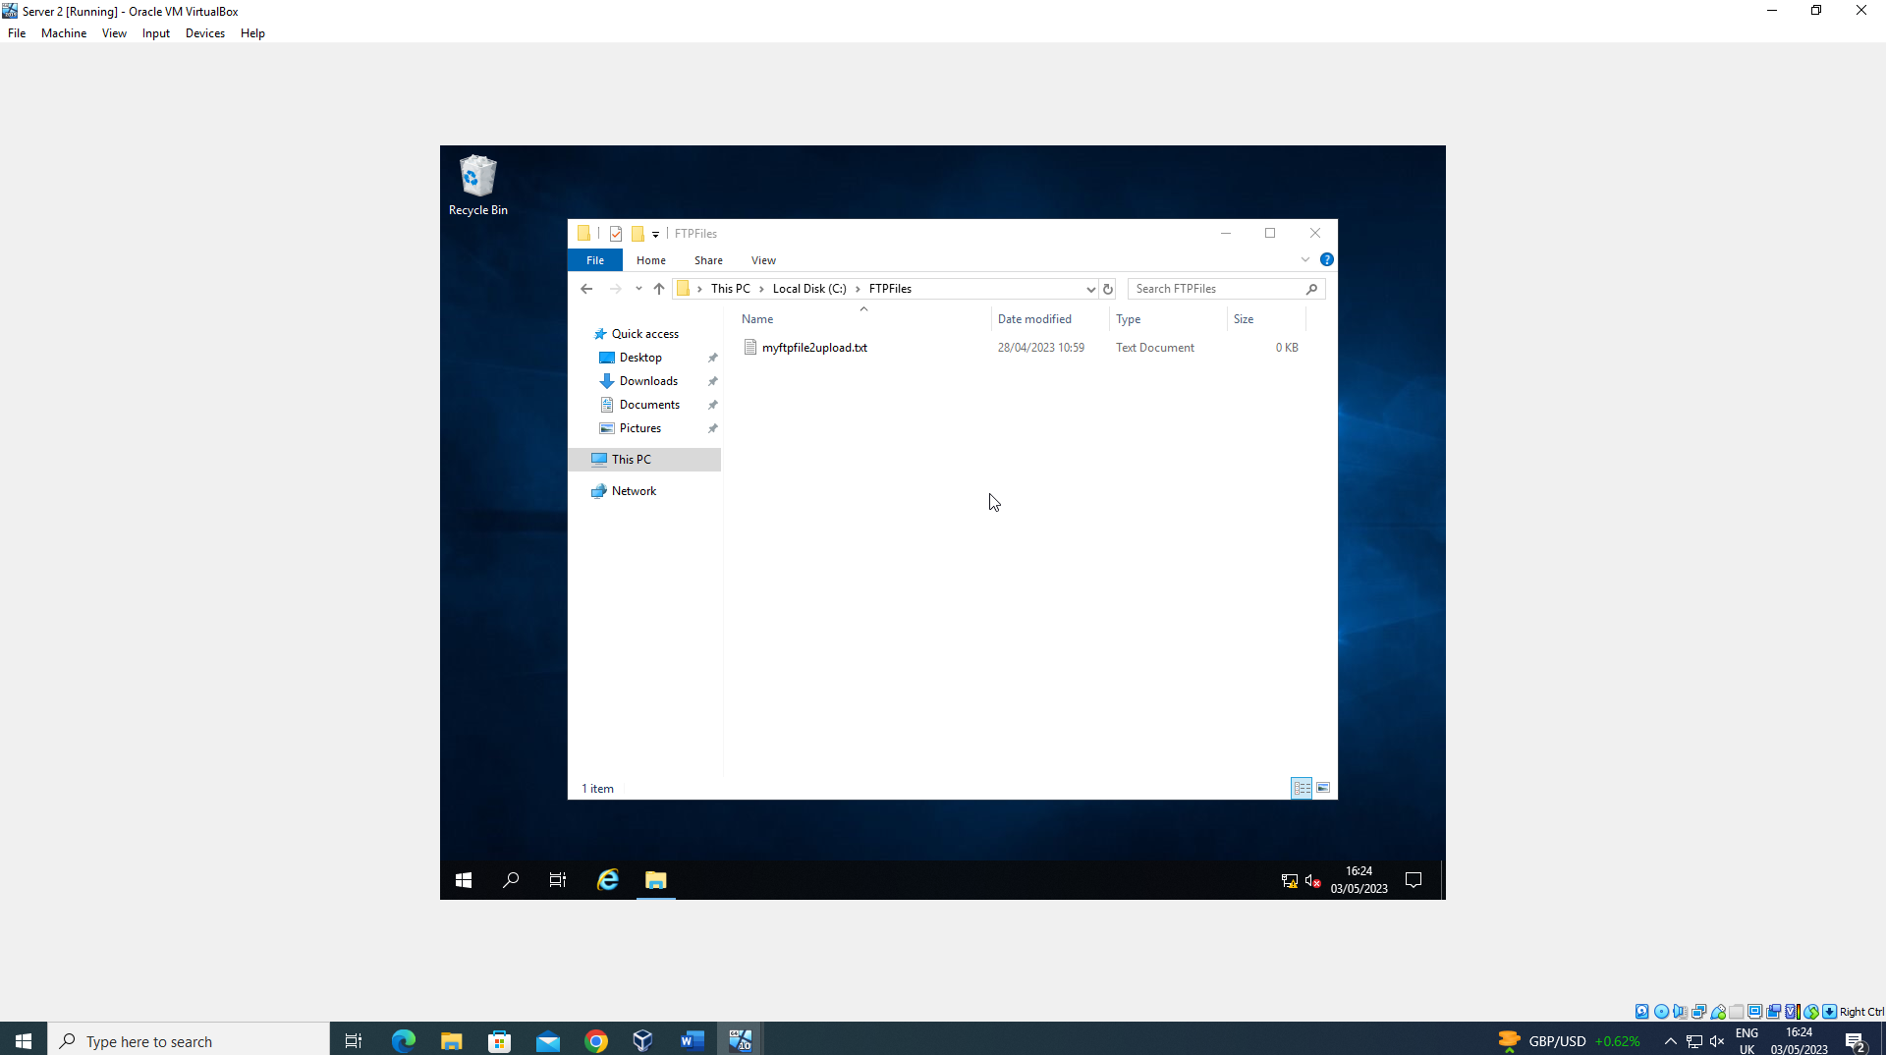
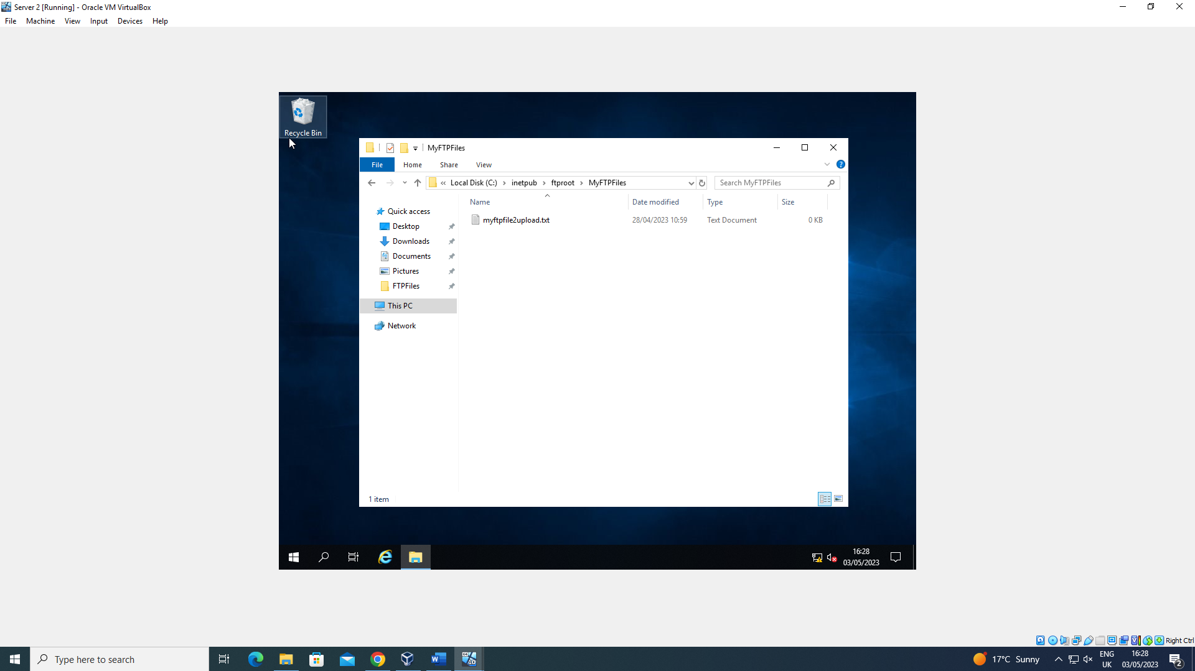
In this section, an FTP server was created into the network, this allows the exchange of files across the network. A new user was created with the name of “ftpuser23” and following that, the Internet Information Services (IIS) tool was used to add an FTP Site with the name of “MYFTPSITE”. After that, the new user was given read/write permissions to this FTP Site. The FTP Site was customised with a banner as a way to greet users and to inform them that they were connecting to the right server. The final screenshots show that the connection to the FTP service was successful.

3 - Installing and Configuring the Routing and Remote Access Service

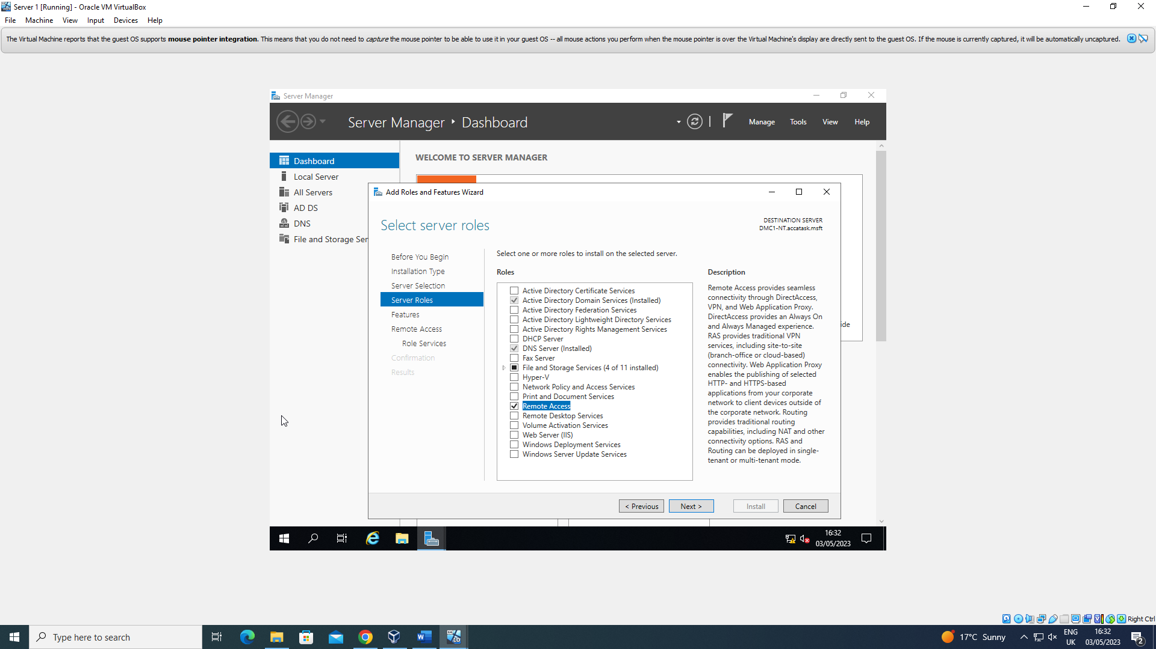

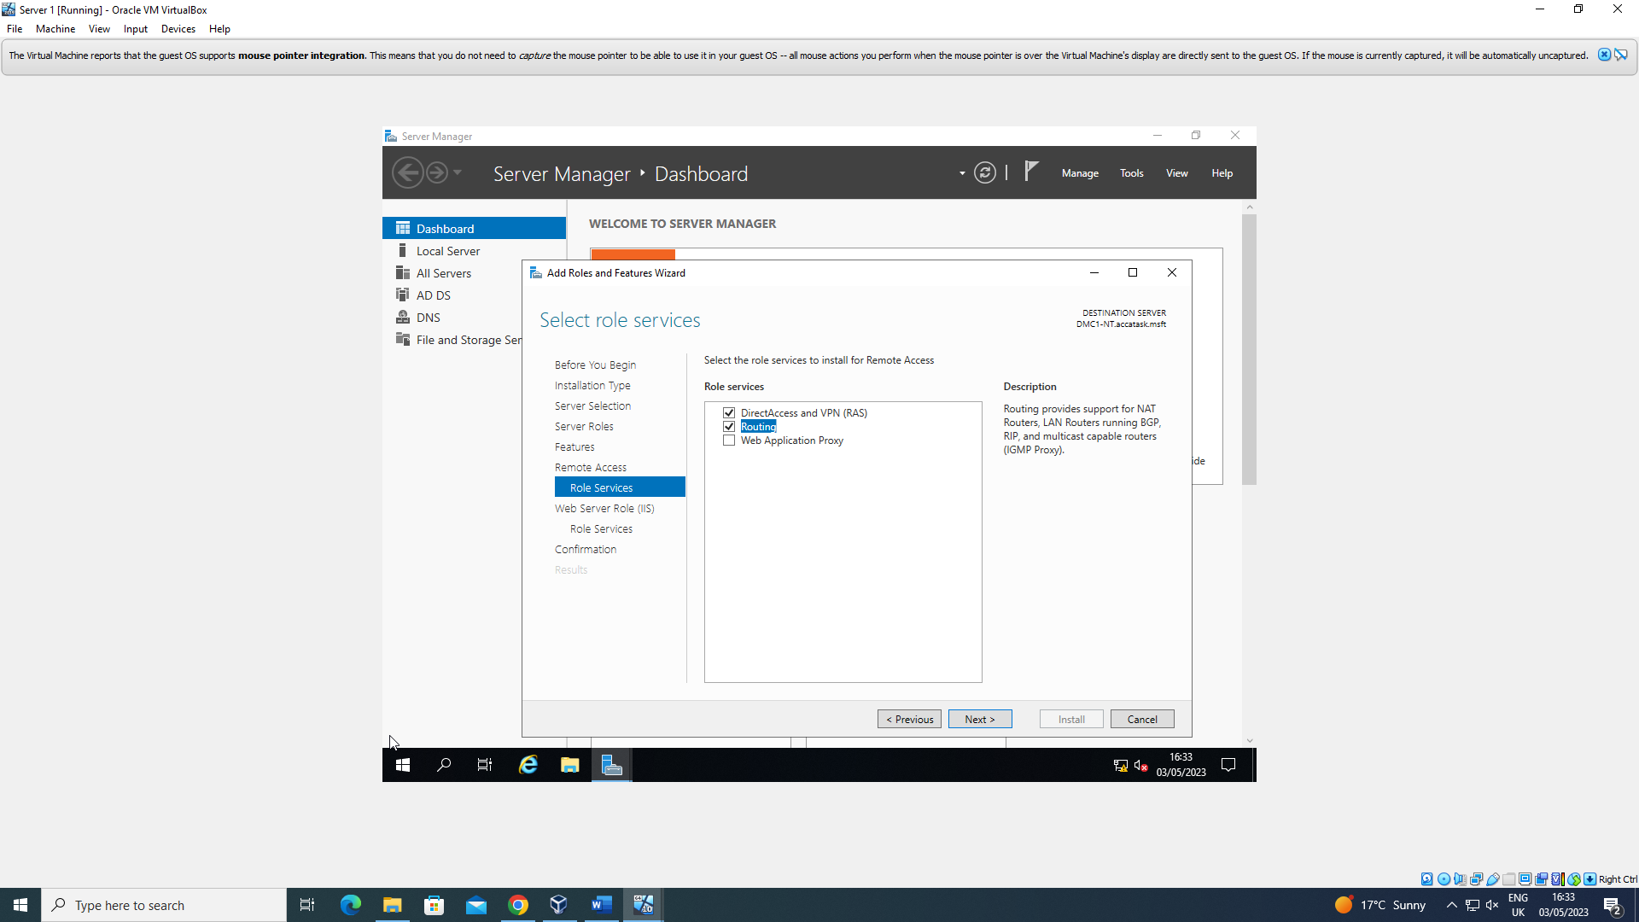

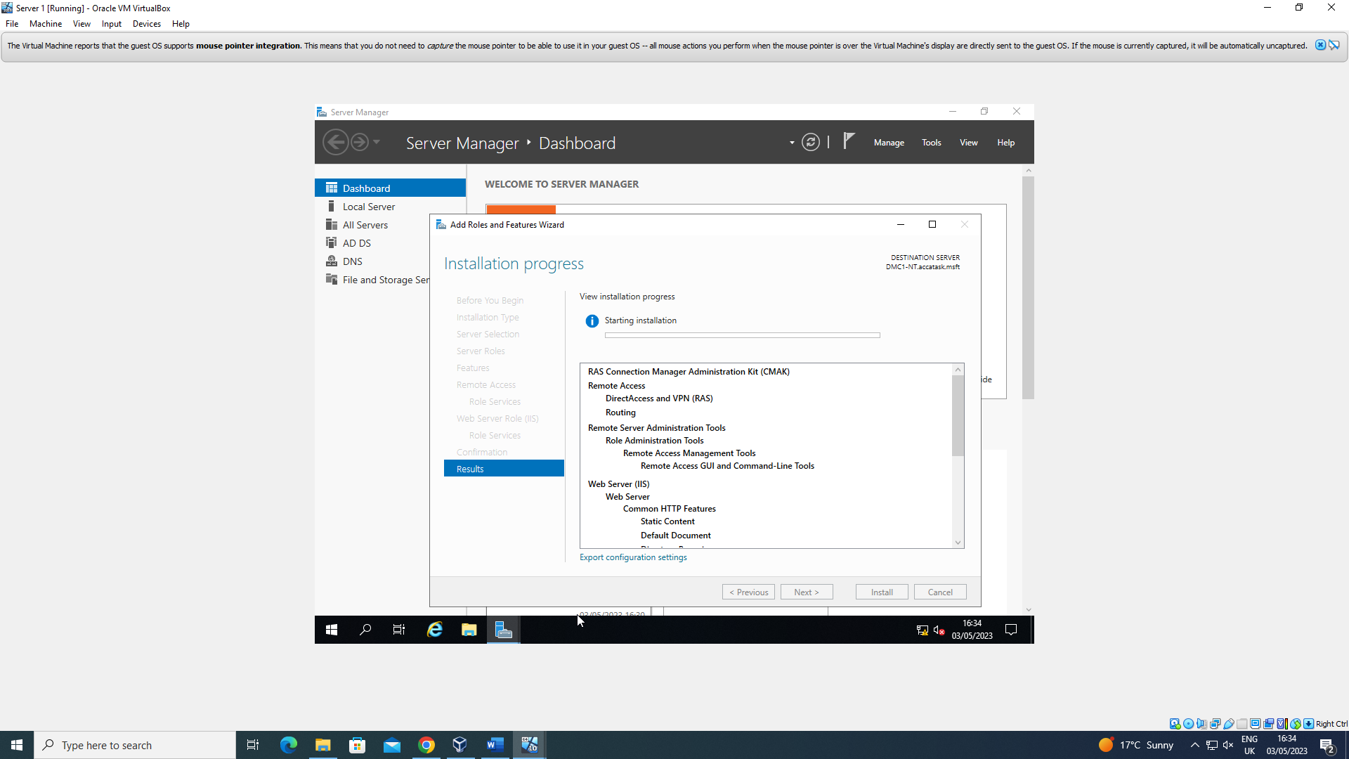

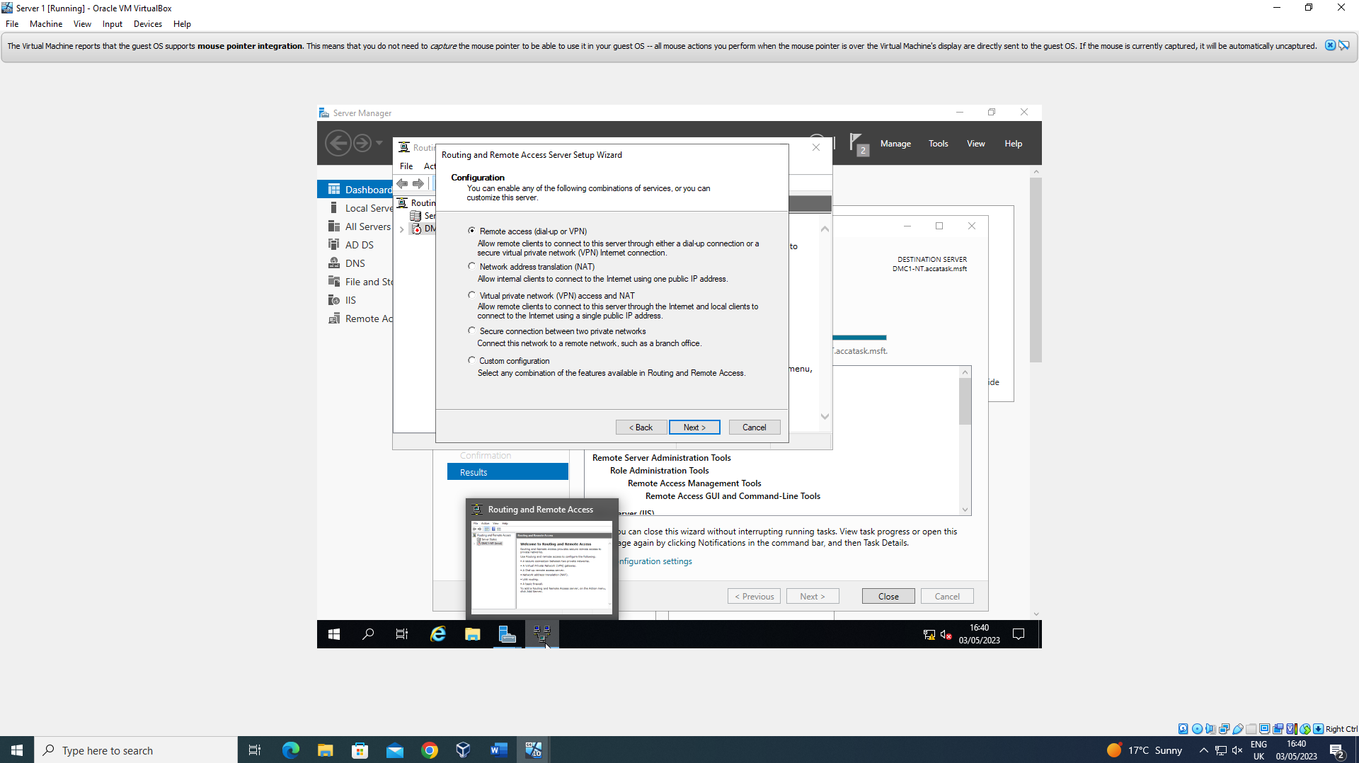

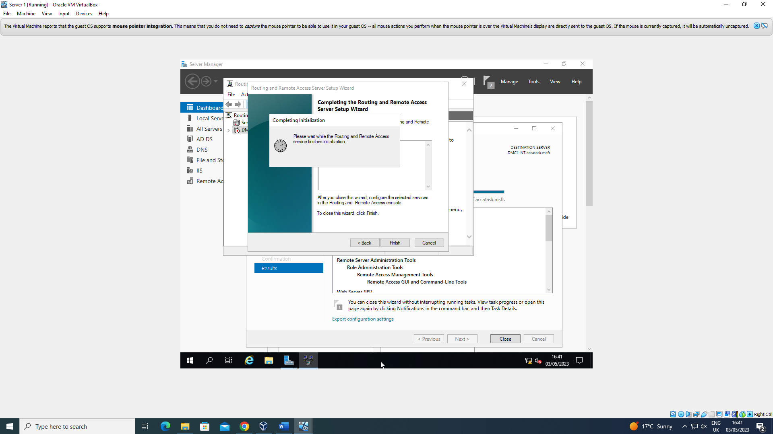

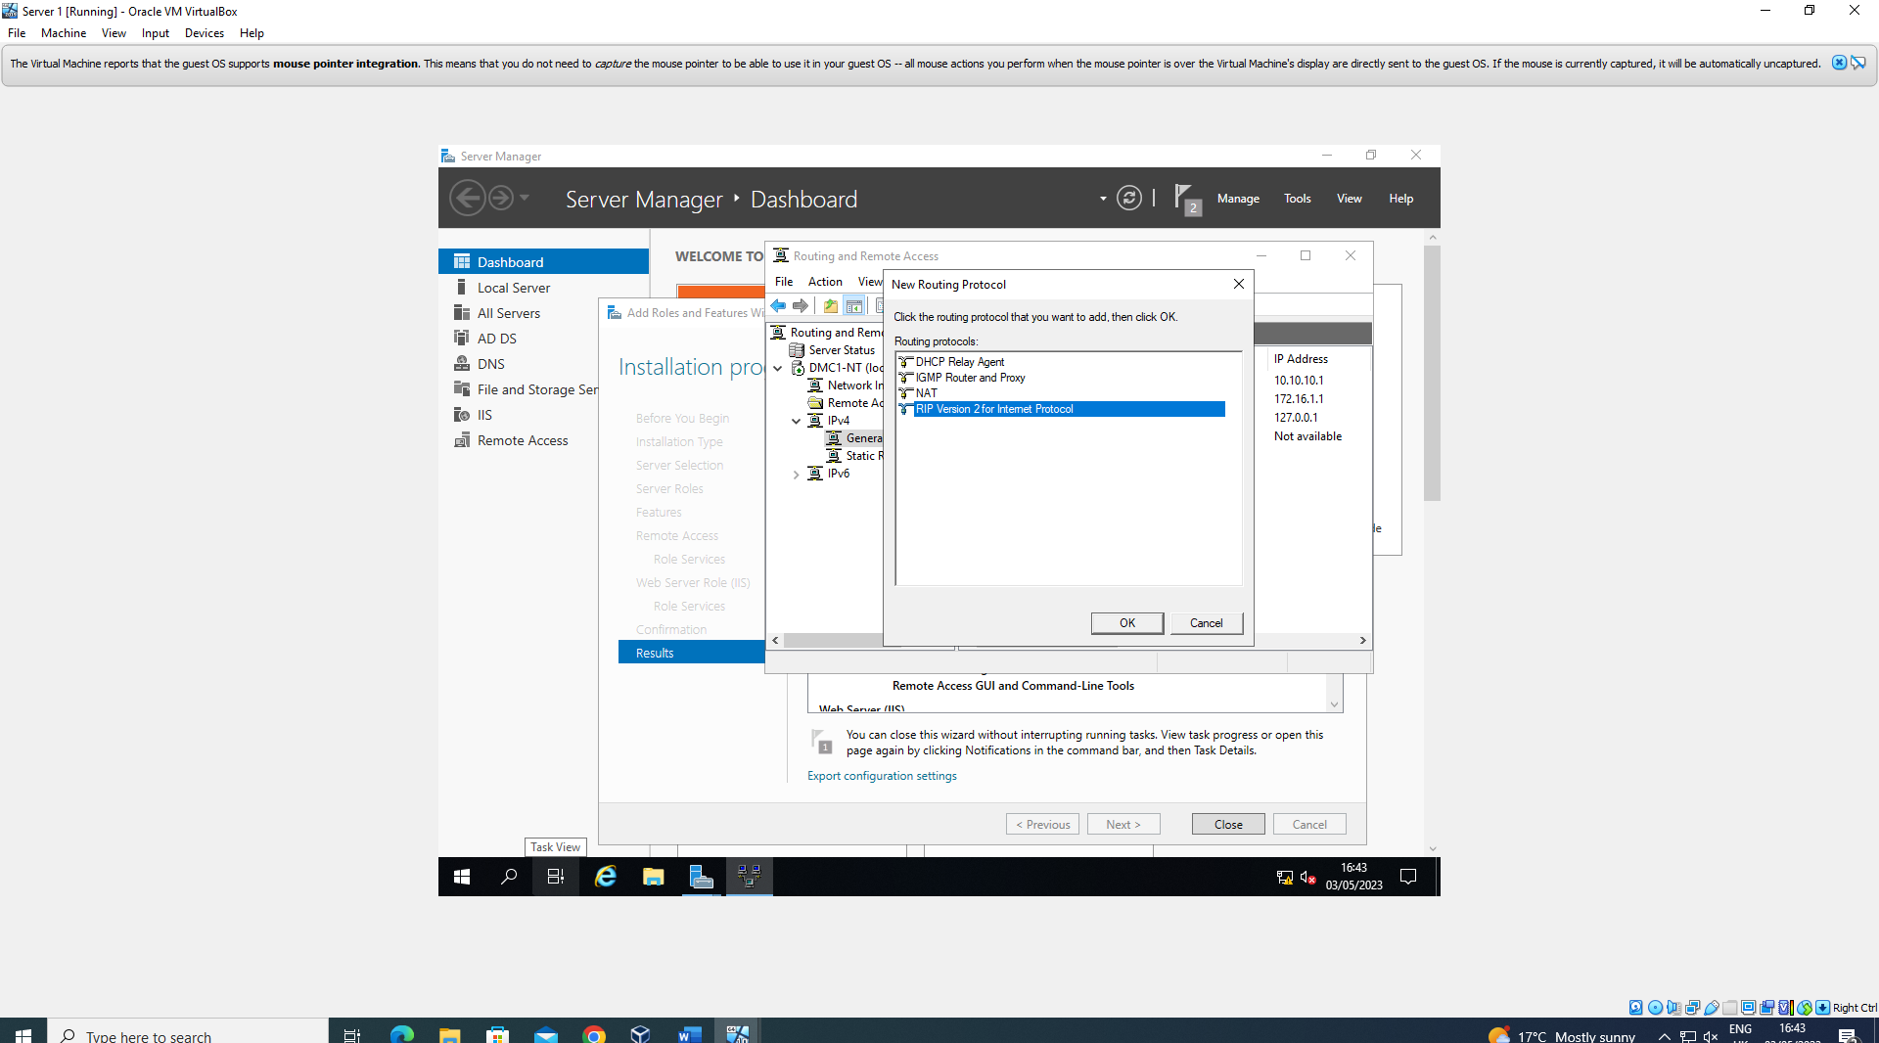

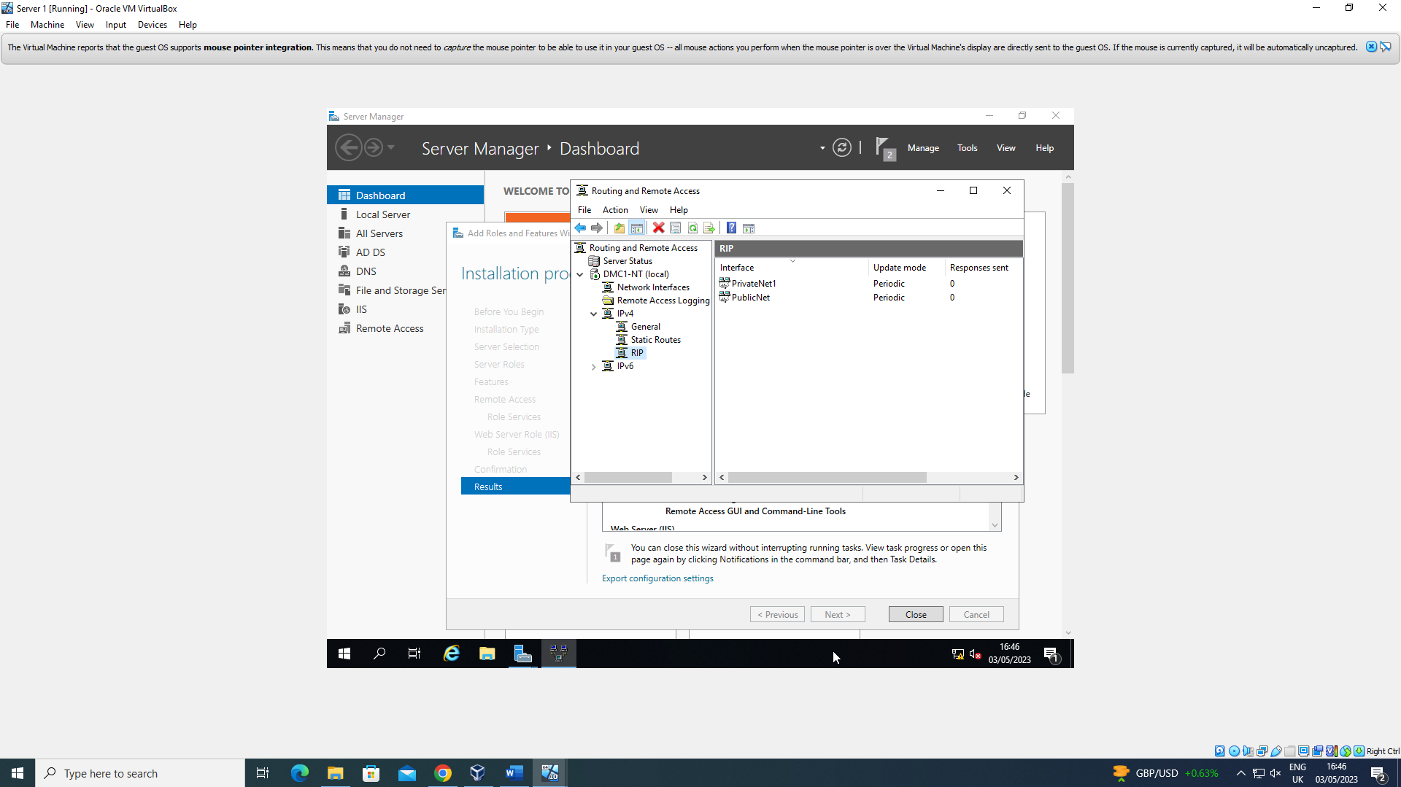

As a side note, the user then repeated this process over again for the second server to make sure that both of them are equipped with Direct Access and VPN with the routing services.

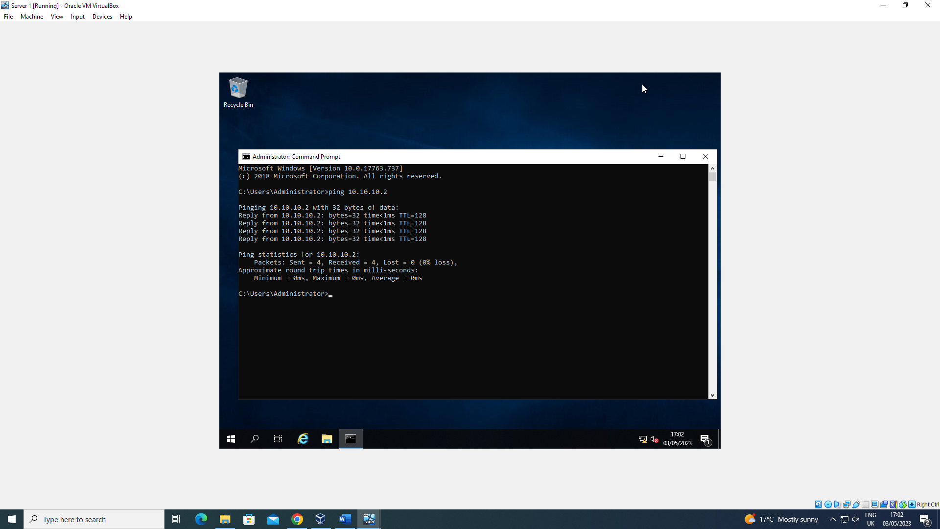

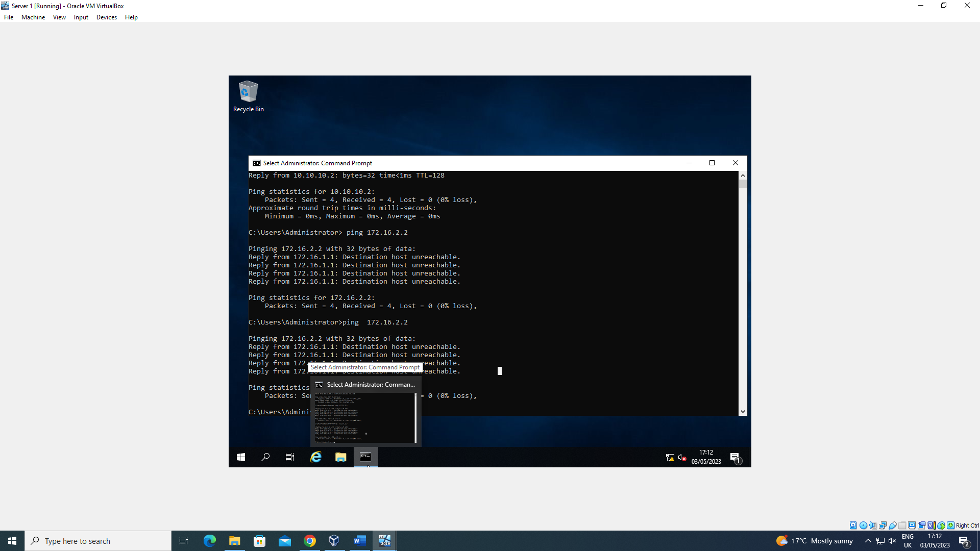
In this section, two local area networks were created and connected using routing protocols. This was done using the Server Manager on the Windows Server OS. These LANs were configured to allow remote connections by using the “Add roles or features” section of Server Manager. The routing protocols were added to the interfaces used to connect both the public and private network in the servers.

4 - IP Packet Filtering

Filter 1

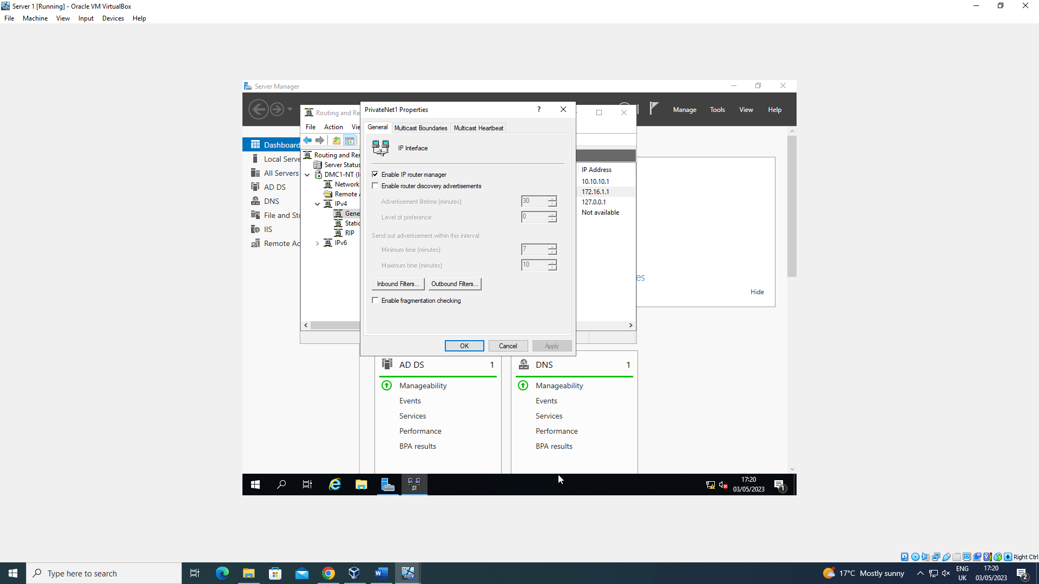

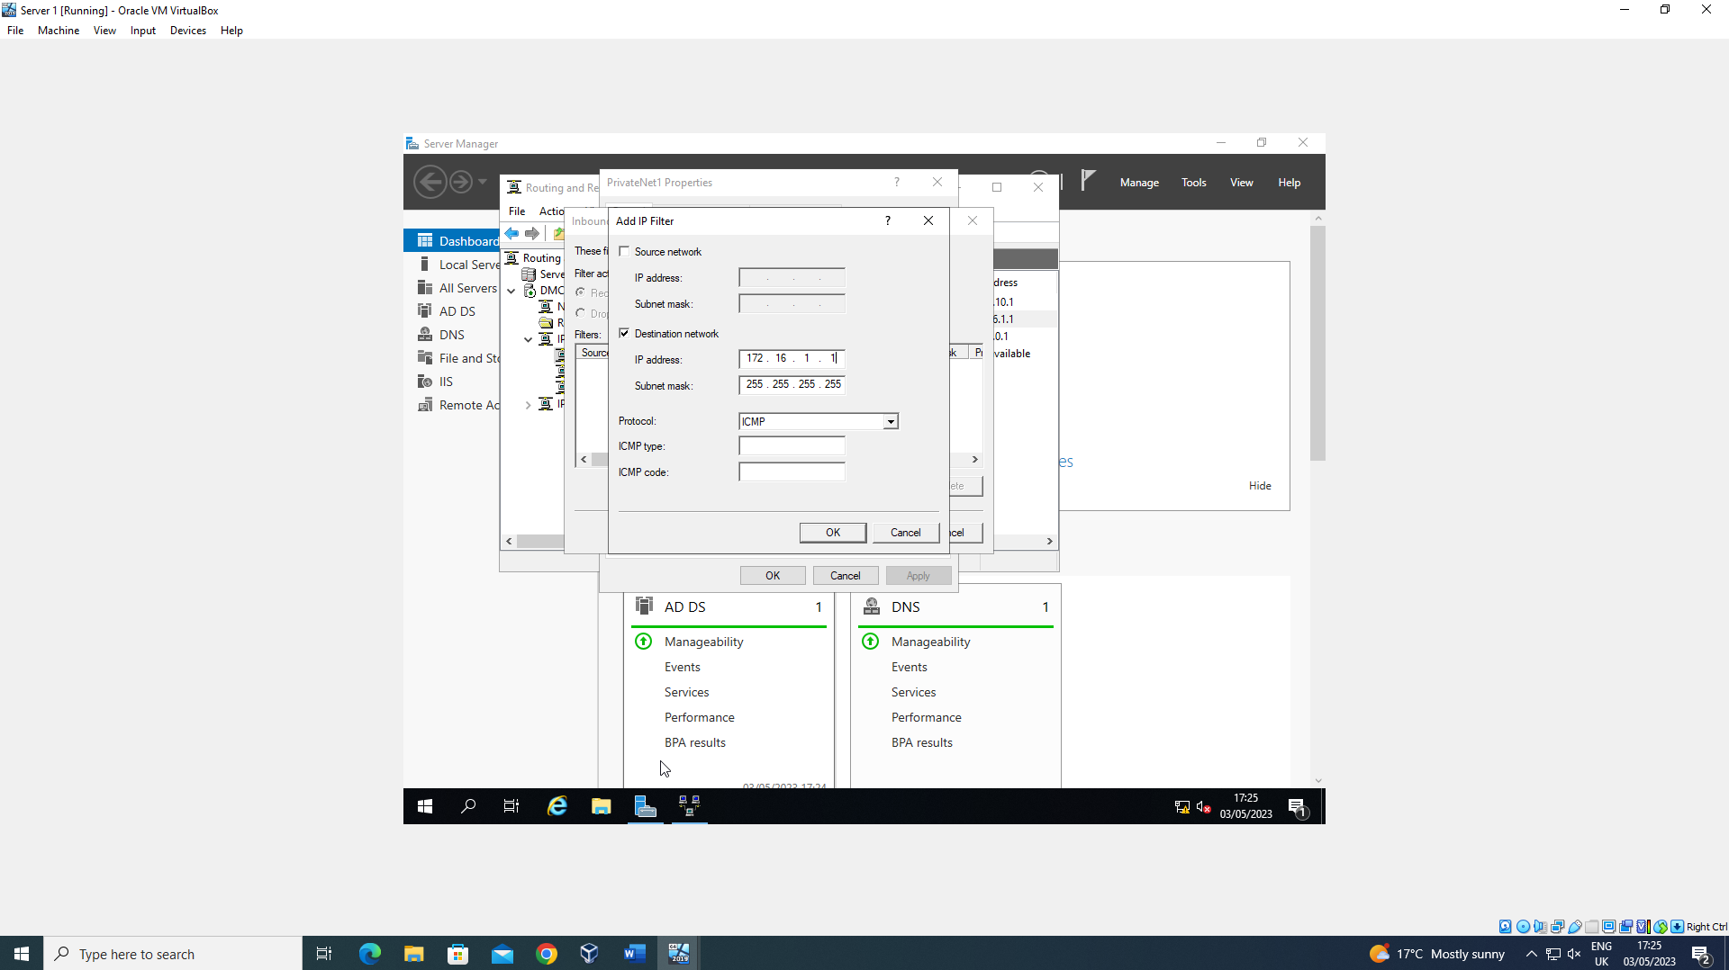

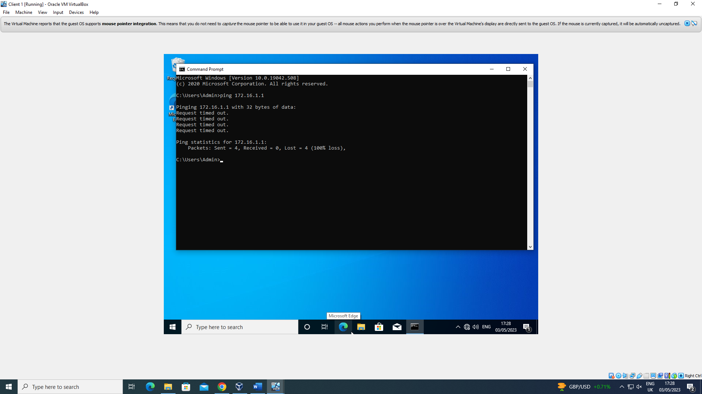
The first filter was used to stop users from pinging the router firewall service, this was done via IP filtering, this was used as a firewall to prevent unwanted outbound and inbound data. This was configured using the “Routing and Remote Access” section of Server Manager. This filter was then tested in the final screenshots above.

Filter 2

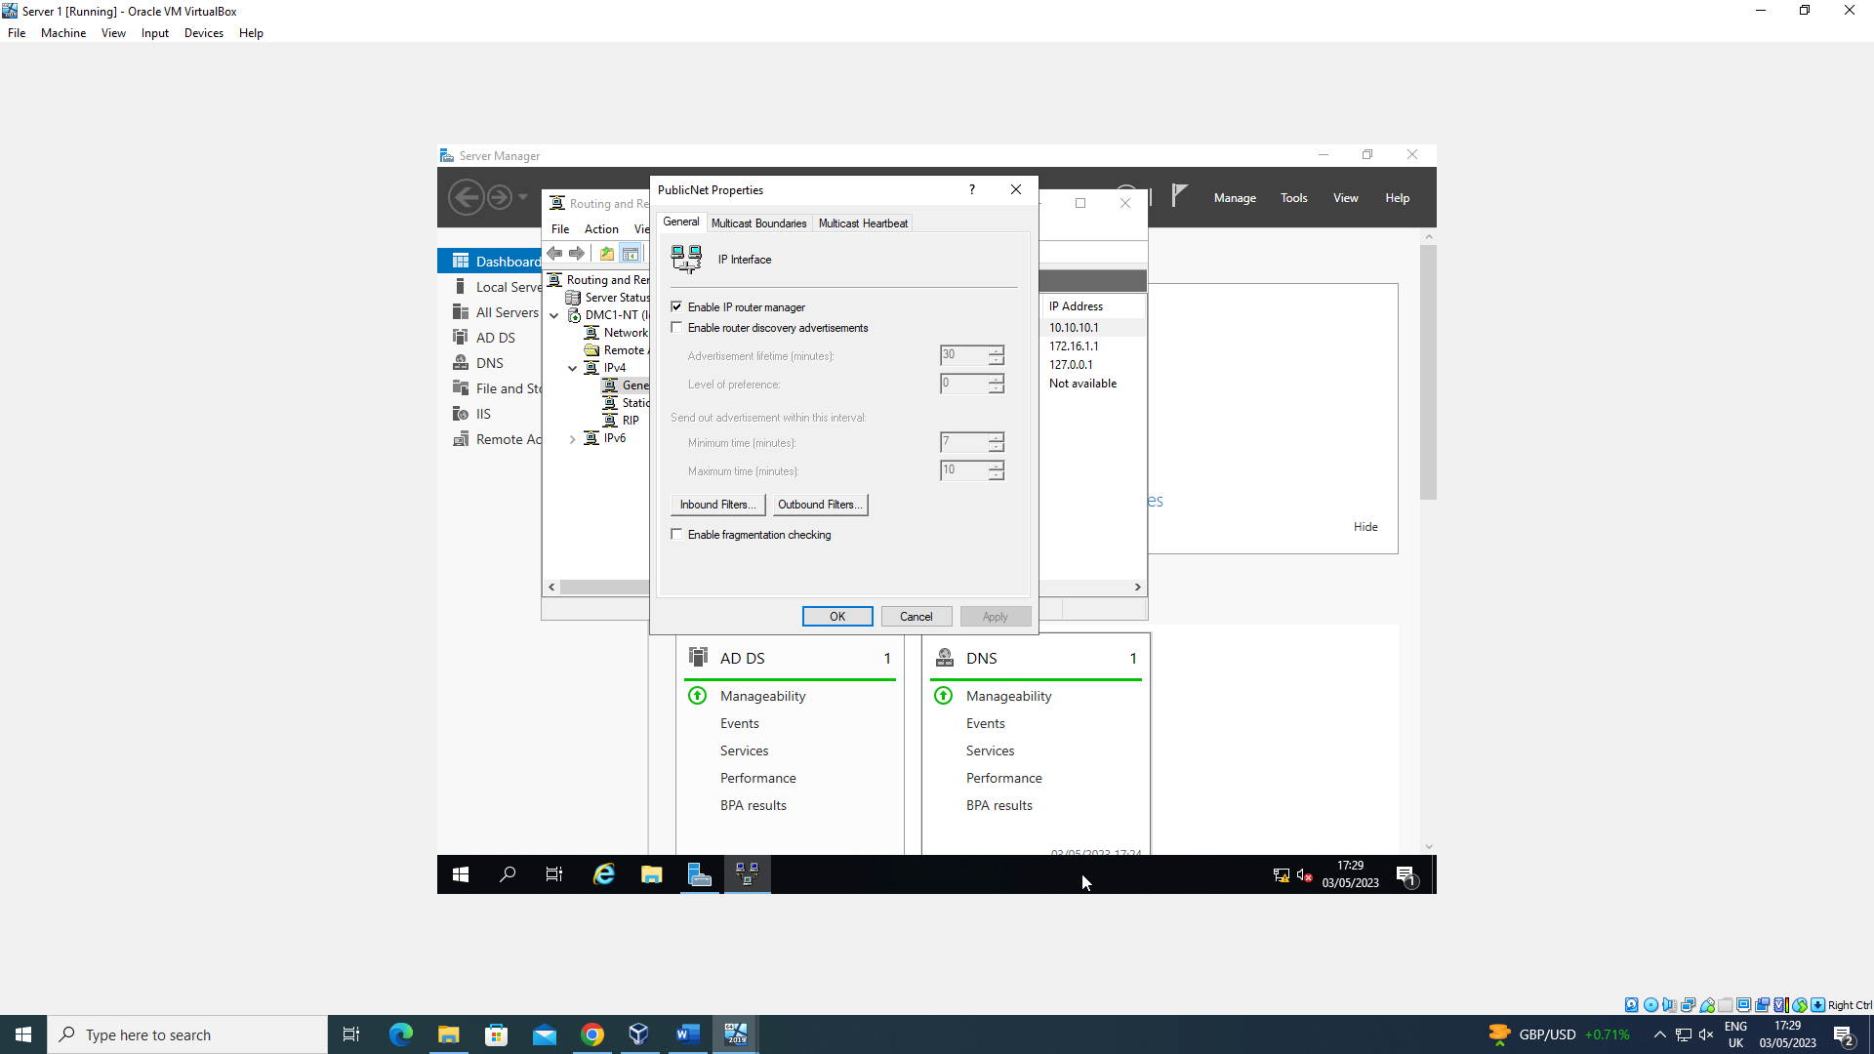

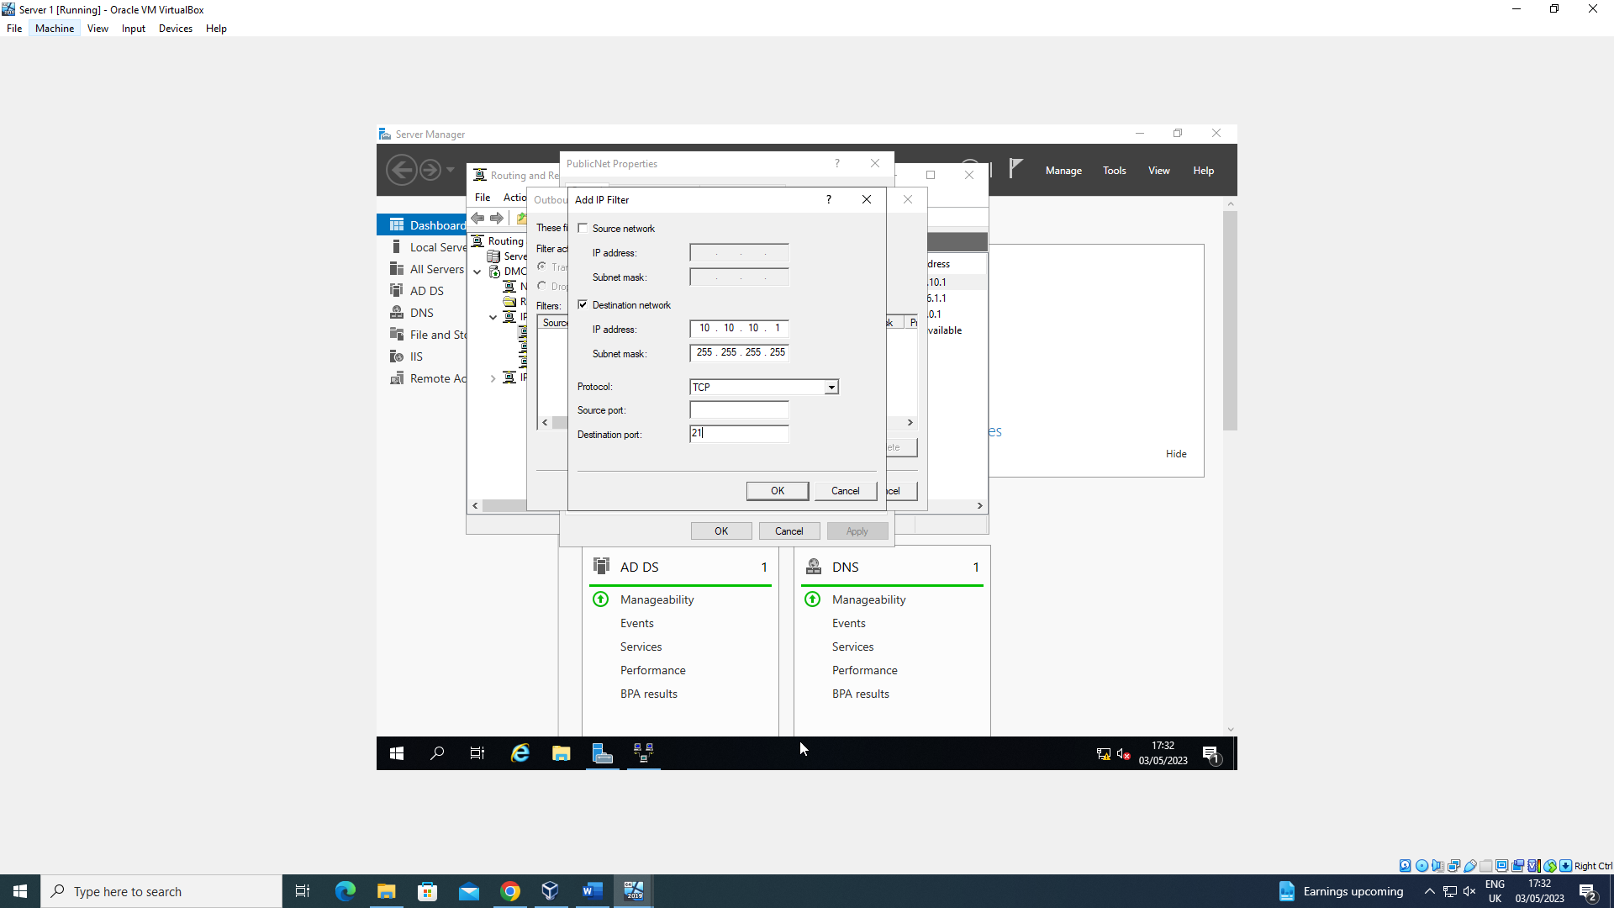

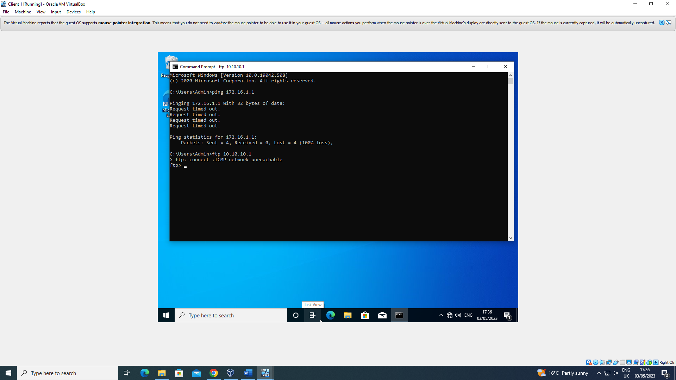
The 2nd filter was to restrict access to the FTP service running on Server 2 to only the users on the PrivateNet2. This was once again achieved by using the “Routing and Remote Access” tool available in Server Manager. This filter was then tested as shown in the final screenshots above.

Filter 3

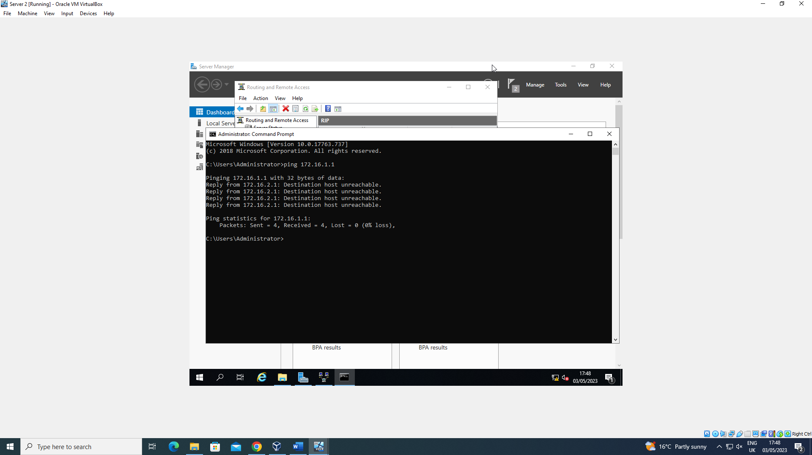

Server 1

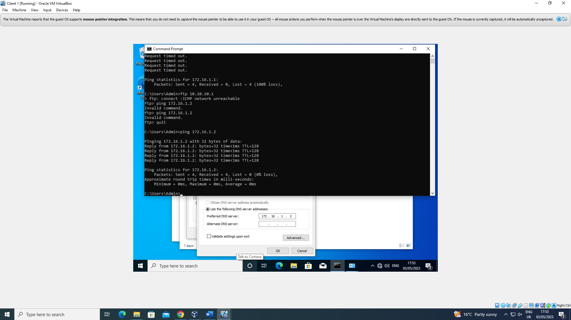
Client 1 success

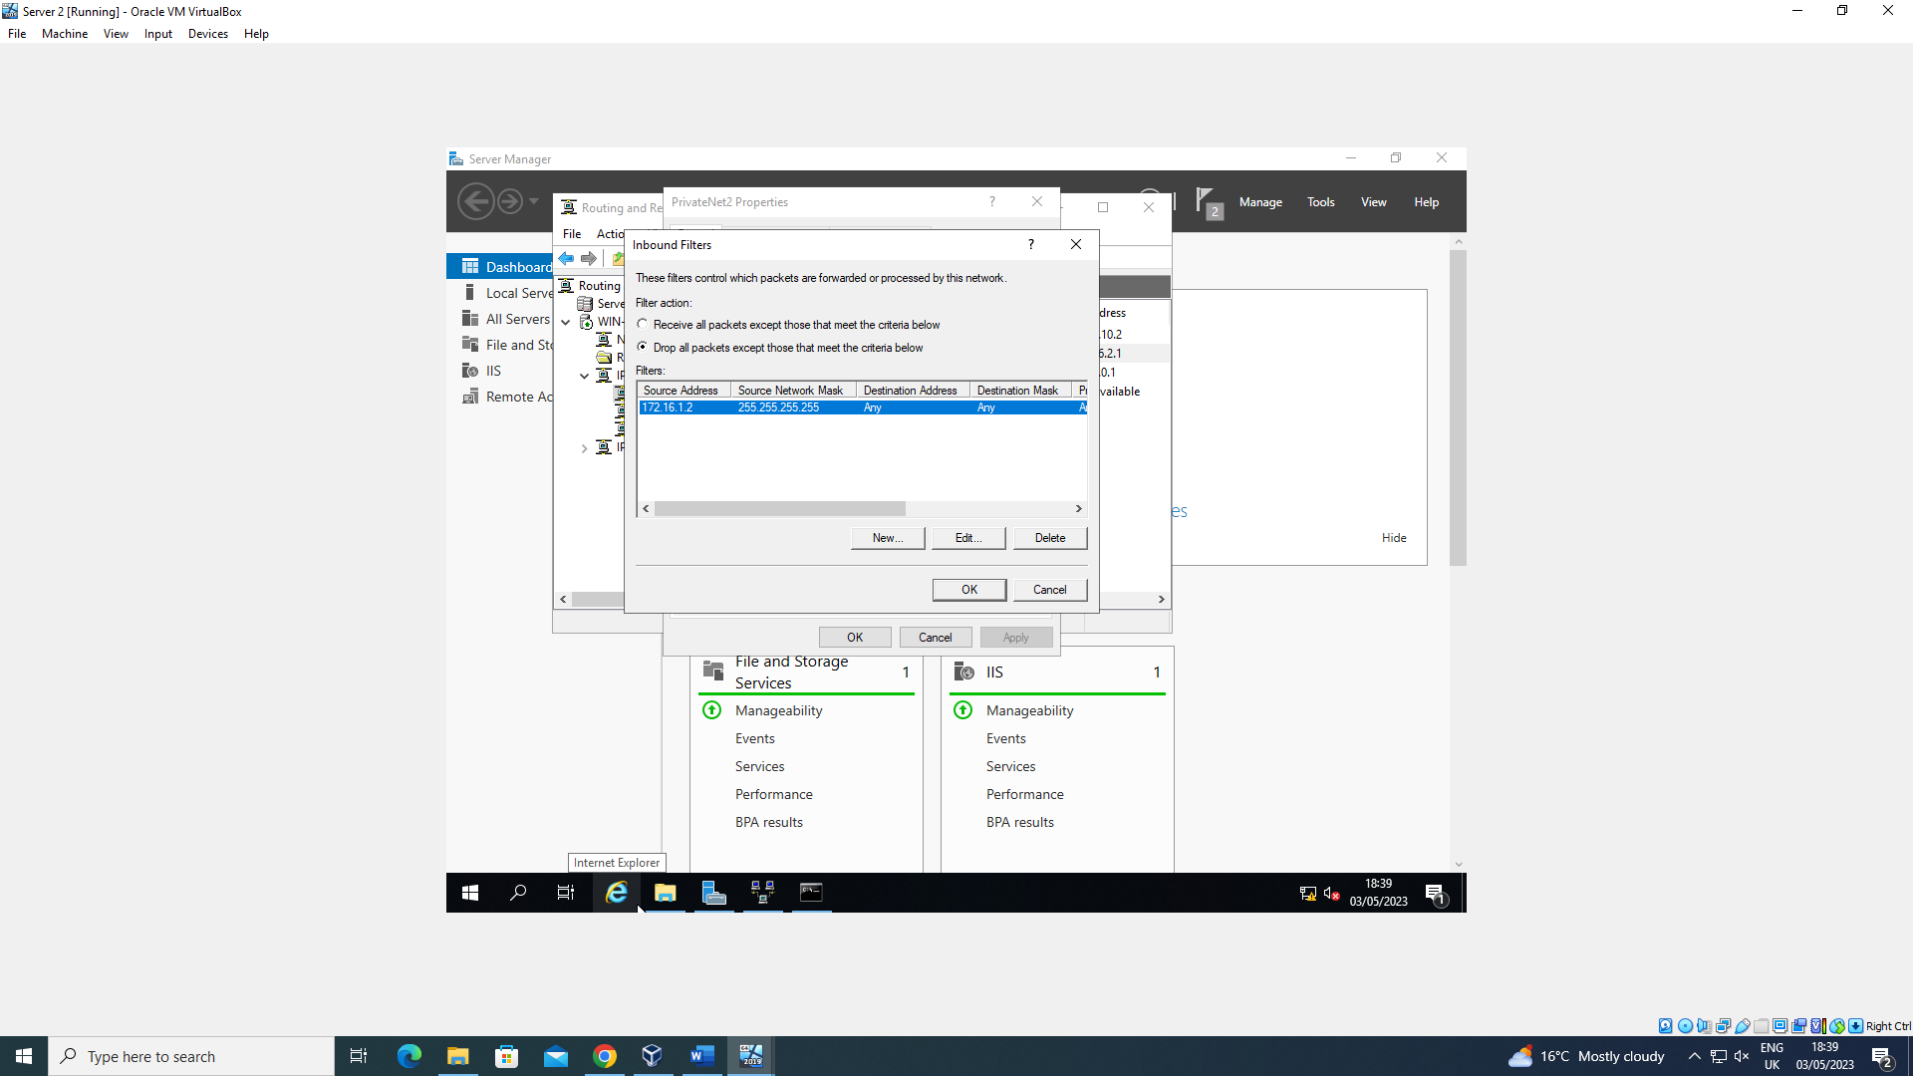
Server 2

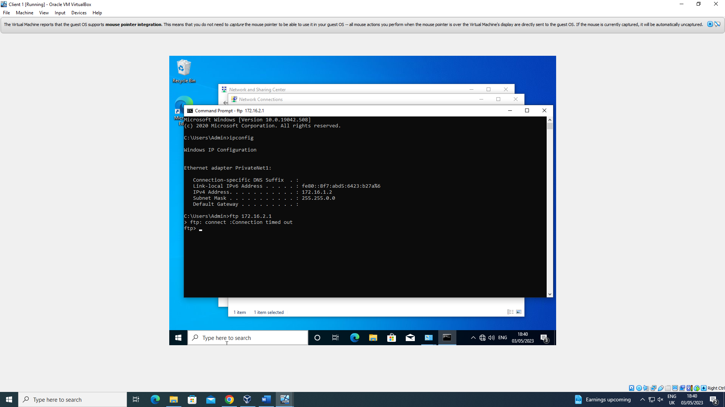
Client 1

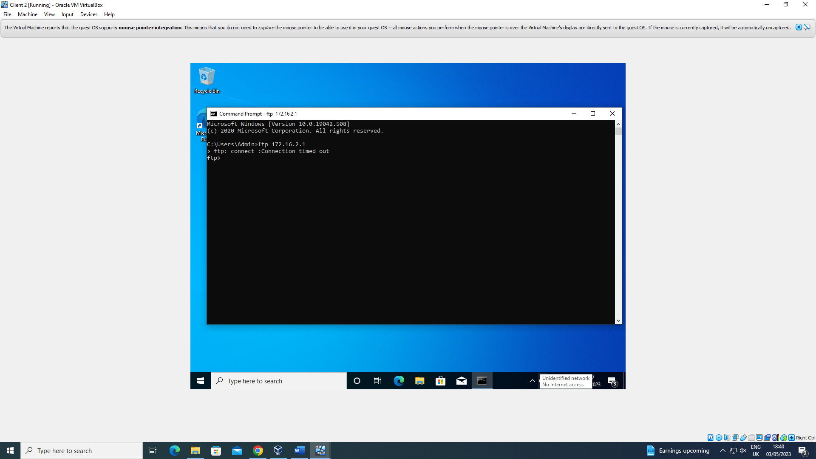
Filter 3 was used to only allow specific hosts on PrivateNet1 to access the FTP service which was running on Server 2. This was done by creating our own rule which allowed us to put a restriction on the access to the FTP server on anyone except Client 1. The final screenshots above show this in effect.

Task 3: Observations

- On a SOHO network, what actions could you take in order to enhance security?

In either a small office or even a home office there are multiple ways that you are able to increase the security within the systems, some of these ways are quite easy and simple to configure and put into place. These different ways are:
- Installing a network wide firewall - Installing and using firewalls are one of the most common ways to increase security within a network as firewalls are the most common way to help defend against attacks and malicious threats. Whereas most routers and operating systems come with firewalls, some can be turned off so make sure that you go back and enable it to help protect yourself.
- Making sure network security is actually enabled - As most homes or offices these days have multiple devices connected to their network, this would prove to be an easy picking for the introduction of malicious code, malware or even hackers into your system as they thrive off of easy access. So making sure that you have some form or a network security will limit this threat
- Keeping software updated - Another crucial thing to have when protecting your network as you might not think it but keeping software updated also rolls out the different new security and software patches out which then makes it difficult for hackers to gain access from the exploits or vulnerabilities that the old system might have had, this then covers off the threat of that.
- Keeping your router secure - Once again the routers are a crucial part for networks as so many people use them and have so many devices connected to them at once. Protecting this may be as simple as changing the WPA key from its most basic original form to something your household or office would only know. Even changing the router's SSID would throw hackers off of finding your router and what type of router that it is so that they could gain exploits from them.

- Failover Clusters - Concepts

What are Failover Clusters?

A failover cluster is a group of independent computers that work together to increase the availability and scalability of clustered roles (formerly called clustered applications and services). The clustered servers (called nodes) are connected by physical cables and by software. If one or more of the cluster nodes fail, other nodes begin to provide service (a process known as failover). (Microsoft 2022).

With that in mind, what do you need to consider when using the system?

When considering the use of failover clusters within a system, you first need to understand the requirements that come along with it. These requirements come down to the hardware, software and network.

Hardware

When it comes to the hardware side of things, many things need to be taken into consideration such as the server requirements which would be to use two of exactly the same types of computers for it. Even the network adapters need to be taken into consideration. Storage is also another big thing to take into consideration as well as you should make sure that there are multiple different drives for it but all separate.

Software

All the servers in a failover cluster must either run the x64-based version or the Itanium architecture-based version of Windows Server 2008 R2 (nodes within a single failover cluster cannot run different versions). All the servers should have the same software updates (patches) and service packs. (Forsenergy 2016).

Network
The network side of things is also another thing to consider as you would need the right person with administrative access to be able to perform the different tasks in changing around the network in order to add failover clusters. For example the servers within should be using DNS event domain roles that need to be configured in order for them to all work as intended as they should all be using the same active directory (Forsenergy 2016).

How Failover Clusters can be implemented.
Obviously this isn't the correct photo, but this is a way that failover clusters can be implemented. By thickening the correct box in the roles and features section in the server manager we are able to click on the addition of Failover Clusters and then move forward on that to then help configure them and implement them into the servers.

Network Policy

A Network policy is a collection of rules that govern the behaviours of network devices (McCauley 2022).

One of the first policies to consider within a network is a:
- Network Security Policy - The purpose of a network security policy is to highlight the importance of following the rules of security that is put in place on to the network in order to help prevent unauthorised access. Some examples included in this policy could be Firewalls, Internet Access and even the use of Remote Connection.
- Access Control Policy - This type of policy puts out a set of rules and instructions to the users within a network properly specifying who is able to access the crucial and important data that may be stored within the network and what places may be able to access specific data and when they can do so. Another important piece to this is what sort of level of classified information that they can gain access to.
- Security Policy Management - This is also another good policy to implement as it ensures that all the policies are able to stay up to date according to guidelines.It also provides much better security to the company as it allows for policies to stay up to date and provides for better use.

- Reflection

Overall after completing this second assignment, looking back over the tasks that I completed as part of my team. To me the tasks varied from being quite simple and easy to implement into the work from being difficult and hard and required help from other team members to which also may be struggling on the same section. But overall I found that the assignment was generally good and was well to be a team working assignment again.

References
Forsenergy. 2016. “Understanding Requirements for Failover Clusters.” Help and Support. https://forsenergy.com/en-us/cluadmin/html/6fe86b30-6820-43a2-8321-3e7b51cbe763.htm.

McCauley, Gary. 2022. “What Is Network Policy? Benefits of Network Policy.” ExterNetworks. https://www.extnoc.com/blog/what-is-network-policy/.
Microsoft. 2022. “Failover Clustering.” Microsoft Learn. https://learn.microsoft.com/en-us/windows-server/failover-clustering/failover-clustering-overview.

