  Component One: Student Journal (learning log) 750 words +/- 10%  Contribution to Overall Module Assessment: 25% | Student No: | Ciolpan Raducu Viorel  2221478
 | Module Title: | Operating Hotel Facilities
 | Module Code: | BMIH4006
 | Lecturer: | Muhammad Cassamo
Housekeeping is considered as one of the most important departments within the business organizations operating within the hospitality industry to serve the needs and requirements of clients. The housekeeping department has the responsibilities of maintaining the order, cleanliness and comfort for the clients during their stay in the hotels (Bridger, 2018). Diverse types of skills are required for the individuals working in this department. This reflective journal discusses about the skills required in the housekeeping department, a reflection of my own skills with the support of industry examples and Gibbs reflective cycle.

Learning Log (Major skills required for the housekeeping department)
Week of learning | Sills to develop | Description of learning and skill development experience
Week 1 | Attention to details skills | The quality of the hotel services depends highly on the cleanliness and providing customized services sincerely to the clients. For this reason, the service quality depends highly on the housekeeping department who require the skill of attention detail to ensure proper cleanliness and providing accurate services to each client’s according to their personal preferences.
Week 2 | Communication skills | Effective communication skills are of great importance to receive orders and requests for service customization from guests, communicate and share information properly with other team members and provide high quality services to guests without any mistakes (Cottrell, 2019).
Week 3 | Multitasking skills | The individuals working in the housekeeping department are responsible for performing several tasks at a time such as taking orders from guests, restocking amenities, cleaning etc. For this reason, multitasking skills are of great importance for themselves.
Week 4 | Problem solving skills | Several different types of unexpected challenges are very common for the housekeeping employees in the workplace such as malfunction of equipment and disputes among the guests (Leiter and Bakker, 2010). These issues need to be resolved quickly and the housekeeping employees are responsible for these. Problem solving skills are important for this reason.
Week 5 | Organizational skills | Housekeeping department employees are responsible for the management and allocation of supplies, maintaining the inventory, managing the tasks related to providing services to the guests. The efficiency in resource management and ensuring the delivery of high-quality services to guests requires effective organizational skills which makes it very important for the housekeeping department employees (Mullins and Dossor, 2013).
Week 6 | Leadership & team working skills | Leadership and team working skills help to achieve higher performance for an individual and for the team as well through expertise and resource sharing.

Reflection on my own skills with the application of Gibbs Reflective Cycle
There exist different reflective models and theories to support learners and individuals in skill development, personal and promotional development activities. Gibbs reflective cycle is one of the most renowned one among these. There are 6 different stages in this reflective cycle. These include description, feelings, evaluation, analysis, conclusion and action plan (Raghubalan and Raghubalan, 2016).
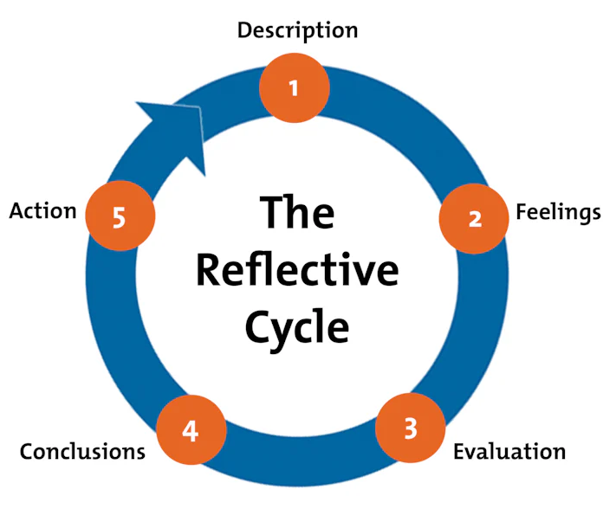
Figure: Gibbs Reflective Cycle (Quick, 2020)

A reflection of my own skills is presented below by applying the Gibbs Reflective Cycle model.
- Description: During my internship at a renowned hotel, I got the scope of working as a part of the team of the housekeeping department. My responsibilities were cleaning the rooms for guests, restocking and checking the amenities, keeping the rooms ready for customer check in and several other activities to ensure quality.
- Feelings: I was overwhelmed at the beginning of the internship and the learning process. It was highly challenging for me to manage the activities and responsibilities of keeping up with the cleaning schedule properly, efficient time management, multitasking and maintaining high quality in my performance altogether. However, I got used to the tasks and activities eventually and was successful to improve my efficiency in the workplace which motivated me further to develop new skills.
- Evaluation: I have successfully identified my strengths and weaknesses as a learner and professional during the internship experience at the hotel. One of my major strengths is the proper and effective attention to detail which helped me a lot to clean the rooms assigned to me with proper and accurate manner. I also received some positive feedback and reviews from the clients which motivated me to perform better. My weaknesses were struggles and difficulties with time management and multitasking which eventually improved with further practice, efforts and sincerity.
- Analysis: I took several effective initiatives for overcoming my weaknesses and improving my skills. Prioritizing my tasks and using a checklist regularly to keep track of my activities helped a lot in this regard. Feedback and suggestions from the experienced colleagues and coworkers were also helpful.
- Conclusion: I have learnt the importance of different skills in the hospitality sector from this learning experience. Effective communication skills, multitasking skills, attention to details are critical skills for the professionals working in this sector. I have got the opportunity to learn and develop these skills from hands on experience of working with the housekeeping department.
- Action plan: I have effective plans to continue improving my problem-solving skills and communication skills. The lessons and skills learnt and developed by myself from this experience will help me to develop a successful career in the hospitality sector.

REFERENCES
Bridger, E. (2018) Employee engagement: a practical introduction. 2nd ed. HR Fundamentals. London: CIPD and Kogan Page.
Cottrell, S. (2019) The Study Skills Handbook. 5th ed. London: Red Globe Press.
Leiter, M. P. and Bakker, A. B. (2010) Work Engagement: A Handbook of Essential Theory and Research. Hove [England]: Psychology Press.
Mullins, L. and Dossor, P. (2013) Hospitality Management and Organisational Behaviour. 5th ed. Harlow: Pearson.
Quick, L. (2020) Managing Events. Real Challenges, Real Outcomes. London: SAGE Publications Ltd.
Raghubalan, G. and Raghubalan, S. (2016) Hotel Housekeeping - Operations and Management. 3rd ed. India: Oxford University Press.

Component Two: Housekeeping cleaning checklist
Contribution to Overall Module Assessment: 25%
Room Cleaning Checklist

Operations section | Task | Frequency of task performing | Responsible team member for the task | Completion status (put tick mark after task completion)
BEDROOM | Making the Bed | Everyday | Housekeeper
BEDROOM | Cleaning & clearing the bed. | Everyday | Housekeeper
BEDROOM | Clearing the nightstand | Everyday | Housekeeper
BEDROOM | Packing things away | Everyday | Housekeeper
BEDROOM | Vacuum & sweeping | Everyday | Housekeeper
LIVING ROOM | Clearing and packing away any clutter | Everyday | Housekeeper
LIVING ROOM | Wiping and cleaning the coffee tables | Everyday | Housekeeper
LIVING ROOM | Straitening and clearing the rugs and pillows. | Everyday | Housekeeper
LIVING ROOM | Dusting off the sofa cushions | Everyday | Housekeeper
LIVING ROOM | Dusting off all surfaces | Everyday | Housekeeper
LIVING ROOM | Moving all dirty dishes and utensils to the kitchen | Everyday | Housekeeper
KITCHEN | Cleaning & spraying the oven properly. | Everyday | Housekeeper
KITCHEN | Wiping the microwave | Everyday | Housekeeper
KITCHEN | Packing and emptying the dishwasher | Everyday | Housekeeper
KITCHEN | Clearing the clutter from the counters | Everyday | Housekeeper
KITCHEN | Sweeping the floors | Everyday | Housekeeper
KITCHEN | Wiping the counters and appliances used in cooking. | Everyday | Housekeeper
BATHROOM | Spraying and cleaning the tub & shower | Everyday | Housekeeper
BATHROOM | Packing away and cleaning any clutter | Everyday | Housekeeper
BATHROOM | Placing toilet cleaner in bowl | Everyday | Housekeeper
BATHROOM | Moving dirty clothes to the laundry | Everyday | Housekeeper
BATHROOM | Wiping and cleaning the basin, toilet, shower, tub | Everyday | Housekeeper
BATHROOM | Checking for water, paper towel, towel, soap, toilet paper and other amenities | Everyday | Housekeeper
LAUNDRY | Checking the load in washing machine | Everyday | Housekeeper
LAUNDRY | Maintaining the washing machine properly | Everyday | Housekeeper
LAUNDRY | Treating any kind of stains for washing the next day | Everyday | Housekeeper
LAUNDRY | Hanging the washed clothes to dry | Everyday | Housekeeper
LAUNDRY | Packing and sending away washed clothes | Everyday | Housekeeper
ENTRANCE | Packing away bags and shoes | Everyday | Housekeeper
ENTRANCE | Moping and sweeping the floors. | Everyday | Housekeeper

Essay on strategies and team effectiveness, checklist
Maintaining cleanliness and standards of the rooms are very important aspects of service quality in the hospitality industry. It is of great importance to maintain high level of loyalty and satisfaction among the clients and guests (Woodside & Airey, 2021). Properly developed room cleaning checklist is a great tool for ensuring the service quality. Strategies for ensuring the cleanliness of rooms up to the standards of the brand, strategies for improving the team effectiveness, critical evaluation of the developed checklist for room cleaning are the points of discussion for this essay.

Ensuring the room cleanliness to brand standards is a crucial aspect in the hospitality industry which requires sincere strategic approaches. Several effective strategies are implemented by me to ensure that the rooms are cleaned to the brand standards (Walker, 2021). Thoroughness is the major strategy in this regard for ensuring the quality of cleaning in rooms, washrooms and other areas of the hotel. Maintenance of the properties and supplies provided to customers for quality assurance is another effective strategy of utilizing the checklist. The checklist is effective for the regular maintaining of appliances for addressing any kind of damages and malfunctions, solving any plumbing issues immediately to ensure great quality. The checklist is also effective for ensuring the amenities in adequate and proper conditions for customers to provide high quality and consistent experience to them (Gossling, Scott, & Hall, 2023). One of the crucial control quality measure strategies is the use of the checklist for final inspections for ensuring that all the team members in the housekeeping department are meeting the highest standards in their performances.

Improving the team effectiveness requires effective strategic approaches and initiatives as well. Several specific measures will be introduced for improving the effectiveness of my team in the housekeeping department (Baron & Cavanaugh, 2022). Effective and regular training and skill development opportunities will be arranged for the team members to increase the effectiveness level of the team. If the team members have better knowledge about appliances, cleaning techniques and brand standards than it will be easier to perform better. Another strategy is the improvement of communication efficiency and transparency so that clear and accurate information are shared among the team members to ensure higher productivity, team efficiency and team performance. Introduction of effective and relevant Key Performance Indicators (KPIs) is another effective strategy for improving the team efficiency.

There are several reasons why I consider my checklist to be the most effective. The major reason is the comprehensiveness and the scope of customization of the checklist. It is also highly effective and helpful for quality control in the housekeeping activities. It is quite easy to use and understand for all the team members (Netto, 2020). The check list is quite user friendly, precise and straightforward so there are no room for misunderstanding and miscommunication among the team members which eventually helps to maintain quality of the performances. The check list is effective as well as helpful in the process of continuous improvement of it based on regular feedback and opinions from the supervisors and the team members about the positive and negative aspects, scopes and opportunities of improving and modification of the checklist according to the needs and requirements for improving the performance and service quality of the team and the housekeeping department.

REFERENCES
Baron, R. A., & Cavanaugh, M. T. (2022). Hospitality management: Concepts and applications (7th ed.). Pearson Education.
Gossling, S., Scott, D., & Hall, C. M. (2023). Sustainability in hospitality management: Principles and practices (1st ed.). Routledge.
Netto, A. V. (2020). Hospitality management in the digital age (3rd ed.). Routledge.
Walker, J. R. (2021). Hospitality management: Principles and practices (6th ed.). Pearson Education.
Woodside, A., & Airey, D. (2021). Hospitality management: An introduction (6th ed.). Routledge.

