Determination of the Formula of Magnesium Oxide

Chemistry

Module code ACDB40011

Alex Clarke
2309711@student.uwtsd.ac.uk
Level 4 OME Course
July 2024


Table of Contents
1 Introduction 3
2 Results 3
3 Discussion 4
4 Conclusion 5
5 References 6
6 Appendices 7
6.1 Appendix A – Combustion of Magnesium in Oxygen method. 7
6.2 Appendix B – Experiment hand out results table. 8
6.3 Appendix C – Results calculations 9

Table 1 Experiment 1 and 2 Results 4
Table 2 Results Calculations 9

Equation 1 Mole calculation 3
Equation 2 Percentage mass calculation 3
Equation 3 Mole ratio calculation 3

Introduction
This laboratory reports documents determination of the formula of magnesium oxide by analysis of the mass/mole ratio of magnesium and oxygen in the product of combustion of magnesium in air. The experiment was carried out by the learner and their two fellow students S. Dean and S. Shepherdson. The details of the method for the combustion of magnesium in air can be found in Appendix A.
Prior to carrying out this experiment the learner was aware that burning magnesium in air would produce magnesium oxide, through the process of combustion. The learner was also aware of the law of conservation of mass, so that the mass of the product could equal the mass of the 2 reactants.
The equations 1 to 3 ^{[1]} will be used by the learner to determine the results of this experiment. It must be noted that for equation 3 to correctly determine the molar ratio, the chemical equation must be balanced first.
Equation 1 Mole calculation
$$Mole \left(mol\right)=\frac{Mass (g)}{Molar Mass (g/mol)}$$

Equation 2 Percentage mass calculation
$$Mass \%= \left(\left.\frac{Mass of chemical (g)}{Mass of compound (g)}\right)\right. x 100$$

Equation 3 Mole ratio calculation
$$Mole ratio = \frac{moles of B (mol)}{moles of A (mol)} = \frac{Coefficient of B*}{Coeffiecient of A*}$$
* The coefficient for A and B in this equation is determined by the number molecules for A and B.
The basic concepts, principles, and laws the learner will apply to this experiment are the law of conservation of mass, law of definite proportions and stoichiometry.
The law of conservation of mass states “The mass in an isolated system can neither be created nor be destroyed but can be transformed from one form to another”. ^{[2]} This means that the mass of the reactants will be equal to the mass of the products and in a chemical reaction the atoms only change their arrangement.
The law of definite proportions states “A give chemical compound always contains the same elements in the exact sample proportions by mass”. ^{[3]} This means the number of elements in the reactant will equal the sample in the products of a balanced equation.
Stoichiometry ^{[4]} is the mass relationship/ proportions in a balanced chemical equation. Both the laws of conservation of mass and definite proportions help determine the stoichiometric relationship.

Results
The experiment was carried out by the learners twice using a 1g and a 2g sample of Magnesium chips. Table 1 below documents the results of the experiments with Appendix B showing the original experimental hand out results, and Appendix C showing the calculations of the results using the equations 1 to 3.
Note: All mass calculations were reported to 4 decimal places as this was the capability of the balances used, other than the mass of magnesium which was 3 decimal places as this was already pre-weighed for the learner. Percentage by mass was reported to only 2 decimal places as the learner thought that any further decimal places would not be required.
Table 1 Experiment 1 and 2 Results
 | Experiment 1 | Experiment 2
Mass of Crucible and lid (g) | 67.5143 | 67.5212
Mass of Crucible, lid and magnesium (g) | 68.5144 | 69.5132
Mass of magnesium before heating (g) | 1.001 | 1.992
Mass of Crucible, lid and product after heating (g) | 69.0544 | 70.6181
Mass of product after heating (g) | 1.5401 | 3.0969
Mass of oxygen which reacted with magnesium (g) | 0.5391 | 1.1049
Moles of Oxygen (mol) | 0.0168 | 0.0345
Moles of Magnesium (mol) | 0.0412 | 0.0820
Mole ratio of Mg to O₂ | 0.4078 | 0.4207
Determined formula of the oxide | MgO | MgO
Percent by mass of Mg in the oxide (%) | 65.00 | 64.32
Percent by mass of O₂ in the oxide (%) | 35.00 | 32.68
Balanced Chemical Equation | 2Mg_{(solid)} + 0_{2 (gas)} = 2MgO_{(solid)}

For experiment 1 the learners applied heat to the crucible and sample for 13.5 minutes and in experiment 2 the learners applied heat for 19.5 minutes first, mixed the sample and then a further 5 minutes of heating.

Discussion
As expected for both experiments, the mass increased with the reaction between the magnesium and oxygen to create magnesium oxide, following the law of conservation of mass with the mass of the magnesium oxide (1.5401 g/ 3.0969 g) being the sum of the mass of the magnesium (1.001 g/ 1.992 g) and the oxygen (0.5391 g/ 1.1049 g). The percentage of mass of the magnesium to oxygen is roughly 2 to 1, as would be expected in the balanced equation following the law of definite proportions.
An area of OME that relates to this experiment and for the formation of metal oxides is the explosive Torpex that was used during World War 2. Torpex was used as an underwater explosive (used in torpedoes, naval mines and depth charges) due to the addition of the aluminium powder in the composition. The addition of the aluminium improved the performance of the explosive by an increase of in the heat of explosion and thus providing an increased temperature. This increase in the heat of explosion was due to alumina (aluminium oxide/ Al₂O₃) having a high heat of formation at 1658 kJ/mole. The addition of aluminium also included a secondary improvement in the form of the possibility of “post-heating” thus increasing the air blast of the Torpex or even the ability for a delayed secondary explosion to occur. This “post-heating” occurred if any aluminium had not reacted in the initial detonation and would oxidise in atmospheric oxygen and produce alumina (aluminium oxide) which has the higher heat of formation [5].
The learner determined the following limitations and/or potential sources of error in the experiment as follows:
- The application of heat to the crucible was determined by the distances from the crucible to the flame from the Bunsen burner. Ideally a thermocouple could have been used to record the temperature in the crucible during the reaction at a fixed distance between the crucible and the flame.
- The experiment could have been carried out in a closed system with only oxygen rather than normal air.
- A different crucible could have been used for each experiment to ensure that any residue from the previous experiment was not present to ensure the results were truly representative of the reaction of the reactants.
- Ideally the learner would have preferred to weigh the mass of the magnesium chips provided for the experiment.
- The balance used for mass measurement was not on a level surface and no evidence of check weights being used to determine the accuracy of balance.

Conclusion
The results of the experiment carried out by the learner support the original hypothesis of the learner and shows that the laws of conservation of mass and definite proportion where observed. Future research could be carried out on this experiment addressing the limitations of this experiment described in section 3.

References
- E. Kazimierska. (2024) Understanding the Mole and Balancing chemical equations [PowerPoint]. Available: Moodle
- "Law of Conservation of Mass." Byjues.com. Accessed: July 2024. [Online]. Available: https://byjus.com/physics/law-of-conservation-of-mass/
- "Law of Definite Proportions" chem.libretext.org. Accessed: July 2024. [Online]. Available: https://chem.libretexts.org/Bookshelves/Introductory_Chemistry/Introductory_Chemistry_(CK-12)/04%3A_Atomic_Structure/4.04%3A_Law_of_Definite_Proportions
- J T Moore, "Determining what you need and what you'll get: Reaction stoichiometry," in Chemistry for Dummies., Wiley Publishing Inc, Hoboken, NJ: 2011, Pages 132-133.
- Baxter, C. F. (2018). The Secret History of RDX The Super-Explosive that Helped Win World War II. University Press of Kentucky

Appendices

Appendix A – Combustion of Magnesium in Oxygen method.
Lab tools, Materials and Supplies:
- Bunsen burner
- Heat-resistant mat
- Matches
- Ceramic crucible and cover
- Ring stand
- Clay triangle
- Furnace tongs
- Analytical balance
- Magnesium chips 1-2g
- Required PPE – Lab coats, nitrile gloves and Safety goggles conforming to correct EN standards.
- Pen and experiment hand out (including table for observations)
Procedure:
- The Bunsen burn was placed on the heat-resistant mat with the ring stand placed over and the clay triangle on top of the ring. A match was used to light the flame. The air vent was open until a non-luminous flame with two blue cones was observed by the learner. The learner ensured that the safety yellow flame (visible) is on when the Bunsen burner was not in use.
- Ensuring the crucible and lid were clean and dry, it was placed on the balance and weighed with the value recorded by the learner.
- 1-2g of the Magnesium chips were added to the crucible, it was place on the balance and weighed with the value recorded by the learner.
- The crucible with the magnesium chips was then placed on the clay triangle on the ring stand with the lid slightly off centre to ensure that air was able to enter without the magnesium oxide escaping.
- The Bunsen burner was then placed under the crucible on the ring stand and gently heated for about 1 minute before heating strongly.
- The crucible and magnesium chips were then heated for 13 to 25 minutes until the magnesium had turned into a grey-white powder and now glowing was observed by the learner.
- The crucible was then allowed to cool before being placed back on the balance to weigh the mass of the crucible, lid and product of the reaction, with the value recorded by the learner.
- Steps 2-7 were then repeated for a second set of results for the learner.

Appendix B – Experiment hand out results table.
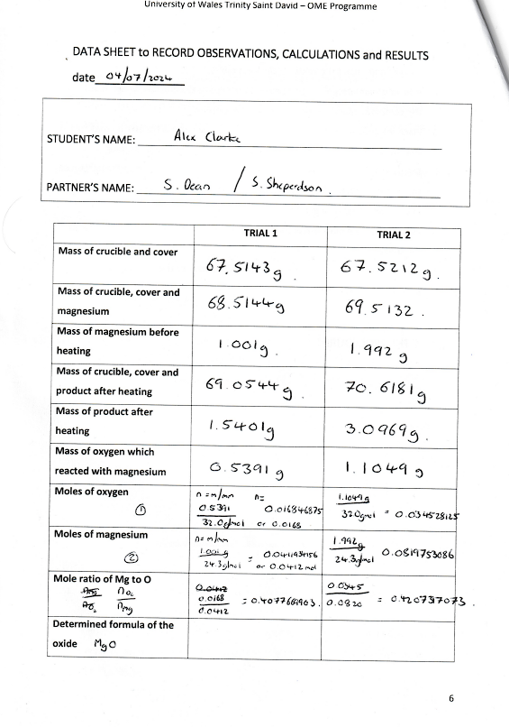
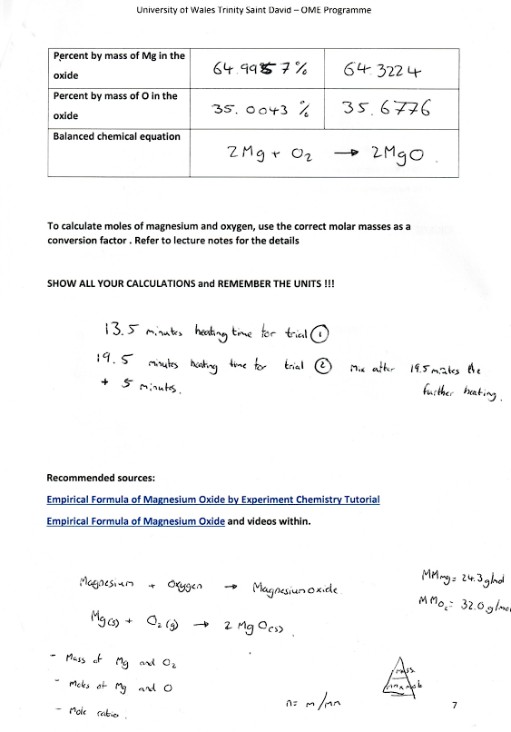

Appendix C – Results calculations
Below are the calculations used for the results in table 1 using the equations 1 to 3.
Table 2 Results Calculations
 | Experiment 1 | Experiment 2
Mass of oxygen which reacted with magnesium (g) | $$1.5401 - 1.001 = 0.5391$$ | $$3.0969 - 1.992 = 1.1049$$
Moles of Oxygen (mol) | $$\frac{0.5391}{32.0}= 0.016846875$$ | $$\frac{1.1049}{32.0}= 0.034528125$$
Moles of Magnesium (mol) | $$\frac{1.001}{24.3}= 0.0411934156$$ | $$\frac{1.992}{24.3}= 0.0819753086$$
Mole ratio of Mg to O₂ | $$\frac{0.0168}{0.0412}=\frac{1}{2}$$  0.4076 = ½  2(0.4076 = ½)  0.8152 = 1.0 | $$\frac{0.0345}{0.0820}=\frac{1}{2}$$  0.4207= ½  2(0.4207 = ½)  0.8414 = 1.0
Percent by mass of Mg in the oxide (%) | $\left(\frac{1.001}{1.5401}\right)x 100 =$64.99577949 | $\left(\frac{1.992}{3.0969}\right)x 100 =$64.3223869
Percent by mass of O₂ in the oxide (%) | $\left(\frac{0.5391}{1.5401}\right)x 100 =$35.00422051 | $\left(\frac{1.1049}{3.0969}\right)x 100 =$35.6776131

