Research Project

Assessing the impact of staff shortages on delivering effective guest experience, a case study of Ibis Hotel Southampton

Student name: Cristina Paulina Mitu
Student nr: 2120015
Module: BMIH6008
Lecturer: Christopher Wilkins

I can confirm that i did not use any AI instruments

Table of Contents
1. Introduction 3
2. Literature Review 4
3. Methodology 7
4. Case study discussion 8
4.1 Semi-structured Interview 8
4.2 Survey 14
5. Theme exploration 20
5.1 Introduction 20
5.2 Theme Exploration 21
6. Conclusion and Recommendation 26
6.1 Conclusion 26
6.2 Recommendation 27
7. Reflective account 28
Reference List 31

1. Introduction
1.1 Research background
Maintaining a high standard of guest experience is crucial in the hospitality industry as it directly influences customer satisfaction, loyalty, and the overall brand reputation. Positive guest experiences lead to repeat business, positive reviews and referrals all of which are crucial for the hotel's financial success (Veloso and Gomez-Suarez, 2023). In an increasingly competitive market, exceptional guest experience differentiates the hotel establishment and can significantly impact the overall profitability. However, in the modern business era, the hotel services, and all the guest experiences are likely to be impacted by several internal business factors out of which is the increasing staff shortages (Candra et al., 2023).
1.2 Research aim and objectives
1.2.1 Research aim
- The primary aim of this research study is to assess the impact of staff shortages on delivering an effective guest experience, referring to the case of Ibis Hotel Southampton (Ibis, 2024)
1.2.2 Research objectives
- To investigate how staff shortages affect the operational efficiency of hotel services delivered by Ibis Hotel Southampton.
- To analyse guest satisfaction factors influenced by lack of staff shortages within Ibis Hotel Southampton.
- To identify staff management strategies in combating ineffective guest experience due to staff shortages within Ibis Hotel Southampton.
1.3 Research question
- How do staff shortages within Ibis Hotel Southampton affect the overall delivery of guest experience?
1.4 Research rationale
This research is essential as the hospitality industry faces increasing staff shortages directly impacting on the guest experience. By focusing on Ibis Hotel Southampton, the study aims to uncover the specific challenges and operational inefficiencies resulting from the reduced staffing. Understanding these dynamics is crucial for hotel management to implement effective strategies that can enhance service quality and maintain guest satisfaction (Abalaka et al., 2023). Ultimately, this research seeks to contribute to better staffing practices and improve guest experiences in a competitive hospitality market.

2. Literature Review
2.1 Introduction
The following chapter is based on exploring the literature that helps in having a conceptual and theoretical understanding regarding how the increasing rates of staff shortages influence the delivery of guest experience within the hospitality industry of the UK.
2.2 Conceptual understanding
Impact of staff shortages on the operational efficiency of hotel services within the hospitality industry of the UK
According to Papademetriou et al. (2023), the staff shortages in the UK hospitality industry significantly impact overall operational efficiency leading to various challenges that affect the service quality in the context of guest experiences with fever employees, hotels struggle to maintain optimum staffing levels across departments such as front desk, housekeeping and food and beverage services. This often results in longer wait times for guests during checking, reduced attention to detail in the room, clean image, and delays in the service delivery at restaurants or bars. Moreover, the remaining staff may experience an increased workload leading to fatigue and a lower model which can further create service issues. As per Belias et al. (2023), higher employee turnover is common in the industry which can make training inexperienced staff a constant challenge resulting in inconsistent service quality. The inadequately trained personnel may struggle to meet the guest's expectations. Ultimately affecting the overall customer satisfaction and hotel reputation. The operational inefficiencies due to staff shortages can lead to revenue loss. To illustrate, understaffed housekeeping may result in the room not being prepared on time, limiting the hotel's ability to accommodate new guests (Amaral et al., 2023). Similarly, the overworked front desk staff may make errors in reservations leading to double bookings for the dissatisfied customer (Vagena et al.,2024). Overall, the impact of staff dress on the operational efficiency in hotels is profound in setting the strategic workforce management to ensure high service standards and make them competitive in the hospitality market.
Guest satisfaction factors influenced by lack of staff shortages within the hospitality industry of the UK
According to Broker (2024), the service responsiveness declines when staff levels are inadequate the guest may experience longer wait times during checking in dining or assistance requests leading to frustration and negative perceptions of the service quality. Likewise, the attention to detail of guest experience also suffers as the inadequate staffing often means that the remaining employees are overburdened which can result in missed tasks such as proper room cleaning or timely maintenance requests (Hinson et al., 2024). This neglect can directly impact the guest's comfort and overall satisfaction. As per Simonis (2023), the quality of interactions within the staff diminishes with fewer employees; interactions may feel rushed or less personal, reducing the overall warmth and hospitality that the guests expect. This can lead to a sense of being undervalued. The availability of services can be compromised, to illustrate that the understaffed dining areas may limit the menu options and are always the operation frustrating the guest who desires to have a comprehensive experience (Abell et al., 2024). Lastly, guest loyalty and word of mouth are affected as the negative experiences stemming from the staff, shortages can lead to poor online reviews, and a decline in repeat business as dissatisfied guests share their experiences with others (Karim and Rabiul, 2024).
Staff management strategies in combating ineffective guest experience and also staff shortages within the hospitality industry of the UK
In accordance with Patrick (2023), flexible scheduling can help align staff availability with peak business hours. By analysing occupancy trends, hotels can create dynamic schedules that optimise staffing levels during the high demand periods, ensuring guests receive timely service. Investing in employee training and development is also crucial in the comprehensive onboarding and continuous training programmers in the staff competencies, enabling the employees to perform multiple roles effectively. This versatility helps to mitigate the impact of staff shortages and improve service quality. According to Almerri (2023), fostering a positive workplace culture is also important for retention, recognizing employee contributions, promoting teamwork, and providing opportunities for growth can lead to higher job satisfaction levels that lead to reducing turn overheads and associated costs of recruiting and training new staff. As a result, it positively influences their productivity levels and customer directions leading to a positive guest experience (Ahli et al., 2024). Lastly, the implementation of technology solutions can also streamline operations tools like mobile checking, chatbots for customer enquiries and inventory management systems can also reduce the workload, understaffed and enhance the guest experience even with fewer employees Also a clear communication strategy is necessary to ensure that staff are aware of expectations and changes (Hubbart, 2023). Regular checking and feedback sessions can help to identify issues, only allowing for prompt resolutions.
2.3 Theoretical understanding
Job characteristics model is considered which emphasises the significance of Job design in enhancing employee motivation and satisfaction (Chanie et al., 2023). By ensuring that the roles are enriching and allow for skill variety, the task, significance, and autonomy of hospitality managers can cultivate a more engaged workforce.
The service quality theory highlights the direct correlation between employee performance and guest satisfaction (Papademetriou et al., 2023). The SERVQUAL Model highlights and suggests that service quality is determined by the gap between customer expectations and perceptions of service delivered. Thus, well-trained and motivated staff can bridge this gap, ensuring a superior guest experience.
The contingency theory is considered which supports the idea that management strategies should be tailored to the specific context of knowledge in that varying levels of staffing and service demands require flexible approaches to staff management (Rose et al., 2023).
Herzberg Two Factor theory is considered which states that employee satisfaction is influenced by hygiene factors that include salary, working conditions and motivators which include recognition achievement, and so on (Ibrahim et al., 2023). This theory underscores the significance of creating a positive working environment to enhance staff retention and performance, which is crucial in mitigating staff shortages.
2.4 Literature Gap
The literature gap can be drawn from the lack of significant research in understanding the specific impact of bearing staffing levels and service quality across the different hotel segments. There is a limited exploration of effective management strategies that are tailored to mitigate these issues in real-time. Further, studies are needed to examine how technology can support staff efficiency and enhance the overall guest experience during shortages.

3. Methodology
This study will employ case study methodology to explore the impact of staff shortages on guest experience at Ibis Hotel Southampton. The case studies are qualitative research approaches which allow for an in-depth examination of specific instances within their real-life context (Frank et al., 2024). This method is particularly beneficial in hospitality research for complex interactions between the service providers and guests can be effectively analysed.
One of the primary advantages of case study methodology is its ability to provide rich contextual insights (Karunarathna et al., 2024). By focusing on a single hotel this approach allows for an in-depth exploration of specific operational challenges, guest feedback and the staff dynamics. This context-sensitive analysis helps to identify nuanced factors affecting guess experience that may have been overlooked in broader quantitative studies (Karunarathna et al., 2024). Furthermore, a case study will facilitate the use of multiple data sources such as interviews, observations, and so on which will enhance the research's validity. Likewise, another significant benefit is the ability to generate practical recommendations for industry practitioners (Ma et al., 2023). The detailed insights gained can inform the management strategies which are focused on improving the service delivery, making the findings more relevant for the hotel operators that are facing staff challenges.
However, a case study methodology is widely criticised for having limited generalisations. The findings from a solitary case may not be applicable to other contexts or establishments which restricts the broader applicability of the result (Hangel and ChoGlueck, 2023), As well, the subjective nature of qualitative analysis may introduce researcher bias which can affect the interpretation of data and conclusions drawn.
The key techniques and methods that will be utilised within the case study methodology include reflective writing, which allows critical engagement of the experiences and observations during the research process (Sirojiddinovna, 2023), Ethnography will also be used to gather Insights from the guest reviews and social media interactions regarding the Ibis Hotel Southampton (Ibis, 2024). However, the data will be collected through a semi structured interview with the 3 hotel staff managers irrespective of their departments. The interview will provide qualitative insights into the operational challenges faced due to the staffing shortages. The data will also be collected with the use of a survey among the 25 staff of Ibis Hotel Southampton that will help to quantify their views regarding the staff's struggles to meet the guest demand. Therefore, the data collection will enable together diverse data services leading to reaching actionable insights for hotel management. Also, this research will be developed ethically with the wide consideration of research ethics ranging from voluntary participation, informed consent, confidentiality, and potential for harm to anonymity (Verbeke et al., 2023). To be more specific, the survey response will be based in an anonymous manner leading to protecting the privacy of individuals who participated. The participants for the survey and interviews will be approached in a formal manner with their own personal will and under no such monetary influence leading to reflect the ethical consideration of voluntary participation (Wallwey and Kajfez, 2023).

4. Case study discussion

4.1 Semi-structured interview

Question 1 | For how long have you been serving the role of a manager at Ibis Hotel Southampton?
Manager 1 | I have been working as a manager for 3 and half years at Ibis Hotel Southampton.
Manager 2 | I have been working as a manager for four years at Ibis Hotel Southampton.
Manager 3 | I have been serving the role of manager at Ibis Hotel, Southampton for four and half years.
Table 01: Interview Question 1
Source (created by the learner)

Question 2 | How has the recent staff shortage affected the overall case experience at Ibis Hotel Southampton?
Manager 1 | I believe that the staff shortage has certainly affected our ability to serve guests. From taking longer time at the reception to being unable to assist during peak times, every core aspect has been affected due to the staff shortage.
Manager 2 | from a guest experience, the shortest has profoundly impacted the personal touch that we have known. We have received some complaints about the slower response times in the restaurant and room service, which remains a Concern issue.
Manager 3 | Staff shortages have increased the pressure on the existing team leading to higher stress levels, which, as a result, has affected the interactions with guests.
Table 02: Interview Question 2
Source (created by the learner)

Question 3 | How do you communicate with guests when there are delays or issues due to the lack of staff?
Manager 1 | In times of delays or issues due to the lack of staff, I make use of transparency by informing the guest regarding the delay, whether it is for check-in or the room service. Doing so allows transparency in services and can mitigate customer satisfaction.
Manager 2 | I extensively make use of appreciating honesty and empathy by making sure that the staff communicates directly with the guest when an issue arises.
Manager 3 | I encourage the staff to be proactive in communicating with the guest, especially in terms of high-stress situations or a key part of managing the issue is mentioning implied morals, so I also focus on keeping the teams informed and confident in their ability to resolve the situation which can be further, conveyed to the guest.
Table 03: Interview Question 3
Source (created by the learner)

Question 4 | Can you share any initiative that has been successful in mitigating the impact of staff shortages, and guest satisfaction?
Manager 1 | From my experience, one of the key strategies that have been successful in mitigating the impact of staff shortages on guest satisfaction includes self-service technology, technology like online service requests and so on that has led to reducing the strain on the frontline staff. As a result, a failure to free up employees to focus on more crucial tasks that directly impact guest satisfaction.
Manager 2 | We have increased the use of guest satisfaction, service, and follow-ups, leading to understanding areas of improvement and have been able to address them accordingly. As a result, it has helped in mitigating the impact of staff shortages on gas satisfaction.
Manager 3 | I have been advocating for flexible, working hours, and offering incentives for the stars to take on extra shifts. As a result, it has been able to provide better service and make improvements in terms of guest satisfaction.
Table 04: Interview Question 4
Source (created by the learner)

Question 5 | How do you ensure that the team members remain motivated and maintain a high standard of service during times of understaffing?
Manager 1 | I make sure to communicate clearly about the significance of every team member's role, even in terms of staff. I remind everyone that they are making a huge difference through their workability and provide opportunities for them to step into higher roles or additional responsibilities to keep them motivated and engaged.
Manager 2 | I focus on recognising and rewarding the good performance of employees as acknowledging the hard work of staff is directly proportional to maintaining the motivation and engagement of employees and leads to high service standards during times of understaffing.
Manager 3 | I actively focus on staff, well-being, offering mental health support and flexible schedules as it helps to manage stress and ensure that they have proper breaks to keep the motivation on track.
Table 05: Interview Question 5
Source (created by the learner)

Question 6 | What steps do you take to investigate Whether guest expectations are still being met during periods of staffing shortages?
Manager 1 | We monitor guest feedback closely through the real-time server data and also review comments. If any sign of customer dissatisfaction such as the longer times, we immediately assess the staffing levels and adjust accordingly
Manager 2 | We have introduced more regular team check-ins to make the staff feel occupied to meet the guests' expectations, helping to gauge whether service levels are up to the standards.
Manager 3 | the implementation of direct guest checks. Ins has helped the team to remain aware of providing guest expectations by proactively seeking feedback from guests, especially during critical moments.
Table 06: Interview Question 6
Source (created by the learner)

Question 7 | Have there been any examples where experience was negatively affected by staff shortages?
Manager 1 | Yes, there was an instance where we had a large group arrive during a shift change, and there was not enough staff to handle the situation. As a result, we resolve it by offering free drinks and room upgrades to keep them engaged and enhance their experience.
Manager 2 | Yes, there has been an instance where staff pronunciation led to a slower response time leading to guest complaints. We adjusted such issues by providing temporary staff support and enhancing the training programs on stress management.
Manager 3 | We had a situation where a guest was unhappy with the cleanliness of the room due to the short staff and housekeeping staff. As a result, we moved the guest to a new room and offered a complimentary meal.
Table 07: Interview Question 7
Source (created by the learner)

Question 8 | How do you manage customer feedback during staff shortages and how do you prioritise addressing it?
Manager 1 | We use guest feedback platforms to prioritise urgent concerns. If there is a complaint about the wet times, we adjust immediately with possible strategies and initiatives.
Manager 2 | we manage customer feedback during staff shortages by acknowledging them within an hour, regardless of the staffing levels and try to resolve them with alternatives such as offering a complimentary meal or vouchers
Manager 3 | we manage customer feedback by reviving the guest feedback in a daily manner to prioritise complaints that affect the overall guest experience
Table 08: Interview Question 8
Source (created by the learner)

Question 9 | How do you balance maintaining efficient operation and ensuring a personal high-quality guest experience during the understaffing?
Manager 1 | in order to maintain efficient operation and high-quality guest experience, I make use of a robust plan by focusing on key areas like check-in room, cleaners, and food service to maintain the guest satisfaction
Manager 2 | I actively make use of human elements from the existing staff to maintain efficient operations and also provide high-quality guest experiences that are focused on key areas.
Manager 3 | I balance efficient operation and high-quality guest experiences by prioritising the core tasks and focusing on the key abilities of employees to provide the best of their abilities during times of understaffing.
Table 09: Interview Question 9
Source (created by the learner)

Question 10 | From your perspective, what are the long-term impacts of staff shortages on guest loyalty and repeat business?
Manager 1 | it can have a core impact leading to a decline in guest loyalty if the service levels drop consistently. Guests expect a certain level of quality and personal attention, and when this is compromised, it can have a long-term impact on guest satisfaction and repeat business.
Manager 2 | When staff shortages become an issue, guests may feel that their experience is undervalued leading to the decline, of repeat business.
Manager 3 | Staff shortages lead to higher employee burnout which directly impacts the guest experience over time.
Table 01: Interview Question 10
Source (created by the learner)

4.2 Survey

Question 1 | How often do you feel that the current staffing levels are insufficient to meet the demand of guests during peak times?
Options | Total respondents | Responses | Percentage
Always | 25 | 15 | 60%
Rarely | 25 | 10 | 40%
Never | 25 | 0 | 0%
Table 01: Survey Question 1
Source (created by the learner)
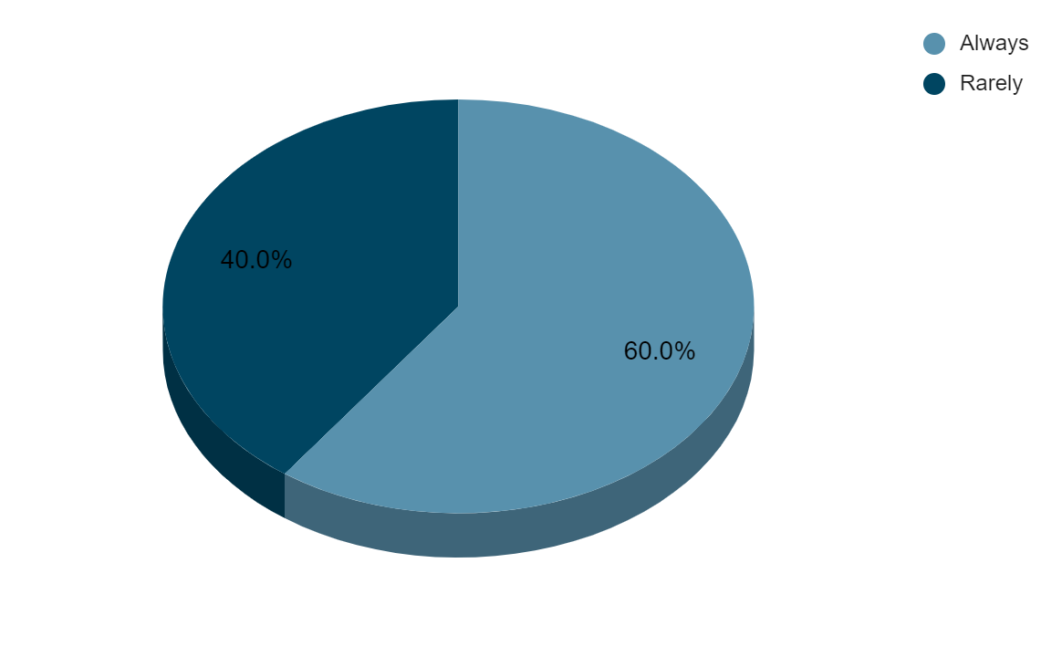
Figure 01: Survey Question 1
Source (created by the learner)

Analysis: From the above illustrated table and figure it can be said that 60% of staff at Ibis Hotel Southampton always feel that the current staffing levels are insufficient to meet the demand of guests during peak times. Likewise, 40% of the staff rarely feels this way.

Question 2 | To what extent do you feel that the staff shortage contributes to increased stress or pressure in the daily tasks?
Options | Total respondents | Responses | Percentage
Significant impact | 25 | 14 | 56%
Moderate impact | 25 | 10 | 40%
No or slight impact | 25 | 1 | 4%
Table 02: Survey Question 2
Source (created by the learner)
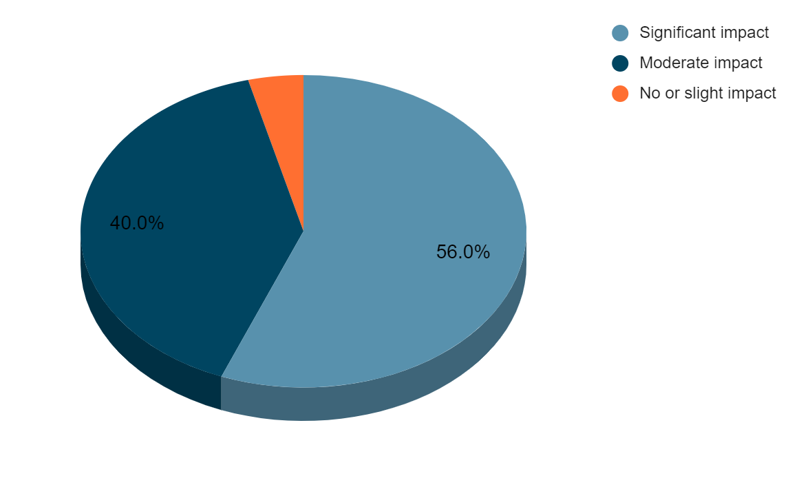
Figure 02: Survey Question 2
Source (created by the learner)

Analysis: from the above-illustrated table and figure here, it can be said that 56% of the staff working in the hotel tend to feel that the staff shortages significantly contribute to the increased stress. Likewise, 40% of the staff feel moderate impact and 4% of the staff feels There is no or slight impact of the staff shortages on the increased stress or pressure in the daily task.

Question 3 | In your opinion how often are you unable to meet the guest expectations during the staff shortages?
Options | Total respondents | Responses | Percentage
Always | 25 | 8 | 32%
Rarely | 25 | 10 | 40%
Never | 25 | 7 | 28%
Table 03: Survey Question 3
Source (created by the learner)
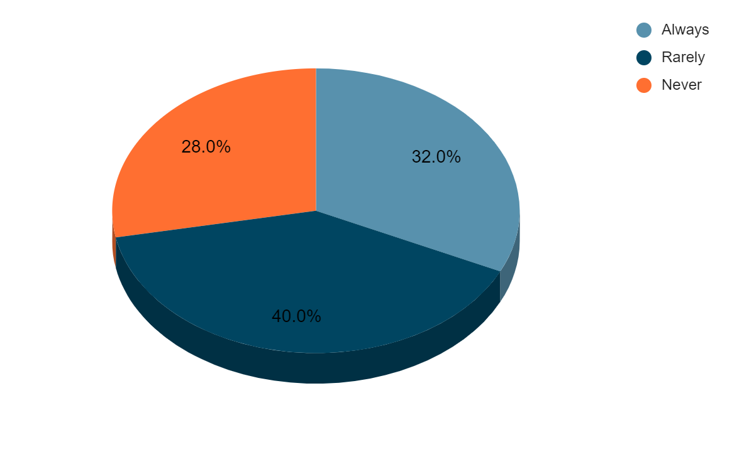
Figure 03: Survey Question 3
Source (created by the learner)

Analysis: from the above-illustrated figure and table here, it can be said that 32% of the stars always feel that they are unable to meet the guest's expectations during staff shortages. 40% of the stars rarely feel and 28% of the stars never feel that they are unable to meet the guest expectations during the staff shortages.

Question 4 | How have staff shortages impacted the morale of a team?
Options | Total respondents | Responses | Percentage
Negatively | 25 | 9 | 36%
positively | 25 | 7 | 28%
Neutral | 25 | 9 | 36%
Table 04: Survey Question 4
Source (created by the learner)
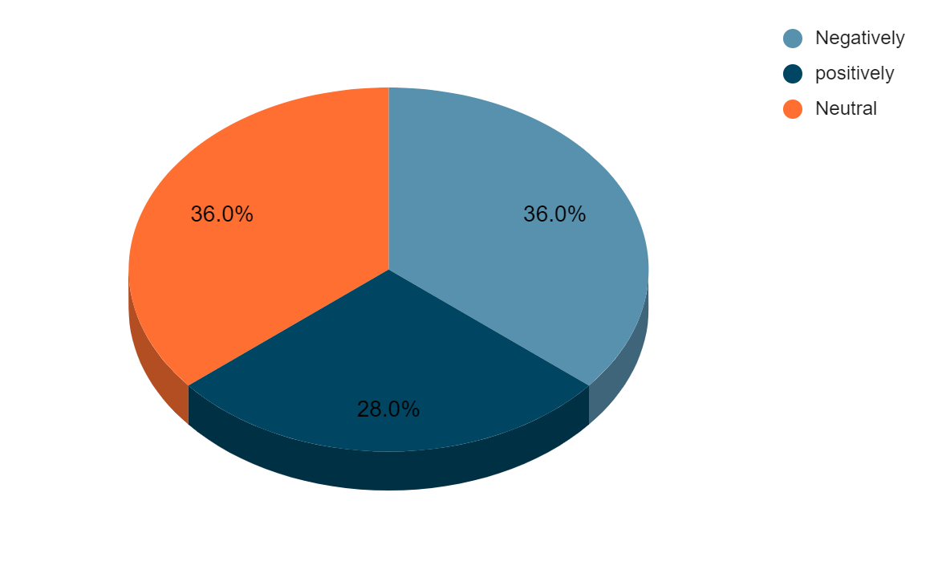
Figure 04: Survey Question 4
Source (created by the learner)

Analysis: from the above illustrated table and figure here it can be said that 36% of the stars negatively feel that the staff shortages have impacted the morale of the team. 28% of the staff feel positive and 36% of the staff feel neutral to have been impacted by the staff shortages.

Question 5 | How often do you receive guest complaints related to delays or reduced service quality due to the lack of staff?
Options | Total respondents | Responses | Percentage
Always | 25 | 5 | 20%
Rarely | 25 | 15 | 60%
Never | 25 | 5 | 20%
Table 05: Survey Question 5
Source (created by the learner)
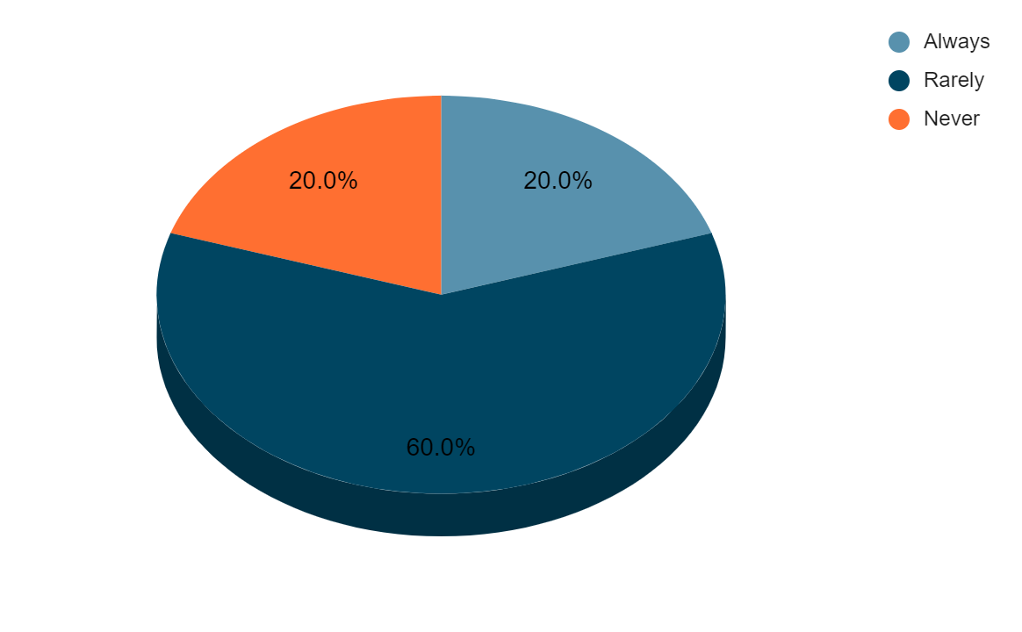
Figure 05: Survey Question 5
Source (created by the learner)

Analysis: from the above table and figure here, it can be said that 60% of the staff rarely feels that they receive guest complaints related to delayed or reduced services due to the lack of staff. 20% of the staff always feel that way and the rest 20% never feels.

Question 6 | How well do you feel supported by the management in terms of handling the challenges associated with staff shortages?
Options | Total respondents | Responses | Percentage
Very well supported | 25 | 6 | 24%
Moderate support | 25 | 9 | 36%
No support | 25 | 10 | 20%
Table 06: Survey Question 6
Source (created by the learner)
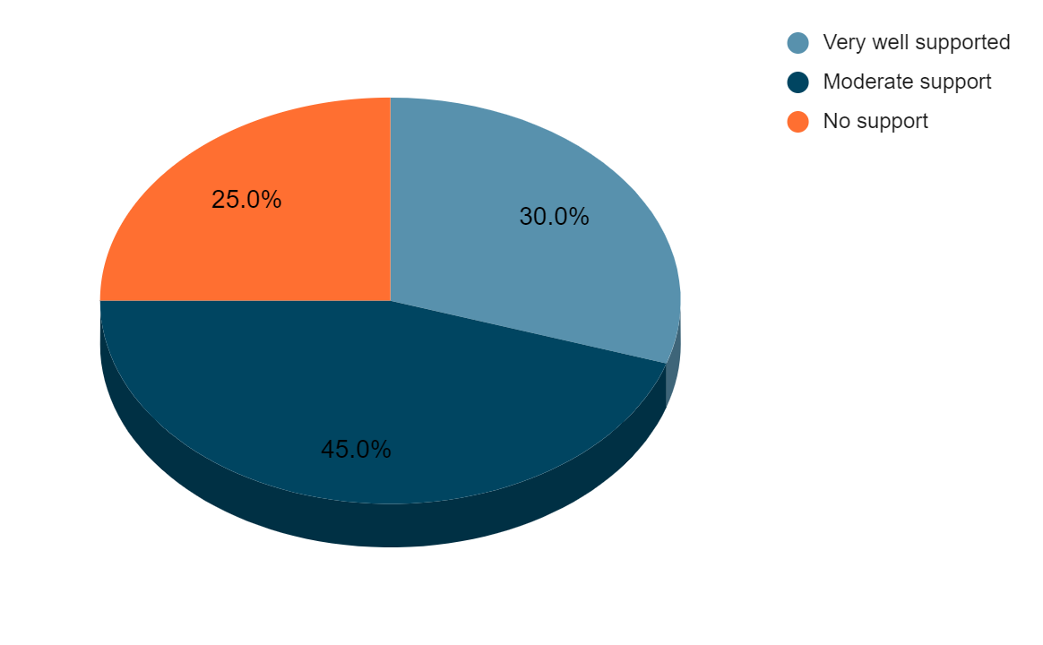
Figure 05: Survey Question 5
Source (created by the learner)

Analysis: From the above-illustrated figure and table, it can be said that 24% of the employees are very well supported by the management in terms of handling the challenges associated with staff shortages. Likewise, 36% feel moderate support and the rest 20% fees, no support from the management in terms of handling the challenges associated with the staff shortages.

5. Theme Exploration

5.1 Introduction
Staff shortages in the hospitality industry present a significant challenge that directly affects service delivery, guest satisfaction, and long-term brand loyalty. The ability of hotels to maintain high standards of service even during staff shortages is important not only for maintaining operational efficiency but also for ensuring that guest experiences are positive (Margaretha et al., 2022). The following chapter will critically analyse the impact of self-shortages on delivering effective guest experiences using Ibis Hotel, Southampton as a case study. Through an exploration of academic literature that is supported by real-world examples and evidence from the hotel, the chapter will identify the challenges imposed by the staffing shortages and suggest areas for improvement and development.

5.2 Theme Exploration
5.2.1 Theoretical framework and literature review
The hospitality industry is inherently service intensive and the relationship between the staff and guest is essential to the delivery of exceptional guest service. A growing body of research indicates that staff shortages have a direct and often negative impact on guest satisfaction and loyalty. According to Wu et al. (2021), service quality in the hospitality industry is determined by the competence of staff. When the staff levels are insufficient, it directly leads to the inability to meet the guest expectations which leads to service delays, increased stress for staff and eventually a lower quality of experience for the guest in the hotel. The SERVQUAL model highlights that there is a likeable gap which often exists between guest expectations and perceptions of service. When the staffing levels are reduced (AlOmari, 2021). These gaps widen as the staff are unable to fulfil the case needs in an effective manner, increasing the likelihood of negative guest feedback, such satisfaction can lead to a decrease in customer loyalty which is particularly detrimental in the highly competitive market of the hotel industry. In accordance with You et al. (2020), indicate that guests are more likely to forgive service failures due to the situation with external factors such as staff shortages are clearly communicated and transparent for the guest to be known. However, the guest perceives that the hotel is understaffed, and this is not communicated to or addressed in an effective manner. The overall satisfaction and future intent may be adversely affected (van Son et al., 2024). The emotional labour involved in guest interaction is heightened during periods of staff shortages as the employees feel increased pressure to maintain the high quality of service despite the inadequate resources.
5.2.2 The role of staffing in guest experience
The direct correlation between staffing levels and guest satisfaction has been well documented with the staff numbers, although with time increases and personalised service becoming harder to deliver staff burnout is inevitable (Baquero, 2023). Staff shortages often result in longer times for the guest to be more specific in reception. The school manifests itself as a slower check-in and check-out process in restaurants. It leads to slower service or missed requests (Febdilan, 2023). As a result, service speed is a crucial element of guest satisfaction, especially for business travelers who prioritise efficiency. As per Wen et al. (2020), personalised service is a significant detriment to guest loyalty as staff shortages can result in employees being inadequately able to engage in personalised interactions as they may be focused on completing tasks rather than catering to individual guest needs. The high levels of stress among the employees due to being understaffed can impact their emotional labour, leading to decreased job satisfaction, and increased turnover (Dangaiso and Mukucha, 2024). Likewise, employee burnout can affect the guest interaction as over-walked staff may not have the energy to provide the high high-level of service that the guest expects (Min et al., 2023). Service recovery is often critical in maintaining customer loyalty, however, when hotels are understaffed guest complaints may go on, adjust or take longer to resolve leading to trust and satisfaction.
5.2.3 Impact of staff shortages at Ibis Hotel Southampton
The Ibis Hotel Southampton has been deeply affected by the staff shortages, which have been caused due to several external factors, including the COVID-19 pandemic, Brexit-related labour shortages, and the high turnover rate in the hospitality industry. These issues have not only impacted the operational efficiency of the hotel but have also negatively influenced the guest experience. According to Stockland et al. (2023), the hospitality sector particularly in the UK has long straw girls with staff shortages, but the situation has been significantly influenced by the COVID-19 pandemic and Brexit. The hospitality industry saw a sharp decline in staffing labour during the pandemic with many workers in the sector due to health concerns, lack of job security and financial instability (Liu-Lastres et al., 2023). While the situation has improved since the pandemic peak, many hotels continue to face challenges in terms of staffing. This has been compounded by Brexit, which has further reduced the flow of EU nationals into the UK workforce, leaving many businesses, including those in the hospitality industry, starting to feel the ideal roles. According to Fagyas and Datta (2023), one of the most common complaints at Ibis Hotel, Southampton, has been the delays in the check-in and checkout processes. The hotel, which typically experiences high volumes of guests, especially in the peak times, has found it increasingly difficult to manage these operations effectively due to the insufficient front desk staffing. The staff shortages have led to the longer term for the guests during both check-in and check-out processes leading to frustration and negative feedback (Birdir and Sahilli Birdir, 2024). Prior to the pandemic and the labour shortages, the average check-in time at the hotel was around five minutes. However, the recent report suggests that this has increased to 10 minutes on average. This may seem like a small increase, but it can be significant during busy periods, especially when the guests arrive in large groups or during big holiday times, the delays in the check-in and check-out processes extend beyond the front desk as the guest has reported waiting longer than expected for the rooms to be ready, which further compounds the inconvenience and lead to the guest, guest satisfaction. The checkout delay is also frequently mentioned to be a core issue as the guests must wait longer to complete their departure, especially when the front desk is understaffed and there are fewer employees available to manage the checkout processes.
According to Yacoub and ElHajjar (2021), another area where the staff shortages have had a noticeable impact on the hotel is in the restaurants and bar services. The reduced number of available staff has led to slower service, especially during the busy period which has affected both guest service and direct feedback, the hotel restaurants which offer a buffet star breakfast and dining have experienced delays in food preparation and delivery, particularly during the peak hours, such as breakfast and dinner (Isaac and Keelson, 2023). During the peak breakfast times, guests have reported longer times for food orders and in some cases, there have been incomplete orders. There is a large reduction in kitchen and service staff, meaning the restaurant cannot operate smoothly, leading to guests providing fewer services (Wood, 2024). Room services on the other hand have been affected with guests experiencing longer times for the orders to be fulfilled, leading to decreased satisfaction and also influencing their overall perception of the hotel's ability to meet their expectations (Cheong and Law, 2023). Guests who have previously enjoyed efficient and high-quality service during their stay have now found themselves waiting significantly longer for even basic services (Ayodeji et al., 2023). Such issues with the service level can make the guest experience feel less enjoyable and create a sense of frustration among the visitors leading to decreased satisfaction, the job service standards, particularly in the restaurants and bar under the hotel, an ability to meet the brand promise of our comfort, stay leading to lower guest satisfaction, and decreased repeat bookings.
As per Pelet et al. (2021), the reduced personalised interactions are also one of the significant impacts of the staff shortages at the hotel. This is so because many guests appreciate the personal touches that are provided in the hotel such as greetings by name, customised recommendations, and personalised service (Vashishth et al., 2024). However, as the staff levels have decreased, many employees are forced to focus primarily on completing the essential operational tasks, such as checking guests in answering rooms are prepared rather than engaging in these more personalised interactions, the feedback from guest has reflected a growing sense of dissatisfaction with the lack of these personal touches (Çeltek, 2024). The guests have reported feeling like they were treated more as numbers or room bookings than as individuals. Likewise, it is also reported that the guest has a lack of personal connection, significantly impacting the hotel's perception. One of the keys selling points of staying at a branded hotel is the consistency of service and the ability to feel valued as a guest (Jeong et al., 2023). Personalised interactions are a key factor in building brand loyalty and repeat business and a reduction of these introductions has the potential to damage the reputation and image in the market.
As per Ghani et al. (2022), in order to address the challenges, the company focuses on improving the recruitment efforts and returning existing staff which is critical by offering competitive wages, improved working conditions, and better training. Likewise, the hotel can even automate certain aspects of gas service, such as the self-checkout on mobile service orders which can help to reduce some of the operational pressures that are caused by staff shortages (August, 2023).
5.2.4 Guest feedback and response to staff shortages
As per Jain et al. (2023), some guests at the Ibis Hotel, Southampton have shown understanding when the hotel is transparent about the issues regarding the understaffed. A review of guest feedback indicates that clear communication regarding the delays or the radio services can meet the frustration, especially in times alternative solutions are provided to the guests who are informed upfront about the potential delays whether it is during the check-in or checkout processes (Zhang, 2024). It can be more understanding as it allows them to adjust their interactions and expectations accordingly. Conversely, when guests are not informed, they are more likely to leave negative reviews, focusing on poor service or lack of responsiveness (Patil and Rane, 2023). The guest satisfaction service from the hotel underscores is correlation between the perceived staff availability and the overall guest satisfaction. Guests who feel the hotel is understaffed or insufficient are significantly more likely to express dissatisfaction (Li et al., 2024). These guests often feel neglected or undervalued, which can result in a lower rating and an anatomist overall experience. There is a noticeable increase in overall satisfaction, even when the expectations are not fully met, which underscores that staff shortages can negatively impact on the service. Transparent communication can help to save guest satisfaction (Gavilan and Al-shboul, 202).
5.2.5 Areas for development and improvement
In accordance with Morosan and Bowen (2022), while the staff shortages are challenging, one of the potential solutions is cross-training employees to handle multiple roles which allows the hotel to maintain flexibility during the peak times. The front desk staff also be trained in basic food and beverage operations allowing them to assist in the restaurant during the high traffic period (Zemlina et al., 2023). This can help to reduce the effects of reduced staffing without compromising service quality. Likewise, the company can implement self-service technology such as mobile check-in, digital room keys, and an automated room service request which can reduce the strain on the front desk and operational staff by following the guests to handle certain tasks themselves (Roy and Pagaldiviti, 2023). The hotel can manage fewer staff while also offering them a personalised experience. Clear, transparent communication about staff shortages can go a long way in maintaining guest trust, and satisfaction (Padma. and Ahn, 2020). To be more specific, proactively informing the guest about the delays at check-in or offering discounts or complimentary services when the issue arises can help to preserve loyalty (Matey, 2024). Supporting staff through programms focused on reducing burnout and improving morale is also important in this regard Initiatives such as regular breaks mental health support and ensuring staffing levels during the peak period will also improve staff performance and guest satisfaction (Saito et al., 2024). The company can even focus on implementing dynamic scheduling systems which take into account guest demand patterns and help to ensure that the hotel has better staff during peak times using data analytics to forecast busy periods can allow for better scheduling and reduce the risk of staff shortages during critical times (Patil et al., 2024).

6. Conclusion and Recommendation

6.1 Conclusion
Summarising the overall research study, it can be said that the research on investigating the impact of staff shortages on delivering effective guest experience referring to the case study of Ibis Hotel, Southampton has been successfully carried out. The research objective of investigating how staff shortages affect the operational efficiency of services delivered by the Ibis Hotel Southampton has been addressed as theme 1 in the literature review chapter and through the data collection. The literature review findings suggest that hotels struggle to maintain optimum staffing levels across departments such as front desk, housekeeping and food and beverage services. This often results in longer wait times for guests during checking, reduced attention to detail in the room, clean image, and delays in the service delivery at restaurants or bars. The interview findings suggest that From taking longer time at the reception to being unable to assist during peak times, every core aspect has been affected due to the staff shortage, likewise 60% of the staff rarely feel that they receive guest complaints related to the delay or reduced services due to the lack of staff which directly links to the effect in operational efficiency of services due to the staff shortages. The second research objective of analysing guest satisfaction factors that are influenced by the lack of staff shortages within the Ibis Hotel, Southampton, has been addressed as theme 2 in the literature review and from the data collection. The literature review findings suggest that the quality of interactions among the staff diminishes with fewer employees; interactions may feel rushed or less personal. The attention to detail of guest experience also suffers as the inadequate staffing often means that the remaining employees are overburdened which can result in missed tasks such as proper room cleaning or timely maintenance requests (Mızrak, 2024). All these are linked to the guest satisfaction factors that are influenced by the lack of staff shortages which left unnoticed can lead to decreased guest satisfaction.
Lastly, the objective of identifying staff management strategies in combating ineffective guest experiences due to staff shortages within the hotel has been achieved as theme 3 in the literature review chapter and from the data collection. The literature review findings suggest that flexible scheduling, fostering a positive workplace culture for retention, recognizing employee contributions, promoting teamwork, and providing opportunities for growth can lead to higher job satisfaction levels that lead to reducing turn overheads and associated costs of recruiting and training new staff. The interview findings suggest that one of the key strategies that have been successful in mitigating the impact of staff shortages on guest satisfaction include self-service technology, technology like online service requests and so on that has led to reducing the strain on the frontline staff. As a result, a failure to free up employees to focus on more crucial tasks that directly impact guest satisfaction. Thus, all the findings result in informing the research aim and objectives.

6.2 Recommendation
- Based on the findings, 36% of staff working in Ibis Hotel Southampton feel that they are provided with moderate support by the management in terms of handling the challenges associated with the staff shortages. Thus, in this regard, it is recommended that the hotel focus on holding regular meetings with the staff to discuss staffing levels, potential shortages, and solutions (Solnet and Golubovskaya, 2023). As a result, it will help the staff to feel informed and involved in the decision-making process. Likewise, encouraging staff to voice concerns and suggestions can also foster a culture of transparency and responsiveness from management (Hina and Siddiqui, 2023).
- It is recommended that the company focus on improving employee well-being and mental health support as it can have a significant impact on the delivery of guest service (Kim et al., 2023). It is important for the management to not only provide practical solutions but also offer emotional support to keep the employee scope up with these challenges. For instance, the company can provide the staff with access to mental health support counselling services or workshops on stress management (Irvine and Suter, 2023). As a result, they are more likely to be mentally, healthy, and resilient in nature leading to offering positive outcomes.

7. Reflective account
During my placement at the Ibis Hotel, Southampton, I observed the effects of staff shortages on operational efficiency and guest experience quality. While I was aware of the challenges imposed by the staff shortages before my placement, it was not until I experienced the issue in the first stand manner, that I gained a deeper understanding of the complexities present through the direct observation interactions with both guest and staff and my involvement in the daily activities. I have gained valuable insights and knowledge into the impact of shortages and how they affect the overall functioning of hotel operation operations. One of the first things that stood out to me upon beginning, my press was the frequent issue regarding slower service and delayed responses during peak periods. Whether it was at the check-in or at the restaurant, the strain of reduced workforce was clear as I noticed that the fronts in particular were often on the staff which created bottlenecks, especially during the check-in and checkout processes (Fox et al., 2023). Guests frequently must wait longer than expected and on several occasions. I witnessed a few guests experiencing frustration due to the delays. It became clear that when staff are overwhelmed or stretched, the ability to provide personalised service is compromised. It was also evidenced during periods of high demand such as weekends or when the hotel was fully booked, one guest in particular voiced disappointment that the hotel was unable to accommodate the request for a room with a better view (Hossain et al., 2023). Request the maid in advance given the staff shortages. The receptionist did not have the capacity to fulfil the request, and I noticed that the guest left the hotel feeling less satisfied with the overall stay. While I actively understood that the staff shortages were causing this issue, I began to realise the quality of service was not simply a matter of operational efficiency and adequate resources, but also a staffing level was actively required. Also to note that the emotional labour involved in the hospitality was greatly influenced, the staff members were clearly stressed and running between the tasks without the time to engage meaningfully with the guests, the personal interactions which created any emotional connection such as welcoming guests by name, offering local recommendation or simply taking a moment to enquire about this day was becoming increasingly difficult to achieve (Xiong et al., 2023). As a part of working in Ibis Hotel Southampton, I learned various lessons and aspects of hospitality industry. I have learnt regarding the management of restaurant, specifically regarding the guest seating to taking orders and serving food and also managing the bar, I have been able to gain various insights regarding the bar operations, including mixing of drinks and handling the financial processes (Wen. and Liu-Lastres, 2023). Such experiences helped me to be aware of how the food and beverage department is critical to the success of hospitality operations. As from the experiences gained in this department, it was significant for me to formulate an acceptable plan which helped me to put the past learning to improve the future performance of the department. The plan also focused on increasing customer service, developing the menu, training staff, and increasing operational efficiency. However, one of the organizational issues which I was exposed to within the food and beverage department includes the high staff turnover which leads to impacting my working pattern negatively.
The gap between the guest expectations and the reality of staff at the question became a consistent team during my investment. It was evident that many guests expected the same level of service, regardless of the staff shortages. This mismatch led to frequent guest complaints about the times of the inability to fulfil the special request. However, I witnessed that clear communication and transparency will play a significant role in managing guest expectations during times of staff shortages, on a few occasions, the management made an active effort to communicate with guests about delays or reduced services and these seemed to improve the guest perceptions (Suwarto et al., 2023). When the hotel was experiencing our staffing shortage in the restaurant, the front desk staff informed the guest in advance about the longer time and provided options for dining outside the hotel, the guests who were informed upfront were found to be understanding than those who were caught by God by the delays. However, there were instances in which poor communication led to guest frustration, a guest who was unaware that the hotel was short-staffed became frustrated after waiting 30 minutes for a response to a room service, request, this lack of transparency led to negative feedback as the guest felt ignored, even though the staff was genuinely trying to keep up with the overwhelming workload (Bazina, 2023). This experience taught me that the significance of being transparent with guests, managing the expectations and providing them with timely updates is crucial. Therefore, I believe that implementing strategic solutions such as improved communication, technology, technology, and staff well-being initiatives in hotel hotels like the Ibis Hotel, Southampton can continue to deliver an excellent guest experience during times of staffing shortages.

Reference List
Abalaka, A., Olaniyi, O. and Adebiyi, O.O., (2023) Understanding and overcoming the limitations to strategy execution in hotels within the small and medium enterprises sector. Available at https://papers.ssrn.com/sol3/papers.cfm?abstract_id=4614043 (Accessed: 01 N0vember 2024)
Abell, A., Biswas, D. and Arroyo Mera, C., (2024) ‘Food and technology: Using digital devices for restaurant orders leads to indulgent outcomes’ Journal of the Academy of Marketing Science, pp.1-19.
Ahli, M., Hilmi, M.F. and Abudaqa, A., (2024) ‘Ethical sales behavior influencing trust, loyalty, green experience, and satisfaction in use public entrepreneur firms’ Aptisi Transactions on Technopreneurship (ATT), 6(2), pp.149-168.
Almerri, H.S.H., (2023) ‘Investigating the impact of organisational culture on employee retention: The moderating role of employee engagement’ Journal of System and Management Sciences, 13(4), pp.488-507.
AlOmari, F., (2021). ‘Measuring gaps in healthcare quality using SERVQUAL model: challenges and opportunities in developing countries’ Measuring Business Excellence, 25(4), pp.407-420.
Amaral, M.F.A., Guerreiro, S. and Major, E., (2023) Opening of a Chain Hotel in a Mediterranean Island: Case Study of Challenges and Strategies for the Future of a Seasonal Hotel.
August, K.G., (2023) ‘Access, Inclusion, and Accommodation’ In Women in Telecommunications (pp. 285-334). Cham: Springer International Publishing.
Ayodeji, Y., Rjoub, H. and Özgit, H., (2023) ‘Achieving sustainable customer loyalty in airports: The role of waiting time satisfaction and self-service technologies’ Technology in Society, 72, p.102106.
Baquero, A., (2023) ‘Is customer satisfaction achieved only with good hotel facilities? A moderated mediation model’ Administrative Sciences, 13(4), p.108.
Bazina, A., (2023). ‘Human resource management of the Hotel enterprise’
Belias, D., Rossidis, I., Sotiriou, A. and Malik, S., (2023) ‘Workplace conflict, turnover, and quality of services. A case study in Greek seasonal hotels’ Journal of Quality Assurance in Hospitality & Tourism, 24(4), pp.453-476.
Birdir, K. and Sahilli Birdir, S., (2024) ‘Staff shortages in hospitality and tourism industries: how technology influences?’ Worldwide Hospitality and Tourism Themes.
Broker, E.A., (2024) ‘An Examination of Frontline Service Workers' Empathy in a Cobot Team’
Candra, P., Mahaputra, M.R. and Mahaputra, M.R., (2023) ‘Service Quality and Customer Satisfaction Have an Impact on Increasing Hotel Room Occupancy Ratio: Literature Review Study’ Greenation International Journal of Tourism and Management, 1(4), pp.400-412.
Çeltek, E., (2024) ‘Unmanned smart hotel: applications and examples’ Worldwide Hospitality and Tourism Themes, 16(5), pp.611-626.
Chanie, W., Melese, S. and Demesie, A., (2023) ‘Linking work characteristics to proactive behaviour: Mediating role of motivational state’ Heliyon, 9(7).
Cheong, F. and Law, R., (2023) ‘Human employees versus robotic employees: Customers and hotel managers’ perceived experience at unmanned smart hotels’ Cogent Social Sciences, 9(1), p.2202937.
Dangaiso, P. and Mukucha, P., (2024) ‘Evaluating the impact of service encounter incivility on employee job stress, turnover intentions and labour attrition: a study on frontline employees in the fast-food service industry’ Cogent Business & Management, 11(1), p.2355671.
Fagyas, C. and Datta, P., (2023) ‘An investigation of the factors associated with consumer behaviour at arrival, check-in, and the check-out process: A case study Marriott International Inc. in the UK’ Journal of Business and Retail Management Research, 17(2).
Febdilan, F.K., (2023) ‘EFFORTS TO INCREASE THE CAPACITY OF RECEPTING GUESTS AND ROOM CLEANING IN STANDARD HOMESTAY BUSINESS IN MANDALIKA TOURISM VILLAGE, CENTRAL LOMBOK’ International Journal of Social Science, 2(5), pp.2123-2136.
Fox, S.E., Shorey, S., Kang, E.Y., Montiel Valle, D. and Rodriguez, E., (2023) ‘Patchwork: the hidden, human labor of AI integration within essential work’ Proceedings of the ACM on Human-Computer Interaction, 7(CSCW1), pp.1-20.
Frank, A.M., Hasan, S., Makki, T. and Hancock, D.R., (2024) ‘Making the case for case studies in Counselor education: Applications to child and adolescent research’ Journal of Child and Adolescent Counseling, 10(2), pp.118-131.
Gavilan, D. and A. Al-shboul, O.A., (2023) ‘Designing innovation in urban hotels through guest experience data on interior design’ European Journal of Innovation Management.
Ghani, B., Zada, M., Memon, K.R., Ullah, R., Khattak, A., Han, H., Ariza-Montes, A. and Araya-Castillo, L., (2022) ‘Challenges and strategies for employee retention in the hospitality industry: A review’ Sustainability, 14(5), p.2885.
Hangel, N. and ChoGlueck, C., (2023) ‘On the pursuitworthiness of qualitative methods in empirical philosophy of science’ Studies in History and Philosophy of Science, 98, pp.29-39.
Hina, A. and Siddiqui, D.A., (2023) ‘How Charismatic Leadership, and Employee Voice Complements the Transformational Leadership in Enabling Championing Behavior among Employees during Organizational Change: A parallel-sequential multiple mediations of Transparent Communication, Organizational Trust, and Openness to Change’ Organizational Trust, and Openness to Change (April 28, 2023).
Hinson, R.E., Mensah, E.A. and Odame, D.A., (2024). Customer Service Delivery in Africa: Consumer Perceptions of Quality in Selected African Countries. CRC Press.
Hossain, M.I., Oppewal, H. and Tojib, D., (2023) ‘High expectations: How tourists cope with disappointing vacation experiences’ Journal of Travel Research, 62(5), pp.989-1009.
Hubbart, J.A., (2023) ‘Organizational change: The challenge of change aversion’ Administrative Sciences, 13(7), p.162.
Ibis (2024) Ibis Southampton Center, Available at: https://all.accor.com/hotel/1039/index.en.shtml?utm_campaign=seo+maps&utm_medium=seo+maps&utm_source=google+Maps (Accessed: 02 November 2024)

Ibrahim, I.W., Ghazali, I.M., Syed, S.A., Abdullah, N.H.R., Hamid, M.H.A. and Aisyah, S.H., (2023) ‘Exploring Motivation for Learning Using Hertzberg’s Two Factor Theory’ International Journal of Academic Research in Business and Social Sciences, 13(3), pp.1065-1083.
Irvine, A. and Suter, J., (2023) ‘Managing mental health problems in the workplace: are small businesses different?’ Employee Relations: The International Journal, 45(5), pp.1161-1179.
Isaac, N. and Keelson, S.A., (2023) ‘The Mediating Effects of Market Culture and Customer Service Skills in the Sensory Marketing and Non-Economic Performance Relationship of Ghana’s Restaurant Sector’ Social Sciences, 10(1), pp.197-212.
Jain, S., Basu, S., Ray, A. and Das, R., (2023) ‘Impact of irritation and negative emotions on the performance of voice assistants: Netting dissatisfied customers’ perspectives’ International Journal of Information Management, 72, p.102662.
Jeong, M., Shin, H.H., Lee, M. and Lee, J., (2023) ‘Assessing brand performance consistency from consumer-generated media: the US hotel industry’ International Journal of Contemporary Hospitality Management, 35(6), pp.2056-2083.
Karim, R.A. and Rabiul, M.K., (2024) ‘The relationships of corporate sustainability, customer loyalty, and word of mouth: the mediating role of corporate image and customer satisfaction’ Journal of Quality Assurance in Hospitality & Tourism, 25(3), pp.421-441.
Karunarathna, I., Gunasena, P., Hapuarachchi, T. and Gunathilake, S., (2024) The crucial role of data collection in research: Techniques, challenges, and best practices.
Kim, M.S., Ma, E. and Wang, L., (2023) ‘Work-family supportive benefits, programs, and policies and employee well-being: Implications for the hospitality industry’ International Journal of Hospitality Management, 108, p.103356.
Li, H., Zhang, J., Wan, Q., Wang, Q. and Xu, J., (2024) ‘Customers’ hotel staycation experiences: implications from the pandemic’ Current Issues in Tourism, 27(11), pp.1732-1749.
Liu-Lastres, B., Wen, H. and Huang, W.J., (2023) ‘A reflection on the Great Resignation in the hospitality and tourism industry’ International Journal of Contemporary Hospitality Management, 35(1), pp.235-249.
Ma, W., Yang, S., Tan, T., Ma, X., Xu, C. and Li, Y., (2023) ‘Context sensitivity without contexts: A cut-shortcut approach to fast and precise pointer analysis’ Proceedings of the ACM on Programming Languages, 7(PLDI), pp.539-564.
Margaretha, F., Wirawan, S.E. and Wowor, W., (2022) ‘The influence of service quality toward customer loyalty at a five-star hotel in Bali’ International Journal of Social and Management Studies, 3(2), pp.175-186.
Matey, D., (2024) ‘Service Etiquette, the Guest, the Provider and the Experience’ International Journal of Research in Engineering, Science and Management, 7(1), pp.26-32.
Min, H., Kim, H.J. and Agrusa, J., (2023) ‘Serving diverse customers: The impact of cultural intelligence on employee burnout, engagement, and job satisfaction’ Journal of Hospitality & Tourism Research, 47(3), pp.503-527.
Mızrak, F., (2024) ‘Effective change management strategies: Exploring dynamic models for organizational transformation’ In Perspectives on artificial intelligence in times of turbulence: Theoretical background to applications (pp. 135-162). IGI Global.
Morosan, C. and Bowen, J.T., (2022) ‘Labour shortage solution: redefining hospitality through digitization’ International Journal of Contemporary Hospitality Management, 34(12), pp.4674-4685.
Padma, P. and Ahn, J., (2020) ‘Guest satisfaction & dissatisfaction in luxury hotels: An application of big data’ International journal of hospitality management, 84, p.102318.
Papademetriou, C., Anastasiadou, S. and Papalexandris, S., (2023) ‘The effect of sustainable human resource management practices on customer satisfaction, service quality, and institutional performance in hotel businesses’ Sustainability, 15(10), p.8251.
Papademetriou, C., Anastasiadou, S. and Papalexandris, S., (2023) ‘The effect of sustainable human resource management practices on customer satisfaction, service quality, and institutional performance in hotel businesses’ Sustainability, 15(10), p.8251.
Patil, D., Rane, N.L. and Rane, J., (2024) ‘Enhancing resilience in various business sectors with ChatGPT and generative artificial intelligence’ The Future Impact of ChatGPT on Several Business Sectors, pp.146-200.
Patil, D.R. and Rane, N.L., (2023) ‘Customer experience and satisfaction: importance of customer reviews and customer value on buying preference’ International Research Journal of Modernization in Engineering Technology and Science, 5(3), pp.3437-3447.
Patrick, M., (2023) ‘OPTIMISING EMPLOYEE SCHEDULING: IMPACTS ON PRODUCTIVITY, SATISFACTION, AND WORK-LIFE BALANCE IN THE HOTEL INDUSTRY’ Shaping the Sustainable Future: Trends and Insights in Economics, Business, Management, and Information Technology, p.110.
Pelet, J.É., Lick, E. and Taieb, B., (2021) ‘The internet of things in upscale hotels: its impact on guests' sensory experiences and behaviour’ International Journal of Contemporary Hospitality Management, 33(11), pp.4035-4056.
Rose, R., Kumar, V.V. and Kesari Jena, L., (2023) ‘Contingency Theory and Public Emotions in Crisis Communication–A Conceptual Study’ Journal of Education Culture and Society, 14(2), pp.30-48.
Roy, B.K. and Pagaldiviti, S.R., (2023) ‘Advancements in arena technology: Enhancing customer experience and employee adaptation in the tourism and hospitality industry’ Smart Tourism, 4(1), p.2330.
Saito, H., Lee, A., Bui, H.T. and Baum, T., (2024) ‘Fostering employee well-being and workplace recovery in the hospitality industry: The role of supportive break times at work’ Journal of Hospitality and Tourism Management, 61, pp.91-100.
Simonis, L., (2023) Customer experiences for senior guests: challenges and opportunities for the hospitality industry
Sirojiddinovna, H.D., (2023) ‘SCIENTIFIC-THEORETICAL FOUNDATIONS OF THE FORMATION OF STUDENTS'INDEPENDENT LEARNING SKILLS BASED ON THE" CASE-STUDY" APPROACH IN TEACHING ENGLISH’ Galaxy International Interdisciplinary Research Journal, 11(11), pp.638-645.
Solnet, D. and Golubovskaya, M., (2023) ‘Research on service frontline employees: a science–practice perspective’ Journal of Service Management, 34(5), pp.1021-1037.
Stockland, K., Rostron, J. and Runge, J., (2023) A qualitative investigation into the experiences of workers in the hospitality sector in Scotland.
Suwarto, T., Pforr, C. and Volgger, M., (2024) ‘Front-desk workforce cultural diversity and its implications for service quality in the accommodation sector: a case from Australia’ Tourism Review, 79(1), pp.234-249.
Vagena, A., Sufi, T., Goyal, A.K. and Chaudhary, H.K., (2024) ‘Enhancing Hospitality: Evaluating Employee Satisfaction and Working Conditions in Crete's (Greece) Hotel Industry’
Van Son, I., Guicherit, O.R. and Lombarts, A., (2024). ‘Help, I May Have to Go Home…’Leaving the Hospital Not Too Early and Not Too Late: Optimising the Discharge Process’ Journal of Health Management, 26(1), pp.92-101.
Vashishth, T.K., Sharma, V., Sharma, K.K., Kumar, B., Kumar, A. and Panwar, R., (2024) ‘Artificial Intelligence (AI)–Powered Chatbots: Providing Instant Support and Personalized Recommendations to Guests 24/7’ In Technology and Luxury Hospitality (pp. 211-236). Routledge.
Veloso, M. and Gomez-Suarez, M., (2023) ‘Customer experience in the hotel industry: a systematic literature review and research agenda’ International Journal of Contemporary Hospitality Management, 35(8), pp.3006-3028.
Verbeke, K., Krawczyk, T., Baeyens, D., Piasecki, J. and Borry, P., (2023) ‘Informed consent and debriefing when deceiving participants: a systematic review of research ethics guidelines’ Journal of Empirical Research on Human Research Ethics, 18(3), pp.118-133.
Wallwey, C. and Kajfez, R.L., (2023) ‘Quantitative research artifacts as qualitative data collection techniques in a mixed methods research study’ Methods in Psychology, 8, p.100115.
Wen, B., Zhou, X., Hu, Y. and Zhang, X., (2020) ‘Role stress and turnover intention of front-line hotel employees: the roles of burnout and service climate’ Frontiers in Psychology, 11, p.36.
Wen, H. and Liu-Lastres, B., (2023) ‘Evaluating food safety education in hospitality management programs through the lenses of situated learning theory: Insights from industry leaders and educators ‘ Food Control, 153, p.109893.
Wood, R.C., (2024) Working in hotels and catering, Taylor & Francis.
Wu, X., Wang, J. and Ling, Q., (2021) ‘Managing internal service quality in hotels: Determinants and implications’ Tourism Management, 86, p.104329.
Xiong, W., Huang, M., Okumus, B., Leung, X.Y., Cai, X. and Fan, F., (2023) ‘How emotional labor affects hotel employees’ mental health: A longitudinal study’ Tourism Management, 94, p.104631.
Yacoub, L. and ElHajjar, S., (2021) ‘How do hotels in developing countries manage the impact of COVID-19? The case of Lebanese hotels’ International Journal of Contemporary Hospitality Management, 33(3), pp.929-948.
You, Y., Yang, X., Wang, L. and Deng, X., (2020) ‘When and why saying “thank you” is better than saying “sorry” in redressing service failures: The role of self-esteem' Journal of Marketing, 84(2), pp.133-150.
Zemlina, Y., Peresichna, S.V.I.T.L.A.N.A., Oliinyk, O.K.S.A.N.A., Danylenko, O., Krasovskyi, S. and Vasylenko, O., (2023) ‘Ensuring the Efficiency of Service, Technology, and Management Processes in the Hotel and Restaurant Business’ WSEAS Transactions on Environment and Development, 19, pp.1132-1144.
Zhang, X., (2024) ‘Customer experience bottlenecks in the airline customer journey: Recommendations and implications’

