STRATEGIC MANAGEMENT
BEATA DUDAK 2010697

TESLA’S ENTRY INTO THE U.S. AUTO INDUSTRY

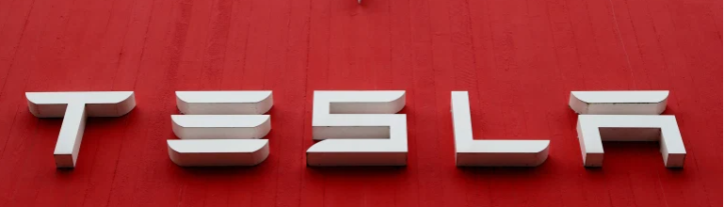

LCMB7003| MODULE LEADER DR G.D. KULOTHUNGAN

2021
Table of Contents
Introduction 2
Industry overview 2
Key success factors for Tesla 4
Internal analysis 5
Value chain analysis 5
Primary Activities of Tesla 6
Tesla - Support activities 9
Resource and capability analysis 10
External analysis 12
Porter’s five forces 12
Bargaining power of buyers – HIGH 12
Bargaining power of suppliers – MODERATE to HIGH 12
Industry competition - HIGH 12
Threat of new entrants – LOW 14
Threat of substitutes - HIGH 14
PESTEL Analysis 15
SWOT Analysis and Confrontation matrix 17
Conclusion 20
Recommendations 21
References 22

Introduction
Strategic management involves the formulation and implementation of organisational initiatives to meet the larger objectives (Ahlemann, et al., 2011). The process of strategic management involves a close analysis of the external and internal environment to arrive at the logical set of steps, procedures, short-term and long-term objectives (Dess, et al., 2014). This report evaluates the strategic management as applied to Tesla. Tesla is the multinational electric vehicle and clean energy firm with its headquarters in Palo Alto, California. The primary products of Tesla include electric cars and batteries, while the firm is also gradually transitioning into renewable energy solutions for homes and offices. Elon Musk is the co-founder and CEO of Tesla, and leads the product design, engineering, and manufacturing of Tesla (Tesla.com, 2020). This report evaluates the strategic management of Tesla with regard to its electric car market in the United States. It elaborates the contemporary strategic management at Tesla, amidst the external and internal factors facing the firm. It explores the key influencers, drivers, opportunities, threats, and recommends necessary strategic steps for the firm to implement.

Industry overview
The passenger car market in the US is estimated at $245 billion in 2021 and has seen a consistent increase in market value since 2017. The sector was valued at $219 billion in 2012 and has grown by around 12% in the last decade (Sull & Reavis, 2019). Some of the key reasons for the growth in this sector include, a strong domestic demand, availability of easy labour, geographic advantage and government support. Apart from the presence of domestic brands, majority of the foreign automobile manufacturers from Japan, Germany, South Korea, etc. have a production base in the USA. The government of US prioritises the automotive sector, as it is historically seen to contribute 3-4% of the US GDP (Hill, et al., 2019). The auto-industry spends additional $16 -$18 billion annually on various research and development programs within the country, thereby adding to the national GDP and regional growth (Hill, et al., 2019).
Within the Electric Vehicle segment, the total units sold in 2018 was 361,000 as compared to 199,818 units in 2017. This was an incremental sale of around 81% (Pyper, 2019). This indicates the growing acceptance and demand for EVs in the US region. The figure below illustrates the total EVs which are on-road in the US:
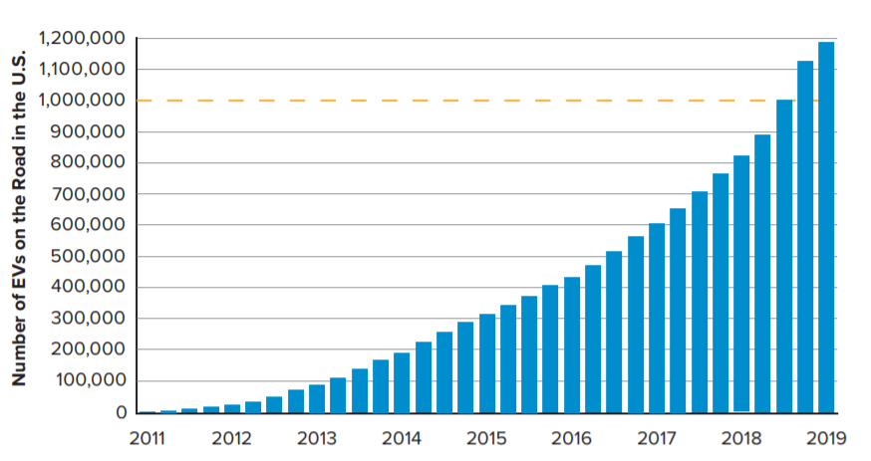
Figure: Number of EVs on road (EEI, 2020)
As seen, by end of 2019, US had a total of 1.18 million electric vehicles running on its roads. The EV sales as a fraction of the total new passenger car sales is only 1.5% (EEI, 2020). The reasons for the slowness being a wait-and-watch approach among the customers. Car buyers in the US are slower to adopt to EVs, as they expect newer models to be more energy efficient with high mileage. Although the EV market share is tiny, yet the rising awareness and preference towards sustainable options, is likely to boost the demand in the future (EEI, 2020). Amongst the EV sales in the US region, the top 5 models account for nearly 60% of the total EV sales:
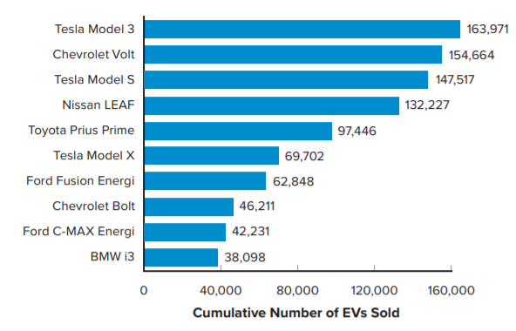
Figure: Top 10 selling EV models in the US (EEI, 2020)
As seen, Tesla model 3 is the highest selling EV in 2019, followed by Chevrolet Volt, Tesla Model S, and Nissan LEAF. Other prominent models are those of Ford, Toyota, and BMW. Tesla represents 3 of the top 10 selling EV models in the region.

Key success factors for Tesla
Below are some of the key success factors which helped Tesla build a strong brand name and competitive differentiation for itself.
Disruptive technology
The disruptive technology of Tesla has been one of the key success factors for the firm. Performance efficiency of the lithium-ion batteries has enabled Tesla to deliver highly efficient and reliable cars. Tesla Roadster offered a unique high-end sports car driven by battery, which gained high prominence and acceptance (Furr & Dyer, 2020). The Model S offers a range of 315 miles, and is the 3rd largest accelerating production car, almost comparable to gas-powered vehicles. With advanced features like, auto-driving, streaming services, full self-driving, advanced parking sensors, auto-raising suspension, etc. the car is amongst the highest performing sedan ever built (Tesla.com, 2020).
Access to capital
Growth and success in the EV segment can be seen to be highly dependent on access to large capital. The sector requires hefty investments into research and development. Elon Musk has been instrumental in funding Tesla right from the early stages. Firstly, through a $7.5 million funding, and a cumulative funding of $55 million over a period of five years, before assuming the role of the CEO (Furr & Dyer, 2020). Likewise, as Tesla became a public firm by 2010, it was able to gain access to a large investor base for high market capitalisation and funding.
Charging infrastructure
One of the critical success factors for Tesla is the provisioning of the charging infrastructure to its EV buyers. Tesla has been gradually investing in setting up a wide network of charging stations across its networks. As of March 2021, Tesla operated around 20,000+ superchargers in 1800+ stations worldwide. Within the US, there are around 900+ such charging stations, while Europe has 520 of them. Canada has 98, Mexico has 16, and Asia Pacific has 398 of them (Debord, 2020). These charging stations have played a major role in boosting the adoption of Tesla vehicles. Located on most major routes with convenient amenities nearby, these stations offer for fast charging infrastructure. A 15-minute charge is known to add around 200 miles. A broad network of fast charging stations ensures a smooth experience for Tesla users who can stop at convenient intervals and spend more time on the road, with small halts.
The Business model
Another unique strategy of Tesla has been its business model which helped the firm build a brand name amidst a highly competitive market. Tesla started its business by targeting the high-end luxury sports car segment and gradually moved towards mass-market models, which was quite opposite to competitor strategies (Macri, 2018). The high-end Roadster model allowed Tesla to operate within a tiny or niche segment of the car market, to gain quick recognition and acceptance. Tesla sold around 2,500 units of Roadster at a high price of $100,000, gaining huge cash initially (Sull & Reavis, 2019). Later, the company moved down the chain to launch Model S, which won the Motor Trend car of the year owing to its high performance and attractive design. The company sold more than 225,000 units of Model S gaining a highly successful competition against luxury cars like BWM and Mercedes. Subsequent models like, the Model 3, was launched for the mass markets as the more economic model, to compete with rivals like Nissan LEAF and Chevy bolt (Sull & Reavis, 2019).
Customer experience
Another crucial success factor for Tesla has been the customer experience management. Tesla made an early decision to eliminate middlemen and not sell cars through traditional dealers. Tesla sells its cars in its own showrooms (Macri, 2018). Unlike traditional dealership, Tesla salesperson do not work on commission. They are salaried individuals who demonstrate high accountability and motivation towards effective customer experience management. As of April 2021, there are a total of 167 Tesla owned showrooms or stores in the USA, allowing Tesla a high control on its value chain (tesla.com, 2021).

Internal analysis

Value chain analysis
The value chain for a firm is a series of activities that the firm carries out to create value for its customers in the form of a valuable product (Balogun & Hailey, 2015). Porter's Value Chain is a very practical strategic management tool. It breaks down an organization's activities into strategically applicable pieces, to identify differentiators, drivers, and areas of changes (Clegg, et al., 2016).
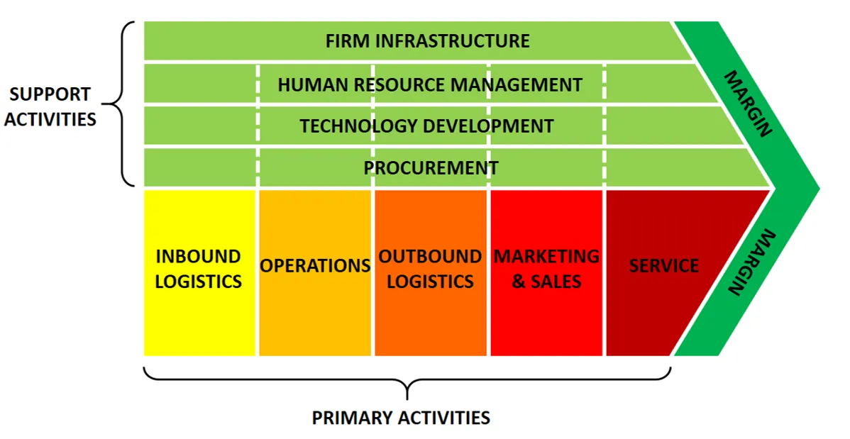
Figure: Porter’s value chain
(Source: https://www.business-to-you.com/value-chain/)

Primary Activities of Tesla
Inbound logistics
Inbound logistics refers to the transportation, storage, delivery and the receiving of goods into a business (Balogun & Hailey, 2015). Tesla owns large number of warehouses mostly located in the US (Taiwan having one), majority of which are rented facilities. The primary manufacturing facility of Tesla is located at Fremont, California, United States which is owned by the company. This facility is used for warehousing mostly but also manufacturing. The size is 5.5 million square feet of manufacturing and office space on 370 acres of land. Other warehouses which Tesla uses for storage besides delivery are located at the below locations (Tesla Annual Report, 2019):
- Livermore California
- Bethlehem, Pennsylvania
- Sparks Nevada
- Lathrop, California
- Elkridge, Maryland and
- Taipei City, Taiwan.

Operations
The company is headquartered in Palo Alto, California, United States. The company has expanded its business operations including supply chain network, manufacturing and sales to different parts of the world. Its European headquarter is located at Amsterdam, Netherlands. Tesla also has a manufacturing factory at Tilburg, where its functioning includes final assembly, quality control and testing for Model X and Model S distributed to the European Union. Tesla also has administrative offices in other parts of the world including Asia, North America and Europe (Tesla Annual Report, 2019).
Outbound logistics
Outbound logistics is the process of storing, transporting and distributing goods from the warehouse to customers (Balogun & Hailey, 2015). The Fremont facility of Tesla Motors houses many manufacturing operations including assembling the final vehicle with its end of line testing. Operations in Tilburg include a parts distribution segment for the company’s European business mainly its service centres. Tesla has many warehouses in the US, most of which are rented facilities where it stores and then ships parts and finished vehicles from (Tesla Annual Report, 2019).
Marketing and sales
The auto industry is considered to be highly competitive. Companies use fierce marketing channels - both digital and traditional for promoting their brands and products. However, Tesla invests very limited in marketing, compared to all other leading automobile firms in the industry. Tesla uses its website and other digital channels for promotion and marketing. Elon Musk personally uses social media (Twitter) to engage with Tesla fans and admirers worldwide.
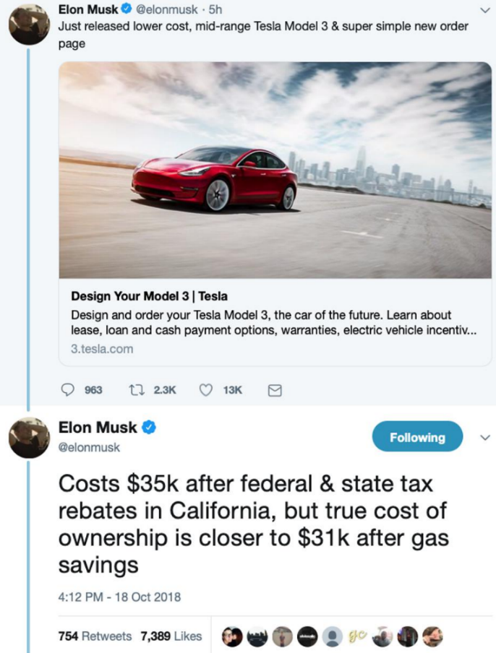
Figure: Elon Musk usage of Twitter page (Ohnsman, 2018)
Tesla even has set up a large system of company-owned galleries and stores. These shops are used for sales and service as well as marketing. While on one hand, these stores assist the company in promoting and strengthening its brand value, on the other, they also enable it to receive customer feedback faster. These galleries and stores are premium stores located in major urban markets where they enjoy much higher visibility. Many of these stores merge their retail sales with customer care services (Shipley, 2020).
Services
The product portfolio of Tesla comprises of the following products - Model 3, Model S, Model Y, Model X, Roadster and Cyber truck besides energy products. The Cyber truck is a newly revealed truck model is biggest item from Tesla which looks nothing less than a Sci-Fi vehicle. The truck is environmentally safe, powerful, and made for a secure driving experience (Shipley, 2020). Unlike other car producers who rely on independent dealers for sale and servicing of their cars, Tesla sells its cars through company-owned shops where sales representatives earn salaries instead of commissions. Tesla owns and runs over 1,300 charging docks and almost 11,000 “Superchargers” (charge points) solely for Tesla vehicle drivers to recharge batteries when on road. Tesla owns 76 service centres all over the United States and roughly half of them are co-located with their stores since Tesla’s EVs constitute fewer parts, hence, less need for physical mends (Tesla Annual Report, 2019).

Tesla - Support activities
Infrastructure
Tesla corporate structure is divided into two main divisions based upon product categories - Automobile and the Energy Generation and Storage segment. The administrative structure of Tesla is very different. Elon Musk is the leading decision-maker at the top. Zachary J Kirkhorn is Tesla’s chief financial officer (CFO) who leads the finance, accounting, and other related areas. Tesla’s other divisions including engineering, production, finance and sales are led by vice-presidents in the structure (Tesla Annual Report, 2019).
HRM
Tesla has employed around 70,000 staff globally. The company depends on the strength of its talented workforce for running the company and maintaining high operational effectiveness (Tesla.com, 2020). One of the important areas of focus for most technology driven organizations is it people management since it is imperative to attract and hold on to talented engineers to stay aggressive. Tesla is now putting a bigger focus on People management to accelerate growth and increase its competitiveness.
Technology
The alternative fuel vehicle market has grown a lot over the past few years. Many Tesla’s competitors like BMW have presented fully electric cars in the market and planning to expand the range of hybrid and fully electric vehicles. Technology is the main differentiator in the global auto industry (Furr & Dyer, 2020). Electric mobility and autonomous driving technology are currently the trending technology areas in the automobile industry. Tesla is one of the dominant firms at the tiller of R&D in both the areas. The company infused $1.46 billion in research and development in the year 2018. Compared to the last year, the R&D figures grew by $82.3 million or 6% (Tesla Annual Report, 2019). Investing in technology has assisted Tesla to continuously upgrade its products and grow its presence in the international market.
Procurement
Tesla manufactured vehicles use large number of parts which the company sources from many different suppliers worldwide. Tesla has developed very strong relationships with many key suppliers. There are many key system parts like cells for whose procurement, strategic ties with suppliers are a must. While Tesla has many suppliers for some basic raw materials, but for many others, it relies on single point sources. Panasonic is the world's leading battery cell manufacturer and a diverse supplier to the global automotive industry including Tesla (Tesla Annual Report, 2019).

Resource and capability analysis
The Resource-based view helps get a detailed view of the competencies and resources available with a firm (Clegg, et al., 2016). VRIO Analysis of Tesla can enable an understanding of the relative contribution which these resources/competencies can make towards building the competitive advantage for the firm. The table below describes the VRIO analysis for the firm:
Competency or Resource | Valuable | Rare? | Hard to imitate? | Firm organised for it? | Result
High Brand value | YES | NO | NO | YES | Temporary Competitive advantage
Leadership of Elon Musk | YES | YES | YES | YES | Long-term competitive advantage
Supercharger network | YES | NO | NO | YES | Temporary Competitive Advantage
New technologies – Auto-driving | YES | YES | YES | YES | Temporary Competitive Advantage
Tesla Giga factories | YES | YES | YES | YES | Long-term competitive advantage
Strong relationship with Panasonic as supplier | YES | YES | YES | YES | Long-term competitive advantage

Table: VRIO Analysis for Tesla
As described in the table above, the brand value of Tesla is a crucial resource for the firm. The sustainable business model of Tesla and the company’s emphasis on innovation has helped Tesla in establishing itself a transformation leader in the automobile sector. The company has accomplished solid brand recognition through leading brands like Roadster, Model S, Model X etc. and it achieves high publicity through word of mouth. Although high brand value gives an advantage, but it is not difficult or rare to imitate, and therefore this offers a temporary competitive advantage to Tesla.
Another crucial resource is the CEO, Elon Musk himself and his leadership. Musk has the record of converting small start-up firms into multibillion dollar organizations. His constant look out for innovation has established an environment of employing only the best talents across the globe (Shipley, 2020). Elon always has big creative ideas and wants to build his team around his mission and vision. He is known for being equal parts workaholic and genius. Besides, his workers are fast to acknowledge that working for him is rewarding and challenging at the same time. It is extremely hard to find and imitate such strong and transformational leaders and thus it provides a long-term competitive advantage to Tesla.
Next, Tesla's massive Supercharger network differentiates the firm from its competitors in the EV space. The company has a wide supercharger network in Europe, North America, Asia, the Middle East which includes a network of approximately 20,000 points all over the globe, allowing Tesla car owners to charge their vehicles for free. Since it not rare or difficult to imitate, it only provides a temporary competitive advantage to Tesla.
Next, Tesla has huge advantage over its rivals in terms of technological innovation. It is famous for its emphasis on innovation and for creating high-quality products with the recent technologies (Shipley, 2020). Lately Tesla models have been fitted with a new design feature “Driverless Smart Summon.” Besides self-driving technology and big touchscreen that enables the customers to control their own driving experience, the firm also has a Tesla app which enables drivers to handle their cars from outside. Tesla’s unique futuristic designs combined with the excellent performance of the cars gives a definite competitive advantage.
Tesla is having long term competitive advantage when it comes to Giga factories. The company is building factories round the globe as its plan to extensively boost productivity in addition to transform energy usage. Elon Musk has termed the Gigafactory as the “machine that builds the machine.” Its one-size-fits-all factories which, basically, can produce anything that Tesla sells — solar panels, batteries, electric cars, home storage solutions that too all under a single roof (Tesla Annual Report, 2019).
Tesla has long and a solid partnership with Panasonic as it’s supplier and the two companies have a joint project of $5 billion Gigafactory in the U.S. Tesla has entered into a new agreement with Panasonic to buy lithium-ion batteries from Panasonic for the next 3 years (Tesla Annual Report, 2019). With a sound and reliable supplier like Panasonic, it is hard to imitate and rare to find, thus giving a long-term competitive advantage to Tesla.

External analysis

Porter’s five forces
Porter’s five forces analysis can help understand the relative power of the various agents in the external market of Tesla.

Bargaining power of buyers – HIGH
Buyers in this sector have a high bargaining power mostly because of the presence of a large number of substitutes, and a low switching cost involved. With the availability of internet, customers find it easy to compare reviews, to research on the brand features, and compare the value for money. Survey amongst US buyers for EVs reveals that the expect EV models to provide higher ranges or mileage at lower prices (Baldwin, 2020). Buyers of EVs expect firms like Tesla and GM to work towards lowering the price of batteries. With most car brands like, GM, Ford, Toyota, investing heavily on hybrid and electric models, customers have more switching options and hence their bargaining power remains high.

Bargaining power of suppliers – MODERATE to HIGH
The suppliers in this sector have moderate to high bargaining power based on the nature of part manufactured. The automotive supply industry is itself a $2.2 trillion industry, with around 11,000 companies having 60,000 production facilities. Typically, the suppliers are of three categories, Tier 1, Tier 2 and Tier 3 (Sull & Reavis, 2019). The tier 1 suppliers are those who provide specialised parts requiring deep technical expertise and have high research and development capabilities. For example: Bosch is amongst a Tier 1 supplier which provides, smart systems, like, climate control, smoke detectors, etc. Hence, tier 1 suppliers are not dependent on automotive sector alone for their revenue and therefore have high bargaining power. On the other hand, Tier 2 suppliers sold parts like, wires, cables, trims, etc. Tier 3 suppliers sold steel, rubber, etc. which are undifferentiated raw materials. Tier 2 and 3 suppliers have comparatively lower bargaining power as compared to tier 1 suppliers.

Industry competition - HIGH
The industry has a significant competition due to the presence of many multinational automobile giants. Within the US, as of 2018, General Motors was the market leader with a share of 16.9% of the market. GM is followed by Ford at 14.1% and Toyota group at 14%. Other prominent players include, FCA US at 12.9% share, Honda at 9.4%, and Nissan at 8.6%. Tesla on the other hand, occupies only 0.2% of the current market share and does not figure in the top-10 list. The figure below illustrates the market share of auto-manufacturers in 2019.
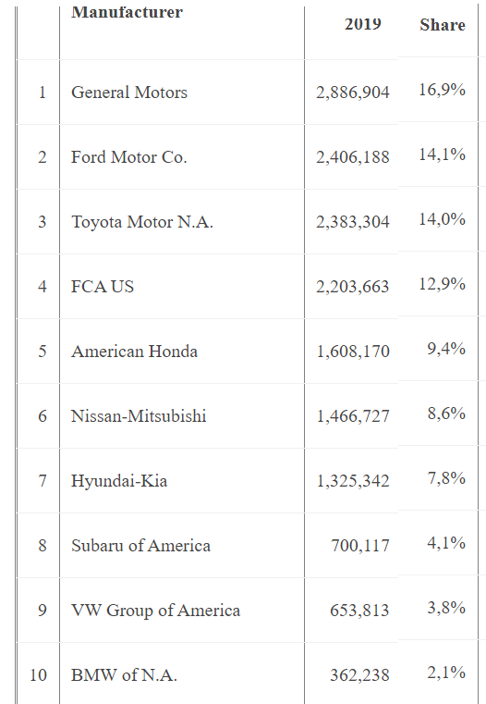
Figure: Top-10 manufacturers based on total vehicles sold across all categories (Dermandt, 2020)
Within electric vehicles, Ford has been an early entrant with its model Focus launched in 2012. GM entered EVs with its Chey Bolt model launched in 2017. Ford is investing an additional $11 billion into rolling out 24 new hybrid vehicles by 2022. Within the EV models, Tesla has emerged to be the market leader, with nearly 381,190 units sold in the USA in 2019 (EEI, 2020). The figure below illustrates the other car manufacturer’s share of the EV market.
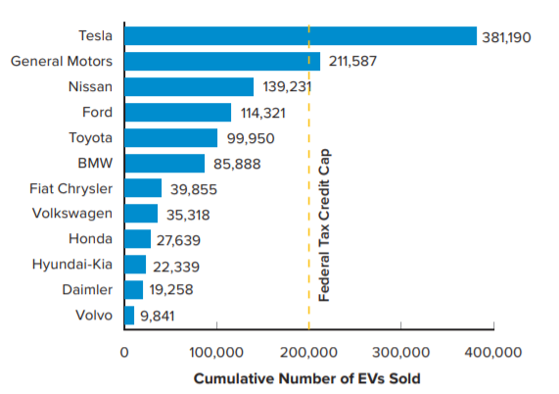
Figure: Tesla leading in EV category (EEI, 2020)

Threat of new entrants – LOW
The threat of new entrants in the sector is quite low. Any new player needs significant investment and infrastructure to build a brand name, develop a strong dealer network, establish large scale manufacturing capabilities. Additionally, such new entrants also need to have sufficient expertise and resources for continuous research and development. All these are tough to achieve and replicate, and hence the threat remains low (Sull & Reavis, 2019).

Threat of substitutes - HIGH
The substitutes for Tesla are in the other forms of transportation. The closest substitute are the hybrid vehicles. These vehicles are powered by internal combustion engine and an electric motor. Battery is charged as the combustion engine runs and operates. The dual operation allows low fuel combustion, along with high energy efficiency. Within the USA, the best-selling hybrid vehicles are, Toyota Prius, Honda Accord, Hyundai Sonata, Toyota Camry, Toyota Avalon, etc. Hybrid vehicles provide high threat as they are lower in cost as compared to Tesla EV vehicles, for instance, Honda Accord hybrid may be available between $25,470 to $35,140. On the other hand, Tesla Model S starts from $79,990 and is predominantly considered as a luxury car (Stafford & Dorian, 2021). Other substitutes are essentially the public modes of transportation, subways, trains, public buses, cycles etc.

PESTEL Analysis
PESTEL analysis for Tesla can be utilised as a framework to understand the role of the underlying factors and their influence.
Political factors
Political factors have a key role to play in influencing the business of electric vehicles. For instance, favourable government support and policies for green energy directly impact the market demand for Tesla. The “EV Everywhere’ program launched by President Obama in 2012 played a key role in advancing electric vehicles. Government subsidies also boost the demand for EVs. In 2019, a number of US states allowed tax credits and rebates for buyers of EVs, like, California offered $2500 per buyer, Connecticut offered $3000 and so on. Government support through rebates makes the product economically viable and attractive for end users (Sull & Reavis, 2019).
Economic factors
Economic factors also have a direct impact on the demand for automobile in general. Higher economic growth, per capita GDP, tend to boost disposable income with end customers. Shrinking economy or declining exchange rate tends to reduce customer spending. The great recession of 2008 sent two of the Big 3 automobile manufacturers – namely, GM and Chrysler into bankruptcy (Bailey, et al., 2010). Likewise, global fuel prices also tend to impact the demand for EVs. Rise in gasoline prices leads to an increase in the total cost of ownership of vehicles, making consumers look for electricity-based cheaper alternatives. The figure below illustrates the average gasoline price compared with electricity charges for the same amount of energy produced.
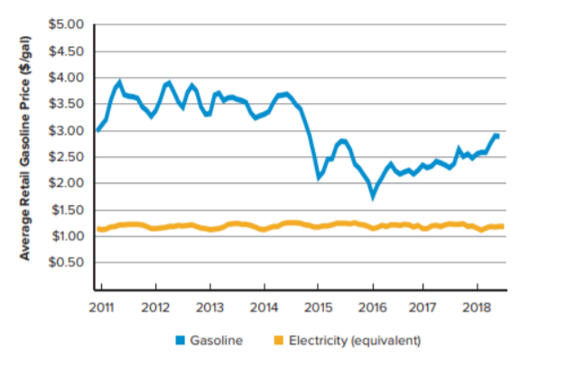
Figure: US Average gasoline price vs electricity rates (for equivalent energy) (EIA, 2020)
As seen, over the last decade, electricity-based vehicles have been the cheaper alternative to gasoline powered ones.
Social factors
Social factors have a direct impact on the consumer behaviour and buying pattern in the car industry. For instance, rise of internet, social media and online browsing habits have radically transformed the car buying habits. For instance, millennials, comprising around 75 million people, prefer cars with advanced features for mobile integration, mp3 players, Bluetooth technology, or navigation system (Sull & Reavis, 2019). Likewise, the millennials spend around 17 hours researching for the cars before making a purchase (Sull & Reavis, 2019). Other social factors like urbanisation, need for independent mobility, etc. are some motivating factors for baby boomer generation to purchase cars.
Technological factors
Improving technology in electric vehicle batteries have also helped increase the adoption of these vehicles. Any major breakthrough in EV technology that can allow batteries to be charged even faster, and less frequently, can benefit the industry in a significant manner. In 2010, the average cost of a battery was $1000 per KWH. By 2018, this has come down to $325 per KWH (Siddiqui, 2020). As latest technologies help reduce the prices of batteries, and improve their life, EVs will find higher acceptance.

Environmental factors
Environmental factors play a key role in influencing the business in this sector. Increased awareness, focus on renewables, and climate change concerns, etc. will continue to favour the adoption of EVs. Countries like UK are already conserving a complete ban on petrol- and diesel-powered cars within the next decade (Dans, 2021). Rising awareness amongst the end customers and pressure for capping the emission limits are other reasons why traditional car companies are gradually moving towards setting up an electric car division.
Legal Factors
Various legal factors impact the business EV manufacturers, including Tesla. For instance, the laws and regulations with respect to carbon footprint reduction, sustainability practices, corporate governance norms, etc. have proven to be beneficial for boosting the business for EVs. Similarly, within the USA, the National Highway Traffic Safety Administration (NHTSA) has been working to implement a mandatory rule to set the standards for corporate average fuel economy (Dans, 2021). Likewise, the Zero Emission Vehicles (ZEV) Program would require that the automobile manufacturers must mandatorily sell a minimum number of EVs per year. The ZEV plans to have a minimum of 12 million ZEVs on road within the next 10 years (Dans, 2021). Added to this, other regular legal factors also constitute important considerations for Tesla. This includes, the labour laws, laws on payments, overtimes, leave policies, inclusive practices, diversity, women welfare etc.

SWOT Analysis and Confrontation matrix
SWOT Analysis can be applied as a useful framework to analyse the alignment of Tesla with market opportunities and threats. It can help to arrive the favourable steps which the firm may need to adopt to leverage the opportunities and counter the threats. To further SWAT analysis Confrontation Matrix tool highlights the way forward strategies that can be employed.

 | STRENGTHS | WEAKNESSES
INTERNAL | - Extensive charging network  - High technology innovation  - Effective leadership  - Personalised customer experience | 1. Manufacturing problems  2. Narrow portfolio  3. High cost
 | OPPORTUNITIES | THREATS
EXTERNAL | - Government subsidies on EVs  - Rising consumer awareness and preference for EVs  - Globalisation | - High competition  - Regulatory challenges  - Dealership regulations

As seen, the core strengths for Tesla are in the form of its high technology innovation, extensive charging network, the leadership of Elon Musk, and the personalised customer experience which it brings. The weakness lies in the manufacturing problems which the company has been facing, Tesla has been known to have capacity management issues in the past, In August 2018, the company faced huge production issues, wherein Elon himself had to spend 120 hours a week on the factory floor (Sull & Reavis, 2019). The company had to make extensive use of robots and manual labour to fulfil the orders for Model 3 cars. Next, another weakness for Tesla is in the form of the narrow portfolio. While, GM already has a wide range of electric cars, it has another 30 models planned till 2025. Toyota also has more than 15 models in the EV category. However, the portfolio of Tesla is quite narrow, with Model S, Model E, Model X, Model Y and the Tesla Cyber truck (Tesla Annual Report, 2019).
Next, the market opportunities are high in terms of the subsidies and incentives from the government, rising awareness and demand for sustainable products, and globalisation allowing for organisations to expand and have multinational presence. However, threats exist in the form of high competition, regulatory challenges globally, and dealership issues in various US states. For instance, the states of Texas and Virginia, USA, do not allow car manufacturers to directly sell their products (Shipley, 2020).
The table below illustrates the respective suggested strategies against each area:
S-O Strategies | W-O Strategies
S1, O3  Tesla can expand and leverage its extensive charging infrastructure to gain the benefits of market expansion, particularly rapid internationalization. Tesla needs to adopt a strategy of market penetration. This strategy is about expanding further into existing markets with the existing products. The extensive charging network and high brand value can help Tesla set up new sales centres, service centres, and other customer facing points. This will ensure that the firm gets higher customer exposure, superior brand recall, and is also easily available for demo or test drives.  S4, O2  A new model for mobility-as-service can be explored and personalised marketing campaign should drive the initiative. Consumers are moving towards a consumption-based model for transportation, rather than owning their private vehicles (Sull & Reavis, 2019). Alternate modes such as public transportation, electric bikes, car-sharing services, etc. allow short-term mobility, without the hassle to spend large money on private ownership. The move has been more significant in urban areas such as Chicago, Atlanta, New York etc. where the ride-hailing services like Uber, Lyft, etc. have seen a tremendous growth. It can be recommended that apart from private care ownership, Tesla should also look towards introducing mobility-as-a-service models. Customers are seeking the usage of mobile apps to commute for their daily commute to work. Newer business models based on limited ownership or temporary vehicle ownership can be explored.  S2, O1  Creative technologies should be leveraged to launch even more feature rich, and energy efficient cars. Government subsidies can enable quick adoption of the new models | W2, W3, O1  Efforts to be made to launch more mass-market models for high customer appeal. Costs of these mass-market models to be kept low. Government subsidies to be leveraged for high market penetration. Higher government subsidies can be used as the means to drive customer persuasion. Necessary market strategies should be built to inform customers of available subsidies, raise their interest, and drive them towards the purchasing decision (Furr & Dyer, 2020).  W1, O3  Manufacturing problems can be resolved by exploring means for capacity expansion into new territories. New geographies may be chosen for setting up additional assembly plants in the long run to meet the domestic demand in the respective region.
S-T Strategies | W-T Strategies
S2, T1  Continued investment into R&D for modern autonomous driving, use of artificial intelligence, etc. to counter threat of competition  S3, T2, T3  Leadership at Tesla to explore new models for business within territories or markets with dealership restrictions. For instance, for US States having ownership restrictions, Tesla can explore joint-venture based operations. | T1, W2, W3  Tesla can work towards reducing the threat of competition by expanding its portfolio, and including both high end and low-end brands. Higher brand options would help to cover customers across a wide range of purchasing power. High end vehicles like Model S can be continued to be positioned as Luxury sports cars. Newer models like Model 3 should be launched.  T2, T3, W2  There is a need to launch market-specific strategies, as Tesla expands into new regions. Local strategy team to ensure compliance to regional laws and regulations. Portfolio may be expanded to launch customised designed vehicles for the respective regions.

Conclusion
Overall, it emerges that Tesla has been gaining high prominence in the EV market, with high market share and brand recognition. Some of the key success factors for Tesla has been the focus on disruptive technology, extensive network of charging infrastructure, the customer experience management, the R&D capabilities, etc. The primary activities of the firm can be seen to be highly streamlined, with effective channel management, supply chain capabilities, quality management, marketing and sales management, etc. Tesla is also seen to increasingly focus on strengthening its support activities in terms of superior infrastructure, HRM practices, technology and procurement management etc. A VRIO analysis for the firm helps understand that capabilities like, Giga factories, strong supplier relationships, and Elon Musk’s leadership provide a long-term competitive advantage. On the other hand, the high brand value, supercharger network, and auto-driving technologies give a temporary competitive advantage. The auto market can be seen to have a high power for buyers, moderate power of suppliers, low threat of new entrants, high threat of substitutes, and an intense industry competition. Likewise, while operating within the highly dynamic auto-sector, Tesla may also need to be considerate towards political factors, economic trends, technological innovations, rising mandates for energy efficiency, and legal regulations on minimum emissions, etc. An analysis of the external and internal environment helps observe that Tesla may need to leverage the opportunities which lie in the form of rising government subsidies, consumer shift towards sustainable products and the benefits of globalisation. The core strengths need to be leveraged to counter the growing competition, handle its manufacturing problems, deal with regulatory challenges, and build a large market share.

Recommendations
An extensive analysis of the current strategy, capabilities, resources, and the external and internal environment, helps arrive at specific recommendations for Tesla. The recommendations emphasise the need to leverage the core strengths, mitigate the weaknesses, and build upon the external opportunities. Firstly, Tesla needs to manage and build upon the customer base. The growing consumer preference for sustainable products, and the rising demand for mobility-as-service are some key drivers to consider. Tesla can adopt a market penetration strategy to reach more consumers, offer lucrative promotions, create word-of-mouth, and promote higher customer exposure (Analytics Insights, 2020). Superior adoption can also be promoted by making extensive use of customer awareness campaigns. These campaigns can help inform customers about the available government subsidies and the reduced total cost of ownership of electric vehicles. Secondly, Tesla also needs to counter the growing threat of competition by building superior offerings and planning for a portfolio expansion (Bomey, 2020). The core technological capabilities can be leveraged in areas of autonomous driving, feature rich cars, energy efficiency, etc. to enable high customer adoption. Competition can also be mitigated by expanding the portfolio of cars to include a wide range of mass market models, in addition to the luxury offerings. Thirdly, technological innovations will continue to drive the market demand for future cars (Analytics Insights, 2020). This implies that Tesla would also need to keep a high research and development focus. Lastly, the leadership at Tesla needs to have a market-oriented approach to bring in necessary customisation in business models and operating strategy, based on the respective territory (Bomey, 2020). Advanced analytics and marketing surveys may be conducted to understand consumer taste and preferences in a region. Newer brands must reflect these respective preferences. Overall, strategic management can enable the leadership at Tesla to actively identify the market drivers, opportunities, and threats, and devise specific strategies to build long-term competitive advantage.

References
Ahlemann, F. et al., 2011. Strategic Enterprise Architecture Management. London: Springer.
Analytics Insights, 2020. Understanding Tesla's intensive growth strategy in 2020. [Online]
Available at: https://www.analyticsinsight.net/understanding-teslas-intensive-growth-strategy-2020/#:~:text=Tesla's%20development%20strategy%20for%202020,%2C%20X%2C%203%20and%20Y.
[Accessed 23 April 2021].
Bailey, D., Ruyter, A., Michie, J. & Tyler, P., 2010. Global restructuring and the auto industry. Cambridge Journal of Regions, Economy and Society, 3(2), pp. 311-318.
Baldwin, R., 2020. Potential U.S. EV Buyers Want More Range for Less Money. [Online]
Available at: https://www.caranddriver.com/news/a33765591/electric-vehicle-buyers-survey-castrol/
[Accessed 21 April 2021].
Balogun, J. & Hailey, V., 2015. Exploring Strategic Change. 4th ed. Essex: Pearson .
Bomey, N., 2020. 6 keys to Tesla's future: Elon Musk's electric car maker beats existential threats. [Online]
Available at: https://www.usatoday.com/story/money/cars/2020/07/27/tesla-cybertruck-tesla-semi-elon-musk-electric-cars/5503979002/
[Accessed 23 April 2021].
Clegg, S., Schweitzer, J., Whittle, A. & Pitelis, C., 2016. Strategy: Theory and Practice. 2nd ed. London: Sage Publications.
Dans, E., 2021. The Five Factors Driving The Mass Adoption Of Electric Vehicles. [Online]
Available at: https://www.forbes.com/sites/enriquedans/2021/01/24/the-five-factors-driving-the-mass-adoption-of-electricvehicles/?sh=3c9eea7739d6
[Accessed 21 April 2021].
Debord, M., 2020. Tesla's extensive, multinational Supercharger network is what separates it from the competition. Take a closer look.. [Online]
Available at: https://www.businessinsider.com/tesla-supercharger-network-versus-other-electric-car-chargers-2020-4
[Accessed 23 April 2021].
Dermandt, B., 2020. US CAR SALES ANALYSIS 2019 – BRANDS. [Online]
Available at: https://carsalesbase.com/us-car-sales-analysis-2019-brands/#:~:text=2019%20Manufacturers&text=FCA%20US%20holds%20a%20stable,gains%20half%20a%20percentage%20point.
[Accessed 21 April 2021].
Dess, G., Mcnamara, G. & Eisner, B., 2014. Strategic Management. London: McGrawHill Publications.
EEI, 2020. Electric Vehicle Sales: facts and Figures. [Online]
Available at: https://www.eei.org/issuesandpolicy/electrictransportation/Documents/FINAL_EV_Sales_Update_April2019.pdf
[Accessed 21 April 2021].
EIA, 2020. Energy Information Adminstration USA. [Online]
Available at: https://www.eia.gov/energyexplained/gasoline/use-of-gasoline.php
[Accessed 23 April 2021].
Furr, N. & Dyer, J., 2020. Lessons from Tesla’s Approach to Innovation. [Online]
Available at: https://hbr.org/2020/02/lessons-from-teslas-approach-to-innovation
[Accessed 23 April 2021].
Hill, K., Cooper, A. & Menk, D., 2019. Contribution of the Automotive Industry to the Economies of all Fifty State and the United States. [Online]
Available at: https://www.cargroup.org/publication/contribution-of-the-automotive-industry-to-the-economies-of-all-fifty-state-and-the-united-states/#:~:text=The%20auto%20industry%20is%20one,Gross%20Domestic%20Product%20(GDP).&text=The%20auto%20industry%20spends%20%241
[Accessed 23 April 2021].
Macri, K., 2018. Case study: How Tesla changed the auto industry. [Online]
Available at: https://www.supplychaindive.com/news/case-study-how-tesla-changed-the-auto-industry/517251/
[Accessed 23 April 2021].
Ohnsman, A., 2018. Musk’s Tweets Aside, The $35,000 Tesla Model 3 Remains As Elusive As Ever. [Online]
Available at: https://www.forbes.com/sites/alanohnsman/2018/10/19/musks-tweets-aside-the-35000-tesla-model-3-remains-as-elusive-as-ever/?sh=7dc8195c65d4
[Accessed 20 April 2021].
Pyper, J., 2019. US Electric Vehicle Sales Increased by 81% in 2018. [Online]
Available at: https://www.greentechmedia.com/articles/read/us-electric-vehicle-sales-increase-by-81-in-2018#:~:text=In%202017%2C%20U.S.%20EV%20sales,percent%20of%20total%20market%20share.
[Accessed 21 April 2020].
Shipley, L., 2020. How Tesla Sets Itself Apart. [Online]
Available at: https://hbr.org/2020/02/how-tesla-sets-itself-apart
[Accessed 23 April 2021].
Siddiqui, F., 2020. Teslas still go much farther on a single charge than their competitors. [Online]
Available at: https://www.washingtonpost.com/technology/2020/01/10/tesla-battery-range/
[Accessed 23 April 2021].
Stafford, E. & Dorian, D., 2021. Best New EVs and Hybrids of 2021. [Online]
Available at: https://www.caranddriver.com/features/g27271118/best-hybrid-electric-cars/
[Accessed 21 April 2021].
Sull, D. & Reavis, C., 2019. Tesla’s Entry into the U.S. Auto Industry. [Online]
Available at: https://mitsloan.mit.edu/teaching-resources-library/teslas-entry-u-s-auto-industry
[Accessed 23 April 2021].
Tesla Annual Report, 2019. Tesla Annual Report. [Online]
Available at: https://www.annualreports.com/HostedData/AnnualReports/PDF/NASDAQ_TSLA_2019.pdf
[Accessed 23 April 2021].
Tesla.com, 2020. About Tesla. [Online]
Available at: https://www.tesla.com/
[Accessed 23 April 2021].
tesla.com, 2021. US Tesla Stores and Galleries. [Online]
Available at: https://www.tesla.com/findus/list/stores/United%20States?redirect=no
[Accessed 21 April 2021].

