An Investigation into The Environmental Impacts of Festivals – A Case Study of Green Man Festival
Research Methods
Reagan Cartwright
P150503

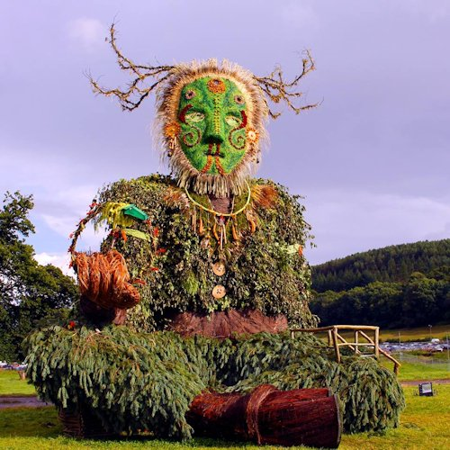

Contents
Executive summary 3
Rationale 3
Aims/Objectives 4
Findings 5
Sustainability and Environmental impacts 5
The research ‘onion’ 7
Primary and secondary research 8
Sampling 8
Quantitative and Qualitative Data 9
Ethical Considerations and Limitations 9
Qualitative 10
Quantitative 10
Reliability 10
Resource planning 10
Appendix 11
Questionnaire 11
Interview questions 13
Gantt Chart 14
Define research aims, objectives & methodology 14
Compile & send questionnaire 14
Analyse questionnaire results 14
Arrange interviews for gaps in research 14
Analyse feedback 14
Conclusion 14
Consultation with Supervisor 14
Proof-read and editing 15
Binding 15
Submission 15
References 15

Executive summary
Within this report I will be finding out if festivals are going environmentally friendly, it will do this by considering each festival closely, it will be done looking through books and journals which contain festival research on the environmental impacts. I will also conduct primary research by creating a survey on ‘survey monkey’ or make one on Word Document, then It will put it on social media via Facebook, Twitter and Snapchat etc. It will include many questions about festivals to give me a rough idea if they are green or that they are going greener. I will ask people to share the questionnaire on Facebook to get the word out about it to give a better percentage of people. I will also conduct a formal interview with the founder of Greenman festival Daniel Josephine Hagan which was founded by him in 2003.

Rationale
Kirby. S states (4th May, 2014) that “The event uses music and art activities on site to raise awareness of environmental issues and promote a sustainable lifestyle. In Einstein’s Garden, the three stages are powered by sustainable sources of energy, and the area gives festival-goers the opportunity to engage with innovative low-carbon technologies like solar power and hydrogen fuel cells. ‘Festival Kidz’ gave it a gold award in 2013” which is showing that we need more festivals like these in order to stop us damaging our planet.
Festivals are very significant for their social and cultural roles, and progressively they have been promoted and created as tourist attractions. They all serve the purpose of bringing happiness to people’s lives. Green Man Festival is an independent music and arts festival held annually in mid-August in the Brecon Beacons in Wales since 2003. It has involved into a 20,000 capacity within a four-day event.
Festivals are amazing hobbies/activities that we do all go to meet up with friends and family or to see a band we love or just to escape the everyday life, and to be shown to new ethnic forms or just to be basically entertained. We hardly consider the stresses our attendance makes on our environment when we go to them. Like all human activities any festival would require resources such as water, land, energy, equipment, food and products of many types. Many festivals or even a local level one can involve hundreds of thousands of attendees these requirements bring with them the possibility for bad environmental impacts.

Aims/Objectives
The overall aim is to provide an understanding on Greenman Festival and their environmental impacts, there will be questionnaires provided on social media to get results about people knowing how bad the waste is during and after festivals. There will also be an interview to the founder of Greenman Daniel Hagan and interviews for people that hasn’t been to Greenman to see what both parties have to say about the environmental impacts in Greenman and other festivals. There will be information about other festival and events that happened to show information about how they sorted their waste. “objectives should be being precisely written and will lead to observable outcomes”
The objectives of this proposal are
- Provide an understanding on how Greenman Festival fits well within proposal.
- Make questionnaires/surveys to get me the information I need.
- Outline the environmental impacts within a festival and Greenman Festival in accessible format.
- I will research how some festivals prevent waste
- Identify any resources required for this future research

Findings

Sustainability and Environmental impacts
Within the events industry festivals play a large role and it is important that staging events and festivals which are more sustainable and environmentally responsible has led to quite a few developments in recent years. Events take a heavy toll on any resources, society and the environment. The ‘Powerful Thinking’ website states “Festivals can reduce their environmental impacts and play a valuable and inspiring role in shaping a positive future” which shows every festival within the UK should go green as it’s damaging our planet. They also state that “It will be much easier, more cost-effective and successful if we work together as an industry” which applies that we should all do our bit to help the planet. 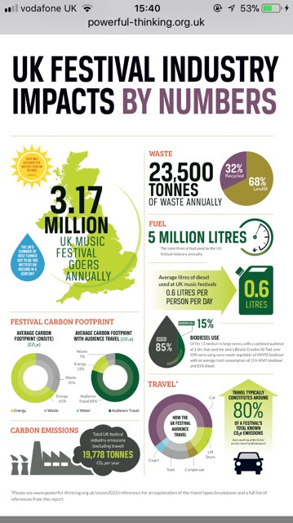

Festivals generate significant waste, put a strain on local resources like water or energy, or even cause complaints within the local community due to noise and road closures. Even events are increasing with their waste for e.g. the London Marathon had over 40,000 runners with 750,000 bottles of water available for them, after that the event produced over 11,000 tonnes of waste but only 4 tonnes were recyclable, it took City Councils cleaning team to clean up all the mess and took them 2 hours. If they had recycling bins then it wouldn’t have taken them all that time. Getz. D(p 321, 2012) states that “The Olympics has an environmental policy that goes some way to ensuring that host cities implement green operations and sustainable design measures” which implies that the biggest event in the world is eco-friendly and I believe that every festival should follow in their footsteps as they are one of the biggest events within the world and they would use a lot of power and produce waste. Glastonbury Festival agrees that every festival should recycle, The (Glastonbury website) states “the festival is committed to minimising the amount of waste, and managing the onsite collection of that waste efficiently, ‘reduce, reuse, recycle’ we want all festival goers to think ‘zero waste’ and to take home what they bring to the festival site” which shows they are making sure when they have their festival that there’s no rubbish left or tents etc, when it’s over.
Getz.D states that ‘the basic policy imperative is to ensure that all events are green’ (p.346, 2012) which shows that festivals are trying to pollute less as by hiring busses so people can use busses instead of multiple cars, since there’s always waste and rubbish during and at the end of an event they hire people or get volunteers to help litter pick and make sure there’s plenty of bins around the site.
“All events should meet the minimum ‘RRR’ standards which stands for Reduce, Reuse and Recycle. Every event should go by the environmental policies, ‘land use planning and controls, noise and traffic by laws, and other environmental influencers” (Getz. D, p346, 2012) which is showing before creating an event you should plan out the event and to make sure you go by the environmental laws. Festivals make sure they space their events out very evenly due to some of them being in a field and the grass and the ground being damaged, it gives it time to grow back. Getz. D(p. 321, 2012) “All events leave a footprint, although there is a big difference between small street festivals, major tourist events and large scale construction projects associated with mega events” which implies that not all events are recycling or recycling in the proper manner. Every event should recycle up the the Olympics standard due to climate change and pollution.
Since the Green Man is within the Brecon Beacons the locals living there might complain due to the noise and road closures but since the event is only once a year it gives the festival time to prepare for that. When a festival happens on a field it does destroy the grass, so when the festival is done for the year it does give time for the ground to recover for the next event. Green Man Festival do provide recycling bins throughout the campsites. Greenman Festival have teamed up with ‘Help Refugees’ and If people did not want their tents, sleeping bags etc. they have drop off points located within the festival and they would donate them to the homeless do they would not go to waste. They provide on their website that getting one of the coaches provide or the train would decrease their carbon footprint, they make sure all their food, snacks and drinks are fair trade, they encourage you to eat out in one of their stalls as all of which provide compostable food ware and fair-trade produce.

The research ‘onion’
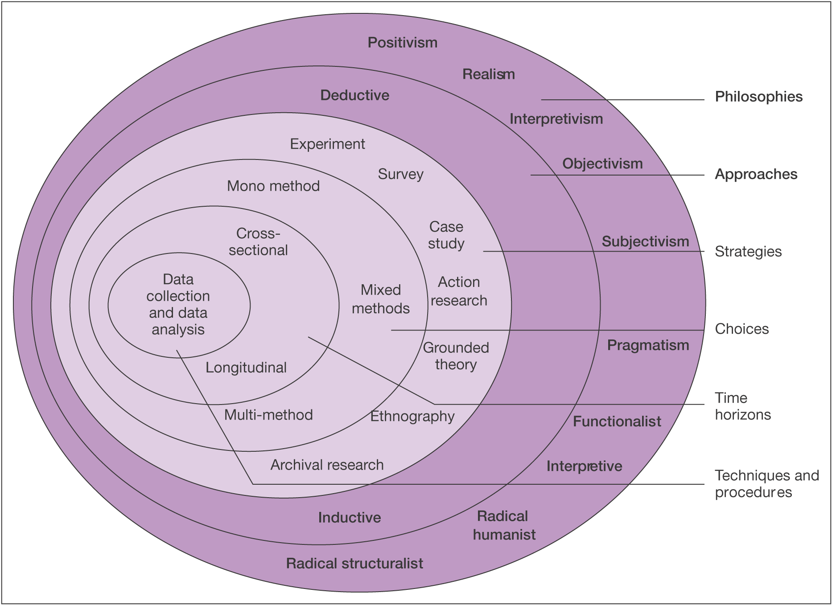
“Many pathways can be taken when conducting research; the ‘Onion’ will demonstrate the diverse phases the researcher will use when designing a research approach” (Saunders et al, 2009)

Primary and secondary research
"Primary data is data that is collected to address a specific problem... Primary data can be collected through either quantitative or qualitative research" (Wild & Diggines, 2009)
Primary research is to gather first-hand information based on raw data which is carried on by the researcher themselves and would be very specific needs towards the researcher. Secondary research involves the use of information gathered originally by primary research, it is analysed and interpreted information and it is carried on by someone else by researching it may or not be specific needs for the researcher as it may not be correct information.
I would use primary research by creating survey online e.g. ‘Survey Monkey’ and possible share it on Facebook to get more people involved with it and I would give surveys to random twenty people to fill out and create a chart to see the results. I would also interview the person that which created the festival to ask them a few questions about their recycling policy and what they’re doing to help the environment when it happens.
For secondary research I will be looking online at the Green Man Festival website to gather information from there, I also be getting leaflets from travel stores, I will be looking through journals and looking at theorist e.g. Donald Getz to find out about the environmental impacts of festivals.

Sampling
A sample is when a group take part in an investigation, they are stated as participants.
“Selecting a sample based on your own judgement regarding which units are most representative or useful” (Rubin & Babbie, 2010).
Purposive sampling is called qualitative data as the research will be carried out by a group e.g. people who work at Greenman Festival, also with expert sampling an individual with the right qualifications/ experience can be used, it would be formal interview with the founder Daniel Hagan, asking him questions about Greenman Festival. It would be about 10 minutes long and I would try and get all the information I need as their answer would be beneficial to this research. It might also be expensive due to traveling to that place. There also be other interviews to interview people that has been to other festivals and asking them about their recycling policy it will also take 10 minutes and there will be 5 interviewers.
Quota sampling is quantitative data as it allows research to be carried out by using a group of people that interested in festivals e.g. students/younger generations
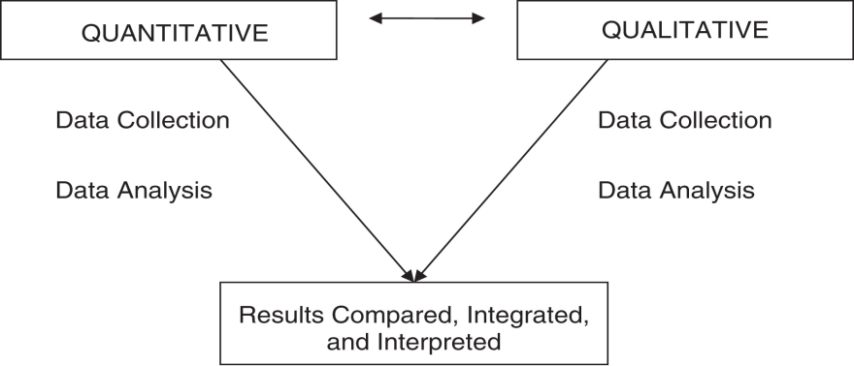

Quantitative and Qualitative Data
With both data’s there will be opportunity to explore the environmental issues in depth, the questions within the questionnaire will be written that links with this study, the questionnaires will effortlessly produce to quantitative data.

Ethical Considerations and Limitations
Ethical Considerations and Limitations For both, “the questionnaires and the interviews, consent will be required from the person answering the questions. Also informing the respondents that they will be anonymous is important as it should mean they are more likely to answer honestly.” (Mitchell & Jolley, 2007, p. 288) since there will not be any interviews with children there will no need to be consent forms given.
There are a few limitations of this research mostly because for the interviews, getting 5 people to interview may be time consuming due to people might have never been to a festival or do not have time to do it which could affect the research of comparing a different festival to Greenman. Also getting Daniel Hagan, which is the founder might be tricky to get in contact with due to him selling his share. So, to overcome this the interviews may have to be a bit shorter and would have to be via Skype. If the questionnaires are online there will be a possibility participant will be a similar age the questionnaire will be made on Survey Monkey and it will be uploaded on to social media via Facebook, Twitter etc.
Qualitative –Defranzo. S states that “Some common methods include focus groups (group discussions), individual interviews, and participation/observations. The sample size is typically small, and respondents are selected to fulfil a given quota.” (2011) Which shows It can take some time to get people involved and some people may not have time to answer all the questions or could answer the questions simple, which can lead to inaccurate data that can be unreliable, because of this study it can be difficult to collect delicate information and accuracy is depending on how and how many people are sampled. Might not be able to get an interview with the person you wanted which can be time consuming.
Quantitative- This research would be carried out would be called ‘quota sampling’. This is good as it allows the researchers to sample a group of people who is a great intrest of this study. This sample would be best for the questionnaires as it does focuses on a specific group of people e.g. people that go to festivals/events. The people who participate in the questionnaire are people 18 an over due to events only being that age and over.

Reliability
There may be a problem that the data from the questionnaire could be biased. And may not give out the correct information due to people not going to a festival. Might also be biased due to the information given out from the interview and the hidden biased would occur when people’s opinions are more valid than others.

Resource planning
A resource is an “Economic or productive factor required to accomplish an activity" (Business Dictionary) there would be multiple sources that would be needed to use to complete the task would be the library, google scholar, online journals, books and the internet, even help from a tutor.
There would be a detailed Gantt chart which will show a timeline for the project throughout the year.

Appendix

Questionnaire

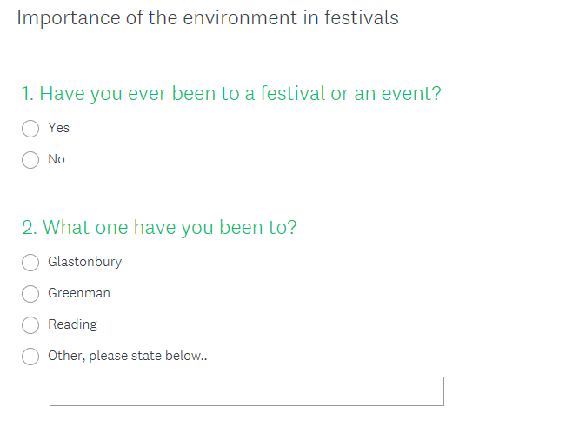

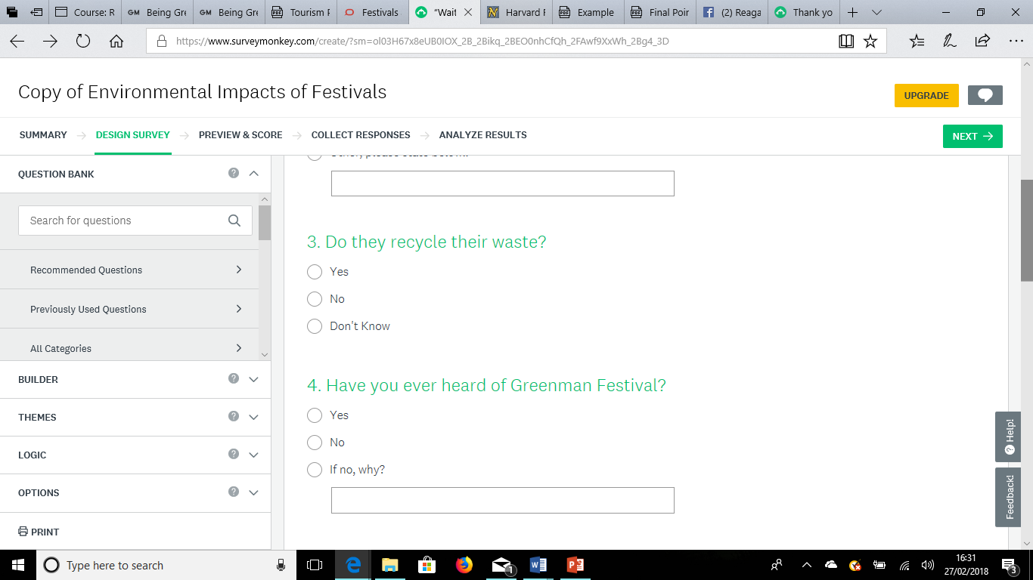
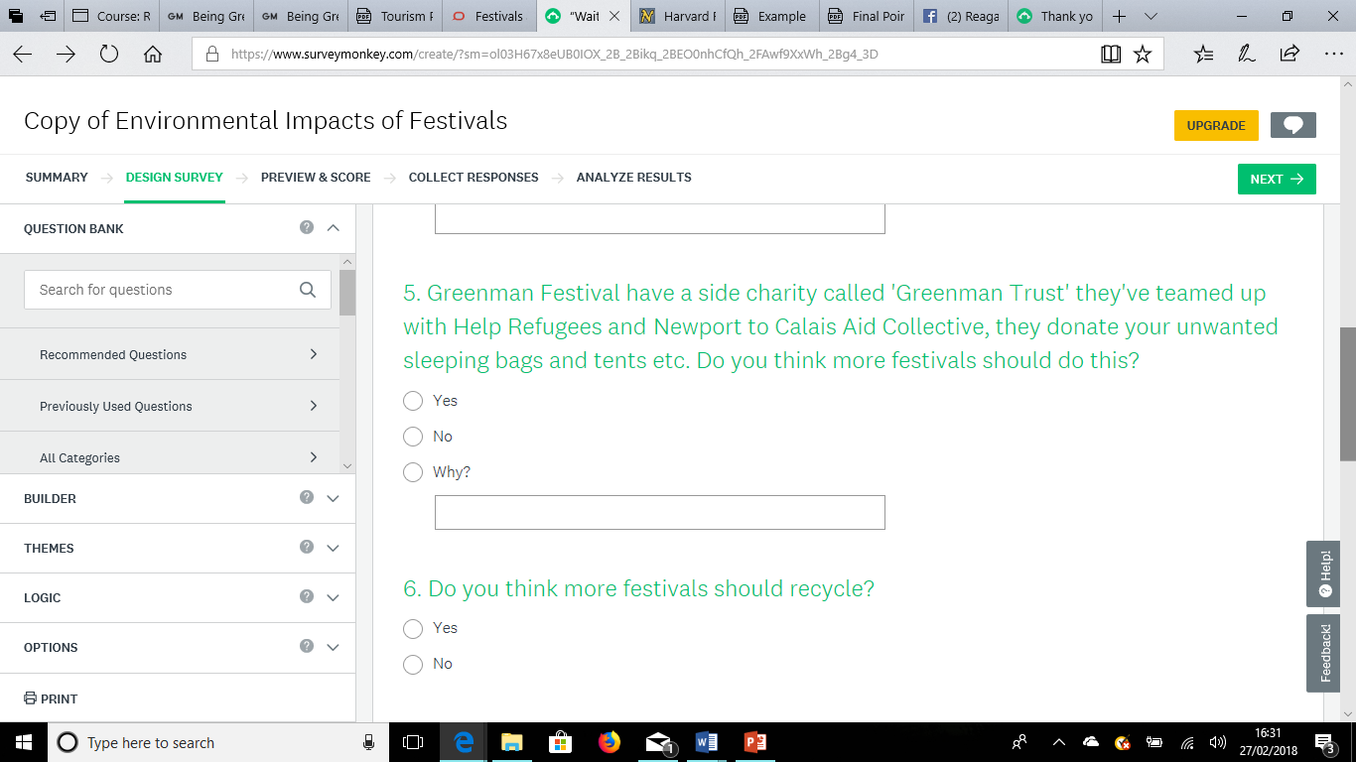

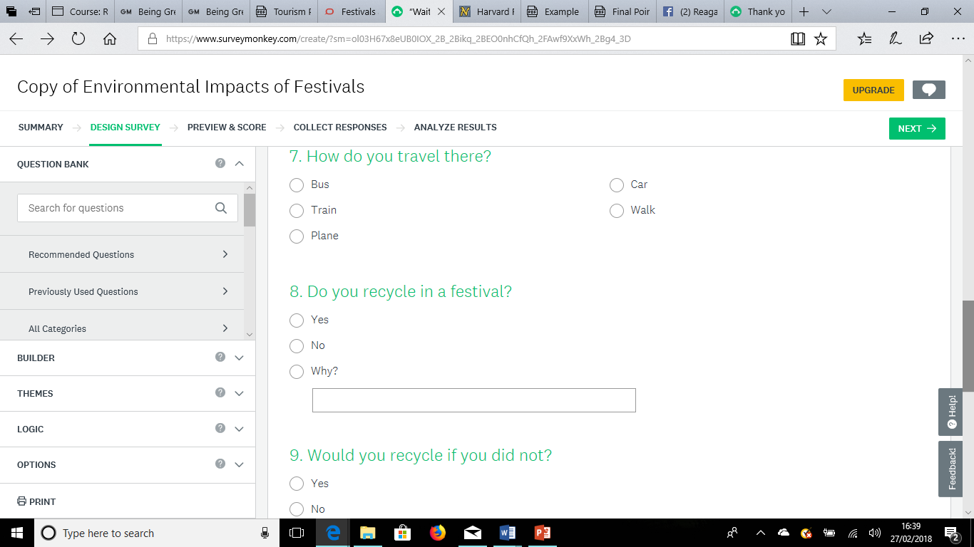
These are the questions within my questionnaire that I created on survey Monkey. I would share this via Facebook, Twitter and Snapchat to get more people involved as I would like a rough estimate if people want festivals to recycle and if they know if other festivals do other than Greenman.
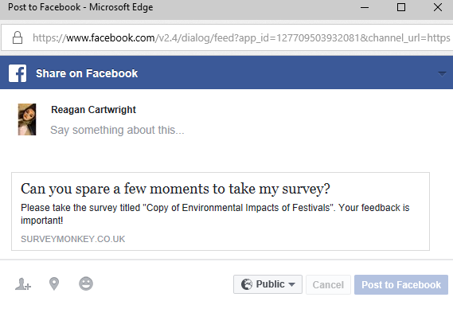

Interview questions
Interview questions that could be asked
- Do you think all festivals should recycle?
- Do you know what RRR menas?
- Do you thimk the government should advise more to festivals about recycling their waste?
- Name me festivals that do recycle?
- do you think if all festivals recycle it would stop a percentage of climate change?

Gantt Chart

No | Environmental impacts for festivals – case study of Greenman Festival | 2018-2019
No |  | Jun | Jul | Aug | Sep | Oct | Nov | Dec | Jan | Feb | Mar | Apr | May
 | Dissertation
1 | Proposal
 | Define research aims, objectives & methodology
2 | Literature Review
 | Carry out extensive research
 | Compile & send questionnaire
3 | Findings & Analysis
 | Analyse questionnaire results
 | Arrange interviews for gaps in research
 | Analyse feedback
 | Conclusion
4 | Submission Preparation
 | Consultation with Supervisor
 | Proof-read and editing
 | Binding
 | Submission

References
Anon. (1997). Our Green Policies . Available: http://www.glastonburyfestivals.co.uk/information/green-glastonbury/our-green-policies/. Last accessed 01/03/18
Anon. (2011). What is a resource?. Available: http://www.businessdictionary.com/definition/resource.html. Last accessed 02/03/18.
Donald Getz (2012). Events Studies. 2nd ed. Oxon: Routledge. p321-350.
Rob Harris. (2013). Festivals and the environmental sustainability challenge. Available: https://theconversation.com/festivals-and-the-environmental-sustainability-challenge-11356. Last accessed 26th February 2018
Rubin. A & Babbie. E (2010). Essential Research Methods for Social Work. Belmont: Cengage Learning.
Survey Monkey https://www.surveymonkey.com/create/?sm=ol03H67x8eUB0IOX_2B_2Bikq_2BEO0nhCfQh_2FAwf9XxWh_2Bg4_3D Accessed: 12/02/18
seth kirby. (2014). 2014 guide to the UK’s top sustainable and green festivals. Available: https://sethkirby.wordpress.com/tag/green-man-festival/. Last accessed 26th February 2018
Susan Defranzo. (2011). What’s the difference between qualitative and quantitative research? Available: https://www.snapsurveys.com/blog/qualitative-vs-quantitative-research/. Last accessed 01/03/18.
Saunders, M., Lewis, P., & Thornhill, A. (2009) Understanding research philosophies and approaches. In M. Saunders, P. Lewis, & A. Thornhill, Research methods for business students (p. 106-135). England. Pearson
Wild, J. & Diggines. C (2009). Marketing Research. Cape Town: Juta and Company ltd.

