
An investigation into the utilisation of reward applications to market FE courses to potential students

By
Logan Evans
Supervisor: Jeanette Adams
Second Marker: Andrew Green

Project submitted as part of the requirements for the award of BSc (Hons) Applied Computing
April 2024

DECLARATION FORM AND FORM OF CONSENT

I, Logan Kai Evans declare that I am the
sole author of this Project; that all references cited have been consulted; that I have
conducted all work of which this is a record, and that the finished work lies within the
prescribed word limits.
This work has not previously been accepted as part of any other degree submission.
FORM OF CONSENT
I Logan Kai Evans hereby consent that
my Project, submitted in candidature for the B.Sc. (Hons) Applied Computing degree, if
successful, may be made available for inter-library loan or photocopying (subject to the law
of copyright), and that the title and abstract may be made available to outside organisations.

Abstract
This project takes a look at the attempted development of a quiz and reward application utilising a range of different methods and techniques to attempt to enhance the engagement that students who are transitioning from compulsory to non-compulsory education would receive during an open evening within the NPTC group of colleges by providing them a range of engaging questions which will earn them reward points which can be spent on freebies provided by the college. The development for the application had been developed with the utilisation of the Laravel framework to support the PHP development of a web-based application utilising XAAMP for Apache to host the webpage and MySQL to host the database to store the required data.
The main deliverables which are present within the project
The main conclusions and recommendations which had been made are that the idea of utilising a reward and quiz application to help with the engagement of potential students is a good idea in practice, however, outside of the word of the school engagement coordinator for the NPTC group, there is no hard evidence to support that the idea presented would be a success due to a lack of sufficient testing as a result of the application not being completed by the end of the project.
Contents
Introduction 5
Literature review 6
Investigation into the target audiences’ transition to from compulsory education 6
Marketing to adolescents 7
Reward applications and rewards systems 9
Questioning methods and techniques 10
methods for solving the problem 11
conclusion of literature review 11
Research methodologies 11
Pragmatism 12
Inductive 12
Action research 12
Cross-sectional 12
Mixed-method 12
Evaluation Criteria 13
Methods of Testing 13
Development Methodology 13
Why feature driven development 13
Advantages of feature driven development 13
Ways to avoid disadvantages of feature driven development 14
Software 14
Hardware 14
Materials and Tools 14
Design 15
Requirements 15
System design 15
System Interfaces 17
Implementation 19
Screencast 19
Problems with development 19
Successes with development 21
Testing 22
Usability Testing 22
Acceptance Testing 23
Evaluation 24
Conclusions and Recommendations 25
Reflection 26
Bibliography 27
APPENDICES 30

Introduction
The project is focused on the creation of a quiz and rewards application designed to engage potential students into choosing to continue into further education with the NPTC group of colleges. The overall question that the project is looking to answer is whether utilising a quiz and rewards application is an effective method for marketing further education courses to potential students. The first objective is to use a literature review to investigate the considerations that the potential students need to make during the transition from compulsory to non-compulsory education. In addition to this, the literature review will cover a range of different questioning techniques that can be applied for the questions within the quiz to make it as engaging as possible and finally, the application will need to be tested to assess and improve the level of engagement that the application is able to provide to the users.
The following chapters discuss the research methodologies, the development methodologies, the software, hardware, tools, and models used within the application, the design and implementation, the testing, and the evaluation of the application.

Literature review
Within the literature review, the main focus will be to look into the target audience for the application and use that to determine what kind of questions would need to be asked, whilst also taking into account the different questioning methods and techniques that can be applied to ensure that the quiz is as engaging as possible from a questioning standpoint, while also looking into the methods for developing and designing the application, whilst keeping in mind the methods of marketing that the college already uses to attempt to market towards the target audience as well as things to avoid to not run into any problems regarding the guidelines that are in place when marketing towards adolescents.
finally, research into other rewards applications and rewards systems will be conducted to determine how to successfully utilise a rewards system or rewards application.

Investigation into the target audiences’ transition to from compulsory education

There are many different pathways which potential students will be considering during their transition from compulsory education onto their next steps. Regarding the college, the main pathways which are present surround the choice of taking either an A-level course or a BTEC course. The main part of this transition which the potential students will need to consider are the grades that they are required to obtain for the courses, which for must subjects requires “at least five GCSEs at grades 9 to 4/a* to C” ⁽¹⁾. However, there are a range of units which do not follow this specific grade boundary, such as the As level / A level law course, which has a heightened requirement of requiring GCSE English language at grade B in addition to five other GCSE at grade C or higher. This slight difference can be important to these potential students as there are some students who may not be aware of these heightened requirements and could be aiming to take a course that is outside of their grade requirements, so it is important to allow these students to become aware of the different grade requirements from subject to subject.
Alternatively, there are also courses such as BTEC level 3 diploma in civil engineering which has an alternative entry requirement of having several years within the industry, which provides those who may not have gotten the grades but have experience in the workplace to improve their qualifications.⁽³⁾ This however is less likely to be the case for the target audience, as these potential students will be coming straight from compulsory education. This course also highlights the fact that there are also courses which have costs which provide an additional barrier to entry, with the additional costs of this course being £156 for a materials fee, which may cause a lot of students to make a sudden decision to not continue with the idea of taking this course if they aren’t aware of it beforehand as there are many options which do not have fees that are nearly as high.

Marketing to adolescents

There are a lot of different points which need to be carefully considered when marketing towards adolescents, as there is a much higher duty of care when considering the target audience being of a younger age since these young potential students are much more vulnerable to the influence of marketing due to their developing minds.⁽⁴⁾ As a result of this there are a range of much stricter rules and regulations to help ensure that adolescents aren’t being taken advantage of and that information is not being stored that may be sensitive, especially when considering that the GDPR age of consent is 16 years old⁽⁵⁾ meaning that as there may be people slightly younger that the data gathered should be very carefully considered to not cause any problems with the GDPR.
One of the governing bodies surrounding the conducting of online advertising is ASA, where the ASA regulations provide a range of guidelines for advertising to those under the age of 16, where there is a section focusing on the utilisation of selling products to children, where for example, while the proposed system attempting to sell the college to the adolescents through incentive doesn’t strictly break the guidelines of ASA⁽⁶⁾ it needs to be kept in mind that any adjustments could start causing the regulations to be broken when looking at the regulations of “marketing on companies’ own websites and in other space they control” or “sales promotions, such as special offers, prize draws and competition” which is very close to covering the incentivising using a reward point system as that could be classified as a special offer.

There are a wide range of methods that the NPTC group already implement when marketing towards adolescents as a way to help them to make sure they choose a pathway that is suitable for the potential students by providing a range of different options within the NPTC group of colleges that are available.⁽⁶⁾ One of the main factors that the NPTC group has to consider when marketing their courses is the competition that exists from other FE providers as the college needs to keep in mind that the potential students are potentially going to decide to go with a different institution providing FE courses without providing unique and appealing reasons for these students to decide to choose the college such as the providing of free breakfasts⁽⁷⁾ which provides an external motivation to these potential students to decide to study with the NPTC group of colleges.
In addition to this, the NPTC group has many different methods to market the college to potential students of different ages such as providing taster days as well as workshops and talks surrounding the different courses that are on offer to provide the potential students with the experience of being a student for the NPTC group so that the potential students are able to envision how their future with the NPTC group of colleges will look. This provides a way to make the transition to further education much less intimidating for the potential students as they will start to know what they are getting themselves into. In addition to this, there are a range of different open evenings which the potential students can attend to take a look at the different options that are available and to discuss with the different teachers throughout the college about the courses and to learn more about the college as a whole. ⁽⁷⁾

Finally, the college has a wide range of different locations that it utilises to provide advertisements for the NPTC group of college in locations where a lot of people visit. For example, in the image shown below the Swansea train station ticket gates and floor are covered with advertisements for enrolment for Neath and Afan college in addition to a billboard on the platform of the train station. These colleges are notably both located near the neath train station and port talbot train station respectively which not only advertises to a large range of people, but it also manages to get people to consider using the train to arrive at the college.
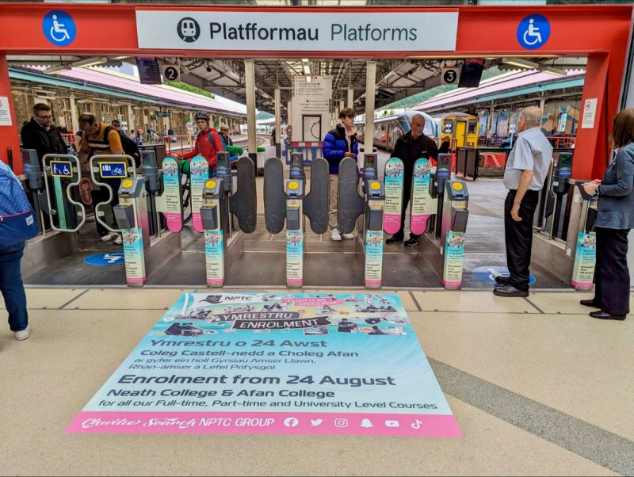 ⁽⁸⁾
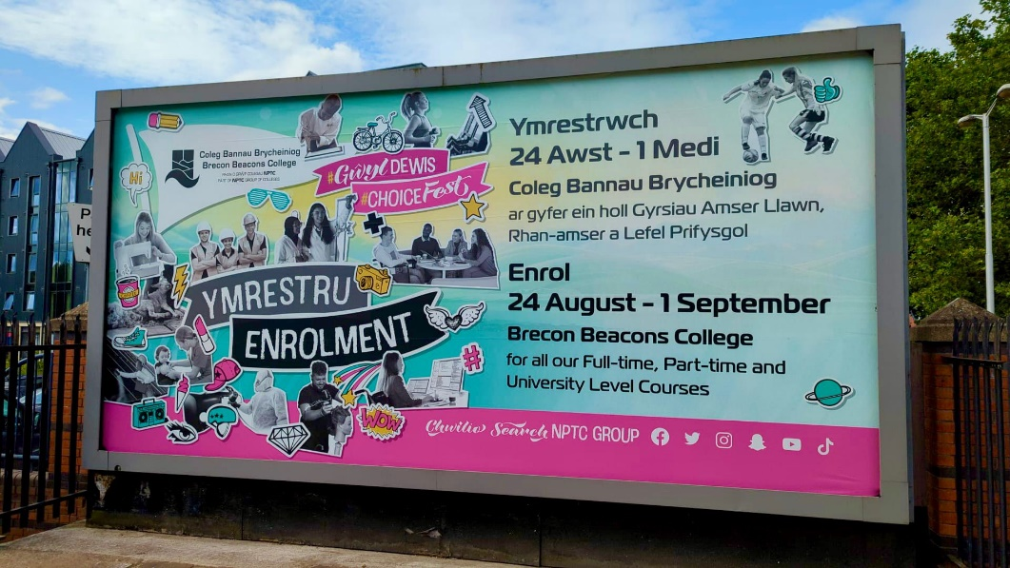
⁽⁸⁾

A final point of marketing which the NPTC group engages in is the gifted and excellence programme which is known as the GATE program. ⁽⁹⁾ This program exists as a way for the college to focus on getting potential students who have been identified to have a minimum of 3 A*s within their GCSEs. This provides an additional option to the potential students and is intended to assist in getting potential students to reach their maximum potential within the NPTC group of colleges as well as helping them to get ready for university and education beyond their time at the college.

Reward applications and rewards systems

There are a wide range of different rewards application and reward systems that are utilised by major businesses to help provide incentive for users to interact with their businesses. One major example of this is google opinion rewards ⁽¹⁰⁾ which is a tool that uses a survey system to provide rewards to the different users which is based on the length of the survey that had been filled in. This method rather than earning points will provide monetary rewards through either google play credit or PayPal credit. Additionally, a similar reward application to google opinion rewards known as Swagbucks.⁽¹¹⁾ Swagbucks follows a similar methodology which results in gift cards or PayPal credit where instead of just answering surveys, Swagbucks also provides rewards for completing a range of offers such as shopping in certain store or downloading and engaging with applications for a rewards.
Swagbucks also has a different way of earning points from its application “Swagbucks daily trivia” which uses themed trivia daily where if a user answers the trivia correctly, the user can receive points and overtime will earn enough points to redeem a monetary reward. The main difference between this and the original application is that rather than providing an incentive to answer many surveys at once, the daily application has a user engaging daily with the application to keep the user engaged.
This leads to the reason that the use of rewards applications is effective as it helps to provide those who engage with the rewards application or rewards systems with an inventive to achieve as task which has been set out by the system. For example, answering a survey with google opinion rewards or answering a daily question with Swagbucks. Through this method, rewards applications can assist in providing encouragement to complete both tasks set out by the rewards system and existing tasks which are able to utilise the incentive to increase the likelihood that these tasks are going to be complete by providing them with rewards. The important part which is generally followed by these rewards system is that it is reliant on being self-sufficient, where the information that is being provided to the companies who are running the rewards systems can be worth more to the company than the money that is being spent on the rewards provided.
One of the main ways that a rewards application can be utilised is for the pure focus of providing a motivating factor that can help direct people into achieving a desired outcome. An example of this would be utilising a rewards system within a workplace to help improve the efficiency of the workers by providing additional motivation and incentive to completing tasks that they have been set. ⁽¹²⁾ However, one of the main drawbacks of utilising a rewards system in this way is that it can lead to an inverse effect of reducing motivation ⁽¹³⁾ if a rewards application or rewards system is not implemented in a way that the participants feel is fair. ⁽¹⁴⁾ For example, if a rewards application had a point worth 1000 points but the number of points earnt for completing a survey was only 5, the users would feel very demotivated by learning this and no longer want to engage with the rewards application. By making sure that everything that is presented is done in a way that is fair, it can help to drastically improve the user experience to help achieve the desired result of a rewards application.

Questioning methods and techniques
An important factor that needs to be considered that a lot of people would fail to think about are the different range of questioning methods and techniques that exist to help generate questions to achieve a desired result.
The first method of questioning that will be discussed is Socratic questioning, which is a questioning method which is based around asking a thought-provoking question such as “what is justice?” ⁽¹⁵⁾ to spark deep thought into the topic of justice, which had then been followed up by asking about the “relation of justice to happiness” which causes a much deeper thought to be placed into the original question due to requiring to now think about how they had answered the original question which will providing much more of a lasting impression on the respondent.
The main use of Socratic questioning is to take a question which can lead to deep thought from the user such as asking about their interest in a certain subject, such as asking “how interested are you in the study of law” followed by asking if they would be interested in studying law at A level as a way to take the fact that the respondent is already deeply thinking about the study of law and will then be able to apply their thought into asking the follow up question.⁽¹⁶⁾ As a result of this, it can lead the respondent to wanting to look into the idea more thoroughly due to the impact of Socratic questioning on the way people think about how they answer questions.
Socratic questioning is also quite similar to another method of questioning known as knowledge questions. Knowledge questions are the most common form of questioning used within schools and education as the purpose of a knowledge question is to draw upon information that a respondent has learnt and tests their knowledge within a subject area.⁽¹⁸⁾ Similarly to Socratic questioning, this type of questioning is capable of making it so the respondent goes into a deep thought regarding the answer they are going to give as way to ensure that they give a correct answer. By using this method of questioning, a respondent can help reinforce their understanding of a certain topic, as well as helping to gain new knowledge if the respondent is not familiar with the question that is being asked. For example, by asking the respondent a question they may not know the answer to such as when Plato’s republic was published, the respondent under this method of questioning benefits from taking some time to figure out what the answer is if they do not know what the answer I which helps to expand the knowledge of the respondent.

In addition to these methods, the addition of incentives to these methods of questioning is a very valuable technique when attempting to engage respondents with a question as it not only gives more people a reason to answer the questions, ⁽¹⁹⁾ but it also provides additional motivation when answering the questions that are provided by both adding a gamification element to the questions by adding a prize, as well as making it rewarding for the respondent.⁽²⁰⁾

methods for solving the problem
One of the main methods of solving the problem would be through the utilisation of PHP ⁽²¹⁾ with a MySQL backend ⁽²²⁾. This would be utilised by using PHP for the application logic to help make the application functional which would utilise the MySQL database on the backend to display and manipulate data for each of the users. The database will contain information about each of the users to track the points which are earnt for claiming the rewards, a unique identifier for each of the points totals so they can be linked to the users, as well as a rewards table to use the points values to remove the points from the users.
Additionally, by implementing the Laravel framework, the ability to utilise the build in login features as part of the authentication of Laravel would lead to the process running a lot more smoothly as it would remove the need to manually develop a login system for each of the users. ⁽²³⁾
In addition to the framework, software, and language to be used from the development standpoint, it is important that the human computer interactions are kept in mind regarding the designing of the application, as by introducing methods of HCI, the design will be significantly more engaging for the users. For example, it is very important to consider that the design of each of the web pages is consistent with one another, as it would be very confusing to the user if the page had drastically shifted in style from one page to another which may intimidate the user into not using the application further.⁽²⁴⁾

conclusion of literature review
To conclude, the most important information for the potential students revolves around providing them with information about the colleges and the different courses available, as there is a lot of information including potential courses, choice of campuses and course requirements that they may not be aware of due to only hearing about a limited number of options. Additionally, while there are a large range of guidelines surrounding the marketing to those under the age of 16, all of the guidelines appear to have no issue with the proposed system as there is no personal information being stored, and nothing is strictly being sold by the application as the only points discovered which may cause a problem are regarding the “advertising withing smartphone and tablet apps” ⁽⁵⁾ however, this app will be web based so that should not be an issue.

Research methodologies

Pragmatism
The pragmatism research methodology has been applied is pragmatism, as the project is based heavily around how users engage with the application that is to be developed. By analysing how many of the users utilise the application and how many points they earn, as it would become an effective way to determine the success of the research. ⁽²⁵⁾
The main disadvantages that would be present within pragmatism is that there is a short time limit as to when the development needs to be completed for effectively utilising this method due to only having one opportunity to test the application with a large group. To get over this hurdle, the application will also be tested with Simon Dickerson, the engagement coordinator within the NPTC group as he has the speciality required to provide valuable insight to make up for the lack of people.

Inductive
The inductive approach has been applied due to the fact that all of the theories which are being tested regarding engagement are being drawn from the research that has been conducted as the utilisation of a rewards application where the questions are being developed as well as research into the target audience to identify what types of questions should be asked from the research as a way to ensure that the application is as engaging as possible.

Action research
The strategy that has been chosen is action research as the main way to determine whether the application achieves its goal is through demonstrating within an open evening how the application appears and to determine how engaging it is through providing a range of participants with the application. By applying action research, the application is also able to be evolved based off how engaged each of the participants are to determine what changes may be made to further develop the questions into becoming more engaging as well as adjusting the point values and reward costs to not make the participants impatient.

Cross-sectional
The cross-sectional time horizon is going to be utilised as the research relies on the testing of the application to determine how successful the project is through data that is all collected at one point in time.

Mixed-method
The use of the mixed-method approach will be applied as it is important that both qualitative and quantitative data is gathered to both determine from a large range of participants how engaged they were with the application as well as speaking to the client to determine how happy they are with the application that has been developed as a way to both determine whether the application is a success from a developer’s perspective, but also from the perspective of the client who many see flaws which had been missed.

Evaluation Criteria
The evaluation criteria that is going to be applied is a range of usability heuristics as well as questions relating to how successful the application ends up being, as for this application it is vital that the application is easy to use and understand due to the nature of it needing to be engaging for the users, where if the application is not easily usable then the engagement would massively decrease as a whole.

Methods of Testing
The method of testing that is going to be applied to the final application is acceptance testing. The main reason for this is due to this project being a development for a client, it is important to ensure that all the requirements for the application are met to the standards of the client, whereby having the client perform an acceptance test on the application it will provide a valuable insight into what went well as well as what went wrong with the final application. ⁽²⁶⁾
In addition to acceptance testing, it will be important for usability testing to be conducted for the application as with one of the major aspects of the application being based around how engaging the application is, it will be important to identify whether the application meets the requirements for this.

Development Methodology

Why feature driven development
The main reason that I have chosen feature driven development is that to complete the development it appears to be the best structure for this application as feature driven development breaks down each part of the development lifecycle into a five-step process revolving around developing a model, building a feature list, planning by feature, designing by feature and then building by feature. As a result, the model for the application can be built first, and the features can be added once the model is in place which allows for a clear step-by-step process towards completion. ⁽²⁷⁾

Advantages of feature driven development
The main advantages that feature driven development present for my application are that it provides a structure which can easily be followed for a website design through first setting out the web pages, then including the content and finally adding the features to make the application work. In addition to this, I will be able to show parts of the development to the client throughout the process as if requested, the current features and model will be available for the client to view as well as discussion as to what would be required to add.

Ways to avoid disadvantages of feature driven development
The main disadvantage to work around for the feature driven development is making sure that the complexity of the system does not reach a point where progress comes to a complete standstill as this will lead to the development of the application not being completed on time. To work around this, I will ensure that I will put all my focus into the development if a roadblock is reached to attempt to deal with it before it stops progress for the rest of the project.
additionally, I will ensure that each feature is realistically achievable within the timeframe, as it is possible to attempt to develop features that are far too complex for the development that aren’t required.

Software
The software which will be utilised within the implementation are VScode and Xaamp. The reason that VScode is being utilised is that VScode is a code editor which allows the use of a wide range of different languages including each of the languages required for the completion of the development, as well as allowing the Laravel framework to be applied.
The reason for the use of XAAMP is that it provides a way to run both Apache and MySQL to both access PHPMyAdmin for the database and its operations and the Apache for the front-end web pages which are accessible once the host files are adjusted for the server.

Hardware
The only hardware which is required for the completion of this application is going to be a laptop, as it can contain the host files, as well as all the necessary programming files within it to locally host the Apache and MySQL services for the application to run.

Materials and Tools
The first tool which is being utilised is Laravel. The Laravel framework provides a wide range of functionality within its framework to provide a way to assist in building PHP web applications through the inclusion of web routes, blades, controllers, and models which are each utilised when developing a web application.
For the languages, the main language that will be used is PHP for the functionality of the application. PHP is a great tool for this as it is a language that is well suited to develop the application logic for the app.

Design

Requirements
To have a functioning login system for the application to separate the different users by user ID to store the individual points from user to user using a 1 to 1 relationship to ensure they are each unique
To have a functional user interface where the user will be able to navigate between the home page, the questions page, and the rewards page. This is to ensure that the application can be easily used by each user.
to ensure that the database can store the user data, points, questions, and rewards data,
For the point total to increase for the specified user once a correct answer is selected.
For upon selection of a reward, the reward cost is either subtracted from the point total if the user has enough points, or the transaction is rejected if the user does not have enough points to make the purchase.

System design

When accounting for the different methods of questioning, the main form of question which had seemed valuable for the application had been knowledge questions relating to the colleges where the questions can ask about the different course requirement, as well as about the different campuses.
While Socratic questioning could have been good to implement, where the first question had asked the students about what subject they had been interested in and a follow up question to ask them if they had considered studying the course. This would work well if the final version of the application were to have an option to select a subject area. For example, selecting “Computing” and then being asked several Socratic questions surrounding computing. However, the basis of Socratic questioning means that the questions which are asked are more subjective questions than factual to provoke thought⁽, therefore knowledge questions are the best option due to them having a singular answer which can be set as the correct answer to each of the questions.
As a result of this, it had been determined that the main type of question that would be asked is knowledge questioning surrounding course information as well as general facts about the NPTC group such as campus locations to keep the questions from becoming too similar, which would lead to a lack of interest from the participants.
The questions will be limited to information that can be found on the NPTC group website as a way to ensure that all of the participants are easily able to access the information by engaging with the college website. Below are 4 different examples of questions that have been developed based off the information from the literature review.
Question | Answer 1 | Answer 2 | Answer 3 | Answer 4
What are the entry requirements for the “As/A level Maths (Full-Time/Part-Time)” course? | Six GCSEs at Grade C or above including English. | Five GCSEs grade C or above | Six GCSEs grade C or above, including A grade in GCSE Maths | 5 GCSEs grade B or above
Which of the following is the first course to appear on the list of “Full-Time” courses for Neath College? | As Level/ A level photography (Full-time/Part-time) | As Level / A Level English Language (Full-Time/Part-Time) | Level 2 Certificate in Cabin Crew (full-time) | Advanced Esports Level 3 (Full-Time)
Which of the following is NOT a NPTC group of colleges campus? | Neath College | Afan College | Llandarcy Academy of Sport | Carmarthen College
What are the requirements for the As/A level Law course? | 5 GCSE at grade C or above | 5 GCSE at grade B or higher including Maths and English Language | 6 GCSE at grade C or higher | 6 GCSE at grade C or above including English Language

The questions that have been developed present a range of information that is able to be found within the NPTCGroup.co.uk⁽²⁹⁾ website, where two questions ask about entry requirements, while the other 2 questions involve the participant looking at the website and using a process of elimination to determine which of the following is the correct answer. As a result of this, the potential student will need to spend a bit of time looking through the different options available, as well as read some of the different options for courses available that are presented in option 2 to understand how many different and unique course options there are.

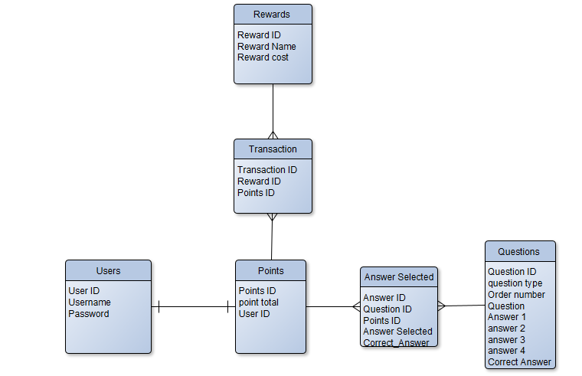
The first part of the design that had been created was an entity relationship diagram. This diagram had been developed to determine how each of the database tables will interact with one another in the final development. Originally the diagram had only contained a users table, a points table, a questions table, and a rewards table. However, as a result of the relationships not working out between the points and questions as well as the points and rewards tables, a transaction table and an answer selected table had been added as a connection point for the development of the transactions to take place between the point total and the reward cost as well as the answer selected table to communicate between the point total and the correct answer field as a way to increase the point total when a correct answer is selected.
This ensured that the foreign keys were able to be stored within tables in a way that does not cause problems within the original tables, as there was no way to reasonably store the reward ID or question ID together with the Points ID or the points table without a separate table.

System Interfaces
The system interfaces follow a consistent and simple to follow design, where the question page has a large question box which will display the questions and the answers drawn from the database, whereby selecting an answer, and submitting the decision to go onto the next question.
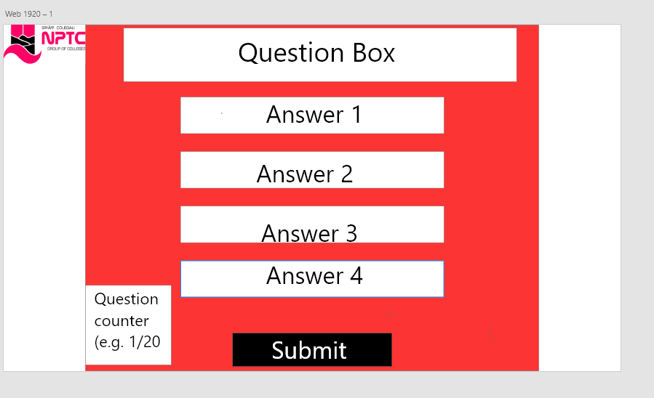se
The design for the rewards redemption page follows a very similar layout, with the rewards being individually selectable and a submit button being present for confirming the transaction. The total cost will display the calculation being accomplished by selecting a reward where the counter will increase to the total cost of all the selected items. Once submitted, the total cost will be removed from the point total and the transaction will be completed.
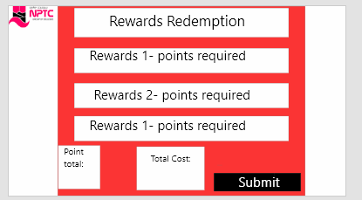

Implementation

Screencast
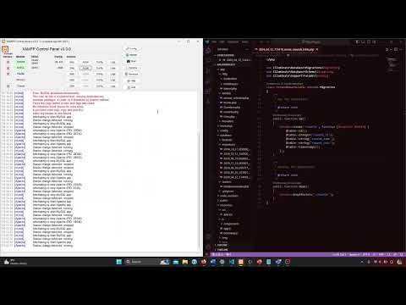

Problems with development
One of the main problems that had been present was learning to utilise the Laravel framework, as it had been very easy to make mistakes which would stop the entire project from working. This had led to several instances of needing to completely start the code from scratch due to it being faster than finding out where the errors were when setting up the pages.
This had led to a large majority of the project time being spent simply doing the same task repeatedly with different errors due to having to ensure everything is correct to the standards set by Laravel and MySQL. As a result of this, a total of 5 different Laravel projects and database projects had been created and destroyed before they had even been functional.
One of the main drawbacks is that MySQL tends to break for no apparent reason, which can lead to a large amount of development time looking through the code to find an error, which had simply been caused because MySQL had determined that it didn’t want to function properly. For example, when trying to start a new project, MySQL needed to be repaired due to there being an error that had occurred without there being any clear indication or information as to what had caused the error.
Another example of this is an error which had occurred where MySQL decided the settings were wrong and wouldn’t launch, while the actual error was caused by a file known as “ibdata1” having an issue with one of the tables.
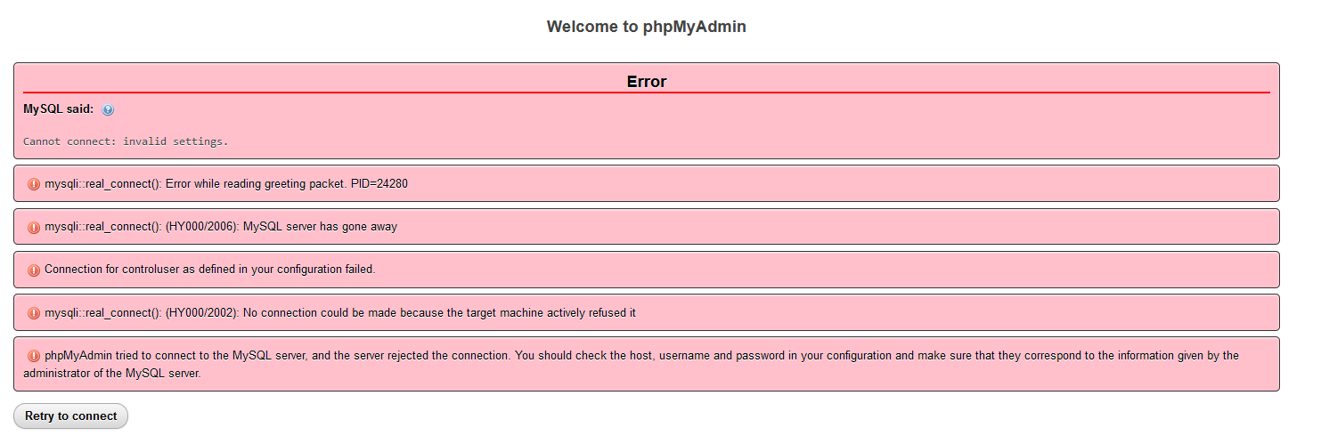
The only way to fix this had been to restore the last backup for mySQL. This had been a problem which had occurred multiple times throughout development, however even with the error logs, it is unclear as to how these errors are occurring, but they do a good job at describing how to fix the errors that occur.

The above image shows an example of this, where innoDB needed to be restored after becoming corrupted.
The major problem which had been faced within the implementation of the application was the lack of experience utilising both Laravel and PHP as Laravel has many moving parts required to get things working. For example, for simply displaying the questions for the question page, a question controller first needed to be set up to extract the information from the database, them the model needed to be created using artisan where the fields within the table needed to be added, then the blade for the design of the tables and then finally the web routes needed to be set up correctly as a way to ensure that the question page was accessible and working. While in hindsight this is a short process, it had taken way too long to gather an understanding of how the Laravel framework operated, leading to several weeks wasted on some of the most basic elements of Laravel which had led to not having enough time to complete the rewards table as well as not enough time to design the application using CSS.

A final error which is available is within the question controller, where the ability to generate a random question table had been figured out. However, it had not been clear how to match this for the correct answer, as by utilising Question::all()->random(1); for the correct answer table, it would randomise separately to the view.
The most practical way that this could be implemented in its current state is by having every single correct answer within the same answer slot. However, this is something that would become very clear very quickly, so it would only work as a temporary solution. It also does not stop the simple ability to just pull the exact same question twice in a row.

Successes with development
One of the major successes of the application was the user login system which had been provided through the utilisation of Laravel. By utilising Laravel, a simple login system had been usable for the users where the password provided has been encrypted. This had provided a way to ensure that all the data that is stored within the database is secure, as this removes the major sensitivity in the data that is stored within the database as the only other data stored is the email address used to apply as well as the points that have been earnt.
In addition to this, the application had successfully managed to load the point total as well as the question and rewards data from the database for the user to view, which then for the questions page allows them to answer the question that is provided to them by selecting 1 of the 4 different options, and if they select correctly the point total that is linked to their user account will increase by 1. This had been the main success of the application as despite it being a fairly small chunk of code, it had taken a very long time to gain the understanding required to understand what was required to make the buttons function correctly such as identifying how to utilise the relationship between the users table and the points table within the code, as well as making it possible to attach the code to each of the different buttons.
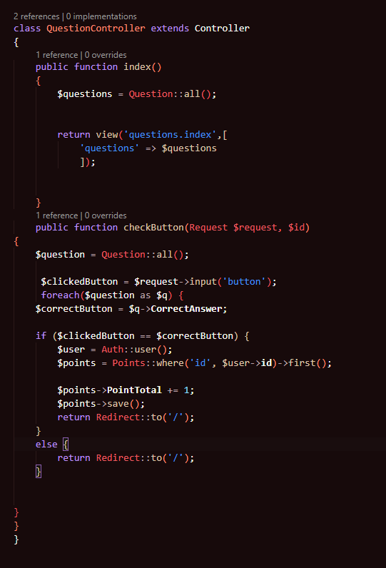

Outside if this, the main success of the implementation was that when discussing with the client, they had appeared happy with the application despite its incomplete state. This had been due to the application showing that the concept was viable and is something that is able to work to help with the engagement of potential students.

Testing

Usability Testing
When conducting a usability test with the client, there had been many problems that had been faced due to parts of the code being incomplete. The first of these problems was that due to $points on the home controller being set to show all, once a new user was created the display had contained two different point totals for the client’s new user account and the testing user. This had been fixed by utilising the link between the user ID and the points ID to only display the points for the user that is logged in. 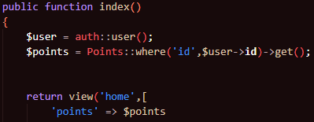

Another issue which had occurred within the usability testing had been caused by the fact that there had only been a singular record within the questions table at the time, which made it so that every single time the question page had been loaded by the user they would always be presented with the exact same question. 

The final point which had made the results of the user testing fairly poor are the final designs. (as shown above for questions page and below for login, home and rewards page)

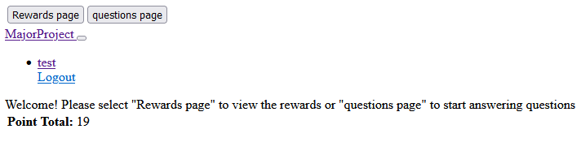
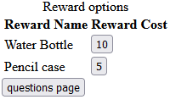
The resulting pages for each of the different parts of the application were very poor, with no actual design being implemented for any of the pages outside of the addition of buttons and placing the different database records that were pulled into tables. As a result, the engagement which the website would be able to provide had drastically decreased.
Acceptance Testing
The acceptance testing had occurred once the application had been ready to demonstrate to the client. Despite not being a completed application without any design or completed functionality across the site, the client had been really pleased by what they were looking at from their perspective as it provided a simple system which had in its current state been able to meet the requirements that had been set out with some additional human interference when redeeming rewards. By instead of having the system remove the points automatically and providing a receipt of the reward being claimed, the system would function just as well by making it so the person administrating the application during an open evening would manually remove the points once the reward has been provided to the user. While this is much less efficient than the original plan, it results in a practical way to use the application in its current state.

The main issue that had occurred with the Acceptance testing is that there had been some clear bias from the client regarding the results of the testing that they had written down.
One of the main indicators of this was stating that “the question and reward functions worked well”. While this could be referring to the buttons that take you to the pages rather than the actual functions within the page, the buttons on the reward page had been tested by the client and he had been faced with an error page stating that there had been a “BadMethodCallException” due to the function that the rewards page buttons are trying to access does not exist under the name it is trying to reference.

Evaluation
From the final result of the application as well as the data that has been collected during an interview with the client, it can be concluded that while the idea works in practice, with the utilisation of a quiz and rewards application being a strong idea for marketing towards potential students as a method to both entice potential students into turning up for taster days and open evenings, as well as learning more about the colleges whilst the potential students are there as there is no system in place that the college is able to use and if the product had been completed, it could have been a very successful product.
The data did not back up the research within the literature review as a lot of the conclusions that could be drawn were heavily reliant on the ability to present the final application within an open evening. This is due to the questions themselves being very important for the research. However, this did not happen due to difficulties with learning how to utilise Laravel and PHP to develop the application and due to spending too much time attempting to get it working without knowing what needed to be done to progress. However, because of this there
The aim of the project had to an extent been met, as the most important functionality for meeting the goal had been met, where the quiz part of the application had worked and kept track of each users’ score.
If the client would want to use the application in its current form, if the person who is handing out the prizes accesses the database and removes the points spent from the user, the aim of the application will be met. However, in reality the true aim of the application itself had not been met as the application itself is only in its current form a quiz application that tracks a point total.

Of the objectives, the only objective that had been met was the utilisation of the literature review to investigate the target audience and methods of generating engaging questions for the application, as the questions had successfully been developed for the application.
However, the development of an engaging quiz and reward application with a database back to store points and redeem awards had not been met as the application was unable to redeem the points that had been earnt.
The answers that have been drawn from the research project are disappointing, as to answer a large majority of the questions presented a sample of potential students would have been required to test the application to determine how engaging it had been, where the point totals and rewards redeemed would have been an indicator of how many questions had been answered correctly. A way this could have been accomplished would’ve been to add a stock count to each of the items within the rewards table to track how many of each reward had been redeemed.

If the project were to have been completed again, due to the failure encountered the first time around, the ability to utilise the software and tools required to develop a quiz and reward based application have drastically improved and given another opportunity to have another chance at completing the project, one of the key things that would be required is to ensure that if there are any roadblocks, to not just hope that the solution manages to appear out of nowhere, and rather to ask for assistance when something has not made any sense. An example of this had been with the functionality of the quiz buttons, where the amount of time that had been spent figuring out what was required to apply the functionality had taken weeks, which is a task that realistically could have taken a very short amount of time now that the process has been understood.
Overall, the main things that would be done differently are ensuring that there is sufficient preparation for learning a new framework and language where there had been very little understanding of prior to the development, as well as remembering that if there is a stage where some assistance is needed be it from a source such as stack overflow, from resources which have been provided throughout the year that can help with the development or from someone with knowledge of how to complete the development, as not only did the development end up not being finished due to a lack of time remaining.
It would also be important that if this were to be done again, that the development does not have such a short amount of time dedicated to it before a strict testing date, and rather the testing date should be determined to match the development’s completion.
Finally, a lot more time should have gone into the planning of the development itself over the planning of all of the designs, as once the development had begun there had been no clear pathway outside of the feature driven development, which if the developer is unsure of how to get started with building the model of the application, then no progress is able to be made until a lot more time had been put into learning the actual languages and frameworks.

Conclusions and Recommendations
To conclude the project, while there had been trouble with the completion of the development, the concept and idea of the project which the client was able to view at the end of the project had sparked a lot of interest in the potential to be utilised to help market FE courses to potential students. The literature review which had been conducted provides a large range of information that had been able to help gain an understanding of the considerations that potential students need to take to progress into further education which had helped drastically to figure out what questions would be best to ask for the quiz as there is a lot of valuable information that the potential students are able to gain from identifying what they would need to know that is available on the NPTC group website while also taking into account the information gained from the research into the different questioning methods and techniques, specifically knowledge questions to have a range of engaging question types that the potential students would be able to answer.
It had also been valuable to identify the ways the college is marketing to the potential students as a way to identify where this application would best fit within the current marketing, where it had been determined that an open evening would be the best situation for this application due to it helping the potential students become more immersed in the different pathways of the college they may not have previously considered.
For meeting the objectives, this had met the first objective due to gathering a large amount of information to suitably develop questions for the quiz despite it not being in a condition where the level of engagement that it had been capable of was not something that could be tested.
However, the application had not managed to be completed in time to be tested as the open evening where this would have been done occurred in March, while the development had not even been completed near the end of April. To meet this objective, there are few different sections of development which would have needed to be completed to fairly test whether the application would be a successful way to market further education courses.
The further work that would need to be completed to expand upon this mostly lie within this completed development, where the application would need a way for the buttons on the rewards page to subtract the rewards cost from the point total, as well as providing a confirmation of redemption which would need to be done in a similar method as the AnswerButton class within the QuestionController which adds 1 point to the user based on the user id, which would need to first check if the point total is above or equal to the reward cost, and then would be repeated with negative values for each of the different rewards. This would then need to route to a reward redeemed page to provide evidence of redeeming the reward so they can claim what they have redeemed.
After this, CSS would be applied to each of the pages to provide a consistent style between each of the pages to help assist with the engagement to the college, as in its current style there is no way of knowing that the website is designed for the college to use.

Reflection
One of the things that had been learnt from the conducting of the project had been that there are a lot of different ways to ask questions to help to engage people, with many different forms of questions serving different purposes to the same goal of collecting information.
Another important factor which had been learnt was gaining the ability to navigate through the Laravel framework and to understand what many the files and folders are used for, including database migrations, web routes, models, blades, and controllers which each served their own purpose in getting the project into its final form. Additionally, it had become clear how to utilise PHP within the framework to help develop functionality for the project, even if not all the functionalities had been completed by the end it had still been very valuable to understand how to utilise the button controls to manipulate the MySQL database.
While Laravel seemed very intimidating to start, once it starts to be understood it is clear that it is a framework that saves a lot of time and simplifies a lot of the processes, as the utility that it provides as a framework with the ability to utilise blades, models, controllers and routes starts to be much easier to understand once it has been used and had started to become functional.

A final point which had been learnt within the project was that while the research had placed a very large emphasis on the questions and making sure that the questions being asked were engaging, it had led to running into a problem of not putting enough focus onto the other aspects of the project. For example, there had been no information gathered on quiz applications as well as little different options considered for the methods for development, where if more research had been put into these aspects over the questioning, then it is likely that a better solution for accomplishing the task may have been found and the development could have been completed rather than ending up with an incomplete application where the questions were no longer as useful as for the questions to be engaging, the application surrounding them would need to be aesthetically pleasing enough to entice the potential students into being interested in reading the questions.

Bibliography
(1)UCAS, “A LEVELS” (accessed 19/04/2024) available at: https://www.ucas.com/post-16-qualifications/qualifications-you-can-take/levels
(2) NPTC group of colleges, “AS Level / A Level Law (Full-Time/Part-Time)” (accessed 19/04/2024) available at: https://www.nptcgroup.ac.uk/courses/as-level-a-level-law-full-time-part-time/
(3) NPTC Group of colleges “btec level 3 diploma in construction & the build environment (civil engineering_) (part time) (accessed 19/04/2024) available at: https://www.nptcgroup.ac.uk/courses/btec-level-3-diploma-in-construction-the-built-environment-civil-engineering-part-time-2/
(4) The chartered institute of marketing, “Leave those kids alone?” 2011, (accessed 19/04/2024) available at: https://www.cim.co.uk/media/4986/leave-those-kids-alone.pdf
(5)Information Commisioner’s Office, “Children and the GDPR” 25th May 2018, (accessed 19/04/2024) available at: https://ico.org.uk/media/for-organisations/guide-to-the-general-data-protection-regulation-gdpr/children-and-the-gdpr-1-0.pdf
(6) (6) NPTC Group, “Transition Planner 2023/24”, [brochure], Wales (UK): NPTC Group; 2023.
(7) NPTC Group, “Free breakfasts for every student at NPTC group of colleges” 12th September 2022 (accessed 19/04/2024) available at: https://www.nptcgroup.ac.uk/2022/09/12/free-breakfasts-for-every-student-at-nptc-group-of-colleges/
(8) Route Media, “Maximise your campaign” (accessed 19/04/2024) available at: https://www.linkedin.com/feed/update/urn:li:activity:7105468346149519360/
(9) NPTC Group, “Gifted and Talented Excellence Programme”, 2021 (accessed 19/04/2024), available at: https://www.nptcgroup.ac.uk/wp-content/uploads/2021/10/GATE-Leaflet-2021-ENG.pdf
10) Google, “Your opinion is valuable” (accessed 19/04/2024) available at: https://surveys.google.com/google-opinion-rewards/
(11)Swagbucks, “Save money. Make money” (accessed 19/04/2024) available at: https://www.swagbucks.com/
(12), Amiri H, Rhaimi F, Biranvand A, “Investigating the Effect of Trust, Motivation and Reward on the Desire to Share Knowledge through Social Networks by Shiraz University of Medical Sciences Staff” 2022, (accessed 19/04/2024) available at: https://faculty.isc.ac/file/download/articlesInPublications/6492d4377ec75-ijol-volume-11-issue-4-pages-384-406.pdf#[{"num"%3A47%2C"gen"%3A0}%2C{"name"%3A"XYZ"}%2C135%2C582%2C0
(13), Boonmoh A, Phungphai K, “Students’ perception towards the use of rewards to enhance their learning behaviours and self-development” June 2021 (accessed 19/04/2024) available at: https://journal.upp.ac.id/index.PHP/JEE/article/view/637/547
(14) Ester B, “Praise and reward” 4th January 2010, (accessed 19/04/2024) available at: https://core.ac.uk/reader/10676919
(15) Plato, “Republic” 375 BC, (accessed 19/04/2024) available at: https://iep.utm.edu/republic/
(16) Teinken C, “Questioning the questions” 2009, (accessed 19/04/2024) available at: https://www.proquest.com/openview/68a94644119b4a8c1d7f5f32966a255d/1.pdf?pq-origsite=gscholar&cbl=25066
(17) Paul R & Elder L, “The art of Socratic questioning” (accessed 19/04/2024) available at: https://offices.depaul.edu/student-affairs/about/assessment/Documents/Incentivizing_Survey_Participation_Report%20_July_2016.pdf
(18) Stanford P & Crowe M, “Questioning for quality”, 2010, (accessed 19/04/2024) available at: https://www.researchgate.net/profile/Jarene-Fluckiger/publication/254715288_Single_Point_Rubric_A_Tool_for_Responsible_Student_Self-Assessment/links/55f88bde08aeafc8ac12dc18/Single-Point-Rubric-A-Tool-for-Responsible-Student-Self-Assessment.pdf#page=36
(19) Kang J, “Incentivising survey participation: best practices and recommendations” July 2016 (accessed 19/04/2024) available at: https://offices.depaul.edu/student-affairs/about/assessment/Documents/Incentivizing_Survey_Participation_Report%20_July_2016.pdf
(20) NCCA, “Effective questioning” (accessed 19/04/2024) available at: https://ncca.ie/media/1924/assessment-booklet-2_en.pdf
(21) The PHP Group, “What is PHP?” (accessed 19/04/2024) available at: https://www.PHP.net/manual/en/intro-whatis.PHP
(22) w3schools, “MySQL intro” (accessed 19/04/2024) available at: https://www.w3schools.com/PHP/PHP_mysql_intro.asp
(23) Laravel, “Authentication” (accessed 19/04/2024) available at:https://laravel.com/docs/11.x/authentication
(24) Dix A, Finlay J, Abowd G, Beale R, “Human-Computer interaction” (accessed 19/04/2024) available at: https://paragnachaliya.in/wp-content/uploads/2017/08/HCI_Alan_Dix.pdf
(25) Saunders M, Lewis P, Thornhill A, “Research Methods for Business Students” 4th edition, 2007, page 102-page 148
(26) the national bureau of standards, “An overview of computer software acceptance testing” 1986 (accessed 19/04/2024) avaialble at: https://nvlpubs.nist.gov/nistpubs/Legacy/SP/nbsspecialpublication500-136.pdf
(27)Goyal S, ”Agile technique for project management and software engineering” 2008, (accessed 19/04/2024) available at: https://csis.pace.edu/~marchese/CS616/Agile/FDD/fdd.pdf
(28) Paul R, Elder L, “The art of socratic questioning” 2006 (accessed 19/04/2024) available at: https://www.criticalthinking.org/TGS_files/SocraticQuestioning2006.pdf
(29) NPTC Group of colleges, “NPTC website home page” (accessed 19/04/2024) available at: https://www.nptcgroup.ac.uk/

APPENDICES
Client testing

Name: Simon Dickerson – School Engagement Coordinator
Date: 18/04/2024

Was it easy to use and understand the application | The application was straightforward to use and understand. The purpose of the app was clear and well thought out.
Did you run into any problems while using it | None
Was there a way to easily navigate through the different pages of the website? | The login process was simple and straightforward. The question and reward functions worked well, and was easy to navigate.
Was the application presented clearly enough to be understood? | The design, while simplistic, allows for easy use and navigation.
Was there any irrelevant information? | The app is in the development phase, but the intention and benefit of the final product is clear and well thought out.
Overall, what do you think of the application | The app has potential to increase applicants’ understanding of College and to reinforce knowledge of specific courses.
Do you have any additional thoughts on the application? | The reward system can provide an incentive for potential students to attend face-to-face events.

Reading list (not looked into previously)
hci
https://paragnachaliya.in/wp-content/uploads/2017/08/HCI_Alan_Dix.pdf
https://core.ac.uk/download/pdf/38115954.pdf
https://core.ac.uk/download/pdf/11820195.pdf

https://www.ftc.gov/sites/default/files/documents/public_statements/advertising-kids-and-ftc-regulatory-retrospective-advises-present/040802adstokids.pdf

