

Student Name: Kitti Takacs
Student Number: 1906398
Lecture Name: Modak Koushik
Module Title: Digital Skills and Research Methods
Modul No: BMSW4003

Table of content

Introduction …………………………………………………………………..3
Literature Review………………………………………………………………3
Research Method……………………………………………………………….3
Population………………………………………………………………………4
Sample & Sample Size ……………………………………………………...…4
Data Collection process ………………………………………………………..4
Ethics in data collection………………………………………………………...4
Finding, Analysis and Discussions……………………………………………5
Summary of the Findings…….….…………………………………………….8
Conclusion...…………………………………………………………………...8
References...…………………………………………………………………...9

Introduction
This report is based on the Virtual Learning Environment, which incorporates a total of 5 questions, there are 4 closed questions and one optional question. I will show with some of my research, questioning 20 classmates from University of Wels Trinity St Davis regarding their experience about Virtual Learning Environment. I will take the information that I received from them and utilise the research method to benefit my abilities. For the best results I will use 2 different types of graphs, bar graphs and pie graphs. I will take all the information from the graphs and explain them. Also, I analysed all the information for a better understanding about what was the experience with Virtual Learning Environment.

Literature Review
“A literature review is a systematic, explicit and reproducible method for identifying evaluating and interpreting the existing body of recorded work produced by researches, scholars and practitioners”. (FINK, A., 1998) Virtual learning environment can make life easier or harder it is depending on the person who is using the information set out in front of them. As we know VLE allow us to learn, read or keep in touch with teachers. VLE require basic computer knowledge. This can cause a problem, if someone not confident in the use of computers. Without basic understanding of computers, it can make VLE hard and unenjoyable or frustrating, at the same time VLE can help you to achieve more if any unexpected problems happen in the environment around you, like the times we are having at the moment with this virus and the closing of all schools. VLE can help people to learn from home even if they are working full time or they live different cities or country. VLE is helping people continue their lifestyle and study when they have any free time. As VLE does not require specific times, allowing you to use any time, of any day.

Research Method
Research method has two different type. Quantitative research method and Qualitative research method. I will use both method in my assignment to show my research. Qualitative research is primarily exploratory research. This method helps to develop ideas. Quantitative research is quantifying the problem by generating numerical data. This data can be transformed into usable statistic as well. This method is more structured than the Quantitative data method. Quantitative data collection allows us various forms of examinations. For example, online surveys, face to face interviews, and more.
Quantitative research method:
Quantitative research is the investigation of phenomena that give themselves to exact measurement and quantification, which attached a rigorous and controlled design. (Denise F, 2008) It’s has main purpose is to measure concept or variables objectively in numerical and statistical process, also relationship between variables. (Parahoo, (2006))
Qualitative research method:
Qualitative research is defined by (Creswell, 2009) as ”a means for exploring and understanding the meaning individuals or groups ascribe to a social or human problem; this process involves emerging questions and procedures, data typically collected in the participant’s setting, data analysis inductively building from particulars to general themes, and the researcher making interpretations of the meaning of the data”. (Creswell, 2009)
Population
“In statistics, a population is an entire group about which some information is required to be ascertained. A statistical population need not consist only of people. We can have population of heights, weights, BMIs, haemoglobin levels, events, outcomes, so long as the population is well defined with explicit inclusion and exclusion criteria. In selecting a population for study, the research question or purpose of the study will suggest a suitable definition of the population to be studied, in terms of location and restriction to a particular age group, sex or occupation. The population must be fully defined so that those to be included and excluded are clearly spelt out (inclusion and exclusion criteria)” (https://www.ncbi.nlm.nih.gov/pmc/articles/PMC3105563/).
Population in research is very important as we know people of all ages can use VLE. My research can reflect all age groups in the population, but not everyone can use VLE. As we know some countries and areas cannot afford or not available any internet or digital equipment.

Sample & Sample Size
“The sample size is a term used in market research for defining the number of subjects included in a sample size. By sample size, we understand a group of subjects that are selected from the general population and is considered a representative of the real population for that specific study.”
To get the right sample and sample size need more calculation about the research. As VLE huge but still lots of people can not use or not available for them. More sample and sample size can affect the final result and outcome for the calculation.

Data Collection process
Parahoo (2006) said “data collection is methods to measure the data sampling which utilized the instrument tools: questionnaires, observation schedule and other measuring tools. He emphasized that the methods should be predetermined, structured and standardized”. (Parahoo, (2006))
Data collation process can be difficult, as we know nowadays receiving the correct information, in an efficient amount of time from people can be very hard.

Ethics in data collection
“This chapter focuses on ethical issues that can arise in the collection and analysis of data in evaluations. We move beyond common ethical issues in data collection and analysis, such as informed consent and coercion, to address four issues: the application of cost‐benefit thinking to judgments about research ethics, the quality of research design as an ethical issue, the need to explore one's data, and the censoring of data.” (Morris, 2003)

Finding, Analysis and Discussions
Virtual Learning Environment questionnaire

Question 1
Do you use Virtual Learning Environment (ex. Moodle)?
Yes | No
20 | 0

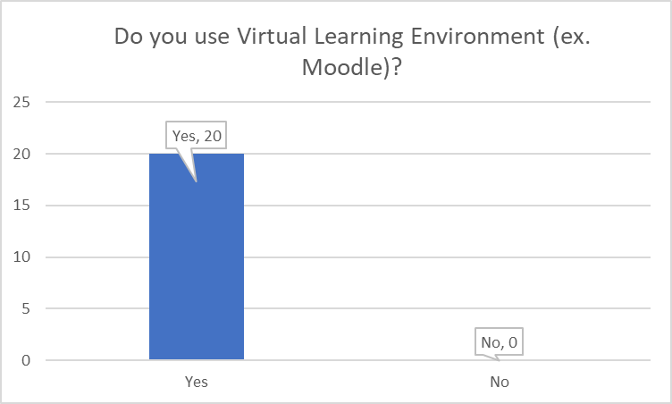
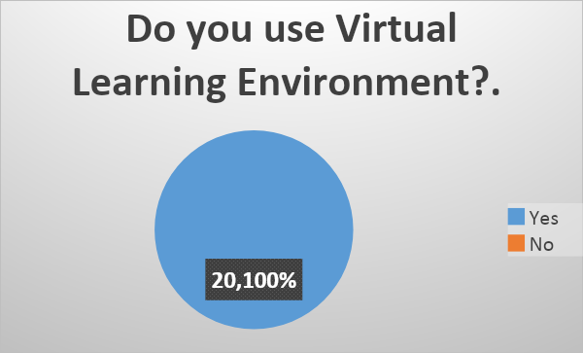

My first question was Do you use Virtual Learning Environment? As you see both of my graphs that out of the 20 people surveyed every one of them is using VLE. At this stage was I was not surprised because this is the only way to continue the education system in our current world crisis.

Question 2

Is this easy to use?

Yes | No
17 | 3
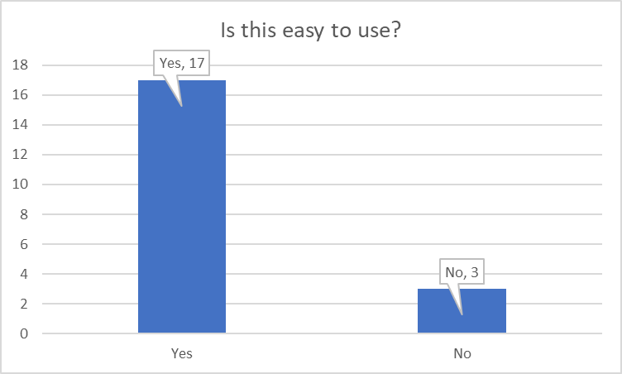
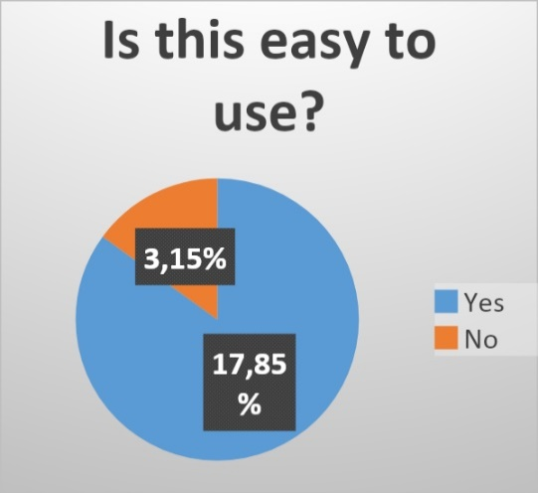

My second question was Is it easy to use? As you see in my graphs 3 of the people, I surveyed said that it is not that easy to use 15% out of the 20 people. 17 people said which is 85% of the people surveyed think VLE is easy to use.

Question 3

Do you find VLE (Moodle) helpful for your academic study?
Yes | No
16 | 4

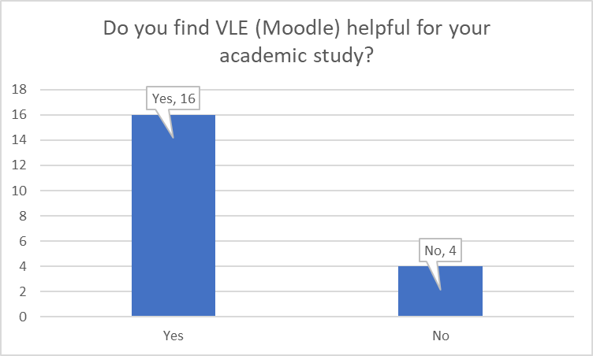
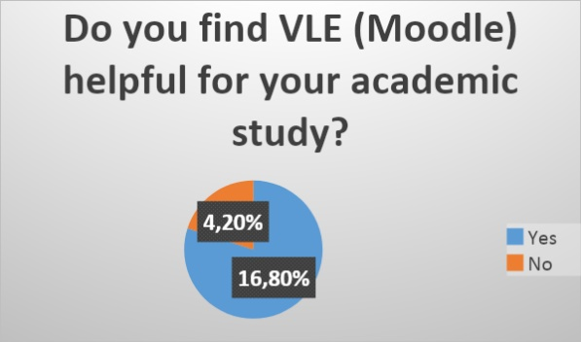

My third Question the graph analysis shows that 80% of the people think that it was helpful for the academic study. Only 4 people out of the 20 which means 20% think that VLE was not helpful for the academic study.

Question 4

What learning process works better for you?

Traditional | Virtual
5 | 15

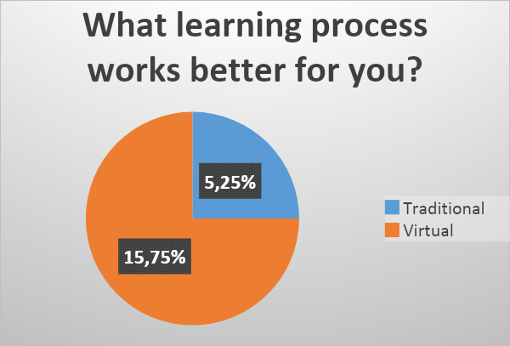

Question 4 graph analysis shows what type of learning process which works better for the people. The research between traditional or virtual learning process works better for my information source. 25% which means 5 people from the 20 thought that the traditional learning process is better. The rest of my source shows 15 people (75%) think the virtual learning process is better.

Question 5
My 5th question is How likely are you to recommend VLE to your friend/family?

The 5th question data analysis shows the results of the question, How likely are you to recommend VLE to your friend/family?
The data analysing shows that 55% are very likely to recommend Virtual Learning Environment to friend/family. 40% likely to recommend VLE and 5% said unlikely to recommend VLE. The graph show that nobody is very unlikely to recommend VLE.

Summary of the findings
The information what I received from the survey and the analysing; I can say that most people are able to use the Virtual Learning Environment platform. Most of the information that came back was in a positive way. I had asked the few people who were not happy about their VLE experience to find out what was the problem, why they do not recommend or like it. I say they all have basic problem about how to use the computer. This can be a big problem to use VLE. I think this VLE is getting better and better every day. However, some people will always prefer traditional learning rather than virtual learning. I had open ended questions regarding, what would you most want to change in VLE (Moodle)? The results came back that as most of the people would like to record every class so even if they have any internet, computer difficulties or they have to be somewhere else, they are able to watch it back so they are not missing out on anything. Another open ending question was, try to explain in a few words how happy are you with the overall performance of VLE (Moodle)? Analysing this question 70% of the people surveyed are happy with the overall performance. VLE helps people to learn and achieve more without leaving your house. This situation in the world, I can say VLE is the best thing that could be available for us even if it is not easy to use for everyone.

Conclusion
“We have the duty of formulating, of summarizing, and of communicating our conclusions, in intelligible form, in recognition of the right of other free minds to utilize them in making their own decisions.” (Kaplan, 2003)
Analysing the virtual learning environment is a good way to better understand a tool that I am using on a daily basis in my own learning experience. This also helps us learn what can we change, how can we do it better. Getting more knowledge about the computer itself. The findings and my analysing show VLE are helpful to most of the people. Analysing people that do not like or are happy about VLE. Most information I have received they do not like to use computers or they prefer traditional methods of learning. Personally, I do prefer face to face learning, as I believe body language can teach a person a lot as well. VLE is an amazing information source, and it helps for millions to learn and achieve more and more in their daily life and further their goals for the future.
References

FINK, A., 1998. Conducting literature research reviews: from paper to the internet. Thousand Oaks, CA: Sage., p.3.
Kader Parahoo (2006) Nursing research principles, process and issues, 2nd ed. Hamspire: Palgrave Macmillan
Denise F, Polit & Cheryl Tatano Beck (2008) Nursing research: generating and assessing evidence for nursing practice, 8th ed. Philadelphia: Lippincot William Wilkins
Creswell, J.W. (2009) Research Design: Qualitative, Quantitative and Mixed Methods Approaches (Third Edition) Thousand Oaks: Sage
https://www.ncbi.nlm.nih.gov/pmc/articles/PMC3105563/
Michael Morris, Ethical Considerations in Evaluation, International Handbook of Educational Evaluation, 10.1007/978-94-010-0309-4_19, (303-327), (2003).
Chances Are: Adventures in Probability". Book by Michael Kaplan and Ellen Kaplan, 2003.

Student Name: Kitti Takacs
Student ID: 1906398
- Do you use Virtual Learning Environment (ex. Moodle)?
YES NO

- Is this easy to use?
YES NO

- Do you find VLE (Moodle) helpful for your academic study?
YES NO

- What learning process works better for you?
- Traditional
- Virtual

- How satisfied are you with the learning through VLE (Moodle)? (Rate in a scale of 1 to 10 where 10 is extremely satisfied)
1 2 3 4 5 6 7 8 9 10

- What would you most want to change in VLE (Moodle)? (Explain in a few words

- Explain in a few words how happy are you with the overall performance of VLE (Moodle)?

- How likely are you to recommend VLE to your friend/family?
a; Very Likely
b; Likely
c; Unlikely
d; Very Unlikely

