
HTML & CSS Web development:
L4 – Introduction to Web and Database Concepts:

May 19, 2021
Scott Davison, 152891
HND Year 1

Table of Contents: Page Number:
1.1 - Introduction: 1
2.1 - Requirements: 1
3.1 - Implementation: 2
4.1 - Evaluation: 7
5.1 - Conclusion: 10
6.1 - References: 10
7.1 - Appendices: 11

- Introduction:
This report was created by the author because they needed to provide documentation of the website they created using a combination of HTML and CSS. As seen in [1], “HTML is the language in which most websites are written.” According to [2], “CSS allows you to create rules that specify how the content of an element should appear”. This report contains several sections that all combine in order to provide the relevant documentation needed. The requirements section outlines the website, its purpose, and the target audience for the website. The implementation section will show all of the web page, evidence of the HTML and CSS code being validated and if any errors are found, they will be discussed further. The evaluation section will essentially have a full evaluation of the website created, with focus on usefulness, accessibility, and search engine optimisation. The conclusion section will be used by the author to sum up their final feelings and a short evaluation on how they thought they did during the creation of the website and the report. The references section will contain any references used throughout the report and the appendices section will contain all of the HTML and CSS code used to create the website.

2.1 - Requirements:
The website the author has created is all about their online presence. The website contains information about the author’s YouTube channel, the author’s Twitch channel, the author’s Soundcloud profile and some personal information about the author. The website is very relevant to the author because it includes information about their online presence, it could also be relevant to any fans of the author’s channels because the website would serve as a mini hub of information about the author. That being said, the author’s main target audience is teenagers and adults and any fans of the author’s channels. The website had to include five web pages, the five web pages are; home page, YouTube page, Twitch page, Music page and About me page.

3.1 - Implementation:
The five web pages are shown below, with some validation for both the HTML code and the CSS code that makes up the website below.
Home Page:
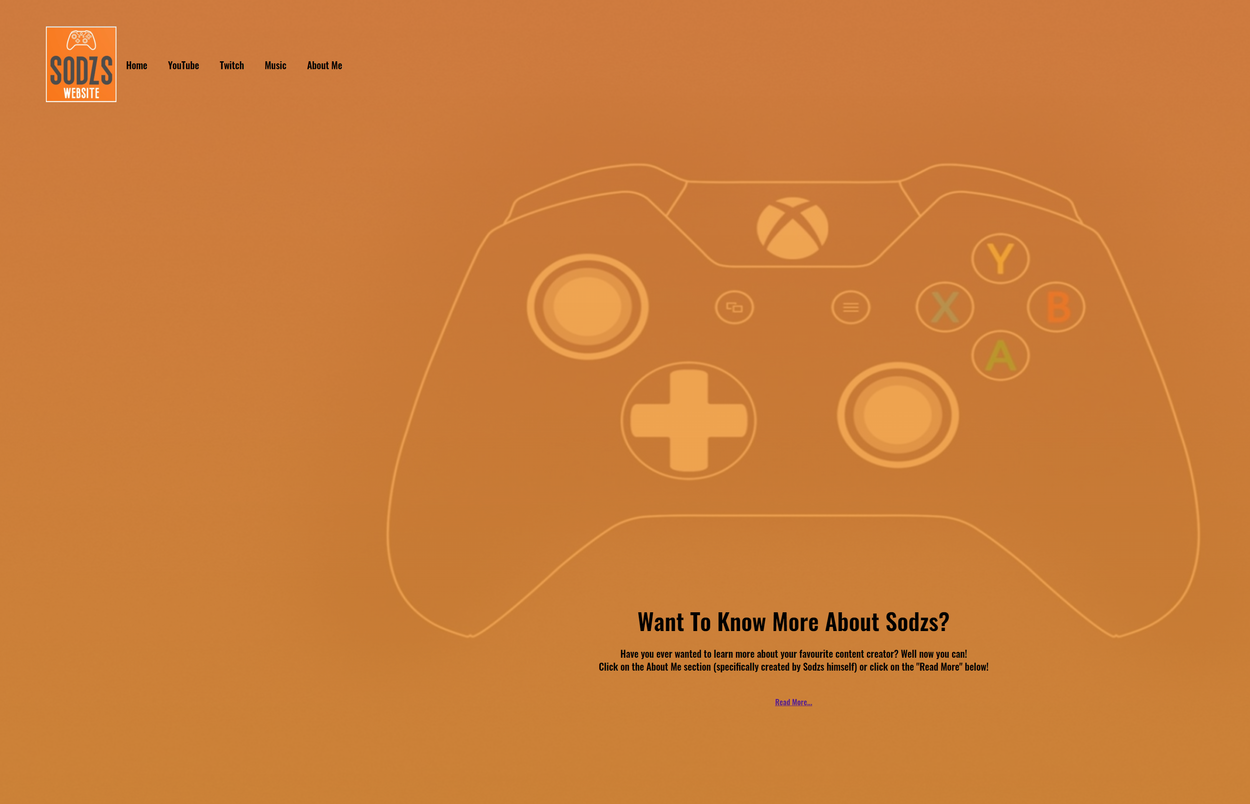
YouTube Page:
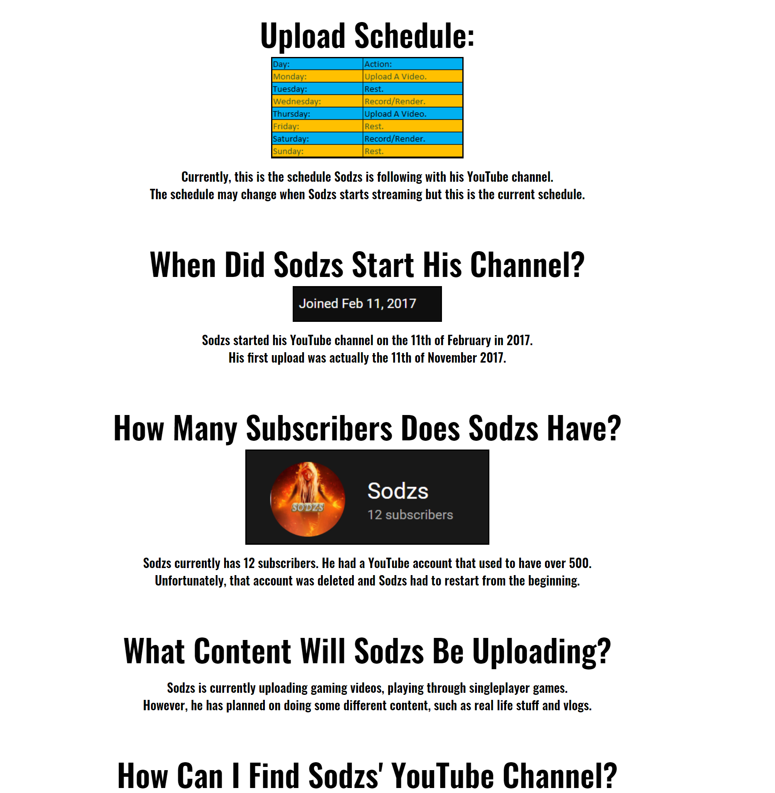
Twitch Page:
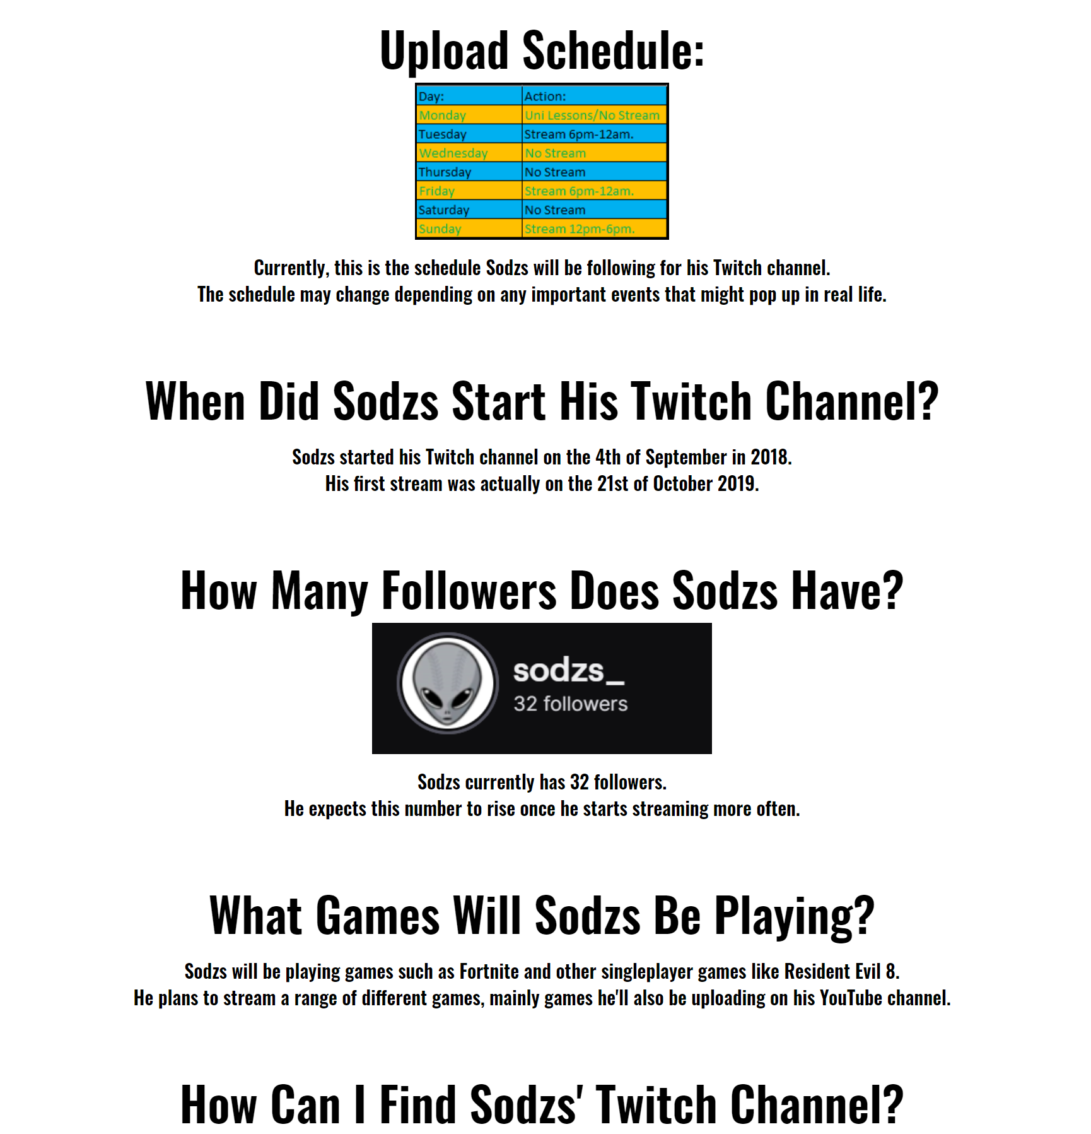
Music Page:
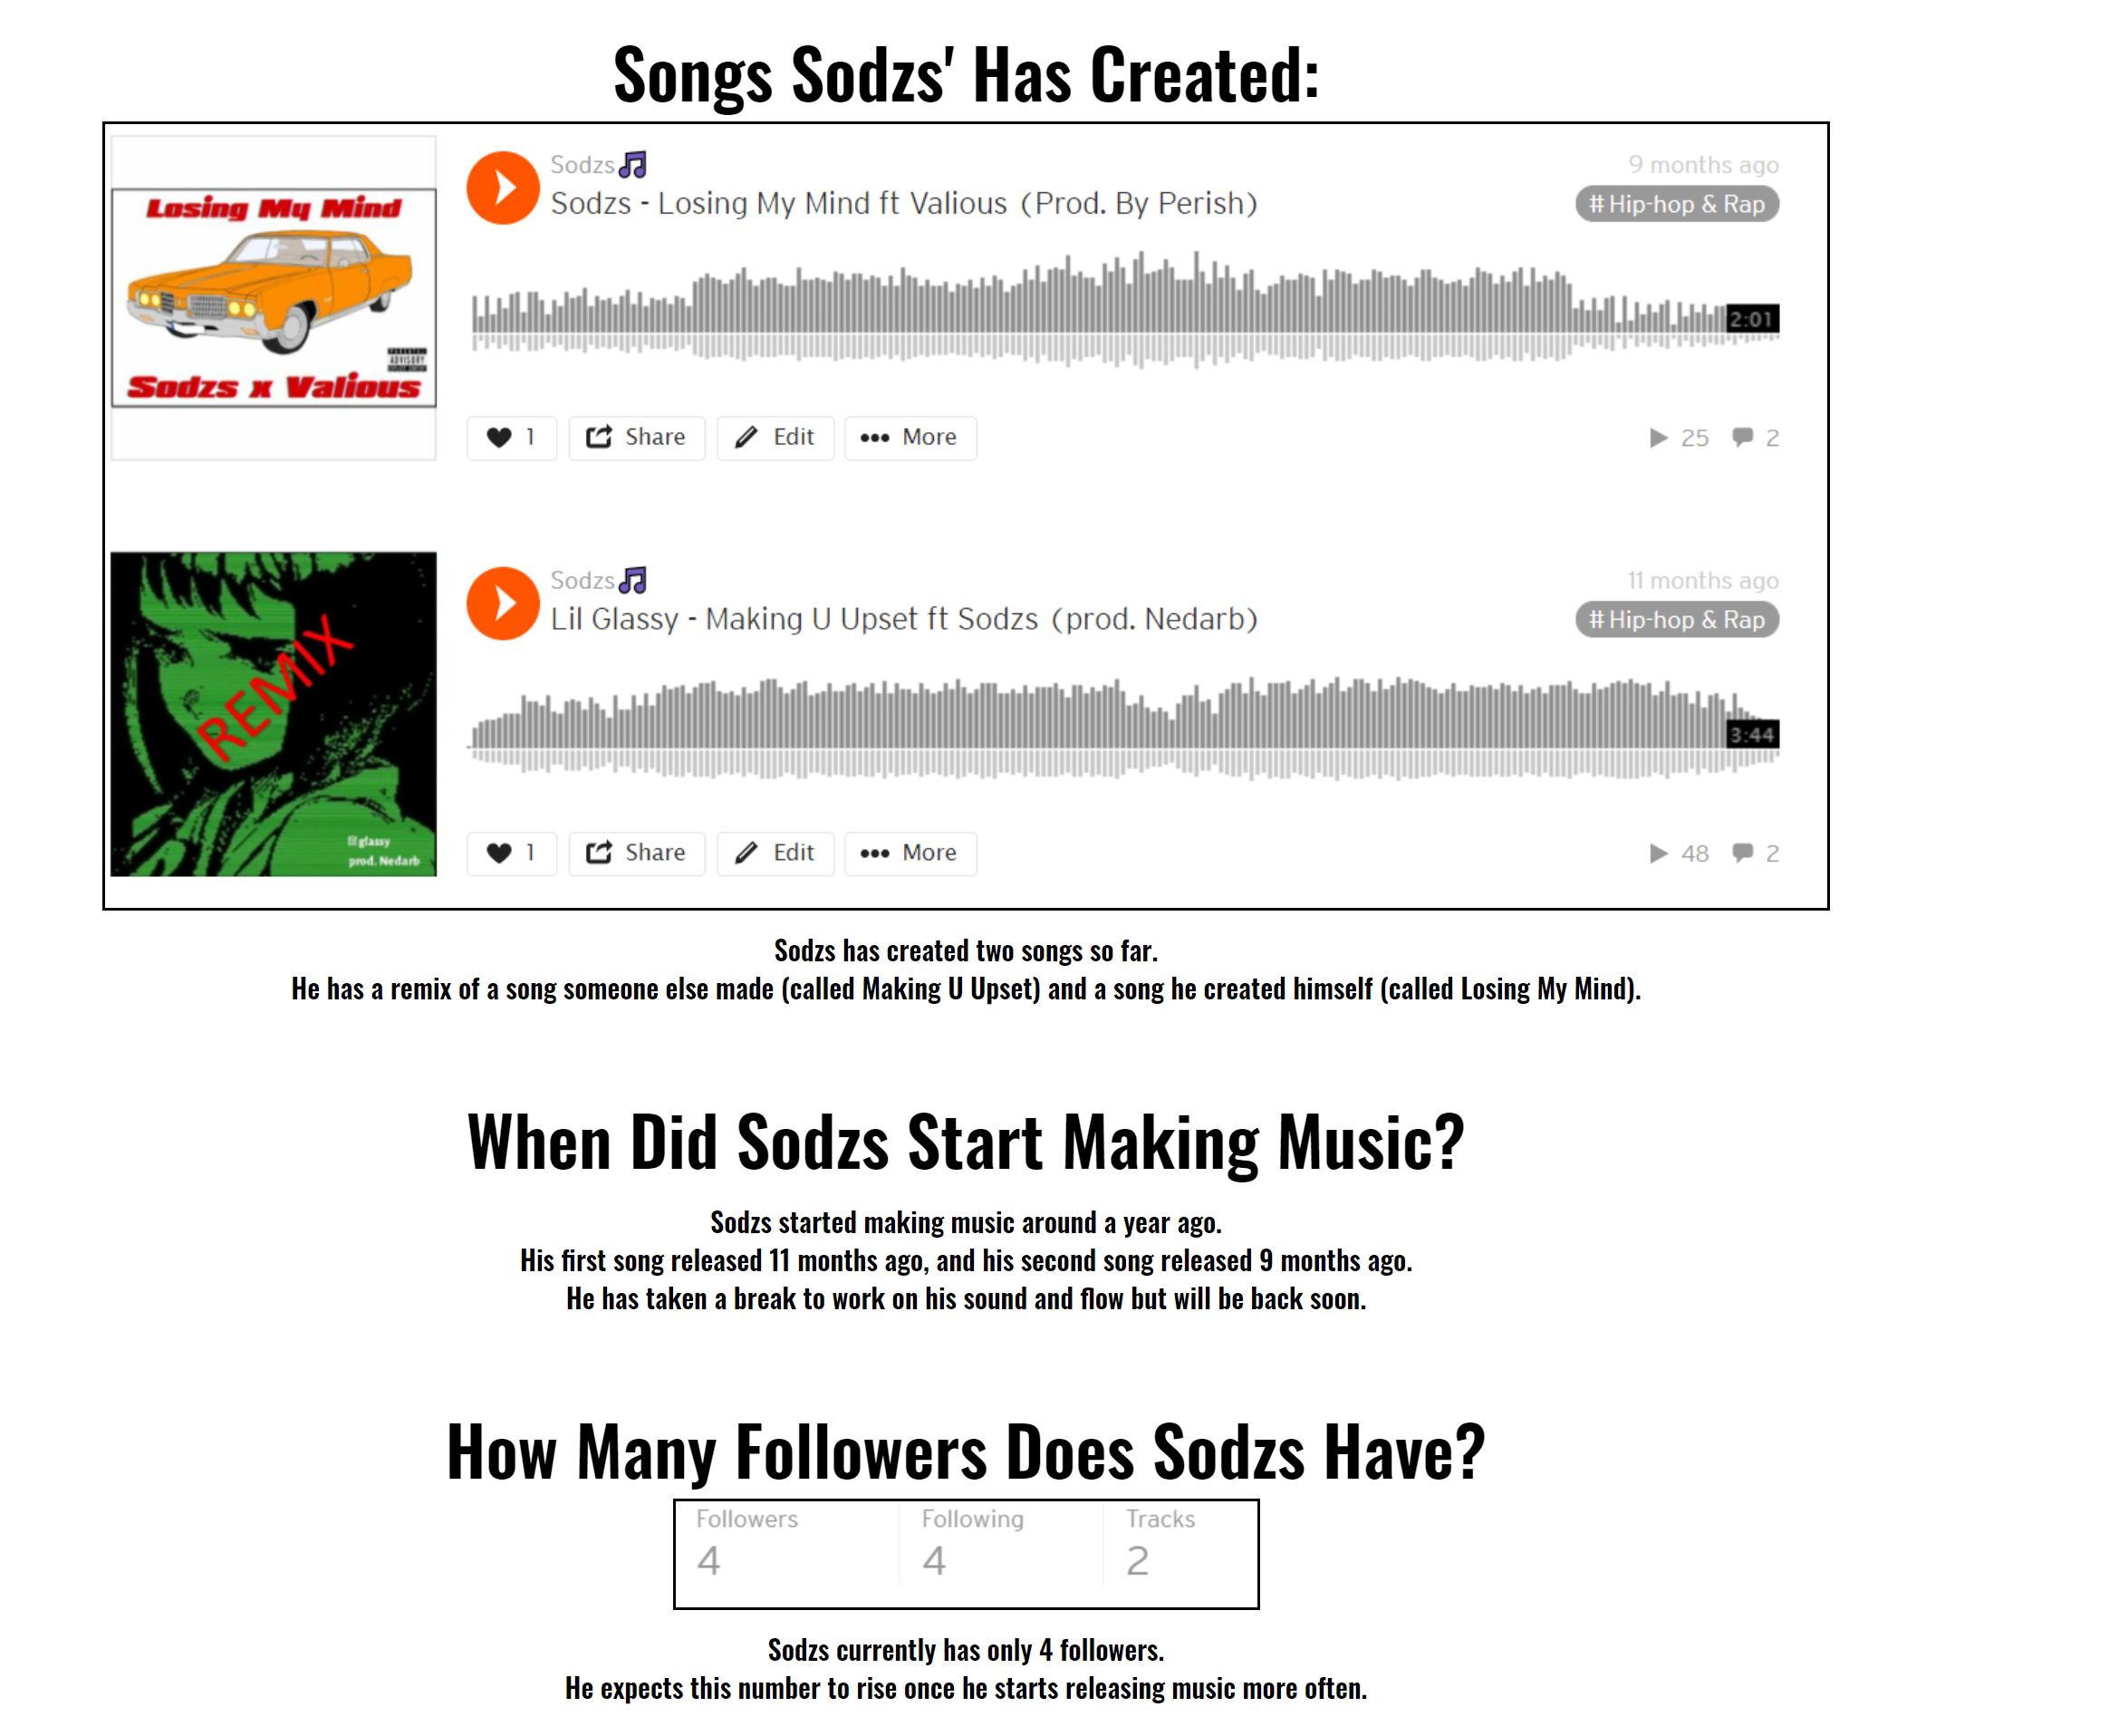
About Me Page:
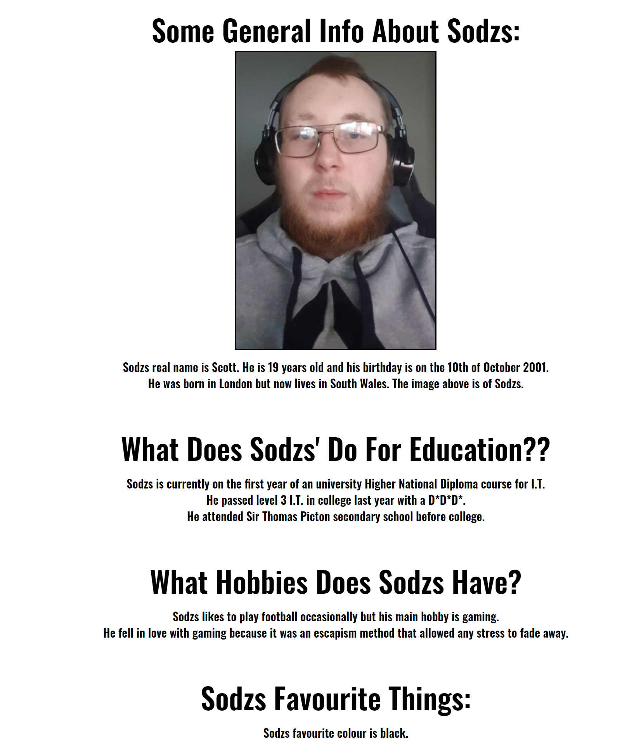
Validation Results:
The author has used two different websites to validate their code, the first one being “http://validator.w3.org/” for the HTML code and “http://jigsaw.w3.org/css-validator/” for the CSS code.
Starting off with the HTML code, the validator found the same two warnings for all five of the web pages. Warning 1 tells the author to consider adding lang to the html tag at the start of the page so that the language of the document is declared properly. This warning can be fixed by simply changing <HTML> to <HTML lang=“eng”> on each web page. This will declare the language of the document correctly. The author made the changes and now the warning doesn’t show anymore. Warning 2 and 3 are very similar, both warnings ask the author to consider using h2-h6 elements to add identifying headings to the header and page footer section of each web page. The author can fix this issue by making the texts in the header and page footer sections have a <h2> at the beginning and </h2> at the end. The author went back into their HTML code and added heading elements to the text so that the warning hopefully does not show anymore. After adding heading elements to the text in the header and page footer sections, only the warning about the header section kept showing. The author did add heading elements to the header section, but it is still showing as an error. The only things inside of the header section is an image, a list for the navigation buttons and two headings. The author doesn’t know what is causing the warning because they have added a heading tag to every bit of text located in the header section.
After validating the HTML code of the website, the author then validated the CSS code for each web page. The author had created a CSS stylesheet for each web page because the author found it easier that way. After validating the CSS code on the five stylesheets, the validator found no errors for the five CSS stylesheets.

4.1 - Evaluation:
For the evaluation section, the author will first research website usability, search engine optimisation and accessibility and explain why they are important for web development. Then after that, the author will evaluate the website they have made looking at the websites usability, the websites accessibility and all of the search engine optimisation techniques used on the author’s website.
[3] says, “the common consensus is that the product in question has to first be functionally correct (does what it’s supposed to do) and then be easy to use.” This would relate to websites too because a user of a website wouldn’t want to return to a website that was poorly designed or wasn’t usable. Website usability is all about simplicity, consistency and having a good flow on your website. The website has to be simple but effective, make sure the information is spread out consistently and that it is all relevant, a user doesn’t want to be bombarded with useless and irrelevant information, they would want to find out what they came there to find out. The website has to be consistent in the sense of the web pages have to be laid out similarly so that the user can learn how to use the website quicker and easier, having different pages laid out inconsistently can cause the user to get confused and not want to use the website anymore. Having a good flow ties in to the consistency of the website. A good flow means having a good layout and good linking to each page. A good navigation bar can help that.
According to [4], “Search engine optimization (SEO) refers to techniques that help your website rank higher in organic (or “natural”) search results, thus making your website more visible to people who are looking for your product or service via search engines.” Search engine optimisation is the process of improving your website to improve the visibility of your website in relevant searches. Search engine optimisation allows more people to find your website and will result in bringing more traffic to your website so that your website can reach a wider audience. Traffic means people visiting your website, imagine a motorway packed with tons of cars stuck in traffic, as time goes on, more and more cars add to that traffic. That is basically the same for traffic on websites, the more people added to the traffic means the more people that would have visited your website.
As seen in [5], “When we discuss web accessibility, we’re referring to the practice of removing barriers that prevent interaction with – or access to – websites by people with disabilities.” Web accessibility involves creating your website with disabled people in mind, ensuring that people with visual impairments, people who suffer from seizures, learning difficulties, hearing impairments and mobility impairments can fully access and use your website safely and easily. It isn’t just for disabled people though, people on mobile phones and TVs and people with slow Internet connections can both be factored in to the web accessibility discussion. Certain colour schemes can be used on the website so that people with colour blindness can easily read text on the web page.
Now that we know what web usability, web accessibility and search engine optimisation are, the author will now evaluate their own website, the usability of the website, the functionality, the design, the content, the accessibility of the website, the techniques the author has used to enhance the search engine optimisation and any future improvements the author can think of.
To start with, the author will evaluate their own website’s usability. The user would like to say that their website is laid out well, the design is consistent and looks good. Users shouldn’t have any problems navigating through the five different web pages because the navigation bar is good and is located in the same place on each web page. The home page also includes another two links that allow the user to click on a “Read More” that will take them to the YouTube page or the About Me page, depending on which one they click on. The website functions well, all of the links work, including the links that take you off of the website (the YouTube channel link, the Twitch channel link, and the Soundcloud profile link). Everything on the website fits well and functions as it should, all of the text and content of the website is displayed correctly and does scale down when the browser window gets smaller. The author would say that the website is easy to use, the links are all easy to find and the content loads correctly, it is so simple that the hardest part of the website is navigating through the five web pages even though the navigation bar is located at the same place and is very easy to use. All the user has to do is left click on one of the navigation bar buttons (Home, YouTube, Twitch etc…) and then they get navigated to the next web page. As the author has said several times, the content of the web pages are all setup similarly and are easily visible. The content is all straight to the point and don’t include hundreds of lines of irrelevant information.
According to [6], some techniques for SEO is “Improve User Experience Across Your Entire Site”, “Optimize For Voice Search”, “Design For Mobile First” and “Focus On Topic Clusters Instead Of Keywords”. To be honest, the author hasn’t used many search engine optimisation techniques on their website, mainly because they didn’t know many techniques for search engine optimisation. The author can say that they have laid out the website neatly and relevantly so that the user’s experience will be good across the entire website, the author has also designed the website for mobile and other larger or smaller screen sizes so that all of the content either scales up or scales down depending on the size of the screen size. These are the only things the user can think of when it comes to search engine optimisation.
The websites accessibility is easy for most users of the website but for people with visual impairments and any other impairments there may be some issues. The code for the website is laid out neatly and everything is easily readable so as far as Visual Studio Code is concerned; the website is very accessible. The website is mainly orange, some colour blindness can affect the colour orange, so already it isn’t the most accessible website out there. Other visual impairments like partial-blindness are fine with the website because the content is decently sized, and the user can zoom in or zoom out using their browser and the content will scale up or scale down depending on their zoom. The website is easy to use so that people with learning difficulties could use it properly without any problems, people with mobility issues might not be able to use it fully because the website doesn’t have any measures like voice search implemented on the website. The content on this website does not have any flashing lights or anything meaning the website is safe for people who suffer from seizures. Overall, the website was created quickly, the author didn’t have a lot of time to implement features that cater to people with disabilities because a lot of them are advanced and hard to implement. The website is safe for people who suffer from seizures and is easy to use for people with learning difficulties.

5.1 - Conclusion:
Overall, the website is well designed and is very easy to use for the majority of users. The author is satisfied that they have made the website and that it meets all of the specification set out for the website. The author could have made it more accessible for people who suffer with disabilities if they had more time, but the website is easy to use, the design is good, the layout is easy to remember and the content is appropriate and relevant. The code used for the website contained virtually no errors and overall the author is satisfied with the website they have created.

6.1 - References:
[1] HTML.com (2015), HTML For Beginners The Easy Way: Start Learning HTML & CSS Today [Online] Available: https://html.com/#What_is_HTML.
[2] Jon Duckett, (18 Nov 2011), HTML & CSS [Online] Available: https://wtf.tw/ref/duckett.pdf.
[3] Heng Belson and Japheth Ho (No Date Available), Chapter 2 Usability [Online] Available: https://www.comp.nus.edu.sg/~seer/book/2e/Ch02.%20Usability.pdf.
[4] HubSpot (No Date Available), Introduction To Search Engine Optimization [Online] Available: https://cdn2.hubspot.net/hub/53/file-13204607-pdf/docs/introduction-to-seo-ebook.pdf.
[5] CrownPeak (No Date Available) Understanding Web Accessibility: Its Opportunities & The Costs Of Non-Compliance [Online] Available: https://www.crownpeak.com/resources/ebooks/web-accessibility-ebook.pdf.
[6] Elise Dopson (2021), 10 Effective SEO Techniques To Drive Organic Traffic In 2021 [Online] Available: https://www.singlegrain.com/seo/effective-seo-techniques-that-work/.

7.1 - Appendices:
Home Page HTML:
<!DOCTYPE html>
<html lang="en">

<head>
<meta name="viewport" content="with=device-width, initial-scale=1.0">
<title> Home Page </title>
<link rel="stylesheet" href="main.css">
<link rel="preconnect" href="https://fonts.gstatic.com">
<link href="https://fonts.googleapis.com/css2?family=Oswald:wght@600&display=swap" rel="stylesheet">
</head>

<body>
<section id="header">
<nav>
<a href="index.html"><img src="images/sodzslogo.jpeg" alt="Logo For Sodzs"></a>
<div id="naviButtons">
<ul>
<li><a href="index.html"><h2>Home</h2></a></li>
<li><a href="youtube.html"><h2>YouTube</h2></a></li>
<li><a href="twitch.html"><h2>Twitch</h2></a></li>
<li><a href="music.html"><h2>Music</h2></a></li>
<li><a href="aboutme.html"><h2>About Me</h2></a></li>
</ul>
</div>
</nav>

<div id="maintextbox1">
<h1>Want To Know More About Sodzs?</h1>
<h3>Have you ever wanted to learn more about your favourite content creator? Well now you can! <br> Click on the
About Me section (specifically created by Sodzs himself) or click on the "Read More" below!</h3>
<a href="aboutme.html"><h3>Read More...</h3></a>
</div>
</section>

<section id="youtubemainpage">
<h1>Want To Learn More Information About Sodzs' YouTube?</h1>
<p>You can find out Sodzs' upload schedule, future playthroughs and much more! Click on the "Read More" below to
find out!</p>
<a href="youtube.html">Read More...</a>
</section>

<section id="pagefooter">
<h2 id="footertext">Website Created By Scott Davison © 2021</h2>
</section>
</body>

</html>
YouTube Page HTML:
<!DOCTYPE html>
<html lang="en">

<head>
<meta name="viewport" content="with=device-width, initial-scale=1.0">
<title> Sodzs' YouTube </title>
<link rel="stylesheet" href="youtubepage.css">
<link rel="preconnect" href="https://fonts.gstatic.com">
<link href="https://fonts.googleapis.com/css2?family=Oswald:wght@600&display=swap" rel="stylesheet">
</head>

<body>
<section id="header">
<nav>
<a href="index.html"><img src="images/sodzslogo.jpeg" alt="Logo For Sodzs"></a>
<div id="naviButtons">
<ul>
<li><a href="index.html"><h2>Home</h2></a></li>
<li><a href="youtube.html"><h2>YouTube</h2></a></li>
<li><a href="twitch.html"><h2>Twitch</h2></a></li>
<li><a href="music.html"><h2>Music</h2></a></li>
<li><a href="aboutme.html"><h2>About Me</h2></a></li>
</ul>
</div>
</nav>

<div id="maintextbox1">
<h1>Sodzs' YouTube:</h1>
<h3>This webpage will inform you on Sodzs' upload schedule, what he will be uploading<br> And other information
relating to his YouTube channel.</h3>
</div>
</section>

<section id="youtubeschedule">
<h1>Upload Schedule:</h1>
<img src="images/uploadschedule.png" id="uploadschedule" alt="Upload Schedule For YouTube.">
<p>Currently, this is the schedule Sodzs is following with his YouTube channel. <br> The schedule may change when
Sodzs starts streaming but this is the current schedule.</p>
</section>

<section id="channelstart">
<h1>When Did Sodzs Start His Channel?</h1>
<img src="images/channelstart.png" id="channelstartimage" alt="Channel Start Image">
<p>Sodzs started his YouTube channel on the 11th of February in 2017. <br> His first upload was actually the 11th of
November 2017.</p>
</section>

<section id="subscribercount">
<h1>How Many Subscribers Does Sodzs Have?</h1>
<img src="images/subscribersyoutube.png" id="subscribersyt" alt="Subscribers Image">
<p>Sodzs currently has 12 subscribers. He had a YouTube account that used to have over 500.<br> Unfortunately, that
account was deleted and Sodzs had to restart from the beginning.</p>
</section>

<section id="futurecontent">
<h1>What Content Will Sodzs Be Uploading?</h1>
<p>Sodzs is currently uploading gaming videos, playing through singleplayer games.<br> However, he has planned on
doing some different content, such as real life stuff and vlogs.</p>
</section>

<section id="youtubelink">
<h1>How Can I Find Sodzs' YouTube Channel?</h1>
<img src="images/youtubepageimage.png" id="youtubepageimage" alt="Image Of Sodzs' YouTube Page.">
<p>You can find his channel by either searching up Sodzs on YouTube.<br> Or you can follow the link below:</p>
<a
href="https://www.youtube.com/channel/UCTHNWrr6pb7d5qEZlFL-qhg/featured">https://www.youtube.com/channel/UCTHNWrr6pb7d5qEZlFL-qhg/featured</a>
</section>

<section id="pagefooter">
<h2 id="footertext">Website Created By Scott Davison © 2021</h2>
</section>

</body>

</html>
Twitch Page HTML:
<!DOCTYPE html>
<html lang="en">

<head>
<meta name="viewport" content="with=device-width, initial-scale=1.0">
<title> Sodzs' Twitch </title>
<link rel="stylesheet" href="twitchpage.css">
<link rel="preconnect" href="https://fonts.gstatic.com">
<link href="https://fonts.googleapis.com/css2?family=Oswald:wght@600&display=swap" rel="stylesheet">
</head>

<body>
<section id="header">
<nav>
<a href="index.html"><img src="images/sodzslogo.jpeg" alt="Logo For Sodzs"></a>
<div id="naviButtons">
<ul>
<li><a href="index.html"><h2>Home</h2></a></li>
<li><a href="youtube.html"><h2>YouTube</h2></a></li>
<li><a href="twitch.html"><h2>Twitch</h2></a></li>
<li><a href="music.html"><h2>Music</h2></a></li>
<li><a href="aboutme.html"><h2>About Me</h2></a></li>
</ul>
</div>
</nav>

<div id="maintextbox1">
<h1>Sodzs' Twitch:</h1>
<h3>This webpage will inform you about Sodzs' Twitch channel.<br> This includes future streaming schedule, games
Sodzs'll be streaming etc...</h3>
</div>
</section>

<section id="twitchschedule">
<h1>Upload Schedule:</h1>
<img src="images/twitchuploadschedule.png" id="uploadschedule" alt="Upload Schedule For Twitch.">
<p>Currently, this is the schedule Sodzs will be following for his Twitch channel. <br> The schedule may change
depending on any important events that might pop up in real life.</p>
</section>

<section id="channelstart">
<h1>When Did Sodzs Start His Twitch Channel?</h1>
<p>Sodzs started his Twitch channel on the 4th of September in 2018. <br> His first stream was actually on the 21st
of October 2019.</p>
</section>

<section id="followercount">
<h1>How Many Followers Does Sodzs Have?</h1>
<img src="images/followerstwitch.png" id="followersttv" alt="Twitch Channel Image">
<p>Sodzs currently has 32 followers.<br> He expects this number to rise once he starts streaming more often.</p>
</section>

<section id="futurecontent">
<h1>What Games Will Sodzs Be Playing?</h1>
<p>Sodzs will be playing games such as Fortnite and other singleplayer games like Resident Evil 8.<br> He plans to
stream a range of different games, mainly games he'll also be uploading on his YouTube channel. </p>
</section>

<section id="twitchlink">
<h1>How Can I Find Sodzs' Twitch Channel?</h1>
<img src="images/twitchpageimage.png" id="twitchpageimage" alt="Image Of Sodzs' Twitch Page.">
<p>You can find his Twitch channel by either searching up Sodzs_ on Twitch.<br> Or you can follow the link below:
</p>
<a href="https://www.twitch.tv/sodzs_">https://www.twitch.tv/sodzs_</a>
</section>

<section id="pagefooter">
<h2 id="footertext">Website Created By Scott Davison © 2021</h2>
</section>

</body>

</html>
Music Page HTML:
<!DOCTYPE html>
<html lang="en">

<head>
<meta name="viewport" content="with=device-width, initial-scale=1.0">
<title> Music Page </title>
<link rel="stylesheet" href="musicpage.css">
<link rel="preconnect" href="https://fonts.gstatic.com">
<link href="https://fonts.googleapis.com/css2?family=Oswald:wght@600&display=swap" rel="stylesheet">
</head>

<body>
<section id="header">
<nav>
<a href="index.html"><img src="images/sodzslogo.jpeg" alt="Logo For Sodzs"></a>
<div id="naviButtons">
<ul>
<li><a href="index.html"><h2>Home</h2></a></li>
<li><a href="youtube.html"><h2>YouTube</h2></a></li>
<li><a href="twitch.html"><h2>Twitch</h2></a></li>
<li><a href="music.html"><h2>Music</h2></a></li>
<li><a href="aboutme.html"><h2>About Me</h2></a></li>
</ul>
</div>
</nav>

<div id="maintextbox1">
<h1>Music Page:</h1>
<h3>This is the webpage for Sodzs' music. <br> This webpage will include the followers Sodzs has, the amount of
songs he's made etc...</h3>
</div>
</section>

<section id="songsmade">
<h1>Songs Sodzs' Has Created:</h1>
<img src="images/sodzssongs.png" id="sodzssongs" alt="Songs Sodzs Has Created.">
<p>Sodzs has created two songs so far. <br> He has a remix of a song someone else made (called Making U Upset) and a
song he created himself (called Losing My Mind).
</section>

<section id="musicstart">
<h1>When Did Sodzs Start Making Music?</h1>
<p>Sodzs started making music around a year ago. <br> His first song released 11 months ago, and his second song
released 9 months ago. <br> He has taken a break to work on his sound and flow but will be back soon.</p>
</section>

<section id="followercount">
<h1>How Many Followers Does Sodzs Have?</h1>
<img src="images/followerssoundcloud.png" id="followerssoundcloud" alt="Soundcloud Followers Image">
<p>Sodzs currently has only 4 followers.<br> He expects this number to rise once he starts releasing music more
often.</p>
</section>

<section id="futurecontent">
<h1>Has Sodzs Got Any Upcoming Projects?</h1>
<p>Sodzs will be releasing an EP by the end of this year.<br> He plans to
release the EP in the winter of this year, the EP will have 4 songs. </p>
</section>

<section id="soundcloudlink">
<h1>How Can I Find Sodzs' Soundcloud?</h1>
<img src="images/soundcloudpageimage.png" id="soundcloudpageimage" alt="Image Of Sodzs' Soundcloud Page.">
<p>You can find his Soundcloud by either searching up Sodzs on Soundcloud.<br> Or you can follow the link below:
</p>
<a href="https://soundcloud.com/sodzs">https://soundcloud.com/sodzs</a>
</section>

<section id="pagefooter">
<h2 id="footertext">Website Created By Scott Davison © 2021</h2>
</section>

</body>

</html>
About Me Page HTML:
<!DOCTYPE html>
<html lang="en">

<head>
<meta name="viewport" content="with=device-width, initial-scale=1.0">
<title> About Me </title>
<link rel="stylesheet" href="aboutmepage.css">
<link rel="preconnect" href="https://fonts.gstatic.com">
<link href="https://fonts.googleapis.com/css2?family=Oswald:wght@600&display=swap" rel="stylesheet">
</head>

<body>
<section id="header">
<nav>
<a href="index.html"><img src="images/sodzslogo.jpeg" alt="Logo For Sodzs"></a>
<div id="naviButtons">
<ul>
<li><a href="index.html"><h2>Home</h2></a></li>
<li><a href="youtube.html"><h2>YouTube</h2></a></li>
<li><a href="twitch.html"><h2>Twitch</h2></a></li>
<li><a href="music.html"><h2>Music</h2></a></li>
<li><a href="aboutme.html"><h2>About Me</h2></a></li>
</ul>
</div>
</nav>

<div id="maintextbox1">
<h1>About Me:</h1>
<h3>This webpage will let you learn some things about Sodzs.</h3>
</div>
</section>

<section id="personalinfo">
<h1>Some General Info About Sodzs:</h1>
<img src="images/sodzspicture.jpg" id="sodzspicture" alt="A Picture Of Sodzs.">
<p>Sodzs real name is Scott. He is 19 years old and his birthday is on the 10th of October 2001. <br> He was born in
London but now lives in South Wales. The image above is of Sodzs. </p>
</section>

<section id="sodzseducation">
<h1>What Does Sodzs' Do For Education??</h1>
<p>Sodzs is currently on the first year of an university Higher National Diploma course for I.T. <br> He passed
level 3 I.T. in college last year with a D*D*D*. <br> He attended Sir Thomas Picton secondary school before
college.</p>
</section>

<section id="sodzshobbies">
<h1>What Hobbies Does Sodzs Have?</h1>
<p>Sodzs likes to play football occasionally but his main hobby is gaming. <br> He fell in love with gaming because
it was an escapism method that allowed any stress to fade away.</p>
</section>

<section id="sodzsfavourites">
<h1>Sodzs Favourite Things:</h1>
<p>Sodzs favourite colour is black.<br> Sodzs favourite football team is Arsenal. <br> Sodzs favourite food is
Pizza, followed closely by anything involving chicken. <br> Sodzs favourite thing to do daily is gaming.
</p>
</section>

<section id="pagefooter">
<h2 id="footertext">Website Created By Scott Davison © 2021</h2>
</section>

</body>

</html>
Home Page CSS:
*{
margin:0;
padding:0;
font-family: 'Oswald', sans-serif;
}
#header{
min-height:100vh;
width:100%;
background-image:linear-gradient(rgba(238, 140, 29, 0.74),rgba(238, 140, 29, 0.788)),url(images/mainpagebanner.png);
background-position:center;
background-size:cover;
position:relative;
}
nav{
display:flex;
padding: 2% 6%;
justify-content:space-between;
align-items:center;
position:relative;
left:-100px;
}
nav img{
width:150px;
}
#naviButtons{
flex:1;
text-align:left;
}
#naviButtons ul li{
list-style:none;
display:inline-block;
padding: 0px 20px;
position:relative;
}
#naviButtons ul li a{
color:black;
text-decoration:none;
font-size:20px;
}
#naviButtons ul li::after{
content:'';
width:0%;
height:2px;
background:black;
display:block;
margin:auto;
transition:0.3s;
}
#naviButtons ul li:hover::after{
width:100%;
}
#maintextbox1{
width:90%;
color:Black;
position:absolute;
top:75%;
left:5%;
text-align:center;
}
#maintextbox1 h1{
font-size:50px;
}
#maintextbox1 p{
margin-top:10px;
margin-left:0px;
margin-right:0px;
margin-bottom:40px;
font-size:20px;
}
#youtubemainpage{
width:80%;
margin:auto;
text-align:center;
padding:100px;
}
h1{
font-size:50px;
font-weight:bolder;
}
p{
font-size:20px;
padding:10px;
line-height:28px;
}
#pagefooter{
text-align:center;
color:grey;
}
#footertext{
font-size:25px;
}
#uploadschedule{
border-style:solid;
}
#channelstart{
width:80%;
margin:auto;
text-align:center;
padding:25px;
}
#channelstartimage{
border-style:solid;
}
#subscribercount{
width:80%;
margin:auto;
text-align:center;
padding:25px;
}
#subscribersyt{
border-style:solid;
}
#futurecontent{
width:80%;
margin:auto;
text-align:center;
padding:25px;
}
#youtubelink{
width:80%;
margin:auto;
text-align:center;
padding:25px;
}
#youtubepageimage{
border-style:solid;
width:50%;

}

YouTube Page CSS:
*{
margin:0;
padding:0;
font-family: 'Oswald', sans-serif;
}
#header{
min-height:100vh;
width:100%;
background-image:linear-gradient(rgba(238, 140, 29, 0.74),rgba(238, 140, 29, 0.788)),url(images/youtubelogo.jpg);
background-position:center;
background-size:cover;
position:relative;
}
nav{
display:flex;
padding: 2% 6%;
justify-content:space-between;
align-items:center;
position:relative;
left:-100px;
}
nav img{
width:150px;
}
#naviButtons{
flex:1;
text-align:left;
}
#naviButtons ul li{
list-style:none;
display:inline-block;
padding: 0px 20px;
position:relative;
}
#naviButtons ul li a{
color:black;
text-decoration:none;
font-size:20px;
}
#naviButtons ul li::after{
content:'';
width:0%;
height:2px;
background:black;
display:block;
margin:auto;
transition:0.3s;
}
#naviButtons ul li:hover::after{
width:100%;
}
#maintextbox1{
width:90%;
color:Black;
position:absolute;
top:75%;
left:5%;
text-align:center;
}
#maintextbox1 h1{
font-size:50px;
}
#maintextbox1 p{
margin-top:10px;
margin-left:0px;
margin-right:0px;
margin-bottom:40px;
font-size:20px;
}
#youtubeschedule{
width:80%;
margin:auto;
text-align:center;
padding:25px;
}
h1{
font-size:50px;
font-weight:bolder;
}
p{
font-size:20px;
padding:10px;
line-height:28px;
}
#pagefooter{
text-align:center;
color:grey;
}
#footertext{
font-size:25px;
}
#uploadschedule{
border-style:solid;
}
#channelstart{
width:80%;
margin:auto;
text-align:center;
padding:25px;
}
#channelstartimage{
border-style:solid;
}
#subscribercount{
width:80%;
margin:auto;
text-align:center;
padding:25px;
}
#subscribersyt{
border-style:solid;
}
#futurecontent{
width:80%;
margin:auto;
text-align:center;
padding:25px;
}
#youtubelink{
width:80%;
margin:auto;
text-align:center;
padding:25px;
}
#youtubepageimage{
border-style:solid;
width:50%;

}
Twitch Page CSS:
*{
margin:0;
padding:0;
font-family: 'Oswald', sans-serif;
}
#header{
min-height:100vh;
width:100%;
background-image:linear-gradient(rgba(238, 140, 29, 0.74),rgba(238, 140, 29, 0.788)),url(images/twitchlogo.jpg);
background-position:center;
background-size:cover;
position:relative;
}
nav{
display:flex;
padding: 2% 6%;
justify-content:space-between;
align-items:center;
position:relative;
left:-100px;
}
nav img{
width:150px;
}
#naviButtons{
flex:1;
text-align:left;
}
#naviButtons ul li{
list-style:none;
display:inline-block;
padding: 0px 20px;
position:relative;
}
#naviButtons ul li a{
color:black;
text-decoration:none;
font-size:20px;
}
#naviButtons ul li::after{
content:'';
width:0%;
height:2px;
background:black;
display:block;
margin:auto;
transition:0.3s;
}
#naviButtons ul li:hover::after{
width:100%;
}
#maintextbox1{
width:90%;
color:Black;
position:absolute;
top:82%;
left:5%;
text-align:center;
}
#maintextbox1 h1{
font-size:50px;
}
#maintextbox1 p{
margin-top:10px;
margin-left:0px;
margin-right:0px;
margin-bottom:40px;
font-size:20px;
}
#twitchschedule{
width:80%;
margin:auto;
text-align:center;
padding:25px;
}
h1{
font-size:50px;
font-weight:bolder;
}
p{
font-size:20px;
padding:10px;
line-height:28px;
}
#pagefooter{
text-align:center;
color:grey;
}
#footertext{
font-size:25px;
}
#uploadschedule{
border-style:solid;
}
#channelstart{
width:80%;
margin:auto;
text-align:center;
padding:25px;
}
#followercount{
width:80%;
margin:auto;
text-align:center;
padding:25px;
}
#subscribersyt{
border-style:solid;
}
#futurecontent{
width:80%;
margin:auto;
text-align:center;
padding:25px;
}
#twitchlink{
width:80%;
margin:auto;
text-align:center;
padding:25px;
}
#twitchpageimage{
border-style:solid;
width:50%;

}
Music Page CSS:
*{
margin:0;
padding:0;
font-family: 'Oswald', sans-serif;
}
#header{
min-height:100vh;
width:100%;
background-image:linear-gradient(rgba(238, 140, 29, 0.74),rgba(238, 140, 29, 0.788)),url(images/musiclogo.png);
background-position:center;
background-size:cover;
position:relative;
}
nav{
display:flex;
padding: 2% 6%;
justify-content:space-between;
align-items:center;
position:relative;
left:-100px;
}
nav img{
width:150px;
}
#naviButtons{
flex:1;
text-align:left;
}
#naviButtons ul li{
list-style:none;
display:inline-block;
padding: 0px 20px;
position:relative;
}
#naviButtons ul li a{
color:black;
text-decoration:none;
font-size:20px;
}
#naviButtons ul li::after{
content:'';
width:0%;
height:2px;
background:black;
display:block;
margin:auto;
transition:0.3s;
}
#naviButtons ul li:hover::after{
width:100%;
}
#maintextbox1{
width:90%;
color:Black;
position:absolute;
top:75%;
left:5%;
text-align:center;
}
#maintextbox1 h1{
font-size:50px;
}
#maintextbox1 p{
margin-top:10px;
margin-left:0px;
margin-right:0px;
margin-bottom:40px;
font-size:20px;
}
#songsmade{
width:80%;
margin:auto;
text-align:center;
padding:25px;
}
h1{
font-size:50px;
font-weight:bolder;
}
p{
font-size:20px;
padding:10px;
line-height:28px;
}
#pagefooter{
text-align:center;
color:grey;
}
#footertext{
font-size:25px;
}
#sodzssongs{
border-style:solid;
}
#musicstart{
width:80%;
margin:auto;
text-align:center;
padding:25px;
}
#followercount{
width:80%;
margin:auto;
text-align:center;
padding:25px;
}
#followerssoundcloud{
border-style:solid;
}
#futurecontent{
width:80%;
margin:auto;
text-align:center;
padding:25px;
}
#soundcloudlink{
width:80%;
margin:auto;
text-align:center;
padding:25px;
}
#soundcloudpageimage{
border-style:solid;
width:50%;

}
About Me Page CSS:
*{
margin:0;
padding:0;
font-family: 'Oswald', sans-serif;
}
#header{
min-height:100vh;
width:100%;
background-image:linear-gradient(rgba(238, 140, 29, 0.74),rgba(238, 140, 29, 0.788)),url(images/aboutmeimage.jpg);
background-position:center;
background-size:cover;
position:relative;
}
nav{
display:flex;
padding: 2% 6%;
justify-content:space-between;
align-items:center;
position:relative;
left:-100px;
}
nav img{
width:150px;
}
#naviButtons{
flex:1;
text-align:left;
}
#naviButtons ul li{
list-style:none;
display:inline-block;
padding: 0px 20px;
position:relative;
}
#naviButtons ul li a{
color:black;
text-decoration:none;
font-size:20px;
}
#naviButtons ul li::after{
content:'';
width:0%;
height:2px;
background:black;
display:block;
margin:auto;
transition:0.3s;
}
#naviButtons ul li:hover::after{
width:100%;
}
#maintextbox1{
width:90%;
color:Black;
position:absolute;
top:82%;
left:5%;
text-align:center;
}
#maintextbox1 h1{
font-size:50px;
}
#maintextbox1 p{
margin-top:10px;
margin-left:0px;
margin-right:0px;
margin-bottom:40px;
font-size:20px;
}
#personalinfo{
width:80%;
margin:auto;
text-align:center;
padding:25px;
}
h1{
font-size:50px;
font-weight:bolder;
}
p{
font-size:20px;
padding:10px;
line-height:28px;
}
#pagefooter{
text-align:center;
color:grey;
}
#footertext{
font-size:25px;
}
#sodzspicture{
border-style:solid;
}
#uploadschedule{
border-style:solid;
}
#sodzseducation{
width:80%;
margin:auto;
text-align:center;
padding:25px;
}
#sodzshobbies{
width:80%;
margin:auto;
text-align:center;
padding:25px;
}
#sodzsfavourites{
width:80%;
margin:auto;
text-align:center;
padding:25px;
}

