Module: Introduction to Public Health
Module code: LCHS 4008
Student Name: Laura Victoria Nicolaescu
Student Number:2512067
Lecturer Name: Tsiwani Khumalo
Assignment Title: Report on a Health Issue (Depression)
Executive Summary
This report is about depression which is considered to be the main issue for health in the world nowadays. The illness makes a person unhappy and feel lifeless. The typical characteristics of depression include problems with feelings, sleep and appetite. Depression is considered to be a complicated phenomenon that appears due to the interaction of biological, ethnic, environmental and social factors. Despite the fact that depression can lead to many complications, it is easy to cope with it by following a traditional treatment scheme. In the UK, depression is a crucial public health problem and specialised treatment is provided by a number of institutions, including the NHS. In addition, the assignment highlighted the process of controlling depression by a combination of psychotherapy, medication, and many more. It has described the consequences of the illness on people in the community, like lost productivity and absenteeism in the workplace. It has identified that social care support services such as psychotherapy counselling and many more are needed. Furthermore, some additional recommendations for the persons suffering from depression include listening to them without giving any comments, helping them to live a more effective life and stirring them to visit a doctor.

Table of Contents
Introduction 4
Main body 5
Different Approaches used to Measure and Monitor Depression 5
The Way Depression is Controlled 6
The Consequences of Depression on People in Society 8
Conclusion 10
References 11
Appendices 13
Appendix 1 13
Appendix 2 14
Appendix 3 15

Introduction
The report aims to discuss a health disease, which is depression. Depression is a serious mental disorder that affects a person’s mood. It causes persistent sadness, loss of interest in activities, and lack of energy. Clinical depression is not the normal temporary sadness. It significantly affects how a person thinks, feels, and functions daily. The most common symptoms of depression include feeling sad, empty, and hopeless, significant change in appetite, and decreased energy or increased fatigue. Other common symptoms of depression include difficulties in concentrating or thinking about minor decisions, and it lasts for more than two weeks, hampering the schedules of the sufferer. It is a common global disease, and 5.7% of adults suffer from depression (who, 2025). On the other hand, approximately 11.3% of adults suffer from mild depression and 3.3% of adults suffer from severe depression in the UK (de la Torre et al., 2021).
The assignment will discuss different approaches to measuring and monitoring the health issue. It will explain the process of controlling the disease as well. In addition, it will describe the consequences of the illness on people in the community. Furthermore, the research will analyse the health and social care support services required to meet the needs of individuals affected by this condition within the community.

Main body

Different Approaches used to Measure and Monitor Depression
Careful assessment is a vital part of evidence-based practice. It includes several clinical assessments, psychological evaluation, and digital tracking. The primary approaches range from traditional, paper-based questionnaires to cutting-edge passive tracking. Measurement-based strategies in depression management focus on the systematic application of validated instruments to monitor symptom severity.
Beck Depression Inventory (BDI)
The Beck Depression Inventory is a widely used screen for measuring behavioural changes and severity of depression (Shura et al., 2025). It can be used for ages 13 to 80, and contains 21 self-report items. Individuals complete it through multiple-choice response formats. It takes a minimum of 10 minutes to complete. It measures the intensity of feelings like sadness and fatigue to evaluate an individual's mental state over the past two weeks.
Hamilton depression rating scale (HDRS)
Hamilton depression rating scale was introduced in 1960 the most used interview scale to measure the severity of depression in an inpatient population. The scale is administered by health care professionals and contains 21 items; however, it scored based on the first 17 items. It takes a total of fifteen to twenty minutes to complete and score.

The Way Depression is Controlled
Depression is managed by a combination of psychotherapy, medication, lifestyle changes and, in severe cases, brain stimulation therapies. As depression affects people differently, a tailored treatment plan made in consultation with a mental health professional or doctors is most effective. Depression is controlled through enforcing clinical diagnostic regimes such as the DSM-5 that standardises and commodifies mental distress in treatable disorders (clevelandclinic, 2022). This systematic approach depends heavily on a biochemical model, prioritising pharmaceutical interventions and evidence-based behavioural therapies to quickly restore individual workplace productivity. Although critical theorists argue that this institutional control pathologies normal human suffering. This focuses on chemical imbalances while then ignoring the profound structural effects of economic inequality, social isolation and systematic oppressions. Through framing depression as an individual biological deficit instead of a societal symptom, institutional power structures maintain social order while deflecting accountability.
According to the 2023 American College of Physicians guidelines on using second-generation antidepressants to treat depressive disorders, patient choices must be given serious consideration at the time of choosing the best course of pharmacotherapy for patients with depressive disorders. The user might want to avoid the use of a particular antidepressant if they have a past negative experience with the drug (Halverson, 2024).
- Psychotherapy (Talk Therapy)
Psychotherapy includes working with a licensed therapist to understand and manage the thoughts and behaviours contributing to depression.
Cognitive Behavioural Therapy (CBT): This is the most common therapy as it helps identify, challenge and replace negative thought patterns with healthier ones.
Interpersonal Therapy (IPT): This focuses on enhancing communication abilities and resolving problems in personal relationships that might worsen mood (clevelandclinic, 2026).
- Medication
These are the antidepressants that are frequently prescribed to balance brain chemicals that regulate mood. The common types involve SSRIs (Selective Serotonin Reuptake Inhibitors) and SNRIs (Serotonin- Norepinephrine Reuptake Inhibitors) (clevelandclinic, 2025). This takes up to 4 to 8 weeks for medication to reach its full effect and sometimes needs trial and error to find the exact medication or dosage which works best for users.
- Lifestyle Modifications
Daily habits play a massive role in regulating mood and boosting energy. Activities such as jogging, walking and yoga can release mood-boosting endorphins. Maintaining a balanced diet and keeping a consistent sleep schedule of about 7 to 9 hours are vital to regulate resilience to stress (clevelandclinic, 2026). Furthermore, cutting back on alcohol and recreational drugs is crucial as these can essentially worsen depressive symptoms.

The Consequences of Depression on People in Society
Depression profoundly affects society through minimising overall quality of life, straining interpersonal relationships and minimising workplace productivity levels. This leads to increased absenteeism, higher healthcare costs, and heightened risk of related medical conditions or substance abuse. In severe cases, this can result in premature mortality. The societal consequences of depression can be categorised in 3 main areas:
Economic and workplace effects: This is a leading cause of disability worldwide. These affected individuals face minimised production, higher rates of absenteeism and job loss, which can result in longer-term financial instability for both the individual and their family.
Physical health complications: Untreated depression can weaken the immune system and complicate the management of chronic diseases such as diabetes and cardiovascular diseases, placing a huge burden on the health care system.
Societal and interpersonal strains: Depression often leads to societal withdrawal and isolation, and this can lead to family conflicts, mental breakdowns and deterioration of personal relationships.
Within communities, depression strains relationships, and people with this disease often feel lonely and misunderstood. Their mood can cause conflicts at home, and it can make it hard to care for a family and keep close relationships. This leaves the person and their loved ones feeling drained. It also lowers the support a person receives. Economically, depression is very costly to society. Workers with depression miss many days of work and struggle to do their jobs well. This lost time costs billions of dollars internationally every year. Within the UK, depression significantly affects society, costing businesses £33-£42 billion yearly due to lost production. Severe depressive disorders affect roughly 3.3% of the population (growth, 2026). This is especially true in the most deprived areas, where rates are about 51%, and they are more likely to suffer from depression, and depressed individuals are twice as likely to be unemployed. Additionally, depression makes the health care system busier and can also lead to worsening physical health and even cause suicide.
The Health and Care Support Service for Meeting Needs of Affected Individuals Within the Community
Community-based care shifts mental health support from institutions to local neighbourhoods. To effectively treat depression, a coordinated system of healthcare, social services and informal support is essential. This makes sure that the individual receives the right help at the time they need it (Ernstmeyer and Christman, 2022).
Primary health care and medical support
For depression, local care means making mental health services a part of daily health care. Doctors at local clinics act as the first line of defence, and they do this through spotting depression at the initial stage. They also prescribe safe medicine to balance brain chemicals. General hospitals offer higher levels of help if the depression is very severe. The rationale behind this is that many people live far away from big hospitals; bringing care to the local level makes it much easier to get help quickly (Hanson et al., 2022).
Types of psychotherapy and counselling
Counselling is one of the most important services in the treatment of depression. Certain methods are used in counselling whereby individuals are mentored to adopt new ways of thinking and acting. A widely used method is known as Cognitive Behavioural Therapy (CBT). CBT helps people replace bad and pessimistic thoughts with good and optimistic thoughts. Additionally, it helps in setting small and simple goals (Beck et al., 2024). It also boosts self-esteem. Group therapy is another good method whereby individuals can communicate their feelings to others who are facing similar challenges. As a result, individuals stop feeling isolated.
Emergency and crisis services
When the condition of depression manifests into acute mental crisis, community intervention in the first place is necessary to outsmart the stressed Accident and Emergency (A&E) departments. Within the UK, the main access point for emergency assistance is the NHS 111 service through which people connect to their nearest mental health practitioner. When it comes to stabilisation in the UK, there occurs the collaborative work of the NHS and voluntary services, which is necessary for providing non-clinical stabilisation. This is where the community-based "Crisis Cafes" or "Safe Havens" come into play. However, severe NHS funding and workforce shortages cause bottlenecks, forcing individuals onto lengthy waiting lists and over-dependency on charities (Ernstmeyer and Christman, 2022).

Conclusion
The report has discussed depression, which is currently a global health issue. 5.7% of adults suffer from depression globally, and approximately 3.3% of adults suffer from severe depression in the UK. It has identified different approaches, such as BDI and HDRS, and the process to measure and monitor the disease. The research discussed that depression is managed by a combination of psychotherapy, medication, lifestyle changes, and, in severe cases, brain stimulation therapies. In addition, it has highlighted that depression causes severe community-wide impacts like lost productivity and absenteeism in the workplace. Moreover, it highlighted that social care support services, including psychotherapy and counselling services and daily support in living, are vital for individual’s how deals with depression. It is required to meet the needs of individuals affected by this condition within the community as well.

References

Beck, A.T., Rush, A.J., Shaw, B.F., Emery, G., DeRubeis, R.J. and Hollon, S.D., (2024). Cognitive therapy of depression. Guilford Publications.
clevelandclinic, (2022). DSM-5. [Online] Available at: https://my.clevelandclinic.org/health/articles/24291-diagnostic-and-statistical-manual-dsm-5 [Accessed 19 07 2026].
clevelandclinic, (2025). Antidepressants. [Online] Available at: https://my.clevelandclinic.org/health/treatments/9301-antidepressants-depression-medication [Accessed 19 07 2026].
clevelandclinic, (2026). Depression. [Online] Available at: https://my.clevelandclinic.org/health/diseases/9290-depression [Accessed 19 07 2026].
de la Torre, J.A., Vilagut, G., Ronaldson, A., Dregan, A., Ricci-Cabello, I., Hatch, S.L., Serrano-Blanco, A., Valderas, J.M., Hotopf, M. and Alonso, J., (2021). Prevalence and age patterns of depression in the United Kingdom. A population-based study. Journal of Affective Disorders, 279, pp.164-172.
Ernstmeyer, K. and Christman, E., (2022). Vulnerable Populations. In Nursing: Mental Health and Community Concepts [Internet]. Chippewa Valley Technical College.
Forth, (2024). Mental Health Statistics UK 2024 - Forth. [Online] Available at: https://www.google.com/search?sca_esv=e0980b4c14b8f9ed&sxsrf=APpeQnuKieRhHFGEwtGib2s2fCTBuBbJnw:1784535822253&udm=2&fbs=ABfTbFVyMZGZf1hfvX9uKjN_-G8c4u0nXx4bEIpwm1lnNH832cY0rzciwbWdjW1sV3VNzLxdnf7_4forAzXNHe3mB2aZhrAI09vRdt6WfSZHuaCTd0btJBJCJI4tOyUrfR9dt8B [Accessed 20 07 2026].
growth, (2026). The Hidden Costs of Poor Mental Health: A Deep Dive into UK Businesses. [Online] Available at: https://growth-planner.co/etiam-bibendum-elit-eget-erat/ [Accessed 19 07 2026].
Halverson, J. L., (2024). Depression Treatment & Management. [Online] Available at: https://emedicine.medscape.com/article/286759-treatment#d1 [Accessed 19 07 2026].
Hanson, K., Brikci, N., Erlangga, D., Alebachew, A., De Allegri, M., Balabanova, D., Blecher, M., Cashin, C., Esperato, A., Hipgrave, D. and Kalisa, I., (2022). The Lancet Global Health Commission on financing primary health care: putting people at the centre. The Lancet Global Health, 10(5), pp.e715-e772.
Renemane, L. and Vrublevska, J., (2021). Hamilton depression rating scale: Uses and applications. In The neuroscience of depression (pp. 175-183). Academic Press.
Shura, R.D., Schroeder, R.W., Ord, A.S., Bieu, R.K., O’Connor, V.L., Magnante, A.T., Snodgrass, M., Miskey, H.M., Martindale, S.L. and Rowland, J.A., (2025). Symptom validity indices for the Beck Depression Inventory-II: Development and cross-validation in research and clinical samples. The Clinical Neuropsychologist, 39(7), pp.1960-1978.
Stewart, C., (2024). Percentage of people worldwide who suffered from depressive disorders from 1990 to 2021. [Online] Available at: https://www.statista.com/statistics/1035132/percentage-of-people-with-depression-worldwide/?srsltid=AfmBOoqWp3GngvxFkItjJ7wUkgfxDaJHgzGp00Pe_-T8Ttwj5R0UFu2q [Accessed 20 07 2026].
WHO, (2025). Depressive disorder (depression). [Online] Available at: https://www.who.int/news-room/fact-sheets/detail/depression [Accessed 19 07 2026].

Appendices

Appendix 1
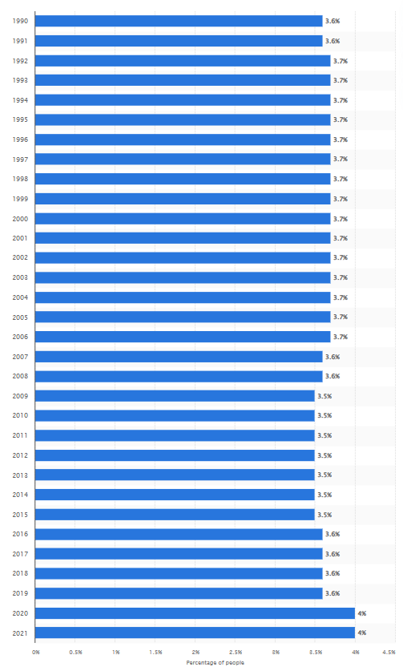
Figure: Percentage of people worldwide who suffered from depressive disorders from 1990 to 2021
Source: (Stewart, 2024)

Appendix 2

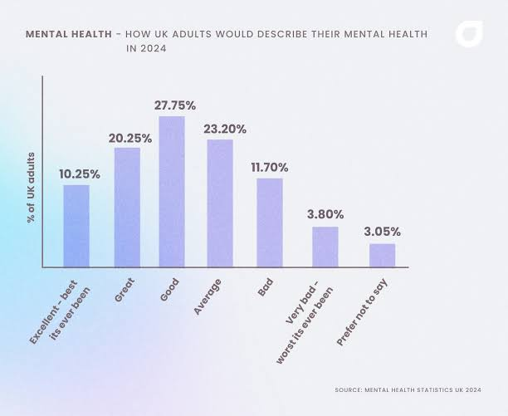
Figure: Mental health statistics UK
Source: (Forth, 2024)

Appendix 3
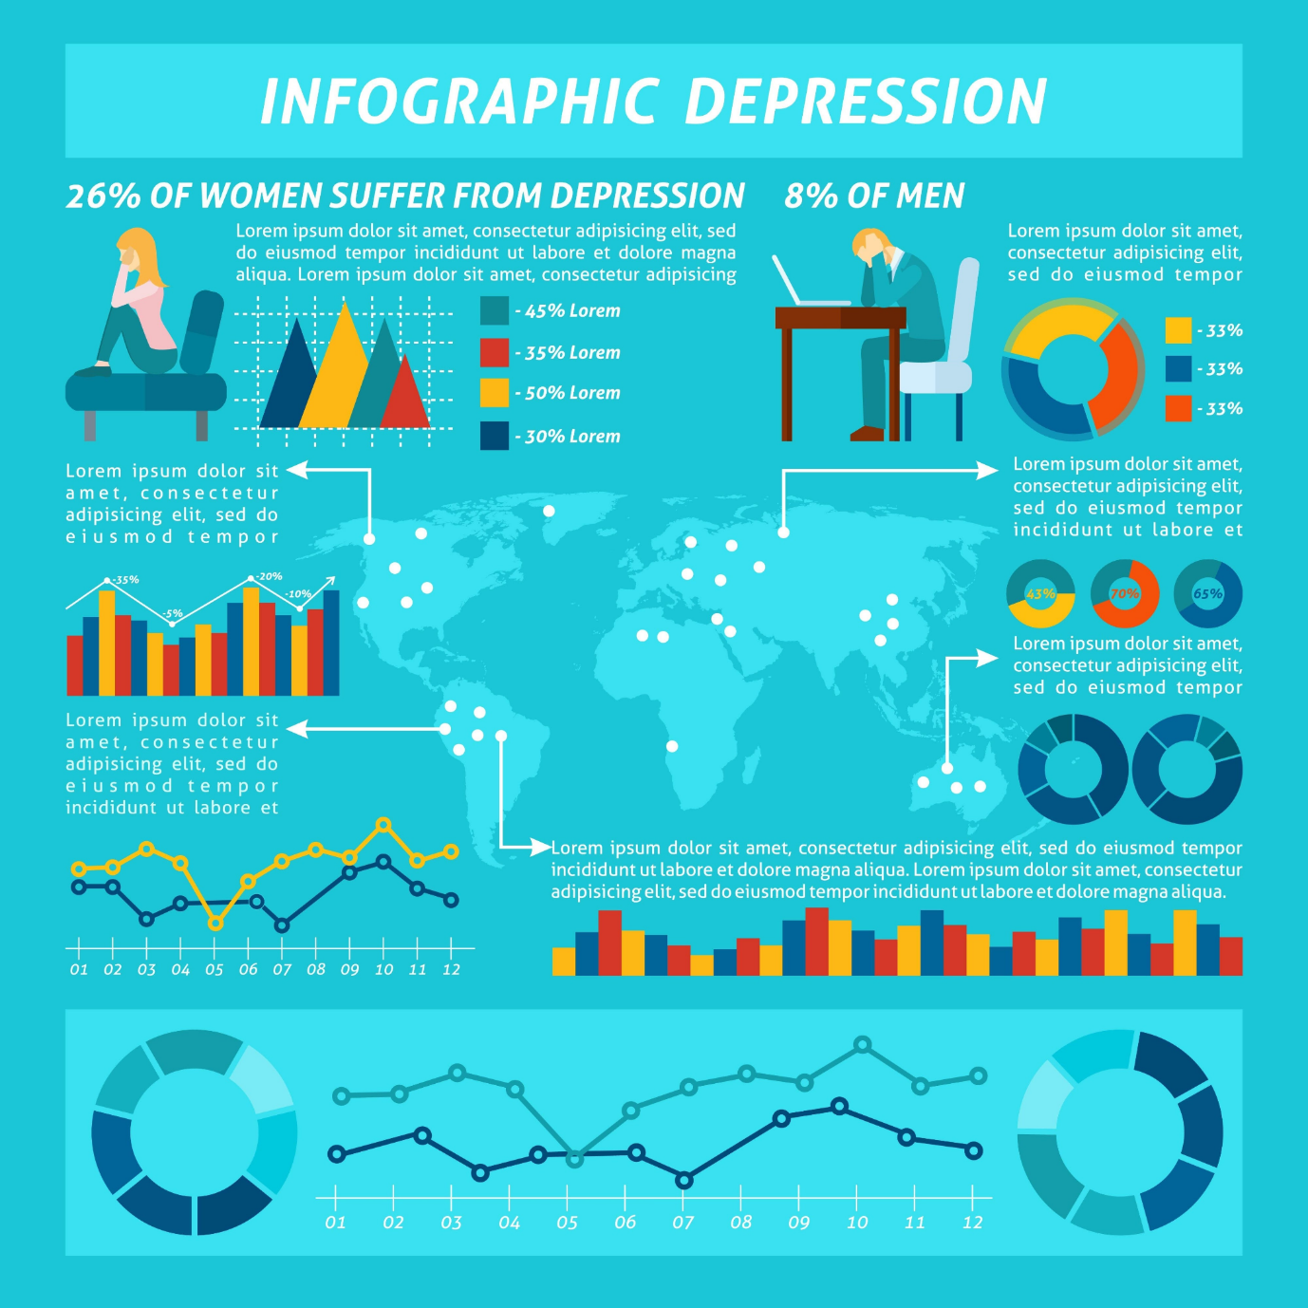
Figure: Infographic Design of Depression

