Managing People
LCBB5004
Assessment 2

Zornitsa Karakitukova
1922160

Lecturer: Charles Oham

Table of Contents
1. Introduction 3
2. Concept and drivers of employee engagement 4
2.1 Employee engagement 4
2.2 Drivers of employee engagement 4
3. Diagnostic tools to measure engagement 6
4. Employee value proposition 8
4.1 Value proposition 8
4.2 Strategies to raise levels of engagement 9
5. Conclusion 10
References 11

1. Introduction
Employee engagement makes sure that the employees of an organization has utmost dedication level and there are a lot of drivers which are connected with the issues. The way they will be working for their company will surely help to make a difference on company performance. Leadership styles are well connected with employees’ engagement because democratic leadership involves a lot of peoples on the processes of decision making. When employees are well connected and interconnected with leadership, it creates an effective kind of dynamics.
With better learning and development chances, an organization can create a chance for personal improvement. It makes the employees even more supportive, engaging, and interactive. In this case, the employees are connected with the workplace environment and survey helps to understand their own perspectives. On the other side, democratic leadership is also responsible for making impact on the roles of employees. It can assist to focus on the dynamics related issues. Another important driver of the employee engagement is the company values and effective employee engagement can be secured on the processes of operations.

2. Concept and drivers of employee engagement

2.1 Employee engagement
Employee engagement is a very important concept for an organization and it can improve the performance of the organization in creative manner. Here, employee engagement makes sure that the employees of an organization has utmost enthusiasm and dedication level. It is expected that employees who are enthusiast about the works will be able to perform for the company in a better manner (Shaw, 2017). The way they will be working for their company will surely help to make a difference on company performance. This is why, employee engagement is very important for an organization to perform better.

2.2 Drivers of employee engagement
There are a lot of drivers which are connected with the issues of employee engagement and other aspects. These drivers are useful to make sure that employees within an organization are being well engaged with each other. In this place, leadership trust is the first driver which can cause the employee engagement. Employees will only engage on organization if they feel that the leaders are supportive (Hughes et al., 2019). Leadership styles are well connected with employees’ engagement because democratic leadership involves a lot of peoples on the processes of decision making. On the other side, democratic leadership is also responsible for making impact on the roles of employees.
So, in this way, the leadership roles can be applicable on the employee engagement issues. In the similar way, the employee relationship issues are also very important in several cases. Here, if the employees are engaged with the leaders from various background, they can be successful at presenting a very important role. When employees are well connected and interconnected with leadership, it creates an effective kind of dynamics (Kusters et al., 2017). This is how, it can assist to focus on the dynamics related issues. As the result, it can help to bring the improvement on the employee engagement issues. These are the main drivers concerned about the employee engagement.
Alongside all these, a handful of learning and development opportunities are also provided to the employees. So, when these learning and development opportunities are provided to the employees, it can help to bring the aspects of employee engagement. With better learning and development chances, an organization can create a chance for personal improvement. In this way, the employee engagement can get better over the time (Levin and Levin, 2019). Another important driver of the employee engagement is the company values. If the company values are matching with the personal goals and objectives of the employees, it can easily support to bring proper level of engagement.
Company values will always have to be well aligned with the personal ideas of the employees. This is how, it can assist to bring changes on the ways of employee engagement. At the end, the proper feedback and employee appraisal will also be needed. When employees are provided with consistent feedback about their performance, they can be successful at understanding the gaps on the employees’ performance (Olander and Hurmelinna-Laukkanen, 2019). It makes the employees even more supportive, engaging, and interactive. As the result, effective employee engagement can be secured on the processes of operations. These are the key drivers which are concerned about the processes of the employee engagement related roles.

3. Diagnostic tools to measure engagement
To measure the level of engagement, a lot of diagnostic tools are available which can help to depend on various cases. Here, the diagnostic tools for measuring the employee engagements are very important. These diagnostic tools are given below:
Employee surveys: To measure the engagement level, there are various ways such as employment surveys. In the survey process, it becomes able to understand the employees’ performance. In this case, the employees are connected with the workplace environment and survey helps to understand their own perspectives (Psychogios and Prouska, 2019). This is how, it can support to understand the ways in which employees are engaged. It shows the ways of measuring engagement level on the operational performance. This is how, it can help to measure the performance related to the engagement.
HR software: HR software is another ways to understand the level of employee engagement. With the support of the HR software, it becomes very easy to track the working time, productivity, retention, and other level of the employees. In this way, it can easily assist to measure the total level of the interaction. This kind of interaction can assist to find the ways in which the employees are engaged with each other (Cerdin and Brewster, 2018). As the result, HR software can help to measure the overall engagement roles on the processes.
Exit interviews: Exit interview is a kind of survey which helps to understand the employer about the perspectives of employees when they are leaving the job. With the assistance of exit interviews, employers can understand the key reasons of leaving a particular job (Bentley and Penman, 2017). In the similar way, it can also help to deal with ideas about the customer interaction and other processes. This is why, the exit interviews are used as very important tool for measuring the employee engagement, and other aspects.
Employee lifecycle: Employee lifecycle is deemed as a very important tool which helps to understand the phases of the employees’ life. It is very vital and necessary for employers to focus on the lifecycle issues. Depending on these discussion about employees’ lifecycle, employers can easily identify the decisions about the employment roles (Nahavandi, 2021). On the other side, it can also assist to make sure that the employees are being interconnected with each other. As the result, it can improve the knowledge about the engagement related issues.
Productivity metrics and retention rate: Productivity metrics can also be used to measure the ways in which employees are performing for the organization. All of these productivity metrics are assisting to make sure that the performance level of the employees can be measured. If the retention rate of the employees is low, it can be said that the organization is creating employee engagement effectively (Bentley and Penman, 2017). This is how, it can support to ways of measuring the engagement roles and responsibilities from different aspects.
These are the tools of the level of measuring employee engagement.

4. Employee value proposition

4.1 Value proposition
Employee value proposition is always important for an organization different manner. In order to create a proper level of employee value proposition, an organization is required to create the brand reputation. With the support of effective brand reputation, an organization can create a good name for their organization. So, this can assist to bring a very strong range of reputation. On another side, the value proposition can be created with the help of value involvement as well (Keene and Stelson, 2017). When the proper values are involved within the operational processes, it can assist an organization to build an effective working structure.
This effective working structure can be supportive for handling and managing the necessary purposes. In this way, the value proposition will be created for the employees in significant manner. There are different processes and governance which can help employees to perform significantly. So, employee value proposition makes sure that these process of governance are being well considered. It helps to create a proper level of control for the employees where they can be a part of the organization (Bentley and Penman, 2017). It creates a proper plan for employment orientation to make positive impact on the organizational operations. This is how, employee value proposition can be successfully created in an organization.
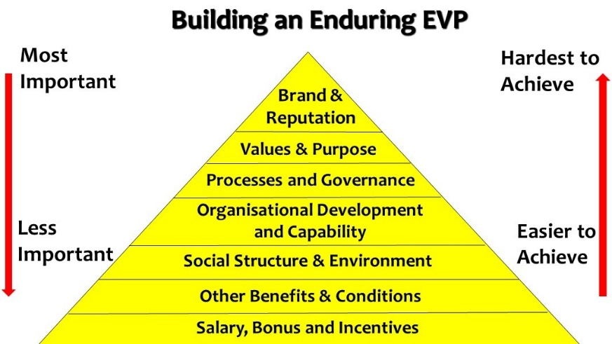
Figure: Employees value proposition (Nahavandi, 2021)
Organizational capability and development chances can also increase the level of value creation for the employees. In the employees’ value creation mode, an organization can become very much successful at dealing with the capability of the processes. If the organizational capabilities are well, it can help to create more values for the operational performance. In the long run, it can assist to focus on the employees’ value proposition related procedures. A proper social structure and environment is necessary for to create the proper value for the employees (Cerdin and Brewster, 2018). To make a value proposition condition successful, an organization will need to be careful about the social structure, and environmental issues and aspects.
On another side, different benefits and conditions are also provided to the employees to create a proper condition of employee value proposition. When the value proposition has been successfully administered, employees can get the effective necessary benefits from their organization. Overall, it assists to make a proper environment which can assist the organization in effective manner. Following this, salary, bonus, and other incentives are also the source of value proposition (Psychogios and Prouska, 2019). This kind of value proposition for the employees can easily assist to create an effective environment for working. As the result, a perfect and proper value proposition can be administered within an organization.

4.2 Strategies to raise levels of engagement
There are various strategies which are connected with the issues associated with the employee engagement. These strategies are:
- With better level of employee engagement, an organization can secure a very positive performance. At the first place, feedback will have to be prioritised within the organization.
- With the better kind of feedback management, organization can pave the paths for the proper kind of employee development. Also, it can also assist to improve the employee engagement level within an organization (Hughes et al., 2019).
- On the other side, organization will also need to prioritize the mental health of the employees. If the mental health of the employees is better, it can definitely bring positive impact on the performance.
- Better employee engagement will need to be administered with the reward management and other issues. Here, reward management can assist to make sure that the employees are well organized and connected.
So, these strategies will surely bring improvement on the processes of employee engagement.

5. Conclusion
If the company values are matching with the personal goals and objectives of the employees, it can easily support to bring proper level of engagement. It is expected that employees who are enthusiast about the works will be able to perform for the company in a better manner. When employees are provided with consistent feedback about their performance, they can be successful at understanding the gaps on the employees’ performance.
Leadership styles are well connected with employees’ engagement because democratic leadership involves a lot of peoples on the processes of decision making. Here, if the employees are engaged with the leaders from various background, they can be successful at presenting a very important role. Depending on these discussion about employees’ lifecycle, employers can easily identify the decisions about the employment roles. With the assistance of exit interviews, employers can understand the key reasons of leaving a particular job.

References
Bentley, P. D., and Penman, T. D. (2017). Is there an inherent conflict in managing fire for people and conservation?. International Journal of Wildland Fire, 26(6), 455-468.
Cerdin, J. L., and Brewster, C. (2018). HRM in Mission Driven Organizations: Managing People in the Not for Profit Sector.
Hughes, C., Robert, L., Frady, K., and Arroyos, A. (2019). Managing people and technology in the workplace. In Managing technology and middle-and low-skilled employees. Emerald Publishing Limited.
Keene, B., and Stelson, U. M. (2017). Managing People as a Leader. In Encyclopedia of Strategic Leadership and Management (pp. 965-976). IGI Global.
Kusters, C. S. L., Batjes, K., Wigboldus, S. A., Brouwers, J. H. A. M., and Baguma, S. D. (2017). managing for sustainable development impact. Wageningen Centre for Development Innovation, Wageningen University and Research.
Levin, S. P., and Levin, M. (2019). Managing Ideas, People, and Projects: Organizational Tools and Strategies for Researchers. Iscience, 20, 278-291.
Nahavandi, A. (2021). The Cultural Mindset: Managing People Across Cultures. SAGE Publications.
Olander, H., and Hurmelinna-Laukkanen, P. (2019). Introduction to managing people for technological innovation.
Psychogios, A., and Prouska, R. (2019). Managing people in small and medium enterprises in turbulent contexts. Routledge.
Shaw, D. (2017). Managing people and learning in organisational change projects. Journal of Organizational Change Management.

