Stanislav Krastev Student ID:2017885 Cloud Computing

Data Analysis and Visualization

Assessment 1 Submission Date:06/08/2021

Table of contents

Introduction. 3
What is infographic? 3
1.The message from the poster: 5
2.Colour usage: 5
3.Text usage: 5
4.Usage of appropriate graphs and charts: 5
5.Graph’s usage: 5
6.User-friendliness. 5
7.Suggestions for improvements 6
Conclusion. 15

Introduction.
The report needs a systematic approach, positive and negative aspects on the impact of Covid-19 occurs in the various types of business. Therefore, all of the types of infographics and the presenting method will be draft throughout the report. Finally, a conclusion will be draft on how the supplied data and information will be systematical.

What is an infographic?
It only fits that we start with a definition of what infographics are. A visual depiction of facts, knowledge, or information is what an infographic is by definition. Thus, the term infographic comprises two words: "information" and "graphic."
They are helpful as a visual way to communicate because they improve the human eye's capacity to identify trends and patterns, making complicated ideas more straightforward to recall.
Infographics tell a narrative, but they also organize data and make it easier to understand for the viewer. That is because, no matter how much information you are showing, it can dispatch into images, graphs, or other visual components, with only a few lines of text. Therefore, infographics are a fun and fast method to learn about a subject without reading a lot of text. Infographics and data visualizations come in a variety of forms. They are used to communicate complex information clearly and concisely. We have various infographics such as Visual, list infographics, map infographic, comparison, flow-chart infographics, data visualization and statistical like in our case. The ultimate objective of any infographics is to create shareable visual material. Infographics are a considerable amount of data present by simplest way increasing or decreasing on different types of business sectors, representing clear view on facts. That can include various types of data and graphics for simple human understanding [4].
Impact of Infographics on data analysis decisions making process.
First, we need to set clear goals that will be achievable through this mode of communication.
Identify the cause of the problem.
Data scarcity is not an issue for most companies and government organizations. There is frequently too much information accessible to make an informed judgement.
In a nutshell, you require improved data analysis of what was previously an overwhelming number of diverse information, becoming a simple, unambiguous decision point with the appropriate data analysis methodology and tools.
Infographics are the most recent advancements in assisting organizations in conveying complicated content via a combination of data and images. That provides for efficient external and internal communication, depending on the demands of your clients, workers or needs [2].

1.The message from the poster: trying to understand better the impact of Covid-19 on various types of business and sectors. Unfortunately, most infographics used an appropriate and systematic approach.
2.Colour usage: In this aspect have so much to improve in all Infographics on word documents are used the same spectrum with just a few colours. They are different for recognised from people with eyesight issues and feel the reduced capacity of their eyesight. In this aspect has been improved colour spectrum with more visible and adaptive colours. The colours you choose for your infographic allow you to draw attention to distinct data sets and their relationships. Finally, the colour combination you choose might affect your infographic's readability and overall reader experience [1].
3.Text usage: Most texts in infographics misused words and sentences, which do not give a transparent image of the data. However, in all of the charts missing the period or real-time (for example, which year or month), this impacts various types of businesspeople (viewers should know more about this because Covid-19 period is not only one year. Moreover, critical text information is missing or incorrect present in infographics. Also are used too many font types, almost half of the infographics. For example, every topic is in a different font. That is unnecessary. Font size is too small should be more visible and increased [6].
4.Usage of appropriate graphs and charts: They are different types such as Bar charts, Pie charts, Histogram, Line graphs, Scatter plots; After analyzing was found there is not used appropriate graphs and charts for most of the infographics. They didn't connect to the content of data information. Difficult for viewers to understand the message behind the graphs [5].
5. Graph's usage: When exploring those graphs, the standardized approach does not present the data. However, it implemented the most standard method for evaluating invisible data and their improvements and highlighting [5].
6.User-friendliness. Businesses require analytics, the excellent data necessary to make sound business decisions. Opinions, hunches, and gut sensations are no longer sufficient. Unfortunately, in those infographics, the present information is relatively small. The contents are not very clear. Part of them has a misunderstanding. If you don't have good content, you cannot make good decisions [3].
7.Suggestions for improvements are on (fig.1-fig.14)
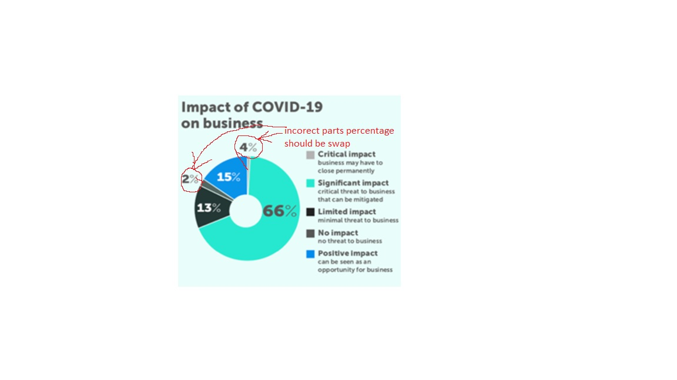
Fig.1

My suggestion for more suitable Infographic.

Fig.2
In the first infographic, my suggestion is to improve vision with a different spectrum of colours to be more eyesight comfortable. That is urgent because it will be difficult to recognize people with eyesight issues.
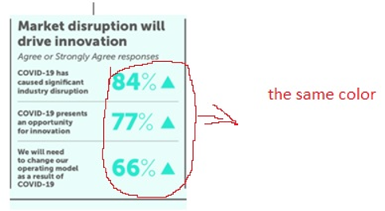
The second improvement is font size. Should be increased to comfortable for people with eyesight issue difficulties, wear glasses, people, to recognized, also

Fig.3

My suggestion for Infographics.

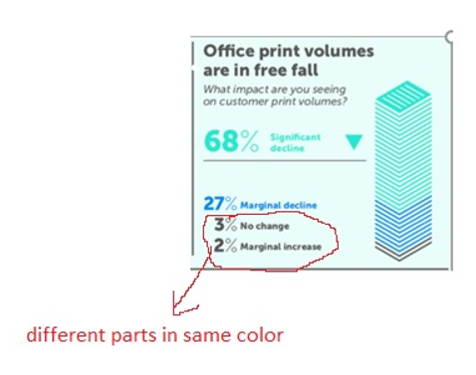
Fig.4
Fig.5

My suggestion for Infographics.
That is a picture of the moment situation during the Covid-19 impact on business. More than 2/3 are the significant decline of crisis. Just 5% of overall are for No change, and marginal increase and this is collapse for Industry for that period.

Fig.6

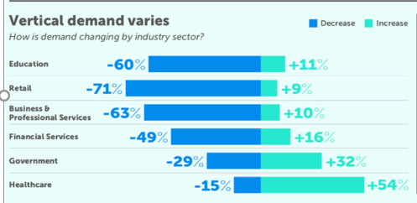

Fig.7
My suggestion for more suitable infographic.
Fig.8
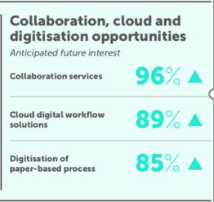

Fig.9

My suggestion for more suitable infographic.
Fig.10

Fig.11 Show as how never been present on this way. Same chart colors as well and percentage is the same color. This is very difficult recognized Infographic.
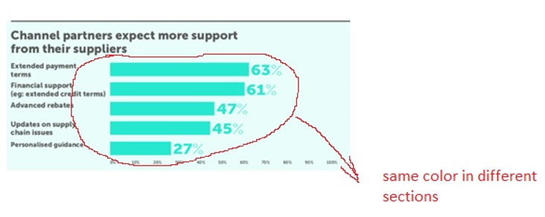
Fig.11

My suggestion for more suitable infographic.
Fig.12
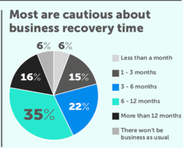
Fig.13

My suggestion for more appropriate Infographic.

Fig.14

Conclusion.
In the future, data visualization and infographics will be going in another direction and more valuable. For example, business companies use infographics for decision-making processes and drawing better perspectives for their issues, customers, targets. The final stage in data analysis is effective data visualization. It is possible that vital ideas and messages may be missed without it. Data visualization is important to Import.io, which is why it's included in our Web Data Integration solution.

Reference list

[1]K. Tomboc, “7 Quick Tips in Picking the Perfect Color Combination for Your Infographics,” Simple Infographic Maker Tool by Easelly, Aug. 07, 2019. https://www.easel.ly/blog/tips-picking-colors-infographic/ (accessed Jul. 26, 2021).
[2]
J. Lankow, J. Ritchie, and R. Crooks, Infographics: The Power of Visual Storytelling. John Wiley & Sons, 2012.
[3]
P. Trujillo, “Look for These 7 User-Friendly Features in Asset Management Software [Infographic],” Business 2 Community, Apr. 25, 2016. https://www.business2community.com/infographics/look-7-user-friendly-features-asset-management-software-infographic-01521954 (accessed Jul. 29, 2021).
[4]
J. Rose, “What are Infographics and Why are They Important?,” Post Infographics:, Jul. 23, 2020. https://www.postinfographics.com/what-are-infographics-and-why-are-they-important/ (accessed Aug. 01, 2021).
[5]
S. Valcheva, “Types of Graphs and Charts and Their Uses: with Examples and Pics,” Blog For Data-Driven Business, Dec. 05, 2017. https://www.intellspot.com/types-graphs-charts/ (accessed Jul. 30, 2021).
[6]
J. McCoy, “How to Write Great Content for Your Infographics,” Express Writers, Feb. 26, 2014. https://expresswriters.com/how-to-write-great-content-infographics/ (accessed Aug. 01, 2021).

