

“The Impact of e-Commerce on Small Retail Businesses in Basildon Borough”

Dissertation – Proposal
Module Code: LCBB6000
BA (Hons) Business Management
University of Wales Trinity Saint David (London Campus)

Student: Stefan Gheorghe (2024473)
Supervisor lecturer: Dr Anupam Mazumdar
Submission date: 30.08.2023

Table of Contents
Chapter 1 Introduction 3
1.1 Introduction 3
1.2 Origin of the Study 3
1.3 Background of the Study 3
1.4 Problem Statement 4
1.5 Aim of the Study 4
1.6 Objectives of the Study 4
1.7 Research Question 4
1.8 Significance of the Study 5
1.9 Scope and Limitations of the Study 5
1.10 Outline of the Study 5
1.11 Conclusion 6
Chapter 2 Literature Review 6
2.1 Defining the terms of the topic 6
2.2 Challenges of E-commerce 7
Chapter 3 Research Methods and Methodology 7
3.1 Introduction 7
3.2 Research Philosophy 8
3.3 Research Paradigm 8
3.4 Research Approach 8
3.5 Research Methods 9
3.6 Research Strategy 9
3.7 Time Horizon 9
3.8 Sampling Technique 9
3.8.1 Sampling Size 9
3.8.2 Data Collection Method 10
3.9 Data Analysis 10
3.10 Research Ethics 10
3.11 Timeline 10
Chapter 4 Conclusion 11
Chapter 5 References 13

Chapter 1 Introduction

1.1 Introduction
The rise of online shopping has brought about a change in the retail industry, opening up unprecedented possibilities for businesses to connect with customers worldwide (Laudon & Traver, 2018). However, there is still much to explore in regard to understanding how this digital transformation affects retailers in places like Basildon Borough, UK. This study aims to bridge that gap by focusing on the experiences and adaptations of retailers in Basildon Borough as they navigate the e-commerce explosion. By examining the challenges and opportunities that arise from embracing e-commerce, the researcher aims to gain insights that can guide strategies for small retail businesses looking to thrive in the local and global marketplace.

1.2 Origin of the Study
As markets continue to evolve dynamically and technology advances rapidly, implementing e-commerce has become necessary for small companies (Nazir & Khan, 2022). What was once a process predominantly understood and adopted by larger companies is now becoming a noticeable trend among smaller enterprises, especially since the Covid-19 pandemic (Enwereji, 2022).
As a student in business and management, I have always been intrigued by the intersection of technology and commerce. My previous work environment and some of the courses taken at the university sparked a curiosity about how online platforms are reshaping the traditional retail landscape. During the past few years, I observed some of the challenges and opportunities that e-commerce presented to local retailers in Basildon Borough. This experience ignited a personal interest in exploring the impact of e-commerce on small retail businesses, particularly in the context of a specific region where I have lived for the past six years, like Basildon Borough, UK.
The contemporary relevance of e-commerce further reinforced the decision to pursue this research topic. In the past few years, and particularly amid the COVID-19 pandemic, there has been a significant rise in online shopping, which has now become a crucial aspect of consumer habits. This shift towards digital channels has profound implications for small retail businesses, which often struggle to compete with larger online retailers. As a student keenly aware of current market trends and the importance of timely research, I recognised that this topic offered an opportunity to contribute valuable insights to an area of study that is both urgent and highly relevant. The focus on Basildon Borough, UK, with its unique blend of traditional retail and emerging e-commerce practices, added a layer of specificity and local relevance to the research.

1.3 Background of the Study
The digital revolution has significantly reshaped the retail landscape, with e-commerce emerging as a player in the market. The e-commerce industry has experienced significant growth in the past years in the United Kingdom, with online revenue sales projected to reach $143.9 billion in 2023 and a further forecasted increase to $194.1 billion by 2027 (Statista, 2023). This shift towards digital channels has been driven by technological advancements and changes in consumer behaviour as more people seek out the convenience and variety offered by online shopping (Badircean et al., 2021).
However, it is important to recognise that the impact of e-commerce on businesses is multifaceted and intricate. While there are opportunities for market expansion and increased sales through e-commerce platforms, challenges like cybersecurity, order fulfilment and increased competition are also involved. Small businesses frequently face challenges when competing with established e-commerce platforms. This can be attributed to their resource constraints and lack of know-how (Markowska et al., 2023).
In Basildon Borough, a region known for its mix of retail businesses, the implication of e-commerce holds significant importance. While online shopping has gained popularity worldwide, the unique experiences and obstacles retailers face in this area have not been thoroughly investigated. This study aims to bridge this gap by conducting research on how e-commerce affects retail businesses in Basildon Borough, UK.

1.4 Problem Statement
The emergence of e-commerce has completely changed the way we shop, offering us options and a wide range of choices. However, while big retail giants like Amazon and eBay have successfully adapted to this digital era, small businesses in regions like Basildon Borough, UK, encounter their own unique set of challenges. The rapid growth of online shopping platforms has raised concerns about the survival and competitiveness of these businesses. It is crucial to examine the obstacles they face, how they adapt to the e-commerce landscape, and how this affects their sales, customer base and overall performance.

1.5 Aim of the Study
The aim of this study is to examine various impacts of e-commerce on small retail businesses in Basildon Borough, UK.

1.6 Objectives of the Study
The objectives of this study are:
- To understand the context of Basildon borough's e-commerce and small retail businesses.
- To identify issues and challenges e-commerce brought to small retail businesses in this area.
- To analyse the impact of e-commerce adoption in small retail businesses in Basildon borough.
- To propose strategies that can address and improve the challenges posed by e-commerce.

1.7 Research Question
The following research question has been set for this study:
“How do small retail businesses perceive and respond to the opportunities and threats of e-commerce in Basildon Borough, UK?”

1.8 Significance of the Study
The importance of this research lies in its potential to enhance our knowledge about the impact of e-commerce on small retail businesses, which is an increasingly important topic in today’s digital era. While many studies have been made in the pursuit of exploring the effects of e-commerce on the industry, there is a lack of research specifically focusing on local retail businesses like those in Basildon Borough, UK.
By investigating how small retail businesses in Basildon Borough, UK, have adapted and responded to the rise of e-commerce, this study can provide insights to help these businesses further thrive in the marketplace. The findings from this study could be particularly beneficial for business owners, policymakers, and other stakeholders interested in supporting the growth and sustainability of small retail enterprises amidst digital transformation. Moreover, by examining a context, this research contributes to our understanding of how global e-commerce trends manifest at a local level. This adds a dimension to the existing literature on e-commerce and its impact on the retail sector.

1.9 Scope and Limitations of the Study
This research focuses on businesses operating within Basildon Borough, UK. Its main objective is to explore how e-commerce affects these businesses by examining its opportunities and challenges, the strategies they employ to adapt to the e-commerce landscape, and how e-commerce impacts their sales, customer base and overall performance. Additionally, based on its findings, this study will offer recommendations for these businesses to navigate the world of e-commerce.
However, it is important to acknowledge some limitations of this study. Firstly, its geographical scope is limited to Basildon Borough, which may reduce the applicability of its findings to regions or countries. Secondly, since this study relies on data and resources, it may not fully capture all the intricacies and complexities associated with how e-commerce affects retail businesses. Lastly, capturing up-to-date information may be challenging, given the changing nature of e-commerce trends and practices.

1.10 Outline of the Study
To accomplish this research, we will undertake the following tasks:
Chapter 1 Introduction will present the origin and background of this study, as well as the research aim, objectives, and research question. It will also underline the importance of the study and the scope and limitations of it.
Chapter 2 Literature Review will define the terms of the research topic and present some issues and challenges in the process of e-commerce adoption highlighted by previous research papers.
Chapter 3 Research Methods and Methodologies will highlight the steps taken to achieve the study objectives. A detailed map of the research process will be presented here, as well as a timeline in the form of a Gantt Chart.
Chapter 4 Conclusion will briefly end this research proposal, highlighting the importance of the research.

1.11 Conclusion
The rise of online shopping has impacted how small businesses operate in the retail industry. This research aims to examine how e-commerce has affected businesses in Basildon Borough. It will focus on the opportunities and challenges brought about by e-commerce, the strategies these businesses employ to adapt to the environment, and how e-commerce has influenced their sales, customer base and overall performance.
This study aims to contribute insights into the experiences and adaptations of retail businesses in Basildon Borough during the digital shopping explosion. The findings could help develop strategies to support businesses in this era of technology.

Chapter 2 Literature Review

2.1 Defining the terms of the topic
Electronic commerce has captured the attention of researchers and industry professionals due to its influence on how businesses function and consumers engage in shopping. Over the years, multiple definitions have been put forward to explain the meaning and scope of e-commerce. Becker (2008) defines e-commerce as the electronic communication transactions of goods and services and makes a distinction between two basic types of e-commerce in the form of business-to-customer (B2C) and business-to-business (B2B). Caffey (2011, p. 10) defines e-commerce as “all electronically mediated information exchanges between an organization and its external stakeholders”. This statement emphasises the role of digital tools in facilitating communication between an organisation and its associated parties. It emphasises a two-way dynamic interaction where information is not just disseminated and received. "Electronically mediated" highlights a shift from traditional communication methods to modern digital channels. Meanwhile, "external stakeholders" signifies a broad spectrum of entities, from customers to investors, emphasising the organisation's need for transparency and open dialogue with those invested in its operations.
The foundation of the United Kingdom's economy lies in its small businesses, which play a substantial role in fostering innovation, generating employment opportunities, and making valuable contributions to the overall National Gross Domestic Product (GDP). These businesses make up the majority of all companies in the country and operate across industries such as retail, hospitality, technology, and manufacturing. What sets them apart is their ability to quickly adapt to market changes and provide tailored solutions for niche markets. As the UK faces challenges and opportunities in a post-Brexit era, it is crucial to recognise that the resilience and dynamism of small businesses are essential for its economic growth and overall prosperity. In the UK, most organisations are registered as small companies (0-49 employees), corresponding to 99.2% of the total business population. These companies provide employment for 12.9 million active people (48% of the total) and have a turnover of £1.4 trillion (34% of the total) (Department for Business, Energy, and Industrial Strategy, 2022).
In the UK, the retail sector spans an array of businesses ranging from brick-and-mortar stores to cutting-edge online marketplaces. It plays a crucial role in driving economic growth and offering consumers many choices. According to Hutton (2021, p. 5) “the retail sector includes any business or individual involved with selling products directly to consumers. The retail sector includes shops, department stores, supermarkets, market stalls, door-to-door sales, and internet retailers”. Positioned at the centre of trade and consumer activity, the retail industry in the UK has consistently transformed itself to align with changing consumer preferences and shifts in the global economic landscape.

2.2 Challenges of E-commerce
The emergence of e-commerce has revolutionized the operational landscape for businesses and revolutionized consumers' shopping habits, providing convenience along with an extensive range of purchasing alternatives. However, this digital revolution has also brought about cybersecurity challenges. Since e-commerce platforms handle large volumes of data, such, as personal information, and financial details they have become attractive targets for cybercriminals (Sriram & Rao, 2021). Concerns like data breaches, identity theft and fraudulent transactions are causing both businesses and consumers to worry. The fear of these cyber threats can discourage customers from embracing shopping due to concerns, about their personal and financial information being compromised. For businesses even a single security breach can lead to losses while also damaging their reputation and eroding customer trust (Xiang et al., 2022).
In the changing world of online shopping small retail businesses are facing intense competition from retail industry giants such as Amazon and eBay. These massive e-commerce platforms have resources that allows them to offer a range of products at highly competitive prices. This puts smaller retailers at a disadvantage as they do not have the economies of scale. Moreover, when these small businesses try to make the shift from brick-and-mortar stores to platforms they face various constraints. They need to establish a presence, synchronize inventory across different channels and effectively handle customer interactions, on the internet. All these obstacles highlight the difficulties that small retailers face in today’s marketplace (Kumar et al., 2012).

Chapter 3 Research Methods and Methodology

3.1 Introduction
Saunders et al. (2019, p. 5) define research as “a process that is undertaken in a systematic way with a clear purpose, to find things out”, emphasising the structured nature of research. By highlighting its "systematic" approach, it underscores the methodical and organised methodologies essential for ensuring validity. The mention of a "clear purpose" indicates that specific objectives, not mere curiosity, always drive research. Ultimately, the phrase "to find things out" captures research's core goal: the pursuit of knowledge and discovery, making it a deliberate and purposeful endeavour.
Conducting structured research can be done with the help of the research “onion” (Fig.1 below), which provides the researcher with systematic steps that must be followed to build an effective approach (Saunders et al., 2019). This framework contains six layers which should be uncovered before arriving at the centre of it, where data collection and data analysis is located.

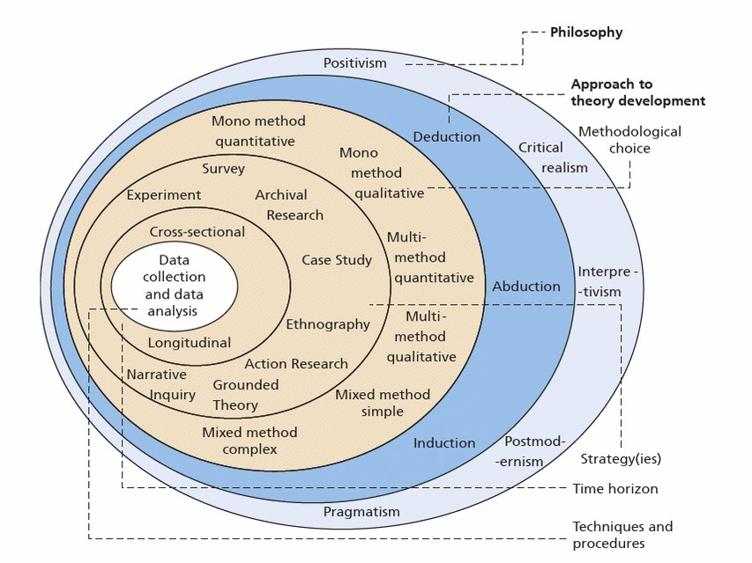

Fig.1 The Research Onion (Source: (Saunders et al., 2019))

3.2 Research Philosophy
Epistemology explores the essence of knowledge, its origins and how we acquire understanding or conviction. In research, epistemology philosophy shapes perspectives on what constitutes evidence and how to collect information. It serves as a set of principles or standards for determining what qualifies as knowledge within a study (O'Gorman & MacIntosh, 2015). For this research, epistemology philosophy was chosen because of the belief that knowledge and evidence about the impact of e-commerce on small retail businesses can be obtained through observable phenomena.

3.3 Research Paradigm
The research paradigm chosen for this research is interpretivism which seeks deep, qualitative insights into human behaviour and experiences. By choosing this paradigm, the researcher aims to delve deep into the experiences of small retail business representatives, understanding their motivations, challenges, and perspectives regarding e-commerce adoption (O'Gorman & MacIntosh, 2015).

3.4 Research Approach
The inductive research approach, which has been chosen for this research, involves generating a theory as a result of observing and analysing specific data or phenomena. It starts with specific observations or real examples of events, trends, or social processes and then moves to the general, culminating in formulating a general theory or conclusion. It is a bottom-up approach where patterns, themes, or generalisations are derived from the data (Saunders et al., 2019). This approach was chosen because it offers the flexibility to delve deeply into the localized experiences and perceptions of small retail business representatives in Basildon Borough, UK. By allowing data to guide the research, it ensures a context-specific, holistic understanding of the phenomenon. Moreover, the inductive method facilitates the generation of new theories or models grounded in actual data, capturing the nuanced impact of e-commerce on these businesses.

3.5 Research Methods
Qualitative research examines phenomena in real-world contexts focusing on understanding and interpreting the meanings, concepts, characteristics, processes, and descriptions of experiences using non-numerical data (Saunders et al., 2019). By choosing the mono-method qualitative research, the researcher aims for a comprehensive, in-depth, and context-specific exploration of the multifaceted impact of e-commerce on small retail businesses, capturing the richness of human experiences and interpretations.

3.6 Research Strategy
Saunders et al. (2019, p. 189) states that “a research strategy may therefore be defined as a plan of how a researcher will go about answering her or his research question”. For this study, the researcher chose the exploratory narrative research strategy which tries to capture the intricate perceptions of individuals, making it ideal for understanding the nuanced experiences of Basildon's retail businesses. Considering the relationship between e-commerce and small enterprises, narrative research offers a comprehensive perspective, taking both the opportunities and obstacles encountered. The exploratory nature of the strategy permits an in-depth exploration free from biases, possibly revealing unforeseen trends and suggesting new research directions. By valuing the genuine perspectives of business representatives, this method ensures that the stories align with the actual hopes and difficulties faced by Basildon's small businesses.

3.7 Time Horizon
The time horizon for this research will be cross-sectional, which usually involves the study of a particular phenomenon at a specific time. The researcher chose this because of the time constraint necessary to conduct the research and the particular point in time when it needs to be completed, which extends to the length of ten weeks (Saunders et al., 2019).

3.8 Sampling Technique
Non-probability purposive sampling, or purposive sampling, is a technique in which the researcher relies on its judgment to select specific individuals or items from a population that they believe are representative or particularly relevant to the research topic (Saunders et al., 2019). Homogeneous sampling is a subtype of purposive sampling where the researcher selects a subgroup of individuals or items that share the same or similar characteristics or traits. The goal is to study the subgroup in-depth, reducing variation and focusing on specific shared attributes (Saunders et al., 2019). The researcher has chosen the non-probability purposive homogeneous sampling in studying the impact of e-commerce on small retail businesses due to the focus of the study and the targeting of a specific subgroup with shared characteristics, which allows for better insights and understanding.

3.8.1 Sampling Size
The primary objective of this research is to delve deeply into the experiences, challenges, and perspectives of small retail businesses in Basildon borough, UK, concerning the rise of e-commerce. Given the qualitative nature of this study, the emphasis is on obtaining rich, detailed, and nuanced insights rather than generalisable quantitative data. In this pursuit, the researcher chose a sampling size that will range between 10 - 15 participants until data saturation is reached.

3.8.2 Data Collection Method
Due to the complexity of the topic and the variability of the sample's experiences, the researcher chose to collect data through semi-structured interviews, as this can provide flexibility, depth, adaptability, and personal interactions necessary to explore and understand the research objectives (O'Gorman & MacIntosh, 2015).

3.9 Data Analysis
Braun & Clarke (2006) state that “thematic analysis is a method for identifying, analysing, and reporting patterns (themes) within data”. The process entails scrutinizing datasets to recognize patterns and subsequently categorizing them into themes that encapsulate the core essence of the information. The researcher has chosen this approach because of its flexibility in identifying patterns and themes that capture the essence of how small retail businesses perceive and respond to e-commerce. Thematic analysis helps organise these narratives into themes ensuring that the collected data richness and nuances are maintained (Braun & Clarke, 2006). Additionally, as this topic explores both the opportunities and challenges presented by e-commerce, thematic analysis allows for an exploration of both positive and negative aspects providing a holistic understanding of the phenomenon, within Basildon Boroughs specific context.

3.10 Research Ethics
To guarantee that the ethical principles adhere to this study, the researcher will demonstrate integrity and fairness and will not be led by biased thinking in any aspect of this study. It will also not disclose any information to third parties about those participants involved in this research and will treat them in a respectful manner at all times. Participation in this study is voluntary, and informed consent will be taken in writing prior to any information disclosed. Withdrawal from the study is an unchallenged right that can be used anytime and without consequences.

3.11 Timeline
The timeline, provided in the form of a Gantt Chart, specifies each activity taken during the five-week supervisory period that the research proposal was expanding (Figure 2). A ten-week Gantt Chart is also available, which presents the activities undertaken for the completion of the research study (Figure 3). Adjustments can be made based on priorities and the feedback received throughout the research process.
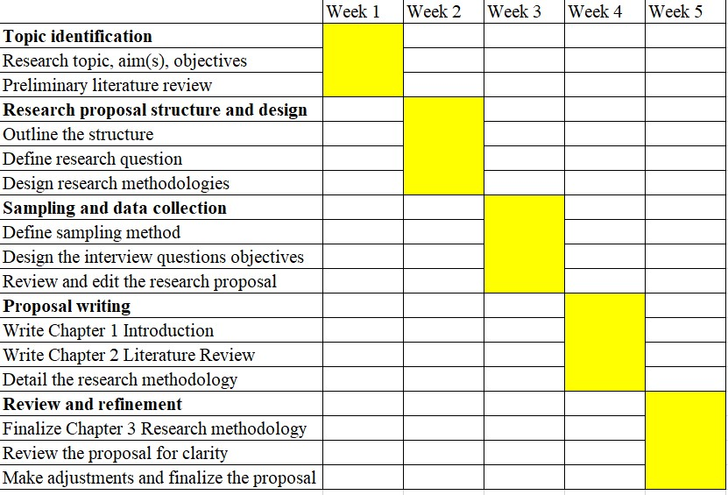
Fig.2 5-Week Gantt Chart
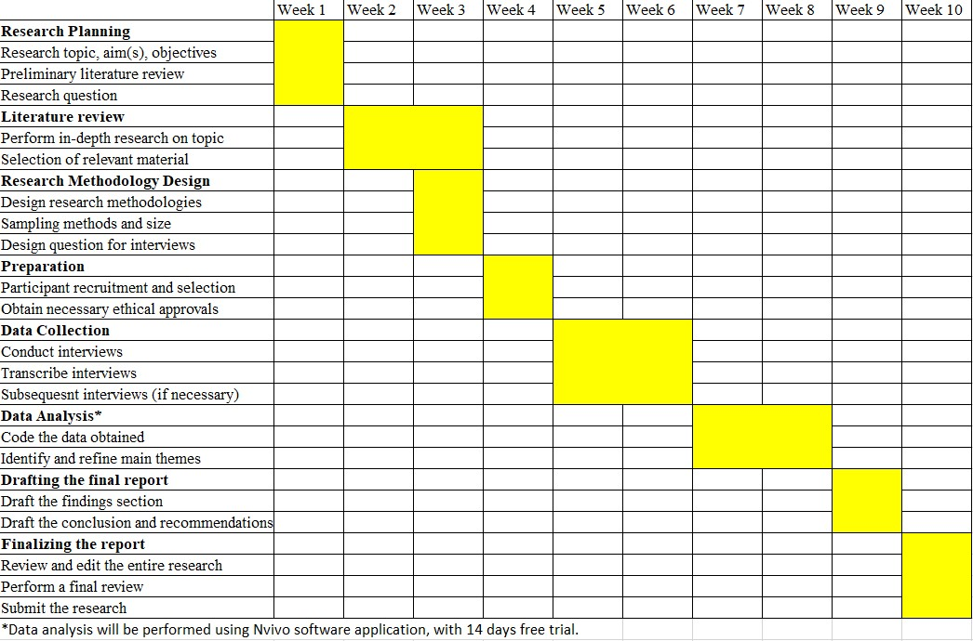
Fig.3 10-Week Gantt Chart

Chapter 4 Conclusion
The opening chapter sets the stage for an exploration of how e-commerce impacts small retail businesses, in Basildon Borough, UK. Acknowledging the influence of e-commerce in today’s business landscape, this research aims to understand its effects on small retailers within a localized context. The introduction chapter emphasizes the importance of this topic considering the digitization of commerce and the unique challenges and opportunities it brings for businesses. It outlines the objectives of the research focusing on one research question. Additionally, it briefly discusses why this research topic was chosen, highlighting both interest and its relevance in shaping business strategies and policy decisions not just for Basildon Borough, but also beyond. The literature review chapter starts by defining the key terms used in this research and continues with some challenges presented by e-commerce adoption. The methodological approach adopted for this research, specifically the exploratory narrative strategy, is important in ensuring an in-depth, participant-centric exploration. The inductive research approach will further anchor the study in the lived experiences of the future participants, ensuring empirical validity. Thematic analysis, as the chosen data analytical tool, will facilitate the extraction of relevant themes, providing a structured and nuanced understanding of the data.
In summary, as the digital commerce landscape perpetually evolves, adaptability remains paramount for all businesses, but is probably more relevant for small businesses. This research, through its location focused, accentuates the significance of context-specific studies in understanding broader commercial shifts. It is anticipated that the insights gathered here will contribute to both academic discourse and pragmatic strategies for businesses and policymakers in Basildon Borough, UK.

Chapter 5 References
Badircean, R. M. et al., 2021. E-Commerce and the Factors Affecting Its Development in the Age of Digital Technology: Empirical Evidence at EU–27 Level. Sustainability, 14(1), p. 101.
Becker, A. S., 2008. Electronic commerce concepts, methodologies, tools and applications. Hershey, PA: IGI Global.
Braun, V. & Clarke, V., 2006. Using thematic analysis in psychology. Qualitative Research in Psychology, 3(2), pp. 77-101.
Chaffey, D., 2011. E-business & e-commerce management : strategy, implementation and practice. 5th ed. s.l.:Pearson/Financial Times Prentice Hall.
Department for Business, Energy, and Industrial Strategy, 2022. Business population estimates for the UK and regions 2022: statistical release. [Online]
Available at: https://www.gov.uk/government/statistics/business-population-estimates-2022/business-population-estimates-for-the-uk-and-regions-2022-statistical-release-html#definitions-and-terminology
[Accessed 27 07 2023].
Enwereji, C., 2022. Impact of Covid-19 on SMMEs and the future sustainability measures: a systematic review. Holistica: Journal of Business & Public Administration, 13(2), pp. 111-131.
Hutton, G., 2021. Retail Sector in the UK. [Online]
Available at: https://researchbriefings.files.parliament.uk/documents/SN06186/SN06186.pdf
[Accessed 17 08 2023].
Kumar, S., Eidem, J. & Diana, N. P., 2012. Clash of the e-commerce titans. International Journal of Productivity and Performance Management, 61(7), pp. 805-830.
Laudon, K. C. & Traver, C. G., 2018. E-Commerce 2018: Business,Technology, Society. 14th ed. s.l.:Pearson.
Markowska, M., Marcinkowski, J., Kiba-Janiak, M. & Strahl, D., 2023. Rural E-Customers’ Preferences for Last Mile Delivery and Products Purchased via the Internet before and after the COVID-19 Pandemic. Journal of Theoretical and Applied Electronic Commerce Research, 18(1), pp. 597-614.
Nazir, A. M. & Khan, S. R., 2022. Dynamic contextual factors, individual agency and adoption of e-commerce in SMEs. Journal of Organisational Studies and Innovation, 9(4), pp. 1-23.
O'Gorman, K. & MacIntosh, R., 2015. Research Methods for Business and Management : A Guide to Writing Your Dissertation. 2nd ed. Oxford, England: Goodfellow Publishers Ltd..
Saunders, M., Lewis, P. & Thornhill, A., 2019. Research methods for business students. 8th ed. Harlow: Pearson.
Sriram, A. & Rao, A. P., 2021. Security Issues in E-Commerce. In: Research Anthology on E-Commerce Adoption, Models, and Applications for Modern Business. s.l.:IGI Global, pp. 53-81.
Statista, 2023. United Kingdom (UK): retail e-commerce revenue forecast from 2017 to 2027. [Online]
Available at: https://www.statista.com/forecasts/477091/e-commerce-revenue-forecast-in-the-united-kingdom
[Accessed 31 07 2023].
Xiang, L. et al., 2022. Cyber security threats: A never-ending challenge for e-commerce. Frontiers in Psycology, Volume 13.

