

Implementation of an Automated Soldering System to Reduce Misfiring in IPL Hair Removal Handsets

by
Ethan Longley

Supervisor: Stalin Jacob Wilson Packia Dhas
Second Marker: Jenifer Prince Devaraj

Project submitted as part of the requirements for the award of
BEng (Hons) Electrical and Electronics Engineering

April 2025
DECLARATION

I, Ethan John Lewis Longley declare that I am the sole author of this Project; that all references cited have been consulted; that I have conducted all work of which this is a record, and that the finished work lies within the prescribed word limits.

This work has not previously been accepted as part of any other degree submission.

FORM OF CONSENT

I, Ethan John Lewis Longley hereby consent that my Project, submitted in candidature for the BEng (Hons) Electrical and Electronics Engineering degree, if successful, may be made available for inter-library loan or photocopying (subject to the law of copyright), and that the title and abstract may be made available to outside organisations.

Abstract

This project investigates the integration of an automated soldering system into an existing production line to address issues associated with manual soldering, including process variability, misfiring, and lack of consistency. A refurbished soldering robot was implemented and integrated using a PLC-based control system, enabling synchronised operation with the conveyor and associated hardware. The system was designed to improve process reliability, reduce defects, and enhance production efficiency while maintaining compliance with industrial safety standards.

Testing and validation demonstrated significant improvements in system performance, including a reduction in cycle time from 31.9 seconds to 11.56 seconds and an 86% reduction in failure rate. The automated system also reduced manual intervention and improved overall product quality. These results confirm that the integration of automated soldering provides a robust and scalable solution for improving manufacturing efficiency and consistency in a production environment.

Contents
Abstract 3
Chapter 1: Introduction 7
1.1. Project Background 7
1.2. Problem Statement 7
1.3. Aim and Objectives 10
1.3.1. Project Aim 10
1.3.2. Project Objectives 10
1.4. Scope and Limitations 11
1.5. Next Steps 11
Chapter 2: Research and Literature Review 12
2.1. Research Introduction 12
2.2. Overview of Industrial Automation in Manufacturing 12
2.2.1. Automation for Manufacturing Consistency and Quality 12
2.2.2. Flexible and Programmable Automation Systems 13
2.2.3. Automation-Enabled Process Monitoring and Data Collection 13
2.3. Programmable Logic Controllers (PLCs) and Automation Control 13
2.3.1. Role of PLCs in Industrial Automation and Process Consistency 13
2.3.2. PLC Communication and System Integration 13
2.3.3. PLCs Compared with Alternative Control Systems 14
2.4. Quality Control in Manufacturing 15
2.4.1. Traceability 15
2.4.2. In Process and End of Line Testing 15
2.5. Automated Soldering Systems 15
2.5.1. Automated Soldering for Process Consistency and Quality 15
2.5.2. Robotic Soldering Systems 16
2.5.3. PLC Integration, Process Control and Monitoring 16
2.6. System Integration and Data Synchronisation 16
2.7. Critical Evaluation and Research Gaps 16
2.8. Summary 17
Chapter 3: System Design 18
3.1. Introduction 18
3.2. System Requirements 18
3.2.1. Functional Requirements 18
3.2.2. Non-Functional Requirements 18
3.3. System Architecture Overview 19
3.4. System Design 20
3.4.1. Production Line Layout 20
3.4.2. Design Process 22
3.4.3. Hardware Design 22
3.4.4. Software Design 30
3.4.5. User Interface Design 31
3.4.6. Design Considerations and Trade-Offs 31
3.5. System Implementation 31
3.5.1. Refurbishment of Solder Robot 31
3.5.2. Mechanical Integration with Production Line 40
3.5.3. Sensors and Hardware Installation 42
3.5.4. PLC Control System Development 43
3.5.5 System Integration and Communication 46
3.6. System Testing 46
3.6.1. Testing Strategy 46
3.6.2. Unit Testing 46
3.6.3. System Integration Testing 46
3.6.4. Usability and Acceptance Testing 47
3.6.5. Test Results Overview 48
3.7. Evaluation and Discussion 48
3.8. Summary 48
Chapter 4: System Evaluation and Analysis 50
4.1. Introduction 50
4.2. Evaluation Objectives 50
4.3. Data Collection for Analysis 50
4.4. Quantitative Results and Analysis 50
4.4.1. Data Analysis 50
4.4.2. System Performance Metrics 51
4.4.3. Reliability and Error Rates 52
4.5. Qualitative Analysis (User Feedback) 52
4.6. Comparison with Literature Review 54
4.7. Summary 54
Chapter 5: Project Evaluation 56
5.1. Introduction 56
5.2. Comparison of Results with Objectives 56
5.3. Alignment with the Project Aim 56
5.4. Comparison with Literature and Industry Practice 56
5.5. Critical Evaluation of Methods Used 57
5.6. Discussion of Unexpected Results 57
5.7. Reflection 57
5.8. Limitations of the Project 57
5.9. Professional, Ethical and Management Considerations 57
5.9.1 Ethical Considerations 57
5.9.2. Risk Management 58
5.9.3. Equality, Diversity and Inclusion 58
5.9.4. Quality Management and Continuous Improvement 58
5.9.5. Engineering Management and Commercial Context 58
5.10. Chapter Summary 58
Chapter 6: Project Conclusion and Reflection 59
6.1. Introduction 59
6.2. Progress and Timeline 59
6.3. Personal and Professional Growth 61
6.4. Future Work/Recommendations 61
6.5. Final Conclusion 61
References 62
Supporting Documents 69

Chapter 1: Introduction

Project Background

Rapid technological advancement has increased expectations for product performance, quality, and manufacturing efficiency [1]. As a result, manufacturers must continuously improve processes to maintain high standards, cost-effectiveness, and competitiveness [2].

Since 2009, CyDen has specialised in Intense Pulsed Light (IPL) hair-removal devices [3]. These products involve complex electronic and mechanical components, requiring multiple assembly and testing stages [4]. As designs have become more advanced, assembly complexity has increased, often leading to defects being identified later in the manufacturing process [5].


Figure 1 - BRAUN IPL Hair Removal Device [6]

To maintain production and quality standards, manufacturing processes must evolve alongside product development, as design changes can introduce variability and defects that impact efficiency and reliability [7]. A key issue in CyDen’s IPL device production is handset misfiring, where the lamp activates without user input or proper skin contact. This presents a significant safety and quality concern, leading to increased rejection rates during end-of-line testing [8]. Addressing this recurring issue requires investigation of root causes and implementation of process improvements to reduce defects, improving reliability while lowering rework, waste, and manufacturing costs [9].

Problem Statement

As previously mentioned, CyDen’s manufacturing process has multiple testing stages to ensure a good quality product throughout. During the end of line (EOL) testing stage, it has been highlighted that a lot of devices have been failing due to misfiring issues.

Below, Figure 2 shows the number of misfiring failures found during the EOL test.

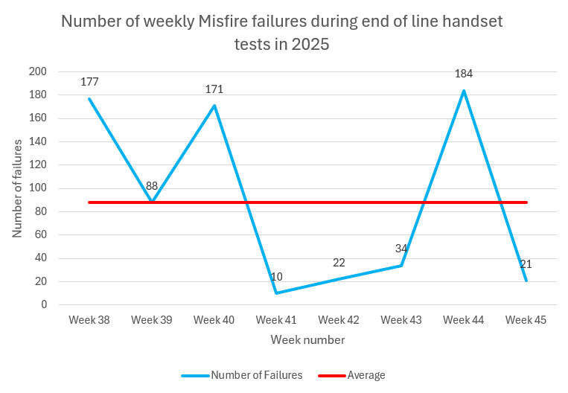
Figure 2 - Graph showing the number of misfire failures over an 8-week period in 2025

As shown, the graph in Figure 2 shows that over an 8-week period, an average of 88 devices per week failed the EOL test due to misfiring.
Knowing the severity of this issue, a route cause analysis was carried out to determine what was causing the issue, using ISHIKAWA as shown below in Figure 3.

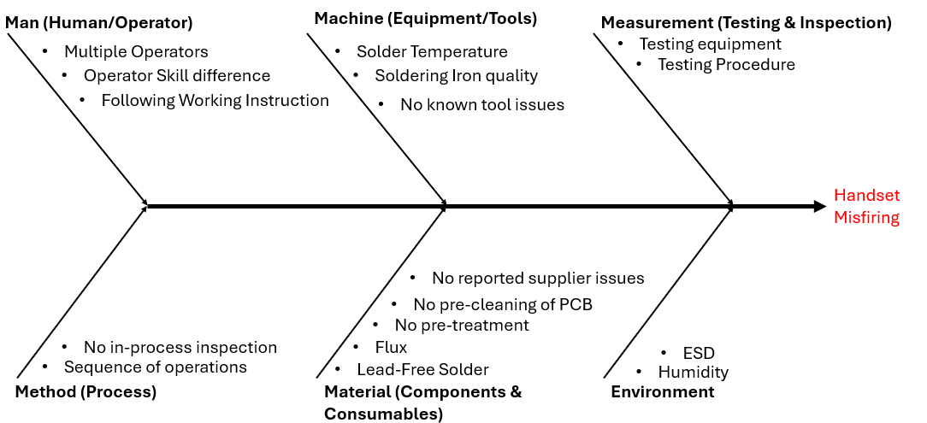
Figure 3 - ISHIKAWA Diagram showing route cause of Misfiring Handsets

Figure 3 shows the root cause of misfiring devices. From this, it can be determined that the root cause of the failures is due to human error during the soldering stage. This provides more detail of what area of the process requires improvement.
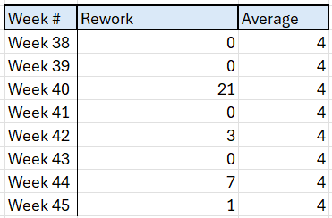
By improving the soldering process of the PCBs, it provides a great cost saving opportunity. Each failure either results in rework being carried out or the device being scrapped, each of these options has its own cost implications.
Table 1 - Number of devices reworked per week
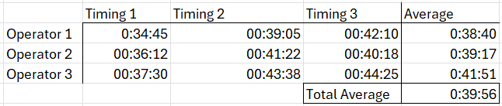
As shown in Table 1, an average of 4 devices is reworked per week.
Table 2 - Time taken to rework devices
Table 2 shows the timings taken during the rework operations carried out correct soldering issues. An average of 39 minutes and 56 seconds is taken to rework each device. CyDen have an hourly operator cost of £15.11, using this a cost can be calculated.
$$£15.11 ×0.66 hours=£9.97 per handset$$
$$£9.97 ×4=£39.89 per week$$
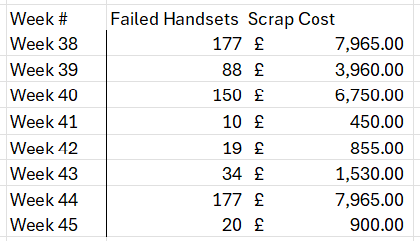
From these calculations, it has been determined that an average of £39.89 is spent each week on average due to rework required. Other handsets which cannot be reworked are then scrapped.
Table 3 - Cost of scrapped handsets per week
It costs CyDen £45 per handset which requires scrapping. Therefore, an average of £3,796.88 is spent on scrapped handsets per week due to issues found with the soldering.
The highest cost of poor quality comes from scrapping devices. With a cost associated with both rework and scrapping, a total annual average can then be calculated.
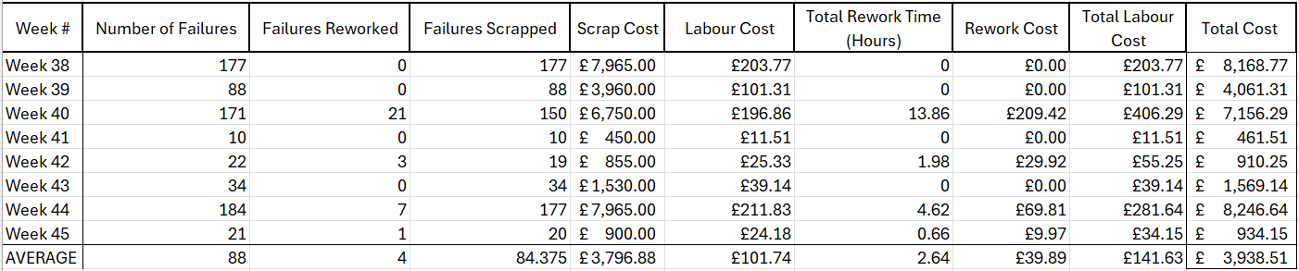
Table 4 shows a breakdown of quantities per week and the associated cost of poor quality. As seen, a total average of £3,938.51 is spent each week due to cost of poor quality.
Table 4 - Breakdown of cost implications associated with soldering faults per week
$$£3,938.51 ×52=£204,802.52 per year$$
As shown, an average of £204,802.52 is wasted each year due to poor soldering on the PCBs causing misfiring issues within the devices. This all stems from a 0.29% average failure rate shown below in Table 5.
Table 5 - Average misfire failure rate per week
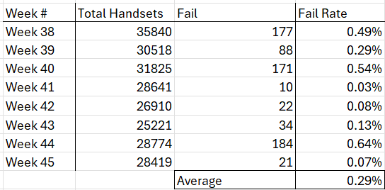
To conclude the problem statement, an average of £204,802.52 is being spent each year on scrapping and reworking devices due to soldering issues caused by human error during the production process.

Aim and Objectives

Project Aim

After concluding that the root cause of the misfiring issues was due to inconsistencies during the manual soldering process, the overall aim of this project is to incorporate a PLC controlled automated soldering system into the current IPL Device production line.

Project Objectives

From the above Problem Statement, a few issues have been identified, allowing for the following objectives to be set for the project.
- Remove manual soldering operations.
- Reduce the number of devices reworked per year by 75%.
- Reduce the annual cost of poor quality associated with soldering issues by 75%.
- Increase product quality.
- Increase production efficiency by 25%.

Scope and Limitations

This project focuses on improving soldering operations within the production line. Due to time constraints, other process improvements are not considered within the 6-month timeframe. Although no fixed budget is defined, costs must be minimised and justified to management. Support from Manufacturing, Automation, and Verification teams is available to assist in meeting project deadlines.

Next Steps

The next steps include further research into automated manufacturing, ensuring that a reliable automated soldering process can be implemented using a PLC control system and can also provide data to the system ensuring that the devices have good traceability throughout the process.

Chapter 2: Research and Literature Review

2.1. Research Introduction

This chapter presents a critical review of relevant academic and industrial literature in the areas of manufacturing automation, PLC integration, and traceability systems. Key topics include industrial automation frameworks, programmable logic control, quality assurance and traceability, and automated soldering technologies. The chapter concludes by outlining the research gap that informs the focus of this project.

2.2. Overview of Industrial Automation in Manufacturing

Automation is essential to modern production because it increases operating efficiency, product quality, and process standardisation. Automation reduces human error and process variation by lowering dependency on manual procedures, leading to more reliable and repeatable manufacturing results. Other automated systems offer early defect detection and enhanced traceability by enabling accurate control and monitoring of critical process parameters. Automation is a crucial component for competitive and sustainable manufacturing since it may improve worker safety, decrease waste and rework, and boost production efficiency in addition
to improving quality [8].
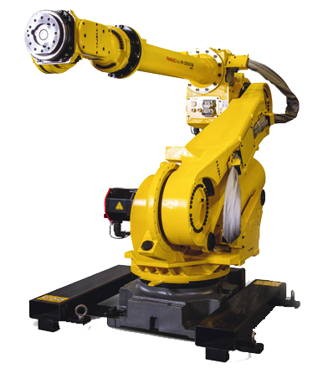
Shown in Figure 4 is an example of a robotic arm which is commonly used in automation to improve efficiency within a process.
Figure 4 - Industrial Robotic Arm [9]

2.2.1. Automation for Manufacturing Consistency and Quality

Automation improves production consistency and quality by reducing reliance on manual processes and minimising variability [86]. Human factors such as skill, fatigue, and environment can lead to inconsistent results and higher defect rates. In contrast, automated systems apply process parameters in a controlled and repeatable manner, enhancing process capability and reducing faults [10]. This also enables manufacturers to meet increasing production demands while maintaining stable and reliable quality [11].

2.2.2. Flexible and Programmable Automation Systems

Flexible and programmable automation systems enable manufacturing to adapt to changes in product design, volume, and process requirements without major retooling [86]. Unlike fixed automation, these systems allow adjustments through software and adaptable hardware, making them suitable for varied production environments. Using standardised platforms such as industrial networks and PLCs, they coordinate complex tasks with precise timing. This flexibility reduces downtime, enables quick changeovers, and improves overall manufacturing responsiveness and competitiveness [12–13].

2.2.3. Automation-Enabled Process Monitoring and Data Collection

Automation enhances process monitoring and data collection by integrating sensors and control systems into manufacturing operations. Unlike traditional end-of-line inspection, automated systems enable real-time measurement of key parameters, improving visibility and control [87]. This data supports early fault detection, traceability, and quality assurance, allowing issues to be identified during production, reducing rework, scrap, and overall costs [14–15].

2.3. Programmable Logic Controllers (PLCs) and Automation Control

Programmable logic controllers (PLCs) are widely used in industrial automation due to their reliability and suitability for demanding environments [16]. They manage sequencing, real-time control, and communication with sensors and actuators. Compared to general-purpose systems, PLCs offer predictable timing, robust fault handling, and standardised communication, making them ideal for quality-critical processes [17].

2.3.1. Role of PLCs in Industrial Automation and Process Consistency

PLCs perform key automation tasks including logic execution, sequencing, timing, and interlocking. Using a predefined scan cycle, they read inputs and produce deterministic outputs, enabling precise and consistent process control [18]. This real-time, predictable operation ensures reliable execution of time-critical tasks [19]. By standardising sequences and interlocks, PLC systems improve product consistency, reduce errors, and enhance overall process reliability and quality [20–21].

2.3.2. PLC Communication and System Integration

Communication and system integration are crucial components to a PLC, this allows the coordination, monitoring and data collection to be as effective as possible. Common communication protocols used within PLCs are Modbus, Ethernet/IP and OPC Unified Architecture [88]. Each of these facilitate a reliable and standardised data transfer between sensors, actuators robots and Human Machine Interfaces (HMI). These different protocols support deterministic and fault tolerant communication which is critical for maintaining a synchronised and critical process [22]. Shown below in Table 6 is a comparison table for industrial communication protocols.
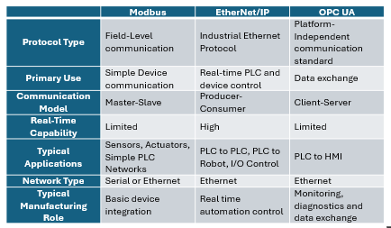
Table 6 - Comparison of various PLC communication protocols [23-25]

2.3.3. PLCs Compared with Alternative Control Systems

PLCs are widely used in industry due to their reliability, deterministic real time performance and suitability for harsher environments [88]. Alternative control systems such as microcontrollers and Industrial PCs (IPCs) offer greater computational flexibility and lower initial costs in some applications, they often lack the robustness, predictable timing and industrial safety certifications required for quality critical manufacturing. PLCs are specifically designed to continuously operate, straightforward maintenance and integration with industrial I/O and communication protocols, making them particularly effective for standardising processes and reducing human error [26].

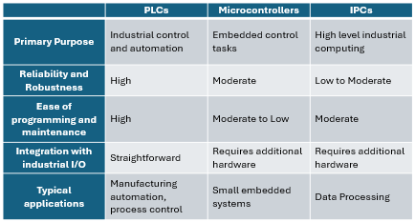
Table 7 - Comparison table for various automation systems [27-29]

2.4. Quality Control in Manufacturing

Quality control is a crucial aspect manufacturing, ensuring that only the best quality of product is allowed to reach the customer [32]. Controlling the quality of a product includes product traceability, quality control gates, in process testing and end of line tests and inspections [30].

2.4.1. Traceability

Traceability is essential for understanding misfiring defects [31]. While current EOL testing records pass/fail results, it provides limited insight into earlier process conditions, particularly during soldering. Enhanced traceability would link manufacturing data—such as timings, solder temperature, and test results—to each device, supporting effective root cause analysis and identification of units requiring rework or quarantine [32]. Methods such as barcode serialisation, PLC data logging, and MES integration enable defects to be traced to specific process stages, improving quality and efficiency [33].

2.4.2. In Process and End of Line Testing

Product testing is another crucial quality control method ensuring that minimal time and resources are put into faulty products and ensuring that faulty products are contained [89]. In process checks are used to control and monitor critical process parameters and detect issues early. EOL testing serves as a final quality gate, confirming that the final product meets the required standard before reaching the customer. Currently, the misfiring issues are found at the EOL stage, however as mentioned, the product would have passed through multiple other stages prior to the issue being identified at this stage, therefore making it difficult to carry out an RCA. However, if there were an in-process test after each stage, the RCA will be focused on the previous assembly stage rather than multiple stages [34-37].

2.5. Automated Soldering Systems

Automated soldering systems improve solder joint consistency by precisely controlling temperature, timing, and solder delivery, reducing defects associated with manual assembly [90]. When integrated into production lines using PLC control, these systems enhance quality, repeatability, and manufacturing efficiency [38].

2.5.1. Automated Soldering for Process Consistency and Quality

Automated Soldering is widely used in electronics manufacturing to improve consistency in solder joints and further reduce defects associated with manual soldering assembly [90]. Manual soldering is strongly influenced by skill and technique, leading to variability in application, volume and joint conditions [39].

Automated soldering mitigates these issues by precisely controlling these aspects and parameters. By executing soldering operations in a repeatable and controlled manner, automated soldering reduces the occurrence of cold joints, insufficient wetting and intermittent connections [90]. Therefore, automated soldering is extremely suitable for quality critical, high-volume manufacturing [40].

2.5.2. Robotic Soldering Systems

Robotic soldering systems are widely used for applications requiring flexibility and access to complex joints [90]. Industrial systems combine programmable multi-axis motion with integrated tools to deliver precise, repeatable soldering operations [41]. Key parameters such as path, solder quantity, and temperature can be controlled through software, allowing quick adaptation to design changes [42].

These systems are well suited to mixed technology assemblies and retrofit projects, often incorporating vision alignment and temperature control to improve accuracy. They can be integrated into existing production lines, enhancing quality, reducing rework, and maintaining flexibility [43–44].

2.5.3. PLC Integration, Process Control and Monitoring

Effective integration of automated soldering systems requires coordinated control of upstream and downstream equipment, such as conveyors and sensors [91]. PLCs are commonly used to achieve this, enabling soldering systems to operate as part of the wider production process rather than as standalone workstations [45].

PLCs also allow real-time monitoring of parameters such as cycle times, machine states, and faults, supporting improved traceability and early defect detection while reducing reliance on EOL testing [46]. This highlights the importance of PLC integration for data-driven process improvement and root cause analysis [91].

2.6. System Integration and Data Synchronisation
Integrating multiple automation systems introduces challenges, particularly when coordinating soldering stations with conveyors, testing equipment, and traceability systems [92]. Differences in communication protocols, timing, and data formats can result in fragmented operation and incomplete data capture, limiting effective root cause analysis when defects are identified at EOL [47].

To address this, standardised communication and data synchronisation are essential. PLCs typically act as the central control layer, managing sequencing and data collection, while supporting real-time monitoring, improved traceability, and early fault detection [48].

2.7. Critical Evaluation and Research Gaps

Existing research highlights the benefits of traceability for quality assurance and PLC-based automation for process control, while automated soldering improves consistency and reduces defects. However, these areas are often addressed separately, particularly in small- to medium-scale production.

This project addresses this gap by integrating traceability, PLC control, and automated soldering within a single system. This approach improves defect tracking, data collection, and process coordination, reducing misfiring and enhancing overall product quality.

2.8. Summary

This review highlighted how traceability, PLC control, and automated soldering improve manufacturing quality and consistency. A key gap was identified in their combined use within small- to medium-scale production, particularly for tracing defects found at EOL. These findings informed the project’s design, supporting the implementation of a PLC-controlled automated soldering system with integrated data monitoring.

Chapter 3: System Design

3.1. Introduction

This chapter presents the design and implementation of a PLC-controlled automated soldering system to address misfiring in the IPL production line. It outlines system requirements, control architecture, and integration, including hardware, PLC logic, and safety interlocking. The aim is to demonstrate improved process consistency, reduced variability, and enhanced traceability through automation.

3.2. System Requirements

The system requirements were defined to ensure that the automated soldering integration met both operational and quality objectives within the existing manufacturing environment. Requirements were identified through observation of the current manual soldering process, analysis of end-of-line (EOL) misfiring data, review of existing production documentation, and discussions with engineering and production personnel. These inputs were consolidated into functional and non-functional requirements to guide system design and validation.

3.2.1. Functional Requirements

To ensure the design of the system is a success, the requirements for the system must be defined and implemented to meet the set objectives.

Below is a list of all functional requirements which need to be implemented into the automated soldering system design.
- PLC control to automate the system.
- Synchronisation to the production line conveyor.
- System and component traceability.
- Safety interlocks and machine guarding.

3.2.2. Non-Functional Requirements

Non-functional requirements ensure that the aims of the project are met, although automating a system is considered as an improvement, special consideration needs to be taken to ensure that the product manufacturing cost doesn’t increase or the product quality doesn’t decrease to a level where the cost of automating the process is no longer beneficial to the product.

Below is a list of the non-functional requirements.
- Operational reliability, increasing production throughput.
- Simple operator interface, ease of use.
- Compliance with current safety standards.
- No negative impact on EOL testing.

3.3. System Architecture Overview

To begin the design of the system, it’s important to consider the area where the system goes and how the system is set up. The architecture of the system shows how each component interacts, from the conveyor to PLC to the solder system.

Figure 5 illustrates the system architecture, where red arrows represent product flow and dashed arrows indicate communication links. The PLC controls the conveyors, stoppers, and solder robot, with bidirectional communication reflecting its input and output capabilities. A unidirectional link to the database shows that the PLC writes data but does not receive information.
Figure 5 shows the design for the system architecture. The red arrows show the flow of the product whilst the black dashed arrows show the communication links between the systems. The PLC controls the conveyors and stoppers before and after the solder robot and at the same time controlling the operations of the solder robot. As shown, the arrows between the PLC, Solder Robot and both Conveyors and Stoppers are double sided. This is due to the PLC having both inputs and outputs, meaning it can also receive information as well as distribute it. Shown at the top of Figure 5 is the connection between the PLC and the database, this is a single sided arrow as the PLC does not directly receive any communication from the database but still writes to it.
Figure 5 - Architecture of Automated Soldering System
Conveyor + Stoppers
Automated Solder Robot
PLC
Database
Conveyor + Stoppers
Data
Control
Status
Control
Product
Flow
Product
Flow

Once the system architecture was defined, the design was developed further for full system design where individual components and layout is considered.

3.4. System Design

The system design was developed collaboratively to align with concurrent improvement projects on the production line. All components were analysed to ensure suitability for both the soldering system and overall process. Regular meetings ensured alignment and informed selection of the most appropriate solutions.

3.4.1. Production Line Layout

As mentioned in section 1.3.1, the PLC controlled soldering robot needs to be incorporated into the current production line. Before designing the system, the space available needs to be considered as well as the production flow.

3.4.1.1. Old Production Line Layout

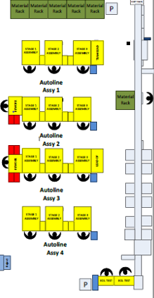
Figure 6 - Old Production Line Layout

Figure 6 shows the original production line, where four assembly lines fed into a conveyor for subsequent processes including laser etching, PCB programming, calibration, and EOL testing before packing. The green arrow indicates product flow, which is inefficient due to movement between assembly lines, the conveyor, and final testing.

3.4.1.2. Proposed Production Line Layout


Figure 7 - New Production Line Layout
Solder M/c
Laser etch
Screw M/c
Screw M/c
Auto EOL
Auto EOL
Figure 7 shows the new production line layout, where assembly stages have been integrated into the conveyor system, including the automated solder robot and screw machine. This removes the need for four assembly lines, reducing manual labour, while EOL automation reduces operator requirements to one.

The green arrows indicate a simplified product flow with a single path to packing after EOL testing. The automated solder robot is located at the third stage, highlighted in red, which is the focus of this project.

3.4.1.3. Production Line Summary

To summarise, the new production line design simplifies the process flow significantly from the old one. This is also a huge cost reduction as it requires twelve less operators to run the line. Considering the timing improvements expected from the newly automated systems, the product throughput won’t be affected by the reduction operators.

3.4.2. Design Process

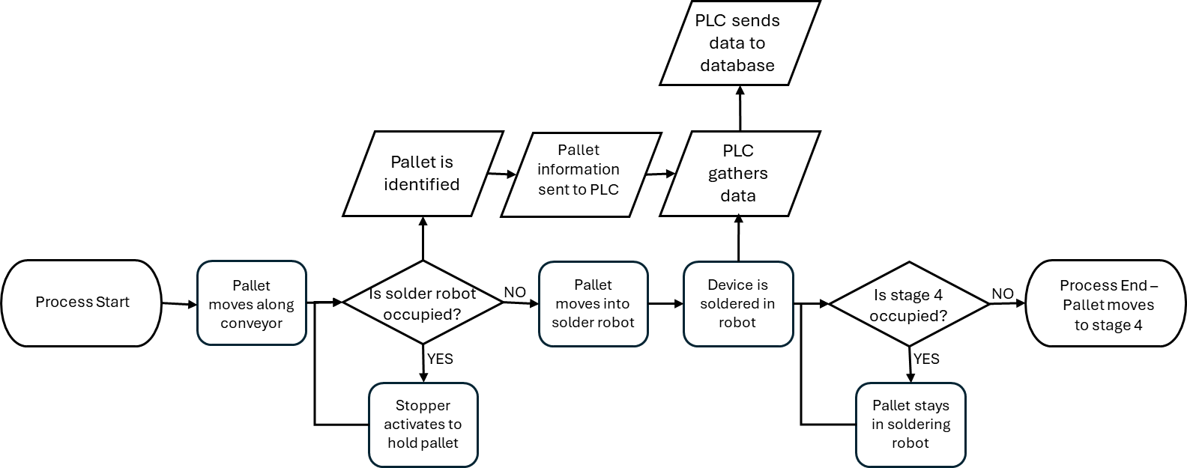
The design of the system was carried out using a flowchart of required operations. This allowed for an organised design approach where each aspect was considered in order of how the handsets where to be produced.
Figure 8 - Process Flowchart

As seen in Figure 8, each step is laid out in order showing how the system works. This allowed for each section to be broken down and individually designed.

3.4.3. Hardware Design

To begin, the hardware for each step was considered. By following the flowchart in Figure 8, it ensures that nothing is missed.

3.4.3.1. Step 1 – Moving along the conveyor

Beginning with the conveyor, this was a simple decision as the new soldering system was being implemented into the old production line, conveyor lines were already in place and suitable for use.

Shown in Figure 9 is the pallets used to transport the handsets down the conveyor through each stage. These pallets required a conveyor suitable for these to safely and effectively move along the line, ensuring all pinch points are protected to ensure operator safety.

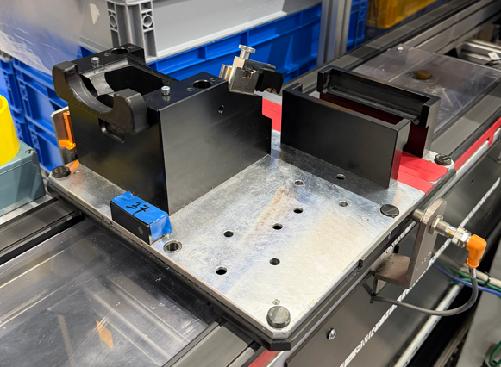
Figure 9 - IPL Device Pallet
The conveyor shown below in Figure 10 is the chosen conveyor.
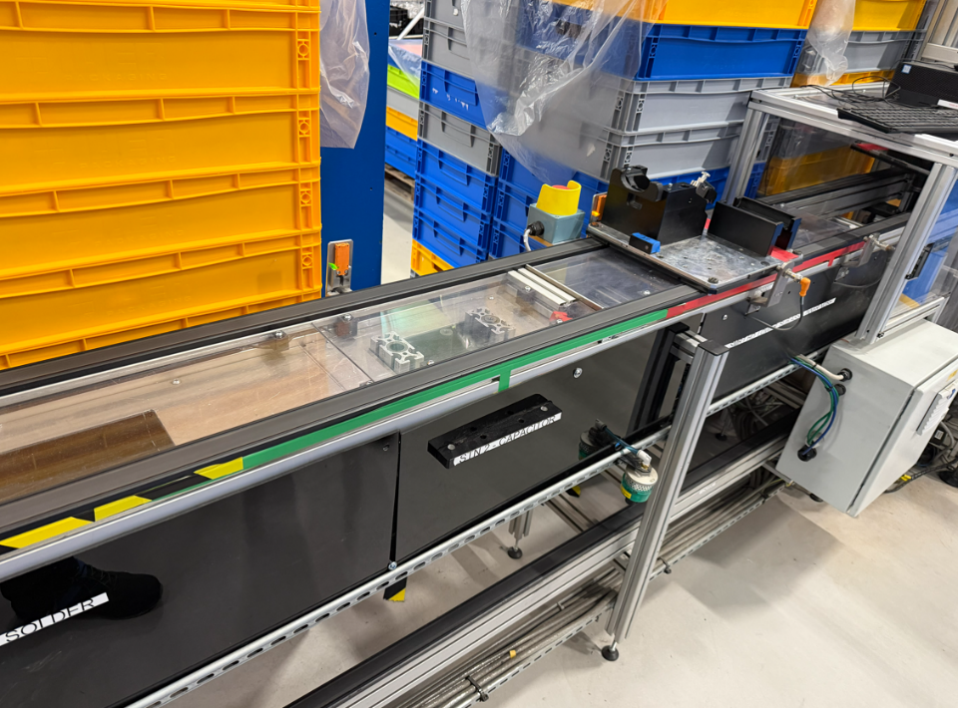
Figure 10 - Production Line Conveyor
The benefit of using this conveyor is that it adds no extra cost to the project to purchase additional conveyors. As it is commonly used around the factory; there are plenty of spare parts and extra lengths stored within the factory. It also standardises the same parts, ensuring that no additional training is required in case of breakdowns etc.

3.4.3.2. Step 2 – Pallet detection and stopping

Step 2 requires the pallet to be identified for traceability purposes as well as a stopper to hold the pallet in place while it waits for the soldering robot to clear. To design this stage successfully, a stopper is required and a sensor to determine when a pallet is in position.
Stoppers were already being used in the previous conveyor line to ensure that the pallets didn’t overload certain areas. These again, like the conveyors can remain the same for the same reasons as the conveyor. It is already proven that they are suitable to be used with the conveyor lines and they are suitable for the pallets. The stoppers can be seen below in Figure 11.

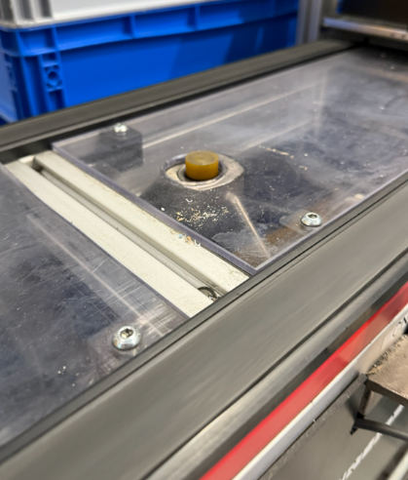
Figure 11 - Conveyor Pallet Stopper
The main hardware decision for this step is the pallet detection. A common sensor used for component detection is a proximity sensor, this is a suitable choice as it detects the pallet when it comes in range and then activates the stopper to hold the pallet when required [49-50].
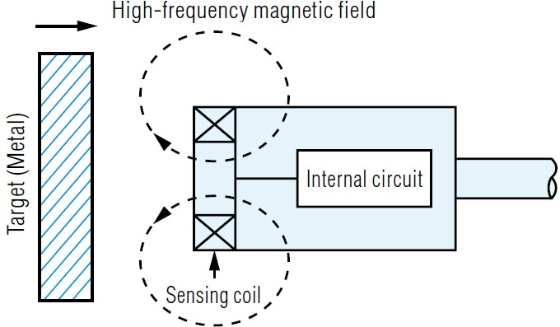
Figure 12 - Proximity Sensor Diagram [51]
Figure 12 shows how a proximity sensor operates. While suitable for pallet detection, it does not meet traceability requirements identified in Figure 8. To address this, a barcode scanner can be used alongside the sensor to identify each pallet and transmit associated data to the PLC.
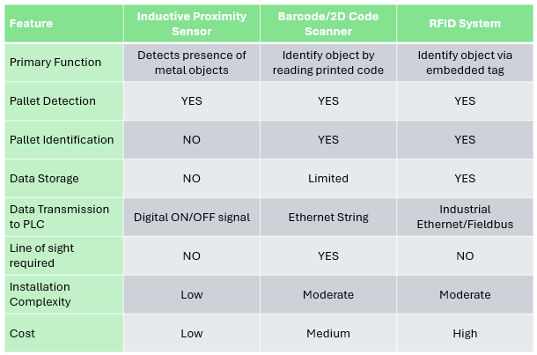
An alternative method would be the use of RFIDs. RFID stands for Radio Frequency Identification; they work by using electromagnetic fields to identify and exchange data with tagged objects. The reader emits a radio frequency signal which in turn energises the tag and prompt it to transmit stored data back to the reader [52-53].
Table 8 - Comparison of various pallet detection sensors [54-62]

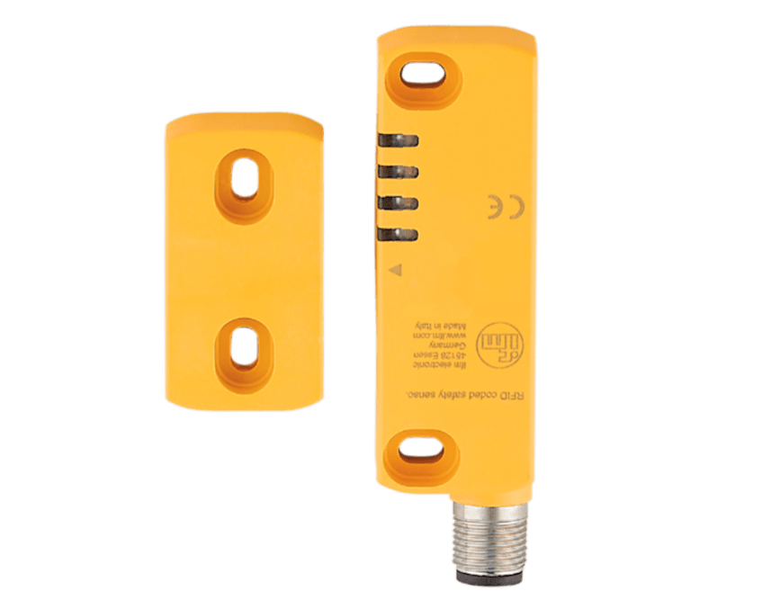
Shown in Table 8 is a comparison between the three types of sensors. From section 2.4.1. Traceability, it is crucial that full production traceability is available, therefore, a RFID system would be ideal for this process. Although the cost is higher and the installation complexity is moderate, the RFID system as shown in Figure 13 massively improves the traceability of the production line down to the pallet.
Figure 13 - RFID Sensor [63]

3.4.3.3. Step 3 – Conveyor Into the robot

Step 3 is like step 1; there is no additional hardware required other than the conveyor systems. The only additional hardware which could come into play at this stage is the safety latches required on the doors leading into the solder robot, however they are covered in the next stage during the robot design.

3.4.3.4. Step 4 – Automated Soldering

The automated soldering is the main area of this project. This is the main contributor to the improvement of the production line. The biggest consideration to be made for this step is the soldering robot. This would be the most expensive purchase for this project, meaning it is important carefully research the equipment and even discuss suitability with the suppliers.
At the beginning of this project multiple robots where researched, such as the Japan Unix
Figure 14 - Japan Unix Gantry Solder Robot [64]
UNIX-DF series and UNIX-GF robots and the QUICK 5331 robot.
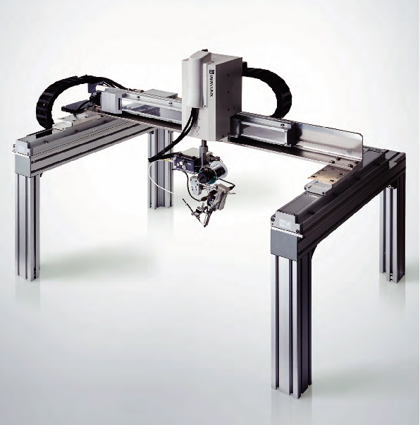
However, when researching the various solder robots and their suitability, a colleague mentioned that a soldering robot that was used for a similar purpose was decommissioned in 2017 and left out in the warehouse. After looking at the condition of the robot, it was possible to refurbish it and use it if suitable.

Below in Table 9 is a detailed comparison of the four different soldering robots considered for the project.
Table 9 - Comparison table of researched Soldering Robots [65-69]
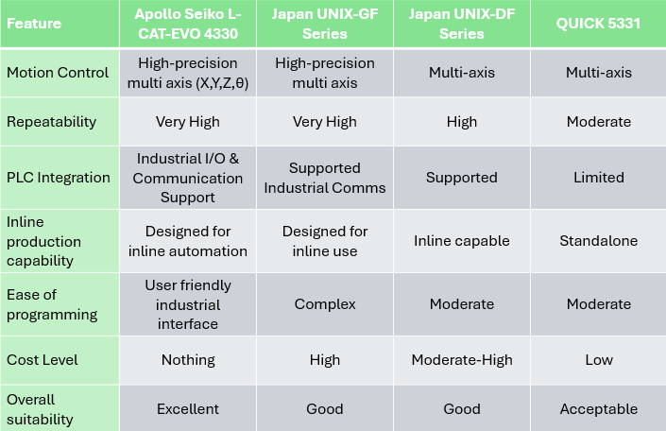

Table 9 shows that one soldering robot was most suitable due to its high precision, multi-axis control, and repeatability, with the added benefit of no additional cost. Although refurbishment posed a risk to the timeline, the cost savings justified its selection.

Due to the robot’s movement and heated components, safety measures were required, including shutter doors with interlocks and pneumatic actuation.

Continuing with this step, the PLC needed to be chosen. Shown in Table 10 is a comparison of all considered PLCs.

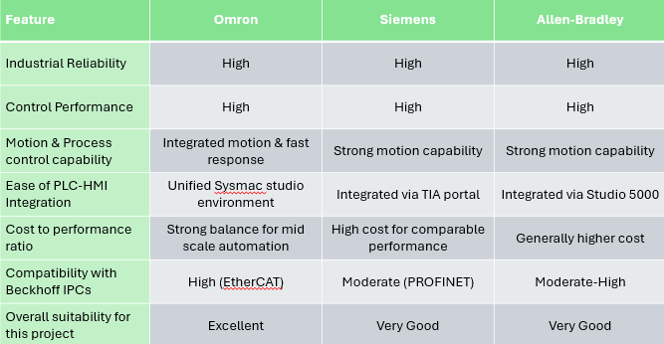
Table 10 - Comparison table of PLCs
[70-74]
From the research carried out in Table 10, each of the PLCs are similar in performance and suitability. However, Omron has been used previously for other automation projects around the factory and therefore was deemed to be the most suitable to keep all equipment standardised.

3.4.4. Software Design

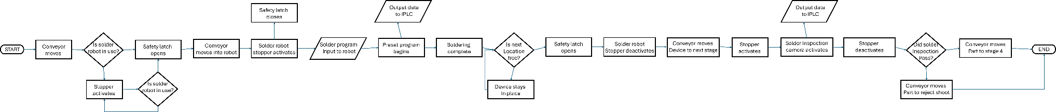

Figure 15 - PLC Flowchart
Figure 15 shows the sequential control strategy for the automated soldering process, where each stage must be completed before the next begins, ensuring controlled and repeatable operation. This approach prevents conflicts and ensures processes occur only when conditions are safe and correct.

Decision points represent checks based on sensor inputs and system status, verifying pallet position and task completion. This structured logic maintains process control, reduces variability, and prevents defects progressing through the line.

3.4.5. User Interface Design

The Human-Machine Interface (HMI) allows operators to monitor and interact with the system, displaying key information, errors, and alarms via communication with the PLC.
It is designed to be simple and standardised, with navigation between system stages and colour-coded indicators to show normal operation, warnings, and faults.

3.4.6. Design Considerations and Trade-Offs

Various design alternatives were evaluated to balance reliability, cost, and integration complexity. For pallet identification, a proximity sensor with barcode scanning was initially considered due to its low cost but was rejected due to limited traceability and reliance on line-of-sight. An RFID system was selected instead, providing reliable identification and improved traceability.

For control architecture, PLCs were chosen over PC-based systems due to their reliability, deterministic control, and compatibility with existing factory systems.
For soldering, refurbishing an existing robot was selected over purchasing new equipment to reduce cost while still meeting precision and repeatability requirements. These decisions ensured the final design met the project objectives.

3.5. System Implementation

With the design of the system determined, the next stage is to begin the implementation of the system. This includes the refurbishment of the soldering robot, creation of the PLC program and the integration of the system within the production line.

3.5.1. Refurbishment of Solder Robot

During the early stages of this project, an automated soldering robot previously used within the factory was identified in storage. The system was previously decommissioned in 2017 and had remained unused since. Due to the potential cost savings associated with reusing existing equipment, the robot was inspected and to determine whether it could be refurbished and used as part of this project. The refurbishment process involved inspection of the robots mechanical and electrical condition, restoration of wiring, functional testing and preparation for PLC integration.

3.5.1.1 Initial Inspection and Condition Assessment

The soldering robot was stored under racking, wrapped in clingfilm, though dust had accumulated due to damage to the covering. No visible structural damage was observed, indicating refurbishment was feasible; however, storage conditions made it difficult to assess mechanical condition and component completeness.

While initial inspection showed no major concerns, full evaluation required moving the robot to the shop floor and beginning restoration to identify any faults or missing components.

3.5.1.2 Electrical System Restoration

The first area of restoration was the electrical system; this was chosen as it would take the largest amount of time and can be put through a FAT test prior to the electrical panel being connected to the machine [75].

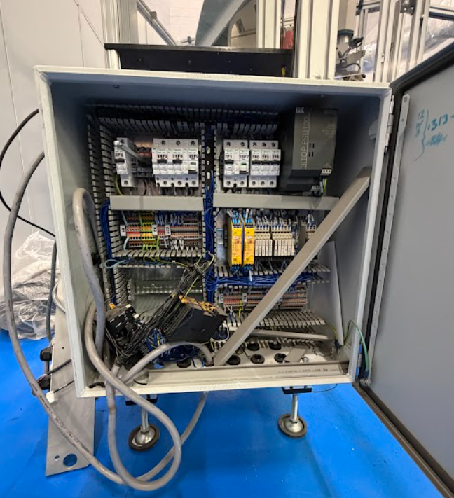
As shown in Figure 16, the electrical panel was in poor condition. While cables and components were generally intact, many were unlabelled and some trunking was missing. The presence of Omron PLC I/O ports indicated previous integration.
Figure 16 - Solder Robot Electrical Panel Pre-Refurbishment

A key risk was incorrect wiring due to missing labels, making it difficult to follow the schematic. Careful consideration was therefore required during restoration to ensure successful refurbishment.

Electrical Safety and Compliance

Electrical safety and compliance are essential when refurbishing panels to ensure safe operation. Protective earthing must be verified to safely direct fault currents and reduce shock risk [76].

Overcurrent protection devices, such as fuses and circuit breakers, must be correctly rated, and safety circuits and emergency stops tested to ensure immediate power isolation [77–78]. These measures ensure compliance with standards such as IEC 60204-1, ISO 13850, and ISO 13849-1 [79–81].

Wiring Integrity and Component Condition

Ensuring wiring integrity and component condition is essential during refurbishment. Wiring must be checked for damage, with faulty connections, insulation, or terminals repaired or replaced to prevent faults. Key components, including relays and power supplies, must also be assessed for functionality to ensure system reliability.

Compliance with standards such as BS EN 60204-1 and BS EN 61439 ensures safe and effective panel assembly [82–83].

Control System Verification

Control system verification ensures all hardware and interfaces function correctly before integration. This includes testing the PLC, I/O modules, and communication to confirm reliable signal transmission between components. Input and output channels are also checked to ensure correct sensor and actuator response, ensuring safe system operation. Compliance with standards such as ISO 13849-1 is required [81].

Functional Power and Testing

Functional power testing is carried out after the refurbishment to ensure that the electrical panel powers up correctly and all components operate as expected. This involves energising the panel under controlled conditions to confirm that the correct operation of power supplies, PLC modules and other components. Input and output signals may also be tested by simulating sensor inputs and verifying responses [84].

Documentation Updates

Following the refurbishment, it is very possible that changes have been made to the original panel to suit the new purpose of the solder robot. These changes need to be documented and included in the schematic diagram, ensuring that future work to the panel can be done and understood without any issues. This would include changing the schematic diagram, component layouts, I/O lists and other written documentation. Maintaining accurate documentation also ensures that suitable maintenance can be carried out or troubleshooting. BS EN 81346 provides guidance on this topic [85].

Panel Refurbishment Result

From each of the discussion points above, it was clear that a lot of consideration was required for the panel refurbishment to ensure that it was to a good standard. Due to the potential delays this refurbishment could have presented to the overall project, the work for refurbishment was split amongst two shifts to ensure more work could be carried out in a shorter timeframe. After working with other team members to complete the panel, it was a success.
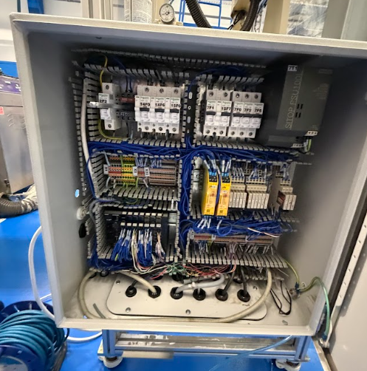
As shown in Figure 17, the electrical panel is much better condition to how it was shown in Figure 16. As mentioned in Control System Verification above, it is important to test the inputs and outputs of the systems, however due to the panel not yet being connected to the sensors and actuators, this was not completed at this time.
Figure 17 - Refurbished Electrical Panel

3.5.1.3 Mechanical Inspection and Refurbishment

Following the refurbishment of the electrical panel, the mechanical components needed to be inspected and refurbished as required. As the robot had remained unused for several years, it was necessary to verify the condition to ensure it can operate correctly.
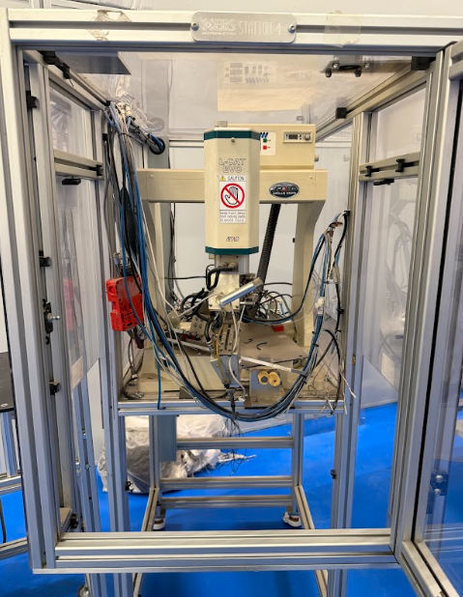
Figure 18 - Front of Robot Before Refurbishment
Shown in Figure 18 is the front view of the robot before undergoing its refurbishment. There are a lot of cables and pneumatic pipes which have been detached from the robot with little care.
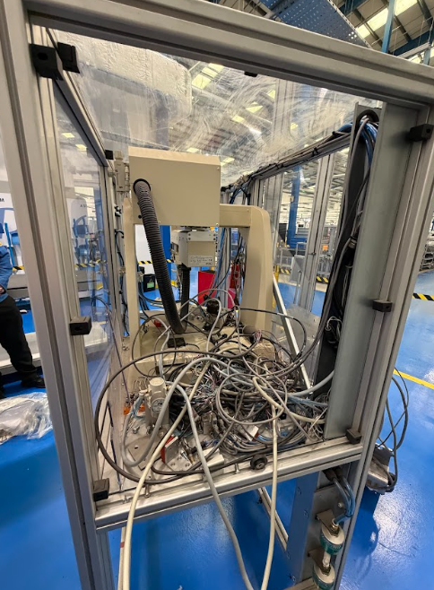
Figure 19 - Rear of Robot Before Refurbishment
Figure 19 shows the rear of the robot which is in worse condition than the front. There is a lot of electrical cables as well as some pneumatic gauges.

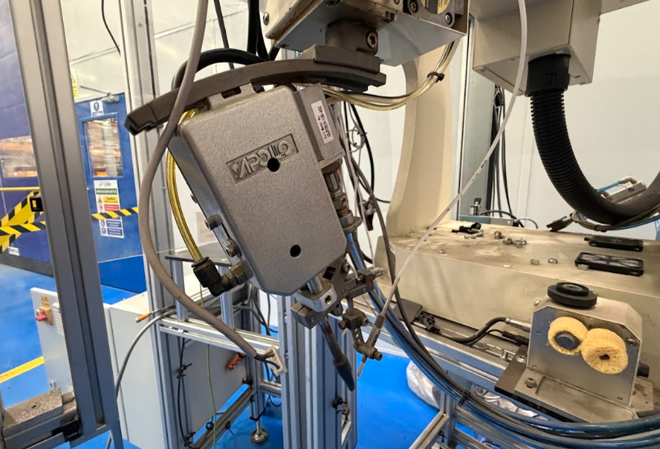
During the refurbishment, the robot axes were inspected for signs of wear, damage and obstruction and each axis was moved manually through its full range of motion to confirm that there were no issues. The moving components were also lubricated in accordance with the manufacturer’s maintenance recommendations.
Figure 20 - Soldering Iron Before Refurbishment
The Soldering Iron Tip as highlighted in Figure 20 by the red arrow, was in poor condition as well as the feeder tube for the solder. This was caused by flux not being properly cleaned before placing the robot into storage. This meant that a replacement iron and feeder tube needed to be purchased.

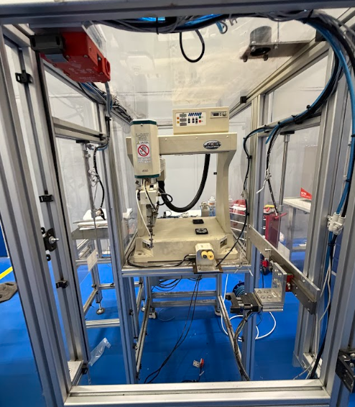
After the robot was cleaned and reassembled, there were no major concerns other than a few missing components which were cheap and easy to replace by using the documentation supplied by the manufacturer.
Figure 21 - Front of Robot After Refurbishment
It was evident from the refurbishment that no critical components needed replacement or fixing as it was in good condition as shown in Figure 21.

The cables from the rear of the robot were also able to be connected into the power supply of the panel and traced correctly around the robot to ensure that they won’t get tangled in any of
the moving parts as can be seen below in Figure 22.

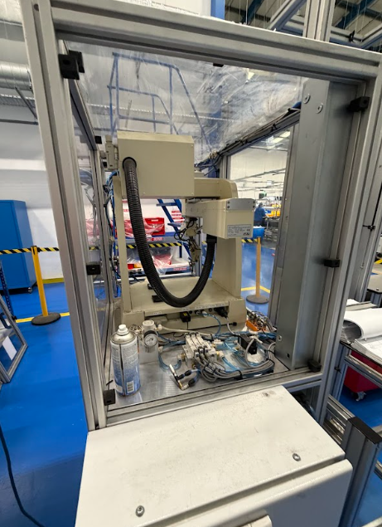
To summarise, the mechanical refurbishment was a success. With minimal issues found due to wear of the components during storage or missing components and brackets. There is little cost to replacing the needed components. All crucial safety features such as interlocks were present and in good condition as can be seen in the upper left corner of Figure 21.
Figure 22 - Rear of Robot After Refurbishment

With the electrical panel and the robot refurbished, it can now be powered up and tested whilst the replacement components and critical spares for maintenance are being ordered.

3.5.1.4 Power and Functional Testing

Functional Test 1

With the full robot being refurbished and in a good working condition, the machine was able to be used for a functional test to check how the robot moves on its own.

The purpose of this functional test, is not to check the soldering quality but to ensure that the robot moves freely and without any concerns and whether the pendulum (Shown in Figure 23) is able to control the robot correctly prior to integrating the PLC.

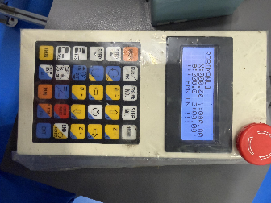
Figure 23 - Soldering Robot Control Pendulum
The functional test enabled engagement with the manufacturer, who provided training on programming and maintenance. During testing, accuracy issues were identified, with the robot overshooting on each axis. The manufacturer diagnosed the issue and recommended calibration, which was later completed, improving performance.

Following calibration, testing confirmed the robot could successfully perform soldering operations with potential to reduce cycle time. Safety interlocks, lighting, and components were also tested, with no issues found.

Overall, calibration resolved the accuracy issue, and the robot was verified as safe and capable of accurate operation.

Functional Test 2

Following the initial test, the robot was confirmed capable of performing the required soldering operations. Before PLC integration, a second test was conducted to assess soldering on actual handsets, delayed until required components were available.

Key considerations were solder quality and cycle time, as improved speed is only beneficial if quality is maintained to prevent misfiring. Handsets were manually positioned in the jig for testing, as shown in Figure 24.
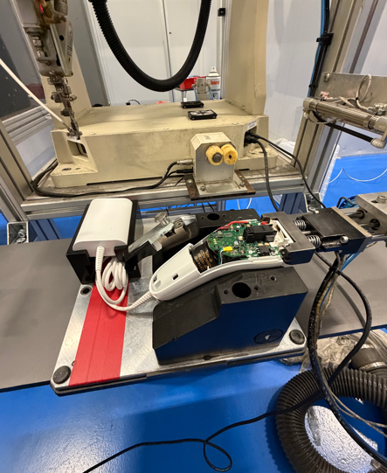
Multiple handsets were put through the functional test, using CyDens TAMU (Target, Acceptable. Marginal, Unacceptable) guidelines for soldering, we were able to determine whether the soldering quality was good or not as the speed increased.
Figure 24 - Handset Positioned into Robot for Functional Test
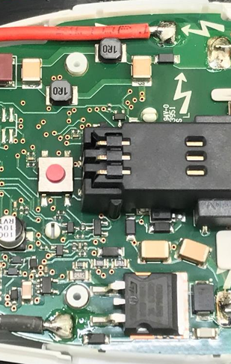
Target solder joint
Target solder joint
Figure 25 - Soldering Carried out by Soldering Robot during Second Functional Test
Shown in Figure 25 is a sample taken from the solder robot which proves that the soldering quality meets the Target of CyDens TAMU document. To ensure that it’s suitable quality the TAMU document mentions that the soldering joint needs to have no evidence of cold solder and a rounded fillet where all the cable is covered. Proving that the soldering robot can produce a quality solder joint.

During these samples, timings were taken each time on the fastest setting we could achieve before the quality reduced.
Table 11 - Functional Test Cycle Timings

As shown in Table 11, the average cycle time for each handset is 11.56 seconds. When compared to the current timings from manually soldering which can be seen Table 12 below.
Table 12 - Cycle Timings from Manual Soldering Operations
From this, the robot has already proven that it is capable of consistently producing good soldering joints and can also reduce the cycle times by 63.8% whilst doing so.

3.5.1.5 Preparation for PLC Integration

Following the successful completion of the functionality test, the soldering robot was prepared for integration with the PLC control system. As the robot would operate as part of an automated conveyor-based process, it was necessary to identify the control and feedback signals required to allow the robot to communicate with the PLC. This ensures that the soldering process occurs at the correct point within the production sequence and the robot is in synchronisation with the
pallet movement on the conveyor.

Key control signals were defined to manage the interaction between the PLC and the robot. A cycle start signal allows the PLC to initiate the soldering operation once the pallet has been detected and correctly positioned at the station. The robot then returns a cycle complete signal to confirm that the soldering process has finished, allowing the PLC to release the pallet and resume conveyor movement.

3.5.2. Mechanical Integration with Production Line

Following refurbishment and testing, the robot was mechanically integrated into the existing conveyor line. It was positioned using a pallet truck and aligned with the conveyor to ensure correct pallet stopping.

Safety guarding was temporarily removed to verify alignment, with multiple pallets tested for consistent positioning. Once confirmed, guarding was reinstated and safety shutters tested to ensure proper operation and protection.

The system was then run in pass-through mode, allowing normal production until full functionality was achieved, as shown in Figures 26 and 27.

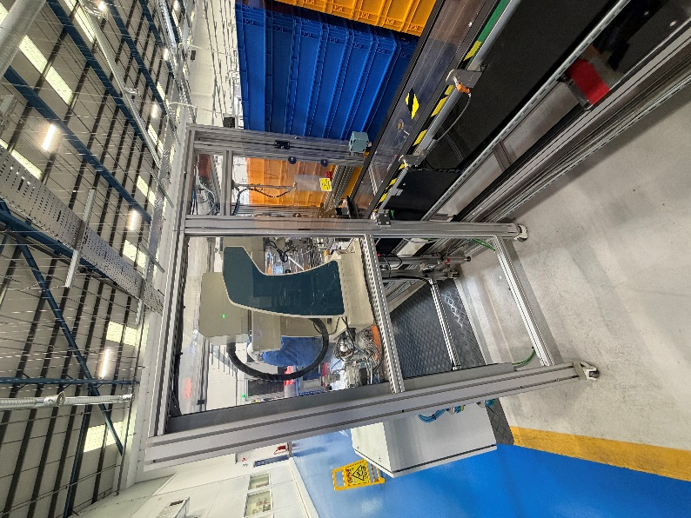
Figure 26 - Solder Robot Integration with Conveyor
Figure 27 - Solder Robot Integrated with Conveyor Side View

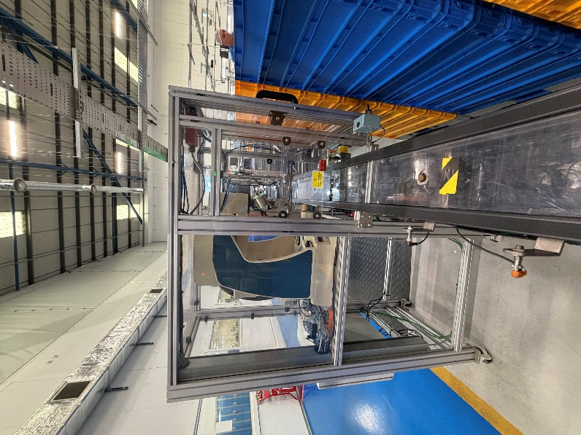

3.5.3. Sensors and Hardware Installation

During the installation of the solder robot, the sensors and hardware were also installed in alignment with the robot to ensure pallet stopping distances and timings were correctly set up.
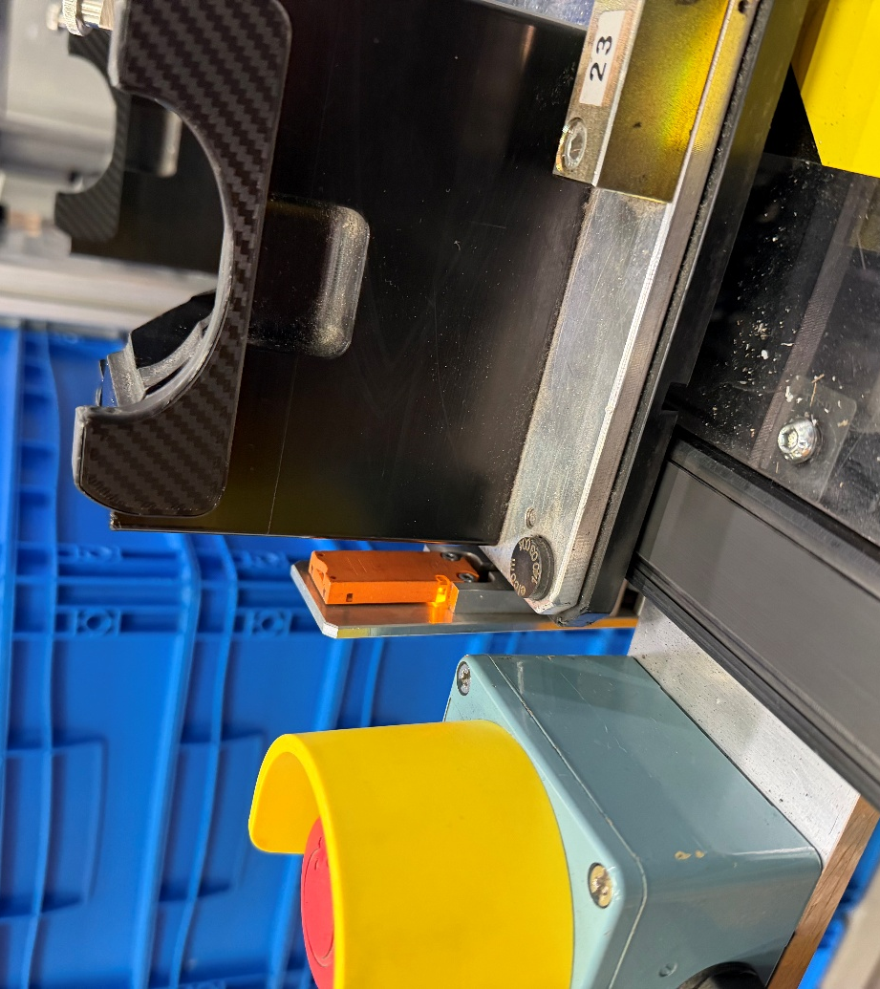
An RFID reader was installed at the entry point of the soldering station (Figure 28) to detect and identify each pallet as it approached the robot. This allowed the PLC to confirm pallet presence and initiate the robot. Mechanical stoppers, actuating using pneumatic cylinders to physically stop the pallets from progressing down the conveyor and colliding with each other. This also ensured that there wasn’t a build up of parts on the line all waiting for soldering operations and causing a back up of parts along the line, it ensures a steady flow of work in progress (WIP) throughout the process if one stage is being carried out quicker than others. It also maintains a consistent supply to other stages after the WIP has passed through the solder station.
Figure 28 - RFID Sensor Implemented on Production Line
As well as the RFID sensor to transfer information from the pallet, there were a few induction sensors which required implementation into the production line to detect pallets but not transfer information from them. The main purpose of the induction sensors was to activate the stoppers at set points, this ensuring that product can be sent down the conveyor and stop to allow for WIP to be built to an extent but not overload certain areas. An example of an induction sensor can be seen in Figure 29.

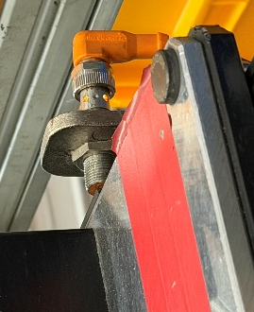
The final component that required implementation were the pneumatic pistons used to open and close the shutters, ensuring the safety of the operators and people around the soldering robot, the shutter doors also ensure operators and other employees keep to the correct procedure when an issue occurs such as jammed pallets, the operators are not be able to put their hands through the door to remove pallets, ensuring they stick to the correct escalation process of calling the maintenance technicians to correct any issues. These shutter doors where integrated with safety interlocks to ensure that the soldering robot does not commence operations until the shutter is fully closed and locked off. The shutter door with all required components can be seen below in Figure 30.
Figure 29 - Induction Sensor Implemented into Production Line
Figure 30 - Solder Robot Shutter with Piston and Safety Interlock

3.5.4. PLC Control System Development

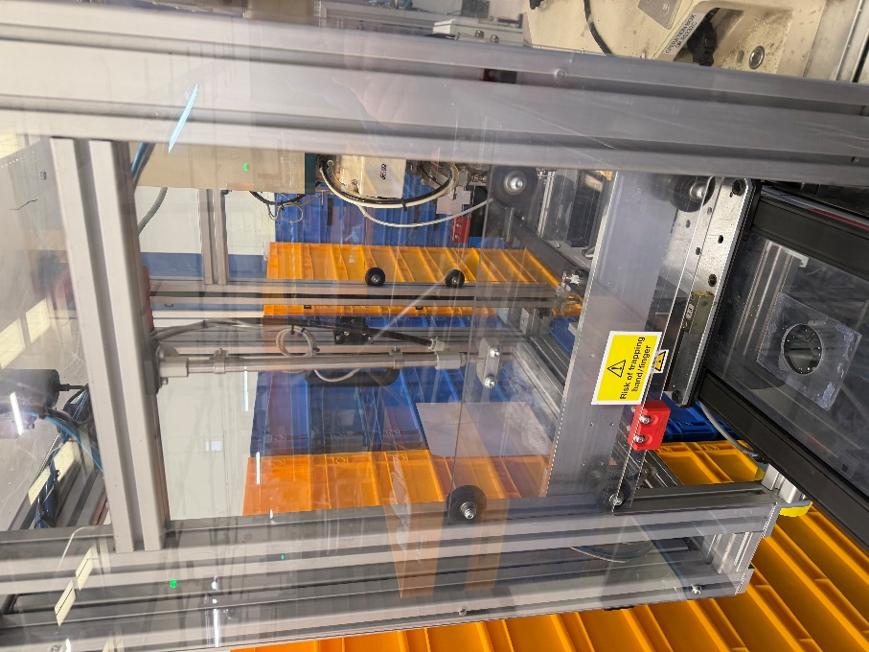
The PLC control system was created to coordinate the operation of the conveyor, pallet handling and soldering robot. The PLC hardware was installed and configured to interface with the required sensors and control signals. Input and output channels were mapped within the program to ensure correct communication between the devices and the control system, as demonstrated in the input mapping section of the program in Figure 31.

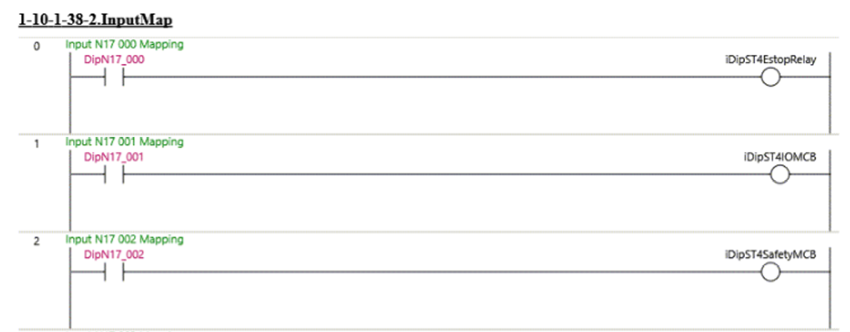
Ladder logic was used to implement the control strategy defined within the system flowchart shown in Figure 15. This included the processing of key inputs such as the pallet detection, robot status, safety conditions and then generating outputs to control the stoppers and start the robot cycle. The program used a structured sequential control approach, where each stage of the process is executed in a defined order. This is evident in the sequence logic, where the system progresses through steps such as pallet detection, pallet positioning, robot cycle initiation and cycle completion before allowing the pallet to progress. An example of the ladder logic can be seen in Figure 32.
Figure 31 - PLC Input Mapping

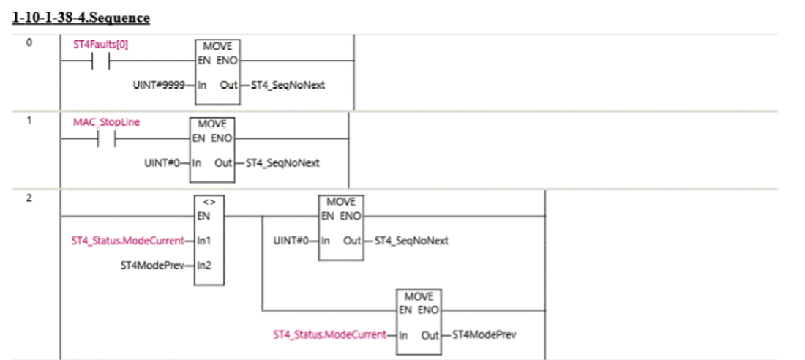
Figure 32 - PLC Program Ladder Logic

Safety interlocks were incorporated throughout the control logic to ensure the system was safe to operate. Inputs from safety devices, such as the guarding and access doors were continuously monitored to prevent the robot from operating unless all safety conditions were met. As well as this, fault signals from the robot were used to stop the process and prevent further operation until the fault is cleared.
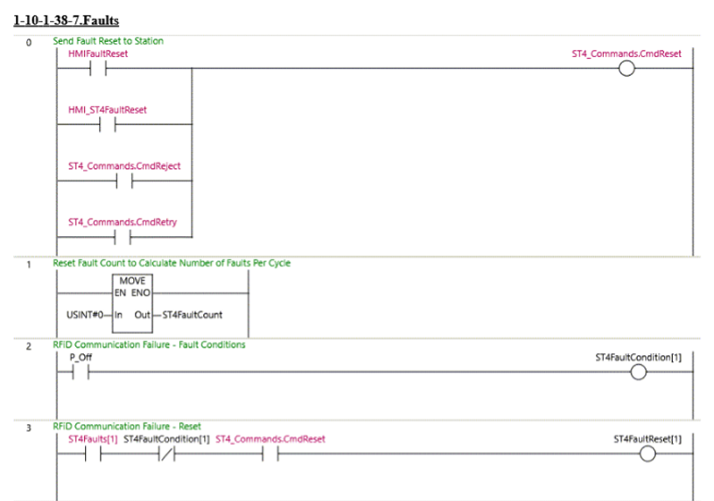
Figure 33 - PLC Fault Control

Overall, the PLC program provides coordinated control of the automated soldering system, ensuring reliable pallet positioning, correct sequencing of operations and safe interaction between the robot and production line.

3.5.5 System Integration and Communication

The automated soldering system was integrated using a PLC as the central controller, coordinating communication between components. It manages the soldering cycle, receives fault and completion signals, and interfaces with sensors for accurate pallet tracking and timing. The PLC also controls conveyor movement and pallet positioning to ensure correct operation.
It continuously monitors inputs and updates outputs to maintain synchronisation between the conveyor and robot. Process timing is managed to ensure correct sequencing, while data such as cycle times can be shared with higher-level systems for traceability and performance monitoring, ensuring reliable and coordinated operation.

3.6. System Testing

With the robot successfully integrated with the conveyor and the PLC program created and installed alongside the sensors and safety interlocks, the system needed to be put through testing to successfully validate the new process, ensuring operator safety and product quality.

3.6.1. Testing Strategy

To ensure the testing of the system is effective, it is crucial to ensure all areas are tested. To begin, the functionality of the components needs to be tested. This can be achieved by forcing the outputs from the PLC to visually see the components respond. The other test which is done is running the line, this is the most important test, running the line shows exactly how each component responds to the other components and ensures that the system is correctly integrated. This also proves that the robot is able to perform consistently over time and is able produce solder joints of the same quality consistently throughout the day.

3.6.2. Unit Testing

Unit testing was carried out to verify the correct operation of individual PLC outputs, sensors, and safety functions prior to full system integration. Output forcing was used within the PLC to manually activate devices such as stoppers, conveyor controls, and robot interface signals, confirming that each output responded correctly. Sensors were then tested by introducing a pallet to validate detection and ensure correct feedback to the PLC. The system was divided into pre-robot, robot, and post-robot sections, allowing each area to be tested independently. This ensured correct operation of pallet positioning, stopper activation, and safety interlocks within each section. The expected outcome was that all components would function as intended, which was confirmed during testing, with only minor adjustments required before progressing to full system testing.

3.6.3. System Integration Testing

System integration testing was conducted to ensure that all subsystems operated together as a coordinated process. This included interaction between the PLC, solder robot, sensors and the HMI. The main objective of this test is to ensure that communication between all components has functioned correctly and that the overall system performed as was intended.

Pallets were introduced to the system to verify that detection, stopping and soldering operations occurred in the correct order. The PLC required accurate control and timing between conveyor movement and robot operation, ensuring that the pallet was positioned correctly before initiating the solder cycle.

Error handling was tested by simulating various fault conditions, such as sensor failures and robot faults to ensure that the system responded correctly. This included stopping the process, triggering the alarms and preventing further operation until the fault was cleared. Successful integration testing confirmed that each of the subsystems operated reliably together, providing confidence in the overall system performance prior to full validation.

3.6.4. Usability and Acceptance Testing

The performance of the automated soldering system was evaluated under real production conditions to assess its ease of use for operators. The team leaders were shown how to read the HMI to silence alarms and reset the processes, the technicians where also shown how to read the error codes on the HMI for troubleshooting requirements. Positive feedback was received from the team leaders and technicians.

The line was then run using production parts allowing us to see the system working and allowing for the system to be validated. Focus was placed on the reliability of pallet detection, ensuring the pallets stopped when required and operations were carried out when required as shown in Figure 34.

Performance improvements were evaluated by comparing system operation before and after implementation. The introduction of the automated soldering reduced process variability and improved consistency, while also enabling more reliable tracking of process completion which can be seen in the data. The reduction of manual intervention and improved process control contributed to increased efficiency and a reduction in defects which support the overall process objectives.
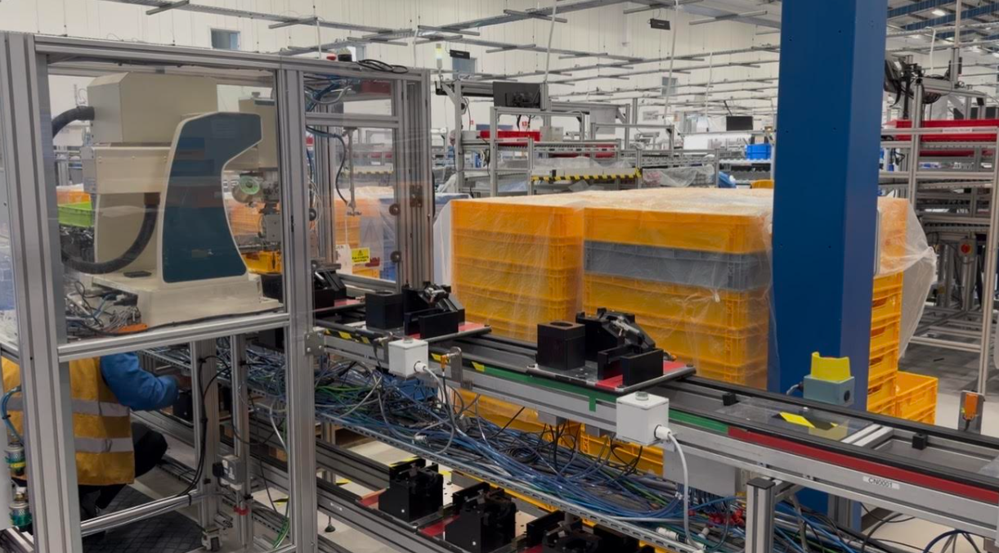
Figure 34 - Solder Robot Trial

3.6.5. Test Results Overview

System testing confirmed that the automated soldering system met the required functional and performance criteria. All subsystems, including the PLC, sensors, conveyor, and soldering robot, operated correctly with no critical faults observed. Testing verified correct pallet detection, sequencing, stopper control, and safety interlock operation, resulting in an overall system pass.

A significant improvement in performance was achieved, with the soldering cycle time reduced from 31.9 seconds to 11.56 seconds, representing a 63.8% reduction as discussed in Table 11 and Table 12. This increased production efficiency while improving process consistency and reducing reliance on manual operation. Key results can be presented using comparative tables or charts to clearly demonstrate the improvement in system performance.

3.7. Evaluation and Discussion

The automated soldering system successfully met its objectives of improving process consistency, reducing cycle time, and enhancing reliability. Testing confirmed that PLC integration enabled accurate sequencing and repeatable operation, addressing issues associated with manual soldering and reducing process variability.

The system performed well in areas such as pallet detection, stopper control, and synchronisation between the conveyor and robot. Minor improvements could include further optimisation of timing and enhanced traceability integration. These results align with literature showing that PLC-based automation improves reliability, reduces human error, and increases manufacturing consistency.

3.8. Summary

This chapter presented the design, implementation, and testing of the PLC-based automated soldering system. Key design decisions, including PLC control, RFID detection, and robot refurbishment, addressed issues related to manual soldering and process variability.

Testing confirmed improved process consistency, reduced cycle time, and enhanced reliability. The following chapter evaluates system performance and overall project outcomes.

Chapter 4: System Evaluation and Analysis

4.1. Introduction

This chapter analyses the results from the testing carried out in section 3.6. System Testing. This determines whether the aim and objectives set in Chapter 1 were met and also determines the success of the project. With the solder robot refurbished and implemented into the production line, the figures and data can accurately be pulled for analysis.

4.2. Evaluation Objectives

Looking at Chapter 1, five objectives were set. The first objective being to remove manual soldering from the process, to achieve this the auto solder robot was decided on, however it was planned to leave a couple of soldering stations available as a backup to avoid downtime if something went wrong with the solder robot.

The second objective was to reduce the number of reworked devices per year by 75%, this was aimed to be achieved by removing manual soldering and therefore having a more consistent and improved solder joint.

Third objective was to reduce annual cost of poor quality by 75%, this goes hand in hand with the reduction of reworked devices as it reduces the cost associated with additional labour cost as well as scrapping parts which can’t be reworked.

The fourth objective was to increase product quality which was aimed to be achieved by the improved quality of the solder joint provided by the robot.

Finally, increasing efficiency by 25%. This was aimed to be achieved by improving the time taken to carry out the soldering process.

4.3. Data Collection for Analysis

The best way to analyse the data for this project is to take data directly from the system which is collected by the PLC and sent to the Beckhoff IPLC which is then downloaded from Cayden’s system. The data taken from there is then compared against the data from before the project. Due to time limitations, only 3 weeks of data is available, and needs to be compared against the 8 weeks of data from Chapter 1.

4.4. Quantitative Results and Analysis

4.4.1. Data Analysis

Three weeks of data was taken from running the newly automated production line. The data was downloaded off the CyDen system and compared against the data shown in Chapter 1.

Table 13 - Data Comparison Pre-Automation vs Post-Automation
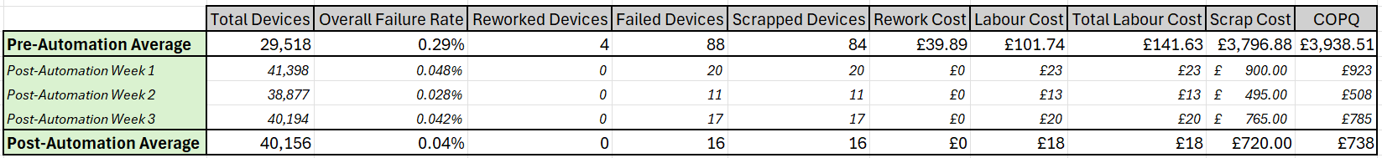

As shown in Table 13 is the comparison between the average data taken before and after the automation process. It clearly shows the results of the total devices able to be produced and the failure rate along with the associated cost of poor quality.

From this the comparison can be used to determine the success of the project and determine whether the objectives have been met.

4.4.2. System Performance Metrics

The data shown in Table 12 shows a 26.49% increase in production output which is smaller than the 63.76% decrease in cycle time shown above in Table 11. From the functional test timings, it was expected that a greater improvement in total devices would be seen, however, the functional test was carried out prior to the robot being integrated into the conveyor line, which wasn’t a true reflection. With the additional time taken for the stoppers to deactivate and the conveyor to move and the stoppers to then reactivate, the data in Table 12 is more realistic.
As shown in Figure 35, the number of devices throughput the production line on average per week is bigger after the automation system was input than it was beforehand, therefore proving that the objective of improving production efficiency has therefore been achieved.

Figure 35 - Graph showing average device throughput pre-automation and post-automation

As well as this, the automation has also allowed for no manual operations to be carried out which has therefore allowed for another objective to be met which is to remove all manual soldering operations.

4.4.3. Reliability and Error Rates

After completing two of the five objectives, the next objective is to reduce the number of devices reworked per week by 75%. Table 13 shows that over 3 weeks of data collection, there were 0 devices which required rework. Devices can require rework for a few issues; therefore, this data was only taken for devices which initially failed due to misfiring and required rework on soldering to ensure that the data remained relevant. Therefore, with a 100% reduction in reworked devices due to soldering, this objective is achieved.

The next objective to be achieved is to reduce COPQ associated with soldering issues by 75%, this is shown in Table 13 by looking at the failed devices, rework and labour cost. The average COPQ before automating the production line was £3,938.51 per week due to cost implications caused by soldering issues. With the automation in place, the weekly average COPQ is £738 per week, which is accumulated through scrapped devices and labour cost. This is a significant reduction of 81.26%. The failures seen in Table 13 were not directly related to soldering issues however, however, to maintain consistency in data they were kept in this data to match the data collected in chapter 1.

Finally, product quality. The final objective was to improve product quality, which can be tracked through failure rate. As shown in Table 13, the previous failure rate was at 0.29%, whereas the new failure rate has reduced by 86.2% and sits at 0.04%. This clearly shows that the quality of the product has improved since introducing the automated solder robot. Shown in Figure 36 is the reduction in failure rate.

Figure 36 - Calculated Failure Rate Before and After Automation

4.5. Qualitative Analysis (User Feedback)

With the data analysed and all objectives being met, it is just as important to gain feedback from the users. In this case, the operators do not directly use the solder robot as it is automated, therefore the most valuable feedback was obtained from the team leaders and engineering technicians who are responsible for maintaining the robot.

A questionnaire was created using Google Forms and sent out to all Engineering technicians and team leaders.

The main purpose of the questionnaire being to gauge how others think of the change to the production line and whether they are satisfied with the improvement. One of the first things noticed was that the users don’t agree that the automated machine has reduced their workload as much as originally thought as shown in Figure 37.

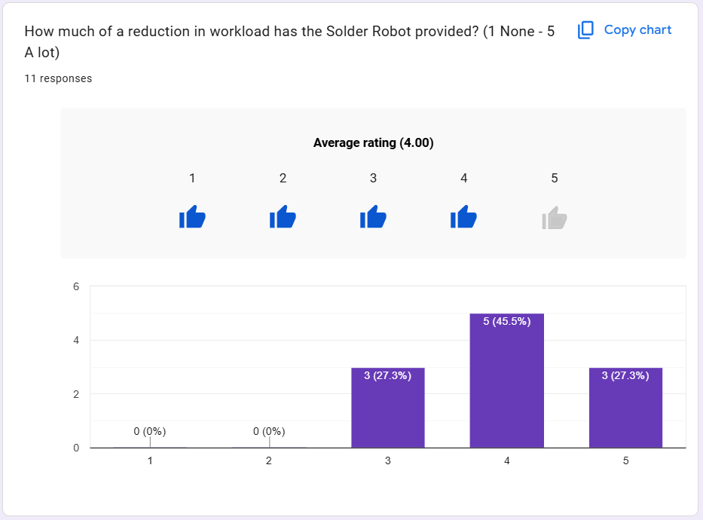
Figure 37 - Questionnaire response results – Question 2
This indicates that although there is no need to carry out solder activities, there is need to do other things which weren’t originally required such as cleaning and maintenance activities. Although the average score in the Likert scale was lower for this compared to others, Figure 38 still indicates that overall, the engagement from other CyDen employees is very positive.
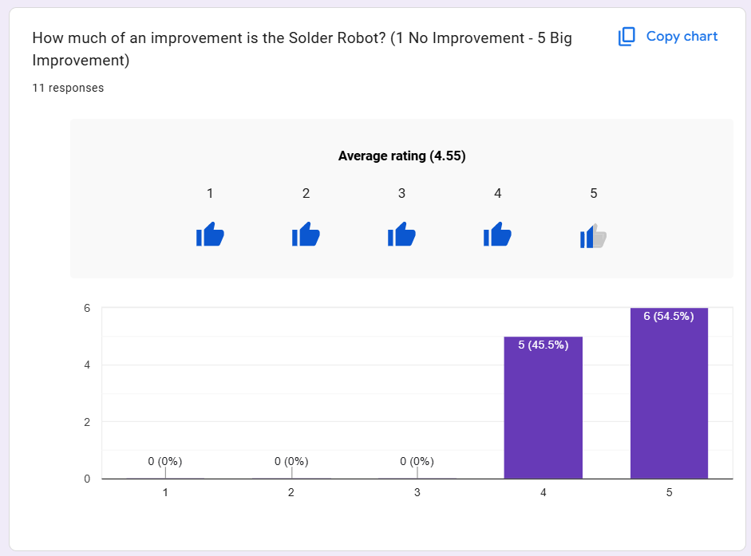
Figure 38 - Questionnaire response results - Question 4

4.6. Comparison with Literature Review

From the literature review in Chapter 2, it was clear that automating a process ensures it is a lot more reliable, efficient and controlled. It is clear from achieving the objectives that this is true. Due to the decrease in failure rate, it proves that the system has become a lot more reliable and controlled. Along with this, the efficiency is proven by being able to manufacture more devices per week.

As well as this, more traceability has been implemented with the RFID tags which has already proven to be very helpful with identifying issues related specifically to certain pallets. Therefore, the literature review was very beneficial as it provided great insight to what could be expected from the project.

4.7. Summary

To summarise, the automation project was a great success. The literature review provided insight to the benefits of automation and how it can improve processes in more ways than one, this was proven with the data that was taken from the CyDen system as it proves that the automation has benefited the process in the ways that the literature review predicted. The data also shows that the objectives have been met which is the core reason that this project was a success. From some employee feedback, it was also shown that others agree that the solder robot is a good improvement to the process.

Chapter 5: Project Evaluation

5.1. Introduction

This chapter evaluates the project and its outcome to compare how the project became a success and what occurred throughout the project which could have been a threat to the success of the project.

5.2. Comparison of Results with Objectives
To begin, the objectives have been revisited to evaluate how these were achieved.

Table 14 - Objective completion evidence
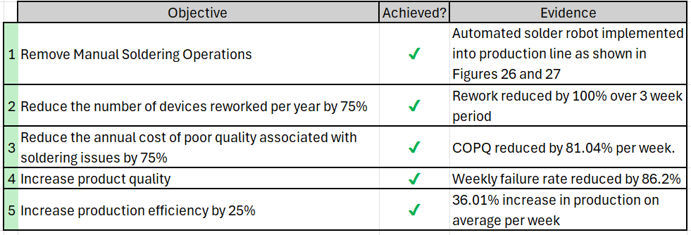

As shown in Table 14, all five objectives have been achieved with the sufficient evidence to support it.

5.3. Alignment with the Project Aim

The project aim was to implement a PLC controlled Soldering Robot to automate the soldering process of the production line. This was successfully achieved by integrating the soldering robot into the main production line to eliminate the manual soldering stations from the process altogether. With the use of a Omron PLC, this was achieved and a suitable program was written to ensure the system had full traceability by using RFID sensors on the pallets and integrating with Beckhoff IPLCs which provide data to CyDens system.

5.4. Comparison with Literature and Industry Practice

As previously discussed in 4.6. Comparison with Literature Review, the literature review proved to be very beneficial for the project as it provided good insight into how the data was going to react to the automation implementation. By researching various components such as the RFID sensors, it allowed for a more educated design to be created to allow for a better performing process and ensured that all components chosen were able to integrate with each other. Chapter 2: Research and Literature Review also provided confidence in the direction that the project was heading in by supporting theories that automating the process would allow for a fully traceable and controlled process.

5.5. Critical Evaluation of Methods Used

The methodology used to continuously trial the solder robot as it was being developed was a good idea as it ensured that issues were identified and corrected before too much work and time was invested into the project. Carrying out an offline test on the electrical panel proved that it was correctly connected by identifying inputs and outputs. It was also very beneficial to force the inputs and outputs on the PLC as it highlighted any unidentified issues with the program. This provided greater confidence in the system before going ahead with our full trial and finally handing the production line over to production.

5.6. Discussion of Unexpected Results

Although a few unexpected and unforeseen events took place throughout the project, there were not many outcomes which weren’t expected from the research in Chapter 2. One of the main issues experienced was with the solder feeder, which occasionally disconnects from the feeder which if unnoticed would cause a device to continue through the line without a soldered connection.

5.7. Reflection

Since the beginning of the project there was a major unforeseen change to the project which changed the scope and therefore had a big impact on the project plan and was a threat to the deadline. Had more research been conducted at the start of the project, this could have been implemented into the plan and included into the project scope. In future, it would be a lot more beneficial to carry out more research at the beginning and not throughout the project design stage.

5.8. Limitations of the Project

The main limitation of this project was restricted time. Due to scope change half way through the project, deadlines where at risk which meant the work was having to be split between day shift and afternoon shift. This meant that on occasion, insufficient handovers would be provided meaning time would be lost trying to find out what work had been completed. Another limitation was the availability of the production line, to ensure that production where able to fulfil orders, it was crucial that the testing was carried out at agreed times which sometimes would mean trials were rushed or opportunities were missed to perfect certain aspects such as timings set by the PLC.

5.9. Professional, Ethical and Management Considerations

5.9.1 Ethical Considerations

This project has been conducted in accordance with professional engineering standards. The primary ethical considerations relate to product safety, data integrity, and responsible implementation of automation. The automated soldering system directly improves product safety by reducing misfiring faults, which could otherwise pose a risk to end users. No personal or sensitive data was collected during this project; however, production data handled by the PLC system was managed securely and used solely for process improvement. All work aligns with professional codes of conduct, ensuring honesty, integrity, and responsibility in engineering practice.

5.9.2. Risk Management

A structured risk-based approach was applied throughout the project. Key risks included equipment failure due to the refurbishment of legacy machinery, integration challenges with existing production systems, and potential safety hazards associated with automated machinery. These risks were mitigated through staged testing (unit, integration, and system testing), compliance with safety standards (e.g., interlocks and emergency stops), and collaboration with engineering teams. Residual risks were minimised through validation and verification processes prior to full deployment.

5.9.3. Equality, Diversity and Inclusion

The system was designed to support an inclusive working environment by reducing reliance on manual, repetitive soldering tasks. Automation minimises operator fatigue and skill dependency, allowing a wider range of employees to operate the system through a simplified HMI interface. This promotes accessibility, reduces physical strain, and supports fair working conditions across the production environment.

5.9.4. Quality Management and Continuous Improvement

This project aligns with quality management principles by focusing on defect reduction, process standardisation, and continuous improvement. The implementation of automated soldering, combined with PLC control and traceability, supports a more consistent and repeatable manufacturing process. The system enables better monitoring of process parameters and facilitates ongoing improvements through data-driven decision making, consistent with industry quality frameworks.

5.9.5. Engineering Management and Commercial Context

The project demonstrates the application of engineering management principles, including cost analysis, resource utilisation, and process optimisation. A key driver was the reduction of the annual cost of poor quality, estimated at over £200,000. The decision to refurbish existing equipment rather than purchase new machinery reflects cost-effective engineering practice. The project also considered production efficiency, labour reduction, and return on investment, ensuring alignment with business objectives.

5.10. Chapter Summary

In summary, the project successfully delivered an automated solder process which met each of its core objectives and demonstrated improvements with reliability and traceability. There were a few limitations and lessons learned throughout the project, but it was still delivered by reviewing literature and using best engineering practices.

Chapter 6: Project Conclusion and Reflection

6.1. Introduction

This final chapter of the report focuses on concluding the project by showing how the plan changed throughout the project and how the project developed over time. It also reflects on experiences and challenges faced throughout.

6.2. Progress and Timeline

Shown below in Figure 39 is the original deadlines for the tasks decided at the beginning of the project. This shows a simple and achievable plan for completing the project comfortably.

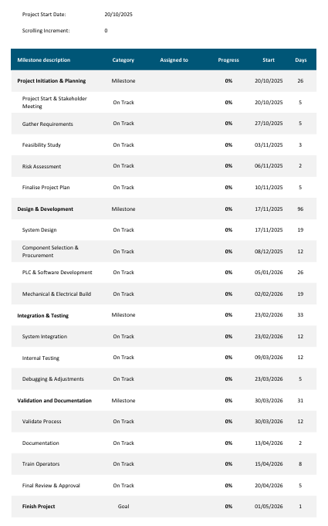
Figure 39 - Original Gantt Chart Tasks and Deadlines
With unforeseen scope change such as refurbishing the solder robot, this needed to be fit into the plan. This comes with numerous risks as it could affect the overall deadline and be a huge risk to the success of the whole project.

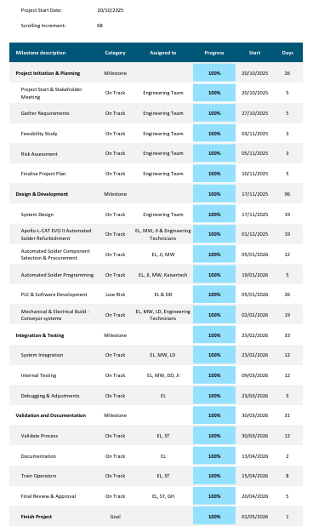
Figure 40 – Updated Gantt Chart Tasks and Deadlines

The Gantt chart in Figure 40 shows the changes which occurred throughout the project. The main change is the Apollo-L-CAT Automated Solder refurbishment task which came into the project after the original plan. This required more team members to be brought into the project and for the task to be carried out over two shifts to ensure that the task was completed as quick as possible to not impact other tasks. However, the refurbishment task did impact the PLC development which required sections of the task to be divided between 2 team members.

Other than this, the agreed plan was achieved, and no additional issues occurred with deadlines, allowing for the project to be completed ahead of schedule.

6.3. Personal and Professional Growth

This project provided significant opportunities for personal and professional development. Starting early in my time at CyDen, it allowed me to build confidence while gaining valuable knowledge of unfamiliar processes, which will support future projects. I also improved my ability to collaborate across different shifts, highlighting the importance of clear and effective handovers to maintain continuity of work. Additionally, the project strengthened my time management skills, enabling me to effectively balance tasks and meet project deadlines.

6.4. Future Work/Recommendations

For future improvements, the main improvement which would be reasonably simple to implement is improving the PLC timings. As previously mentioned, there was not enough time to trial the system on the line to reduce timings to make the process even more efficient. Another improvement which can be made is more detailed error messages, there are a lot of failure modes which can occur during the test period of this process, this will be a huge help for future troubleshooting.

6.5. Final Conclusion

To finally conclude the overall project, it was a great success. From beginning with data analysis to identify a critical area which is costing the company over £204,800 is cost of poor quality per year due to misfiring issues caused by manual soldering operations to carrying out appropriate research relating to the brief given by the engineering manager to automate the process. This allowed for achievable objectives to be set to achieve the overall aim of the project to be achieved.

With the objectives and research carried out, an accurate plan was created to ensure tasks were completed in time to not extend the deadline. With changes to the scope, such as needing to refurbish a previously used soldering robot, it required more attention to allocating tasks to other members of the team, especially when deadlines where approaching.
With the successful implementation of the solder robot and a PLC program, it was evident that the research was useful as it predicted that the task would allow for each of the objectives to be completed.

The final result of the project was an improvement in product quality, thanks to the consistency of the solder application which resulted in a reduction of reworked devices, and a reduction in cost of poor quality over the year, resulting in a new annual cost of poor quality of £38,376 proving that automation is a great improvement for production lines and all manufacturing industries.

References

[1] G. Hopkins and S. Thomas, “CyDen processes and IPL working principles presentation,” Nov. 05, 2025.
[2] L. Morris and S. Thomas, “Definition of misfiring in IPL Devices,” Nov. 2025.
[3] M. Judd and K. Brindley, Soldering in Electronics Assembly. Elsevier, 1999.
[4] C. Coombs, Coombs’ Printed Circuits Handbook. McGraw Hill Professional, 2001.
[5] F. D. Petruzella, Programmable Logic Controllers. McGraw-Hill Science, Engineering & Mathematics, 1996.
[6] F. Lamb, Industrial Automation: Hands On. S.L.: Mcgraw-Hill Professional, 2019.
[7] M. P. Groover, Automation, production systems, and computer-integrated manufacturing. Ny Ny: Pearson Education, Inc, 2019.
[8] Prof. Dr. H. Kagermann, Prof. Dr. W. Wahlster , and Dr. J. Helbig, “Securing the future of German manufacturing industry Recommendations for implementing the strategic initiative INDUSTRIE 4.0 Final report of the Industrie 4.0 Working Group,” 2013.
[9] Robots Done Right, Factory Robots. 2018.
[10] A. Fang, V. Chen, and M. A. McDonald, “Breaking down the impact of automation in manufacturing,” Aug. 2023.
[11] I. Ilevbare, D. Khripko, T. McKeon, S. Salih, and N. Athanassopoulou, “MANUFACTURING TRENDS AND DRIVERS OVER THE NEXT 5 YEARS AND BEYOND,” Nov. 2024.
[12] R. WILD, “Mass production in engineering∗,” International Journal of Production Research, vol. 12, no. 5, pp. 533–545, Jan. 1974, doi: https://doi.org/10.1080/00207547408919573.
[13] P. S. Adler, “Managing Flexible Automation,” California Management Review, vol. 30, no. 3, pp. 34–56, Apr. 1988, doi: https://doi.org/10.2307/41166513.
[14] A. Medisetty, “Intelligent Data Flow Automation for AI Systems via Advanced Engineering Practices,” International Journal of Computational Mathematical Ideas, vol. 13, no. 01, pp. 957–968, 2021, doi: https://doi.org/10.70153/ijcmi/2021.13101.
[15] Beena Puthillath, Mahmoud M.S. Albattah, C. Manjunath, N.N. Wasatkar, V.J. Vijayalakshmi, and L. Verma, “Leveraging Big Data Analysis in Real-Time Automation for Improved Operational Efficiency,” 2022 13th International Conference on Computing Communication and Networking Technologies (ICCCNT), vol. 01, no. 01, pp. 1–6, Jun. 2024, doi: https://doi.org/10.1109/icccnt61001.2024.10725654.
[16] H. Mishra, “PLC BASICS COURSE,” 2005.
[17] E. Talova, “Introduction to PLC,” SSRN Electronic Journal, 2019, doi: https://doi.org/10.2139/ssrn.3668699.
[18] E. Estévez, M. Marcos, and D. Orive, “Automatic generation of PLC automation projects from component-based models,” The International Journal of Advanced Manufacturing Technology, vol. 35, no. 5–6, pp. 527–540, Jul. 2007, doi: https://doi.org/10.1007/s00170-007-1127-4.
[19] M. G. Hudedmani, R. M. Umayal, S. K. Kabberalli, and R. Hittalamani, “Programmable Logic Controller (PLC) in Automation,” Advanced Journal of Graduate Research, vol. 2, no. 1, pp. 37–45, May 2017, doi: https://doi.org/10.21467/ajgr.2.1.37-45.
[20] A. Al Fahim, M. Mizanur Rahman, M. W. Hridoy, and K. R. Uddin, “Development of a PLC Based Automation Cell for Industry,” Journal of Integrated and Advanced Engineering (JIAE), vol. 3, no. 2, pp. 87–100, Sep. 2023, doi: https://doi.org/10.51662/jiae.v3i2.94.
[21] B. Tomar, N. Kumar, and M. Sreejeth, “Real Time Automation and Ratio Control Using PLC & SCADA in Industry 4.0,” Computer Systems Science and Engineering, vol. 45, no. 2, pp. 1495–1516, 2023, doi: https://doi.org/10.32604/csse.2023.030635.
[22] Z. Lin and S. Pearson, “An inside look at industrial Ethernet communication protocols Strategic Marketing Manager Texas Instruments,” 2018.
[23] G. Thomas, “Introduction to the Modbus Protocol,” 2008. Available: https://www.ccontrols.com/pdf/Extv9n4.pdf
[24] P. Brooks, “Ethernet/IP -Industrial Protocol,” 2002. Accessed: Jan. 08, 2026. [Online]. Available: https://web.archive.org/web/20170808195536id_/http://www.rockwellautomation.com/resources/downloads/rockwellautomation/pdf/industries/water-wastewater/enetip.pdf
[25] S. Cavalieri and F. Chiacchio, “Analysis of OPC UA performances,” 2010. Available: https://www.researchgate.net/profile/F-Chiacchio/publication/259134481_Analysis_of_OPC_UA_performances/links/5b9cbff092851ca9ed0ab273/Analysis-of-OPC-UA-performances.pdf
[26] P. G. Lee, “A review of automated control systems for aquaculture and design criteria for their implementation,” Aquacultural Engineering, vol. 14, no. 3, pp. 205–227, Jan. 1995, doi: https://doi.org/10.1016/0144-8609(94)00002-i.
[27] G. Dunning, “INTRODUCTION TO PROGRAMMABLE LOGIC CONTROLLERS Second Edition Introduction to Programmable Logic Controllers, Second Edition,” 2020.
[28] S. F. Barrett and D. J. Pack, Microcontrollers Fundamentals for Engineers and Scientists. Springer Nature, 2022.
[29] F. Eisinger, “Les experts médicaux, entre éthique personnelle et enjeux financiers,” Après-demain, vol. N ° 22, NF, no. 2, pp. 8–10, Apr. 2012, doi: https://doi.org/10.3917/apdem.022.0008.
[30] V. Magar and V. Shinde, “Application of 7 Quality Control (7 QC) Tools for Continuous Improvement of Manufacturing Processes,” International Journal of Engineering Research and General Science, vol. 2, no. 4, 2014.
[31] M. J. Cheng and J. E. L. Simmons, “Traceability in Manufacturing Systems,” International Journal of Operations & Production Management, vol. 14, no. 10, pp. 4–16, Oct. 1994, doi: https://doi.org/10.1108/01443579410067199.
[32] K.-S. Wang, “Intelligent and integrated RFID (II-RFID) system for improving traceability in manufacturing,” Advances in Manufacturing, vol. 2, no. 2, pp. 106–120, Feb. 2014, doi: https://doi.org/10.1007/s40436-014-0053-6.
[33] I. Kavasidis, E. Lallas, G. Mountzouris, V. C. Gerogiannis, and A. Karageorgos, “A Federated Learning Framework for Enforcing Traceability in Manufacturing Processes,” IEEE Access, vol. 11, pp. 57585–57597, 2023, doi: https://doi.org/10.1109/access.2023.3282316.
[34] A. Grochowski, D. Bhattacharya, T. R. Viswanathan, and K. Laker, “Integrated circuit testing for quality assurance in manufacturing: history, current status, and future trends,” IEEE Transactions on Circuits and Systems II: Analog and Digital Signal Processing, vol. 44, no. 8, pp. 610–633, 1997, doi: https://doi.org/10.1109/82.618036.
[35] G. Implementing Quality, Throughout, Enterprise, and Production Process, “Journal of Information Technology Management A Publication of the Association of Management IMPLEMENTING QUALITY GATES THROUGHOUT THE ENTERPRISE IT PRODUCTION PROCESS,” Journal of Information Technology Management, vol. XXII, no. 1, 2011.
[36] T. Wuest, A. Liu, C.-Y. Lu, and K.-D. Thoben, “Variety Management in Manufacturing,” 2014, doi: https://doi.org/10.1016/j.procir.2014.01.071.
[37] V. Hirsch, P. Reimann, O. Kirn, and B. Mitschang, “Analytical Approach to Support Fault Diagnosis and Quality Control in End-Of-Line Testing,” Procedia CIRP, vol. 72, pp. 1333–1338, 2018, doi: https://doi.org/10.1016/j.procir.2018.03.024.
[38] J. Neubert and H. Lipson, “Soldercubes: a self-soldering self-reconfiguring modular robot system,” Autonomous Robots, vol. 40, no. 1, pp. 139–158, Jul. 2015, doi: https://doi.org/10.1007/s10514-015-9441-4.
[39] M. Liukkonen, “Intelligent Methods in the Electronics Industry Quality Analysis of Automated Soldering,” 2010.
[40] J. Liu, S. Wu, Z. Lin, H. Zhang, Y. Fan, and W. Xie, “Design and implementation of power socket soldering robot arm system,” Journal of Physics: Conference Series, vol. 2816, no. 1, p. 012072, Aug. 2024, doi: https://doi.org/10.1088/1742-6596/2816/1/012072.
[41] Apollo Seiko, “L-CAT EVO-Ⅱ Iron Tip Soldering Robot,” 2025.
[42] Y. Gao, Z. Chen, J. Lin, X. Li, and Y.-H. Liu, “Development of an automated system for the soldering of USB cables,” Robotics and Computer-Integrated Manufacturing, vol. 79, p. 102440, Feb. 2023, doi: https://doi.org/10.1016/j.rcim.2022.102440.
[43] N. Mar, C. Fookes, and P. Yarlagadda, “Design of automatic vision-based inspection system for solder joint segmentation Analysis and modelling,” 2009.
[44] T. Wenger et al., “The automated system for technological process of spacecraft’s waveguide paths soldering You may also like Reflow soldering for low-cost electronics using near-infrared LEDs Research on Thermal Simulation Improving the Components’ Soldering Quality in Electronic Module Joint characteristics of ultrasonic welded CC bridge joints for HTS coil applications The automated system for technological process of spacecraft’s waveguide paths soldering,” The automated system for technological process of spacecraft’s waveguide paths soldering, vol. 01, no. 01, 2016, doi: https://doi.org/10.1088/1757-899X/155/1/012007.
[45] P. Cheng, “PROFESSIONAL LEARNING COMMUNITY (PLC): TECHNOLOGY INTEGRATION AT A TITLE I ELEMENTARY SCHOOL A Dissertation Presented to The Faculty of the Educational Doctoral Program in Educational Leadership,” 2017.
[46] S. Kobori and A. Noda, “Case Study on Traceability Application of PLC Unit with Embedded Script Engine,” 2005.
[47] J. O. Grady, System Integration. CRC Press, 2019.
[48] K. Nakatani, T.-T. Chuang, and D. Zhou, “Data Synchronization Technology: Standards, Business Values and Implications,” Communications of the Association for Information Systems, vol. 17, 2006, doi: https://doi.org/10.17705/1cais.01744.
[49] B. Wu, T. Jiang, Z. Yu, Q. Zhou, J. Jiao, and Ming Liang Jin, “Proximity Sensing Electronic Skin: Principles, Characteristics, and Applications,” Advanced Science, vol. 11, Jan. 2024, doi: https://doi.org/10.1002/advs.202308560.
[50] Y.-X. Guo, C. Lai, Z.-B. Shao, K.-L. Xu, and T. Li, “Differential Structure of Inductive Proximity Sensor,” Sensors, vol. 19, no. 9, p. 2210, May 2019, doi: https://doi.org/10.3390/s19092210.
[51] Keyence, “What is a inductive proximity sensor? | Sensor Basics: Principle-based Guide to Factory Sensors | KEYENCE,” www.keyence.co.uk, 2024. https://www.keyence.co.uk/ss/products/sensor/sensorbasics/proximity/info/
[52] R. Want, “RFID is at a critical price point that could enable its large-scale adoption. What strengths are pushing it forward? What technical challenges and privacy concerns must we still address? About the Review Process,” 2006.
[53] P. Kumar, H. W. Reinitz, J. Simunovic, K. P. Sandeep, and P. D. Franzon, “Overview of RFID Technology and Its Applications in the Food Industry,” Journal of Food Science, vol. 74, no. 8, Oct. 2009, doi: https://doi.org/10.1111/j.1750-3841.2009.01323.x.
[54] RS, “Proximity Sensors - A Complete Guide,” uk.rs-online.com, Jan. 24, 2023. https://uk.rs-online.com/web/content/discovery/ideas-and-advice/proximity-sensors-guide
[55] SICK, “IME18-08BPSZC0S IME INDUCTIVE PROXIMITY SENSORS,” 2022.
[56] IFM, “Proximity Sensors: Detect Without Contact,” Ifm.com, 2025. https://www.ifm.com/gb/en/gb/landing-page-uk/proximity-sensors-explained-types-applications-and-benefits
[57] WASP Barcode Technologies, “Advantages of 2D Barcode,” Wasp Barcode Technologies, 2015. https://www.waspbarcode.com/buzz/advantages-of-2d-barcodes
[58] Cognex, “2D Barcodes Explained: From QR Codes to Data Matrix and More,” Cognex.com, Oct. 30, 2025. https://www.cognex.com/en/tools-and-resources/resource-center/2d-barcodes-explained-from-qr-codes-to-data-matrix-and-more (accessed Feb. 22, 2026).
[59] Peak Technologies, “RFID vs Barcode - Advantages, Disadvantages & Differences,” Peak Technologies, Nov. 21, 2019. https://www.peaktech.com/blog/rfid-vs-barcode-comparison-advantages-disadvantages/
[60] Barcode Warehouse, “10 examples of RFID technology in everyday life,” Thebarcodewarehouse.co.uk, 2022. https://www.thebarcodewarehouse.co.uk/blog/10-examples-of-how-rfid-technology-is-used-in-everyday-life/
[61] History of Simple Things, “What Is RFID and How Does It Work?,” YouTube, Jan. 25, 2026. https://www.youtube.com/watch?v=m5wQyRxtHI4 (accessed Feb. 22, 2026).
[62] IFM, “RFID sensors - ifm,” Ifm.com, 2026. https://www.ifm.com/gb/en/category/230_010_040_020#/best/1/50 (accessed Feb. 22, 2026).
[63] RFID 4 u, “​What Are RFID Tags and Why You Should Use Them,” RFID4USTORE, 2026. https://rfid4ustore.com/rfid-blog/what-are-rfid-tags-and-why-you-should-use-them/
[64] Japan UNIX, “Gantry Soldering Robot | Japan Unix - Automated Soldering Robot Manufacturer,” Japan Unix - Automated Soldering Robot Manufacturer, Nov. 06, 2019. https://www.japanunix.com/en/products/automation/gf-series/ (accessed 2026).
[65] Japan UNIX, “Gantry Soldering Robot | Japan Unix - Automated Soldering Robot Manufacturer,” Japan Unix - Automated Soldering Robot Manufacturer, Nov. 06, 2019. https://www.japanunix.com/en/products/automation/gf-series/#01 (accessed Feb. 22, 2026).
[66] E. II, “Apollo Seiko,” Apollo Seiko, Jun. 05, 2017. https://www.apolloseiko.com/products/l-cat-evo-ii (accessed Feb. 22, 2026).
[67] Apollo Seiko, “L-CAT-EVO4330 L-CAT-EVO4430 L-CAT-EVO4540 Operation and Maintenance Manual,” 2012.
[68] Shenzhen Hansome Technology Co.,Ltd., “5 Axis Soldering Robot HS-S5331R,” 2019.
[69] Japan UNIX, “Soldering: UNIX-DF304S,” 2020.
[70] Omron, “Programmable Logic Controllers (PLC),” industrial.omron.co.uk, 2024. https://industrial.omron.co.uk/en/products/programmable-logic-controllers
[71] Omron, “CP-series CP1E CPU Units CP1E-E@@SD@-@ CP1E-N@@S@D-@-@ CP1E-E@@D@-@ CP1E-N@@D@-@/NA20D@-@ The CP1E Programmable Controller: Economical, Easy to use, and Efficient,” 2023. Available: https://files.omron.eu/downloads/latest/datasheet/en/p061_cp-series_cp1e_cpu_units_datasheet_en.pdf?v=1
[72] Siemens, “SIEMENS Simatic S7 - DREAMland PLC,” Dreamland-plc.com, 2020. https://dreamland-plc.com/info/8/siemens-simatic-s7?gad_source=1&gad_campaignid=20546062242&gbraid=0AAAAAp0Ru1IQDhhyNOUko05KOyfe2D51H&gclid=Cj0KCQiA7-rMBhCFARIsAKnLKtB99mU6JBDKMj_N85UFKxtl7eOSDdin9dlE88fV6rBRKebD9RE7N3caAqzhEALw_wcB (accessed Feb. 22, 2026).
[73] Siemens, “Data sheet 6ES7211-1AE40-0XB0 Subject to change without notice © Copyright Siemens,” 2024. Accessed: Feb. 22, 2026. [Online]. Available: https://docs.rs-online.com/1b13/0900766b81639d61.pdf
[74] Allen Bradley, “Micro800® PLC Family Featuring Allen-Bradley® Connected Components WorkbenchTM Design and Configuration Software,” 2024. Available: https://docs.rs-online.com/c09f/0900766b81447272.pdf
[75] Operations 1, “Factory Acceptance Test (FAT) | Operations1,” Operations1, 2024. https://operations1.com/en/glossary/factory-acceptance-test
[76] Zero Instrument, “application of electromagnetic flow meter in wastewater treatment - Just Measure it,” Just Measure it, May 2022, doi: https://doi.org/10811793894/oeWNCIX2lqQDEObDu6Mo.
[77] K. Arendt, “Overcurrent Protection and Overcurrent Protection Devices,” www.mechprod.com, 2021. https://www.mechprod.com/blog/overcurrent-protection-and-overcurrent-protection-devices
[78] L. Eitel, “Basic Understanding of Safety Circuits,” DigiKey, Apr. 27, 2020. https://www.digikey.co.uk/en/articles/basic-understanding-of-safety-circuits?srsltid=AfmBOopRH9rdAydk_I0Mrhsozxcii_IpSgJA6DTLqkTCuJPYVMnIrVO3 (accessed Mar. 09, 2026).
[79] IEC, “IEC 60204-1 INTERNATIONAL STANDARD Safety of machinery -Electrical equipment of machines - Part 1: General requirements INTERNATIONAL ELECTROTECHNICAL COMMISSION,” 2016.
[80] ISO, “Safety of machinery -Emergency stop function -Principles for design Sécurité des machines -Fonction d’arrêt d’urgence -Principes de conception,” 2015.
[81] ISO, “Safety of machinery -Safety-related parts of control systems - Part 1: General principles for design,” 2023.
[82] BSI, “BSI Standards Publication Safety of machinery -Electrical equipment of machines,” 2018.
[83] GAMBICA Technical Guide, “GAMBICA Technical Guide LOW-VOLTAGE POWER SWITCHGEAR AND CONTROLGEAR ASSEMBLIES,” 2013.
[84] E. Co., “Power Supply Functional Testing,” Prodigit.com, Dec. 22, 2019. https://www.prodigit.com/show/power-supply-functional-testing.htm
[85] IEC, “INTERNATIONAL STANDARD NORME INTERNATIONALE Industrial systems, installations and equipment and industrial products - Structuring principles and reference designations - Part 2: Classification of objects and codes for classes Systèmes industriels, installations et appareils, et produits industriels - Principes de structuration et désignations de référence - Partie 2: Classification des objets et codes pour les classes,” 2019.
[86] L. B. Gardner and Astm Committee E-31 On Computerized Systems, Automated manufacturing : a symposium. Philadelphia, Pa.: Astm, 1985.
[87] A K Gupta, (College Teacher Of Mechanical Engineering, J. R. Westcott, and S. K. Arora, Industrial automation and robotics. New Delhi: University Science Press, 2017.
[88] M. Costanzo, Programmable logic controllers : the industrial computer. London ; New York: Arnold, 1997.
[89] W. Klippel, “End-Of-Line Testing,” Sep. 2018.
[90] TMS Virdi, “Soldering Robot and Types Everything you need to know about a Soldering Robot,” Nov. 2019.
[91] A. Mousavi, M. Danishvar, and A. Spieser, “Programmable logic controller 2 Programmable Logic Controller (PLC),” Mar. 2014.
[92] B. Daniel, “SYNCHRONIZATION USING PLC,” 2015.

Supporting Documents

[A] Gantt Chart
[B] PLC Program
[C] Questionnaire Feedback

