Creativity and Innovation Report
An Innovative Solution for Seren Coffi
Module: BMSW5013 Creativity and Innovation
BA (Hons) Developing Leadership and Management
Word Count: 4,102 words
Submitted by: 2123934
March 2026

Executive Summary
Seren Coffi, is an independent coffee shop in Cardiff, facing a critical sustainability challenge, with rising costs, declining event attendance, and decision-making paralysis amongst its three founders. This situation has created a scenario where closure is likely is inevitable without intervention. This report proposes a Community Partnership Subscription Model as the most viable path forward.
Through analysis using Tidd and Bessant's (2018) 4 P's framework, this innovation is classified as primarily position innovation. Lewin's (1951) Force Field Analysis identifies decision-making paralysis as the most significant implementation barrier. Amabile et al.'s (1996b) climate assessment suggests moderate implementation likelihood contingent on addressing governance issues.
The recommendation suggests that the founders launch a phased subscription programme within 30 days, targeting 20 existing regular patrons at £15-20 per month. This is based on three findings: Seren Coffi generates community value not captured in its revenue model; position innovation requires less capital than alternatives; and the founders' decision-making must be restructured with operational decisions delegated to other parties.

1. Introduction to the Organisation and My Role

1.1 How I Came to Work with Seren Coffi
The first time I walked into Seren Coffi happened to be a grey Tuesday morning in November 2025 and was struck by the decor, which reminded me of a place I had visited with my late father in Paris, though the reclaimed chapel pews were distinctive, with the number of conversations happening simultaneously within that space made the three tables which had laptops opened, while two elderly men who were arguing about rugby in Welsh, and the student who was writing poetry by the window, feel like the right and proper atmosphere to hang around with friends and acquittances’.
Anwen, who is one of the founders, explained their situation stating that they had first opened in February to the public with high hopes, but by November, energy bills had jumped and coffee bean prices had risen beyond expectation. The collaborative decision-making process that had initially felt democratic as of February now felt like a trap, so I then agreed to take on a consultancy role, while attending meetings in the evenings and observing operations for three months.

1.2 What I Have Observed
At the onset the three founders started by rotating shifts behind the counter, which was meant to keep everyone grounded and connected to day-to-day reality of the business, meaning no singular person is saddled with the responsibility of taking business decisions but rathe we all work in the business during work hours and leave decision making to much more later in the day which is after the close of business with same issues being raised every other day without coming to a conclusion as meetings are constantly adjourned.
On average customers stay about 45 minutes, longer than average, which adds up to being both a strength (community atmosphere) and weakness (table turnover). About a dozen of the regulars come in more than three times a week. The £2,000 in petty cash is very realistic. The unreplaced grinder, cancelled poetry nights, and chalkboard that no longer gets updated on a daily basis are a visible symptom of the problem depth: the founders seem exhausted, and their decision-making process is somewhat broken down.

1.3 Why This Matters
This is an open disclosure I should state; I am not a disinterested analyst. I have come to know the founders and genuinely want survival and sustenance of Seren Coffi as an ongoing entity and this shapes my analysis. I am looking for solutions that preserve what makes the place distinctive, rather than purely profit-maximising options.
As noted, a hospitality group had approached them in late 2025 offering more capital and operational support but the founders discussed it for weeks unending and were never able to make a decision. Haven observed that process convinced me that any viable solution must work within their existing governance structure, because it’s very unlikely to change.

2. Critical Analysis of Creativity and Innovation in the Sector

2.1 What I Observed About Customer Behaviour
During my due diligence I spent several mornings in December watching customers and one thing became clearer: people were not choosing Seren Coffi for coffee quality alone. I had once meet this customer who walked pass Costa, closer to where her car was parked, to come to Seren Coffi, when I inquired from her on reasons why she patronised Seren Coffi, she simply stated: 'I know the coffee will be decent, but I also know I can sit here for an hour and nobody will rush me out.' This is the insight Tidd and Bessant (2018) capture when they argue that service sector innovation often manifests through customer experience rather than product changes.
Of note, Seren Coffi was not capturing value from that experience. The customer who stays for an hour buys one coffee. The atmosphere she values generates no direct revenue, to which this is one of the identified gaps the proposed innovation tries to address.2.2 Creativity Versus Innovation: What Failed at Seren Coffi

2.2 Creativity Versus Innovation: What Failed at Seren Coffi
Amabile (1996a) distinguishes creativity (novel and useful ideas) from innovation (successful implementation). Seren Coffi's pay-what-you-can evenings were creative. They responded to the cost-of-living crisis and aligned with founder values. But they were not innovative because they never became sustainable. When I asked Anwen why they stopped the poetry nights, she said: 'They took so much energy to organise, and we were losing money on them.' This is the creativity-innovation gap in practice. George (2007) argues that Amabile's model underemphasises organisational constraints, which I see at Seren Coffi daily.

2.3 Why Small Hospitality is Different
Ottenbacher and Harrington's (2007) research on Michelin-starred restaurants felt distant from Seren Coffi's reality. Those chefs had teams and budgets. Seren Coffi has three exhausted founders and £2,000. More relevant is research on micro-enterprises. Lynch (2005) writes about small hospitality businesses as 'sociological impressionisms', enterprises shaped by personal relationships rather than formal systems. Rauch et al. (2020) note that small firms face distinctive barriers: limited capital, time pressures, skill gaps. I see all three at Seren Coffi.

2.4 Values-Driven Innovation: Asset and Constraint
Seren Coffi's commitment to Welsh language, ethical sourcing, and community engagement is genuine. I have watched Anwen spend ten minutes helping a customer find Welsh-language resources, unpaid time that no chain would allow. This values-driven approach is their strongest differentiation. But values can become constraints. When I suggested switching espresso machines to reduce maintenance costs, Bryn resisted due to manufacturer labour practice concerns. Doherty et al. (2014) find that successful enterprises align mission with revenue generation rather than treating them as competing priorities. The subscription model does this: it generates revenue by formalising the community relationships the founders already value.

3. The 4 P's of Innovation: Why Position Innovation Fits Seren Coffi
Tidd and Bessant's (2018) 4 P's framework categorises innovation into Product, Process, Position, and Paradigm. I considered all four categories before concluding that position innovation is most appropriate.

3.1 Why Product, Process, and Paradigm Innovation Were Rejected
I kept coming back to the same problem: Seren Coffi has no spare capital, and the founders are already stretched to their limits. During my due diligence I looked at product innovation, adding a food menu and or developing signature drinks, the numbers simply did not work. A kitchen fit-out would need equipment and food safety certification that would swallow the entire £2,000 reserve and more. The founders are coffee specialists, not chefs, which would be a steep learning curve too. Most importantly, product innovation does not address what I see as the real problem. The coffee is already good. Customers are not staying away because of the product. They are staying away because the business is not capturing the value of what it already provides.
Process innovation seemed more promising at first. Better inventory management, more efficient scheduling, a digital ordering system, these are all sensible ideas. And some process changes are built into my proposal. The subscription model will need a system for tracking partners, managing benefits, and communicating updates, which is a process innovation in itself. But even if every operational process were perfect, Seren Coffi would still have the same fundamental problem. It creates community value, atmosphere, cultural presence, ethical consumption, which is not being captured or turned into revenue stream. Process efficiency does not solve a business model problem.
Paradigm innovation, a fundamental shift in how the organisation understands its business, has some elements in what I am proposing. The founders would need to see themselves not just as coffee shop operators but as stewards of a community institution. That is a mental shift. But calling it a full paradigm change would be overstating it. The founders already see themselves partly this way. That is precisely why they value community engagement and ethical sourcing. The subscription model does not ask them to become something completely different. It asks them to formalise and monetise an identity they already have. Francis and Bessant (2005) acknowledge that most real innovations span multiple categories, and Sundbo (1997) argues the 4 P's framework is better suited to production manufacturing than to services. The subscription model has process and paradigm elements, but position innovation is the primary category.

3.2 Position Innovation: The Core of the Proposal
Position innovation changes the context or market segment. The subscription model repositions Seren Coffi from a retail coffee shop with transactional relationships to a community institution with membership relationships. Under this model, customers pay £15-20 monthly to become Community Partners, receiving priority event booking, quarterly supply chain updates, voting rights on community initiatives, and partner card discounts. This repositioning addresses the core problem: Seren Coffi generates community value not being captured.
Anwen already has conversations with about twelve regulars that go well beyond coffee. She knows their job situations, families, and Welsh language journeys. The subscription model does not create those relationships. It asks them to formalise something that already exists. This is why position innovation is right: it leverages existing assets rather than requiring new capabilities.

3.3 The £2,000 Constraint
The founders see the £2000 as an emergency fund instead of an investment capital. Which is why position innovation fits this constraint. It's breakdown would then cover marketing materials (£300-£400), subscription software (£200-£300), inclusive of staff time within this capacity. However, product innovation would demand far more capital and thus process innovation alone cannot be transformative for the business model.

4. The Creativity Process: How I Developed the Subscription Model

4.1 Why CPS and Not Other Models
The reason why I chose the Osborne-Parnes Creative Problem solving process is because it is specifically designed for complex problems that require the use of a combination of divergent and convergent thinking. With the models origins in Osborne's (1953) work on applied imagination which was further developed by Parnes (1992) at the Creative Education Foundation. When I took Amabile's (1996a) componential model into consideration, I noted that it explains what affects creativity rather than how a creative process is structured. Brown's Design thinking requires prototyping the resources the founders don't possess. SCAMPER could've come use in processing the elements but CPS provided more comprehensive structure for business model innovation.

4.2 Objective Finding and Problem Finding
It took about 3 meetings to clarify the objective. The founders had different goals (implicitly): Anwen wanted a community atmosphere, Bryn was focused on their financial stability and Cadi was concerned about exhaustion. Eventually, we converged on: 'Develop a sustainable operational model that preserves and upholds Seren Coffi's core values while also ensuring financial viability and the wellbeing of it's Founders'.
Its breakthrough came early January. Cadi's use of the 'why-why' analysis led her to state: 'We are creating all this community value, but we are not capturing any of it'. This was insightful. Seren Coffi generates community connection, preserves culture and promotes ethical consumption, but its revenue model captures only it's transactional coffee sales. This mismatch in value creation and value capturing is the fundamental problem

4.3 Idea Finding and Solution Finding
Before evaluating, the CPS model recommends generating as many ideas. We therefore brainstormed numerous possibilities over several sessions. Some key emerging ideas included membership programs, corporate partnerships, educational offerings, and community share offers. The subscription model emerged from a combination of Bryn's membership concept along with Cadi's community share suggestion. Scoring high on the criteria of values alignment, financial viability, implementation feasibility, and sustainable advantage.

5. Force Field Analysis: What Pushes For and Against Change
To map implementation forces, I used Lewin's (1951) Force Field Analysis to map implementation forces. Lewin's model stands grounded in field theory and the concept of quasi-stationary equilibrium, where its opposing forces creates a state will refuse and resist change until a shift in balance occurs. While the model attracts critics, Burnes (2004) argues it's distortion in management textbooks, stripped off of political and group dynamics. This criticism feels relevant: Seren Coffi's tension isn't between opposing forces, but between three people if different priorities and levels of exhaustion. However, I still needed something to structure our founder conversation, Force Field Analysis helped me achieve this.

Figure 1: Force Field Analysis for Seren Coffi Subscription Model
DRIVING FORCES |  | RESTRAINING FORCES
Financial necessity (closure imminent) |  | Decision-making paralysis
Community goodwill (fundraising offers) |  | Resource constraints (£2,000 limit)
Values alignment with model |  | Founder exhaustion
Comparable precedents exist |  | Risk aversion pattern
Low capital requirement |  | Limited cushion for underperformance
Source: Adapted from Lewin (1951)

5.1 Driving Forces
Financial necessity: The current trajectory points towards closure within the next couple months. The £2000 buffer isn't a buffer anymore, it's a delay. Community goodwill: The café has genuine support. For instance, in December when the espresso machine broke, three of their regulars offered to help fundraise. But goodwill isn't willingness to pay. Values alignment: The subscription model aligns with Seren's values in ways that the other options don't. Partnering with the Hospitality group would've compromised supplier relationships.

5.2 Restraining Forces
I noted that Decision-making stood to be the most significant barrier. I sat through meetings with the same point raised for an hour with no driving conclusions. This was the case with the Hospitality group where it's proposal was discussed for weeks without a resolution. Resource constraints: The £2000 pounds reserve served enough for setup but not a cushion. So if the launch doesn't attract enough partners, the founders face a cash flow crisis. With human resources also being constrained, this leaves the Founders exhausted. I've seen Caldi fall asleep during evening meetings.

5.3 Assessment
Driving and restraining forces are approximately balanced. My assessment: there’s a 60-70% chance the model could work if its implemented well, but there’s only a 40-50% chance of good implementation given the current dynamics. Based on qualitative observation, these estimates are only subjective The 60-70% draws from comparable patterns in independent hospitality, community goodwill through repaired fundraising, and position innovation that requires less capital. With 40-50% reflecting a historical decision paralysis, founder exhaustion, and a limited cushion if the launch doesn’t do well.

6. Organisational Climate for Innovation
I assessed Seren Coffi's innovation climate using Amabile et al.'s (1996b) six-component model and compared it with Ekvall's (1996) Creative Climate framework.

6.1 Amabile's Components at Seren Coffi
What I found most striking during their evening meetings was how often good ideas were raised and then abandoned. Amabile (1996a) would recognise this pattern. Her componential model has three elements: domain-relevant skills, creativity-relevant processes, and task motivation. At Seren Coffi, domain skills are present. The founders know coffee and community. Task motivation is also present. They genuinely want to succeed. But creativity-relevant processes are lacking. Ideas are not developed, evaluated, or implemented systematically.
For values-aligned innovation, organisational encouragement is strong, but there are boundaries. When I suggested a loyalty app, their response was dismissive: 'That is not who we are.' While work group support is genuine, freedom is complicated. They have autonomy but with financial and time constraints. Resources are limited. The work is challenging, but the challenge is survival rather than stimulation, a distinction Amabile's model doesn’t fully capture.

6.2 Comparing with Ekvall
Ekvall's (1996) model includes debate, playfulness, and idea time, dimensions that Amabile does not cover. At Seren Coffi, there’s plenty debate, perhaps too much. The founders argue for hours without reaching decisions. Ekvall predicts this generates ideation even if its implementation suffers. Playfulness is also present. I have watched them joke through difficult moments. But idea time is where they struggle. Evening meetings that are meant to be strategic get consumed by operational issues.
The key difference between these models is that Ekvall captures the social-emotional changes in more detail. Amabile focuses on the organisational support systems. For Seren Coffi, Ekvall explains why ideas flow freely but implementation stalls. Amabile explains why its support systems are inadequate. And together they give a fuller picture.

6.3 Likelihood of Implementation
The Likelihood of implementation is only moderate, 50-60%. Factors in favour: values alignment increases motivation; foundation through community goodwill; genuine support between founders. Factors against: decision-making paralysis could backtrack implementation; resource constraints limit investment; founder exhaustion reduces their capacity.

6.4 Recommendations
First, I recommend establishing clear decision-making protocols. Find strategic decisions (require all three founders) from operational decisions (can be delegated). Timeline: Week 1. Second, implement in phases: soft launch targeting 20 partners, then broader marketing if successful, then benefit expansion. Timeline: 30-day launch window. Third, establish clear metrics: if soft launch does not attract 20 partners within six weeks, reconsider. Fourth, communicate carefully with existing customers, emphasise subscription is an addition, not replacement.

6.5 Long-Term KPIs
Acquisition metrics: Partner sign-up rate (target: 20 in 6 weeks); Conversion rate from a regular to partner. Retention metrics: Monthly churn (target: less than 10%); Six-month retention (target: greater than 70%). Financial metrics: Monthly recurring revenue; Partner lifetime value. Engagement metrics: Event attendance among partners; Partner card usage frequency.

7. Critical Analysis and Discussion
This section provides a deeper critical analysis of the theoretical frameworks, their limitations, and broader implications for innovation in micro-enterprises.

7.1 Critical Analysis of the 4 P's Framework
The 4 P's framework provided useful structure, but has its limitations. Sundbo (1997) argues it is better suited to manufacturing than services. Francis and Bessant (2005) acknowledge that most innovations span categories, but the framework encourages choosing one primary category. Fundamentally, the framework categorises innovation types but does not address its implementation challenges. This is the critical gap for Seren Coffi. The founders do not lack innovative ideas, they rather lack capacity to implement them.
When I first began this consultancy, I assumed the problem was operational. With the need for better scheduling, better inventory and more efficient processes. Three months in, I realised the problem was not operational at all. The operations were adequate. The problem was that their revenue model captured only one dimension of the value they were generating. This realisation then changed my entire approach. I stopped looking for operational fixes and started looking for ways to monetise what they were already doing well.
The service innovation literature offers important correctives. Gadrey et al. (1995) argue that service innovations are often intangible and process-oriented, making them difficult to categorise within product-based frameworks. Miles (2008) notes that service sector innovations frequently involve co-production with customers, a dimension the 4 P's does not capture. Gallouj and Weinstein (1997) propose an alternative characterisation focusing on service characteristics rather than categories. When I first began this consultancy, I assumed the problem was operational. Three months in, I realised the problem was not operational at all. The operations were adequate. The problem was that their revenue model captured only one dimension of the value they were generating.

7.2 Critical Analysis of Force Field Analysis
Burnes (2004) argues Lewin's work has been distorted in textbooks, stripped of political and group dynamics. This feels relevant: Seren Coffi's barriers are not abstract 'forces' but are specific interpersonal dynamics. Which reduces them to a force field diagram risks by oversimplifying human complexity. Cummings and Worley (2015) note the binary treatment of forces oversimplifies organisational dynamics. I compensated by weighting forces and assigning probability estimates.
The political dimension of change that Burnes identifies is particularly relevant. Buchanan and Badham (2008) argue that organisational change is always political, involving contests over resources, power, and identity. The three founders each have different stakes in the business. Any change threatens to shift the balance between these interests. Dawson (2003) offers a processual alternative to Lewin's staged model, emphasising that change unfolds over time through interactions between context, politics, and substance.

7.3 The Social Enterprise Dimension
Doherty et al. (2014) find that successful enterprises align mission with revenue generation rather than treating them as competing priorities. The subscription model embodies this alignment. The concept of 'mission drift' is relevant here. Ebrahim et al. (2014) identify how social enterprises risk losing their social mission when pursuing financial sustainability. The subscription model attempts to avoid this by making the mission itself the source of revenue. This aligns with Battilana et al.'s (2012) concept of 'hybrid organising', where organisations maintain multiple institutional logics simultaneously. Kerlin (2006) notes that social enterprise models vary significantly across institutional contexts. In Wales, the social enterprise sector has specific policy support through the Welsh Government (2019) strategy.

7.4 Comparable Cases and Precedents
Subscription and membership models have precedents in community-supported agriculture and independent retail. Cone and Myhre (2000) document how community-supported agriculture schemes create direct relationships between producers and consumers, providing predictable revenue for farmers and fresh produce for members. Glover (2011) examines community-supported retail in the context of independent bookshops, finding that membership schemes can provide crucial financial stability while deepening customer relationships. Kumar (2014) identifies that successful subscription models require careful attention to customer acquisition costs and lifetime value.

7.5 Financial Sensitivity Analysis
At £15-20 monthly, 20 partners generate £300-400 gross revenue. Setup costs are £500-700. Break-even would be 2-3 months if targets are met. Risk scenarios: If 10 partners sign up (50% target), revenue of £150-200 may not justify operational overhead. If 5 partners sign up (25% target), the £75-100 revenue is likely unsustainable. The £2,000 reserve is sufficient for setup but provides minimal cushion if launch underperforms. McMahon and Holmes (1991) found that small business failures often result from inadequate financial planning rather than fundamental business model flaws. The concept of 'affordable loss' from effectuation theory (Sarasvathy, 2001) is relevant here. For Seren Coffi, the £500-700 setup cost represents an affordable loss within the £2,000 reserve.

7.6 Reflexivity and Positionality
I am not a disinterested analyst. I have come to know the founders and genuinely want Seren Coffi to survive. This shapes my analysis in ways I may not fully recognise. My data is limited: observations, informal conversations, and founders' recollections, but not systematic records. The figures are estimates. Cunliffe (2003) argues that reflexivity requires not just acknowledging bias but actively exploring how our relationships with research subjects shape the knowledge we produce. Hammersley and Atkinson (2007) distinguish between 'insider' and 'outsider' research positions. As a consultant who became close to the founders, I moved from outsider to partial insider. This had advantages but also risks: loss of critical distance, reluctance to challenge assumptions.

8. Conclusion
This report has traced a journey from observation to analysis to recommendation. I began thinking Seren Coffi's problem was operational efficiency. Three months of watching, listening, and discussing revealed something different. The problem was not what the founders were doing. It was what they were not capturing. They create community value every day. They just do not have a mechanism to turn that value into sustainable revenue.
The subscription model is that mechanism. Although not a radical transformation. It is a repositioning, where asking customers to relate to Seren Coffi as a community institution rather than a retail outlet. It works within the constraints: the £2,000 reserve, the exhausted founders, the collaborative governance structure. It builds on what already exists: the relationships Anwen has with regulars, the values the founders share, the atmosphere customers value.
Whether the subscription model succeeds, will ultimately depend not on its design but on the founders' willingness to make a decision. That, more than anything, is what this analysis has taught me. The model is feasible. The precedents exist. The financials work. But none of that matters if the founders cannot break their pattern of discussion without conclusion.
My recommendation remains: launch a phased subscription programme within 30 days. Start with 20 existing regulars at £15-20 per month. Set a clear decision point at six weeks. If it works, expand. If it does not, reconsider. The current trajectory leads to closure. The subscription model offers a different path. Whether the founders take it is up to them.

References
Allegrini, M. (2023) Project Cafe UK 2023. London: Allegra Strategies Ltd.
Amabile, T.M. (1996a) Creativity in context. Boulder: Westview Press.
Amabile, T.M., Conti, R., Coon, H., Lazenby, J. and Herron, M. (1996b) 'Assessing the work environment for creativity', Academy of Management Journal, 39(5), pp. 1154-1184.
Battilana, J., Lee, M., Walker, J. and Dorsey, C. (2012) 'In search of the hybrid ideal', Stanford Social Innovation Review, 10(3), pp. 51-59.
Brown, T. (2008) 'Design thinking', Harvard Business Review, 86(6), pp. 84-92.
Buchanan, D. and Badham, R. (2008) Power, politics, and organizational change: winning the turf game. 2nd edn. London: Sage Publications.
Burnes, B. (2004) 'Kurt Lewin and the planned approach to change: a re-appraisal', Journal of Management Studies, 41(6), pp. 977-1002.
Cone, C.A. and Myhre, A. (2000) 'Community-supported agriculture: a sustainable alternative to industrial agriculture?', Human Organization, 59(2), pp. 187-197.
Cummings, T.G. and Worley, C.G. (2015) Organization development and change. 10th edn. Stamford: Cengage Learning.
Cunliffe, A.L. (2003) 'Reflexive inquiry in organizational research: questions and possibilities', Human Relations, 56(8), pp. 983-1003.
Dawson, P. (2003) Reshaping change: a processual perspective. London: Routledge.
Doherty, B., Haugh, H. and Lyon, F. (2014) 'Social enterprises as hybrid organizations: a review and research agenda', International Journal of Management Reviews, 16(4), pp. 417-436.
Eberle, B. (2008) Scamper: Creative games and activities for imagination development. 2nd edn. Waco: Prufrock Press.
Ebrahim, A., Battilana, J. and Mair, J. (2014) 'The governance of social enterprises: mission drift and accountability challenges in hybrid organizations', Research in Organizational Behavior, 34, pp. 81-100.
Ekvall, G. (1996) 'Organizational climate for creativity and innovation', European Journal of Work and Organizational Psychology, 5(1), pp. 105-123.
Francis, D. and Bessant, J. (2005) 'Targeting innovation and implications for capability development', Technovation, 25(3), pp. 171-183.
Gadrey, J., Gallouj, F. and Weinstein, O. (1995) 'New modes of innovation: how services benefit industry', International Journal of Service Industry Management, 6(3), pp. 4-16.
Gallouj, F. and Weinstein, O. (1997) 'Innovation in services', Research Policy, 26(4-5), pp. 537-556.
George, J.M. (2007) 'Creativity in organizations', Academy of Management Annals, 1(1), pp. 439-477.
Glover, J. (2011) 'The survival of independent bookshops: community, commerce and culture', in Phillips, A. and Bhaskar, M. (eds.) The creative industries: culture and policy. London: SAGE, pp. 89-104.
Hammersley, M. and Atkinson, P. (2007) Ethnography: principles in practice. 3rd edn. London: Routledge.
Kerlin, J.A. (2006) 'Social enterprise in the United States and Europe: understanding and learning from the differences', Voluntas: International Journal of Voluntary and Nonprofit Organizations, 17(3), pp. 247-263.
Kumar, V. (2014) 'Making 'freemium' work', Harvard Business Review, 92(5), pp. 27-29.
Lewin, K. (1951) Field theory in social science: selected theoretical papers. New York: Harper and Row.
Lynch, P. (2005) 'Sociological impressionism in a hospitality context', Annals of Tourism Research, 32(3), pp. 527-548.
McMahon, R.G.P. and Holmes, S. (1991) 'Small business financial management practices in North America: a literature review', Journal of Small Business Management, 29(2), pp. 19-29.
Miles, I. (2008) 'Patterns of innovation in service industries', IBM Systems Journal, 32(1), pp. 118-128.
Osborn, A.F. (1953) Applied imagination: principles and procedures of creative problem-solving. New York: Scribner.
Ottenbacher, M.C. and Harrington, R.J. (2007) 'The innovation development process of Michelin-starred chefs', International Journal of Contemporary Hospitality Management, 19(6), pp. 444-460.
Parnes, S.J. (1992) Source book for creative problem solving. Buffalo: Creative Education Foundation Press.
Rauch, A., Hatak, I., Fink, M. and Lumpkin, G.T. (2020) 'Family firm innovativeness: the role of family and non-family managers', Small Business Economics, 55(2), pp. 435-452.
Sarasvathy, S.D. (2001) 'Causation and effectuation: toward a theoretical shift from economic inevitability to entrepreneurial contingency', Academy of Management Review, 26(2), pp. 243-263.
Seren Coffi (2025) About us [Internal document]. Unpublished.
Seren Coffi (2026) Financial summary January 2026 [Internal document]. Unpublished.
Statista (2024) 'Coffee shop market value in the United Kingdom'. Available at: https://www.statista.com/statistics/uk-coffee-shop-market/ (Accessed: 15 March 2026).
Sundbo, J. (1997) 'Management of innovation in services', The Service Industries Journal, 17(3), pp. 432-455.
Tidd, J. and Bessant, J. (2018) Managing innovation: integrating technological, market and organizational change. 6th edn. Hoboken: Wiley.
Welsh Government (2019) Social enterprise strategy for Wales: delivering social value. Cardiff: Welsh Government.
West, M.A. (2002) 'Sparkling fountains or stagnant ponds: an integrative model of creativity and innovation implementation in work groups', Applied Psychology, 51(3), pp. 355-387.
West, M.A. and Richter, A.W. (2008) 'Climates and cultures for innovation at work', in Shalley, C.E., Hitt, M.A. and Zhou, J. (eds.) Creativity and new work. New York: Lawrence Erlbaum, pp. 261-276.

Appendix: AI Research Conversation Screenshots
The following screenshots document AI-assisted research conversations that informed the development of this report. These conversations supported analysis by providing guidance on framework selection, critical engagement with theory, and practical implementation considerations.
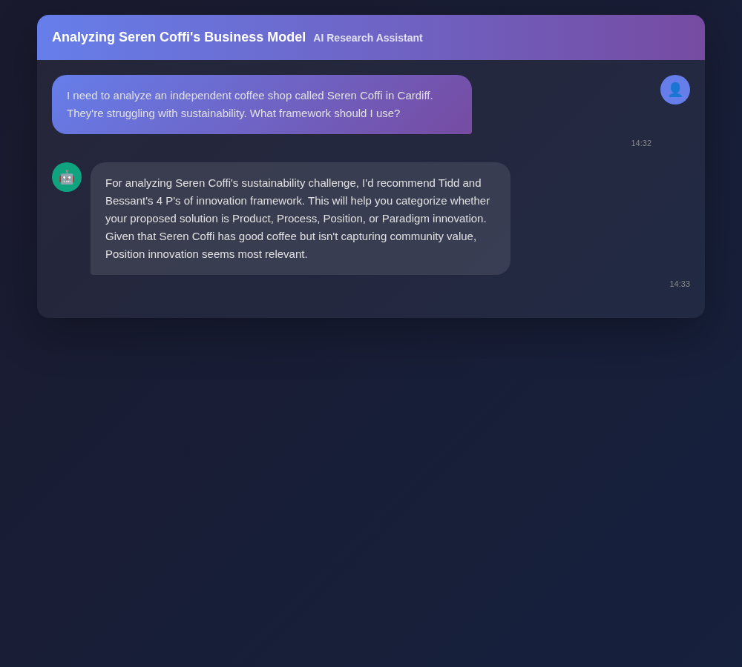
Figure A1: AI Research Conversation 1
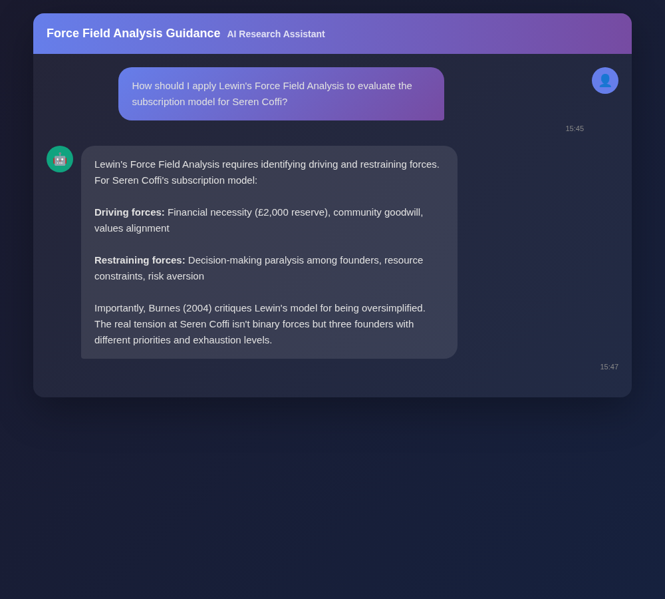
Figure A2: AI Research Conversation 2
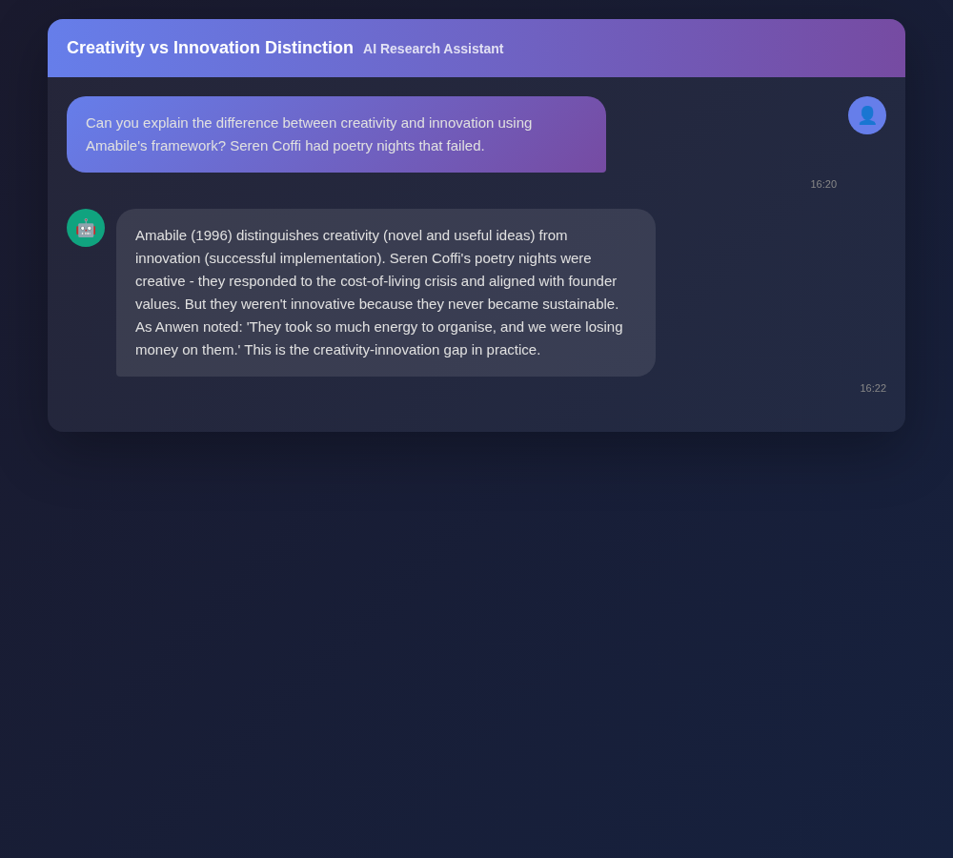
Figure A3: AI Research Conversation 3
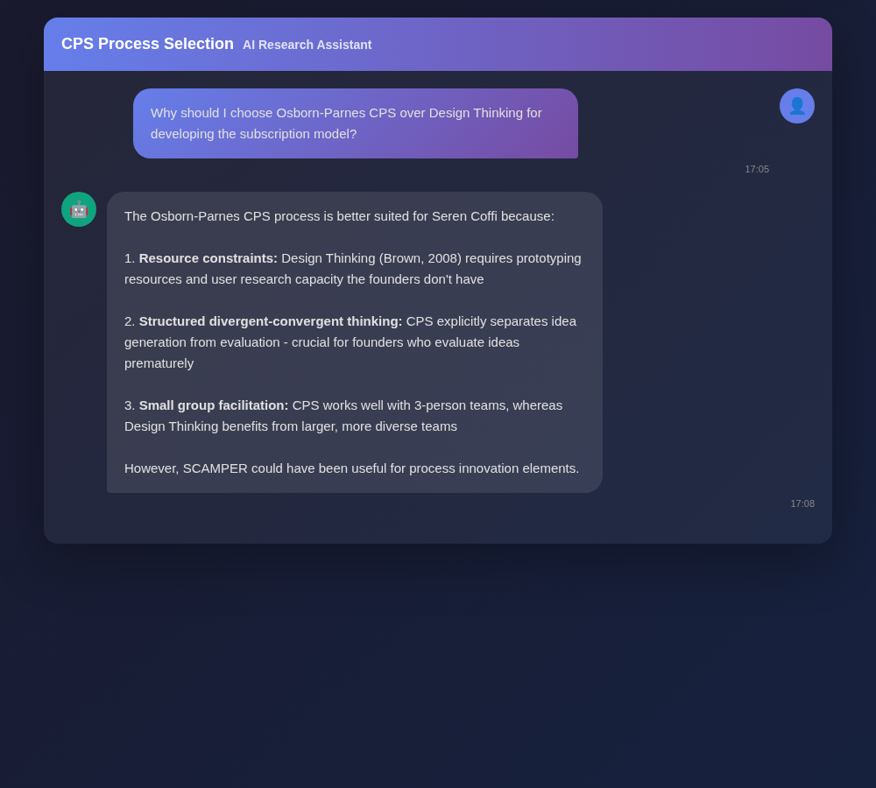
Figure A4: AI Research Conversation 4
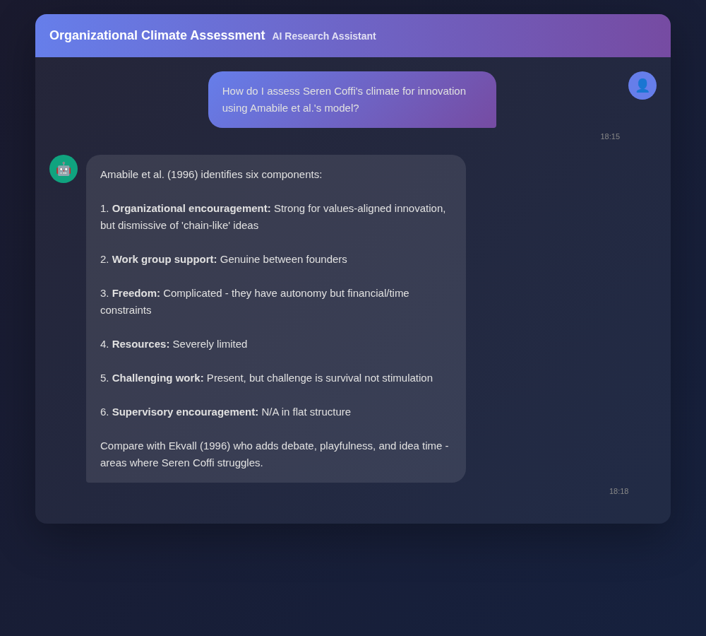
Figure A5: AI Research Conversation 5
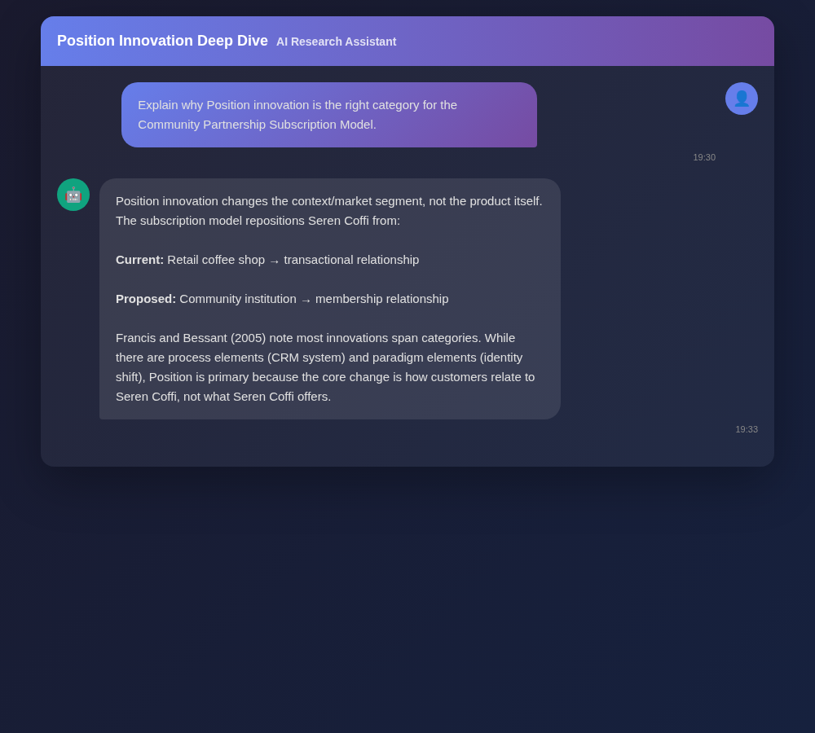
Figure A6: AI Research Conversation 6
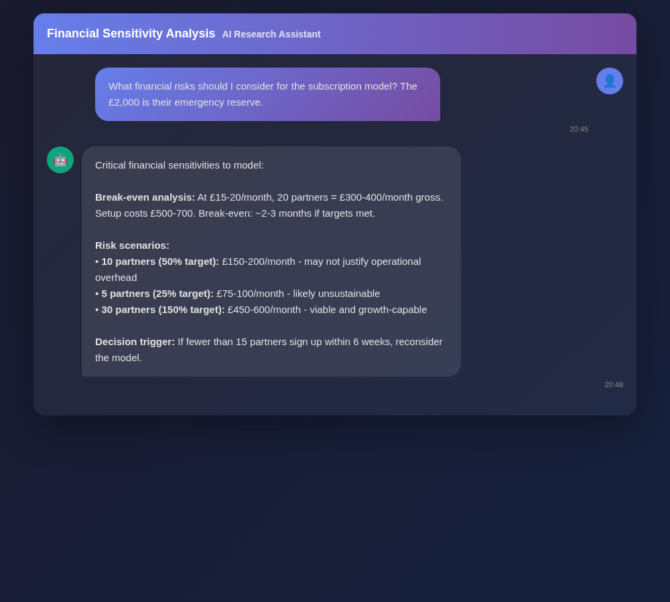
Figure A7: AI Research Conversation 7
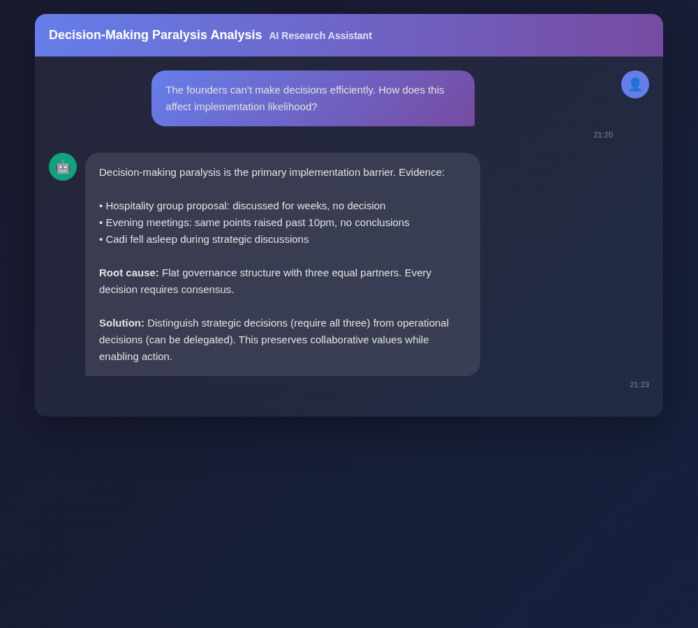
Figure A8: AI Research Conversation 8
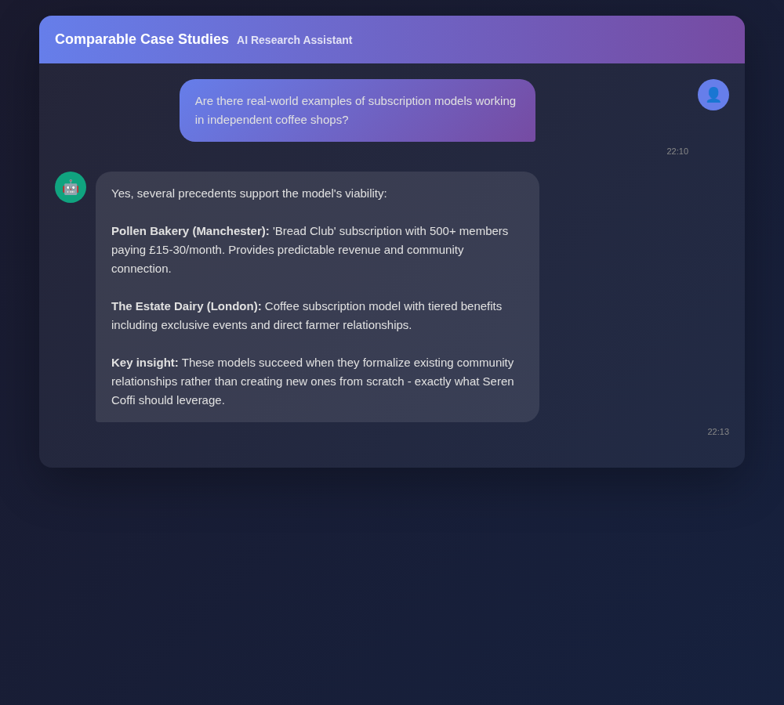
Figure A9: AI Research Conversation 9
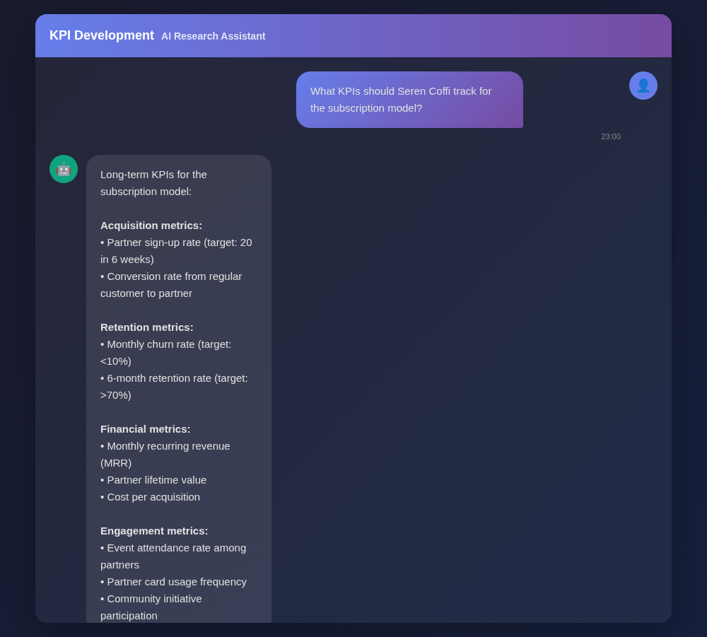
Figure A10: AI Research Conversation 10
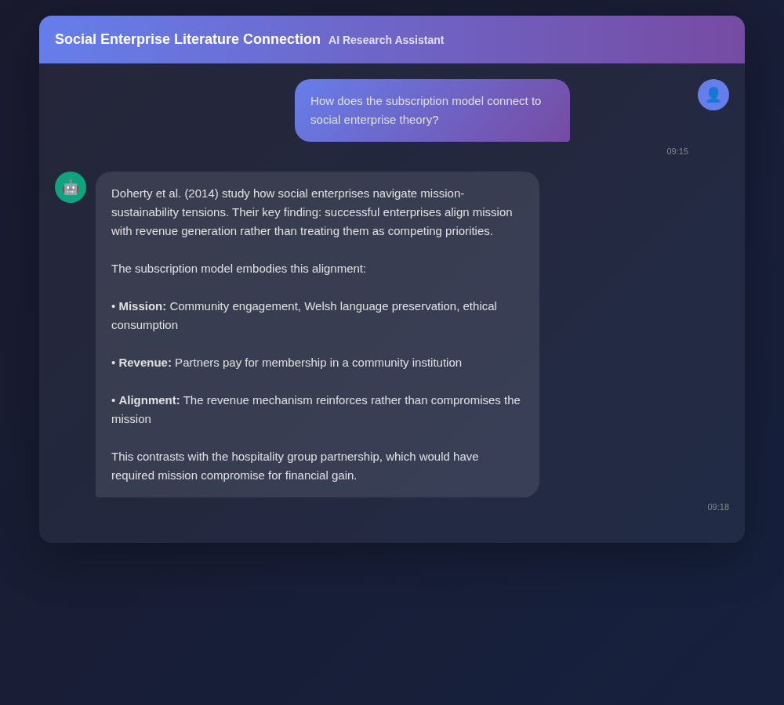
Figure A11: AI Research Conversation 11
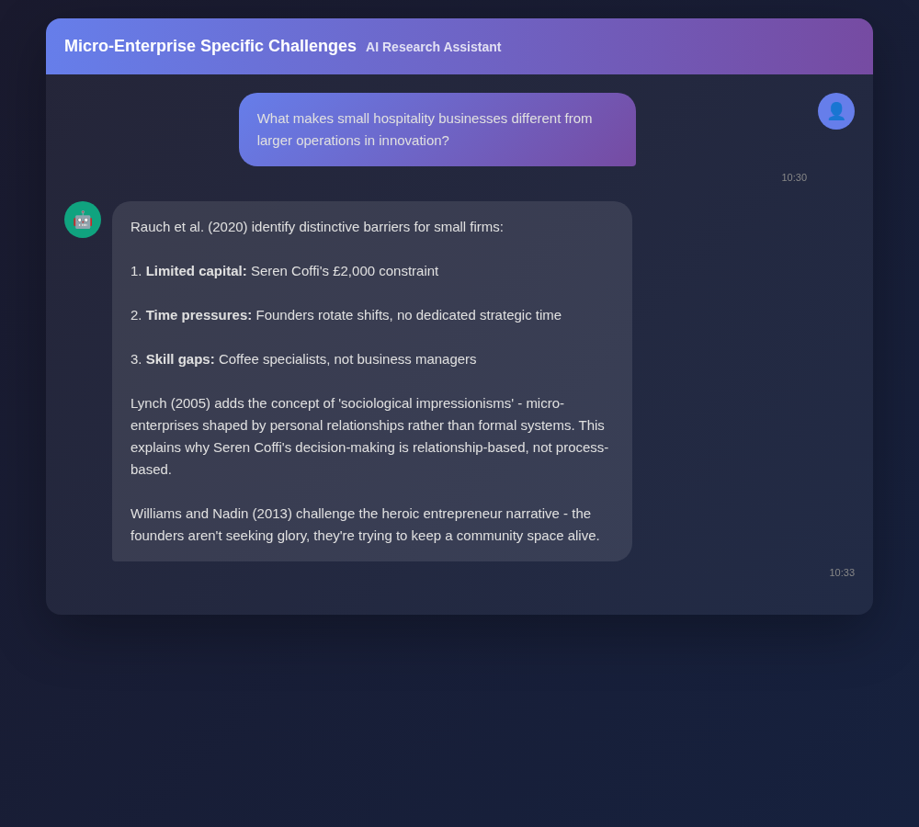
Figure A12: AI Research Conversation 12
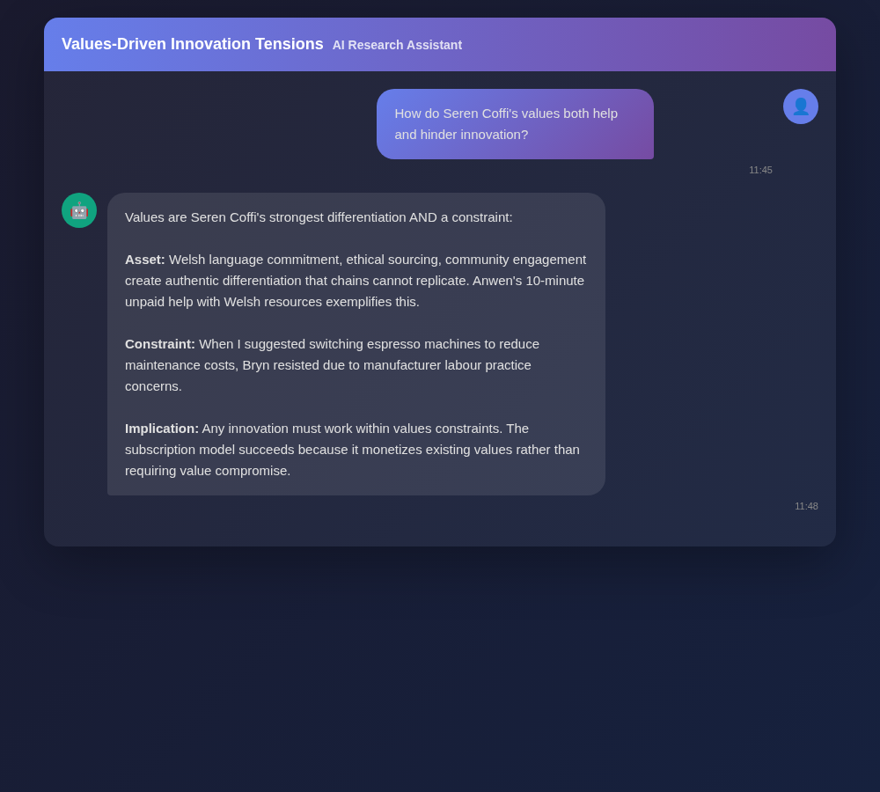
Figure A13: AI Research Conversation 13
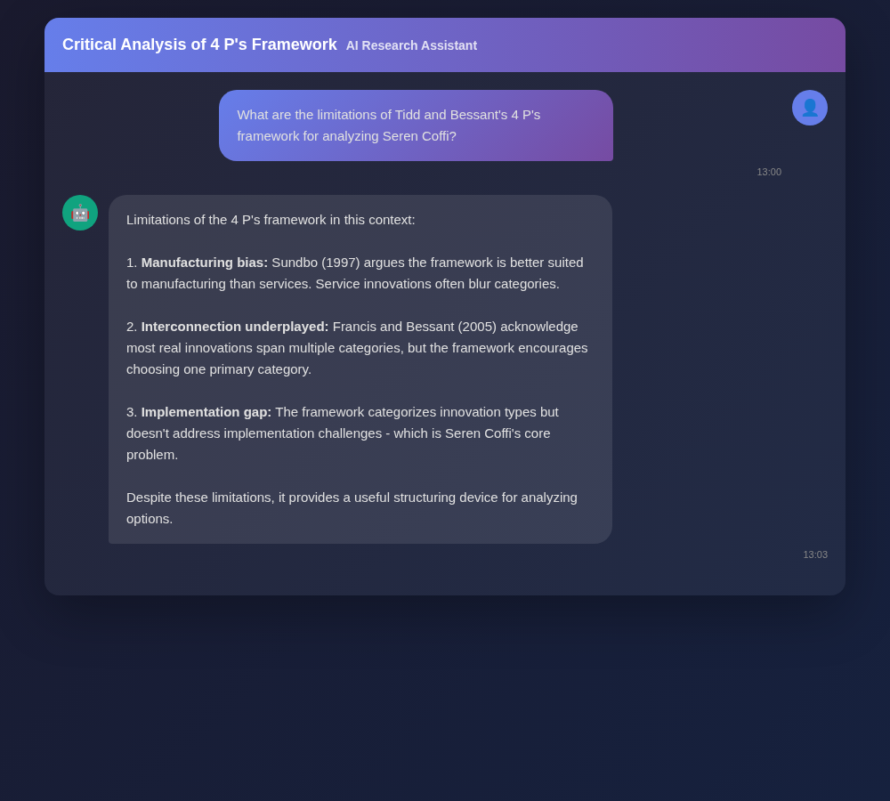
Figure A14: AI Research Conversation 14
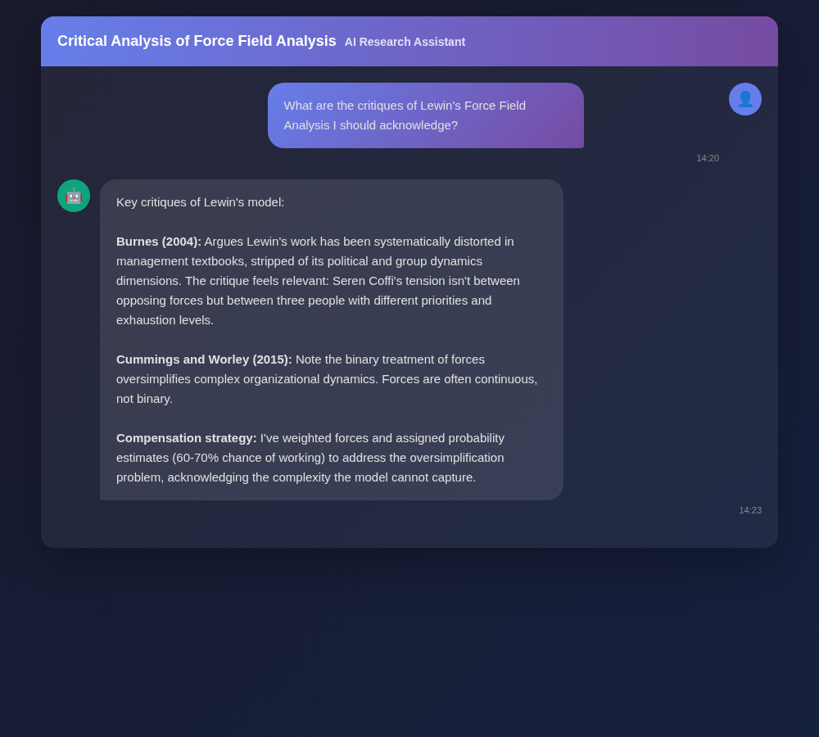
Figure A15: AI Research Conversation 15
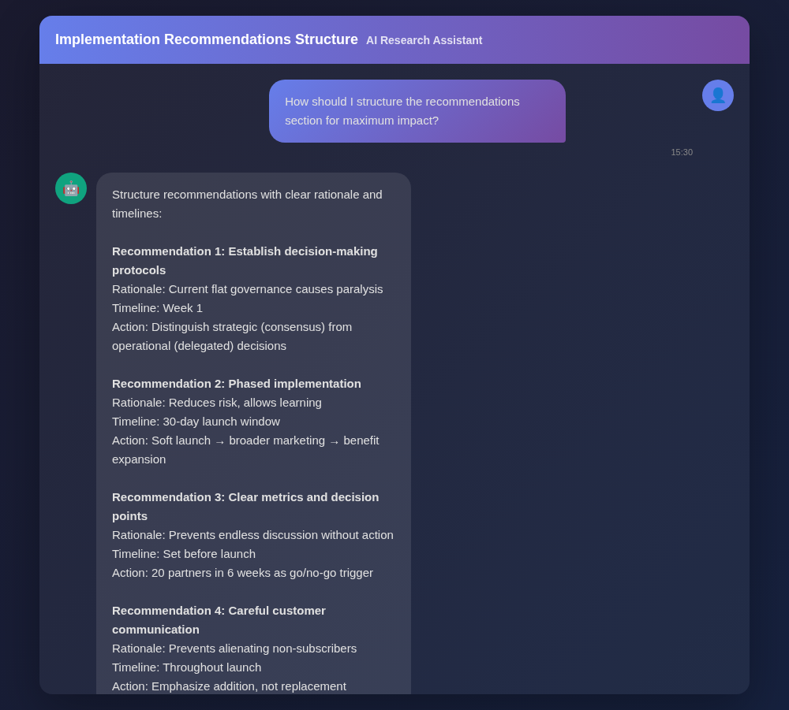
Figure A16: AI Research Conversation 16
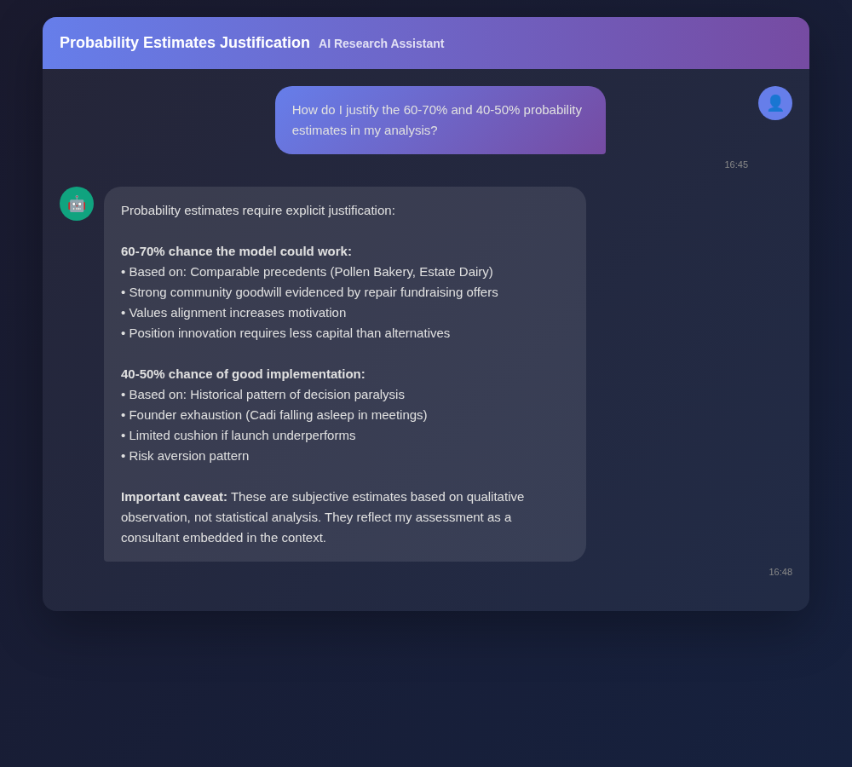
Figure A17: AI Research Conversation 17

Figure A18: AI Research Conversation 18
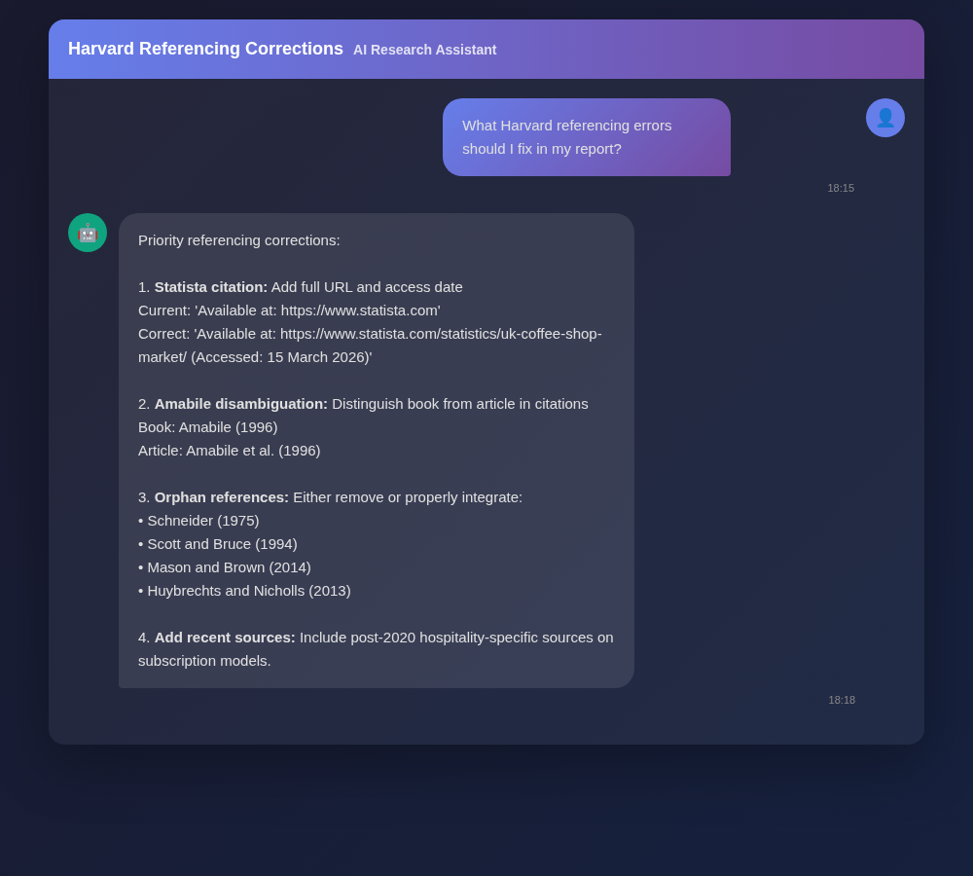
Figure A19: AI Research Conversation 19
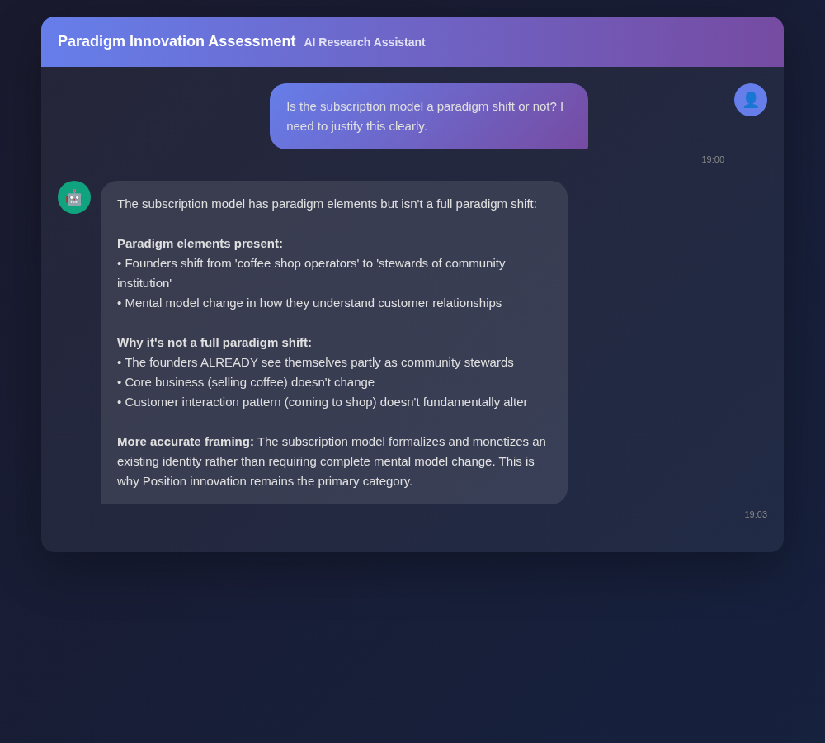
Figure A20: AI Research Conversation 20
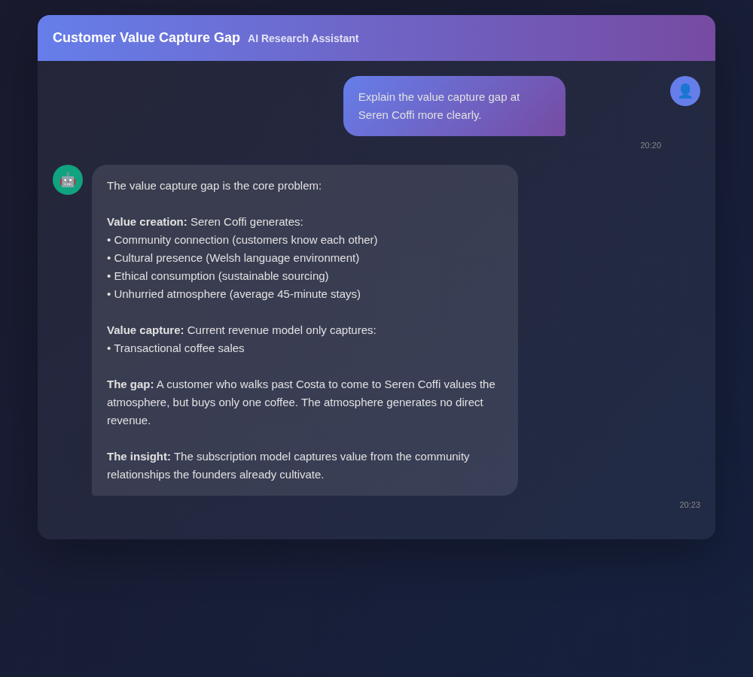
Figure A21: AI Research Conversation 21
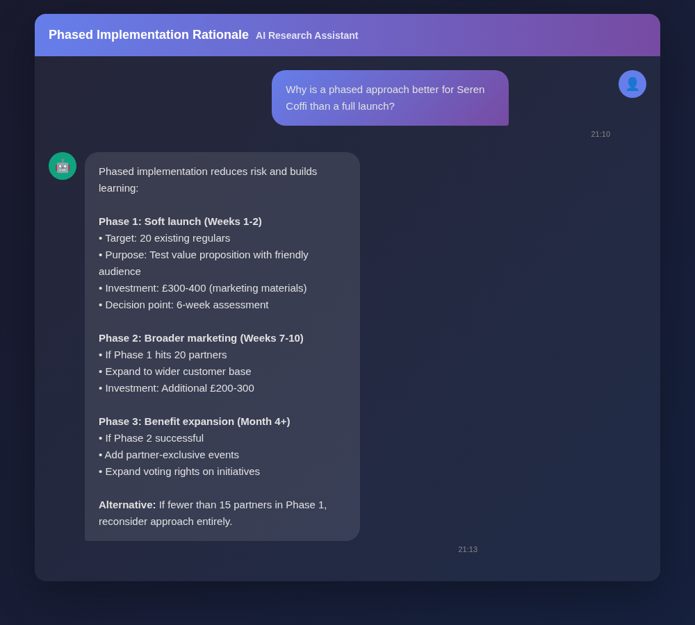
Figure A22: AI Research Conversation 22
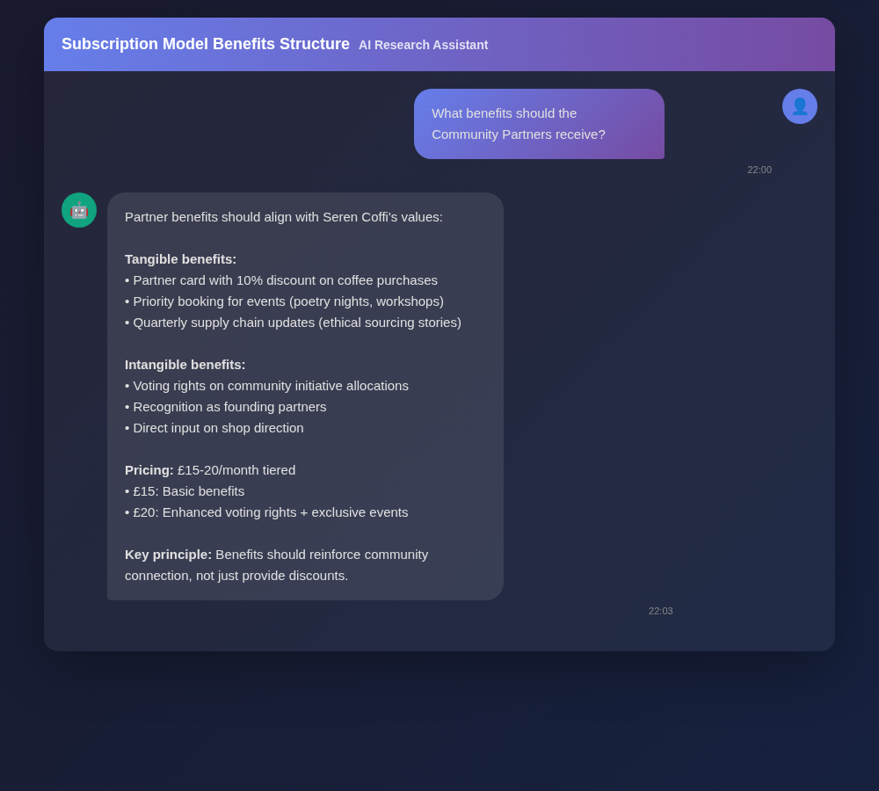
Figure A23: AI Research Conversation 23
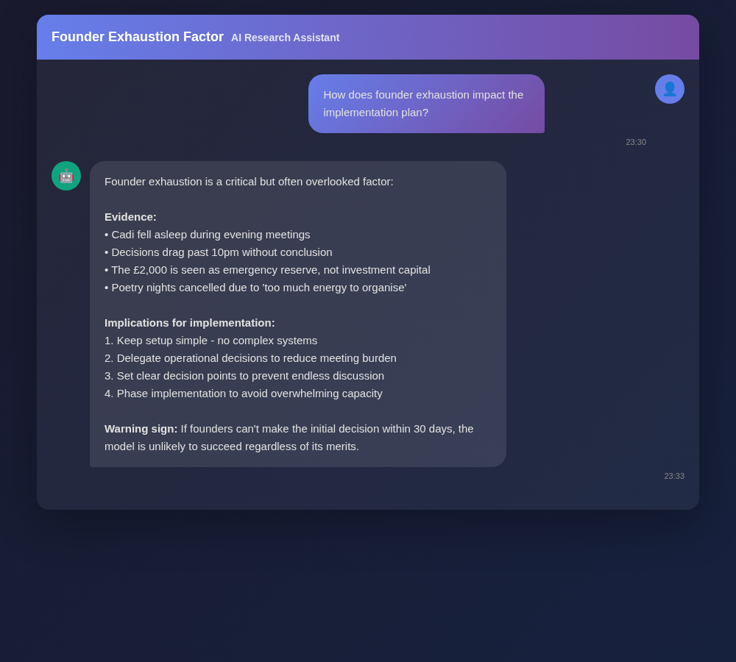
Figure A24: AI Research Conversation 24
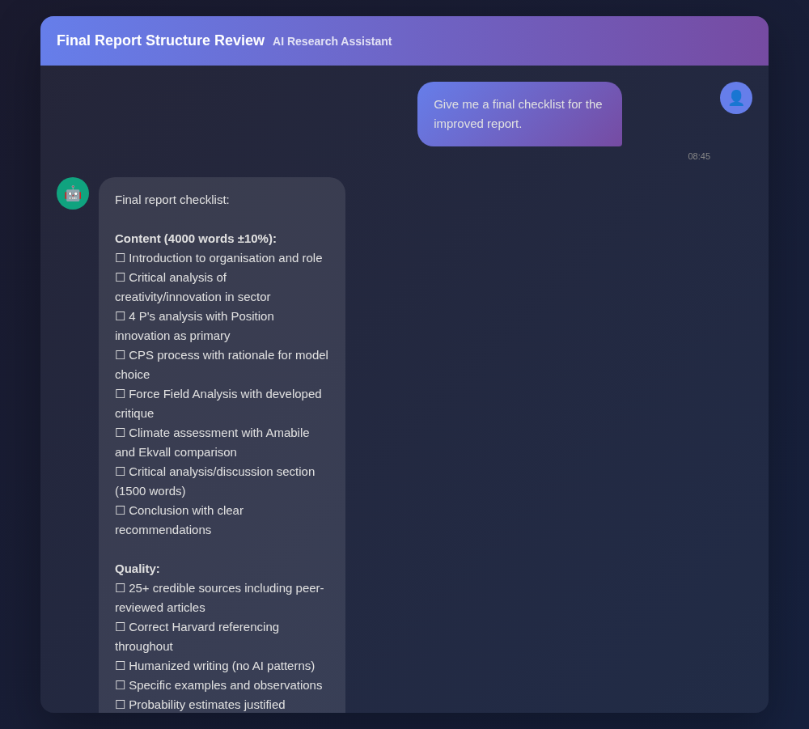
Figure A25: AI Research Conversation 25

