6/9/2026
Kyle Hall (2533563)
University of wales trinity saint david
HTML & CSS Web Development
BSc/HND Computing (All Streams)

Table of Contents
Introduction 2
Requirements 2
Implementation 2
Validation 5
Evaluation 5
Part 1. 5
Usability 5
Accessibility 5
Search Engine Optimisation (SEO) 5
Part 2. 6
Usefulness 6
Search Engine Optimisation (SEO) 6
Accessibility 6
Part 3. 7
The comparison of 2 Websites 7
Usability 7
SEO 8
Mobile Responsiveness 8
Conclusion 8
References 9
Appendices 9
Appendix 1 – Index 9
Appendix 2 – Childhood 13
Appendix 3 – FutureGoals 17
Appendix 4 – career 20
Appendix 5 – Education 25
Appendix 6 – Styles 30

Introduction
This report is designed to document, the development of my personal autobiography website. For the website I used HTML and CSS to design and construct website. This report will cover the requirements and purposes of the website, as well as the evaluation of the website in terms of usability, accessibility, and even search engine optimisation. It concludes with a comparison of two live websites that will serve a similar purpose to mine.

Requirements
The Website is a five-page autobiography. The purpose of it is to present my life story, openly and honestly, it covers my childhood, education, career, and even my future goals, with the sole aim of motivating others who have faced the same or similar struggles in their lives. Each page will focus on a distinct area of my life, giving the site a clear and easy to navigate structure throughout.
The target audience I have attempted to appeal to, is young people aged roughly 15-25, who have or are experiencing academic or personal difficulties. The content is written in a directed and personal tone to suit this audience, and the site is also designed to be standardised, so it is easy to navigate. It keeps a clear and consistent layout with an easy to use navigation bar to go to different pages.

Implementation
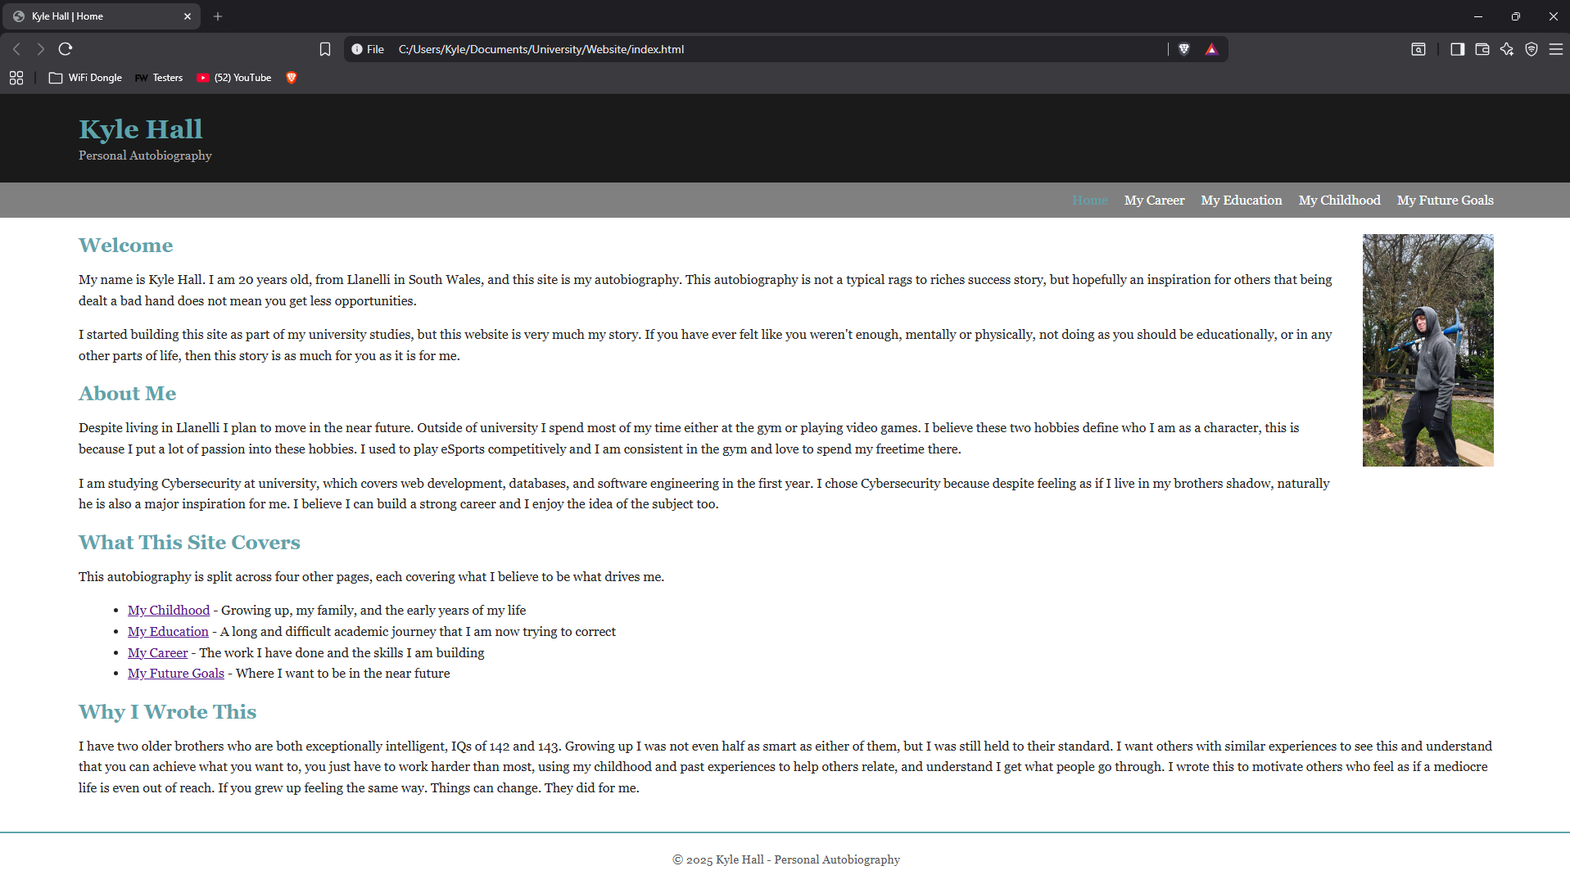
Home Page / Index page.

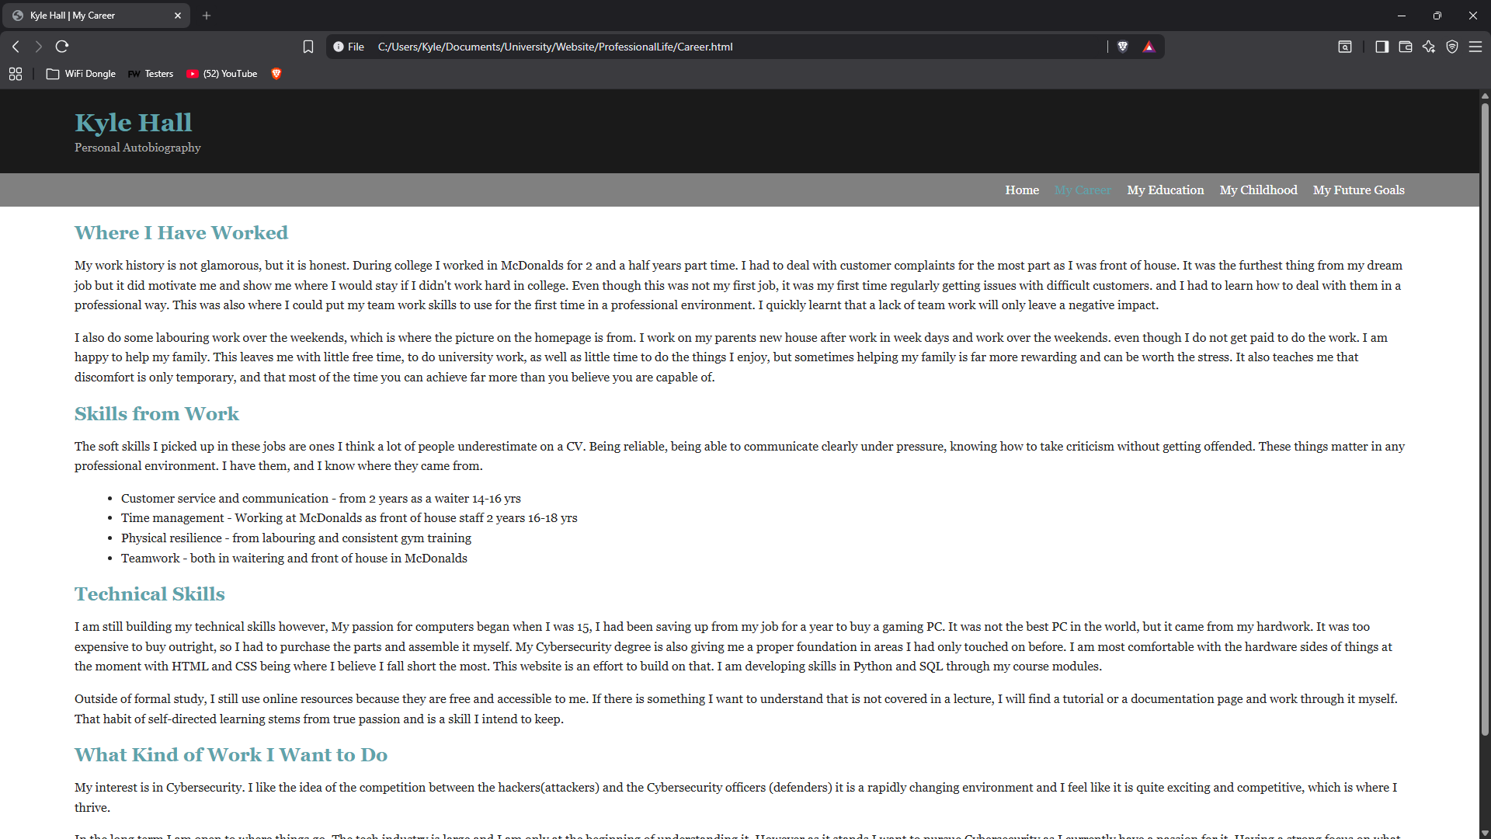
My career page.

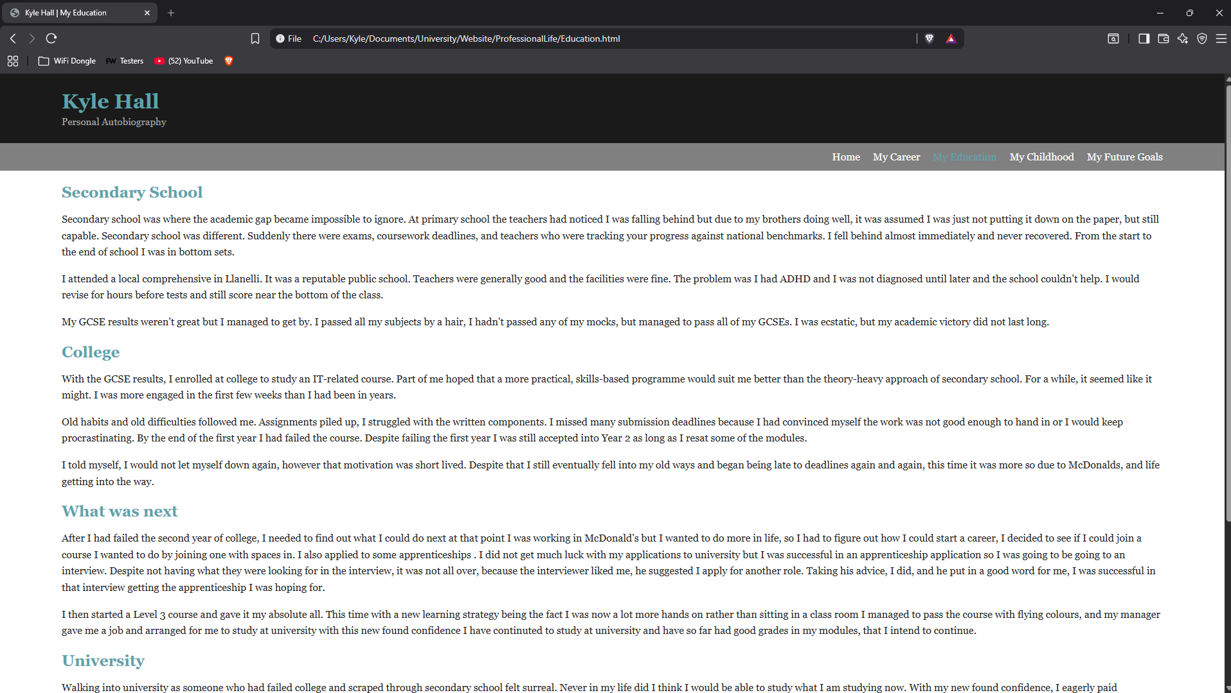
My education page.

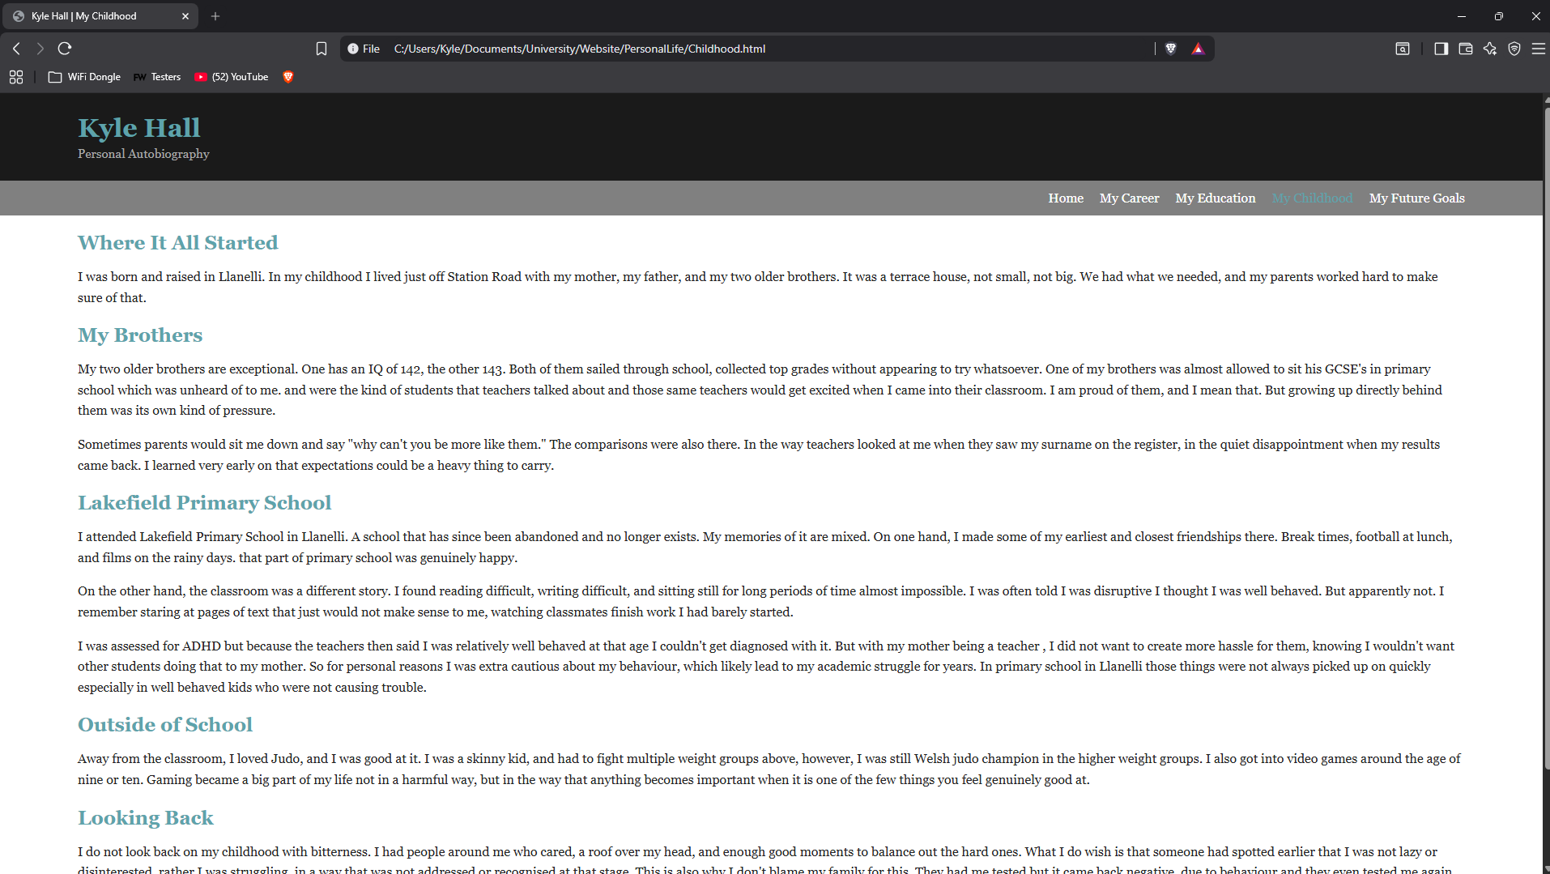
My childhood page.

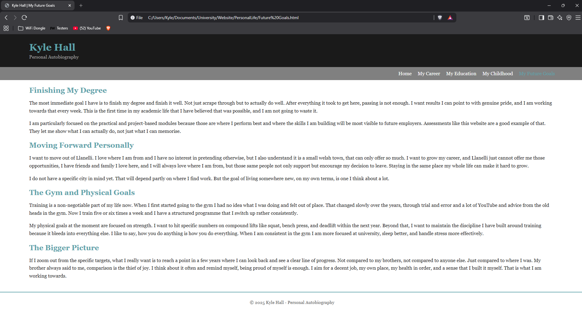
My future goals page.

Validation
I ran the Validator at W3C HTML Validator at validator.w3.org [1]. It came back with two errors both however, was the same root issue. The issue was an illegal space character in the file path in the “Future Goals” page, the path was not permitted as spaces are not allowed in URL paths. I decided to correct it by changing the name of the file and then updating every link pointing to that page across all other pages, I then re- validated and it came back with no errors after I had fixed the issue.
The stylesheet was validated using the W3C CSS Validator [2]. The initial validation returned with 1 error. A parse error on line 102, caused by a missing closing curly bracket on the media query block. This was corrected by adding the closing bracket in line 102, and then the validation returned with no errors.

Evaluation

Part 1.

Usability
Usability refers to how effectively, efficiently and satisfactorily a user can interact with a website, to achieve what they need to. In web development, usability is all about layout, navigation, readability and ease of use. A review of web usability was conducted between 2005 and 2014 the findings shown that the navigation was the most frequently identified for usability issue across 199 reviewed studies, with most researchers, using user-based evaluation methods, like questionnaires as well as usability testing. [3]

Accessibility
Web accessibility refers to designing websites so that people with disabilities can still interact, understand, navigate and utilise the website equally. The W3C’s Web content Accessibility guidelines, WCAG 2.1, sets out four core principles: perceivable, operable, understandable, and robust. Another review that was published in IEEE Access investigated 25 empirical studies on the web accessibility in educational websites. The findings shown that most sites had failed to meet WCAG standards, with automated tools set to identify widespread accessibility barriers across most evaluated sites. [4]

Search Engine Optimisation (SEO)
Search Engine Optimisation is the practice of optimising a website so that it ranks higher in the search engine’s results increasing traffic. Some on-page optimisations can include the use of descriptive meta tags, meaningful headings, alt attributes on the images, and keyword-relevant content. Research on this was published in Online Information Review identified ALT text and bounce rate as significant determinants of search engine optimisation performance, which found that the correct implementation had a measurable positive effect on the search engine rankings and its visitor numbers. [5]

Part 2.

Usefulness
The utility of the website fulfils its purpose. It presents a personal autobiography across five clear and separated pages. Each of the pages load correctly, navigation being clear and consistent on all pages, and the photo on the homepage also displays as intended. No broken links or missing functionality. However, the site does lack interactive features such as contact forms, maps to view where I grew up, which will ultimately reduce the visitors that engage with the content rather than just reading it.
The usability of the layout is clean and easy to follow. The sticky navigation bar will always remain visible even on the pages where scrolling is necessary, which makes it a lot easier to move between pages. My chosen colour of teal that I used for the highlights and the nav bar provides a clear visual indication of what page the user is on. The main text uses Georgia with a line height of 1.6, which I believe helps with readability. An oversight on my behalf was image using a float, as on smaller screens, such as smart phones, layout issues and glitches can occur.
The content side of the site I believe covers a distinct and clearly defined topic with sufficient detail to give the reader a meaningful idea of each aspect of my life. I should have added more visual content like images, or a timeline element to break up the text on longer pages.

Search Engine Optimisation (SEO)
My page contained unique title tags, to clearly demonstrate to users and the search engine what page it is, I utilised the pipe character for a more professional look. I also added a description with what I believed was relevant for the page. All the pages on the site also contain a heading hierarchy, using different heading tag sizes where it is appropriate. The image on the homepage also has alt text which I used to both increase accessibility and search engine optimisation. I also used a meta tag for viewport, on every page, which supports mobile rendering and is a factor in search engine ranking.

Accessibility
I evaluated the site against the four WCAG 2.1 principles. For ‘perceivable’ The photograph includes appropriate alt text and the colour contrast between the teal highlights on the dark header background is sufficient for most users. For ‘operable’ I utilised a sticky navigation as this is accessible via keyboard and no content relies on timed interactions. For ‘understandable’ the language I used throughout is clear and consistent, the site will also behave as intended. Finally, ‘robust’ the site uses sematic HTML elements including, headers, nav, main, and footer too which is consistent through all pages. Both the HTML and CSS have ben validated. Something I wish to implement in the future is the use of ARIA roles. This would improve compatibility with screen readers even further.

Part 3.

The comparison of 2 Websites
I have selected two sites for comparison, the first is Linkedin.com [6] and the second is about.me [7]. Both websites are widely recognized platforms that serve similar functions to my autobiography website. Their job is to present a persons identify and personal story, or background, as well as their career onto an online audience.

Usability
LinkedIn’s profile layout is structured well and will be familiar to most users, it has clearly defined sections for a person’s summary, experience, education, and skills. Navigation is consistent and the sticky top bar always allows for quick access to other areas of the website. The layout is logical and follows standardised rules, with content broken into smaller sections that allow for it to be easy to locate specific information. LinkedIn however enforces a strict template across all the profiles., which reduces the creative freedom to differentiate yourself visually and present information in a way that reflects a personality.
About.me is a much simpler platform, and has a single-page structure, this means there are much fewer accessibility concerns. However, the single-page structure also comes with its drawbacks, for example it is heavily dependent on background images, and user-submitted profile pictures, a colour contrast can also vary significantly between multiple profiles, depending on the user’s background of choice. This is also a notable weakness is a poor contrast between background and foreground text can fail WCAG 2.1 success criterion 1.4.3, as this requires a contrast ratio of at least 4.5:1 for normal text. The ‘WAVE’ Accessibility evaluation tool could also be used on either platform to identify contrast errors or any missing structural elements. WAVE identifies errors as definite WCAG failures that must be fixed, alerts or the elements that may cause accessibility issues and should be reviewed but also features that positively contribute to accessibility.
Having compared the two sites, I would say LinkedIn is the stronger performer on the accessibility front I would justify this due to its enterprise-level investment in inclusive design.

SEO
LinkedIn has exceptionally strong SEO. LinkedIn therefore ranks highly in google search results. When searching for a person’s name, their LinkedIn profile is typically always on the first page. This is likely due to LinkedIn being a high authority domain trusted by search engines. Every profile would include a unique title, based on the person’s name. as well as a headline for a description of them, structured content across experience, education and skills alike, all of those will contribute to the search visibility. LinkedIn articles are also indexed by Google. This gives them a double SEO potential compared to other regular posts.
About.me also provides reasonable SEO value. Every profile is assigned a unique URL, which is based on the user’s name and the page title is set automatically from their profile name. About.me however suffers from short profiles and contain limited text content. There is very little opportunity for keyword rich, content that search engines can index in depth. There are also no headings or hierarchies on a standard About.me page, the minimal content means the site relies heavily on the platform’s own domain authority, rather than the content of the individual page itself.
Overall, I would say that LinkedIn is the stronger platform when it comes to search engine optimisation.

Mobile Responsiveness
Both the platforms are fully responsive and were designed with mobile users in mind. LinkedIn’s mobile website mirrors the desktop experience very closely, with content reflowing into a single column, the navigation moving to a bottom bar for a more convenient access point for smaller handheld devices. LinkedIn also gathers data and uses that data to update and improve the website for mobile devices.
About.me is a well-suited website for mobile devices. The single page layout naturally adapts to the smaller screens. Without restructuring. The full background image and centred text is a layout scales cleanly across the screen sizes, there are not any complex navigation elements to manage. In some respects, About.me is a better mobile experience than LinkedIn’s.
The autobiography site I designed includes one responsiveness breakpoint; this will adjust the header as well as the navigation for the smaller screens. Unlike LinkedIn’s and About.me, it has not been tested on actual devices, and the floated image on the homepage remains a known limitation on the mobile screens that I would address in a future version.

Conclusion
Overall I would say LinkedIn has the stronger platform across all the key points I have discussed, it has a strongly structured layout, enterprise level, accessibility commitment as well as enormous domain authority to make it a far more powerful tool for presenting a personal biography to a wide audience, the about.me is a much simpler yet cleaner on mobile. About.me is however let down by its lack of depth that LinkedIn’s website achieves.

References

[1] | W3.org, “Nu Html Checker,” W3.org, 27 June 2026. [Online]. Available: https://validator.w3.org/nu/#textarea. [Accessed 27 June 2026].
[2] | W3C , “The W3C CSS Validation Service,” W3C , 27 June 2026. [Online]. Available: https://jigsaw.w3.org/css-validator/validator. [Accessed 27 June 2026].
[3] | T. G. S. Ç. C. İ. E. İ. G. V. a. B. M. Ugras, “ Research Trends in Web Site Usability: A Systematic Review,” in International Conference on Design, User Experience, and Usability (DUXU 2016), Toronto , 2016.
[4] | M. L.-M. S. a. V. L. Campoverde-Molina, “Empirical Studies on Web Accessibility of Educational Websites: A Systematic Literature Review,” IEEE Access, vol. 8, p. 91676–91700, 2020.
[5] | D. R. A. K. N. a. S. Y. Mladenović, “ Search Engine Optimization (SEO) for Digital Marketers: Exploring Determinants of Online Search Visibility for Blood Bank Service,” Online Information Review, vol. 47, no. 4, p. 661–679, 2023.
[6] | LinkedIn, “LinkedIn,” LinkedIN. [Online].
[7] | about.me, “About.me,” About.me. [Online].

Appendices

Appendix 1 – Index
<!DOCTYPE html>
<html lang="en">
<head>
<meta charset="utf-8">
<meta name="viewport" content="width=device-width, initial-scale=1.0">
<meta name="description" content="Kyle Hall's personal autobiography. My story of resilience and growth.">
<title>Kyle Hall | Home</title>
<link rel="stylesheet" href="Styles.css">
</head>
<body>

<header>
<h1><span class="highlight">Kyle Hall</span></h1>
<p>Personal Autobiography</p>
</header>

<nav>
<a href="index.html" class="active">Home</a>
<a href="ProfessionalLife/Career.html">My Career</a>
<a href="ProfessionalLife/Education.html">My Education</a>
<a href="PersonalLife/Childhood.html">My Childhood</a>
<a href="PersonalLife/FutureGoals.html">My Future Goals</a>
</nav>

<main>

<img src="Images/KyleHallPhoto.jpg" alt="A photograph of Kyle Hall" class="page-photo">
<h2><span class="highlight">Welcome</span></h2>
<p>My name is Kyle Hall. I am 20 years old, from Llanelli in South Wales, and this
site is my autobiography. This autobiography is not a typical rags to riches success
story, but hopefully an inspiration for others that being dealt a bad hand does not
mean you get less opportunities. </p>

<p>I started building this site as part of my university studies, but this website is very
much my story. If you have ever felt like you weren't enough, mentally or physically,
not doing as you should be educationally, or in any other parts of life, then this story
is as much for you as it is for me. </p>

<h2><span class="highlight">About Me</span></h2>
<p>Despite living in Llanelli I plan to move in the near future. Outside of university
I spend most of my time either at the gym or playing video games. I believe these two hobbies
define who I am as a character, this is because I put a lot of passion into these hobbies.
I used to play eSports competitively and I am consistent in the gym and love to spend my
freetime there.</p>

<p>I am studying Cybersecurity at university, which covers web development, databases, and
software engineering in the first year. I chose Cybersecurity because despite feeling as if
I live in my brothers shadow, naturally he is also a major inspiration for me. I believe I
can build a strong career and I enjoy the idea of the subject too. </p>

<h2><span class="highlight">What This Site Covers</span></h2>
<p>This autobiography is split across four other pages, each covering what I believe to be what drives me.</p>
<ul>
<li><a href="PersonalLife/Childhood.html">My Childhood</a> - Growing up, my family, and the early years of my life</li>
<li><a href="ProfessionalLife/Education.html">My Education</a> - A long and difficult academic journey that I am now trying to correct</li>
<li><a href="ProfessionalLife/Career.html">My Career</a> - The work I have done and the skills I am building</li>
<li><a href="PersonalLife/FutureGoals.html">My Future Goals</a> - Where I want to be in the near future</li>
</ul>

<h2><span class="highlight">Why I Wrote This</span></h2>
<p>I have two older brothers who are both exceptionally intelligent, IQs of 142 and 143.
Growing up I was not even half as smart as either of them, but I was still held to their
standard. I want others with similar experiences to see this and understand that you can
achieve what you want to, you just have to work harder than most, using my childhood and
past experiences to help others relate, and understand I get what people go through.
I wrote this to motivate others who feel as if a mediocre life is even out of reach. If you
grew up feeling the same way. Things can change. They did for me.</p>

</main>

<footer>
<p>&copy; 2025 Kyle Hall - Personal Autobiography</p>
</footer>

</body>
</html>

Appendix 2 – Childhood
<!DOCTYPE html>
<html lang="en">
<head>
<meta charset="utf-8">
<meta name="viewport" content="width=device-width, initial-scale=1.0">
<meta name="description" content="Kyle Hall's childhood. growing up in Llanelli, family life, and primary school years.">
<title>Kyle Hall | My Childhood</title>
<link rel="stylesheet" href="../Styles.css">
</head>
<body>

<header>
<h1><span class="highlight">Kyle Hall</span></h1>
<p>Personal Autobiography</p>
</header>

<nav>
<a href="../index.html">Home</a>
<a href="../ProfessionalLife/Career.html">My Career</a>
<a href="../ProfessionalLife/Education.html">My Education</a>
<a href="Childhood.html" class="active">My Childhood</a>
<a href="FutureGoals.html">My Future Goals</a>
</nav>

<main>

<h2><span class="highlight">Where It All Started</span></h2>
<p>I was born and raised in Llanelli. In my childhood I lived just off Station Road with my mother,
my father, and my two older brothers. It was a terrace house, not small, not big. We had
what we needed, and my parents worked hard to make sure of that.</p>

<h2><span class="highlight">My Brothers</span></h2>
<p>My two older brothers are exceptional. One has an IQ of 142, the other 143. Both of them
sailed through school, collected top grades without appearing to try whatsoever. One of my
brothers was almost allowed to sit his GCSE's in primary school which was unheard of to me.
and were the kind of students that teachers talked about and those same teachers would get excited
when I came into their classroom. I am proud of them, and I mean that. But growing up directly behind them
was its own kind of pressure.</p>

<p>Sometimes parents would sit me down and say "why can't you be more like them."
The comparisons were also there. In the way teachers looked at me when they saw my
surname on the register, in the quiet disappointment when my results came back. I learned
very early on that expectations could be a heavy thing to carry.</p>

<h2><span class="highlight">Lakefield Primary School</span></h2>
<p>I attended Lakefield Primary School in Llanelli. A school that has since been abandoned
and no longer exists. My memories of it are mixed. On one hand, I made some of my earliest
and closest friendships there. Break times, football at lunch, and films on the rainy days.
that part of primary school was genuinely happy.</p>

<p>On the other hand, the classroom was a different story. I found reading difficult, writing
difficult, and sitting still for long periods of time almost impossible. I was often told I was
disruptive I thought I was well behaved. But apparently not. I remember staring at pages of text
that just would not make sense to me, watching classmates finish work I had barely started.</p>

<p>I was assessed for ADHD but because the teachers then said I was relatively well behaved at that age
I couldn't get diagnosed with it. But with my mother being a teacher , I did not want to create more
hassle for them, knowing I wouldn't want other students doing that to my mother. So for personal reasons
I was extra cautious about my behaviour, which likely lead to my academic struggle for years.
In primary school in Llanelli those things were not always picked up on quickly especially in well behaved kids
who were not causing trouble.</p>

<h2><span class="highlight">Outside of School</span></h2>
<p>Away from the classroom, I loved Judo, and I was good at it. I was a skinny kid, and had to
fight multiple weight groups above, however, I was still Welsh judo champion in the higher weight
groups. I also got into video games around the age of nine or ten. Gaming became a big part of my life
not in a harmful way, but in the way that anything becomes important when it is one of the few
things you feel genuinely good at.</p>

<h2><span class="highlight">Looking Back</span></h2>
<p>I do not look back on my childhood with bitterness. I had people around me who cared,
a roof over my head, and enough good moments to balance out the hard ones. What I do wish
is that someone had spotted earlier that I was not lazy or disinterested, rather I was
struggling, in a way that was not addressed or recognised at that stage. This is also why
I don't blame my family for this. They had me tested but it came back negative, due to behaviour
and they even tested me again which was in year 10. This is when I got diagnosed. </p>

</main>

<footer>
<p>&copy; 2025 Kyle Hall - Personal Autobiography</p>
</footer>

</body>
</html>

Appendix 3 – FutureGoals
<!DOCTYPE html>
<html lang="en">
<head>
<meta charset="utf-8">
<meta name="viewport" content="width=device-width, initial-scale=1.0">
<meta name="description" content="Kyle Hall's future goals - graduating, working in tech, and building the life he wants.">
<title>Kyle Hall | My Future Goals</title>
<link rel="stylesheet" href="../Styles.css">
</head>
<body>

<header>
<h1><span class="highlight">Kyle Hall</span></h1>
<p>Personal Autobiography</p>
</header>

<nav>
<a href="../index.html">Home</a>
<a href="../ProfessionalLife/Career.html">My Career</a>
<a href="../ProfessionalLife/Education.html">My Education</a>
<a href="Childhood.html">My Childhood</a>
<a href="FutureGoals.html" class="active">My Future Goals</a>
</nav>

<main>

<h2><span class="highlight">Finishing My Degree</span></h2>
<p>The most immediate goal I have is to finish my degree and finish it well. Not just
scrape through but to actually do well. After everything it took to get here, passing is
not enough. I want results I can point to with genuine pride, and I am working towards
that every week. This is the first time in my academic life that I have believed
that was possible, and I am not going to waste it.</p>

<p>I am particularly focused on the practical and project-based modules because those
are where I perform best and where the skills I am building will be most visible to
future employers. Assessments like this website are a good example of that. They
let me show what I can actually do, not just what I can memorise.</p>

<h2><span class="highlight">Moving Forward Personally</span></h2>
<p>I want to move out of Llanelli. I love where I am from and I have no interest in
pretending otherwise, but I also understand it is a small welsh town, that can only
offer so much. I want to grow my career, and Llanelli just cannot offer me those
opportunities, I have friends and family I love here, and I will always love where
I am from, but those same people not only support but encourage my decision to leave.
Staying in the same place my whole life can make it hard to grow. </p>

<p>I do not have a specific city in mind yet. That will depend partly on where I find
work. But the goal of living somewhere new, on my own terms, is one I think about a lot.</p>

<h2><span class="highlight">The Gym and Physical Goals</span></h2>
<p>Training is a non-negotiable part of my life now. When I first started going to the
gym I had no idea what I was doing and felt out of place. That changed slowly over the
years, through trial and error and a lot of YouTube and advice from the old heads in
the gym. Now I train five or six times a week and I have a structured programme that
I switch up rather consistently.</p>

<p>My physical goals at the moment are focused on strength. I want to hit specific
numbers on compound lifts like squat, bench press, and deadlift within the next year.
Beyond that, I want to maintain the discipline I have built around training because
it bleeds into everything else. I like to say, how you do anything is how you do everything.
When I am consistent in the gym I am more focused at university, sleep better, and handle
stress more effectively.</p>

<h2><span class="highlight">The Bigger Picture</span></h2>
<p>If I zoom out from the specific targets, what I really want is to reach a point
in a few years where I can look back and see a clear line of progress. Not compared
to my brothers, not compared to anyone else. Just compared to where I was. My brother
always said to me, comparison is the thief of joy. I think about it often and remind
myself, being proud of myself is enough. I aim for a decent job, my own place, my
health in order, and a sense that I built it myself. That is what I am working towards.</p>

</main>

<footer>
<p>&copy; 2025 Kyle Hall - Personal Autobiography</p>
</footer>

</body>
</html>

Appendix 4 – career
<!DOCTYPE html>
<html lang="en">
<head>
<meta charset="utf-8">
<meta name="viewport" content="width=device-width, initial-scale=1.0">
<meta name="description" content="Kyle Hall work, skills, and plans for working in the technology industry.">
<title>Kyle Hall | My Career</title>
<link rel="stylesheet" href="../Styles.css">
</head>
<body>

<header>
<h1><span class="highlight">Kyle Hall</span></h1>
<p>Personal Autobiography</p>
</header>

<nav>
<a href="../index.html">Home</a>
<a href="Career.html" class="active">My Career</a>
<a href="Education.html">My Education</a>
<a href="../PersonalLife/Childhood.html">My Childhood</a>
<a href="../PersonalLife/FutureGoals.html">My Future Goals</a>
</nav>

<main>

<h2><span class="highlight">Where I Have Worked</span></h2>
<p>My work history is not glamorous, but it is honest. During college I worked in
McDonalds for 2 and a half years part time. I had to deal with customer complaints
for the most part as I was front of house. It was the furthest thing from my dream
job but it did motivate me and show me where I would stay if I didn't work hard in college.
Even though this was not my first job, it was my first time regularly getting issues with
difficult customers. and I had to learn how to deal with them in a professional way.
This was also where I could put my team work skills to use for the first time in a
professional environment. I quickly learnt that a lack of team work will only leave
a negative impact.</p>

<p>I also do some labouring work over the weekends, which is where the picture on the homepage
is from. I work on my parents new house after work in week days and work over the weekends.
even though I do not get paid to do the work. I am happy to help my family. This leaves
me with little free time, to do university work, as well as little time to do the things I
enjoy, but sometimes helping my family is far more rewarding and can be worth the stress.
It also teaches me that discomfort is only temporary, and that most of the time you can achieve
far more than you believe you are capable of.</p>

<h2><span class="highlight">Skills from Work</span></h2>
<p>The soft skills I picked up in these jobs are ones I think a lot of people
underestimate on a CV. Being reliable, being able to communicate clearly under
pressure, knowing how to take criticism without getting offended. These things
matter in any professional environment. I have them, and I know where they came from.</p>

<ul>
<li>Customer service and communication - from 2 years as a waiter 14-16 yrs</li>
<li>Time management - Working at McDonalds as front of house staff 2 years 16-18 yrs</li>
<li>Physical resilience - from labouring and consistent gym training</li>
<li>Teamwork - both in waitering and front of house in McDonalds</li>
</ul>

<h2><span class="highlight">Technical Skills</span></h2>
<p>I am still building my technical skills however, My passion for computers began
when I was 15, I had been saving up from my job for a year to buy a gaming PC.
It was not the best PC in the world, but it came from my hardwork. It was too expensive
to buy outright, so I had to purchase the parts and assemble it myself. My Cybersecurity
degree is also giving me a proper foundation in areas I had only touched on before.
I am most comfortable with the hardware sides of things at the moment with HTML and CSS
being where I believe I fall short the most. This website is an effort to build on that.
I am developing skills in Python and SQL through my course modules.</p>

<p>Outside of formal study, I still use online resources because they are free and accessible
to me. If there is something I want to understand that is not covered in a
lecture, I will find a tutorial or a documentation page and work through it myself.
That habit of self-directed learning stems from true passion and is a skill I intend to keep.</p>

<h2><span class="highlight">What Kind of Work I Want to Do</span></h2>
<p>My interest is in Cybersecurity. I like the idea of the competition between
the hackers(attackers) and the Cybersecurity officers (defenders) it is a rapidly
changing environment and I feel like it is quite exciting and competitive, which
is where I thrive. </p>

<p>In the long term I am open to where things go. The tech industry is large and I am
only at the beginning of understanding it. However as it stands I want to pursue
Cybersecurity as I currently have a passion for it. Having a strong focus on what I want
to do has been my method and my approach to most things so far in life. </p>

</main>

<footer>
<p>&copy; 2025 Kyle Hall - Personal Autobiography</p>
</footer>

</body>
</html>

Appendix 5 – Education
<!DOCTYPE html>
<html lang="en">
<head>
<meta charset="utf-8">
<meta name="viewport" content="width=device-width, initial-scale=1.0">
<meta name="description" content="Kyle Hall's education journey from secondary school struggles to studying computing at university.">
<title>Kyle Hall | My Education</title>
<link rel="stylesheet" href="../Styles.css">
</head>
<body>

<header>
<h1><span class="highlight">Kyle Hall</span></h1>
<p>Personal Autobiography</p>
</header>

<nav>
<a href="../index.html">Home</a>
<a href="Career.html">My Career</a>
<a href="Education.html" class="active">My Education</a>
<a href="../PersonalLife/Childhood.html">My Childhood</a>
<a href="../PersonalLife/FutureGoals.html">My Future Goals</a>
</nav>

<main>

<h2><span class="highlight">Secondary School</span></h2>
<p>Secondary school was where the academic gap became impossible to ignore. At primary
school the teachers had noticed I was falling behind but due to my brothers doing well,
it was assumed I was just not putting it down on the paper, but still capable. Secondary
school was different. Suddenly there were exams, coursework deadlines, and teachers who
were tracking your progress against national benchmarks. I fell behind almost immediately
and never recovered. From the start to the end of school I was in bottom sets. </p>

<p>I attended a local comprehensive in Llanelli. It was a reputable public school. Teachers were
generally good and the facilities were fine. The problem was I had ADHD and I was not diagnosed
until later and the school couldn't help. I would revise for hours before tests and still score
near the bottom of the class. </p>

<p>My GCSE results weren't great but I managed to get by. I passed all my subjects by a hair,
I hadn't passed any of my mocks, but managed to pass all of my GCSEs. I was ecstatic, but my
academic victory did not last long.</p>

<h2><span class="highlight">College</span></h2>
<p>With the GCSE results, I enrolled at college to study an IT-related course. Part
of me hoped that a more practical, skills-based programme would suit me better than the
theory-heavy approach of secondary school. For a while, it seemed like it might. I was
more engaged in the first few weeks than I had been in years.</p>

<p>Old habits and old difficulties followed me. Assignments piled up, I struggled
with the written components. I missed many submission deadlines because I had convinced
myself the work was not good enough to hand in or I would keep procrastinating.
By the end of the first year I had failed the course. Despite failing the first year I was
still accepted into Year 2 as long as I resat some of the modules. </p>

<p>I told myself, I would not let myself down again, however that motivation was short lived.
Despite that I still eventually fell into my old ways and began being late to deadlines again
and again, this time it was more so due to McDonalds, and life getting into the way.</p>

<h2><span class="highlight">What was next</span></h2>
<p>After I had failed the second year of college, I needed to find out what I could do next
at that point I was working in McDonald's but I wanted to do more in life, so I had to figure
out how I could start a career, I decided to see if I could join a course I wanted to do
by joining one with spaces in. I also applied to some apprenticeships .

I did not get much luck with my applications to university but I was successful in an
apprenticeship application so I was going to be going to an interview. Despite not having
what they were looking for in the interview, it was not all over, because the interviewer
liked me, he suggested I apply for another role. Taking his advice, I did, and he put in
a good word for me, I was successful in that interview getting the apprenticeship I was
hoping for. </p>

<p>I then started a Level 3 course and gave it my absolute all. This time with a new learning
strategy being the fact I was now a lot more hands on rather than sitting in a class room
I managed to pass the course with flying colours, and my manager gave me a job and arranged
for me to study at university with this new found confidence I have continuted to study at university
and have so far had good grades in my modules, that I intend to continue. </p>

<h2><span class="highlight">University</span></h2>
<p> Walking into university as someone who had failed college and scraped through secondary school
felt surreal. Never in my life did I think I would be able to study what I am studying now. With my new found confidence,
I eagerly paid attention. I decided to continue learning in work, and applying my skills to my course work. </p>

<p>The modules I am studying include:</p>
<ul>
<li>Introduction to Web and Database Concepts - which this website is part of</li>
<li>Software development</li>
<li>Computer Architecture and Operating Systems</li>
<li>Learning in the Digital Era</li>
</ul>

<p>My new method of learning suits the way I am, in a way that school and classrooms never
did. Learning more hands on in work, helps me continue to pay attention with my ADHD and
what I study in university is immediately applicable to my work. and since it is being used i
find it easier to remember. </p>

</main>

<footer>
<p>&copy; 2025 Kyle Hall - Personal Autobiography</p>
</footer>

</body>
</html>

Appendix 6 – Styles
body {
margin: 0;
font-family: Georgia, "Times New Roman", Times, serif;
background-color: #ffffff;
color: #222222;
}

.highlight {
color: #5EA3AB;
}

header {
background-color: #1a1a1a;
color: white;
padding: 25px 6em;
}

header h1 {
font-size: 2rem;
margin: 0 0 5px 0;
}

header p {
margin: 0;
color: #aaa;
font-size: 0.95rem;
}

.page-photo {
float: right;
margin: 0 0 15px 25px;
width: 160px;
height: auto;
}

main {
margin: 20px 6em;
}

nav {
display: flex;
justify-content: flex-end;
gap: 20px;
background-color: gray;
padding: 12px 6em;
position: sticky;
top: 0;
}

nav a {
color: white;
text-decoration: none;
transition: color 0.2s ease;
}

nav a:hover {
color: #5EA3AB;
}

nav a.active {
color: #5EA3AB;
}

main h2 {
margin-top: 20px;
margin-bottom: 8px;
}

main p {
margin-bottom: 12px;
line-height: 1.6;
}

ul {
margin-left: 20px;
margin-bottom: 12px;
line-height: 1.6;
}

footer {
margin-top: 40px;
border-top: 2px solid #5EA3AB;
padding-top: 10px;
text-align: center;
font-size: 0.9em;
color: #555;
}

@media (max-width: 768px) {
header {
padding: 20px 1.5em;
flex-direction: column;
align-items: flex-start;
}

nav {
padding: 12px 1.5em;
flex-direction: column;
align-items: flex-start;
gap: 10px;
}
}

