PRESENTATION OF WORK STRESS IN UK
^{Catalina Tihulca 2027642}
Module: Problem Solving and Decision Making-BMSW4004
^{Lecturer: Chijoke uba}

Table of Contents
Introduction 3
Cause-and-effect analysis of the complex problem 3
Pestel Analysis 4
Political factors 5
Economic factors 5
Social factors. 5
Environmental factors 6
Legal Factors 6
Fishbone diagram 6
Cause and Effects Diagram 7
PMI 7
PMI CHART 8
Reference List 9

Introduction
Individuals are surrounded by issues daily. Many difficulties have various components: "Every difficulty occurs whenever a person seems to have a purpose but still doesn't understand when the objective will be accomplished. When someone does not proceed out the specific scenario to the target value just through action, there needs to start thinking" (Duncker, 1945). Considering that an issue has been recognized, the structure of a person's facts is linked with the problem that has important ramifications for something like the course of action, they perform. To comprehend this reasoning, it is indeed crucial to distinguish the solver's description for the problem but also the series of events the solver does to get through the particular scenario towards the target.
In the UK looking at the statistics, we can see that stress-related from work is a complex problem. In 2020the work, the stress was answered by almost four-fifths of the persons, and it is followed by the financial stress

Cause-and-effect analysis of the complex problem
The nature of the problem is generally beneficial to people since this provides direction to our lives and provides enjoyment for the majority of individuals. A particular bit of work pressure is typically a positive thing since it may motivate you to put more effort and best equip you for demanding situations. However, if the level of stress and expectations becomes too much, it might result in job stress. Several factors might contribute to job stress, it includes things like an enormous number of tasks or unreasonable expectations.
-To be under pressure to fulfill objectives or deadlines.
-Having unpleasant working interactions with coworkers and even being bullied at the work management style
-Uncertainty about your employment function and what you are expected to perform Being in the incorrect job for your talents, abilities, and expectations.
-Doing this in the wrong field for your expectations
There is no one source of work-related stress in every situation. It might occur as a result of a buildup of tiny things over time, or because of a combination of factors among either your work or personal development.
The impact of the stress may get both emotional and physical consequences. Because everyone responds differently to stress, the effect and symptoms of job stress might differ depending on someone’s character and how one handles pressure. The following are a few of the most prevalent emotional repercussions or symptoms of work-related stress:
Starting to feel as though you are unable to keep up with your task
Losing faith in your ability to focus.
Having difficulty staying enthusiastic or devoted to their career, or feeling dissatisfied about their performance on the job
Feeling down/out and experiencing irritation or having a personal fuse.
Experiencing a sense of exhaustion with mood changes is a common occurrence. Work "The balance from what is needed of an employee versus what the employee can offer, at conditions that failing could bring grave repercussions," according to this definition of stress.(Kolbell, 1995; Kureczka, 1996; McGrath, 1992;). Stress factors could be beneficial or destructive, and a human's response to one is diverse and interesting, based on the significance he assigns to an experience. The severity of an employee's reaction will be determined by how he creates his understanding of the occurrence.

Pestel Analysis
A Pestel Analysis is a tool that helps us find intelligently the factors involved in change, it guides us to see as a whole the environmental threats. PESTLE is a tactical thinking method that assesses the potential effects of political, economic, social, technical, environmental, and legal elements on a plan. It involves a corporation considering the surrounding environment before commencing on a project. It's a great way to ensure and consider all of the potential risks or obstacles. Environmental analysis is essential for gaining a long-way market edge, identifying opportunities and problems, and promoting productive partnerships with different firms. According to a set of studies, several concepts and methods for macroeconomic research have been utilized in the setting (Lynch, 2009) Without it will be difficult to start since every organization is affected differently by external factors.
Political elements influence just how a government can influence a business or a specific corporation. A law may, for example, impose a new fee or charge, causing enterprises' entire profit processes to change.
Economic: Can decide the performance of a market, which has a significant impact on a firm effect. A rise in the rate of prices in practically every country would influence how firms offer their services and commodities. Additionally, it will have an impact on the buying capacity of the general populace. Economic issues include inflation, asset prices, currency costs, and financial inclusion trends.
Sociological: This element takes into account all events that already have a social effect on the economy and society. Therefore, the advantages and disadvantages to citizens inside the region in which the activity has been carried out must be assessed. Among these are social norms, community composition, excellent awareness, professional development, climate change, and other events. These parts look at the social structure of the sector and evaluate things like current thinking, demography, and community data.
Technical: elements relating to technological breakthroughs that may have a favourable or negative impact on economic dynamics. This word is referred to as, technological advancement, and the technical knowledge of a market.
Environmental: these elements are not used to evaluate a country's climatic and topographical characteristics. Researchers likewise evaluate a country's resource availability. This one is significant because products in places with harsh environmental variables must fulfil different standards than those in their homeland.
Legal: This component considers all legal issues, such as jobs, permits, income, capital, and open markets, among others.
Using the Pestel Analysis for our problem Stress at work we can identify

Political factors
- Growing political focus and pressure on healthcare.
-Increase pricing pressure.
-Change in taxation policy.

Economic factors
-Global economic crisis.
-Reduction in individual income.
- Employees may seek greater wages as a result of economies of scale, which will increase prices.
-Demand for a company's products may be boosted by higher country wages growth.Social factors.
-More pressure on customer services.
- Increased the need for education and more price transparency.
-Better intelligence gathering is required.
-Employee/employer bad communication

Environmental factors
-Climate change
-Weather

Legal Factors
-Discrimination laws
-Employment laws
Here I just elected in a Pestel Analysis what are the external factors of our problem the one that almost everybody calls Work Stress. The results of the case study investigations lead to the development of a conceptual perspective that visualizes the inner principle of work stress representative as well as the profession's changing business environment. The results add to a deeper academic knowledge of the service's structure and will provide specific direction for developing a comprehensive production.

Fishbone diagram
If with the PESTEL we identify the problem by understanding the internal and external factors that cause it, with the Fish Bone Analysis, we Identify and tackle the root of our problem rather than simply addressing its symptoms with a cause-and-effect diagram. Such graphics, also known as a fishbone diagram, allow for rapid analysis, identifying the fundamental causes of business problems so that viable remedies can be better understood. A detailed fishbone diagram can not only assist your process by identifying problems but can save time and resources by reducing reoccurring problems and prioritizing practical solutions.
The Ishikawa diagram or the fish bone chart is a technique for identifying the root causes of quality issues. Kaoru Ishikawa, a Japanese quality control researcher who developed the graph in the 1960s, and it was named after him. (Juran, 1999).
The Fishbone diagram is a methodical way of displaying the outcomes and impacts, as well as the reasons that cause or affect those outcomes. And for its role, it is often known as a cause-and-effect diagram (Watson, 2004).
The fishbone (Ishikawa) diagram is primarily a form of suggestive presentation for the relationships between an event (effect) and its many occurrences causes. The diagram's structure aids team members in thinking systematically. Constructing a Fishbone diagram has several advantages, including assisting in the identification of the fundamental possible causes or a quality attribute. Basic Tools for Process Improvement, 2009).
The diagram is made to mimic the skeleton of a fish. The interpretation can be simplistic, with angled contour lines leaning on a straight ax to indicate the allocation of the causal factors and sub-causes that produce them, but it can also be more complex, with qualitative and quantitative perceptions, titles, and scripting of the risks that characterize the causes and sub-causes, elements that show their sequence, and other risk procedure options. The diagram can also be used to assess the risks of the effect's causes and sub-causes, as well as the overall risk (Ciocoiu, 2008).
After the Fishbone diagram, the investigation usually proceeds with additional interpretations and approaches for determining intervention objectives.
The fact of Stress in the UK, an unpleasant event with negative implications, was chosen as the challenge for the application given in this paper. The risk labeled to the event under investigation will be the "Stress in the UK” and here we try to represent our main factors and explore each one to identify more specific ‘causes of causes.

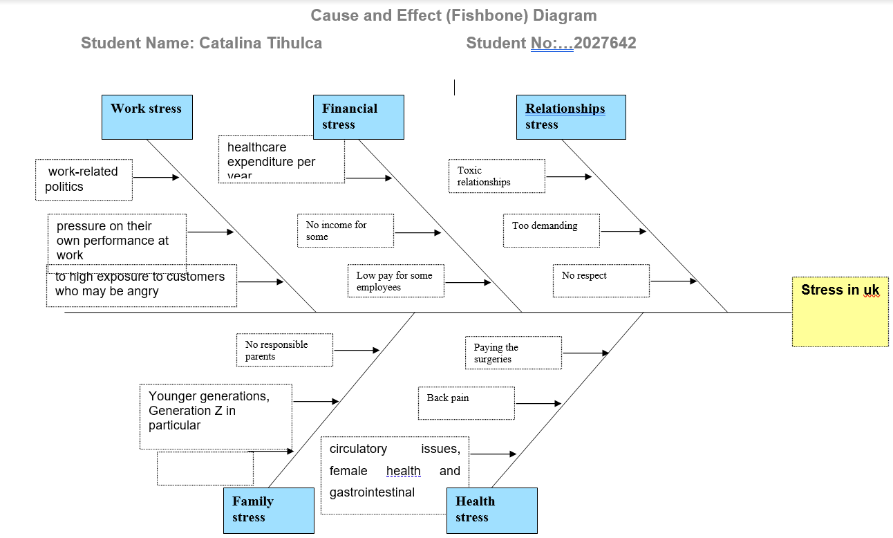
Cause and Effects Diagram

We identify the problem and brainstorm the main factors of it, now we can tackle the three main problems in the UK and we will try to apply the PMI table in such a way to find solutions.
PMI (plus, minus, interesting) is a brainstorming process that allows debate members to consider a topic from several perspectives.
Dr. Edward de Bono (1984), a believer of critical thinking education in schools, created PMI. Dr. de Bono is called by the name "lateral thinking," a problem-solving strategy that supports innovative, non-traditional approaches to problem-solving. PMI's objectives are to assist members in seeing both points of view and thinking more comprehensively about a topic. One of the difficulties with conventional belief, according to Dr. de Bono, is that people spend their focus on how to back up what is already a reasoned position. PMI is intended to stimulate innovation and help open every person's thinking.
The main problems in the UK are:
-Work Stress

PMI CHART
Work Stress
 | P (PLUS) | M (MINUS) | I (INTERESTING) | Total
Avoid conflictual Co-workers | Less nervousness +5  Easily work +3 | More work for you-6 | Better focus on what you need to do +10 | 12
Change the job | Better management+10  Doing what you like +10 | Less pay rate -8  Far from home -5  different shift -3 | Driving more +4  Enjoy the different shift +5 | 13
Do just the amount of work that you can do. | You do not go to exhaustion +10 | More conflicts with co-workers if they do more than you -10 | Understanding if you like the job +5 | 5

Reference List
Aguilar, F., 2021. Scanning the business environment. (Book, 1967) [WorldCat.org]. [online] Worldcat.org. Available at: <https://www.worldcat.org/title/scanning-the-business-environment/oclc/166317/> [Accessed 6 December 2021].
Basic Tools for Process Improvement. (1995, May 3). Retrived December 20, 2009, from Balanced Scorecard Institute: http://www.balancedscorecard.org/Portals/0/PDF/c-ediag.pdf
Ciocoiu, C. N. (2008). Managementul riscului. Teorii, practici, metodologii. Bucharest: ASE.
De Bono, E., (1984). Critical Thinking Is Not Enough. Educational leadership, 42(1), pp.16-17.
Duncker, K. and Lees, L.S., (1945). On problem-solving. Psychological monographs, 58(5), p.i.
Edwards, L. and Edwards, L.J., 1995. Practical risk management in the construction industry. Thomas Telford.
Juran, J. M. (1999). Juran's Quality Handbook (5th Edition). McGraw-Hill
Kolbell, R.M., (1995). When relaxation is not enough.
Available at: https://psycnet.apa.org/record/1995-98878-003
(accessed:7 December 2021)
Kureczka, A.W., (1996). Critical incident stress in law enforcement. FBI L. Enforcement Bull., 65, p.10.
Lynch, R. (2009). Strategic management. England: Pearson Education Limited
MacKay*, C.J., Cousins, R., Kelly, P.J., Lee, S. and McCAIG, R.H., (2004). ‘Management Standards’ and work-related stress in the UK: policy background and science. Work & Stress, 18(2), pp.91-112.
Maria, R.(2021) What is a PESTLE analysis? Available at: What is a PESTLE analysis? | How To Do, How To Apply, Who Created It? (cpdonline.co.uk)
(Accessed: 6 October 2021)
Marques, l. and LeBlanc, N,J. (2021). How to handle stress at work - Harvard Health. [online] Harvard Health. Available at: <https://www.health.harvard.edu/blog/how-to-handle-stress-at-work-2019041716436> [Accessed 6 December 2021].
Novick, L.R. and Bassok, M., (2005). Problem Solving. Cambridge University Press
Watson, G. (2004). The Legacy Of Ishikawa. Quality Progress 37(4) , 54-47.
Yüksel, I., (2012). Developing a multi-criteria decision-making model for PESTEL analysis. International Journal of Business and Management, 7(24), p.52.

