UNIVERSITY OF WALES TRINITY SAINT DAVID
2020
MD KALAM
LECTURER

ACADEMIC AND EMPLOYABILTY SKILLS BMSW4001
STRUCTURED ACADEMIC REPORT ON LEARNING USING MODELS OF REFLECTIONS
MARIS GARUBA: 1910039.Owner

UNIVERSITY OF WALES TRINITY SAINT DAVID LONDON CAMPUS

Table of Contents
INTRODUCTION 1
REFLECTIVE MODELS 2
HONEY AND MUMFORD 2
JOHN GIBBS REFLECTIVE CYCLE 3
CRITICISM 4
DESCRIPTION 5
FEELING 5
EVALUATION 6
ANALYSIS 7
CONCLUSION 7
ACTION PLAN: 8
DISCUSSION: 9
CONCLUSION 9
REFERENCES 9
APPENDIX 10

INTRODUCTION
The aim of this report is to reflect on my learning modules, using recognised modules of reflection to support my work. It will begin by discussing the various learning styles such as Honey and Mumford learning styles, Kolb’s learning cycle and Gibbs reflective cycle. This report will also discuss academic and employability skills acquired during the course of studying. Some of the academic skills will include summarising, paraphrasing, referencing, presentation and research. Employability skills to be discussed will include CV writing, cover letters, job application, communication, time management, and critical thinking: This report is very important because it will provide me the opportunity to reflect on what I have achieved since starting a certificate course, in a university setting, challenges faced, areas I need to improve on, and then draw up a professional career plan.

REFLECTIVE MODELS
According to David Kolb’s learning style (Kolb, 1984) transformation of effective learning can be seen when an individual progresses through a cycle of four stages which are: Having a concrete experience. The category of individuals tends to feel more than they think and are good at relating to others. Reflecting on the experience through reflection and review, they are known for watching and observing and embrace differing points of view. The Active Experimentation, these individuals are very practical, they try out what has been learnt, repeat an experience using another approach. The Formation of abstract concepts through conclusions\stroke learning from the experience

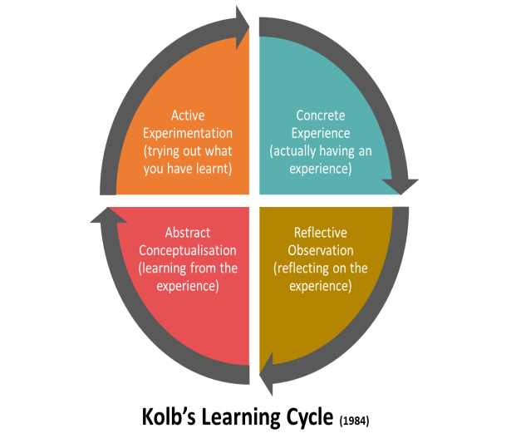

HONEY AND MUMFORD

Peter Honey and Alan Mumford learning style theory was developed based on Kolb’s works and idea on his Experiential learning cycle. They believed that individuals have four different learning styles which can be maximized when the individual is able to understand the type of learning styles that is most suitable to him/her. According to Honey and Mumford (1982), knowing one’s learning style will enable you to be more efficient in identifying learning opportunities, easily grasp leaning content and increase versatility. The four learning styles identified by Honey and Mumford are detailed below
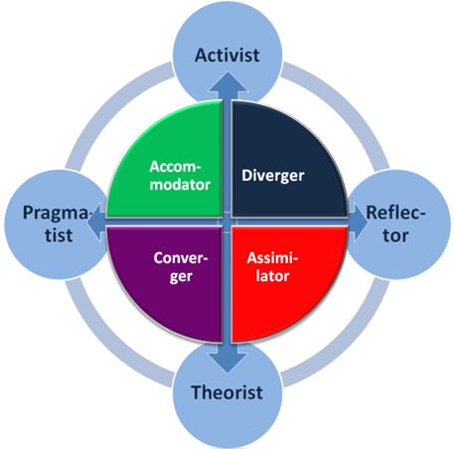
Characteristics
Learning styles | Attributes | Activities
Activist | They learn by active participation, | - Role play  - Work in groups
Theorists | Theorists take to solve problems by thinking using logical methods; they are precise and tend to be perfectionists. | - Statistics  - Use of quotes  - Apply theory
Pragmatists | Pragmatist- they like to try out new things, take part in discussions and prefer to get to the point | - Use case studies  - Discussion
Reflectors | Learn by observing and learning | - Feedback from other people  - Observe activities

JOHN GIBBS REFLECTIVE CYCLE
John Gibbs, an American sociologist and Psychologist in 1988, published his book, ‘Learning by Doing’ and it encourages individuals to think of their experiences, reflect on them, look at both the positive and negative effects it had on them and work with it.

CRITICISM
Although the above models all have their pros and cons, by using them to reflect, enables the individual to start thinking about their experiences. Some of the pros of these models are:
- They offer a structure to follow
- They provide useful starting points
- Enables you to assess all areas of the experience
Cons
- The models may not apply to every situation
- You may not start at the beginning in the actual event
- It has a defined way and steps to follow

Having reviewed all three models, in order to complete this report, I will be reflecting on the well-established model of reflection, which is the John Gibbs reflective cycle, which identifies 6 stages of reflection.



DESCRIPTION
After a family tragedy, I took up the opportunity to apply to university when the appropriate time arose. I stopped and listened to some agents looking for potential persons interested in going back to education and that paved the way for me to secure an admission at the University of Wales, Trinity Saint David London. After the euphoria of getting admitted subsided, the reality sets in and I began to get nervous of how I would cope after a long period of time away from a classroom setting.
My first day at university was almost marred by the Extinction Rebellion protest in London, leading to disruption to trains and buses, pouring rain, and a broken umbrella. Despite my initial challenges and worry, the first day went surprisingly well. The tutors were very friendly and approachable, and they treated us with gloves hands for the first 2-3 weeks to enable us settle in. the work on the other hand was more challenging as I learnt to sit for hours to take lectures and various information coming from different tutors, as well as from the student services and the technical team. The ability to log into the website proved difficult initially, but the technical department were on hand to provide support and information. Course work began properly after two weeks of induction. Various topics such as academic writing skills which included: summarising, paraphrasing, referencing, conducting research, both primary and secondary sources were taught.
The challenges of how to go about my presentation on a given topic with four other students in my group proved very demanding as there were clashes of opinions and compromises from all concerned. Finding out assignment had to be researched, sighted, referenced and submitted through Turnitin, rather than the usual way of submitting your written work to a tutor was confusing and overwhelming. While I was able to scale through the first term, the second term started well, until the global outbreak of the COVID 19 pandemic, which led universities to move class room based teaching to online delivery of lessons.

FEELING
According to Gibbs reflective cycle second stage, I felt while studying this module, very anxious of how I will be able to fit in after such a long break from education. I was worried of how my family would cope if I had to leave home early to catch the train. I didn’t know what to expect from the tutors and how lectures would be delivered. I wasn’t that confident initially, I asked a lot of questions and it got annoying at a certain point as evidenced from the look on the faces of whoever I was talking to. I went down to the reception to ask questions as well to get information. We had a group presentation where external examiners had to sit in and observe. I felt very anxious of speaking in front of the class during my group’s presentation but the lecturer reassured us that it was natural reaction to speaking in public.
The biggest worry came when the lecturer started talking about Harvard referencing, academic and reflective writing, essay, report, literature review, Turnitin and word limit to keep to on the essays and report. These were all foreign to me as I had never heard some of these terminologies. I looked some of them up on Google and after some time I familiarised myself and learnt to apply them into my everyday use
I had very limited digital skills and when classes were moved online due to the Covid 19 global outbreak, I found it difficult to understand what virtual learning was all about. However after settling into academic life by constant attempts of trial and error, I gained confidence, aspired to achieve one hundred per cent in attendance, complete all assignments to the best of my ability and apply knowledge that I had gained to my job.

EVALUATION
I’ve gained countless new and exciting knowledge as a result of attending university. I’ve learnt to differentiate between academic and employability skills, including when and how to apply them. I learnt how to carry out literature reviews using journals, articles, books, magazines, and newspapers. i was able to conduct primary research to collect qualitative and quantitative data by generating survey questionnaires to receive feedback from responders. I learnt to submit assignments through Turnitin, and follow assignment brief and instructions in terms of minimum words required.
However, when I submitted my assignment and got the feedback, I was disappointed with some of the grades I got from two of the modules. I read through the tutors’ feedback and discovered I did not do the literature review as requested; there were a few grammatical errors throughout my report. I failed to critically evaluate and analyse the literature review to a satisfactory level. I also learnt that in order to complete my assignment. I had to acknowledge and embrace the delivery of academic materials online via VLE.

ANALYSIS
In retrospect, I could have done more research and attend open days in order to gain more knowledge of University life would be like as these are all discussed on open days. Even though I was ready to gain some new experiences, I was caught off guard and was overwhelmed initially. I didn’t realise I had to do a lot of learning on my own, carry out research, analyse and complete assignment to a high standard.
According to Crutsinger(1994),time management is the process of setting goals, priotise them at specific times, allocation to these tasks, review goals and observe results, I could have manage my time better by adopting the 20/80 rule as it is very important to priotise.
I could have started writing my essays and reports earlier than when I. And the pressure to meet the deadline became too much. It could have been avoided by approaching my assignment feeling calm and prepared to enable me to plan the format and have a draft which could be sent to the lecturers for feedback.
In my group presentation, I could have taken a more proactive role, instead of going along the team leader said. I failed to reference my speaker note during my presentation. That caused me to lose marks. I was upset with the team leader for making us lose marks. I could have spoken up or at least dealt with the situation as it was better to deal with certain issues as it happens (Cooper 2001)
I could have also used the online library more often to do my research, rather than use Google, Wikipedia, and blogs and watch YouTube videos. This could have helped me to use books, articles and journals which have been peer reviewed and well established.

CONCLUSION
In conclusion, it was a great achievement to attend a University as it has helped me to acquire more knowledge, I have been able to identify the areas I need to improve on, such as time management skills by applying Eisenhower Matrix model of what are important and urgent, use the record, analyse and change (RAC), de-cluttering, scheduling, and have a start and stop time. I have been able to read more about the process of carrying out a literature review as well as improve on my referencing.
.

ACTION PLAN:
In order to improve myself on some of the challenges faced, I will be taking these necessary steps:

Skills | Why it is important | Ways to improve the skills | Resources | Anticipated obstacles | Time Scale
Time management | To ensure tasks are completed, to limit time wastage | Schedules, delegate, diary, notes, de-cluttering, follow-ups, 80/20 rule, prioritize | Schedules  Plans  Reminder apps | Procrastination, lack of clarity, too many distractions | On going
Communication | Communicate effectively, to understand others and be understood | Develop listening skills, use appropriate body language, read books etc., | Library  Attend seminars  Attend classes | Use of jargons | On going
Academic writing | For analysis, referencing, research  Critical thinking | Write as often as possible  Proof read  Follow guidelines | Books  Journals  Attend seminars | Plagiarism  Lack of planning  Grammatical errors  Writing informally | Academic duration
Employability skill | Better employment prospect | Networking  Teamwork  Professionalism | Apprenticeship  Positive attitude  Apply and attend job interviews | Disadvantage background  Lack of basic skills  Poor history of employment | On going

DISCUSSION:
The objective of drawing up this personal development plan is to enable me analyse my skills, knowledge, my capabilities, possible obstacles and identify the areas to improve on. This will serve as a guide to achieve my career path in the future. I will review and update this plan to meet my goal and most importantly hold myself responsible to follow through.

CONCLUSION
The transition from class room based teaching to online delivery of lectures due to the outbreak of COVID 19 has taught me that I have the capability to make changes as situation calls for it, (Lewin 1958) Overall I’m glad I am using this course as an exit to achieve my target of becoming a qualified professional adult nurse in the near future.

REFERENCES

Kolb, A.,(1984). Experiential learning: Experience as the source of learning and development (Vol. 1). Englewood Cliffs, NJ: Prentice-Hall.

Crutsinger, C., (1994). Thinking smarter: skills for academic success [Online]. Available from https://study.com/academy/lesson:Accessed:30 April, 2020

Lewin, K. (1958) Group decision and Social Change. [Online]. Available from https://www.mindtools.com. Accessed: 28 April, 2020.

Gibbs, G.,(1988). Learning by doing: A guide to a teaching and learning methods. Oxford, Polytechnic: Further Educational Unit.

APPENDIX



